

Bachelor of Computer Applications (BCA) Programme

Project Report

BCA Sem VI

AY 2022-23

*Book My Trip*

*By*

|  |  |
| --- | --- |
| Exam No | Name of Student |
| 3387 | Dodiya Darshan P. |
| 3035 | Dhaduk Arpit S. |
| 3031 | Dave Keyur H. |

Project Guide by: Prof. Khushbu Surati

# Acknowledgement

The success and final outcome of this project required a lot of guidance and assistance from many people and we are extremely fortunate to have got this all along the completion of our project work. Whatever we have done is only due to such guidance and assistance.

We would not forget to thank I/C Principal Dr. Aditi Bhatt, Head of Department Dr. Vaibhav Desai and Project guide Prof. Khushbu Surati, and all other Assistant professors of SDJ International College, who took keen interest on our project work and guided us all along, till the completion of our project work by providing all the necessary information for developing a good system. We are extremely grateful to her for providing such a nice support and guidance though she had busy schedule managing the college dealings.

We are thankful and fortunate enough to get support and guidance from all Teaching staffs of Bachelor of Computer Application Department which helped us in successfully completing our project work. Also, we would like to extend our sincere regards to all the non-teaching staff of Bachelor of Computer Application Department for their timely support.

Dave Keyur H. (3031) Dodiya Darshan P. (3387) Dhaduk Arpit S. (3035)

*I N D E X*

|  |  |  |
| --- | --- | --- |
| **Sr. No** | **Description** | **Page No.** |
| 1 | Introduction | 1-2 |
|  | 1.1 Project Summary | 1 |
|  | 1.2 Project Technical Profile | 2 |
| 2 | Scopes & Planning | 3-9 |
|  | 2.1 Requirement Analysis | 3-5 |
|  | 2.2 Feasibility Study | 6 |
|  | 2.3 Timeline Chart | 7 |
|  | 2.4 Future Development | 8 |
|  | 2.5 Technology Details | 9 |
| 3 | Designing | 10-55 |
|  | 3.1 Data Flow Diagram | 10-17 |
|  | 3.2 Use Case Diagram | 18-19 |
|  | 3.3 ER Diagram | 20-23 |
|  | 3.4 Database Design | 24-27 |
|  | 3.5 User Interface | 28-55 |
| 4 | Testing | 56-64 |
|  | 4.1 Unit Testing | 56-60 |
|  | 4.2 Navigation Testing | 61-62 |
|  | 4.3 Functional Testing | 63 |
|  | 4.4 Environment Testing | 64 |
| 5 | Conclusion | 65 |
| 6 | Bibliography | 66 |



# Introduction

## Project Summary

The main purpose of “Book My Trip” is to provide a convenient way for a customer to book hotels, flight, train and bus for tour packages. The objective of this project is to develop a system that automates the processes and activities of a travel agency. In this project, we will make an easier task of searching places and for booking packages. In the present system a customer has to approach various agencies to find details of places and to book tickets. This often requires a lot of time and effort. We provide approach skills to critically examine how a tourist visits and its ability to operate in an appropriate way when dealing with the consequences of tourism, locally, regionally, and nationally including visitor security and ecological influences. It is tedious for a customer to plan a particular journey and have it executed properly. The project is developed to replace the currently existing system, which helps in keeping records of the customer details of destination as well as payment received.

This website is to provide best travelling packages to the customers and travel agents. We have developed Book My Trip to provide a search platform where a tourist can find their tour places according to their choices. This system also helps to promote responsible and interesting packages so that people can enjoy their holidays at their favorable places. This system also helps to develop tourism with different cultures so that they enrich the tourism experience and build pride. We develop this system to create and promote forms of tourism that provide healthy interaction opportunities for tourists and locals and increase better understanding of different cultures, customs, lifestyles, traditional knowledge and believes. This system also provides a better way to connect with various events.



* 1. **Project Technical Profile**

|  |  |
| --- | --- |
| **Project Title:** | Book My Trip |
| **Developed For:** | S.D. J. International College, Vesu Surat |
| **Project Guide:** | Prof. Khushbu Surati |
| **Front End:** | Html, CSS, JavaScript |
| **Scripting language:** | PHP |
| **Back End:** | MySQL |
| **Operating System:** | Microsoft Windows 10 |
| **Designing Tools** | Bootstrap, JavaScript |
| **Submitted By** | Dhaduk Arpit (3035)  Dave Keyur (3031)  Dodiya Darshan (3387) |



# Scopes & Planning

## Requirement Analysis

To develop any web application system, it is most important to identify the user requirement in very specific manner. Also, to function properly, all interfaces of proposed system with surrounding system must be identified. The correct system is that satisfied all users requirement. Therefore, it is very important to analyze the existing system and to document the software requirement specification for proposed system which in turn provides the base for development of the proposed system.

Our project guide conducted a series of lectures to impart us the required knowledge about the system. During the lectures, we also had question and answer session at the end, which helped us to have a clear idea about the Expected system.

## Fact Gathering Techniques

Fact –finding is the job of a person or group of people in administrative proceedings that has or have the responsibility of determining the facts relevant to decide a controversy. The term trier of fact gathering denotes the same function the process isan extremely important part of the communication process.

They are:

### Interview

* + This method is used to collect the information from groups or individuals. Analystselects the people who are related with system for the interview.
  + In this method the analyst sits face to face with the people and records theirresponses.
  + All basic requirements are conducted at this stage.
  + It is a basic source of qualitative information.

### Questionnaires

* + It is the technique used to extract information from number of people. Thismethod can be adopted and used only by an skillful analyst.



* + The questionnaires consist of series of question framed together in logicalmanner
  + In this, we get all information related to student fees collects related information.
  + Gathering some data.

### Records inspection

* + Records review is used to revise all the requirements before implementation.
  + Here we revise all systems requirements like design & view of system facilities, policies,terms & condition, time-duration and all.
  + Background reading or research is a part of the process.

### Observation

* + Unlike the other fact-finding techniques, in this method the analyst himself vis- its the organization and observe and understand the flow of documents, workingof existing System, the user of the system.
  + At this stage, we consider all design & data related information like how to showsour form, which kind of interface gives to user & going with all this.

### Conclusion of fact-finding technique

* + I have use observation technique.
  + I have used all above mentioned technique to find and gathering information related to system but the one which i used most is observation technique.

### Functional requirement (Admin)

* + Admin can also manage registration, verification process of user who registers.
  + Admin manage facility for insert, update and delete packages.
  + Admin can display facilities for product orders have.
  + Admin can manage enquiry.
  + Admin can show the users details, Total number of order and total amount.
  + Admin can Change his profile.



### Functional requirement (User)

* + User can register to the Book My Trip process system and log in it.
  + User can forget password.
  + Forgot password will change password by just entering valid email id and provide link of change the password in mail.
  + User can click remember buttons in day often not entre email id and password to login website.
  + If any inquiry or details are required then the user can also contact admin regarding Particular service.
  + User can get Response for his Query from Admin.
  + User can also check package Details on the website who uploaded by admin.
  + User can see the package.
  + User also have right to cancel booking.



## Feasibility Study

This activity is design to help to do initial operational, technical, schedule & economic feasibility evaluation of the project and also practice these three approaches to cost benefit analysis knowledge of cost benefit analysis is critical for a successful systems analyst and also for anyone who must decide whether or not to approve a project. It is the measure of how beneficial or practical the development of information system will be to an organization.

### Technical feasibility

* + It is measure of practicality of a specific technical solution and the availability of technical resources and expertise. All the software needed for developing the project are like sublime with php, MySQL are already available so the system is technically Feasible.
  + Technical feasibility center on the existing manual system of the test management process and to what extent it can support the system.
  + According to feasibility analysis procedure the technical feasibility of system is analyzed and the technical requirements such as software
  + Facilities, procedure, inputs are identified. It is also one of the important phases of the system development activities.
  + The system offers greater levels of user friendliness combined with greater processing speed. Therefore, the cost of maintenance can be reduced.



## Timeline Chart

|  |  |  |  |  |  |  |  |  |  |  |  |  |  |  |  |  |  |  |
| --- | --- | --- | --- | --- | --- | --- | --- | --- | --- | --- | --- | --- | --- | --- | --- | --- | --- | --- |
| **Work Tasks** | **Dec** | | **Jan** | | | | **Feb** | | | | **March April** | | | | | | | |
| **Week** | **3** | **4** | **1** | **2** | **3** | **4** | **1** | **2** | **3** | **4** | **1** | **2** | **3** | **4** | **1** | **2** | **3** | **4** |
| **1.Requironment Gathering & Analysis** |  |  |  |  |  |  |  |  |  |  |  |  |  |  |  |  |  |  |
| 1.1 Learn PHP |  |  |  |  |  |  |  |  |  |  |  |  |  |  |  |  |  |  |
| 1.2 Requirement Gathering |  |  |  |  |  |  |  |  |  |  |  |  |  |  |  |  |  |  |
| 1.3 Requirement Analysis |  |  |  |  |  |  |  |  |  |  |  |  |  |  |  |  |  |  |
| **Milestone**: Requirements Gathered. |  |  |  |  |  |  |  |  |  |  |  |  |  |  |  |  |  |  |
| **2.Modeling** |  |  |  |  |  |  |  |  |  |  |  |  |  |  |  |  |  |  |
| 2.1 Identifying proposed project profile. |  |  |  |  |  |  |  |  |  |  |  |  |  |  |  |  |  |  |
| 2.2 Identifying Objectives. |  |  |  |  |  |  |  |  |  |  |  |  |  |  |  |  |  |  |
| 2.3 Scope definition. |  |  |  |  |  |  |  |  |  |  |  |  |  |  |  |  |  |  |
| 2.4 Review. |  |  |  |  |  |  |  |  |  |  |  |  |  |  |  |  |  |  |
| **Milestone**: Modeling Completed. |  |  |  |  |  |  |  |  |  |  |  |  |  |  |  |  |  |  |
| **3.System Design** |  |  |  |  |  |  |  |  |  |  |  |  |  |  |  |  |  |  |
| 3.1 Design system flow. |  |  |  |  |  |  |  |  |  |  |  |  |  |  |  |  |  |  |
| 3.2 Database Design. |  |  |  |  |  |  |  |  |  |  |  |  |  |  |  |  |  |  |
| 3.3 Admin Side Design. |  |  |  |  |  |  |  |  |  |  |  |  |  |  |  |  |  |  |
| 3.4 Client-Side Design |  |  |  |  |  |  |  |  |  |  |  |  |  |  |  |  |  |  |
| 3.5 Review. |  |  |  |  |  |  |  |  |  |  |  |  |  |  |  |  |  |  |
| **Milestone**: System Design completed |  |  |  |  |  |  |  |  |  |  |  |  |  |  |  |  |  |  |
| **4.Coding** |  |  |  |  |  |  |  |  |  |  |  |  |  |  |  |  |  |  |
| 4.1 Admin Side Coding |  |  |  |  |  |  |  |  |  |  |  |  |  |  |  |  |  |  |
| 4.32Client-Side Coding |  |  |  |  |  |  |  |  |  |  |  |  |  |  |  |  |  |  |
| **Milestone**: Coding completed |  |  |  |  |  |  |  |  |  |  |  |  |  |  |  |  |  |  |
| **5.Testing** |  |  |  |  |  |  |  |  |  |  |  |  |  |  |  |  |  |  |
| 5.1 Unit Testing |  |  |  |  |  |  |  |  |  |  |  |  |  |  |  |  |  |  |
| 5.2 Navigational Testing |  |  |  |  |  |  |  |  |  |  |  |  |  |  |  |  |  |  |
| 5.3 Functional Testing |  |  |  |  |  |  |  |  |  |  |  |  |  |  |  |  |  |  |
| 5.4 Environmental Testing |  |  |  |  |  |  |  |  |  |  |  |  |  |  |  |  |  |  |
| **Milestone:** Testing Complete |  |  |  |  |  |  |  |  |  |  |  |  |  |  |  |  |  |  |
| **6. Documentation** |  |  |  |  |  |  |  |  |  |  |  |  |  |  |  |  |  |  |



* 1. **Future Development**
  + The Book My Trip provides some of the type products which are most frequently sell in e- commerce website. This system accommodates the changing needs of the seller.
  + Enhancements Of products price and discounts.
  + Developed in Application.
  + Further this website can be prolonged by merely adding up the required services and additional payment systems. Currently this website provide only admin and sub admin can manage the products and products stock and category of products further the website can extend as per the requirements of the user. This website can have prolonged by adding services such as exchange the products, payment using debit card or credit card get 10% discounts and many more.



## Technology Details

### Hardware Requirement

**Processor :** i5 5th generation or above

**Ram :**6.00 GB

**HDD :**250 GB

**SSD :**250 GB

### Software Requirement

**Operating System :** Windows 10 Home

**Front End :** Html, CSS, JavaScript

**Back End :** MySQL

### Code Behind : PHP

**Other Tools Used :** Bootstrap



# Designing

## Data Flow Diagram

* **Context Level Data Flow Diagram**

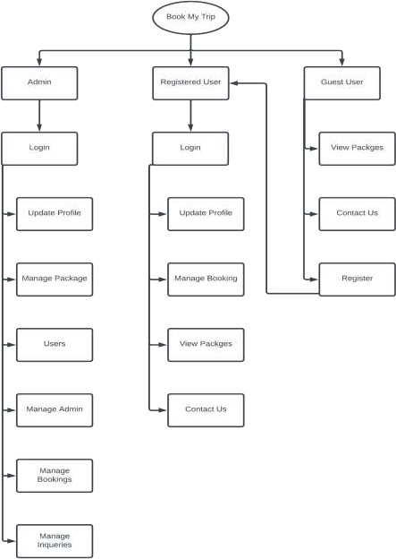

*Figure 1 context / 0 level DFD*



* **1st level DFD**

## Admin side

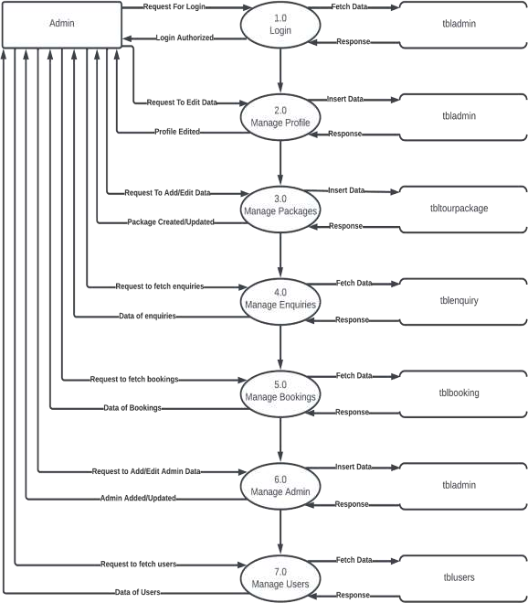

*Figure 2 1st level Admin side DFD*



## User side

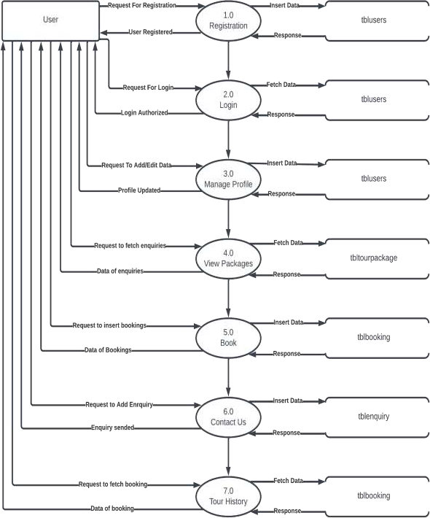

*Figure 31st level User side DFD*



* **2nd level DFD**

## admin side

* **login**

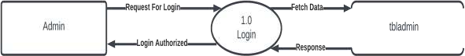

*Figure 4 2nd level dfd Admin side (login)*

## Manage profile

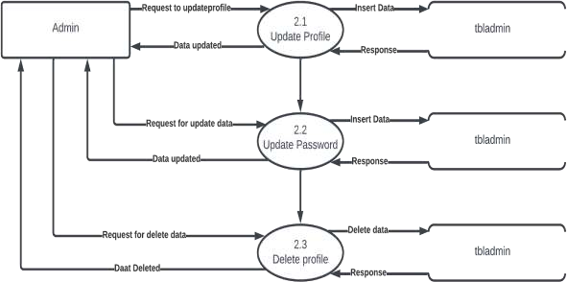

*Figure 5 2nd level DFD Admin side (manage profile)*



## Manage package

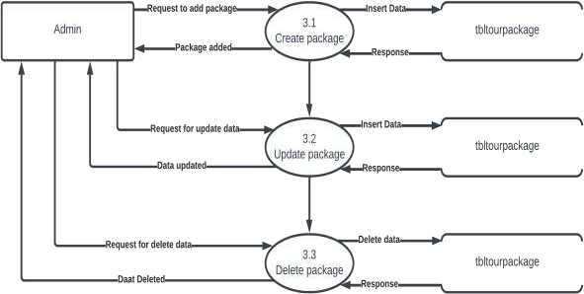

*Figure 6 2nd level DFD Admin side (manage package)*

## Manage Enquiries

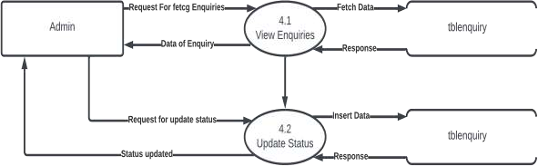

*Figure 7 2nd level DFD Admin side (manage enquiries)*



## Manage Bookings

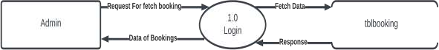

*Figure 8 2nd level DFD Admin side (manage bookings)*

## Manage Admin

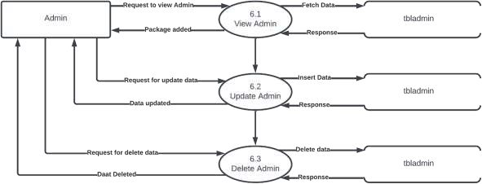

*Figure 9 2nd level DFD Admin side (manage admin)*

## Manage Users



*Figure 10 2nd level DFD Admin side (manage users)*



## User side

* **Registration**



*Figure 11 2nd level DFD User side (Registration)*

## Login



*Figure 12 2nd level DFD User side (login)*

## Manage Profile

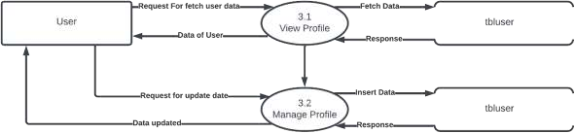

*Figure 13 2nd level DFD User side (manage profile)*



## View Packages



*Figure 14 2nd level DFD User side (view packages)*

## Book



*Figure 15 2nd level DFD User side (book)*

## Contact Us



*Figure 16 2nd level DFD User side (contact us)*

## Tour History

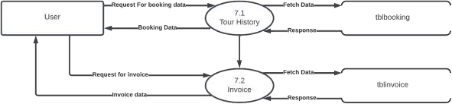

*Figure 17 2nd level DFD User side (tour history*



## Use Case Diagram

* **Admin**

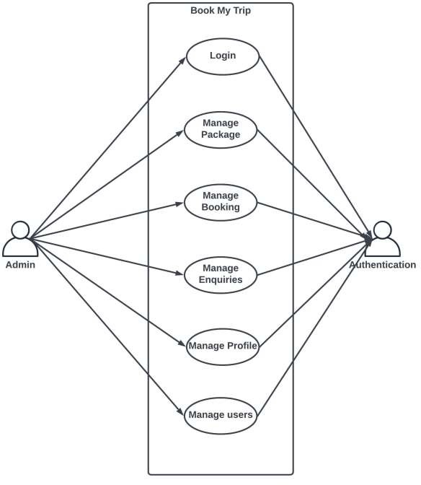

*Figure 18 Use case diagram (Admin)*



## User

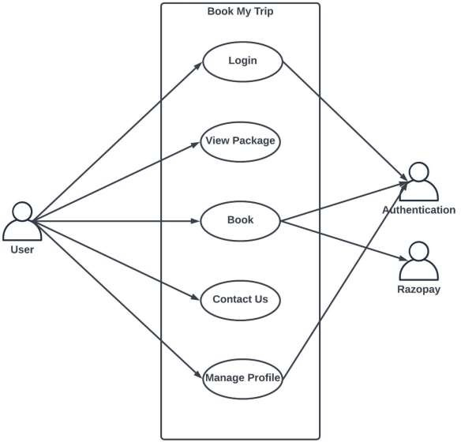

*Figure 19 Use case diagram (User)*



## ER Diagram

* 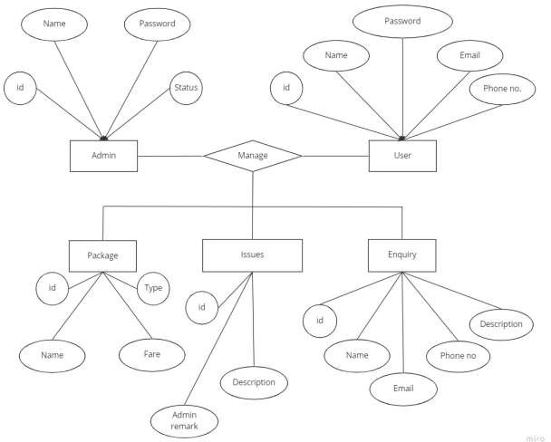**Admin**

*Figure 20 ER diagram (Admin)*



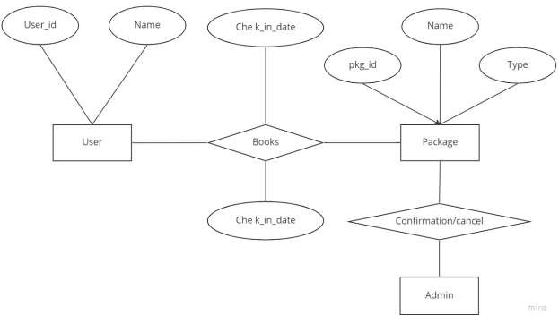



## User

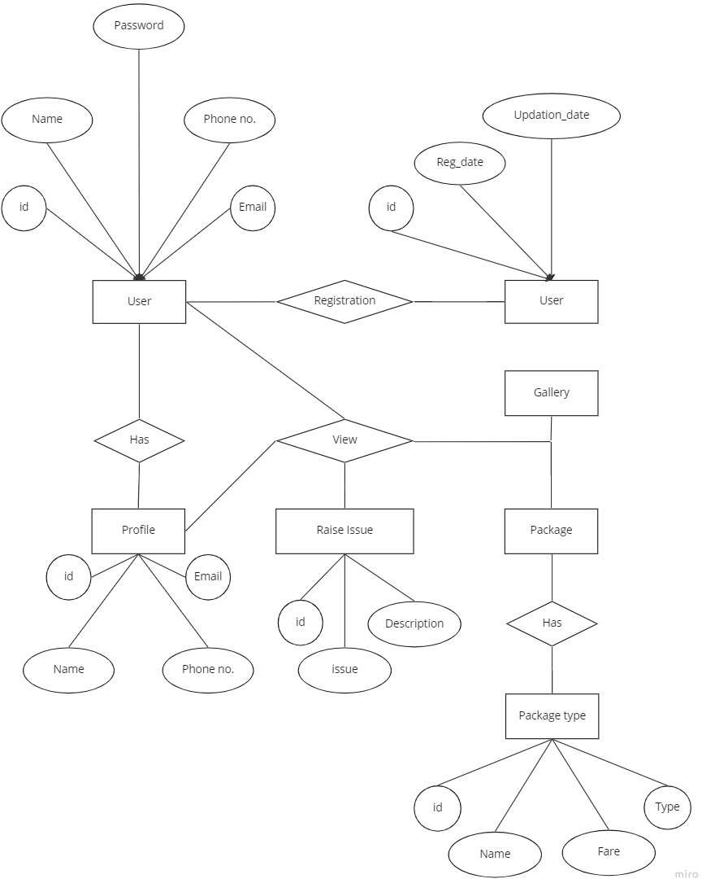

*Figure 21 ER diagram (User)*







## Database Design

1. **tbladmin**

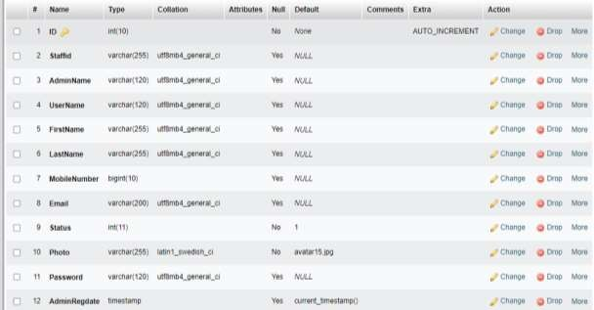

*Figure 22 tbladmin*

## tblusers

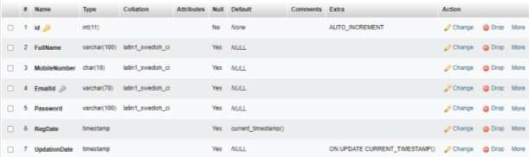

*Figure 23 tblusers*



## tblbooking

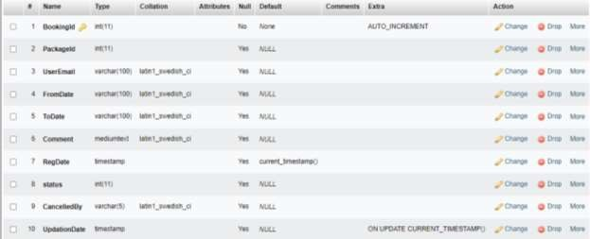

*Figure 24 tblbooking*

## tbltourpackages

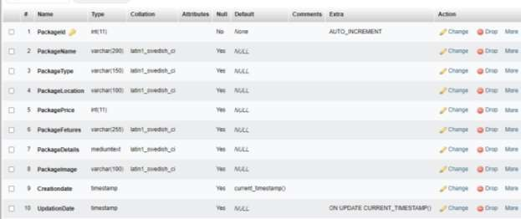

*Figure 25 tblpackages*



## tblenquiry

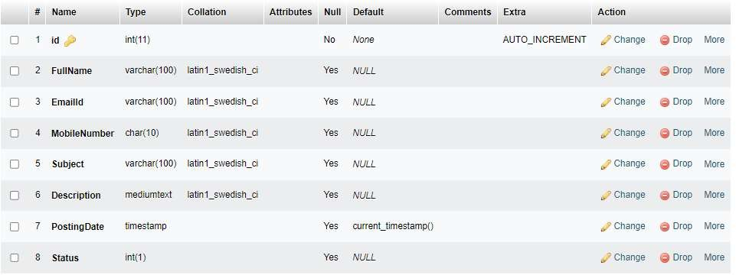

*Figure 26 tblenquiry*

## tblpermissions

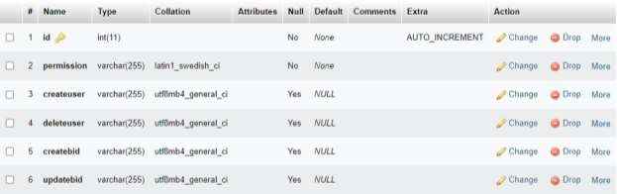

*Figure 27 tblprmissions*



## tblinvoice

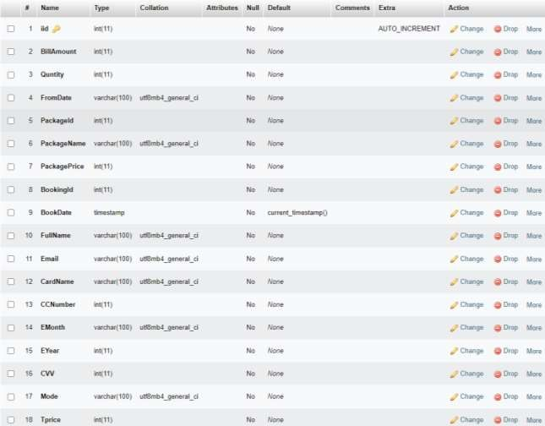

*Figure 28 tblinvoice*



## User Interface

1. **Admin**

## Login

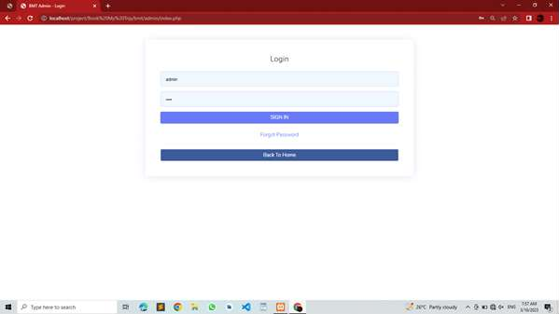

*Figure 29*

Description: -

This page provide facility to login as admin if the Id and Password are correct the user will be directed to dashboard.



## Forgot password

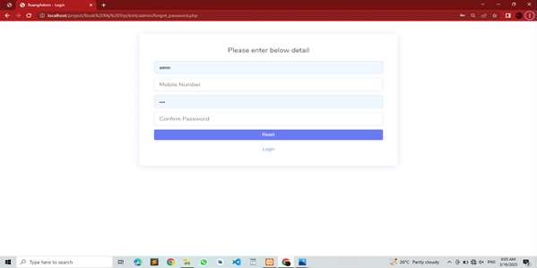

*Figure 30*

Description: -

This page provide facility to change password if user forgot it but the condition is that user have to provide correct email and mobile number which they provided during registration, if either of them is wrong password will not change.



## Dashboard

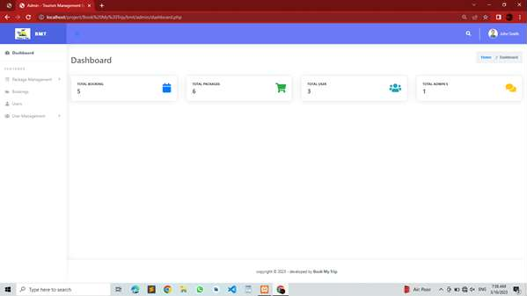

*Figure 31*

Description: -

This page provide facility to open functiones like manage package, bookings, etc.



## Manage Bookings

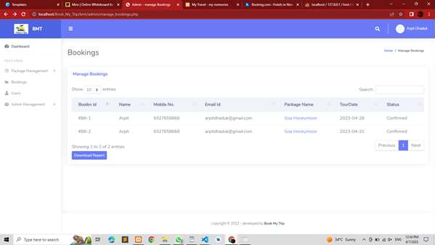

*Figure 32*

Description: -

This page provide facility to generate report of all the bookings done by users and cancel them if admin finds it necessary.

Moreover, Admin is also ale download the report in pdf format by simply clicking on Download report.



## Booking Report

*Figure 33*

Description: -

This is a pdf report which contains info regarding boking.



## Manage Package

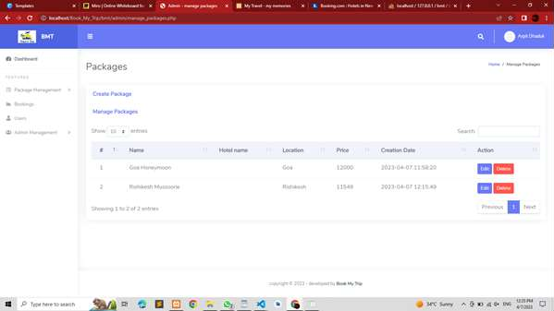

*Figure 34*

Description: -

This page provide list of available packages and user can delete or edit particular package.



## Create Package

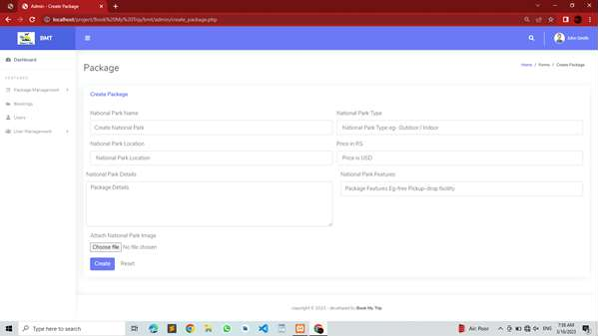

*Figure 35*

Description: -

This page provide facility to create a new package.



## Update package

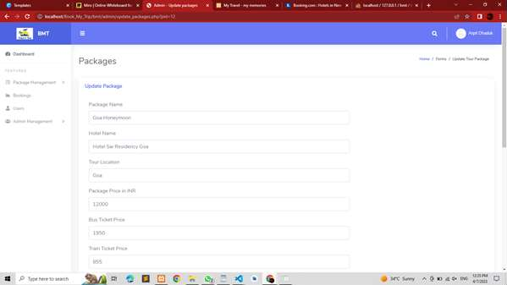

*Figure 36*



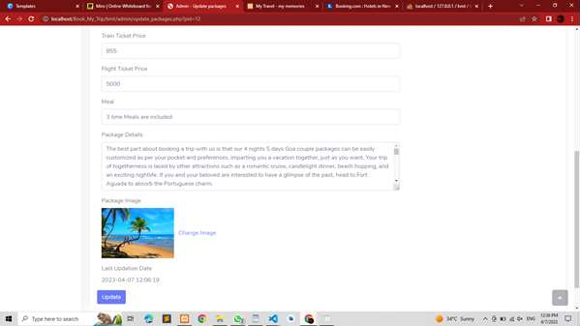

*Figure 37*

Description: -

This page provide facility to update data of existing package.



## Manage profile

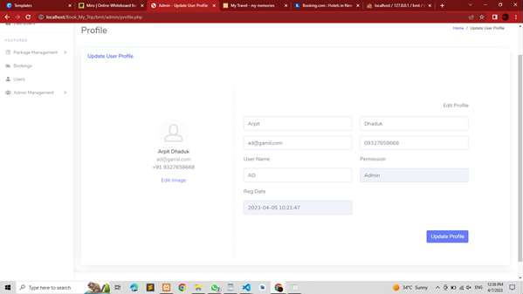

*Figure 38*

Description: -

This page provide facility to edit profile info of admin like Name, Photo etc.



## Manage User

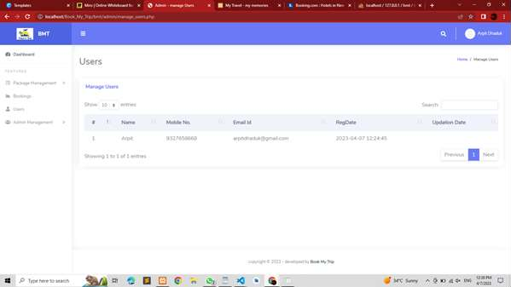

*Figure 39*

Description: -

This page provide facility to generate list of users.



## Admin Management

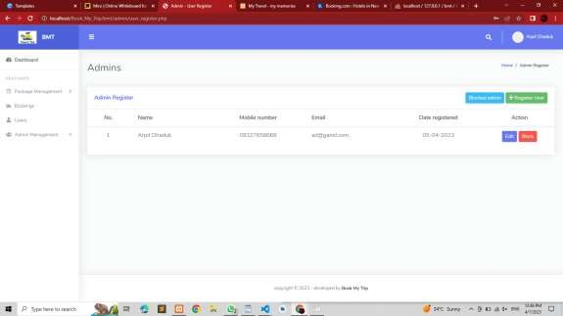

*Figure 40*

Description: -

This page provide facility to choose option either edit info of another admin or delete them.



## Edit Admin

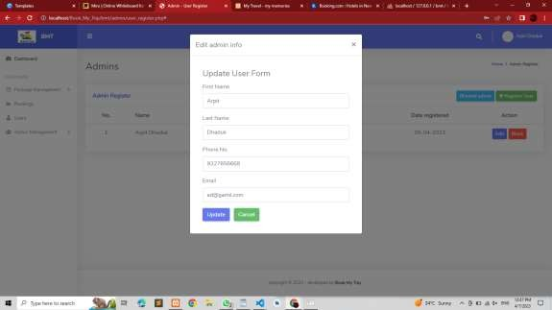

*Figure 41*

Description: -

This page provides a form in which the info is displayed and be changed.



## Register Admin

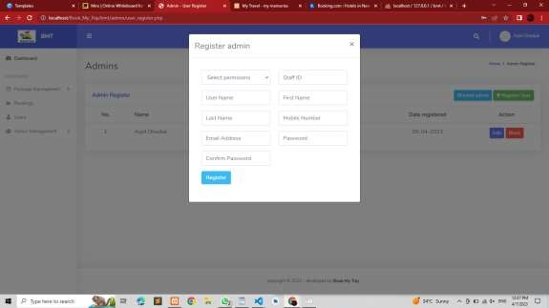

*Figure 42*

Description: -

This page provide facility to add new admin and also current admin can decide which kind of authority new admin will have.



## Admin Permissions

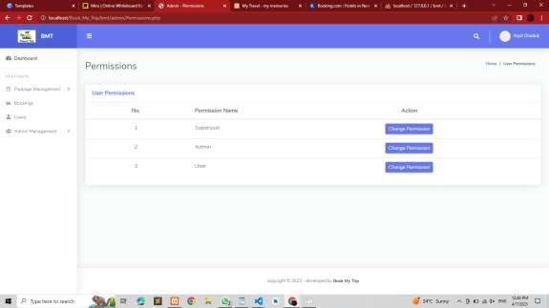

*Figure 43*

Description: -

This page provide facility to manipulate permission of other admins who falls into the particular category.



## User

* 1. **Registration**

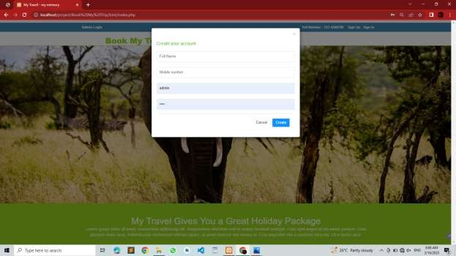

*Figure 44*

Description: -

This page provide facility for new user to register themselves.



## Login

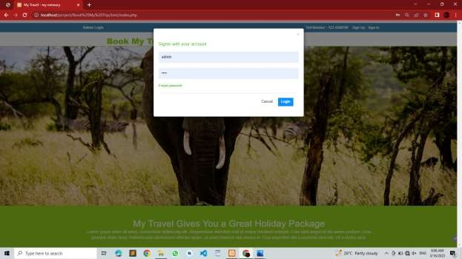

*Figure 45*

Description: -

This page provide facility to login for users who already have registered.



## Recover password

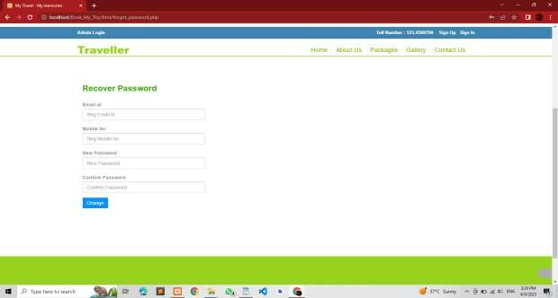

*Figure 46*

Description: -

This page provide facility to recover password for users who already have registered.



## About Us

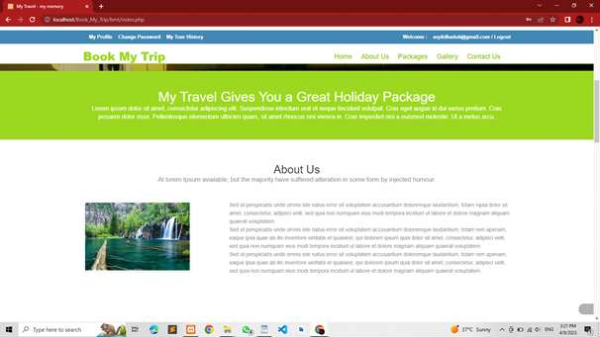

*Figure 47*

Description: -

This page provides show some details about company to users.



## Manage Profile

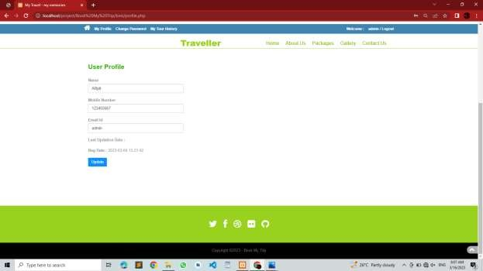

*Figure 48*

Description: -

This page provide facility to change user profile.



## Packages

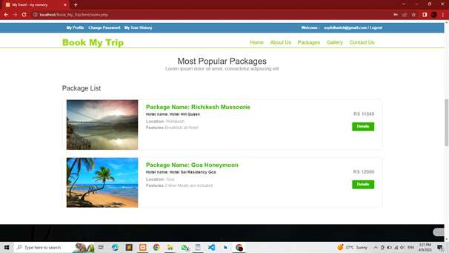

*Figure 49*

Description: -

This page shows a list of packages to user.



## Package Details

*Figure 50*



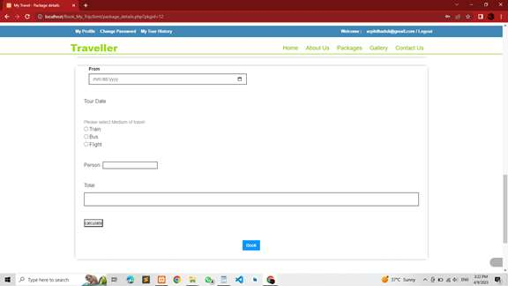

*Figure 51*

Description: -

This page shows a all details of package which user has selected, moreover user can book that particular package.



## Payment

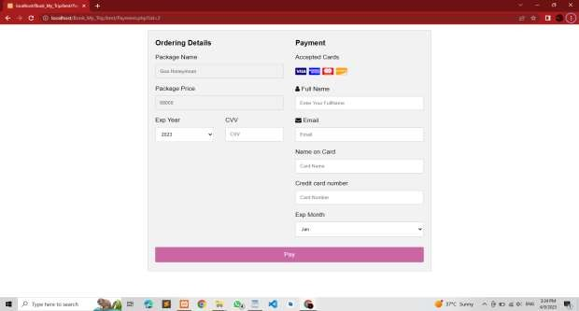

*Figure 52*

Description: -

After booking package user will be redirected to this page where they can make payment using card.



## Gallery

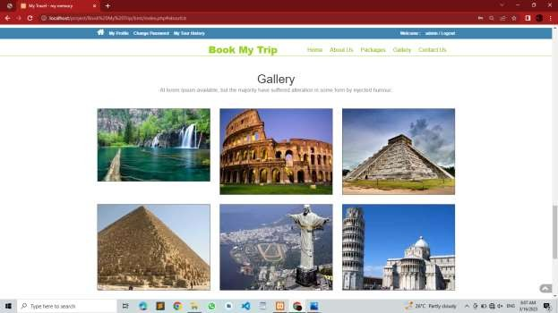

*Figure 53*

Description: -

This page shows a some images of good tourist spots to user.



## Contact Us

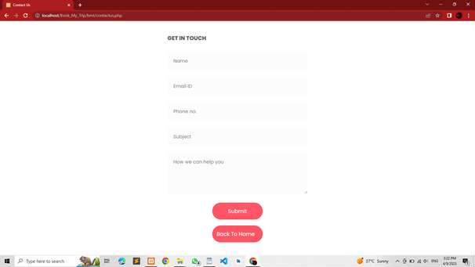

*Figure 54*

Description: -

This page allows user to send their question to admin.



## Tour History

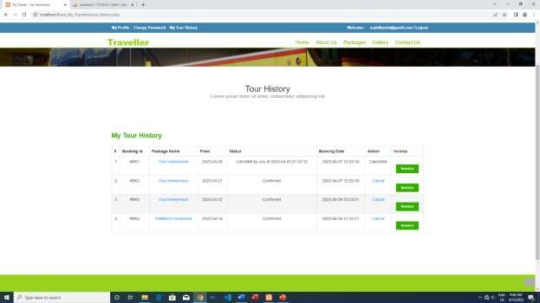

*Figure 55*

Description: -

This page provides the list of bookings as well as it also allows to download invoice of particular booking.

## Invoice

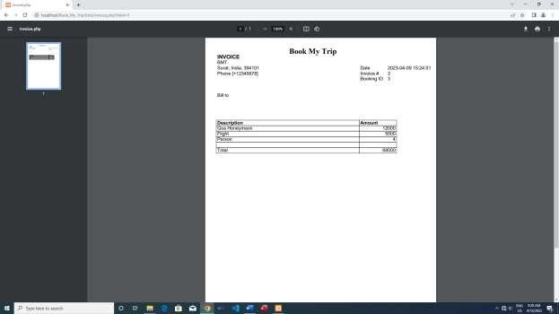

Description: -

*Figure 56*

This is a pdf invoice which contains info regarding boking.



# Testing

## Unit Testing

1. **Admin Testing**

### Test Case for Admin – Login

|  |  |  |  |  |
| --- | --- | --- | --- | --- |
| Test Id | Test field | Step Execute | Executed Result | Actual Result |
| 1 | E-mail | Empty | Msg. Required | As Expected |
| 2 | E-mail | Wrong | Msg. please correct Your Email or  password | As Expected |
| 3 | Password | Empty | Msg. Required | As Expected |
| 4 | Password | Wrong | Msg. please correct your Email  or password | As Expected |

**Test Case for Admin - Change Password**

|  |  |  |  |  |
| --- | --- | --- | --- | --- |
| Test Id | Test field | Step Execute | Executed Result | Actual Result |
| 1 | E-mail | Empty | Msg. Required | As Expected |
| 2 | E-mail | Wrong | Msg. please correct Your Email or  password | As Expected |
| 3 | Password | Empty | Msg. Required | As Expected |
| 4 | Password | Wrong | Msg. please  correct your Email or password | As Expected |



**Test Case for Admin – Member**

|  |  |  |  |  |
| --- | --- | --- | --- | --- |
| Test Id | Test field | Step Execute | Executed Result | Actual Result |
| 1 | Select Permission | Empty | Msg. You must choose an item  from list | As Expected |
| 2 | User Name | Empty | Msg. Required | As Expected |
| 3 | Last Name | Empty | Msg. Required | As Expected |
| 4 | First Name | Empty | Msg. Required | As Expected |
| 5 | Staff ID | Empty | Msg. Required | As Expected |
| 6 | Mobile  Number | Empty | Msg. Required | As Expected |
| 7 | E-mail | Empty | Msg. please correct Your Email or  password | As Expected |
| 8 | Password | Empty | Msg. Required | As Expected |
|  | Confirm-  Password | Empty | Msg. Required | As Expected |
| 9 | Confirm- Password | Wrong | Msg. Password and Confirm Password Field  do not match !! | As Expected |



## Test Case for Admin – Package

|  |  |  |  |  |
| --- | --- | --- | --- | --- |
| Test Id | Test field | Step Execute | Executed Result | Actual Result |
| 1 | Package  name | Empty | Msg. Required | As Expected |
| 2 | Package Price | Empty | Msg. Required | As Expected |
| 3 | Package  Description | Empty | Msg. Required | As Expected |
| 4 | Tour Location | Empty | Msg. Required | As Expected |
| 5 | Hotel Name | Empty | Msg. Required | As Expected |
| 6 | Bus Proce | Empty | Msg. Required | As Expected |
| 7 | Flight Price | Empty | Msg. Required | As Expected |
| 8 | Train Price | Empty | Msg. Required | As Expected |
|  | Image | Empty | Msg. Required | As Expected |



1. **User Testing**

### Test Case for User – Registration

|  |  |  |  |  |
| --- | --- | --- | --- | --- |
| Test Id | Test field | Step Execute | Executed Result | Actual Result |
| 1 | Full Name | Empty | Msg. Required | As Expected |
| 2 | E-mail | Empty | Msg. Required | As Expected |
| 3 | Mobile No | Empty | Msg. Required | As Expected |
| 4 | Password | Empty | Msg. Required | As Expected |

**Test Case for User – Login**

|  |  |  |  |  |
| --- | --- | --- | --- | --- |
| Test Id | Test field | Step Execute | Executed Result | Actual Result |
| 1 | E-mail | Empty | Msg. Required | As Expected |
| 2 | E-mail | Wrong | Msg. please correct Your Email or  password | As Expected |
| 3 | Password | Empty | Msg. Required | As Expected |
| 4 | Password | Wrong | Msg. please correct your Email  or password | As Expected |

### Test Case for User – Book

|  |  |  |  |  |
| --- | --- | --- | --- | --- |
| Test Id | Test field | Step Execute | Executed Result | Actual Result |
| 1 | From Date | Empty | Msg. Required | As Expected |
| 2 | Medium | Empty | Msg. Required | As Expected |
| 3 | Person | Empty | Msg. Required | As Expected |



**Test Case for User – Payment**

|  |  |  |  |  |
| --- | --- | --- | --- | --- |
| Test Id | Test field | Step Execute | Executed Result | Actual Result |
| 1 | CVV | Empty | Msg. Required | As Expected |
| 2 | User Name | Empty | Msg. Required | As Expected |
| 3 | Card name | Empty | Msg. Required | As Expected |
| 4 | Card number | Empty | Msg. Required | As Expected |
| 5 | Exp Year | Empty | Msg. Required | As Expected |
| 6 | Exp Month | Empty | Msg. Required | As Expected |
| 7 | E-mail | Empty | Msg. Required | As Expected |



## Navigation Testing

**Admin**

|  |  |  |  |
| --- | --- | --- | --- |
| **Link** | Expected Page | Result | Of Page |
| **Admin Login** | Admin Login page | Admin Login Page | |
| **Admin Edit Profile** | Admin Edit Profile Page | Admin Edit Profile Page | |
| **Admin Change Password** | Admin Change Password  Page | Admin  Page | Change Password |
| **Admin Dashboard** | Admin Dashboard Page | Admin Dashboard Page | |
| **Package** | Admin Package Page | Admin Package Page | |
| **User** | User page | User page | |
| **Booking** | Booking Page | Booking Page | |



## User

|  |  |  |
| --- | --- | --- |
| **Link** | Expected Page | Result Of Page |
| **User Registration** | User Registration Page | User Registration Page |
| **User Login** | User Login page | User Login Page |
| **User Home** | User Home Page | User Home Page |
| **Package Detail** | Package Detail Page | Package Detail Page |
| **Book** | Book Page | Book Page |
| **Tour History View** | Tour History Page | Tour History Page |
| **Contact us** | Contact Us page | Contact Us page |



* 1. **Functional Testing**
* Login and Password validation process has been co-operated properly.
* Email system module has been done properly and accurately.
* Sending Forgot Password through mails is working properly.
* Visibility of category wise product are working Properly.
* User registration is working Properly.
* Product stock manage properly.
* Invoice download pdf format is working properly.
* File Upload Images work properly
* Notifications of add to cart product Displaying Properly.
* All Pages Design is perfect.



## Environment Testing

* Firefox browser, Internet explorer and chrome consider testing for environment operability of software
* Web server – Apache/xampp
* Database – MYSQL Server
* OS – Windows 10
* Browser – Firefox/ Internet Explorer/ Chrome



# Conclusion

* Technology has made significant progress over the years to provide consumers a better online shopping experience and will continue to do so for years to come. With the rapid growth of products and brands, people have speculated that online shopping will overtake in-store shopping.
* While this has been the case in some areas, there is still demand for brick and mortar stores in market areas where the consumer feels more comfortable seeing and touching the product being bought. However, the availability of online shopping has produced a more educated consumer that can shop around with relative ease without having to spend a large amount of time.
* In exchange, online shopping has opened up doors to many small retailers that would never be in business if they had to incur the high cost of owning a brick and mortar store. At the end, it has been a win-win situation for both consumer and sellers.



# Bibliography

* **Website**:-
  + [www.makemytrip.com](http://www.makemytrip.com/)
  + [www.redbus.com](http://www.redbus.com/)
  + <https://www.w3schools.com/php/>
* **Books**:-
  + PHP & MySQL Novice to Ninja
  + Head First PHP & MySQL
  + Murach’s PHP & MySQL