Technical Architecture
Trustworthy Deep Learning for Pharmaceutical Tablet Quality Prediction
Arpit Joshua Elias | 24257567 | MSc in Artificial Intelligence

1. What I am working on
So basically, I am building a deep learning system that predicts the quality of pharmaceutical tablets straight from the raw sensor data of a tablet press, instead of using just the summary features like most of the existing studies do. The model I have designed is called MT-TrajNet, and it predicts four quality attributes at the same time: dissolution, hardness, weight uniformity, and tensile strength. It also gives two different types of uncertainty for each prediction, so the operator can tell when the model is confident and when its not.
The dataset I am using is the Žagar and Mihelič (2022) pharmaceutical manufacturing dataset, which was published in Scientific Data (IF 9.8). It has 1,005 GMP-compliant production batches across 25 product codes, with sensor readings recorded every 10 seconds. That comes to about 4.7 million rows in total. The dataset is publicly available on figshare under a CC BY 4.0 licence, so no permission issues.

2. What changed from my first proposal (CA1)
In CA1 I framed the project around predicting drug dissolution outcomes on this dataset. When I discussed it with the lecturer (Anderson Simiscuka), he pointed out that to fully validate that kind of claim, you would actually need chemistry lab testing alongside the ML work which is outside the scope of an MSc AI thesis. The feedback was very useful, because it made me realise the original framing was reaching beyond what a purely computational thesis can prove on its own.
So for CA2 I repositioned the whole project. The motivation and the dataset are still the same (trustworthy ML for pharmaceutical quality), but now every claim I make in the thesis can be tested purely through computational methods. No lab work, no chemistry validation, nothing physical. The three new research questions are:
- RQ1 (Trajectory representation): Does deep learning on raw 10-second sensor trajectories give better predictions than models trained on engineered summary features?
- RQ2 (Multi-task structure): Does predicting all four quality attributes together with one shared encoder work better than training a separate model per attribute?
- RQ3 (Trustworthy deployment): Can the model give well-calibrated uncertainty and meaningful explanations even when applied to product codes it has never seen during training?
All three questions can be answered using only the published dataset, my code, and statistical tests. No physical experiments are involved at any stage.

3. The novel bit (why this is thesis-worthy)
There is a specific part of this project that to the best of my knowledge has not been done before. It is the combination of evidential deep learning with uncertainty-stratified attribution analysis on a regulated manufacturing dataset. In simple words, the model not only predicts the quality and how confident it is, but I also analyse whether confident predictions and uncertain predictions are looking at different parts of the production run when they make their decisions.
This matters a lot for regulated deployment, because a regulator needs an explanation for every prediction the system makes, but a confident prediction and an uncertain one should really come with different kinds of explanations. Current explainability methods like SHAP treat every prediction as equally explainable which is a known limitation. My approach is designed to fix that gap.

4. The full pipeline
Below is the end-to-end flow of the system, from the raw sensor data all the way to the final Streamlit demo.
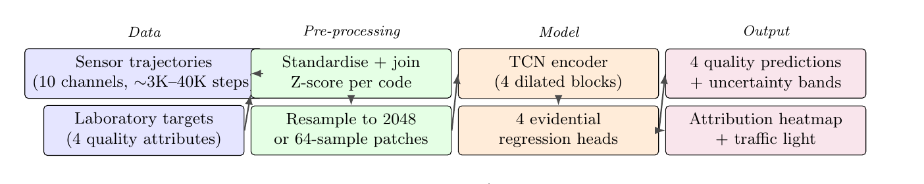
Pipeline stages, briefly:
- Data: the sensor trajectories from the tablet press (10 channels per batch) and the lab quality results for each of those batches.
- Pre-processing: I standardise the 25 CSV files, z-score normalise the sensor channels within each product code (to remove product-specific scale differences), join the time-series to the lab data by batch ID, and add a gap-indicator channel to mark weekend stoppages so the model does not try to interpolate across them.
- Model (MT-TrajNet): A shared TCN encoder reads the full trajectory, and four task-specific heads predict the four quality attributes along with their uncertainty values.
- Output: four quality predictions with uncertainty bands, a traffic-light flag (in-spec / uncertain / out-of-spec), and a temporal heatmap that shows which parts of the production run drove each prediction.

5. Inside the MT-TrajNet model
The model has three parts: an input module that handles the length variation in the trajectories, a shared TCN encoder, and four task-specific heads that produce the actual predictions.
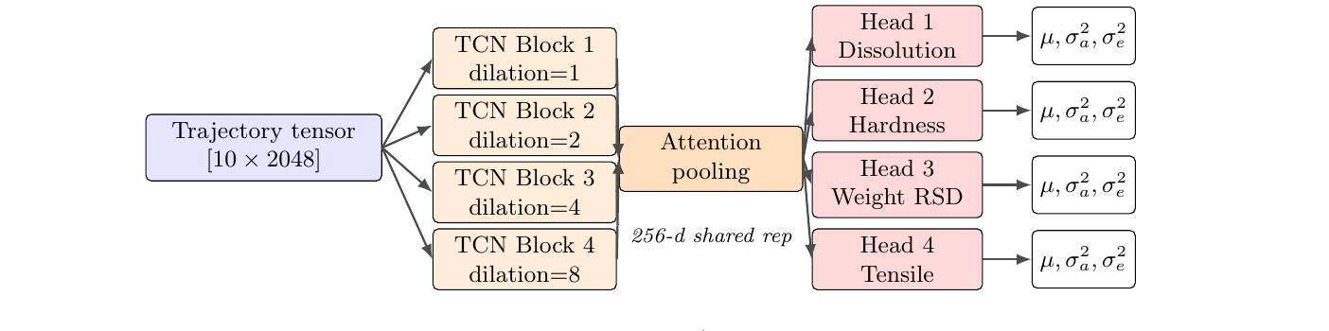
- Input module: trajectories vary a lot in length, from about 1,000 samples to over 41,000. So each one is either resampled to a fixed 2,048 steps using linear interpolation, or split into 64-sample patches (similar to PatchTST). Both approaches are tested in the ablation to see which works better.
- Shared TCN encoder: four residual blocks of dilated 1D convolutions, with dilation factors 1, 2, 4 and 8. Kernel width is 3, dropout 0.1, weight normalisation enabled. The receptive field grows logarithmically with depth, which keeps compute linear in sequence length. Honestly this is much cheaper than running a Transformer for these long sequences.
- Attention pooling: a learned attention-weighted mean across time, which gives a 256-dimensional batch-level representation that is shared across all four tasks.
- Four task heads: each head is a 2-layer MLP that outputs four parameters of a Normal-Inverse-Gamma distribution, following the evidential regression formulation from Amini et al. (2020). This gives the predicted mean plus the aleatoric and epistemic uncertainty in a single forward pass.
- Multi-task loss: the four task losses are balanced using the uncertainty weighting scheme from Kendall et al. (2018), which handles tasks of different scales automatically without needing manual tuning.

6. Tools and tech stack
Most of these are pretty standard ML stack choices, but a few of them I picked specifically for this project.
Component | Tool / why
Language | Python 3.11
Deep learning | PyTorch 2.x
Classical baselines | scikit-learn (LASSO), XGBoost — these are the published state-of-the-art on this dataset (Susto and McLoone 2015)
Hyperparameter search | Optuna (TPE sampler)
Explainability | Captum (integrated gradients) — for the uncertainty-stratified attribution part
Experiment tracking | Weights & Biases — for keeping the runs organised
Deployment / demo | Streamlit
Cloud compute | AWS EC2 g4dn.xlarge spot instances (NVIDIA T4 GPU), eu-west-1 — using spot to keep cost low
Storage | Amazon S3 (also where checkpoints go so spot interruptions dont kill the run)
Version control | Git + GitHub

7. How I will evaluate it
I am using nested cross-validation: an outer 10-fold split for estimating generalisation, and an inner 5-fold split with Optuna for hyperparameter search. For the statistical testing, I am using the Nadeau-Bengio corrected repeated-measures test instead of a normal paired t-test, because the standard t-test on CV folds inflates the Type-I error rate. Multiple comparisons are corrected using Benjamini-Hochberg.
- Accuracy: RMSE, MAE and R² with bootstrap 95% confidence intervals, compared against the LASSO and XGBoost baselines on engineered features.
- Calibration: Expected Calibration Error (ECE) and Prediction Interval Coverage Probability (PICP) at 80%, 90% and 95% coverage levels.
- Out-of-distribution test: leave-one-product-code-out. I hold out all the batches of one product code, train on the other five, and then test if calibration still holds on the unseen code. This is repeated across the 6 product codes that have at least 50 batches each.
- Explanation analysis: integrated gradients are computed for each held-out batch, then grouped into low, medium and high epistemic uncertainty bins. Then I check whether confident vs uncertain predictions are looking at different regions of the trajectory, tested with a Kendall's τ permutation test.

8. The final deliverable
At the end of the semester I will deploy a Streamlit web application where an operator can upload a batch's raw sensor CSV file. The app then shows:
- The four predicted quality values, each with an uncertainty band around it.
- A traffic-light flag: green for confident in-specification, amber for uncertain, red for confident out-of-specification.
- A temporal heatmap showing which parts of the production trajectory the model focused on when making each prediction.

9. Where I am right now
CA2 (the research proposal) has been submitted on Moodle and the ethics declaration form was already filed last semester. The proposal also includes a full 12-week Capstone plan with milestones, deliverables, a Gantt chart, and a scope-management plan in case anything overruns.
The next thing I am working on is the data pipeline and the EDA notebook, which is what I have to bring to our session on 28 May. I will send you a short report before the meeting.
If anything has to be cut later due to time or compute constraints, the lowest-risk thing to drop is the deep ensemble (Milestone 5), since the evidential method alone is enough to answer RQ3. The core contributions stay in under every scenario.

