Abstract:

DDOS attack are very prevailing these days. Every day you hear that some big organization is getting attacked[1]. So it is evident that current industry solutions are not sufficient to deal with these kinds of attack and consistent research is needed. Most of the current industry solution involve setting up centralized expensive hardware system which can process the packets and come up with solutions. Also each organization or ISP(Internet Service Provider) has different system which are not compatible with other ISP. In this paper I am going to suggest a way to handle the Distributed Denial of Service Attack with minimal hardware requirement and which could be used on any router.

[1]:http://techgenix.com/ddos-attacks-increasing/

Exciting Systems

Distributed Denial of Service (DDOS) attack is the way to jam the host with large number of data packets so that host become disabled to serve. The real challenge in detecting and defending DDOS attack is because of its dynamic nature. It is very difficult to detect as the source is not a single node but many and often distributed over the Internet, also the source of data is often spoofed, which makes more harder to know the attacker source. On top of that many time the the source its self is not aware that its part of the attack as its been used as bot by attacker.

Most of the solutions available in the market or the research that was done is to collect IP flow samples at the gateways and process/feed it on the central system to analyze. Some of the major such as
Internet Protocol Flow Information Export (IPFIX) protocol created by Internet Engineering Task Force (IETF). This protocol has defined standard way to export flow information from router and similar devices. Similarly Ciscos NetFlow[2] and Sflow(Sampled flow)[3]

[2]https://www.cisco.com/c/en/us/products/collateral/ios-nx-os-software/ios-netflow/prod_white_paper0900aecd80406232.html
[3]http://www.sflow.org/using_sflow/index.php

All these flow monitoring protocol gather information and send to the centralized server where user can login and do analyses or it can have some modules which are specifically used for DDOS detection.

E.g. Cisco netflow has flow exporter, collector, Analysis modules. Flow exporter is generally router who send flow information to collector module which acts as flow storage. Analysis module then try to find out different patterns in the flow.

These technologies scales well and sufficient to indicate trends in network traffic, but they are not cross platform. Sflow router would not be able to work with Cisco routers. So if we could come up with the way to detect attack at the routers independent of firm, and create a protocol to communicate the attack parameters to allow routers to take decisions then we would be more efficient in detecting attack.

Here I want to propose the distributed approach where gateway(routers/switches) would try to find the pattern in the data and would be able to report the change in the patter to other routers.

With the advance of electronic and the Internet of things small devices are getting equipped with faster processing speed so thus routers are also very powerful. Only thing that is missing is the storage space. If we use the learning techniques which don't need much storage then we don't have to store the packets instead we would learn form every flow and discard once learning is done. This is necessary because number of entries on the Internet routing table has steadily grown. Now that the table has passed 500,000 routes[3] so storing information of so many routes could be difficult.

[3]https://supportforums.cisco.com/t5/network-infrastructure-documents/the-size-of-the-internet-global-routing-table-and-its-potential/ta-p/3136453

To achieve this we can divide the flow into 5 min(300 sec) frame (This can vary based on the system it is implemented) and apply learning techniques on each flow iteratively to gain deeper knowledge.

Current Approch

Switches creates a network. Routers connect networks. A router links computers to the Internet through other routers. Routers are the backbone of the network who helps to forward packet from one point to other point on the Internet. Every packet traveling on Internet has to go through router[4].
[4]: https://www.cisco.com/c/en/us/solutions/small-business/resource-center/connect-employees-offices/network-switch-what.html]

Router knows to where packet is destine hence it could serve as first point of knowledge about the change in the flow information for a destine network. Each router has interfaces to which hosts or other network are connected. So router is aware to whom it is connected. Router uses protocol to communicate and by that they gather knowledge about other networks or router on the Internet. ICMP[5] is one of the most frequently use protocol by routers to communicate.

[5]https://tools.ietf.org/html/rfc792

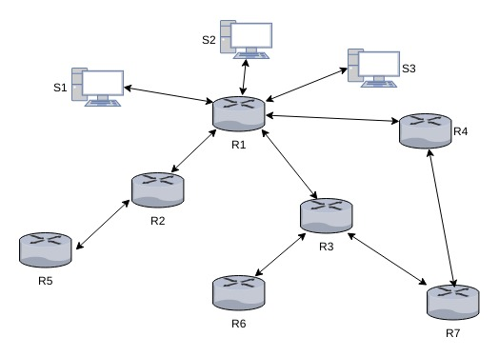

- Lets illustrated this using an example.

- In the figure we can see that host S1, S2, S3 are connected to router R1 and router R1 is connected to Internet through router R2, R3, R4 so every packet that would be reaching to S2 would come from either of three routers. All three routers are situated at different geographical region.

- Most of the websites are regional, either county, state or nation (If we leave out few global websites) and hence they are mostly accessed from those region. e.g. Rutgers University website would be accessed mostly from the eastern region and that too mostly from the New Jersey or the Philadelphia region.

- Using traceroute we can find out how many hope away the destination is. Each hope is the router on the Internet. Following is one of the captured traceroute for Rutgers University website.

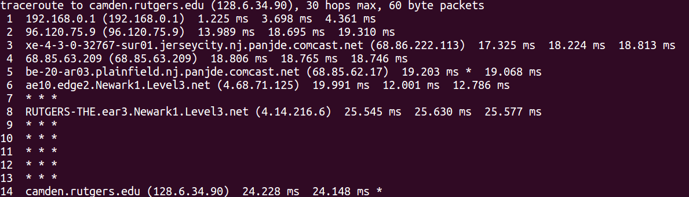

Some of the website such as GeoIP or Google know about location from where the traffic is coming in the network which only approximate based on the source IP but in the case of DDSOS attack packet source address are often spoofed. So it could be difficult to know the actual geographical location from which packet has come. But routers which come under ISP are well aware of their own geological location. Router also know to which network they are connected.

- In the proposed system, each router will itself act as a analyzer. Each packet will be analyzed and
statistic would be created based on the destination IP address.

- Based on the statistic we would cluster IP address. This clustering would be periodic.

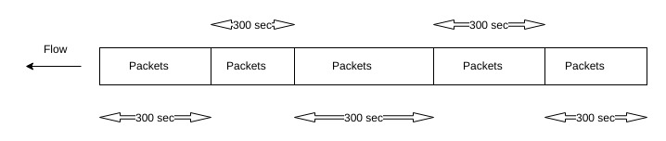

- Once cluster is learned it would be used as bench mark for all future traffic. If there is deviation of an IP from the cluster, router would notify the upstream router(router to which the destination ip packet would be forwarded) about that. There is less probability that upstream router would detect shift before the down stream.

- The upstream router would also be checking if there is shift from lower cluster to the higher for the given IP.

- If enough number of routers are able to report change in cluster then the probability that a destination is under attacked get increased.

- Need to keep track of on how many routers have reported the shift. Once we have enough proof that destination IP is under attack then every router who has detected the shift can be asked to discard packets which are destine to attacked IP address.

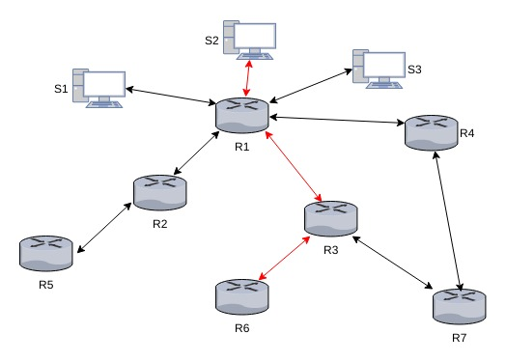

In the above figure attack initiated from the region where router R6 is located and from R6 data packets reach to victim from R3 and R1.

If we could detect attack at R6 itself then we can discard packets at R6 which are heading towards S2

------------------------

\includegraphics[width=\textwidth]{traceroute.png}

\includegraphics[width=\textwidth]{router.png}

4 Implementation

Botnets plays important role in DDOS attack. Those are the compromised system controlled by attacker for launching attack. Those can be anywhere on the Internet they are not bounded by geographical boundaries. The major DDOS attacks are the volume based attacks.

- Wireshark, an open source application, was used for packet capturing. Packets are captured for 5 hr. Once the packets are captured they are saved as pcapng file which is a wireshark file format for captured packets.

- Wireshark capture every detail of the packets but we dont need all of the information but only the IP packets as routers are layer 3 devices.

- Use data_extraction program to extract only the IP packets and club them into frame of 300 sec. Because of of the limited resouce each frame is written to the file with time and sample number.

- Once we have extracted information form all the packets and sampled them we can use them to create feature table.

- IP_clustering is used to create feature from the extracted IP which would be of the following format. Which has destination IP and the protocol. Number in the table represents the frequency of the packet of the particular protocol destine for particular destination.

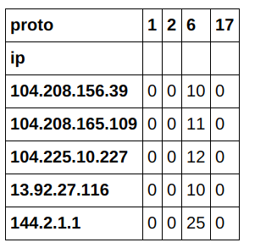

- For our algorithm frequency of the protocol would serve as feature vector.

- For the sake of simplicity would be dealing with TCP and UPD flood attacks

- Attack is engineered using LOIC (Low Orbit Ion Canon), a free tool which is even used by attackers int the realworld.

- Flow based model is build as it more reliable and fast. Packet analyzing is often difficult due to size and encryption. Port could not reliable information in detecting attack as attacker use different ports.

- There are many algorithm which can be used to learn from the data, they can be categorized as Supervised or Unsupervised.

- Supervised algorithm such as One Class Support Vector Machine(SVM) could be efficient to identify the anomalies in the data but it is very process and memory intensive so they can be used only for the highest cluster IP address.

- Unsupervised learning algorithms are fast and consume less data so they would be useful for our analysis at router level.

- K-Mean clustering is one of the most efficient algorithm for creating clusters.

- In K-mean clustering algorithm randomly assigns centroid and then tried to classify every sample to one of the randomly chooses centroid based on the distances. In each iteration it recalculate the centroid and reassign samples to clusters.

Algorithms

\begin{algorithm}
\caption{K-Mean algorithm}\label{kmean}
\begin{algorithmic}
\State{K (number of clusters)}
\State{Training set $x^{i}$, $x^{i}$, ..., $x^{i}$ Where $x^{i} \in R$}
\State {Randomly initialize K cluster centroids $\mu_{1}$, $\mu_{2}$, ..., $\mu_{k}$}
\Loop\Comment{Until we have found our clusters}
\For{$i\gets 1, m$}
%\State {$c^{i}$ = index (from 1 to K) of cluster centroid closest to $x^{i}$}
\State{$c^{i} = argmin_{k} || x^{i} {-} \mu_{k} ||^{2}$}\Comment{Cluster Assignment}
\EndFor
\For{$k\gets 1, K$}
%\State {$\mu_{i}$ = average (mean) of points assigned to cluster k}
\State{$\mu_{k} = \frac{1}{n} [x^{(k_{1})} + x^{(k_{2})} + ... + x^{(k_{n}})] \in R$}\Comment{Move Centroid}
\EndFor
\EndLoop
\end{algorithmic}
\end{algorithm}

\begin{algorithm}
\caption{Algorithm for Detection and Mitigation}\label{detectmitigate}
\begin{algorithmic}[1]
\State{Divide traffic into window of 5 min (This could be less than that).}
\State{Filter data based on the required features.}
\State{Run Clustering algorithm on the data. (Use elbow method to decide on number of clusters).}
\State{Find the probability of certain IP lying in a particular cluster.}
\State{Divide hours into periods and find probability in each period.}
\State{Once the clusters are decided our model is ready.}
\State{now to test model we would cluster and label each IP and if there is change in the cluster.}
\State{If No change $\rightarrow$ traffic is normal.}
\State{If change change $\rightarrow$ traffic not normal.}
\end{algorithmic}
\end{algorithm}

Once the change in the normal behavior has been reported then router communicate to the destination network. Destination network collect that information to know the source of the attack. This information can be used to know the nature of the attack.

6. Conclusion.

A novel way to identify and mitigate DDOS attack has been suggested in the paper. With the advance of NVF(Network Virtual Functional) it would be easy to push the learning algorithms to routers and thus making them efficient in detecting the attacks.

