- What is DDOS

- What is router
A data packet is typically forwarded from one router to another router
through the networks that constitute an internetwork until it reaches its destination node.

For the first set of packets, the first router receives the packet, decrements the TTL value and drops the packet because it then has TTL value zero. The router sends an ICMP Time Exceeded message back to the source. The next set of packets are given a TTL value of two, so the first router forwards the packets, but the second router drops them and replies with ICMP Time Exceeded. Proceeding in this way, traceroute uses the returned ICMP Time Exceeded messages to build a list of routers that packets traverse, until the destination is reached and returns anICMP Echo Replymessage

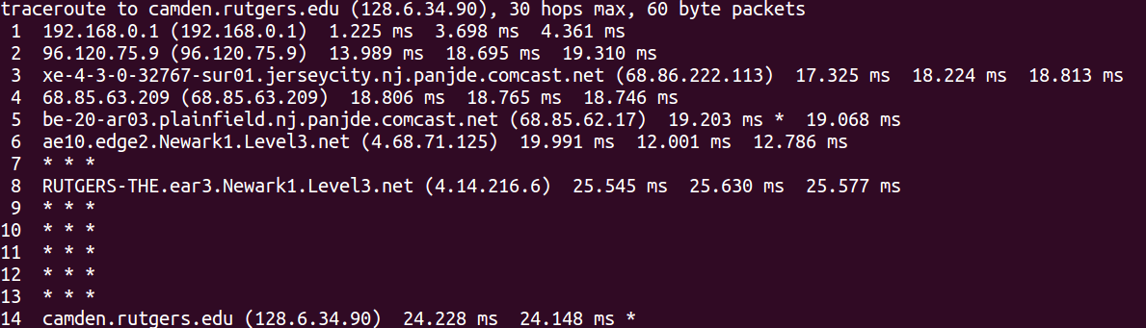

Router create a network in which there are different directly connected hosts and each router connect to other networks through routers.
Home Router IP address:
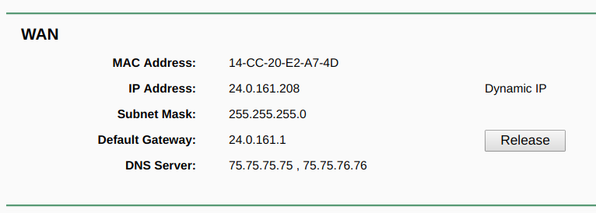
Default Gateway:

A default gateway in computer networking is the node that is assumed to know how to forward packets on to other networks. Typically, in a TCP/IP network, nodes such as servers, workstations and network devices each have a defined default route setting, (pointing to the default gateway),
defining where to send packets for IP addresses for which they can determine no specific route.
The gateway is by definition a router.
- How router communicate
-
- Internet Structure

- Use probabilistic algo to determine the probability of attack on the perticular IP
- Need to develop routing communication protocol

Subnets are usually divided in one of three classes:
- Class A addresses, supporting 16 million hosts on each of 27 networks
- Subnets: 0.0.0.0 to 127.255.255.255
- Class B addresses, supporting 65,000 hosts on each of 16,000 networks
- Subnets: 128.0.0.0 to 191.255.255.255
- Class C addresses, supporting 254 hosts on each of 2,000,000 networks
- Subnets: 192.0.0.0 to 223.255.255.255
- Everything above 224.0.0.0 is reserved for either multicasting or future use.
In addition, certain subnets are reserved for private use and are not routed across public networks:
- 10.0.0.0 to 10.255.255.255
- 172.16.0.0 to 172.31.255.255
- 192.168.0.0 to 192.168.255.255

CISCO :NetFlow is typically used on a central site because all traffic from the remote sites is characterized and is available within NetFlow.

How does NetFlow give you network information?

What is an IP Flow?

Each packet that is forwarded within a router or switch is examined for a set of IP packet attributes. These attributes are the IP packet identity or fingerprint of the packet and determine if the packet is unique or similar to other packets.
Traditionally, an IP Flow is based on a set of 5 and up to 7 IP packet attributes.
IP Packet attributes used by NetFlow:
• IP source address

• IP destination address

• Source port

• Destination port

• Layer 3 protocol type

• Class of Service

• Router or switch interface

All packets with the same source/destination IP address, source/destination ports, protocol interface and class of service are grouped into a flow and then packets and bytes are tallied. This methodology of fingerprinting or determining a flow is scalable because a large amount of network information is condensed into a database of NetFlow information called the NetFlow cache.

This flow information is extremely useful for understanding network behavior
• Source address allows the understanding of who is originating the traffic

• Destination address tells who is receiving the traffic

• Ports characterize the application utilizing the traffic

• Class of service examines the priority of the traffic

• The device interface tells how traffic is being utilized by the network device

• Tallied packets and bytes show the amount of traffic

Additional information added to a flow includes
• Flow timestamps to understand the life of a flow; timestamps are useful for calculating packets and bytes per second

• Next hop IP addresses including BGP routing Autonomous Systems (AS)

• Subnet mask for the source and destination addresses to calculate prefixes

• TCP flags to examine TCP handshakes

Ref: https://www.cisco.com/c/en/us/products/collateral/ios-nx-os-software/ios-netflow/prod_white_paper0900aecd80406232.html

Bohatei: Flexible and Elastic DDoS Defense

Would be dealing with following attacks

1. SYN flood (Figure 8): We track the number of open
TCP sessions for each source IP; if a source IP has
no asymmetry between SYNs and ACKs, then mark
its packets as benign. If a source IP never completes
a connection, then we can mark its future packets as
known attack packets. If we see a gray area where the
source IP has completed some connections but not
others, in which case we use a SYN-Proxy defense
(e.g., [9, 28]).
2. DNS amplification (Figure 9): We check if the DNS
server has been queried by some customer IP. This
example highlights another advantage—we can de-
couple fast (e.g., the header-based A LIGHTCHECK
module) and slow path analyses (e.g., the second A
module needs to look into payloads). The responses
are quite simple and implement logging, dropping, or
basic forwarding to the destination. We do not show
the code for brevity.
3. UDP flood: The analysis node A UDP identifies
source IPs that send an anomalously higher num-
ber of UDP packets and uses this to categorize each
packet as either attack or benign. The function
forward will direct the packet to the next node in the
defense strategy; i.e., R OK if benign, or R LOG if
attack.
4. Elephant flow: Here, the attacker launches legiti-
mate but very large flows. The A module detects ab-
normally large flows and flags them as attack flows.
The response is to randomly drop packets from these
large flows (not shown).

----------------

A_SYNFLOOD
//DiffCount tracks diff b/w syn and ack
//aggregated over some window
srcIP = pkt.srcIP
if (TCP pkt with SYN set and ACK unset)
SynCount[srcIP]++;
if (pkt is TCP and first ACK)
FirstAckCount[srcIP]++;
UpdateDiffCount(srcIP)
if (DiffCount(srcIP) = SynCount[srcIP])
markAsA'ack(pkt);
else if (DiffCount(srcIP) > 0)
markAsUnknown(pkt);
else if (DiffCount(srcIP) = 0 )
markAsBenign(pkt);
forward(pkt);

The Size of the Internet Global Routing Table and Its Potential Side Effects

Since the early 1990s, we’ve watched as the number of entries on the Internet routing table has steadily grown. It wasn’t that long ago (2008) that the table reached 256k routes, triggering action by network administrators to ensure the continued growth of the Internet. Now that the table has passed 500,000 routes, it’s time to start preparing for another significant milestone – the 512k mark.
Looking Ahead to 512k
As an industry, we’ve known for some time that the Internet routing table growth could cause Ternary Content Addressable Memory (TCAM) resource exhaustion for some networking products. TCAM is a very important component of certain network switches and routers that stores routing tables. It is much faster than ordinary RAM (random access memory) and allows for rapid table lookups.
https://supportforums.cisco.com/t5/network-infrastructure-documents/the-size-of-the-internet-global-routing-table-and-its-potential/ta-p/3136453

(BGP can have upto 200,000 routes)

Even the small ISP can sometimes hop onto a local exchange, and peer with other companies, schools or ISPs in the area. An exchange is a network connection point, and every city has at least one. All the major players in an area will connect to the exchange, and maintain their own routers within. If they decide to peer with a friend, they can simply have the exchange operators patch some fiber through to their friend's rack, and viola, free packets. There's normally a port charge to connect to exchanges.
http://www.enterprisenetworkingplanet.com/netsp/article.php/3613781/Networking-101--Understanding-Internet-Routing-and-Peering.htm]

DNS Resolver:

To scale to a global level, the DNS system was designed as a multi-level reference network that would allow any user on the Internet to query a set of servers that will iteratively find where a specific domain is owned and get the name to IP address mapping from that location. To accomplish this, it is made up of root servers controlling top level domains such as .com, .gov, and .org, Global Top Level Domains (TLDs) controlling regional domains such as .br, .fr and .uk, authoritative servers controlling specific domains such as myfavoritestore.com and a very large group of recursive resolvers that end user systems connect to

https://www.arbornetworks.com/blog/asert/on-dns-and-ddos/

Infrastructure ACLs are used to minimize the risk and effectiveness of direct infrastructure attack by explicitly permitting only authorized traffic to the infrastructure equipment while permitting all other transit traffic.

https://www.cisco.com/c/en/us/support/docs/ip/access-lists/43920-iacl.html

SD-WAN (Software Defined WAN):
https://www.youtube.com/watch?v=MSzeITPFWbc

IGP - Interior Gateway Protocol [RIP, IGRP, EIGRP, OSPF]
EGP - Exterior Gateway Protocol [BGP]

IGP has better convergence. BGP is the backbone of the Internet and it as the slowest convergence. Ability to track down the best route varies between IGP and BGP, where IGP uses hop count, cost, bandwidth and delay. In BGP, it uses 14 different path attributes.

Ingress vs. Egress traffic on Inside and Outside interfaces. Similarly, egress traffic on an outside (WAN) interface should also technically be flowing OUT, since it is being transmitted by the WAN on its way out of the network.

Volume-based DDoS attacks : Flood victim with high volume of Internet packets which would result in eating many of the victim resources.

Application DDoS attacks: target HTTP aiming to exhaust Web servers and services. Voice over IP (VoIP), DNS, and others are often targeted

Low-rate DoS (LDoS) attacks: take advantage of application implementation weaknesses and design flaws. A prime example of these types of attacks is Slowloris, a tool that allows an attacker to take down a victim's web server with minimal bandwidth requirements and without launching numerous connections at the same time.

Examples of DDOS attacks

Internet Control Message Protocol(ICMP) Floods: Also called as Ping flood. Flood victim with ICMP echo requests. The Internet Control Message Protocol (ICMP) is a supporting protocol in the Internet protocol suite. It is used by network devices, including routers, to send error messages and operational information indicating, for example, that a requested service is not available or that a host or router could not be reached

SYN Flood Attacks:

- The client requests a connection by sending a SYN (synchronize) message to the server
- The server acknowledges this request by sending SYN-ACK back to the client
- The client responds with an ACK (acknowledgement) and the connection is established
In a SYN flood attack, the attacker does not reply to the server with the expected ACK. To do this, the attacker can spoof the source IP address or simply not reply to the SYN-ACK.

UDP Flood Attacks:
Similar to TCP flood attacks, the main goal of the attacker when performing a UDP flood attack is to cause system resource starvation. A UDP flood attack is triggered by sending a large number of UDP packets to random ports on the victim's system. The system will notice that no application listens at that port and reply with an ICMP destination unreachable packet. Subsequently, if a large number of UDP packets are sent, the victim will be forced to send numerous ICMP packets. In most cases, these attacks are accomplished by spoofing the attacker's source IP address. Most modern operating systems now limit the rate at which ICMP responses are sent, minimizing the impact and mitigating this type of DDoS attack.

Teardrop Attacks:
Teardrop attacks involve sending crafted packets with overlapping, over-sized payloads to the victim system. Modern operating systems are now immune to this attack, but because of a deficiency in the TCP fragmentation and reassembly implementation of older operating systems, this attack caused a crash of those systems

DNS Amplification Attacks:
The attacker triggers and directs the compromised machines to begin the attack
- The compromised machines send a DNS query for the domain example.com and set the source IP address to the victim's IP address
- The open resolver servers ask the upstream name server(s) the location of example.com
- The name server sends a reply back to the open recursive servers
- The open recursive servers send DNS responses to the victim

SIP INVITE Flood Attacks
The Session Initiation Protocol (SIP) is a VoIP standard defined in RFC 3261. SIP INVITE messages are used to establish a media session between user and calling agents. In SIP INVITE flood attacks, the attacker sends numerous (often spoofed) INVITE messages to the victim, causing network degradation or a complete DoS condition.

Encrypted SSL DDoS Attacks: CPU is consumed more in encryption and decryption process. Also many defense don't support decryption.

Slowloris: partial http request keeps many connections open over time.

Ref: https://www.cisco.com/c/en/us/about/security-center/guide-ddos-defense.html

http://www.networksorcery.com/enp/protocol/icmp.htm

The purpose of these control messages is to provide feedback about problems in the communication environment, not to make IP reliable.

General Algorithm for working

\begin{algorithm}
\caption{Algorithm for DDoS attack Detection}\label{detectmitigate}
\begin{algorithmic}[1]
\State{Divide traffic into minor time window (e.g. 300 sec).}
\State{Filter data based on the required features.}
\State{Run Clustering algorithm on the data. (Use elbow method to decide on number of clusters).}
\State{Find the probability of certain IP lying in a particular cluster.}
\State{Once the clusters are decided our model is ready.}
\State{now to test model we would cluster and label each IP and if there is change in the cluster.}
\State{If No change $\rightarrow$ traffic is normal.}
\State{If change change $\rightarrow$ traffic not normal.}
\end{algorithmic}
\end{algorithm}

