**CS1125**

**Robotic Process Automation**

RPA Project Report

**Stock Automation Bot**

PREPARED BY FACULTY GUIDE

**Arpit Vyas** **Dr. Santosh Verma**

**(2019BTECHCSE011) Dr. Gireesh Kaushik**

**Department of Computer Science engineering**

**Institute of Engineering and Technology (IET)**

**JK Lakshmipat University Jaipur**

**May 2022**

Abstract

In this project we will be building a bot using UiPath that will fetch filtered stock from a scanner and store in excel file. Then according to users input it will those stocks in selective platform. This bot will not only save time and effort but with help of good screener will result in profitable trades in long term. This bot can be complied with Machine learning for more better results. And as it is a bot it will help removing human emotions from trading process that may lead to uneven risk reward ratios.

# 

# Table of Contents

Table of Contents 3

1. Introduction 4

2. Methodology 5

2.1 Flow Diagram of workflow 5

2.2 Algorithm 6

2.3 Steps in Details 7

3. Result 11

4. Conclusion 11

5. Further Work 11

# Introduction

Robotic process automation (or RPA) is an evolving type of business process automation technology based on the concept of automated robots or AI employees. RPA can do almost any complex rule-based work and can do so by communicating with any application software or website. It is a digital link to the computer user interface's human world. Which kinds of system processes can be automated? RPA is not a replacement for the workers of human customer service. It is suitable for tasks that do not require human interaction — tasks that are often considered unattended tasks. Most tasks require a human connection, but in many situations, it is also possible to automate at least part of the work.

Algorithmic trading uses algorithms that follow trends and define a set of guidelines for making trades. Trading is superhuman and can generate income with increased speed and frequency. The set of specialized trading recommendations delivered to the program depends on time, cost, amount, or any mathematical model. In addition to discoveries beneficial to traders, algorithmic trading makes markets more liquid and makes trades more accurate, eliminating the influence of human emotions on trades.

We have used RPA to automate stock selection and taking trades based on the screeners output. User can place paper trade or trade in kite. We build a stock screener from scratch and based on its output data is downloaded in excel format. After login to trading platform successfully we buy the stocks in selective quantity and securely log out. It not only saves time and effort but also gives profitable results in long term.

# Methodology

2.1 Flow Diagram of workflow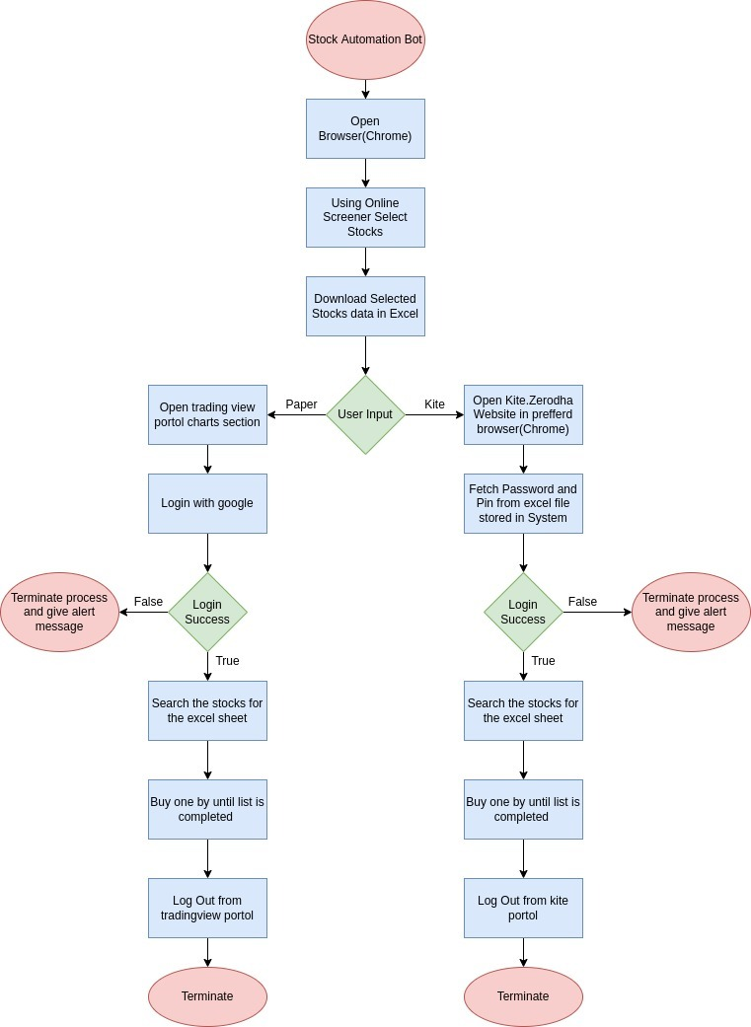

Figure 1: Flow Diagram of workflow

## Algorithm

**STEP 1: ‘**RPA Bot’ is triggered.

**STEP 2:** Bot starts the process and the default web browser is started(Chrome).

**STEP 3:** It open opens online stock Screener (<https://chartink.com/screener/swing-2022-05-07> ) and download the selected stocks in excel file.

**STEP 4:** It takes user input for paper trade(<https://in.tradingview.com/> ) or trade in kite portal (<https://kite.zerodha.com/> )

**STEP 5:** It open that particular portal according to user input in new browser (Chrome)

**STEP 6:** If kite is selected then it fetch password and pin from excel already stored in system and logs in securely.

**STEP 7:** from excel downloaded before it search all the shortlisted stocks and buys them.

**STEP 8:** after completing buying process it logs out from that portal.

**STEP 9:** it deletes the stock excel file from system

**STEP 10:**  Bot is then turned off and waits for the next trigger to start the process again

## Steps in Details

Step1: open chartink(<https://chartink.com/screener/swing-2022-05-07>) website and select screener and download the selected stocks in excel file.

Figure 2: downloading selected stocks in excel from online screener

Step2: Take Input from user if he wants to paper trade or trade in kite

Figure 3: taking input from user

Step 3: If kite is selected then open kite and login using excel file store in system having credentials

Figure 4: Logging into kite

Step 4: If paper is selected open tradingview portal

Figure 5: opening tradinview

Step 5: Search stocks from the excel downloaded and buy them

Figure 6: searching stocks and buying them

Step 6: Deleting the stock data excel File

Figure 7: deleting stock file

# Result

We successfully build the bot that fetch stocks and buy them in selective quantity.

This bot can be complied with task manger using bat file for taking morning trades for long term.

For Further assessment please check this link :- <https://github.com/arpitgits/RPA_StockAutomation>

# Conclusion

* Trades are more precise by precluding the effect of human feelings on trading.
* Algorithmic trading bots not only provide security, value and speed, but are also innovative technologies for the future financial markets and economy.
* Algorithmic trading bots make it easy for both new and experienced traders to achieve profitable results with minimal effort, time and loss.

# Further Work

As the next steps in our project, the following will be implemented:

* Integrating the bot and screener with Machine Learning for better and profitable results
* Integrating bot on other brokers platform
* Including Cryptocurrency
* Interactive but easy-to-use bot user interface on the web platform.
* Integrate the bot into the user interface using the Django framework.
* Including live testing of all bots to ensure best performance statistics.