PREDICTIVE ANALYTICS

Arpit Gupta, Nirmith Satish, Samarth Khare, Soniya Tanwani

**Marketing Insights of RUFFLES Brand**

OVERVIEW

**Ruffles** is a brand of Potato Chips marketed by Frito-Lay since 1961. Ruffles have various sub brands like Baked Ruffles, Ruffles flavor rush, among others. We are provided with the scanner data of the different delivery stores and customer’s demographics. Using the analysis we formulated the recommendation which can be used to boost the sales of the product by targeting the influential customers by running promotional offers.

We used three different types of analysis -

1. Descriptive Analysis: Exploratory Data Analysis
2. Hypothesis Testing and Regression Analysis
3. RFM Analysis.

**1. Descriptive Analysis**

Descriptive statistics is the term given to the analysis of data that helps describe, show, or summarize data in a meaningful way such that, for example, patterns might emerge from the data.

Here we tried to get some understanding about **Ruffles** brandand how our insights can help Ruffles to increase their sales and their customer base.

**CUSTOMER LOCATION & PRODUCT ANALYSIS**

**Total Sales by Location:** We try to capture top product types and locations across the USA.

**Top Grocery Stores:** After looking at the geographic data of the sales, Los Angeles comes first for the total sales we can see that followed by Chicago, San Francisco, and St. Louis respectively.

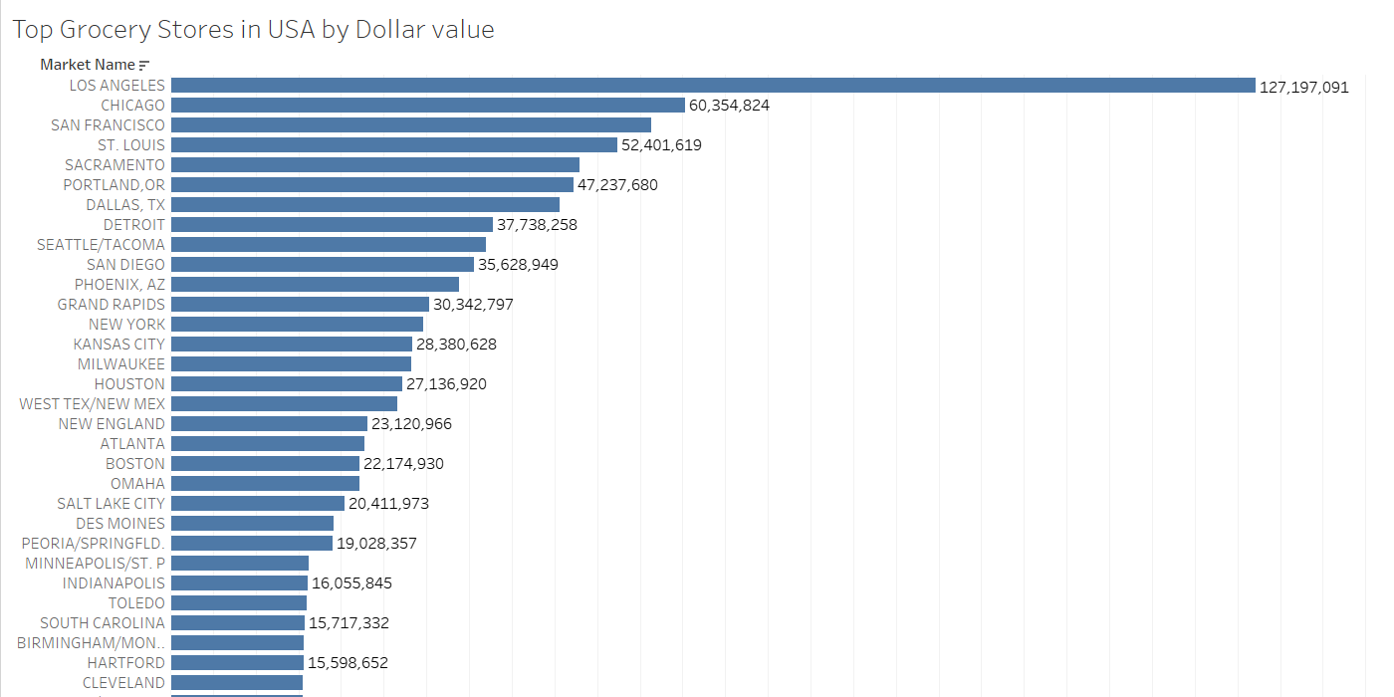

Below graph capture sales values of different products of Ruffles in top markets.

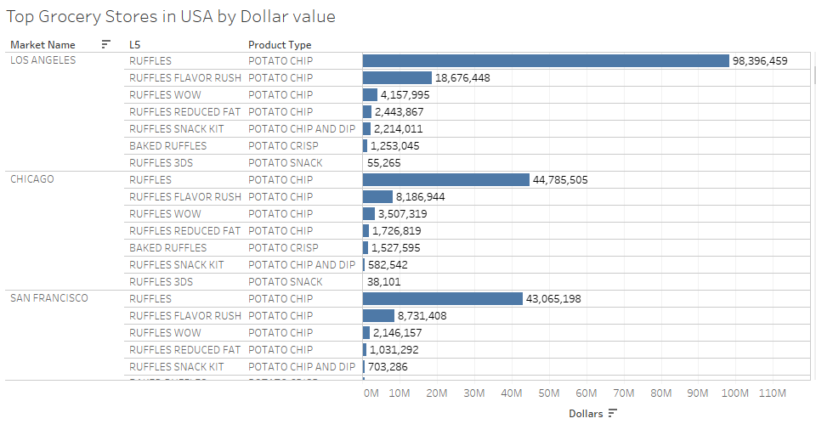

**Top Drug Stores:** After looking at the geographic data of the sales, Los Angeles comes first for the total sales followed by San Diego, San Francisco, and Detroit respectively.

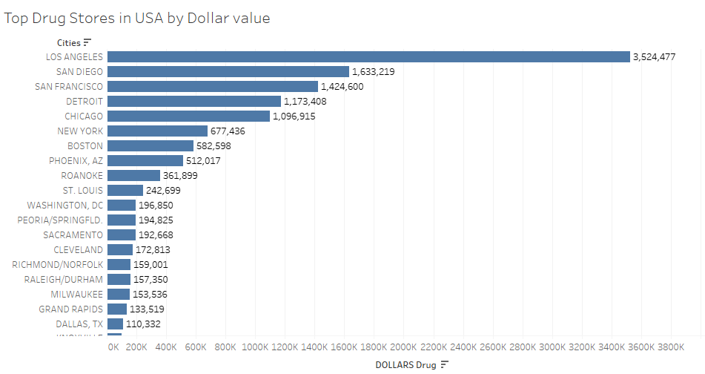

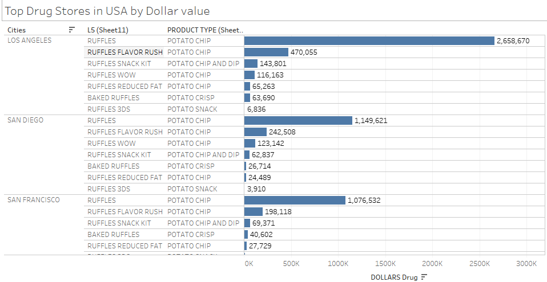

Los Angeles is the top Market for Ruffles in terms of revenue weather from grocery or drug store. It has a good presence in all regions of the US Market which could be put into use to improve sales uniformly throughout the States. We can see Ruffles Potato chips have a huge market and 10 times more sales than any of its products. Also, Grocery stores have 28 times more sales than Drug stores.

**Total Sales based on age:** From the below visualization which depicts the total sales of the potato chip brand ‘Ruffles’ is highest among the children group category 8 i.e. the family size greater than 0 but have no children. This means either single people or couples with no children purchase the product of this brand.

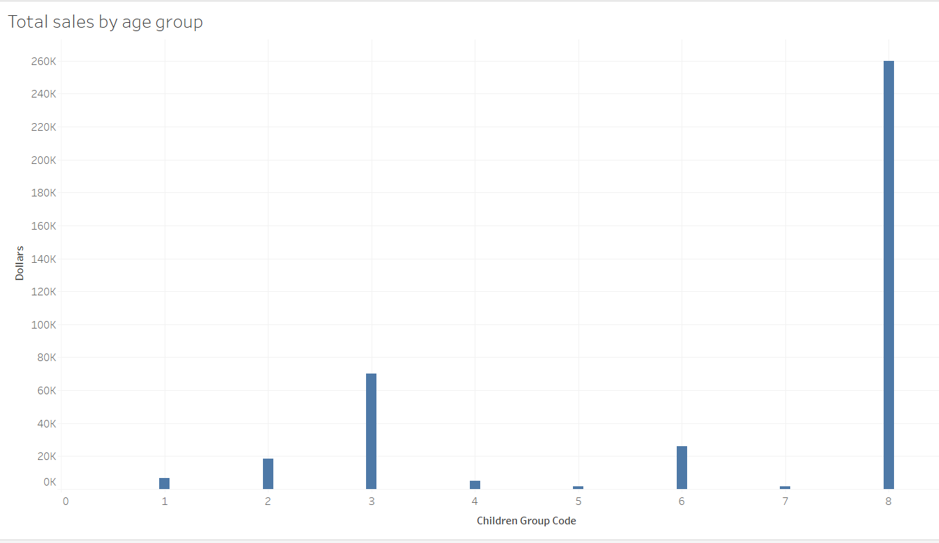

**Total Sales based on Family size: The** Below graph confirms that the total sale is the highest among the family of two i.e the families with no children.

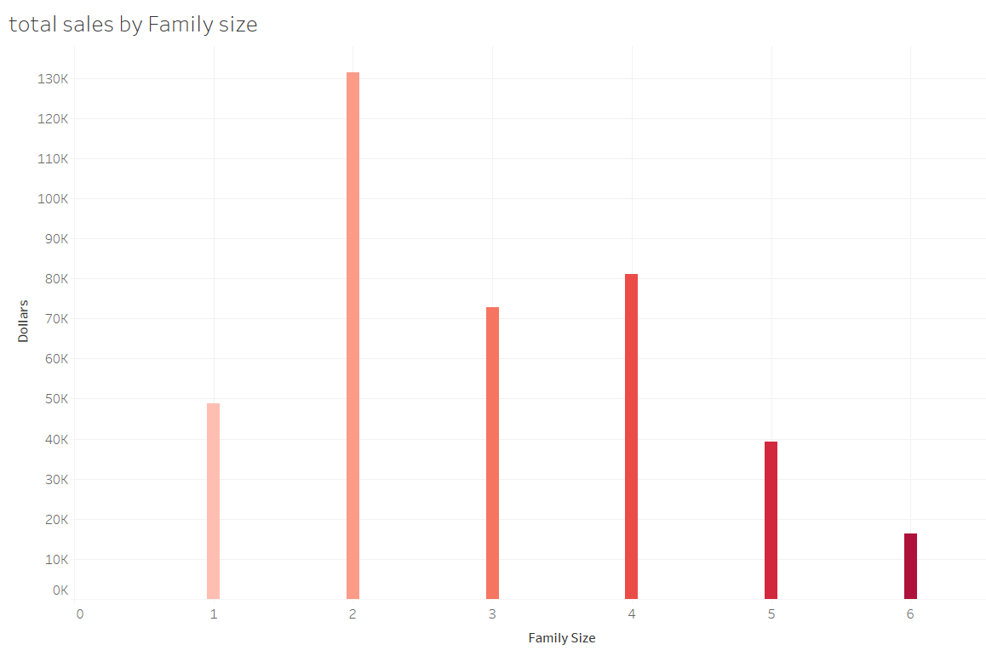

**Weekly Sales by dollar value:** The Line graph shows the weekly dollar sales of Ruffles over the observed period. The maximum revenue was generated between the Weeks 1164.

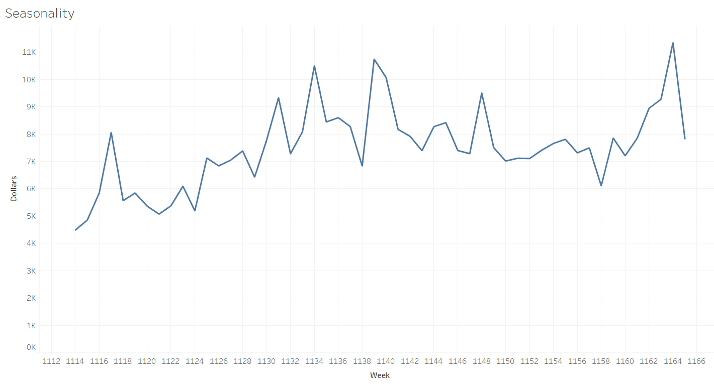

**Feature and Display effect on sales:** From the bar graph for Ruffles, shows dollar sales value when having display and feature. The maximum sales occurred when there is no feature and display. Overall feature and display interaction not providing enough benefit to Ruffles.

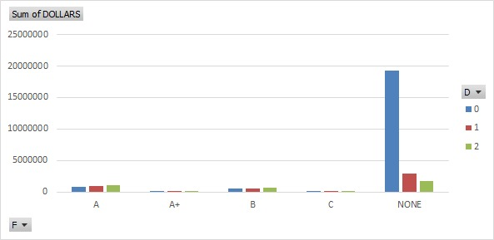

Recommendations :

1. Los Angeles generates the highest revenue by selling the ‘Ruffles’ potato chips, the company can run ad campaigns periodically to continue to dominate the market of the chips brand and to stay on the top.
2. Couples with no child or a family of 2 tend to buy the chips most, considering the fact that they are working professionals of a younger age between 20 to 30 years, company can run promotional offers to make them purchase more and thus help in increasing the revenue.
3. Chips has the highest sales during the mid year i.e June-July and during the end of the year in December, In order to increase sales during these holiday months company can launch the ad campaigns focusing on the particular seasons.
4. Ruffles should do Featuring and Display’s frequently to boost their sales.They should provide coupons to customers to get some extra discount on their next or coming purchase.

**2. Hypothesis Testing and Regression Analysis**

**ANOVA Analysis**

ANOVA analysis was carried out to understand the effects of the various variables such as:

1. The various sub-brands of Ruffles Chips

2. The shape of the Chip (L51).

3. Flavors

4. Features

5. Display features

***Null Hypothesis 1:***

There is no difference in the contribution of various Sub-Brands to the total sales.

***Alternate Hypothesis 2:***

There is a difference in the contribution of various Sub-Brands of ruffles to the total sales.

The P-Value is <0.005, this implies that the Null cannot be rejected

This implies that each of the Sub-Brands has a statistically significant impact on the overall sales revenue of ruffles.

***Managerial Implications:*** This enables a manager to understand if product segmentation and having multiple brands targeting various customer segments is a good strategy to use to improve revenues.

***Null Hypothesis 2:***

There is no difference between the contribution of the shape of the chips (ridged/rippled) to the total sales.

***Alternate Hypothesis 2:***

There is a difference between the contribution of the shape of the chips (ridged/rippled) to the total sales.

The P-Value is <0.005, this implies that the Null cannot be rejected.

This implies that each of the shapes of the chips has as statistically significant impact on the total revenue.

***Managerial Implications:*** Having this understanding of how both shapes of chips contribute towards the total sales, will enable managers to come up with plans to forecast the demand for each type of Chips and further analysis will help in capacity planning to supply future demand.

***Null Hypothesis 3:*** There is a difference in the contribution of the flavor of chips to the to the total revenue.

***Alternate Hypothesis 3:*** There is no difference in the contribution of the flavor of chips to the to the total revenue.

The P-Value is <0.005, this implies that the Null cannot be rejected.

This implies that each type of flavor of the chips has a statistically significant impact on the total revenue.

***Managerial Implication:*** This insight enables us to analyze this effect further and gain better understanding of customer preferences and tastes. This will enable us to better

***Null Hypothesis 4:*** There is a difference in the contribution of features to the to the total revenue.

***Alternate Hypothesis 4:*** There is no difference in the contribution of features to the to the total revenue.

The P-Value is <0.005, this implies that the Null cannot be rejected.

This implies that each of the different features of the chips has as statistically significant impact on the total revenue.

***Managerial Implication:*** This will give us an indication about the features that are used in terms of different types of ads, loyalty programs and coupons and the effect they have on the further. This will give us an understanding of what type of features that are to be used in order to improve customer engagement and the sales.

***Null Hypothesis 5:*** There is a difference in the contribution of whether the product was on Display at the store or not to the to the total revenue.

***Alternate Hypothesis 5:*** There is no difference in the contribution of whether the product was on Display at the store or not to the to the total revenue.

The P-Value is <0.005, this implies that the Null cannot be rejected.

This implies that whether a product is on display or not has a statistically significant impact on the total revenue.

***Managerial Implication:*** Analyzing the effects of having a specialized display at various stores at different period of time is something managers can assess, whether that investment will pay dividends or not.

***Regression Analysis:***

*Model: DOLLARS = 6.547-0.45241Feature_col+4.5042display_col+0.76769+2.0400UNITS*

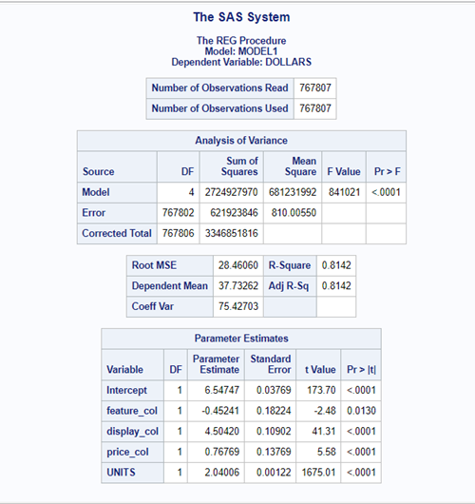

The R-Square adjusted R-Square of this model 0.8142, this means that 81.42% of the variance in the. Since the adjusted R-Square and R-Square are essentially similar, the model is good for analysis.

In the presence of a feature, there is an average $0.45 drop in the “DOLLARS” i.e, revenue per transaction.

When the product has been displayed, there is an increase of $4.5 on average on the “DOLLARS” i.e. revenue per transaction.

When there is a reduction in the price, i.e. store-wise discount, there is an increase of $0.76 on average on the “DOLLARS” i.e. revenue per transaction.

For every extra unit purchased, there is on average an increase of $2.04 in the “DOLLARS” i.e. revenue per transaction.

Although, this model is considering a few dependent variables that look at the effect of promotions on each transaction. From a marketing prescriptive, where we invest the marketing resources.

Further exploration will reveal that certain features are more effective compared to others and can be used to understand what works best in different scenarios. Based on location, some features might work better, in certain cases, advertising targeted to certain demographics.

Also, we see that it is beneficial to invest in displaying the product at stores. Considering the type of product, a snack such as this is, the likelihood of a customer picking up a packet of chips when they are passing by is high. Therefore, having a means of catching the customers attention will improve the likelihood of a purchase.

1. **RFM Segmentation**

RFM (recency, frequency, monetary) analysis is a marketing technique used to determine quantitatively which customers are the best ones by examining how recently a customer has purchased (recency), how often they purchase (frequency), and how much the customer spends (monetary).

For this analysis, we combined merged data with demographic data. We chose the brand “Ruffles” and performed segmentation on its customers. We performed a PROC Means procedure on the three variables - Recency, Frequency and Monetary.

The output is as given below:

The following is the number of days from last purchase, number of transactions and money spent by first few customers.

We rank R, F and M based on a 5-scale system (5 indicating the best)

We created 5 segments:

* Best Customers
* Most Loyal Customers
* Highest Paying Customers
* Faithful Customers
* Slipping Customers

This is the distribution of customers into five segments.

**Best Customers**

• RFM Segment : Recency < 27, Frequency > 7, Monetary > $130

• Who They Are: Highly engaged customers who have bought the most recent, the most often,

and generated the most revenue.

• Marketing Strategies: Best strategies for this segment are loyalty programs and new product

introductions. These customers have proven to have a higher willingness to pay, so marketing

tactics like discount pricing should not be used with this segment. Instead, focus should be on

value added offers like product recommendations based on previous purchases.

**Most Loyal Customers**

• RFM Segment: Frequency > 7

• Who They Are: Customers who buy the most often from your store.

• Marketing Strategies: Loyalty programs are effective for these repeat visitors. Rewards like Free

Shipping or other benefits should be considered.

**Highest Paying Customers**

• RFM Segment: Monetary > $130

• Who They Are: Customers who have generated the most revenue for your store.

• Marketing Strategies: These customers demonstrate a high willingness to pay. Consider

premium offers, subscription tiers, luxury products, or value add cross/up-sells.

**Faithful Customers**

• RFM Code: Frequency > 7, Monetary < $130

• Who They Are: Customers who return often, but do not spend a lot.

• Marketing Strategies: These customers are already loyal. Focus should be on increasing profits

through recommendations based on past purchases and incentives tied to spending thresholds.

**Slipping Customers**

We are not considering slipping /rookie customers because they don't add considerable amount of

revenue as compared to the other segments. However to entice them, we can send them promotional

offers and discounts.

Here is a pie chart depicting the segmentation of customers:

|  |  |
| --- | --- |
| Best Customers | 0.96% |
| Loyal Customers | 17.01% |
| Highest Paying Customers | 18.2% |
| Faithful Customers | 31.38% |
| Slipping Customers | 32.46% |