- Create Database

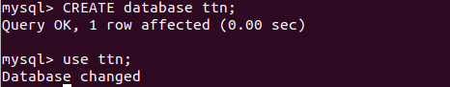

- Design Schema
- Create tables

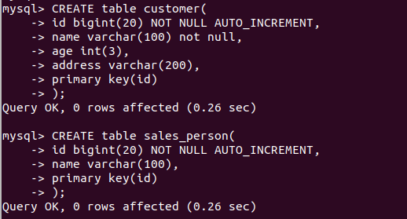
- Insert sample data

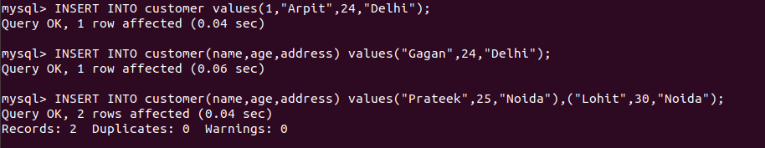
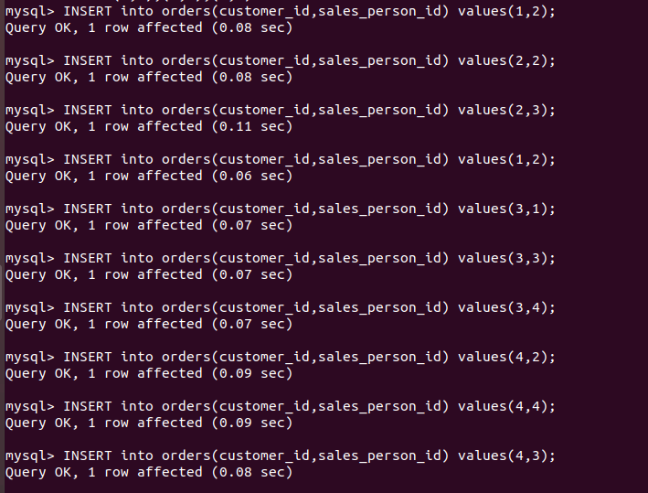
- Find the sales person have multiple orders.

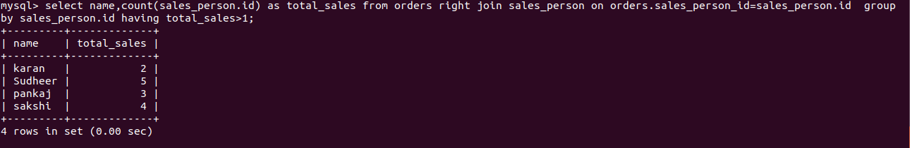
- Find the all sales person details along with order details

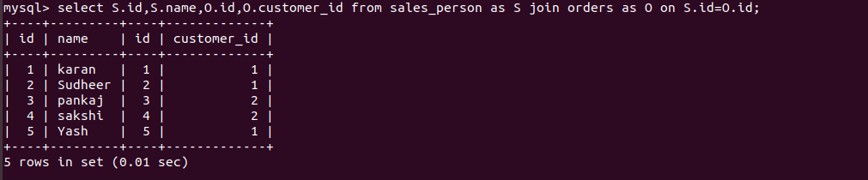

- Create index

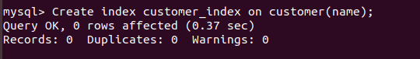
- How to show index on a table

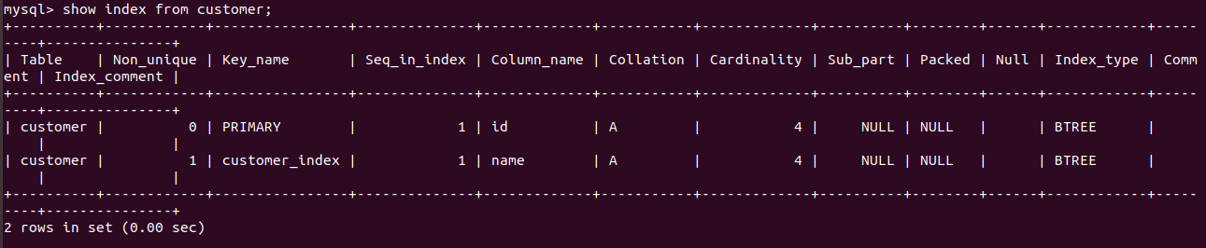
- Find the order number, sale person name, along with the customer to whom that order belongs to

