1.How are inline and block elements different from each other?

Block elements always starts on a new line and takes up the full width of the line. Like <div> tag.
Where as inline elements takes up the width that the need.They do not consume the whole line like <span> tag.

2.Explain the difference between visibility:hidden and display:none

display:none means that the tag in question will not appear on the page at all (although you can still interact with it through the dom). There will be no space allocated for it between the other tags.

visibility:hidden means that unlike display:none, the tag is not visible, but space is allocated for it on the page. The tag is rendered, it just isn't seen on the page.

3. Explain the clear and float properties.

Float allows the elements to float in left, right, both and none.

Clear tells other elements that it should allow the element to float or not.

4. explain difference between absolute, relative,fixed and static.

They are all the position property in CSS.

Static : By default elements have static property, here the elements are not positioned in a special way. They are positioned in the normal flow of the page.

Fixed: This fixes the element relative to the viewport which means they stay the same position even if the page is scrolled.

Relative: The position is relative to its normal position. We can set it as left, right, top or bottom.

Absolute: Here the element is positioned relative to its closest ancestors instead of fixed, relative or static.

5) Write the HTML code to create a table in which there are 4 columns( ID , Employee Name, Designation, Department) and at least 6 rows. Also do some styling to it.

<!DOCTYPE html>
<html>
<head>
<style>
table,th,td {
border: 1px solid black;
border-collapse: collapse;
}
table#tt1{
background-color: grey;
}
table#tt1 th{
background-color: aqua;
}
</style>
</head>
<body>
<table style="width:75%" id="tt1">
<tr>
<th> ID </th>
<th> Employee Name </th>
<th> Designation </th>
<th> Department </th>
</tr>
<tr>
<td> 1 </td>
<td> Aditya Arora </td>
<td> Trainee </td>
<td> Python </td>
</tr>
<tr>
<td> 2 </td>
<td> Abhilash Kumar </td>
<td> Trainee </td>
<td> JAVA </td>
</tr>
<tr>
<td> 3 </td>
<td> Surbhi Bhaskar </td>
<td> Trainee </td>
<td> MEAN </td>
</tr>
<tr>
<td> 4 </td>
<td> Bhavini Khanna </td>
<td> Trainee </td>
<td> Blockchain </td>
</tr>
<tr>
<td> 5 </td>
<td> Bhavya Khanna </td>
<td> Trainee </td>
<td> FEEN </td>
</tr>
<tr>
<td> 6 </td>
<td> Neeti Malhotra </td>
<td> Trainee </td>
<td> Python </td>
</tr>
</table>
</body>
</html>

OUTPUT:

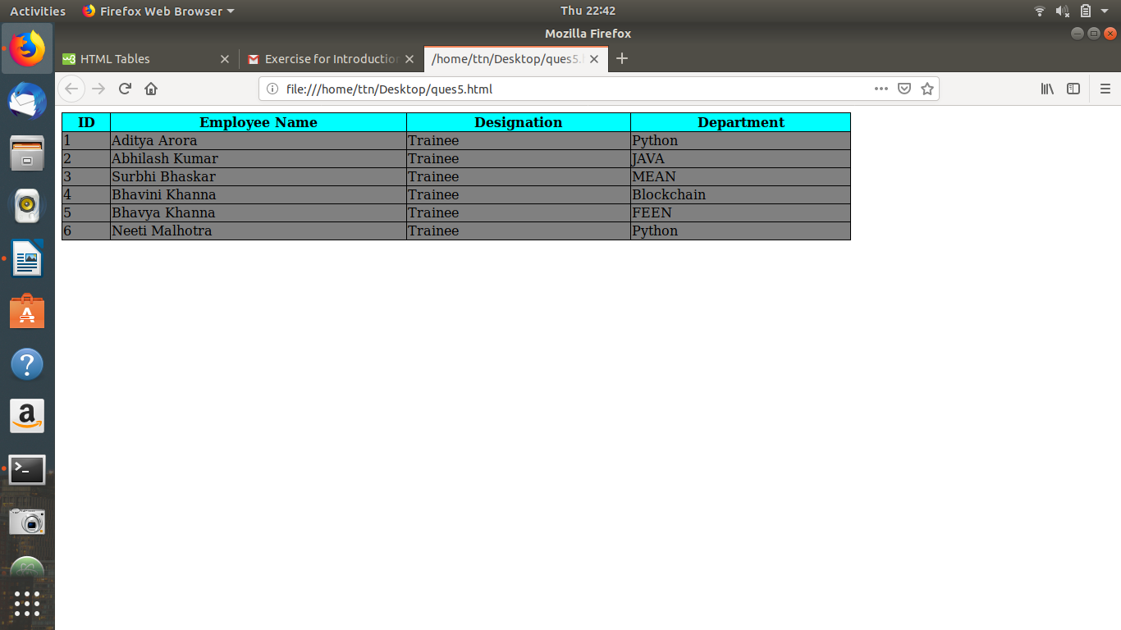

6) Why do we use META tag ?

<meta> tag is used to give data about the data.
Metadata is not displyed on the page.
It gives data about the HTML document that we are making.
Meta data is for the browser which is used to specify page description, charcterset and other details.(can be used by the browser like how to display/process the information).
<meta> tag is always defined inside head of a HTML document and alwasys passed as name value pair.

For Example:

<head>
<meta charset=”UTF-8”>
<meta name=”author” content=”Abc”>
</head>

7. Explain box model.

All HTML elements can be considered as boxes. "Box model" is used when talking about design and layout.

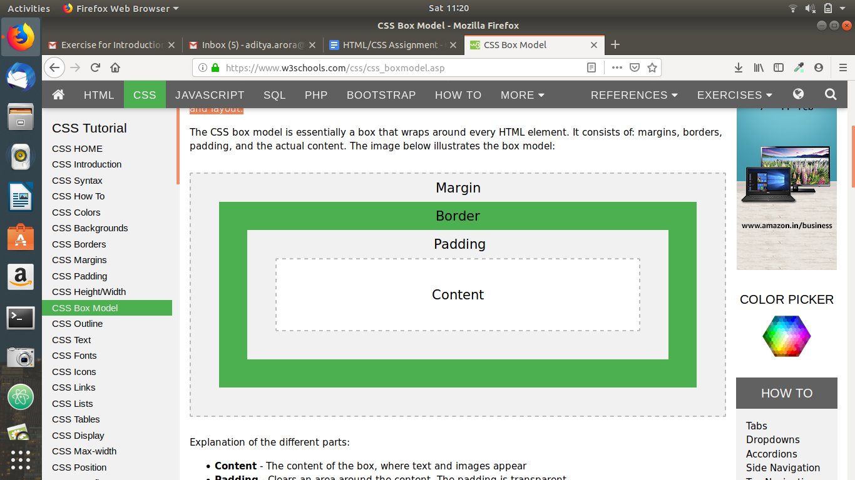
It consists of concentrix boxes around a single element. And by the use of this model we can change all the properties of an element, such as padding, border, margin.
They can be applied in a certain way so that they look good to the eye of the viewer.
Content - The content of the box, where text and images appear
Padding - Clears an area around the content. The padding is transparent
Border - A border that goes around the padding and content.
Margin - Clears an area outside the border. The margin is transparent.

8. What are the different types of CSS Selectors?

Selectors are patterns used to select the element(s) you want to style. When we use them as in our external css file or internal css stylesheet we have to reference them such that they get proprty that we want them to get.

Here is the way by which we can access them:

.class -> Selects all elements with class
#id -> Selects the element with id
* -> Selects all elements element
p -> Selects all <p> elements
element,element -> Selects all elements and all second elements

We also have precedence while operating on them, and we can use that while making our stylesheets.

9) Define DOCTYPE

<!DOCTYPE> is not a HTML tag. It is defined before the <HTML> tag. It is an instruction to the browser about what version of HTML the page is written in.
It is explicit DTD ( Document Type Definition). It tells which html (1.0-5) complies to our web page.
<!DOCTYPE> is NOT case sensitive.

For Example:

<!DOCTYPE html> for HTML 5

10) Explain 5 HTML5 semantic tags.

<header> -> Head content of a HTML page.
<nav> -> NAvbar content comes under this tag.
<footer> -> All the content that we would like to see in the footer we can put it here it will appear at the bottom of the page.
<section> -> section tag defines a section within our HTML page. If we want to section the content we can use this tag.
<article> -> article contains self contained content on a page.

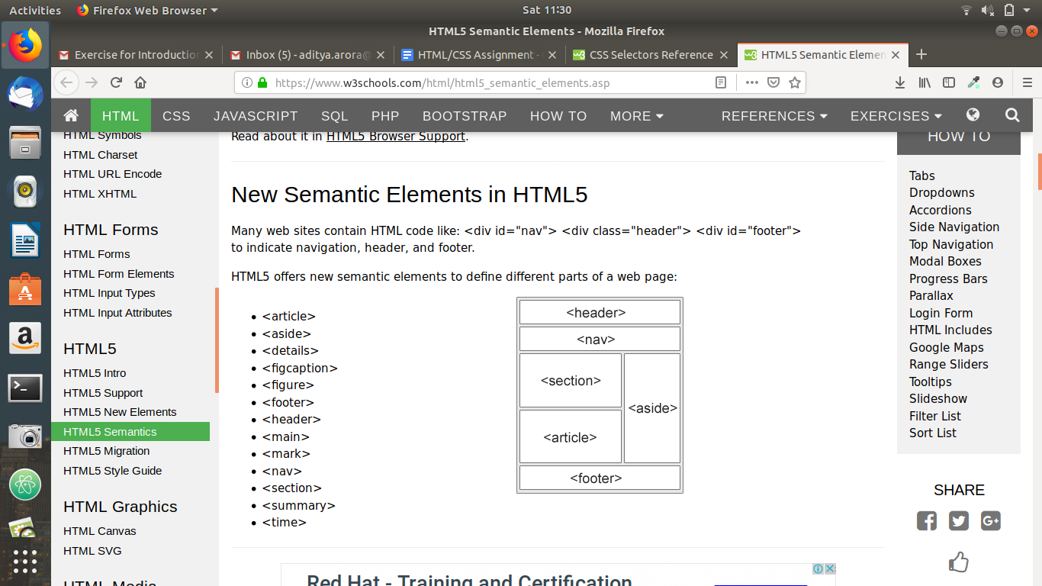

11. Create HTML for web-page.jpg (check resources, highest weightage for answers)

12. Create HTML for form.png (check resources, highest weightage for answers)

