NAME: ARPITH PRADEEP

ID: 35548251

**ICT 171**

**Introduction To Server Environments & Architectures**

**Documentation**

IP Address: 16.16.93.15

Domain Name: <https://burgerdxb.online/>

Contents

Step 1: Make an Amazon AWS account . 3

Step 2: Login to AWS console. 3

Step 3: Open the EC2 Dashboard. 3

Step 4: Lauch a New Instance . 3

Step 5: Configuring the web server. 3

Step 6: Setting up an elastic ip for ease of access . 6

Step 7: SSH into the web server. 7

Step 8: Installing Apache , Wordpress, MySQL . 7

Step 9: Buying a domain name. 7

Step 10: Changing NameServers from godaddy to AWS. 8

Step 11: Obtaining SSL/TLS certification . 8

# Step 1: Make an Amazon AWS account .

* Go to <https://signin.aws.amazon.com/signup?request_type=register> to make an account.
* Fill in all your details.

# Step 2: Login to AWS console.

* Go to <https://aws.amazon.com/>
* Click “Sign In to the Console”.
* Enter your email and password.

# Step 3: Open the EC2 Dashboard.

* In the search bar at the top, type “EC2”.
* Click on “EC2” under Services.

# Step 4: Lauch a New Instance .

* On the EC2 Dashboard, click on “Launch Instance”.

# Step 5: Configuring the web server.

* Give a name for you web server.
* A white rectangular object with a white background

  AI-generated content may be incorrect.
* Configuring the Amazon Machine Image.  
  A screenshot of a computer

  AI-generated content may be incorrect.
* Instance type .  
  A screenshot of a software

  AI-generated content may be incorrect.
* Create a keypair .  
  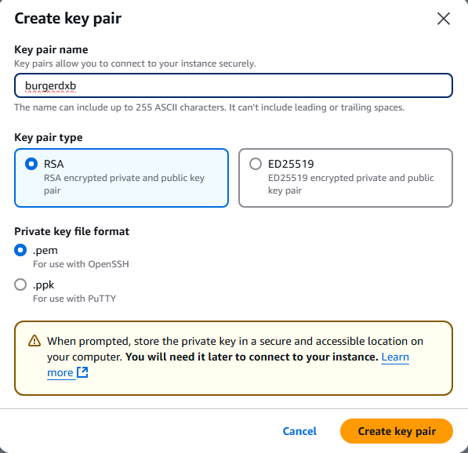
* Network settings .  
  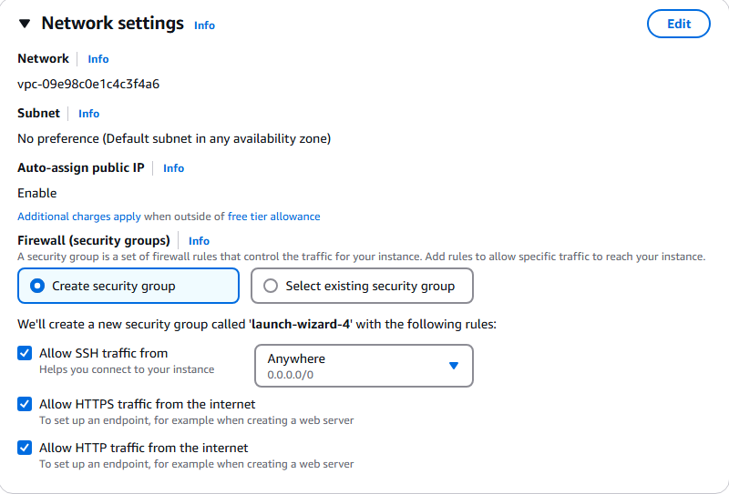
* Configure storage .  
  A screenshot of a computer

  AI-generated content may be incorrect.
* Then we can launch our instance.

# Step 6: Setting up an elastic ip for ease of access .

* In EC2 under Network & Security 🡪Elastic IPs.
* Click on Allocate Elastic IP address.
* Keep default settings and click “Allocate”.
* Click on your elastic ip to allocate it to your web server.  
  



* 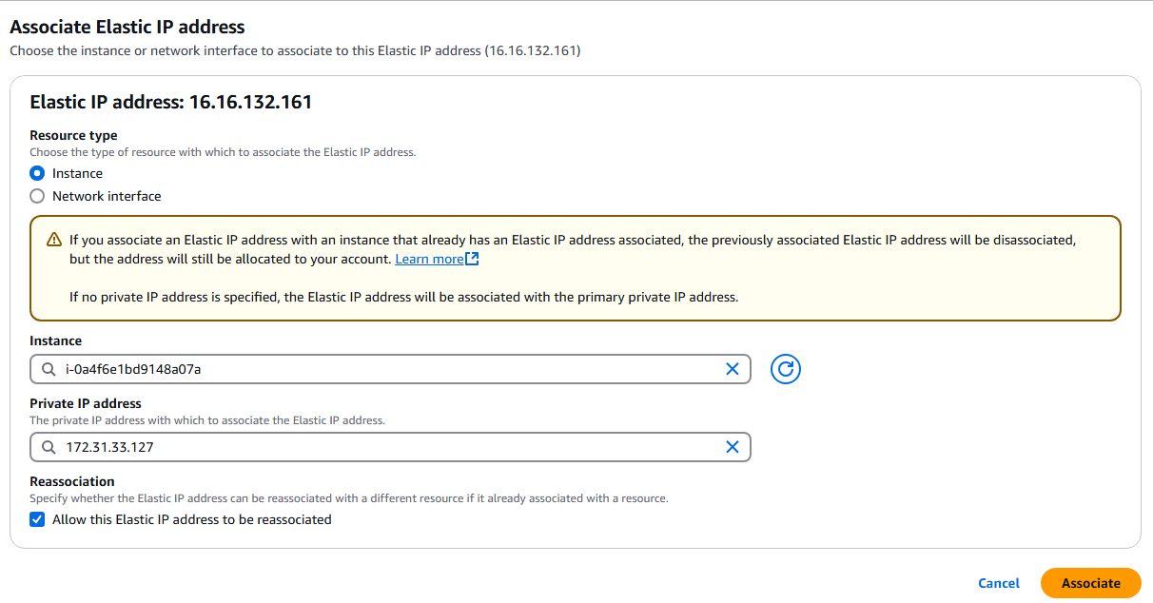

# Step 7: SSH into the web server.

* Open terminal on your PC.
* ssh -i "location of keypair saved on your PC" ubuntu@ip address of server
* eg: 

# Step 8: Installing Apache , Wordpress, MySQL .

* Follow the steps provided in the video .  
  <https://youtu.be/18rfWZYbS7o?si=Owj6a9VclTLl7PZX>
* And copy paste the commands from the below website.  
  <https://portforwarded.com/install-wordpress-on-ubuntu-22-04-lts-lamp-stack/>

# Step 9: Buying a domain name.

* Go to <https://www.godaddy.com/>
* Buy a domain name .

# Step 10: Changing NameServers from godaddy to AWS.

* Follow the following video .  
  <https://youtu.be/RI8oy-HGkIQ?si=px-ZXntsABxBtlMU>

# Step 11: Obtaining SSL/TLS certification .

* Follow the instructions and commands provided in the following website.  
  <https://certbot.eff.org/instructions?ws=apache&os=snap>
* 
* SSH into your server then, follow the commands
* 
* 
* Next we go to “sudo nano /etc/apache2/sites-available/000-default.conf” and add our server name and server alias into the file.  
  A screenshot of a computer screen

  AI-generated content may be incorrect.
* A screen shot of a computer

  AI-generated content may be incorrect.  
  Click enter to select all the domains.
* A screen shot of a computer program

  AI-generated content may be incorrect.Now we have successfully obtained an SSL certification for our website.  
  A screenshot of a computer

  AI-generated content may be incorrect.
* Testing automatic renewal for our website.  
  