ICT10020 - Systems Thinking with Technology
Assignment 1: Procedural Python Programming
- Team Members:
- Arpitha Munagala
- Challayamma (Chandu) Kotikalapudi
- Manually Generate a Table of Data (.csv)
Filename: students.csv (uploaded separately)
CSV Contents:
student_id,name,email,year,course,qualification,study_mode,fees
106050,Chandu,chandu@gmail.com,2025,Computers,Master,Online,20000
106051,Arpitha,arpitha@gmail.com,2025,Data Science,Bachelor,Campus,25000
106052,srikar,srikar@gmail.com,2025,Arts,Bachelor,Online,25000
106053,srinika,srinika@hotmail.com,2025,Law,Diploma,Campus,15000
106054,riyansh,riyansh@outlook.com,2025,Cybersecurity,Certificate,Campus,8000
106055,rishik,rishik@gmail.com,2025,Arts,Diploma,Online,10000
106056,murali,murali@gmail.com,2025,Animation,Advanced Diploma,Campus,20000
106057,deepu,deepu@outlook.com,2025,Health,Master,Online,25000

3: Parallel Arrays and Reading CSV
Python Code Snippet: import csv # In order to handle reading data, import the CSV module.
# Global parallel arrays to hold various student data fields
student_id = [] # Student numbers are stored as integers.
name = [] # stores Student names.
email = [] # stores email id of students
year = [] # stores year of enrolment
course = [] # stores course/module names
qualification = [] # Stores level of study (e.g., Diploma, Bachelor)
study_mode = [] # stores learning modes, like as on-campus and online.
fees = [] # Stores fees as integers
def load_data(filename):
""" loads student data into the parallel arrays from the designated CSV file.
There is a header row in the CSV file that will be skipped."""
with open(filename, newline='') as file:
reader = csv.reader(file)
next(reader) # Skip header row
# Append values to the respective arrays by iterating through each row.
for row in reader:
student_id.append(int(row[0])) # Convert student ID to int
name.append(row[1]) # Student name
email.append(row[2]) # Email ID
year.append(int(row[3])) # Enrolment year as int
course.append(row[4]) # Course/module name
qualification.append(row[6]) # Level of study
study_mode.append(row[5]) # Mode of delivery
fees.append(int(row[7])) # Fees as int
4: Formatted Display
def display_table():
""" Displays the student data in formatted table. """
# Print the table header
print(f"{'ID':>7} | {'Name':<10} | {'Email':<25} | {'Year':>4} | {'Course':<15} | {'Qualification':<18} | {'Mode':<10} | {'Fees':>6}")
print("-" * 120)
# Print all student's data row by row
for i in range(len(student_id)):
print(f"{student_id[i]:>7} | {name[i]:<10} | {email[i]:<25} | {year[i]:>4} | "
f"{course[i]:<15} | {study_mode[i]:<18} | {qualification[i]:<10} | {fees[i]:>6}")
# Entry point for testing the program
if __name__ == "__main__":
load_data("students.csv")
display_table()

5: Demonstration Notes
All required files have been submitted, including:
- Python source code (final.py)
- Data file (students.csv)
Python script reads data from the CSV file and displays it in a properly formatted table using parallel arrays.
Demonstration of Editing the CSV: To demonstrate the prototype functionality we added one record manually to the students.csv file
106058,agastya,agastya@gmail.com,2025,Arts,Diploma,Campus,15000
Output Verification:

6. Main Menu Interface in Functions - uploaded final.py
7. Git and Github Screenshots
Chandu Commit setup screenshots 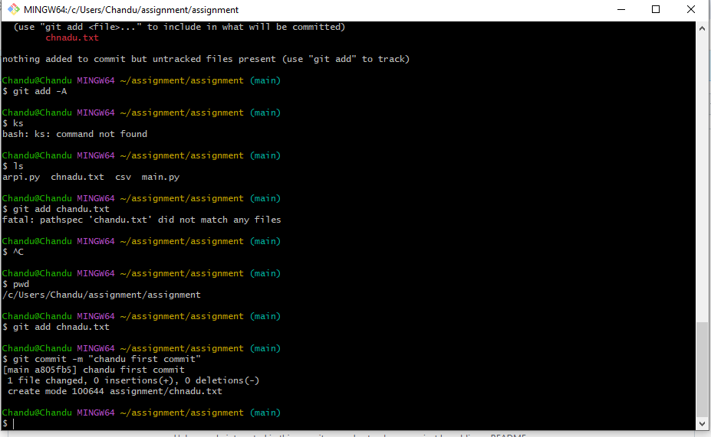
Arpitha Commit setup screenshot -
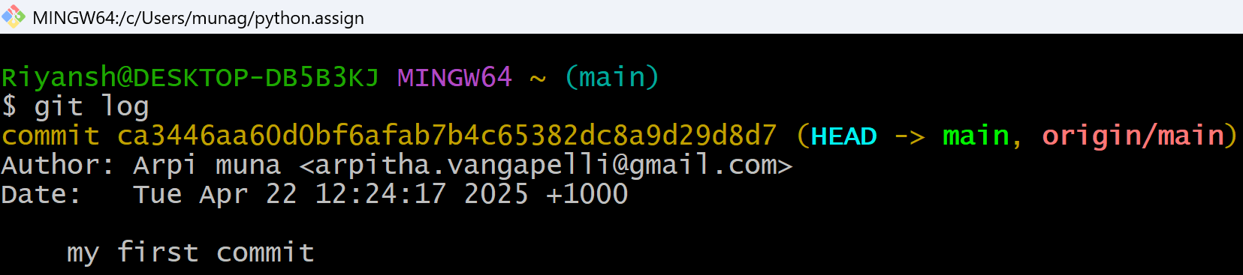
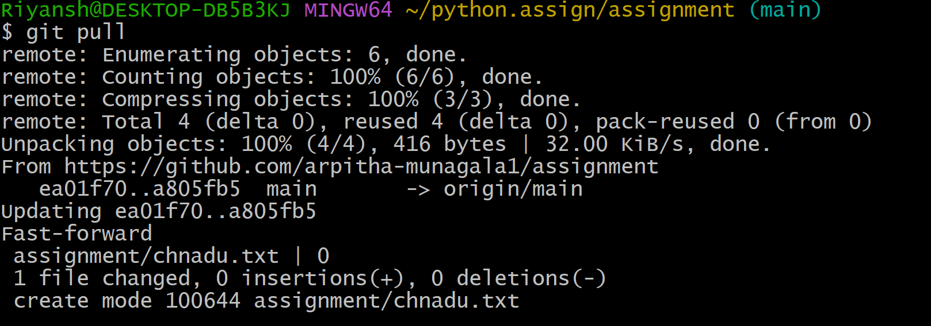

Chandu and Arpitha Commit Log
