Intro to Vertex Pipelines

This document shows the details of creating and running ML Pipelines

1. Setting the project and enabling APIs required to build vertex pipelines

1. Creating a Cloud Storage Bucket

1. Creating a Vertex AI Workbench instance

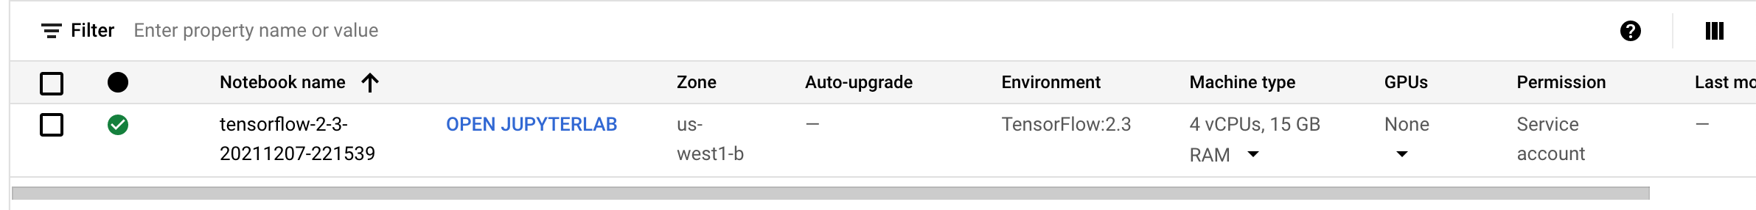

**Attaching the Python notebook for the pipeline in github

**Pipeline after completion**

**After clicking on the build-sentence component to see the final output

Creating an end-to-end ML pipeline

* Using UCI Machine Learning [Dry beans dataset](https://archive.ics.uci.edu/ml/datasets/Dry+Bean+Dataset), from: KOKLU, M. and OZKAN, I.A., (2020), "Multiclass Classification of Dry Beans Using Computer Vision and Machine Learning Techniques."

This pipeline will:

* Create a dataset in Vertex AI
* Train a tabular classification model with AutoML
* Get evaluation metrics on this model
* Deploy the model to an endpoint

**Attaching the Python notebook for the pipeline in github

Output:

INFO:google.cloud.aiplatform.pipeline_jobs:Creating PipelineJob

INFO:google.cloud.aiplatform.pipeline_jobs:PipelineJob created. Resource name: projects/267810977261/locations/us-central1/pipelineJobs/automl-tab-beans-training-v2-20211208065510

INFO:google.cloud.aiplatform.pipeline_jobs:To use this PipelineJob in another session:

INFO:google.cloud.aiplatform.pipeline_jobs:pipeline_job = aiplatform.PipelineJob.get('projects/267810977261/locations/us-central1/pipelineJobs/automl-tab-beans-training-v2-20211208065510')

INFO:google.cloud.aiplatform.pipeline_jobs:View Pipeline Job:

<https://console.cloud.google.com/vertex-ai/locations/us-central1/pipelines/runs/automl-tab-beans-training-v2-20211208065510?project=267810977261>

After navigating to the link given, we see the below results:

1. ML Pipeline

1. Dataset:

1. Model artifacts:

We also see that the model is deployed to the endpoint:

1. All other artifacts:

