**CLUB MANAGEMENT SYSTEM AT IIT KANPUR**

Welcome to the project description page of this project: Club management system at IIT Kanpur.

Project Description and Salient features:

* The project intends to keep record of activities and people involved in the activities by various clubs at IIT Kanpur (focussing on SnT right now).
* The course also maintains a central database of attendance recorded in various events happening round the year under the Science and technology wing at IIT Kanpur.

Types of events to be covered:

* Lectures
* Workshops
* Independent Events
* Events associated with Techkriti
* Events associated with external organizations(other tie ups like Microsoft,DirectI,Google,Startup lectures, Case study workshops, workshops on embedded systems)
* Users can export and import the data via **CSV** files based on the rights they have over the database (admin rights or user rights).Hence, the records can be maintained by the people in easy to use CSV format and the data can be imported/exported at one go in the database.
* The project maintains a central database of the attendance records during these events. The central database is being run on the host machine of SntSecy. He possesses all the admin rights of
  + adding an event,
  + adding new users to manage the database,
  + maintaining the attendance records,
  + adding new club coordinators,
  + adding new secretaries,
  + adding new event coordinators
  + adding new event assists( secretaries, club mentors, other people involved with the club)
  + Making new queries to the database.
* The people who can login are given a unique username and a corresponding password. Apart from SntSecy (who enjoys full control over the database), these users can make changes to the database in terms of adding new records (and not modifying/deleting entries). The users are however not given the ability to look into the database (read values) as we expect even secretaries to have a username/password and hence it will not be fair for them to look into the involvements of other fellow secretaries/coordinators.
* Only SntSecy can even give MySql queries directly which can run on the backend server.
* We make use of the fact that SntSecy has access to the student database list containing names, rollno, department, roomno, hall, email id of the students in the college as we take input values posed to the context that the person involved in the club is a student of IIT Kanpur (taking into account that the event CAN include faculty members, people from external organizations, and people from administration as secondary contributors).
* The portal makes use of login based system and has been made as much as possible to avoid SQL injection.
* The portal runs on the basis of sessions and cookies and any person having direct links to the portal php files CANNOT access it unless he/she is logged in.
* Appropriate care has been taken to ensure that the portal is as smooth as possible.php files have been named accordingly so that any person can easily interpret them and the SntSecy can make changes to the source code easily.
* Appropriate error messages and redirection links have been put in the code for easy functionality.
* It is possible for multiple clubs to jointly host one event (when clubs collaborate).Such cases have been included in the design. However, for any event we consider any one club as primarily responsible for that event (based on which club functions in the area of the event on).
* It has been observed that first yearites often are involved in multiple clubs during their first year. When nominations are called for posts like secretaries it becomes really cumbersome to manage issues like loyalty to one club. For example: The nominations even reach hundred when all of them are taken into consideration. Right now, this is clarified by word of mouth and phone calls.
* The system keeps track whether the individual is actually associated with the club or not, based on his/her participation based on attendance in the various events the club holds. By the time nominations are called for coordinators of respective clubs and SnT general secretary knows of people involved and mark out misrepresentation of people.

**Clubs included right now:**

* Aero modelling club
* Business club
* BRAIN
* Electronics Club
* HAM Club
* Programming Club
* Robotics Club

**Persons assisting the functioning of club:**

* Coordinators
* Secretaries
* Mentors (note that mentors are assumed to be as students and hence possess a roll no.)

**EER Diagram**

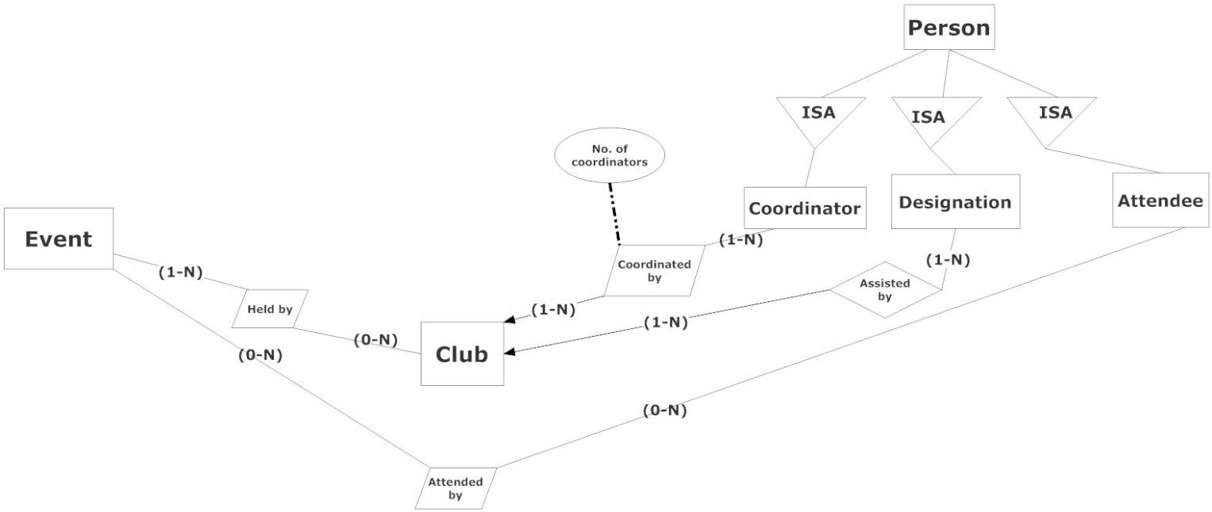

**Basic EER diagram**

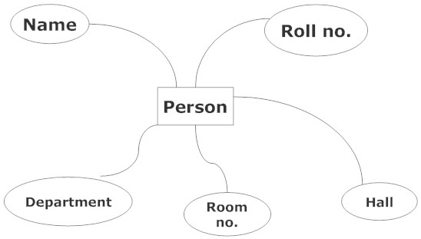

**Person entity set**

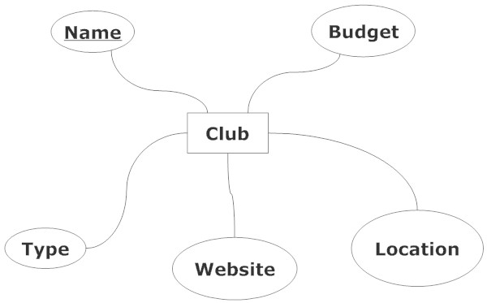

**Club Entity set**

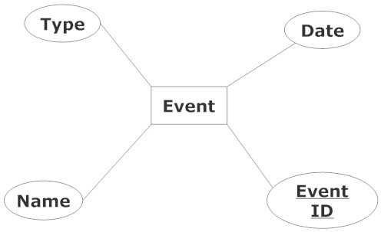

**Event entity set**

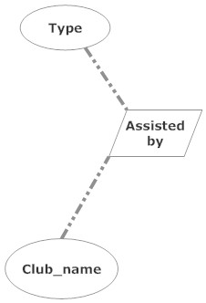

**Assisted by Relationship set**

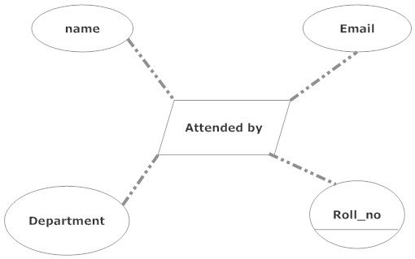

**Attendedby relationship set**

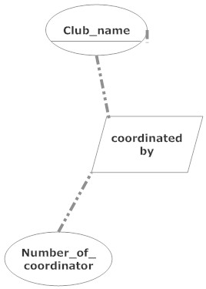

**Coordinatedby relationship set**

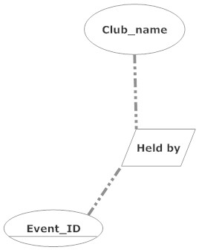

**Heldby relationship set**

(Ovals indicate attributes, Rectangles indicate entity sets, and Oblique rectangles represent relationship sets, and dashed lines represent attributes of relationship sets.)