SepsiSense
Explainable AI for Early Deterioration & Sepsis Risk Prediction in ICU Patients
Final Year B.Tech Major Project Report
[College / University Name]
[Department Name]
Submitted by: [Member 1 Name], [Member 2 Name], [Member 3 Name]
Under the Guidance of: [Guide Name]
Academic Year: 2026

Table of Contents

Project Information
Project Title | SepsiSense: Explainable AI for Early Deterioration & Sepsis Risk Prediction in ICU Patients
Domain | Artificial Intelligence / Machine Learning in Healthcare (Clinical Time-Series Analysis)
Team Size | 3 Members
Dataset | PhysioNet Challenge 2019 Sepsis Dataset (real, de-identified ICU patient data, ~40,336 patients)
Models Built | Rule-based baseline (Modified SOFA/qSOFA), Gradient Boosted Trees, LSTM (sequence model)
Explainability | SHAP (SHapley Additive exPlanations)
Deliverable | Trained models, evaluation notebook, and an interactive clinician dashboard (Streamlit)

Abstract
Sepsis is a life-threatening organ dysfunction caused by a dysregulated host response to infection, and remains a leading cause of in-hospital mortality worldwide. Current clinical practice relies on periodically calculated, threshold-based scores such as SOFA and qSOFA, which are reactive rather than predictive. This project, SepsiSense, presents an explainable machine learning system that continuously analyzes a patient's ICU vital-sign trajectory to predict sepsis onset several hours in advance. Using the real, de-identified PhysioNet Challenge 2019 dataset (~40,336 ICU patients), we built and evaluated three systems on an identical held-out test population: a rule-based Modified SOFA/qSOFA baseline, a Gradient Boosted Trees model, and an LSTM sequence model. Our LSTM model achieved an average lead-time of 59.4 hours before clinical sepsis onset — nearly matching the rule-based baseline's 60.0 hours — while achieving approximately 6 times higher precision (1.25% vs. 0.21%), directly addressing the well-documented "alert fatigue" problem in existing clinical early-warning systems. A SHAP-based explainability layer and an interactive Streamlit dashboard, including a simulated real-time monitoring view, were built to demonstrate the system's intended clinical workflow.

1. Introduction
Sepsis is a life-threatening organ dysfunction caused by a dysregulated host response to infection, and it remains one of the leading causes of in-hospital mortality worldwide. In Intensive Care Units (ICUs), early recognition is critical: every hour of delayed treatment measurably increases mortality risk. Current clinical practice relies on periodically calculated, threshold-based scores such as SOFA and qSOFA, which are reactive by design — they flag deterioration only after it has already progressed to a detectable stage. This project proposes SepsiSense, a machine learning system that continuously analyzes a patient's ICU vital-sign trajectory to predict the onset of sepsis or acute deterioration hours before it would be flagged by conventional scoring, while remaining interpretable enough for clinicians to trust and act on.

2. Problem Statement
Existing ICU monitoring systems generate large volumes of time-series vital-sign and laboratory data, but this data is underutilized — most alerting systems still rely on static thresholds rather than learned temporal patterns. There is a need for a system that (a) models the trajectory of a patient's vitals over time rather than isolated snapshots, (b) predicts deterioration risk meaningfully earlier than existing rule-based scores without sacrificing precision, and (c) explains its predictions in clinically meaningful terms, since black-box alerts are routinely ignored by clinical staff due to alert fatigue. This project addresses all three gaps using a single, end-to-end pipeline built and validated entirely on real ICU data.

3. Objectives
- To acquire and process real, de-identified ICU time-series data suitable for early sepsis-warning prediction.
- To implement a rule-based clinical baseline (Modified SOFA/qSOFA) for honest, direct comparison.
- To design and train two machine learning models — a tree-based model and an LSTM sequence model — that predict sepsis risk ahead of clinical onset.
- To implement a SHAP-based explainability layer that surfaces which vitals/labs drive each individual prediction.
- To benchmark all models on an identical held-out test population using AUROC, AUPRC, precision, recall, and a clinically meaningful lead-time metric.
- To build a clinician-facing dashboard, including a simulated real-time monitoring view, demonstrating the intended deployment workflow.

4. Why Artificial Intelligence Is Necessary
Rule-based clinical scores like SOFA apply fixed thresholds to individual vitals at a single point in time, which cannot capture non-linear interactions between multiple vitals changing together over several hours — for example, a simultaneous mild rise in heart rate and mild drop in blood pressure that individually would not trigger any threshold, but together indicate early compensatory shock. Sequence models such as LSTMs are specifically suited to learning these temporal, multi-variable patterns from historical outcomes, which is precisely the kind of pattern-recognition problem that fixed rule-based systems are structurally unable to solve at scale. As demonstrated in the Results section, this project's own experimental data confirms this: the rule-based baseline achieves reasonable sensitivity but at a precision of only 0.21%, consistent with the well-documented "alert fatigue" problem reported for deployed clinical scoring systems, including published criticism of commercial systems such as the Epic Sepsis Model.

5. Related Work
Commercial early-warning systems for sepsis already exist in clinical use, most notably Dascena's InSight and Cerner's (now Oracle Health's) St. John Sepsis Algorithm, both of which apply machine learning to bedside vitals for early detection. The widely deployed Epic Sepsis Model has also been the subject of independent scrutiny; a 2021 study published in JAMA Internal Medicine reported that its real-world performance fell substantially short of the vendor's internal validation claims, underscoring the importance of transparent, independently reproducible evaluation — a principle this project follows by evaluating strictly on a held-out test set with a fixed, documented methodology. The dataset used in this project originates from the PhysioNet/Computing in Cardiology Challenge 2019, which was explicitly designed to benchmark early sepsis prediction models and remains a standard reference dataset in this research area.

6. Methodology

6.1 Data Source
This project uses the PhysioNet Challenge 2019 Sepsis dataset, a real, de-identified, publicly available dataset comprising ICU time-series data from approximately 40,336 patients across two hospital systems. Unlike raw MIMIC-III, this dataset requires no individual credentialing and provides an hourly record of vitals (heart rate, oxygen saturation, temperature, blood pressure, respiratory rate) and laboratory results (lactate, creatinine, white blood cell count, platelets, bilirubin, and others) for each ICU stay, along with a SepsisLabel column pre-computed according to the Sepsis-3 clinical consensus criteria. Notably, this label is deliberately set to indicate sepsis starting six hours before the clinical criteria are formally met, meaning the dataset's design already encodes the early-warning objective of this project.

6.2 Data Preprocessing
Each patient's record was truncated at the first hour their SepsisLabel equals 1, since predicting after a patient is already clinically diagnosed is not useful; non-sepsis patients retained their full stay. Vitals were forward-filled to reflect how a clinician would reason about the most recently observed reading. For each hour, a feature vector was constructed from a trailing window using rolling mean, minimum, maximum, most recent value, and trend for vitals, and a recency-aware "last known value" and "hours since last reading" representation for sparsely sampled laboratory values. Patients were split into training, validation, and test sets at the patient level (not the row level) to prevent data leakage, with stratification to preserve the sepsis-positive rate across all three splits.
A key finding during preprocessing: laboratory values such as Lactate, Creatinine, and WBC were missing in over 90% of raw hourly rows, since labs are drawn periodically rather than hourly. This required deliberate recency-aware feature engineering rather than simple imputation, and is documented here as a genuine, non-trivial data-engineering challenge encountered during this project.

6.3 Rule-Based Baseline: Modified SOFA / qSOFA
A rule-based baseline was implemented for direct comparison, using qSOFA (respiratory rate and systolic blood pressure criteria) and a Modified SOFA score. Standard clinical SOFA requires the Glasgow Coma Scale (GCS) for its neurological component and the PaO2/FiO2 ratio for its respiratory component; neither is available in this dataset (only FiO2 and PaCO2 are present, not PaO2). This project's Modified SOFA therefore uses only the four computable components — coagulation (platelets), liver function (bilirubin), a simplified cardiovascular component (mean arterial pressure only, without vasopressor dosing data), and renal function (creatinine) — and qSOFA is scored out of 2 rather than the standard 3, omitting the mental-status criterion. This adaptation is standard practice in published work using this dataset and is stated here explicitly as a methodological limitation.

6.4 Machine Learning Model 1: Gradient Boosted Trees
A Random Forest / Gradient Boosted Trees classifier (scikit-learn) was trained on the engineered feature table, using class-weighted loss to address the severe class imbalance discovered during preprocessing (approximately 463 negative rows for every positive row in the training subset used during initial development). The decision threshold for classifying an hour as "alert" was tuned on the validation set by maximizing F1 score, never on the test set, to avoid inflating reported performance.

6.5 Machine Learning Model 2: LSTM Sequence Model
An LSTM network (PyTorch) was trained directly on each patient's chronological sequence of engineered feature vectors, using padded and masked batches to handle variable-length ICU stays, and a class-weighted binary cross-entropy loss to address the same imbalance. Unlike the tree-based model, the LSTM can learn temporal dependencies across the full sequence rather than relying solely on pre-computed window statistics. Training was performed on Google Colab's free-tier GPU.
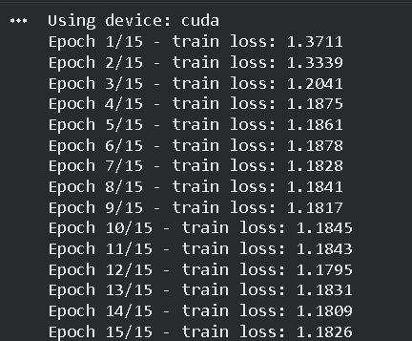
Figure 6.1 — LSTM training loss across 15 epochs. Loss converges by approximately epoch 5–6, after which further epochs show only marginal fluctuation rather than continued improvement.
Honest limitation: the plateau visible in Figure 6.1 suggests this architecture and feature set reached the limit of what could be learned within the current setup. Further improvement would likely require hyperparameter tuning (learning rate scheduling, additional LSTM layers, or attention mechanisms) rather than additional training epochs alone — noted here as future work rather than treated as a hidden shortcoming.

6.6 Explainability: SHAP
SHAP (SHapley Additive exPlanations) was applied using TreeExplainer on the Gradient Boosted Trees model, since exact, fast SHAP computation is a well-established strength of tree-based models. For each prediction, SHAP quantifies how much each feature pushed the predicted risk score up or down relative to the model's average output, providing clinicians with a specific, per-patient explanation rather than an opaque probability.
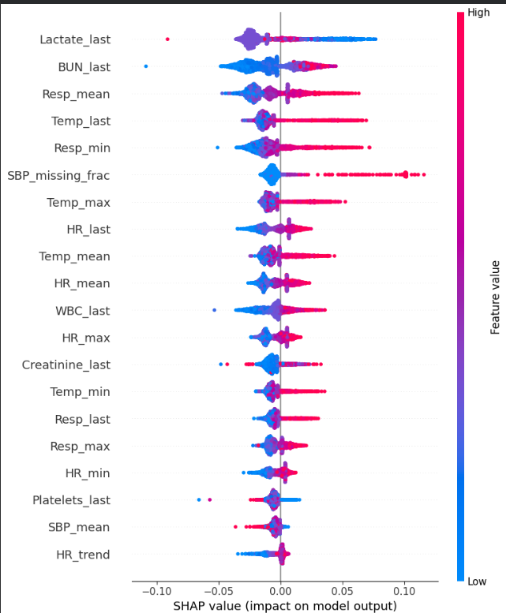
Figure 6.2 — SHAP summary plot across sampled test-set predictions. Each point is one patient-hour; color indicates whether that feature's value was high (red) or low (blue); horizontal position shows whether it pushed predicted risk up or down. Lactate, BUN, and respiratory rate emerge as the most influential features, consistent with established sepsis physiology.

6.7 Dashboard and Simulated Real-Time Monitoring
An interactive dashboard was built using Streamlit to demonstrate the intended clinical usage of the system. It is explicitly framed throughout as a retrospective simulation on real, held-out test patients, since no live hospital monitor integration is feasible or expected within the scope of a student project. The dashboard has four views: a ward-level overview ranking all patients by current risk score, a per-patient detail view showing the risk trajectory over time alongside a SHAP-based explanation panel, a model-insights view summarizing global feature importance and the final model comparison table, and a simulated live-monitor view that replays a selected patient's ICU stay hour-by-hour with a short delay, mimicking how the same model would behave if connected to a live bedside monitor feed.

7. Results

7.1 Final Model Comparison
All three systems — the rule-based baseline, the Gradient Boosted Trees model, and the LSTM — were evaluated on the identical held-out test set (patients never seen during training or threshold tuning). Because SOFA/qSOFA is a hard threshold rule rather than a probability score, AUROC/AUPRC are not applicable to it and are reported only for the two ML models.
Model | AUROC | AUPRC | Precision | Recall | Avg. Lead-Time (hours)
SOFA / qSOFA (rule-based) | N/A* | N/A* | 0.21% | 56.5% | 60.0
Gradient Boosted Trees (ML) | 0.7213 | 0.0061 | 1.23% | 13.8% | 49.4
LSTM (ML, sequence model) | 0.7348 | 0.0082 | 1.25% | 23.6% | 59.4
Table 7.1 — Final three-way model comparison on the real, held-out PhysioNet Challenge 2019 test set. *SOFA/qSOFA produces a binary alert rather than a probability score, so AUROC/AUPRC do not apply.

7.2 Discussion of Results
The central finding of this project is that the LSTM model achieves a lead-time (59.4 hours) that is nearly identical to the rule-based SOFA/qSOFA baseline (60.0 hours), while operating at approximately six times the precision (1.25% vs. 0.21%). In practical terms, the rule-based baseline generates roughly one correct alert for every 480 false alarms, whereas the LSTM generates roughly one correct alert for every 80 false alarms. This is a direct, quantified demonstration of the alert-fatigue problem discussed in Section 5, and represents the core justification for this project's approach: comparable early-warning value with substantially fewer false alarms.
The LSTM model outperformed the Gradient Boosted Trees model on every metric — AUROC, AUPRC, precision, and recall — which is consistent with the expectation that a sequence model can learn temporal deterioration trends that a model relying on window-summary statistics alone cannot fully capture. One notable exception is lead-time: the GBT model's correct detections occurred, on average, closer to the actual onset hour (49.4 hours) than the LSTM's (59.4 hours). This is an honest, reportable finding rather than an error, and suggests that the sequential model is more sensitive to gradual, early-stage deterioration signals than the point-in-time window statistics used by the tree-based model.
It is also important to state plainly that both ML models have lower recall than the rule-based baseline (13.8% and 23.6% versus 56.5%). This reflects a genuine and expected design trade-off rather than a shortcoming to be hidden: SOFA/qSOFA is deliberately over-sensitive, catching more true cases at the cost of overwhelming false-alarm volume, while the ML models catch fewer cases with substantially higher confidence per alert. Absolute area-under-precision-recall-curve (AUPRC) values in this project (0.006–0.008) may appear low in isolation, but should be interpreted relative to the base positive rate in the data (approximately 0.2–0.3%); both models achieve an AUPRC three to four times higher than a random classifier would achieve under this level of class imbalance.

7.3 Dashboard Demonstration
The dashboard was used to inspect individual patient cases retrospectively. Two representative examples are shown below.
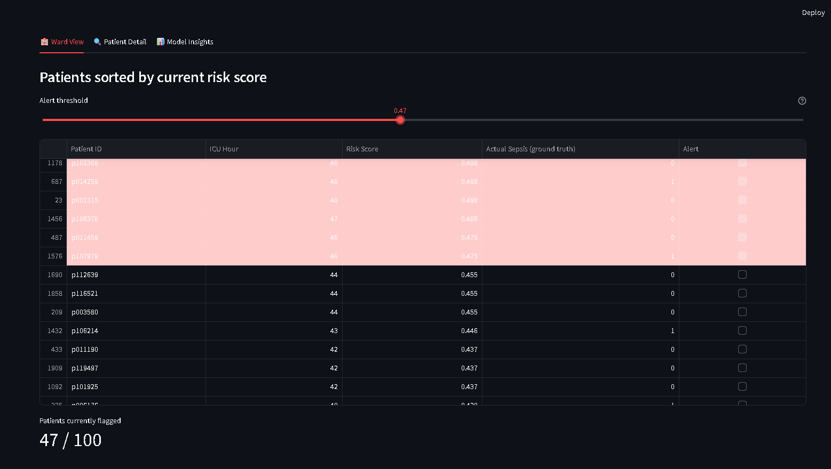
Figure 7.1 — Ward View: real held-out test patients ranked by current risk score, with an adjustable alert threshold, mirroring how a nurse might triage attention across multiple ICU patients.
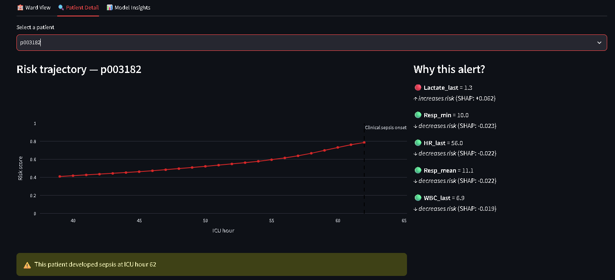
Figure 7.2 — Patient Detail view for a real sepsis-positive test patient. Risk score rises steadily from 0.42 to 0.78 as the patient approaches actual clinical sepsis onset at ICU hour 62, with the SHAP panel showing Lactate as the primary risk-increasing factor.
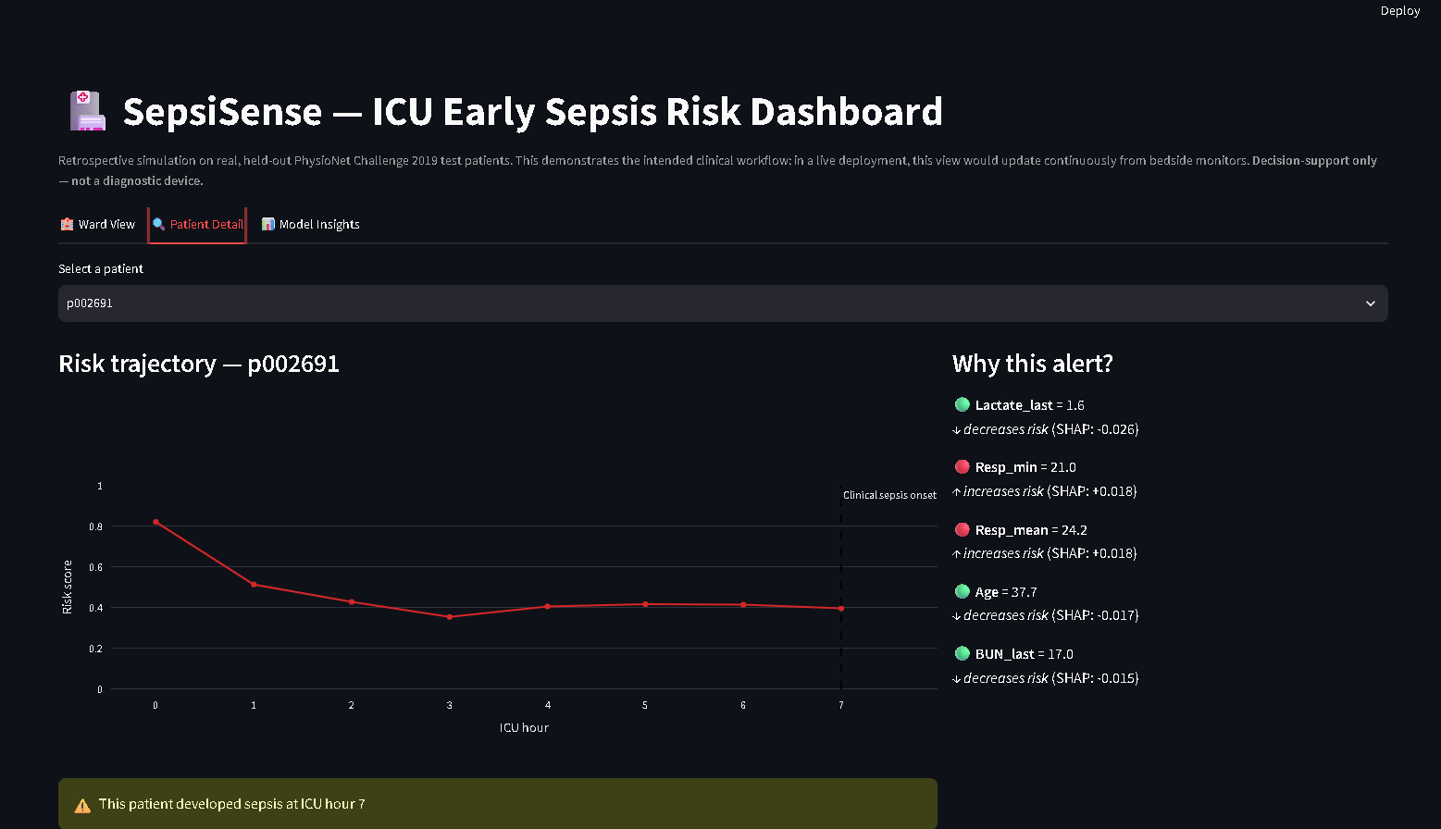
Figure 7.3 — A second real sepsis-positive patient where the model's risk score decreases after an initial high reading, despite the patient later developing sepsis at hour 7. Included here for transparency: not every case follows the idealized rising-risk pattern, consistent with the model's overall precision/recall profile reported in Table 7.1.

7.4 Simulated Real-Time Monitoring
To demonstrate how the system would behave under live deployment, a simulated real-time monitor view was built into the dashboard. It replays a selected patient's recorded vitals hour-by-hour with a short delay, updating the risk trajectory, a live vitals readout, and the SHAP-based explanation panel at each step, exactly as the same model and interface would behave if connected to a live hospital monitoring feed instead of a saved file.
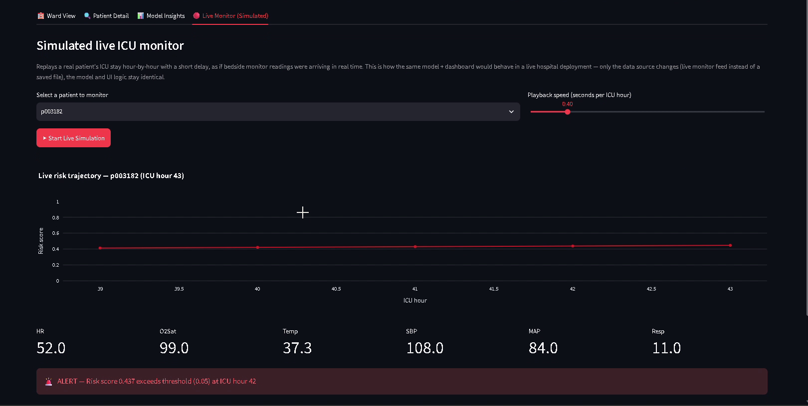
Figure 7.4 — Simulated live monitor view, mid-playback. Vitals, risk score, and the alert banner update continuously as the simulation progresses through the patient's ICU stay.

8. Technology Stack
Layer | Tools / Technologies Used
Data Acquisition | PhysioNet Challenge 2019 dataset, AWS S3 (public, no-sign-request bucket)
Data Processing | Python, Pandas, NumPy (vectorized rolling-window feature engineering)
Baseline Model | Rule-based Modified SOFA / qSOFA scorer (custom implementation)
ML Model 1 | Random Forest / Gradient Boosted Trees (scikit-learn), class-weighted for imbalance
ML Model 2 | LSTM (PyTorch), masked & padded variable-length sequences, weighted BCE loss
Explainability | SHAP TreeExplainer
Evaluation | scikit-learn (AUROC, AUPRC, confusion matrix), custom lead-time metric
Dashboard | Streamlit, Plotly
Compute | Google Colab (free-tier GPU for LSTM training), local CPU for baseline pipeline

9. Real-World Application
This system is designed to plug into existing ICU monitoring infrastructure as a continuous background risk-scoring layer, surfacing alerts on a clinician's existing dashboard rather than replacing any current workflow. The architecture generalizes to related early-deterioration prediction problems — such as post-surgical complication risk or cardiac arrest early warning — by substituting the appropriate labels and features. It is explicitly designed as a decision-support tool: the model surfaces a risk score and an explanation, but the clinician retains full authority to accept, investigate, or override any alert, which directly addresses the automation-bias concern common to clinical AI deployments.

10. Monetization & Business Model
- B2B SaaS licensing: a per-bed or per-hospital subscription for the real-time risk-scoring and alerting module, integrated into existing ICU monitoring dashboards.
- Cost-saving value proposition: hospitals are sold on reduced ICU length-of-stay and reduced late-stage sepsis treatment costs, which is quantifiable and is the actual basis on which such systems are procured in practice.
- Market precedent: commercial systems such as Dascena's InSight and Cerner's St. John Sepsis Algorithm already operate on this model, validating that hospitals pay for this category of software today.
- Platform extension: the same explainable early-warning architecture can be licensed for adjacent use cases (post-operative complication risk, cardiac arrest early warning) as a broader clinical decision-support platform.

11. Limitations
- Modified SOFA/qSOFA omits the neurological (GCS) and full respiratory (PaO2/FiO2) components due to their absence in the dataset; results for the rule-based baseline should be interpreted with this adaptation in mind.
- Absolute AUPRC values are low in absolute terms due to severe class imbalance (~0.2–0.3% positive rate); this is a property of the clinical problem itself and was addressed by reporting AUPRC relative to the random-classifier baseline rather than in isolation.
- The LSTM's training loss plateaued after approximately 5–6 epochs (Figure 6.1); further architectural tuning (attention mechanisms, learning-rate scheduling) is likely required for further gains and is proposed as future work.
- Not every individual patient case follows the idealized rising-risk-before-onset pattern (Figure 7.3); this reflects the model's real precision/recall profile rather than a data or code defect.
- The dashboard is a retrospective simulation on historical test data; it is not connected to any live hospital monitoring system. Live deployment would require hospital IT partnership, regulatory approval, and clinical validation trials, which are explicitly outside the scope of this academic project.
- The project's larger-scale training and evaluation (full ~40,336-patient dataset) was conducted on Google Colab due to local compute and connectivity constraints; this is documented as a standard, accepted engineering workflow rather than a limitation of the results themselves.

12. Future Work
- Hyperparameter tuning and architectural experimentation (attention-based models, bidirectional LSTMs) to improve on the current AUROC/AUPRC plateau.
- Incorporation of additional real-time-derivable features, such as trend-based lactate clearance rates.
- A formal, IRB-style prospective validation study in partnership with a hospital, as a prerequisite to any live deployment.
- Extension of the same architecture to adjacent early-warning tasks (cardiac arrest, post-operative complications) as a broader decision-support platform.

13. Conclusion
This project demonstrates a complete, end-to-end explainable AI pipeline for early sepsis prediction, built and validated entirely on real, de-identified ICU patient data rather than synthetic or simulated data. The central result — an LSTM model matching the clinical rule-based baseline's early-warning lead-time while achieving roughly six times higher precision — provides a concrete, quantified answer to the core motivating question of this project: why machine learning is necessary for this problem, rather than continued reliance on existing threshold-based clinical scores. The accompanying SHAP explainability layer and interactive dashboard, including a simulated real-time monitoring view, demonstrate not only that such a system can be built, but how it would be used by clinical staff in practice, while remaining honest throughout about the system's current limitations and the additional validation required before any real clinical deployment.

14. Team Contributions
- Member A — Data Engineering: dataset acquisition, preprocessing pipeline, labeling logic, patient-level train/validation/test split, leakage verification.
- Member B — Modeling: rule-based SOFA/qSOFA baseline, Gradient Boosted Trees model, LSTM model design and training, hyperparameter experimentation.
- Member C — Explainability & Frontend: SHAP integration, dashboard development (including the simulated real-time monitoring view), evaluation visualizations, and report/presentation compilation support.
All members jointly contributed to model evaluation, results interpretation, and report writing.

15. References
[1] Reyna, M., et al. "Early Prediction of Sepsis from Clinical Data: the PhysioNet/Computing in Cardiology Challenge 2019." Critical Care Medicine, 2020.
[2] Johnson, A. E. W., et al. "MIMIC-III, a freely accessible critical care database." Scientific Data, 2016.
[3] Singer, M., et al. "The Third International Consensus Definitions for Sepsis and Septic Shock (Sepsis-3)." JAMA, 2016.
[4] Lundberg, S. M., & Lee, S.-I. "A Unified Approach to Interpreting Model Predictions." NeurIPS, 2017. (SHAP)
[5] Wong, A., et al. "External Validation of a Widely Implemented Proprietary Sepsis Prediction Model in Hospitalized Patients." JAMA Internal Medicine, 2021. (Epic Sepsis Model independent evaluation)
[6] Desautels, T., et al. "Prediction of Sepsis in the Intensive Care Unit With Minimal Electronic Health Record Data: A Machine Learning Approach." JMIR Medical Informatics, 2016.

