# Application of Microservice Architecture to B2B Processes

(IBM Watson Customer Engagement)

*by*

**Arpit Jain**

## (2015047)

**Supervisor(s):**

|  |  |
| --- | --- |
| **External** | **Internal** |
| Mr. Atul A. Gohad  (IBM ISL, Bangalore) | Dr. Aparajita Ojha  (PDPM IIITDM Jabalpur) |



**Computer Science and Engineering**

**INDIAN INSTITUTE OF INFORMATION TECHNOLOGY, DESIGN AND MANUFACTURING JABALPUR**

## (29st June 2018 – 10th July 2018)

## Interim Review

# Introduction

The International Business Machines Corporation (IBM) is an American multinational [technology company](https://en.wikipedia.org/wiki/Technology_company) headquartered in [Armonk, New York](https://en.wikipedia.org/wiki/Armonk,_New_York), [United States](https://en.wikipedia.org/wiki/United_States), with operations in over 170 countries. IBM manufactures and markets computer [hardware](https://en.wikipedia.org/wiki/Computer_hardware), [middleware](https://en.wikipedia.org/wiki/Middleware) and [software](https://en.wikipedia.org/wiki/Computer_software), and provides [hosting](https://en.wikipedia.org/wiki/Internet_hosting_service) and [consulting services](https://en.wikipedia.org/wiki/Consultant) in areas ranging from [mainframe computers](https://en.wikipedia.org/wiki/Mainframe_computer) to [nanotechnology](https://en.wikipedia.org/wiki/Nanotechnology).

IBM aims to bring Businesses closer and smarter than ever with the help of their state of the art enterprise software product called B2B Sterling Integrator. IBM B2B Integrator helps companies integrate complex B2B (Business to Business) / EDI (Electronic Data Exchange) processes with their partner communities. IBM aims to transform the B2B Sterling product into Microservice architecture.

Brief Overview

Until now, I have completed several tasks pertaining to the B2Bi Sterling Integrator. Proceeding in stages, Firstly, I researched about the microservice architecture and Business-to-Business processes. Secondly, understood the basic Business process modelling language(BPML). BPML is an XML standard to write business process. To experiment further with the microservice software development architecture, I developed two Microservices – One on node.js (Backend Service) and other using Java JSP (Frontend Service). I gave a presentation regarding I established a REST API connection channel between both services. Lastly, I got myself acquainted with the Sterling Integrator product and deployed a Sample War file on this platform. I also got access to the B2B Sterling Integrator code repository and I explored the code structure to build services and deploy onto this platform.

**Report on the Present Investigation**

(Progress until the Interim review)

Task 1: Researching about Microservice Architecture and B2B Processes

A close up of a rock

Description generated with high confidenceDuring this duration, I researched and studied about these topics and gave a presentation meeting to the entire B2B Team regarding my study and findings. Following is the link to the presentation I delivered.

A pile of rocks

Description generated with high confidence[[Link]](https://github.com/arpitjainds/UI-Java-Microservice)

Task 2: Getting access to the B2B sterling Integrator server

A screenshot of a social media post

Description generated with very high confidenceTo work on the B2B Sterling Integrator product, access to the servers of IBM on which the product is currently deployed and is running live was to be acquired. The access to the servers and the B2B project team was requested and was granted within a week.

A screenshot of a social media post

Description generated with very high confidenceTask 3: Microservice Demo application

To demonstrate the usage of Microservices architecture for better application design, I implemented a two-microservice application. One microservice acted as a Backend API Fibonacci microservice which was called by another microservice which acted as an UI.

**A screenshot of a cell phone

Description generated with very high confidence**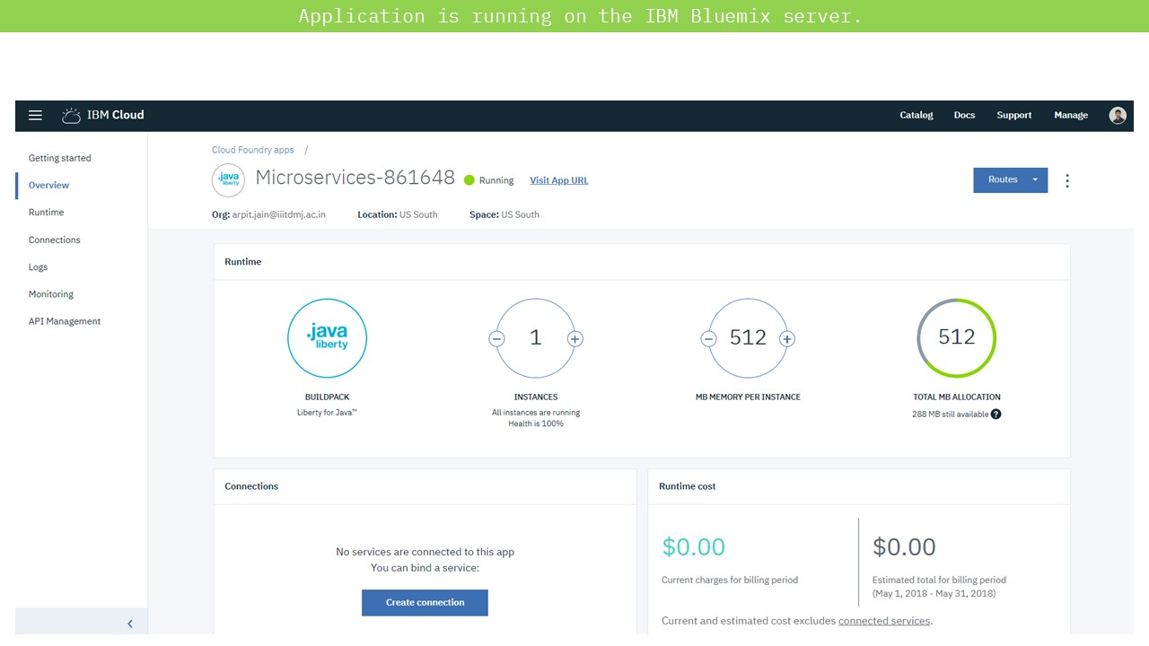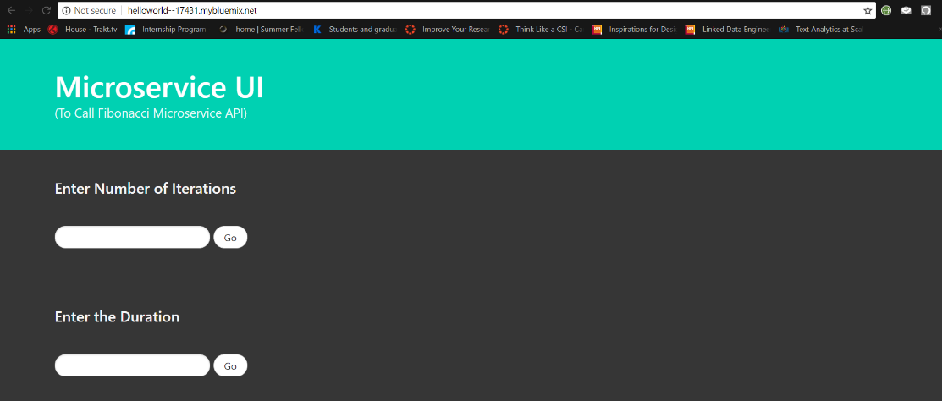

Task 4: Deploying a sample WAR file on the B2B SI server

B2B Sterling Integrator works based on the Business processes. These business processes are used to automate the operation of the services in the business environment. There is a basic set of base services which form the core of the SI product. These services are written in Java and are pre-packaged altogether in a WAR archive format. To execute and test these services, the B2Bi war file is to be deployed on the SI server. Before deploying the actual B2Bi war file, I deployed a sample WAR packaged JSP application to test out the dependencies.

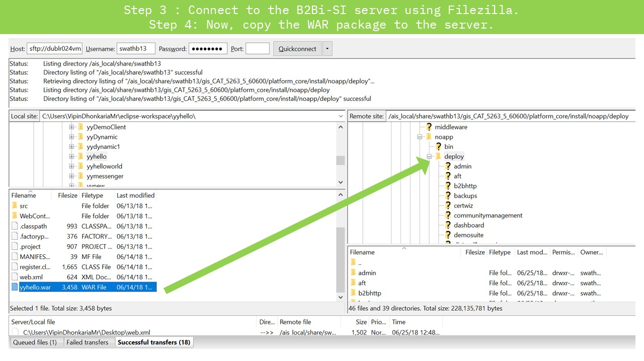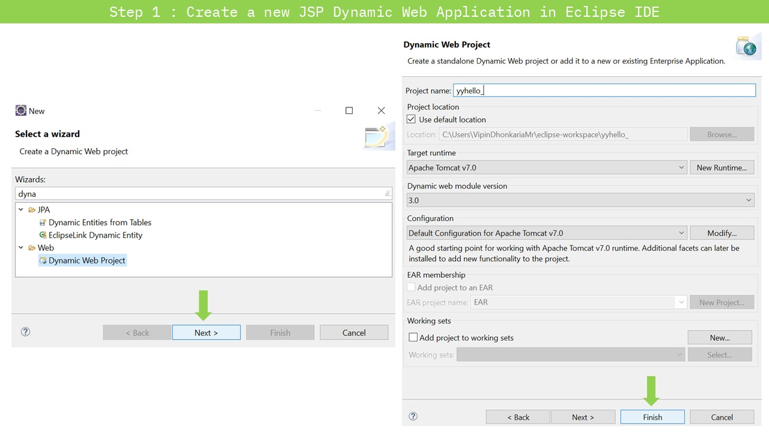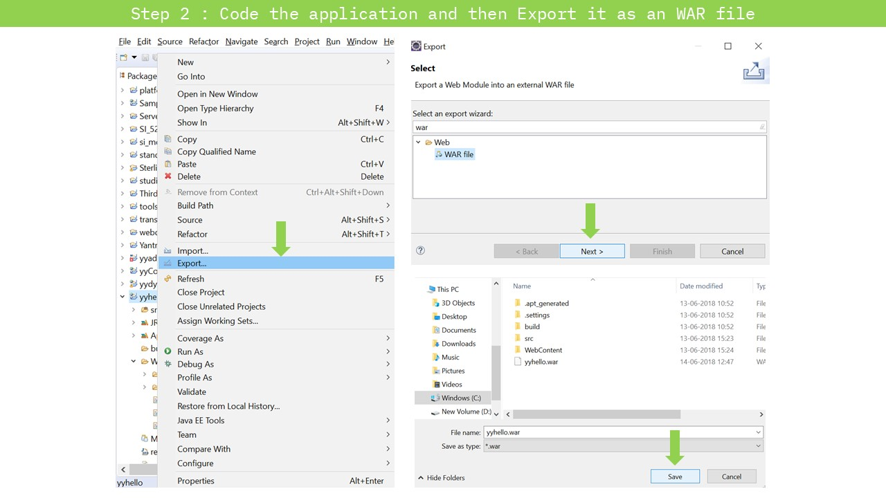

# C:\Users\ArpitJainMr\AppData\Local\Microsoft\Windows\INetCache\Content.Word\Slide6.jpgC:\Users\ArpitJainMr\AppData\Local\Microsoft\Windows\INetCache\Content.Word\Slide5.jpg[[Link]](https://github.com/arpitjainds/PBI-Documents/blob/master/Interim(29Jun-10July)/Presentations/Sample%20JSP%20WAR%20deployment.pdf)

# Results and Discussions

Microservices are an effective and fault-tolerant manner of designing and developing an application. B2Bi is a large monolithic application which needs to be divided into microservices.

The heart of B2Bi is composed of several business processes which are used to automate the operation of B2B services (Mailbox, Invoice, Order; etc). Separate microservices can be deployed on the B2B SI platform server to enhance the functionality.

# Conclusions

During past few weeks, I got acquainted to the Microservice architecture of software development, researched about the B2B processes and learned to code them. For implementing these ideas into practical uses, I had to understand about how the Sterling Integrator code functions. Using this knowledge, I deployed a sample WAR service to the server of SI.

**Next Target**

My target for the next 15 days is to understand the SI WAR deployment procedure on the SI local server. My primary aim would be to deploy a B2Bi Services packaged WAR file on the Sterling Integrator Server. After deployment, I would experiment and play around with all the APIs that B2Bi offers.