# Application of Microservice Architecture to B2B Processes

(IBM Watson Customer Engagement)

*by*

**Arpit Jain**

## (2015047)

**Supervisor(s):**

|  |  |
| --- | --- |
| **External** | **Internal** |
| Mr. Atul A. Gohad  (IBM ISL, Bangalore) | Dr. Aparajita Ojha  (PDPM IIITDM Jabalpur) |



**Computer Science and Engineering**

**INDIAN INSTITUTE OF INFORMATION TECHNOLOGY, DESIGN AND MANUFACTURING JABALPUR**

## (21st May 2018 – 21st August 2018)

## Midterm Review

# Acknowledgement

## It is exceptional working here at IBM ISL, starting my professional career among such great colleagues and friends. I have taken efforts in this project. However, it would not have been possible without them. I would like to extend my sincere thanks to all of them.

## It is an amazing learning as well as a valuable experience for me to work in the IBM Watson Customer Engagement department. I am grateful for all your support, help, encouragement, innovation, and dedication which will always be a lesson in my life. I take this opportunity to express my profound gratitude and deep regards to Mr. Atul A. Gohad who has guided me in all aspects. Also, I would extend my gratitude to Ms. Rashmi Acharya for her wonderful mentorship, continuous guidance and for providing necessary information regarding the project & also for support in completing the project. Further, I thank my project partner, Mr. Vipin Dhonkaria for his valuable support and team spirit.

## I would also take advantage of this opportunity to express gratitude and thankfulness to Dr. Aparajita Ojha (Internal Supervisor). I perceive this opportunity as a huge milestone in my career development and overall growth as an individual.

|  |  |
| --- | --- |
| Date: 21st August, 2018 | Screenshot (1)Warmest Regards, |
|  | (Arpit Jain) |

# Table of Contents

1. Introduction …………………………………………………………………………………………………………… (3)
   1. Brief Overview
   2. Literature Survey
   3. Internship Plan
2. Report on Present Investigation ………………………………………………………………………. (5)
   1. Researching about Microservice Architecture and B2B Processes
   2. Getting Access to the B2B Sterling Integrator Server
   3. Microservice Demo Application
   4. Deploying a sample WAR file on the B2B SI Server
   5. Writing Rest API Client Java Service
   6. Writing Rest API Business Processes to test (run) the service
   7. Installing the Service to IBM Sterling B2B Integrator
   8. Running (Testing) the service
3. Results and Discussions …………………………………………………………………………………….... (14)
4. Summary and Conclusions ……………………………………………………………………………….... (15)
5. Appendix ……………………………………………………………………………………………………………….... (16)
6. Literature Citations ………………………………………………………………………………………………. (18)
7. Publications …………………………………………………………………………………………………………... (18)

# 1. Introduction

Chapter 1

The International Business Machines Corporation (IBM) is an American multinational [technology company](https://en.wikipedia.org/wiki/Technology_company) headquartered in [Armonk, New York](https://en.wikipedia.org/wiki/Armonk,_New_York), [United States](https://en.wikipedia.org/wiki/United_States), with operations in over 170 countries. IBM manufactures and markets computer [hardware](https://en.wikipedia.org/wiki/Computer_hardware), [middleware](https://en.wikipedia.org/wiki/Middleware) and [software](https://en.wikipedia.org/wiki/Computer_software), and provides [hosting](https://en.wikipedia.org/wiki/Internet_hosting_service) and [consulting services](https://en.wikipedia.org/wiki/Consultant) in areas ranging from [mainframe computers](https://en.wikipedia.org/wiki/Mainframe_computer) to [nanotechnology](https://en.wikipedia.org/wiki/Nanotechnology).

Until this mid-term review, I was involved in gaining knowledge Microservice Architecture, REST API architecture and about the project structure & organization along with workflow of the IBM Product called Sterling B2B (Business to Business) Integrator. Using this knowledge during these three months, I developed a REST API Client service for the Sterling B2B Integrator.

I was also a part of IBM Lab - Call for Code Hackathon and Developed a Web application called “Dsense.AI”. The Web App simplified the process of Human Resource tracking during the mass scale disasters. Our project is selected for the Global Call for Code challenge. Apart from this, I am also a member of XLence program for IBM interns. As a member of this program, me along with other IBM interns, aim to develop an external project. This project deals with the smoothening of DevOps by providing a combined UI for Jenkins, Dockers and Kubernetes toolchain.

1.1 Brief Overview

During this period of 3 months, I have completed several tasks pertaining to the B2Bi Sterling Integrator. Proceeding in stages,

Firstly, I researched about the Microservice Architecture, REST APIs and Business-to-Business processes.

Secondly, I understood the basics of Business Process Modelling language(BPML). BPML is an XML standard to write business process. I gave a presentation regarding the application of microservice architecture to my team. To experiment further with the microservice software development architecture, I developed two Microservices – One on node.js (Backend Service) and other using Java JSP (Frontend Service). Then, I established a REST API connection channel between both services.

Thirdly, I got myself acquainted with the Sterling Integrator product and deployed a Sample WAR (Web Application Archive) file on this platform. Further, I deployed the B2B-API WAR file on this platform.

Finally, I developed and Installed a REST-API Client service and Business workflow for Sterling Integrator. This will allow the clients to place CRUD calls onto the APIs deployed in the previous step. This is a major step as a lot of Sterling Integrator clients required a service like this.

* 1. Literature Survey

IBM Sterling B2B Integrator

IBM B2B Integrator helps companies integrate complex B2B (Business to Business) / EDI (Electronic Data Exchange) processes with their partner communities. It provides a single, flexible B2B platform that supports most communication protocols, helps secure your B2B network and data and achieve high availability operations. The offering enables companies to reduce costs by consolidating on a single B2B platform and helps automate B2B processes across enterprises while providing governance and visibility over those processes.

It is a B2B integration software to help synchronize the business partner communities. Today’s empowered customers expect more from the companies they do business with.

IBM Sterling B2B Integrator software helps companies execute a smarter commerce strategy by synchronizing virtually every part of the value chain. It addresses complex integration challenges, enabling you to connect your systems to those of your business partners.

* IBM Sterling B2B Integrator is a transaction engine and set of components designed to run processes you define and manage according to your business needs.
* It supports high-volume electronic message exchange, complex routing, translation, and flexible interaction with multiple internal systems and external business partners.
* Has robust security infrastructure, visual management tools for easy configuration of and visibility into work flows, system and trading partner activities.

Integrates applications, processes, data and people, both within and outside an organization.

For the proper understanding and gaining prerequisite knowledge, we referred to several IBM DeveloperWorks articles and Sterling Integrator Documentation. Links for the References are cited in the Literature Citations Chapter.

* 1. Internship Plan

Briefly, stating holistically, the complete internship consists of three major tasks-

* Firstly, getting acquainted with the Sterling Integrator, Business Processes and microservice architecture. I gave a presentation to my team on Microservice Architecture. Also, I researched a way of deploying B2Bi WAR file on the SI server.
* Secondly, I was assigned to a project in which I had to Develop a Rest-API client service for the Sterling Integrator.
* Thirdly, I am currently working on Importing previously created REST APIs onto the Spring-boot framework.

If time permits, further tasks will be assigned to me.

**2. Report on the Present Investigation**

(Progress until the Midterm review)

Chapter 2

2.1 Researching about Microservice Architecture and B2B Processes

A close up of a rock

Description generated with high confidenceDuring this duration, I researched and studied about these topics and gave a presentation meeting to the entire B2B Team regarding my study and findings. Following is the link to the presentation I delivered.

A pile of rocks

Description generated with high confidence[[Link]](https://www.linkedin.com/pulse/application-development-architecture-from-cloud-perspective-jain/?published=t&lipi=urn%253Ali%253Apage%253Ad_flagship3_profile_view_base%253BTohjbjTmQTmbPKywxKxEBA%253D%253D)

2.2 Getting access to the B2B sterling Integrator server

A screenshot of a social media post

Description generated with very high confidenceA screenshot of a social media post

Description generated with very high confidenceTo work on the B2B Sterling Integrator product, access to the servers of IBM on which the product is currently deployed and is running live was to be acquired. The access to the servers and the B2B project team was requested and was granted within a week.

2.3 Microservice Demo application

**A screenshot of a cell phone

Description generated with very high confidence**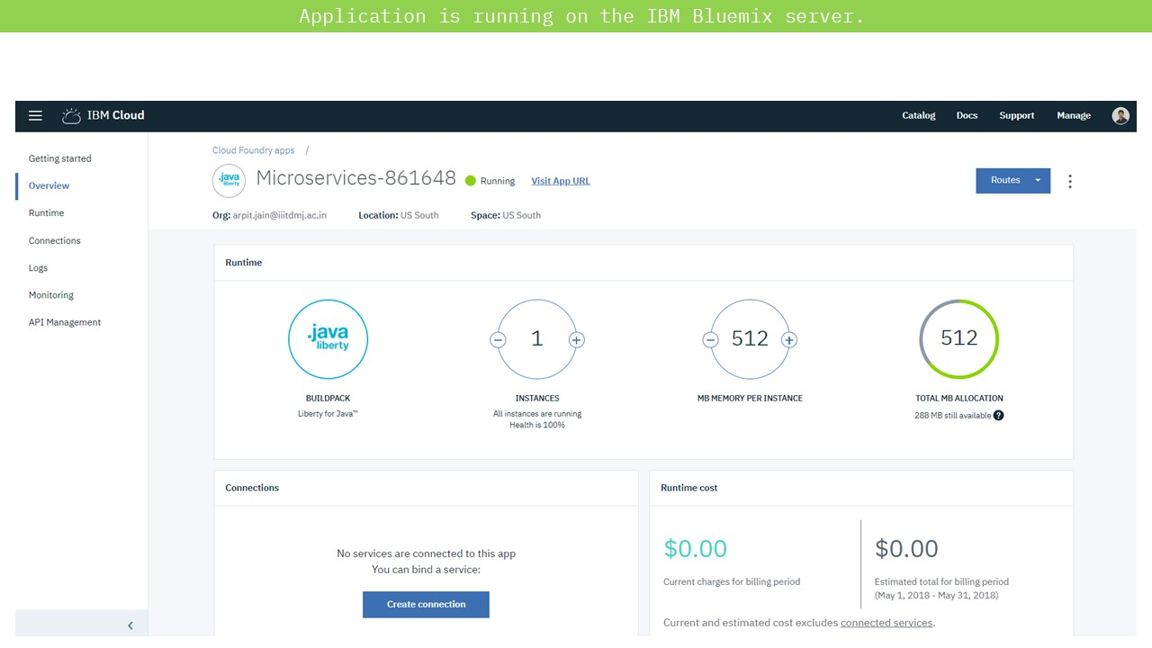To demonstrate the usage of Microservices architecture for better application design, I implemented a two-microservice application. One microservice acted as a Backend API Fibonacci microservice which was called by another microservice which acted as an UI.

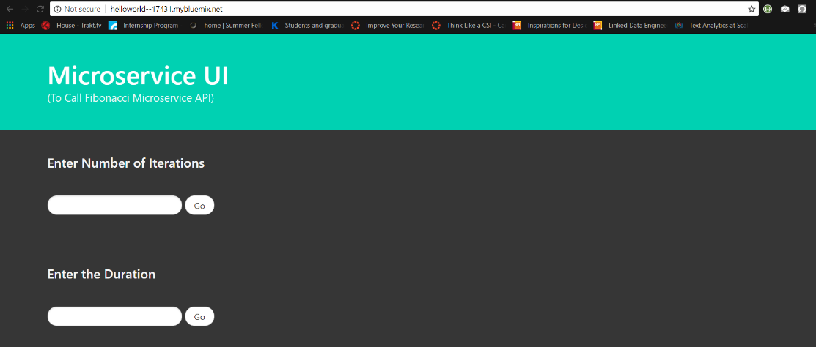

[[Link]](https://github.com/arpitjainds/UI-Java-Microservice)

2.4 Deploying a sample WAR file on the B2B SI server

B2B Sterling Integrator works based on Business processes. These business processes are used to automate the operation of the services in the business environment. There is a basic set of base services which form the core of the SI product. These services are written in Java and are pre-packaged altogether in a WAR archive format. To execute and test these services, the B2Bi WAR file is to be deployed on the SI server. Before deploying the actual B2Bi WAR file, I deployed a sample WAR packaged JSP application to test out the dependencies.

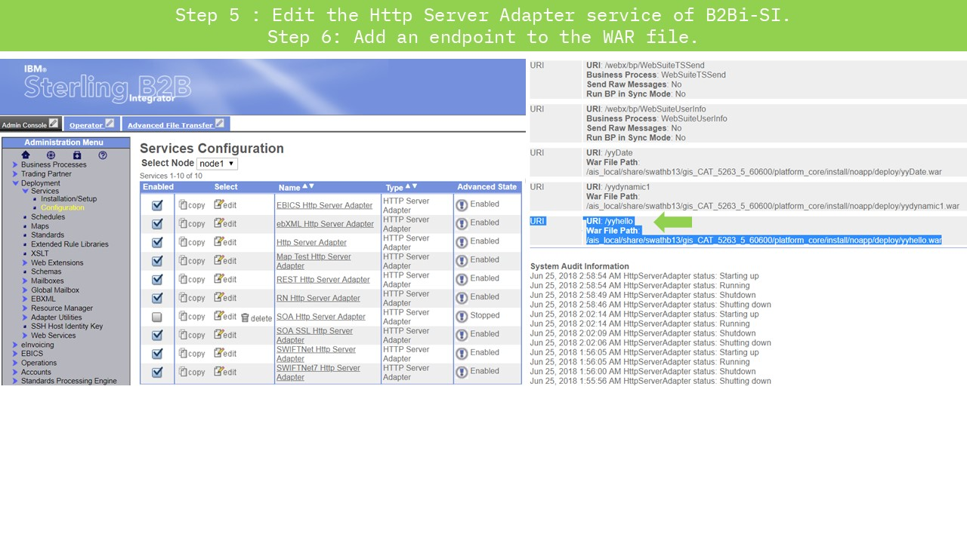

# C:\Users\ArpitJainMr\AppData\Local\Microsoft\Windows\INetCache\Content.Word\Slide6.jpg[[Link]](https://drive.google.com/file/d/1fynizuQ6T8vLwBV3d4PrIBkgul7e7UtH/view?usp=sharing)

2.5 Deploying B2B-API WAR file on the B2B SI server

B2Bi REST implementation

It was introduced in B2Bi 526 and it allows user to programmatically Create, Read, Update and Delete resources in B2Bi. JSON and XML supported as input and output formats. It provides support for Partner Engagement Manager PEM. It is a more efficient mechanism for on boarding trading partners compared to Xapi (Prior to SFG 526 and REST API).

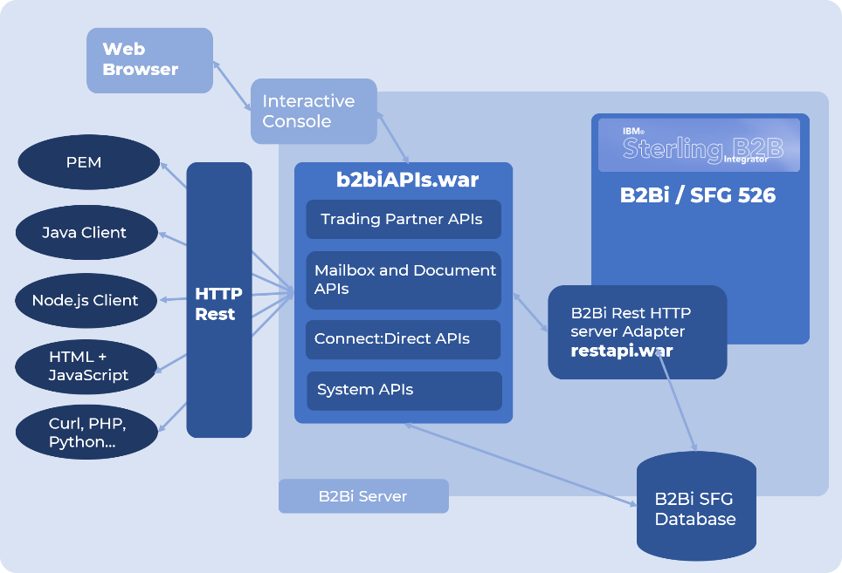

B2Bi REST API Resources

|  |  |  |
| --- | --- | --- |
| |  |  | | --- | --- | | |  | | --- | |  | | |

A screenshot of a cell phone

Description generated with very high confidence

B2B Sterling Integrator 5.2.6.1 introduced a new REST API interface to provide support for the recently released Partner Engagement Manager (formerly Multi-Enterprise Relationship Management (MRM)). The REST API provides a more efficient mechanism for onboarding trading partners. On the successful installation of B2B Sterling Integrator, B2Bi services WAR file is generated in the installation directory. For the deployment of this WAR file, a HTTP Server Adapter service is to be created for Binding the APIs to an URI (endpoint).

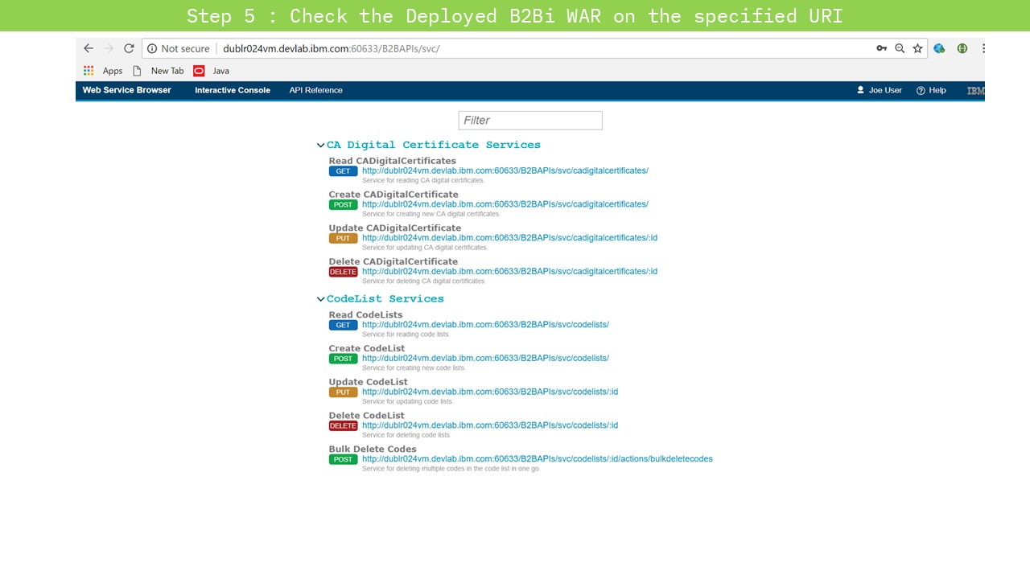Finally, after the deployment of the B2Bi WAR file (nearly takes 2-3 Hours), the APIs can be accessed at the previously specified URI. The web interface thus opened, shows the list of all the APIs along with their Call methods.

The core of B2Bi is composed of multiple business processes which are used to automate the operation of B2B services (Mailbox, Invoice, Order; etc). Separate microservices can be deployed on the B2B SI platform server to enhance its functionality. By the deployment of B2Bi APIs on the sterling integrator platform, REST API calls can be placed to interact with the product. B2Bi APIs are composed of a set of multiple APIs like mailbox, certificates, codelists, useraccounts; etc. Services in the sterling Integrator are utilised using these APIs only.

2.6 Writing Rest API Client Java service

A service in Sterling Integrator is at least one Java class that implements an interface from Sterling Integrator. In addition to that you have a deployment descriptor that tells the installer during runtime which service you are trying to install. It also tells the system the name of the class that is the entry point into your custom service.

A screenshot of a cell phone

Description generated with very high confidence

All the service Java files are packaged as following to provide the class definition. This packaged JAR file contains following three files (In the proper package hierarchy)–

com

sterlingcommerce

woodstock

services

genericrest

genericrest.java

RestRequestHandler.java

RestAPIClientGET.java

RestAPIClientPOST.java

RestAPIClientPUT.java

RestAPIClientDELETE.java

genericrestserver.java

genericrestserverImpl.java

.

genericrest.java – The service which actually acts as a gateway to handle the upcoming requests depending upon the input parameters from the process data.

RestRequestHandler.java – The java file which distributes the current request depending upon the request type.

RestAPIClientGET.java – The java file which executes the GET request.

RestAPIClientPOST.java - The java file which executes the POST request.

RestAPIClientPUT.java - The java file which executes the PUT request.

RestAPIClientDELETE.java - The java file which executes the DELETE request.

genericrestserver.java – The java file that is responsible for restarting, shutdown; etc of the genericrest service.

genericrestserverImpl.java – The java file that implements the genericrestserver class.

2.7 Writing Rest API Business Processes to test (run) the service

Following is a test workflow for testing the service. When it is executed, it sets the requesttype and url from the user interface into the process data, and then genericrest service is executed. Following is the Code for a sample Request from Business process. It represents the code for a single instance of the generic rest Java service. Within sequence section, Multiple operations can be written for invocation of multiple Service instances from the same Business process -

<process name="genericrest">

<sequence>

<operation name="Request">

<participant name='genericrest'/>

<output message='xout'>

<assign to='url'>URL 1, URL 2, URL 3, …</assign>

<assign to='restoperation'>Request type 1, Request type 2, Request type 3, …</assign>

<assign to='.' from='*' />

</output>

<input message="xin">

<assign to='.' from='*' />

</input>

</operation>

</sequence>

</process>

* 1. Installing the Service to Sterling B2B Integrator

Installation is carried out by Pre-packaging the application (jar). Then, on the machine where the SI is running, use the InstallService.sh or Install Service.cmd file to install the packaged JAR file. A service called genericrest Service will be shown created in the SBI dashboard. This service can be seen by going to the Deployment>>Services>>Configuration from the left panel menu.

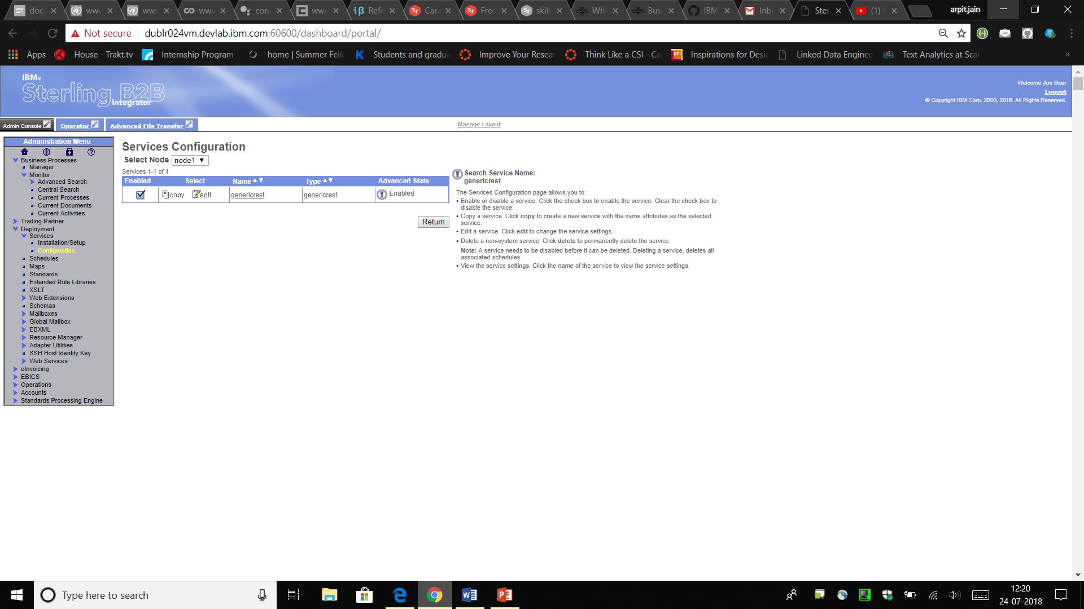

A workflow (business process) called genericrest will also be created. You can test the service by executing this business process. The response from the Service will be specified in the Process Data itself.

# 

# Running / testing the service

A screenshot of a cell phone

Description generated with very high confidenceA screenshot of a social media post

Description generated with very high confidenceOnce the Service is successfully installed, it can be tested by running the Business Process. Following is the sample Business process which executes two consecutive GET calls.

# External Project (IBM Call for Code)

As a part of IBM Call for Code Hackathon, we (team of 5 interns) developed a Web-application called Dsense.AI Refer to the following Slides for further Information about the project. For further description and preview, refer Appendix 5.1

A screenshot of a cell phone

Description generated with high confidenceA screenshot of a cell phone

Description generated with very high confidenceA screenshot of a cell phone

Description generated with high confidenceA screenshot of a cell phone

Description generated with high confidenceA screenshot of a computer

Description generated with very high confidence

# 3. Results and Discussions

Chapter 3

1. Speaking on high-level, I got to know and learn about important Software-Industry level concepts. Some of these are – Microservice Architecture, Cloud deployment/development, Software as a Service (SAAS).
2. The Tasks given to me were mostly stepwise in order. Hence, I needed to report at regular intervals with the current status of my job, and future work to my Mentor.
3. I got acquainted with the Business-Driven Methodology while working on Sterling Integrator Product. Also, I learned about Business Process Modelling using XML and XPATH standard.
4. Most of the initial days were mainly focused on familiarising myself with the company’s work methodology, performing initial Laptop Setup and getting Server permissions.
5. My knowledge of Java and OOP concepts in development improved drastically by working on the project in Eclipse IDE both locally and on remote Server.
6. My project dealt mainly with REST APIs hence my knowledge in that domain also improved.
7. Apart from my Main project, working on the side Hackathon project allowed me to manage time more judiciously.

**Errors and Difficulties**

1. Failure of POST and PUT operations just before the Demo.

On the day when the Demo meeting of our Service implementation was scheduled, nearly an Hour before the demo of the service to the team, POST and PUT service logics failed. We skipped the demonstration of the POST and PUT. Later we found out that it was merely a fault of a wrong statement order. Even before the connection was established (before opening the connection), we were requesting for the Response code and message. The program caught the exception and threw the error. Such merely small error caused such large trouble. That day I realized the importance of Pre-Demo testing.

1. Information passing from One service instance to Another.

In the last week of our first project completion, we had to implement the transfer of information (mainly input parameters) from one service to another within the same Business Process. The syntax of XPATH requires the Relative input paths (directory format) to be specified inside the Double quotes. The problem here is that the input received into these input fields themselves have embedded Double quotes which renders the Whole input line invalid. As only possible solution, we had to substitute the double quotes by Escape Characters of XML (Like instead of “ using &quot).

# 4. Summary and Conclusions

Chapter 4

During this period of 3 Full Months, I came across various technologies that are being used in the industry and especially in IBM Watson Customer Engagement department. I got to learn and work on a lot of new things which will be very helpful for me to grow as a software developer. I came to know about the work culture of a company and how things go around in the professional business and technical world. I laid my hands on a lot of new technologies and learnt and implemented them successfully. During this period, I also learnt to work independently and as a team. I got to know the importance of collaboration and teamwork.

I have learnt quite a few new technologies and tools like Microservices, Service Oriented Architecture, Maven, Java Spring, DevOps, IBM Cloud cognitive service offerings; etc. I got a hands-on experience of JAVA and spring. I got acquainted to the Microservice architecture of software development, researched about the B2B processes and learned to code them. For implementing these ideas into practical uses, I understood the Code and working of IBM Sterling B2B Integrator.

Above all, I learnt from my mentor how to plan. I learnt small things like how to code efficiently and cleanly. I learnt how to think through things, how your requirements should be clear and then work on them maintaining the positivity of the Team even in the Hard-times.

**Next Target**

My next target is to import existing B2B-APIs like User Accounts and Trading Partners onto Spring Boot framework and deploy it as an individual WAR pre-packaged file.

**5. Appendix**

5.1 Dsense.AI

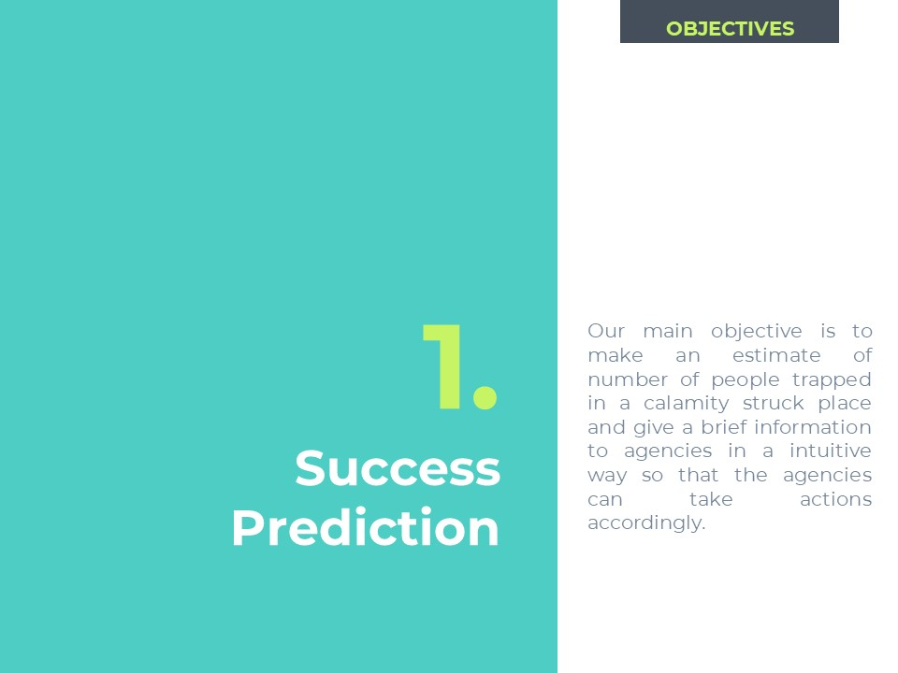



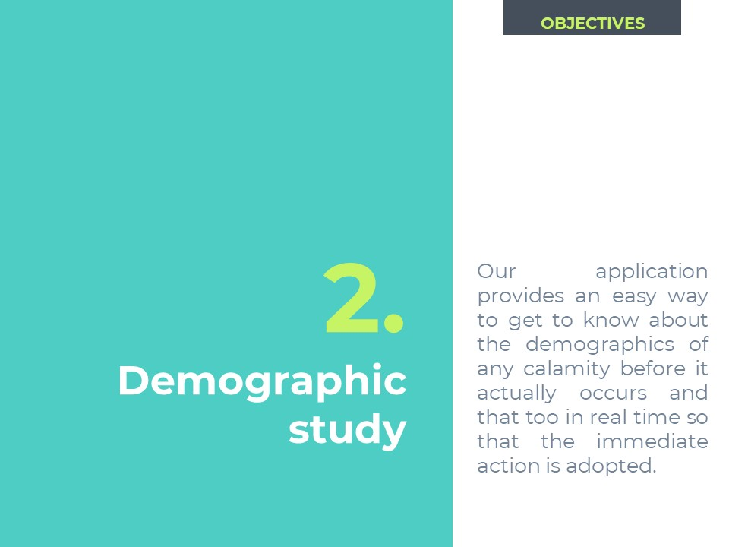



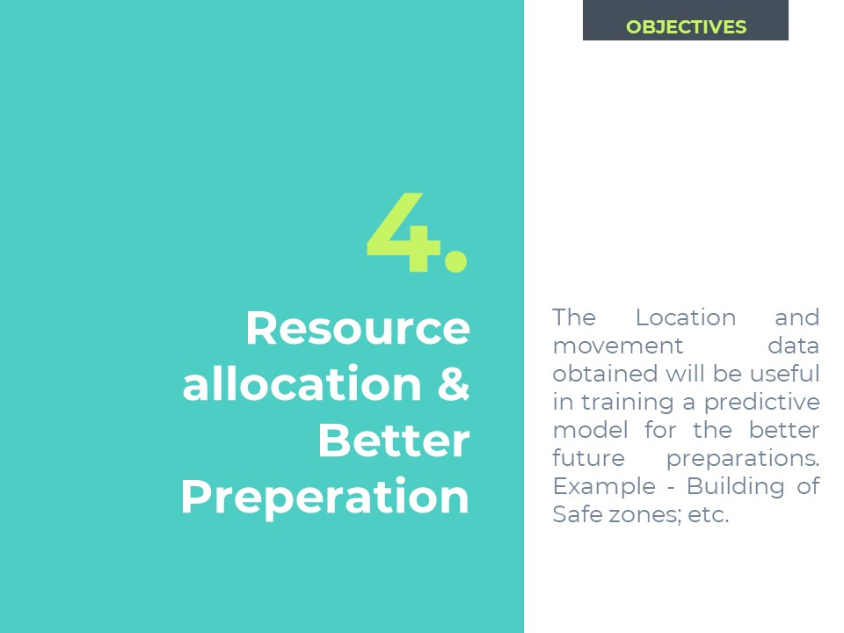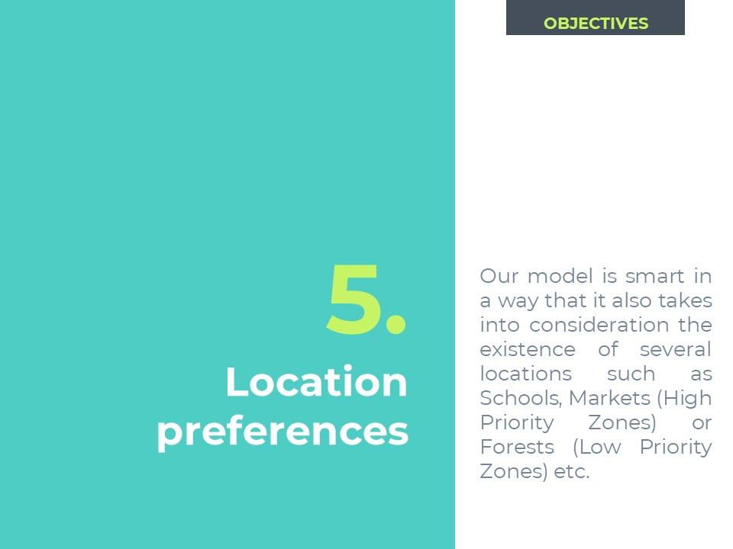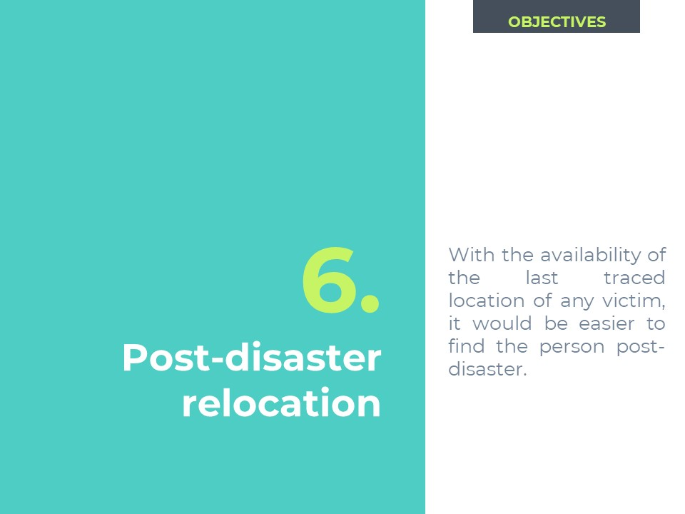

**6. Literature Citations**

6.1 Documentation of Sterling B2B Integrator.

Documentation of the product can be found [here.](https://www.ibm.com/support/knowledgecenter/en/SS3JSW_5.2.0/welcome/product_landing.html)

6.2 Developing Business Processes – Best Practices.

Source can be found [here.](https://www-01.ibm.com/support/docview.wss?uid=swg27043594&aid=1)

6.3 Business Process Modelling Book.

Source can be found [here.](ftp://public.dhe.ibm.com/software/commerce/doc/sb2bi/v5r2/SI52_BP_Modeling_book.pdf)

6.4 Writing Custom services in IBM Sterling B2B Integrator.

Source can be found [here.](https://www.ibm.com/developerworks/community/blogs/SterlingB2B/entry/Writing_Custom_Services_in_IBM_Sterling_B2B_Integrator?lang=en)

6.5 Creating custom services and adapters.

Source can be found [here.](https://www.ibm.com/support/knowledgecenter/en/SS3JSW_5.2.0/com.ibm.help.manage_svcs_adpts.doc/CS_AboutAddingNewSvcToSI.html)

6.5 XPath and Process Data.

Source can be found [here.](https://www.ibm.com/support/knowledgecenter/en/SS3JSW_5.2.0/com.ibm.help.bpml.doc/SI_XPathAndProcessData.html)

6.5 Update, Compile and Redeploy WAR files in ISBI.

Source can be found [here.](https://www.ibm.com/support/knowledgecenter/en/SS3JSW_5.2.0/com.ibm.help.web_extns.doc/WebExtns_UpdtCmplRdplyWAR.html)

**7. Publications**

7.1 “REST client adapter- B2B Integrator”.

We wrote an IBM DeveloperWorks Article. Our Article encompasses the research work that we went through. Using our proposed service, Clients would be able place CRUD calls to B2B APIs using Business Processes.

The Article can be found [here.](https://www.ibm.com/developerworks/community/forums/html/topic?id=13052465-b633-4480-8515-31b02333a3a3&amp;ps=25)