SMS Servers:

<https://www.textlocal.in/bulk-sms-pricing-india>

<https://www.bulksms.com/pricing/>

Domain: GoDaddy-> Rs. 99 for 1st yr, and Rs. 959 later years

Hosting Servers:

Windows:

<https://in.godaddy.com/hosting/windows-dedicated-server>

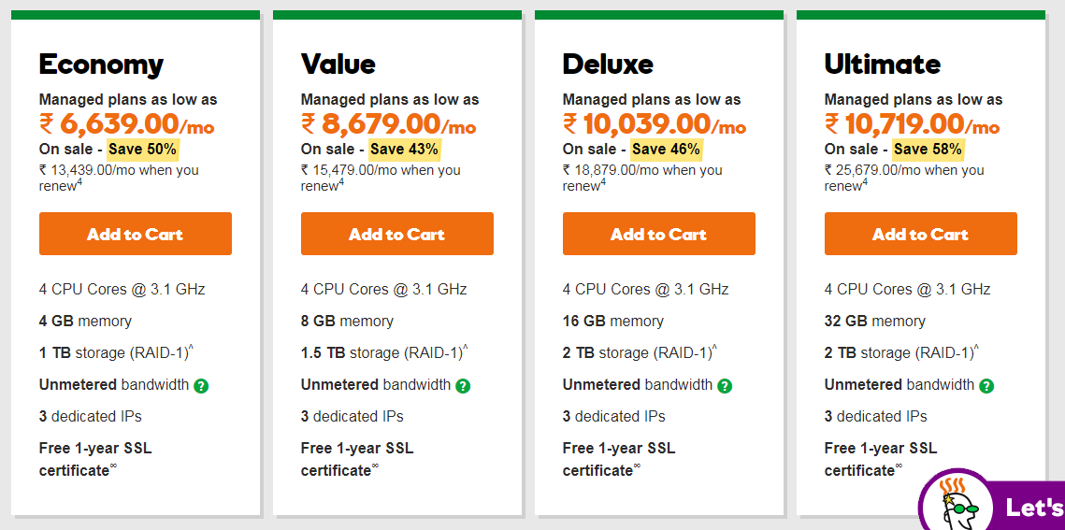

Linux:

<https://in.godaddy.com/hosting/dedicated-server>

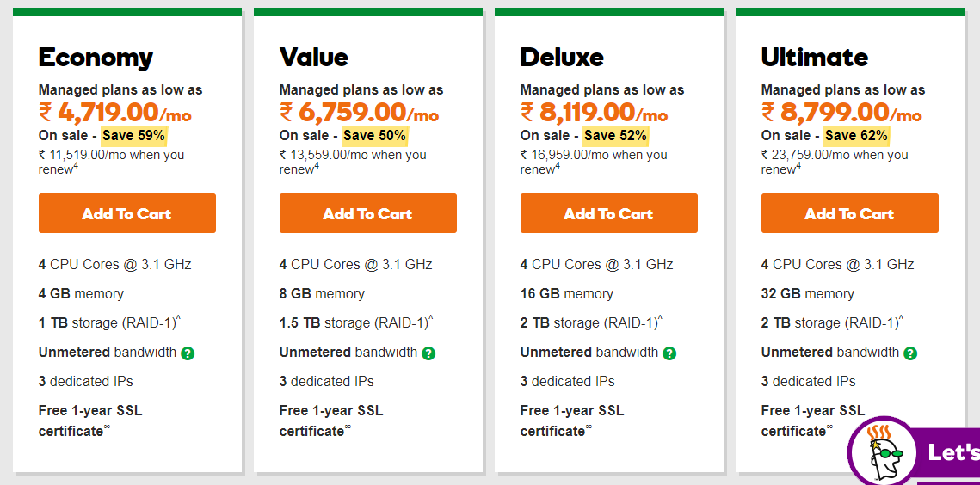

Load Balancing ?