vaccination portal
IDBMS Project

Submitted by group-05
Arpit bhuva(20ucs027)
Avish vijay (20ucs044)
Chiroshree Tiwari (20ucs058)
Aditya khadekar (20ucs009)

Introduction:
It demonstrates Basic working of a vaccination portal that has multiple vaccines for children across the country. It has 2 types of system users - admin and parents.
Software Requirements:
1. This project is a web page which uses html and php in frontend.
2. MySQL server (version 8.0.20) in backend.
3. It is developed on XAMPP 8.0.12.
4. Connection to MySQL using php.

Basic Functionalities include
1. Admin can login to the System.
2. He / She can view the total entries by parents for vaccination.
3. He / She can view details of all the vaccines available.
4. He / She will allot the vaccines as per availability and requirement.
5. Parents can view only the entry they added.
6. When using first time parent has to register and enter child details.
7. For every new entry done by parent, customers have to enter child details and vaccine required.

Relations and Attributes:
We have created a database having 5 interconnected tables described as follows:

1. admin(username VARCHAR(15) NOT NULL ,lastname VARCHAR(15),
gender VARCHAR(8) NOT NULL, city VARCHAR(30), birth DATE, type VARCHAR(10), email VARCHAR(30) UNIQUE, pass VARCHAR(25));
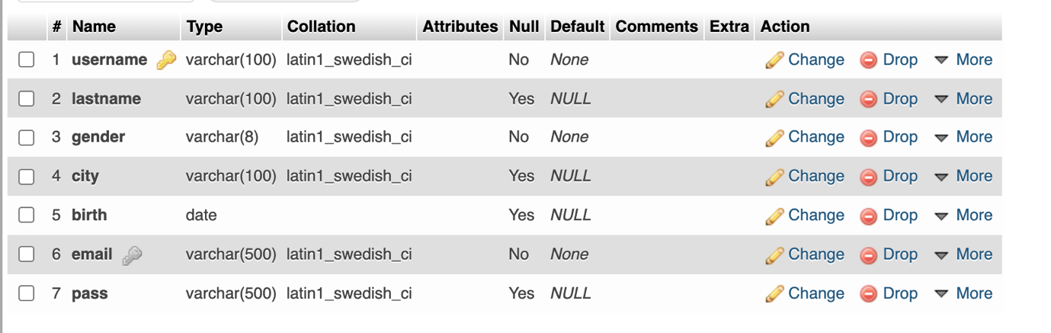
2. child(c_name VARCHAR(15) NOT NULL, c_gender VARCHAR(8), c_city VARCHAR(30), c_birth DATE, c_age INT(3), c_weight INT(5), c_height INT(5), c_vaccine VARCHAR(100), p_username VARCHAR(15), FOREIGN KEY(p_username) REFERENCES);
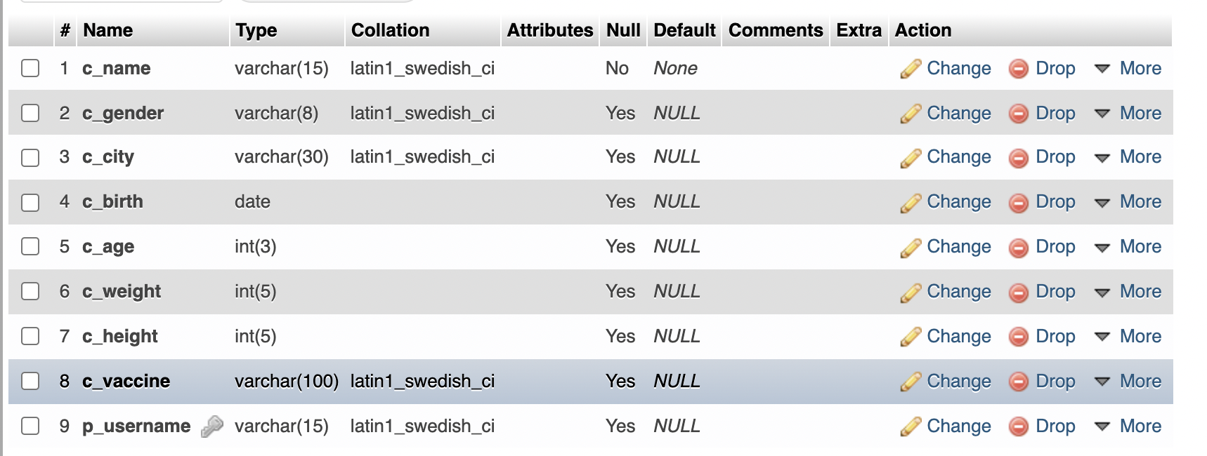
3. parent(p_username VARCHAR(15) NOT NULL primary key, p_lastname VARCHAR(15), p_gender VARCHAR(8) NOT NULL, p_city VARCHAR(30), p_birth DATE, type VARCHAR(10), p_email VARCHAR(30) UNIQUE, p_pass VARCHAR(25));
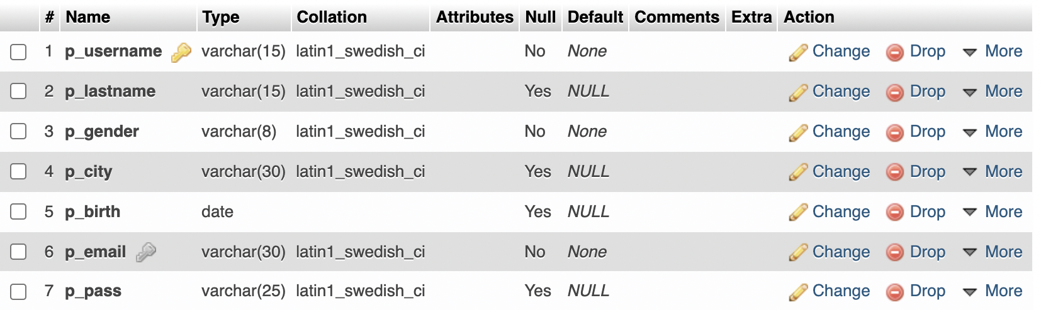
4. vaccine(name VARCHAR(50) NOT NULL primary key,timing VARCHAR(20) NOT NULL);
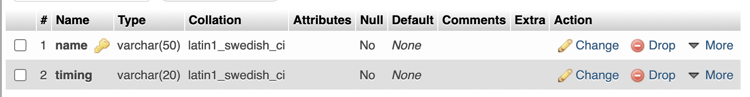
5. vaccine_dates(name VARCHAR(50) NOT NULL, v_date DATE, timing VARCHAR(20) NOT NULL, c_name VARCHAR(15), p_username VARCHAR(15), status VARCHAR(6), FOREIGN KEY(p_username) REFERENCES parent(p_username), FOREIGN KEY(c_name) REFERENCES child(c_name), FOREIGN KEY(name) REFERENCES vaccine(name));
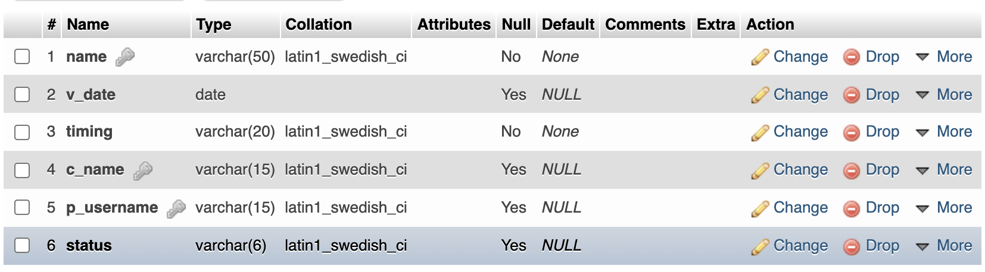

ER diagram:
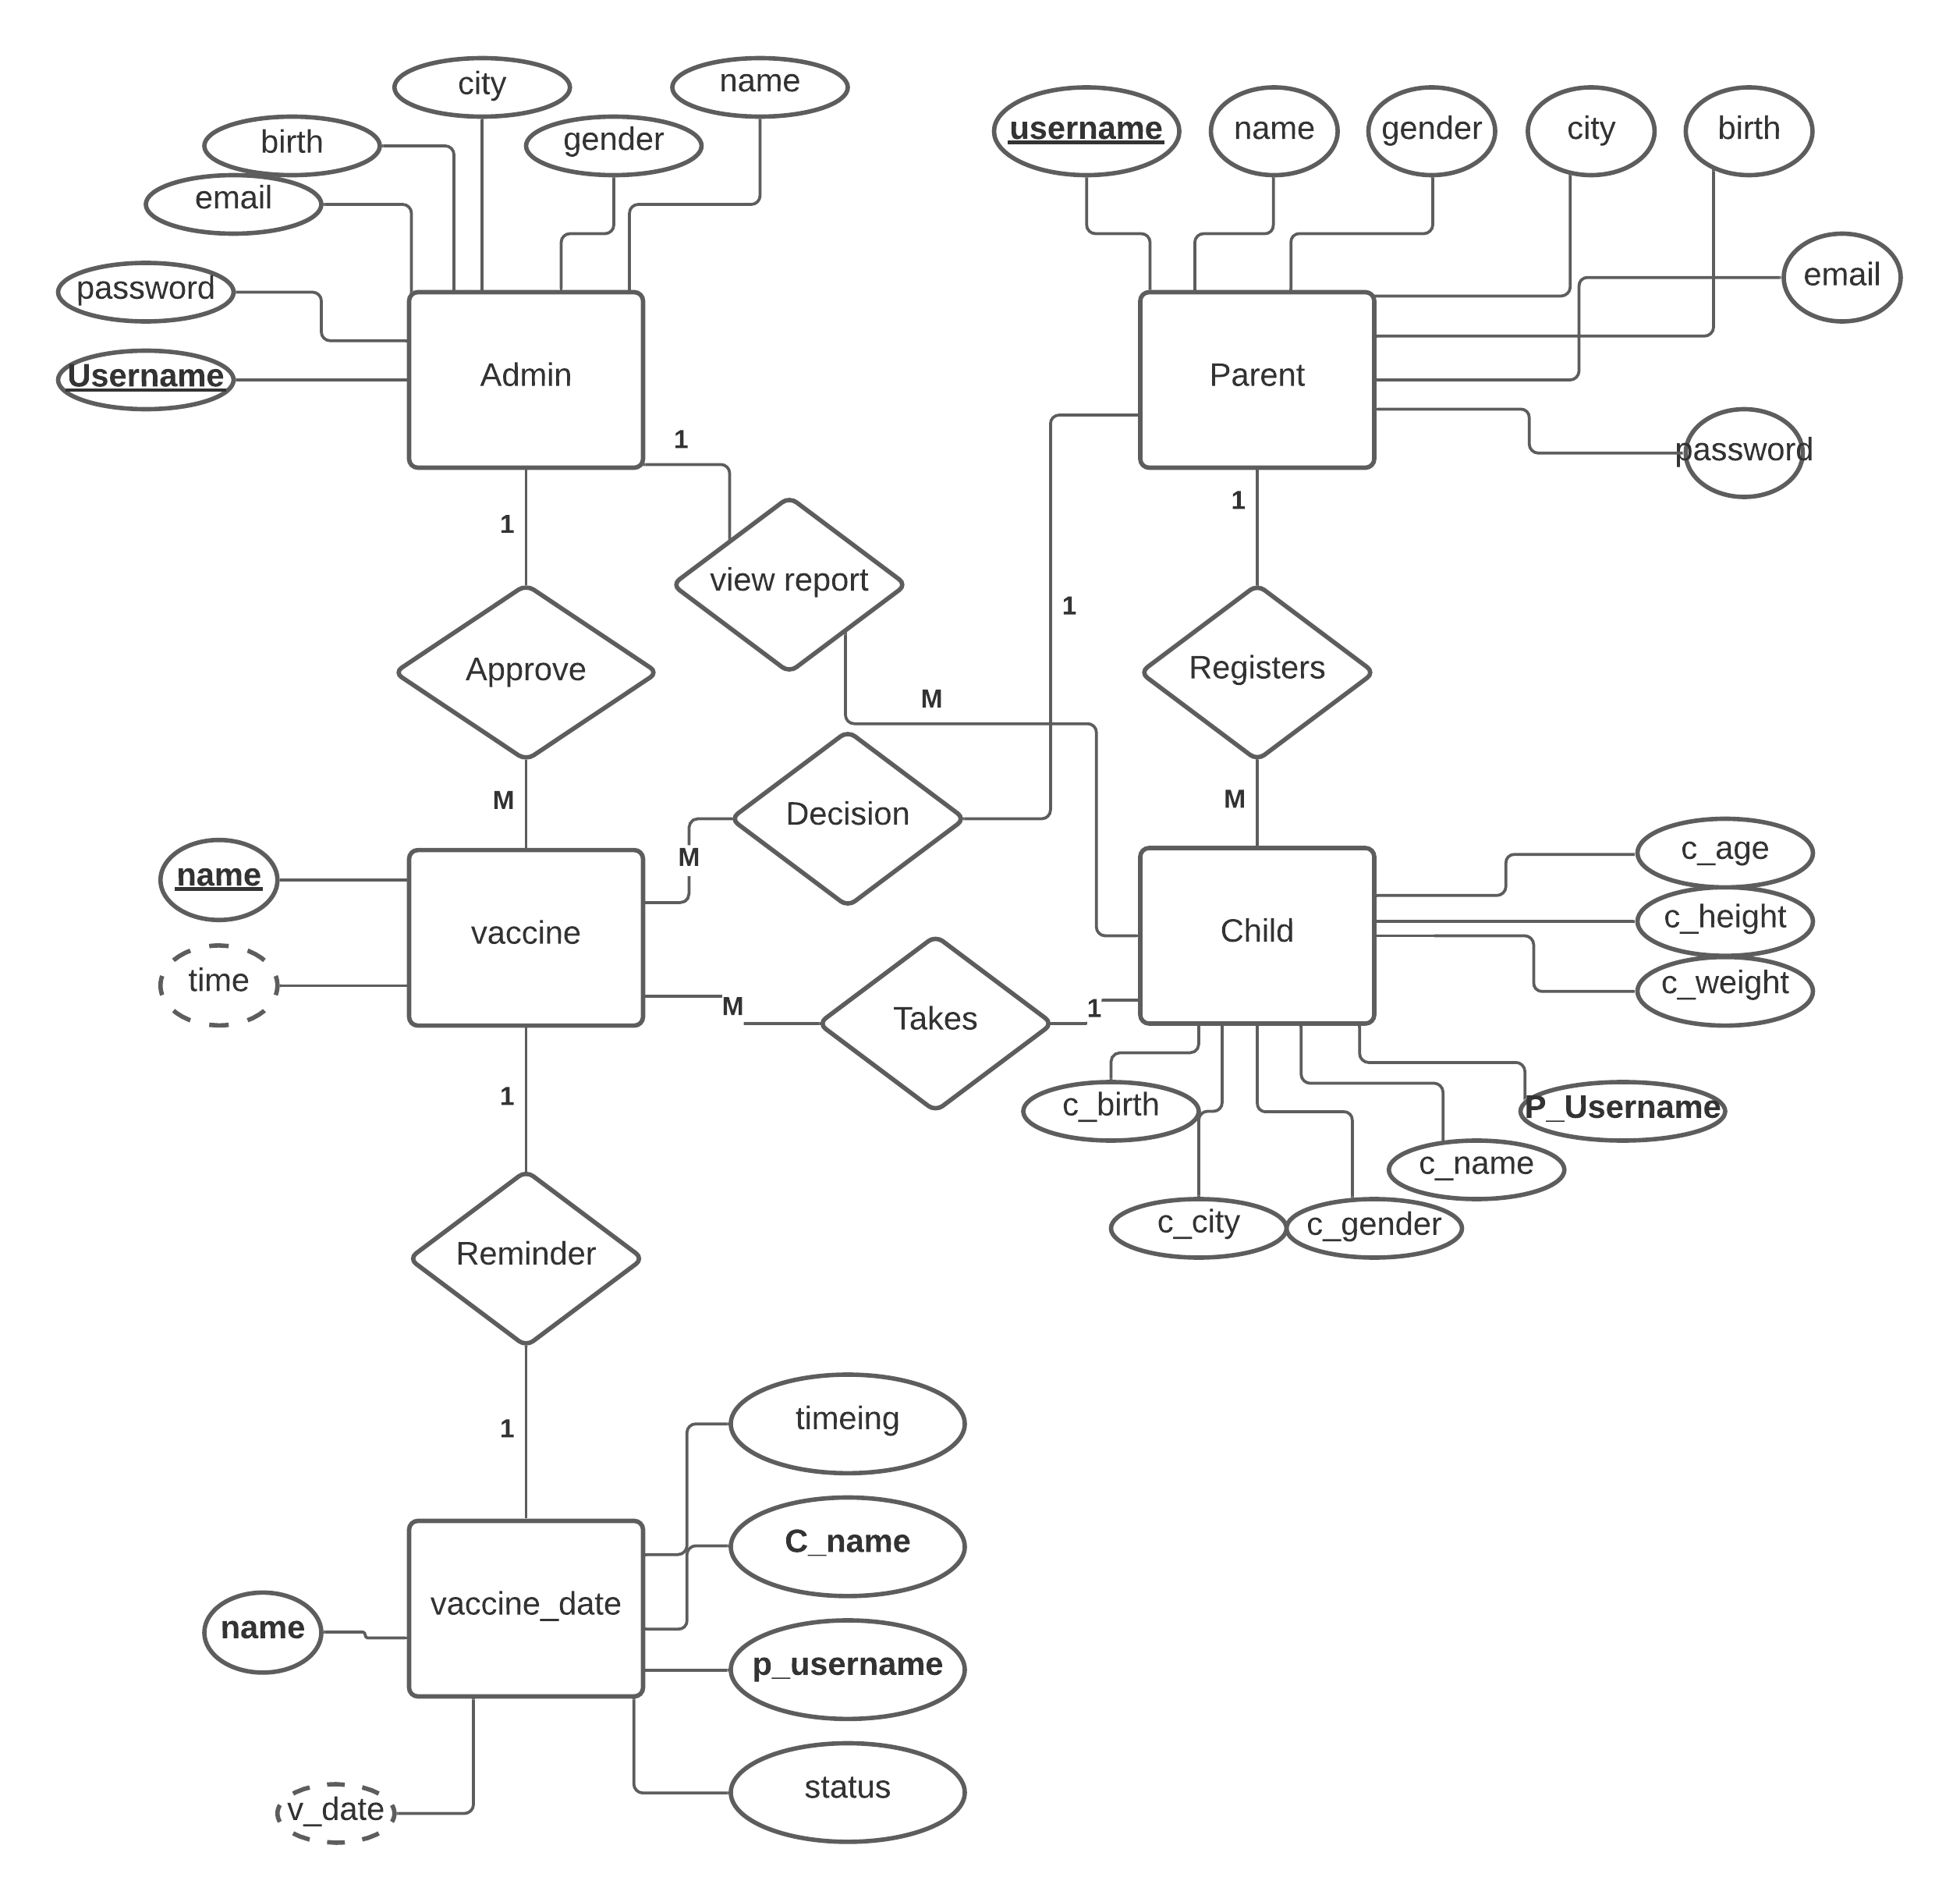
Working:
1. We will first create a database ‘E VACCINATION’.
2. Then add the 5 tables as specified: ‘admin’, ‘child’, ‘parent’, ‘vaccine’ and ‘vaccinedate.
3. Then we enter some sample data in the tables.
4. Now, as we run our project we select ‘Login.java’ as our Main Class.
5. The execution of the project is described in the file ‘VaccinationPortal’.
6. If we are an admin then we enter the credentials and click on ‘Login’.
a. If the credentials are correct we are redirected to the ‘adminindex.php’ page otherwise an error message will appear.
7. On ‘adminindex.php’ page admin has 5 options:
a. to view the child detail.
b. option to add new vaccine.
c. to allocate vaccine.
d. to view report.
e. to log out.
8. As admin click on add vaccine he/she gets option to add new vaccine such as DPT 1st booster , Hepatitis B Birth dose, Pentavelant, Hepatitis B Birth dose, Rota Virus Vaccine DPT2 2nd Booster.
9. If we want to view details of a child he/she will click on child detail and information parent registered will appear.
10. Admin can either allocate vaccine to child or exit using the log out button.
11. If we are a parent we can directly select from login and will redirect to ‘parentindex.php’.
12. On ‘parentindex.php’ page the parent as 4 options such as Add New Child, View Child Details, My Vaccine Reminder and log out.
13. On clicking Add New Child parent can add the details of their child such as name, age, gender , vaccine required, etc.
14. On clicking ‘View Child Details’ parent has option the edit the information added by them.
15. In option ‘My Vaccine Reminder’ parent can view the start vaccine date and vaccine reminder date.
16. According to details added by the parent, the admin will allot the vaccine.
17. After vaccine allocation system will generate reminder according to child’s date of birth.
18. On clicking option ‘View Report’, report containing parent details, child details and vaccine details will appear.
19. Admin can delete the child details.

