1-a

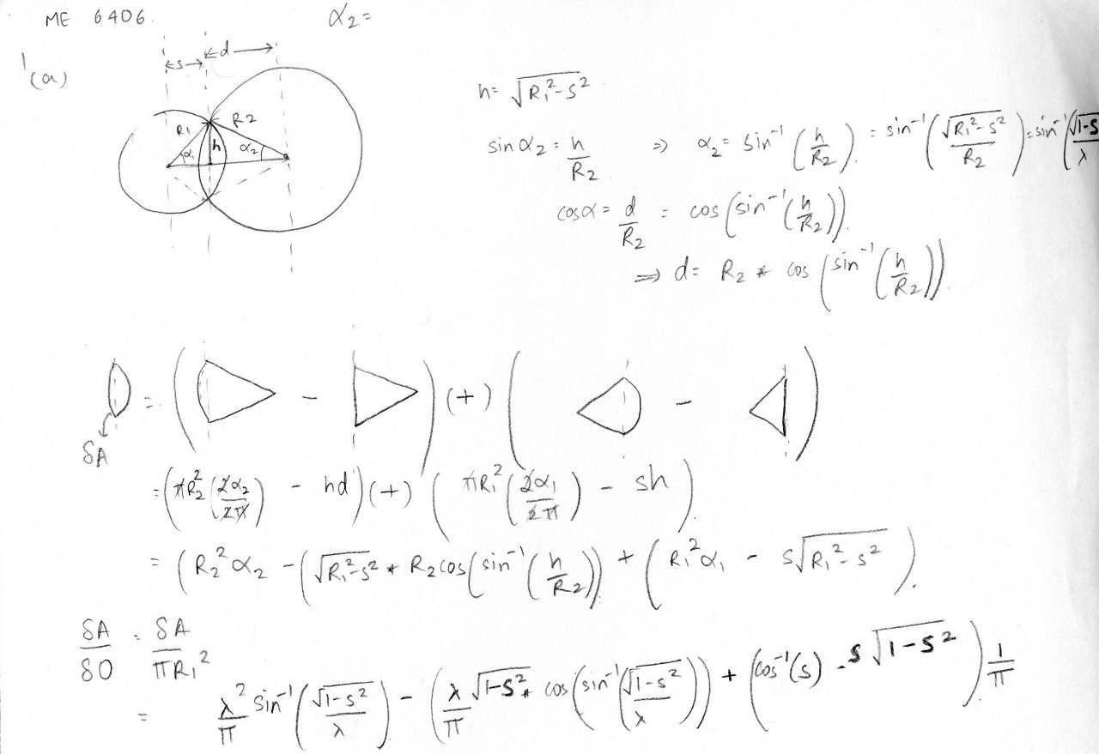

1 (b)

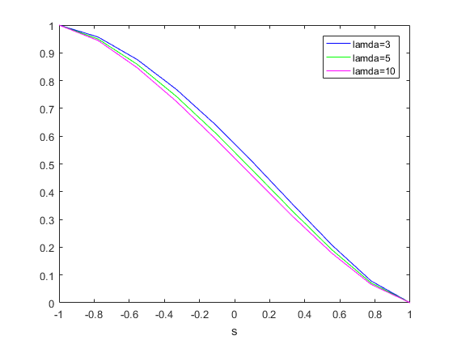

We can see that as ‘S’ increases to reach 1(s =R 🡪 The two circles are separate), the overlap area is same as the area of the projected pin hole, which makes sense. This phenomenon is also repeated when ‘S= -1 which again logically makes sense. However, in between, we observe that the projected area is a complex function which is proportional to lamda, and as R2/R1 increases , the projected area increases. We can also observe that the projected area is only a function of ‘S’ and ‘lamda’ and not R1 and R2 in particular.

2-a

|  |  |  |  |  |
| --- | --- | --- | --- | --- |
| Gray level | # of pixels | cdf | q(k) | round(qk) |
| 117 | 1 | 1 | 5.3125 | 5 |
| 118 | 2 | 3 | 15.9375 | 16 |
| 119 | 2 | 5 | 26.5625 | 27 |
| 120 | 0 | 5 | 26.5625 | 27 |
| 121 | 3 | 8 | 42.5 | 43 |
| 122 | 3 | 11 | 58.4375 | 58 |
| 123 | 2 | 13 | 69.0625 | 69 |
| 124 | 5 | 18 | 95.625 | 96 |
| 125 | 4 | 22 | 116.875 | 117 |
| 126 | 4 | 26 | 138.125 | 138 |
| 127 | 5 | 31 | 164.6875 | 165 |
| 128 | 5 | 36 | 191.25 | 191 |
| 129 | 5 | 41 | 217.8125 | 218 |
| 130 | 3 | 44 | 233.75 | 234 |
| 131 | 2 | 46 | 244.375 | 244 |
| 132 | 2 | 48 | 255 | 255 |

Sub-region matrix after histogram equalization

|  |  |  |  |  |  |  |  |
| --- | --- | --- | --- | --- | --- | --- | --- |
| 96 | 165 | 191 | 234 | 245 | 245 | 218 | 218 |
| 117 | 69 | 117 | 117 | 191 | 244 | 234 | 234 |
| 218 | 165 | 69 | 96 | 117 | 138 | 191 | 191 |
| 218 | 165 | 96 | 43 | 58 | 58 | 138 | 138 |
| 244 | 218 | 138 | 58 | 27 | 27 | 43 | 96 |
| 191 | 165 | 165 | 96 | 43 | 16 | 16 | 5 |

B(1) Original Image: Eyeball.png

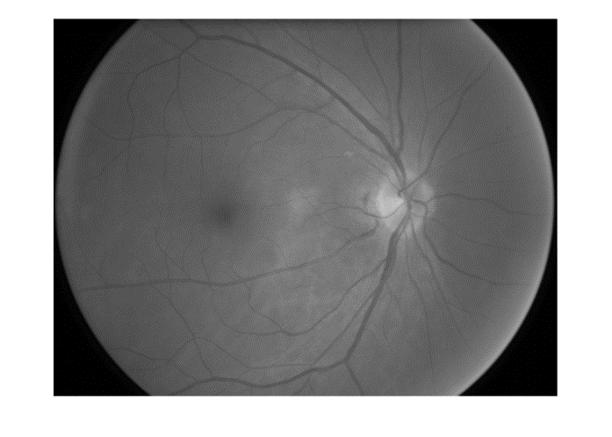

ORIGNAL IMAGE and HISTOGRAM

 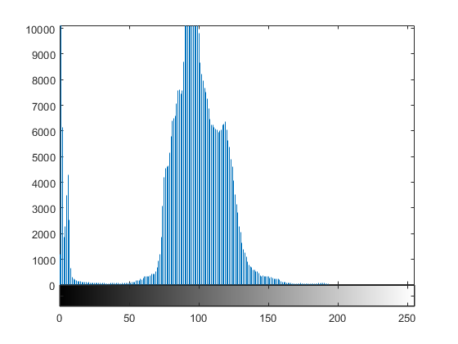

PROCESSED IMAGE and HISTOGRAM

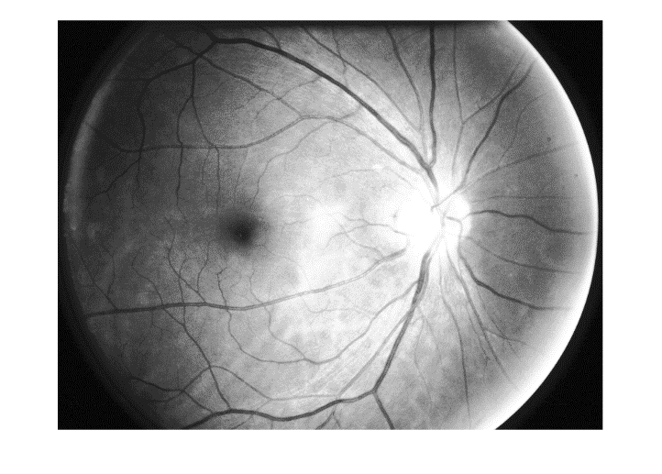 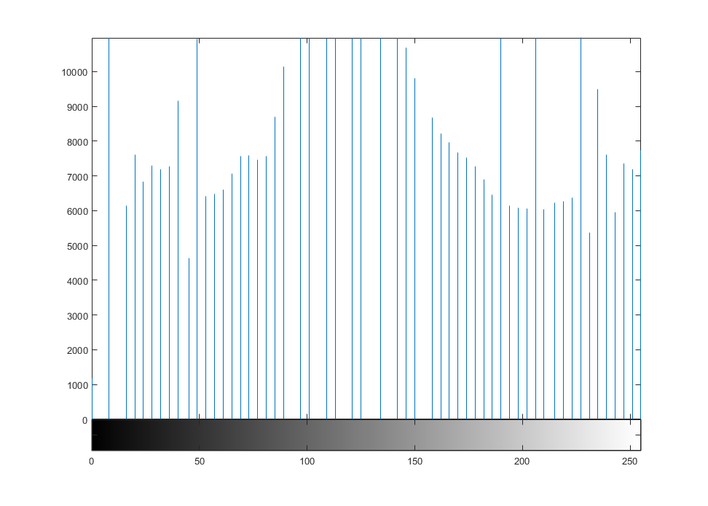

We can observe that after histogram equalization , the picture intensity evenly distributed and the picture is much clearer as the new image has a lot more contrast. The nerve optics in the eye, which were originally hidden, becomes clearer after the histogram equalization.

3(a). H(x)= [-1 -2 -1; 0 0 0;1 2 1]

H(y)= [-1 0 1;-2 0 2;-1 0 1]

I = [125 123 125;129 127 123;129 127 124]

I(3,2) = 127

G(x) = [-125 -246 -125;0 0 0;129 254 124]

= 11

G(y) = [-125 0 125;258 0 246;-129 0 124]

= -17

Direction = tan-1(-17/11) = -57.09°

Y

|  |  |  |
| --- | --- | --- |
| 125 | 123 | 125 |
| 129 | 127 | 123 |
| 129 | 127 | 124 |

Magnitude = (G(x)2 + G(y)2)0.5

= 20.24

Direction of Gradient

57.09°

X

We can observe that the gradient is pointed towards the pixels with high gray scale (125,129 and 129), which makes sense. If all the numbers on the lower left quadrant were 129, we could expect the gradient to be at -45°. However, since one of the numbers is -127, the gradient is weighed towards the -ve Y axis and thus makes sense.

3 (b)

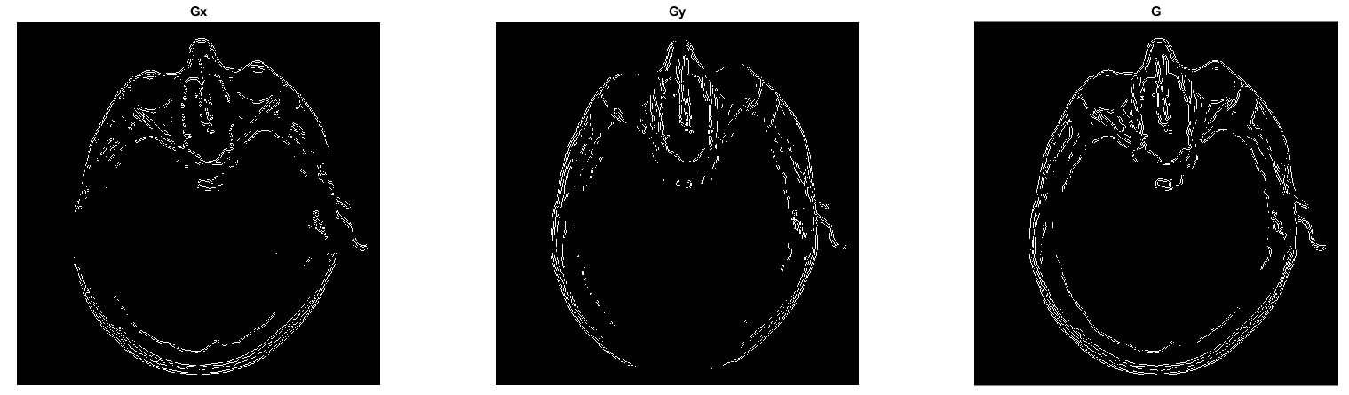

We can observe how as we incorporate the gradient in the both X and Y direction, we get the complete gradient, which is able to give most of the information needed for edge detection. We can also see how G incorporates data from both Gx and Gy , which confirm with our theory.

3(c)

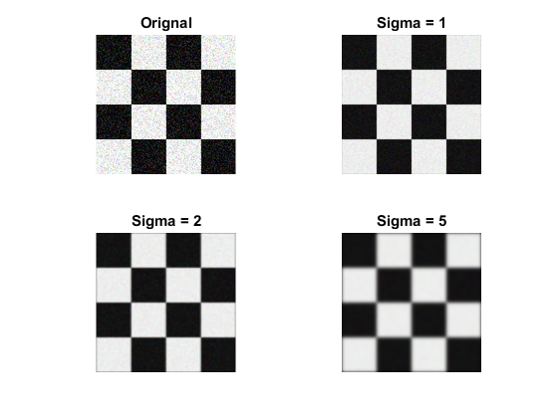

We can observe that as we increase the value for sigma, we incorporate more and more standard deviation. Thus the Gaussian curve becomes wider and smoother. We can also observe this effect on the image, as a Gaussian helps reduce the noise at low sigma (sigma= 1) , however, if we increase sigma beyond a point, we lose data and the image becomes blurry.

3(d)

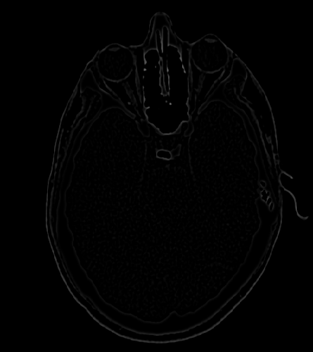

We can see that DOG helps for the purpose of reducing noise(since the noise from the two sigma’s cancels out) and is helpful in making the image clearer and thus identify boundary edges.

4(a)

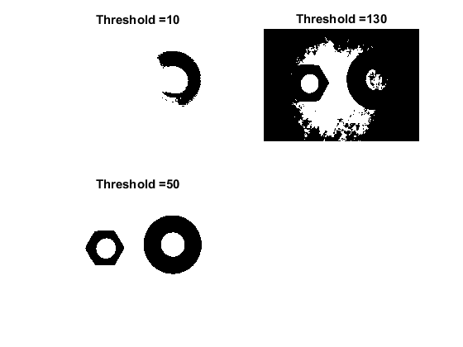

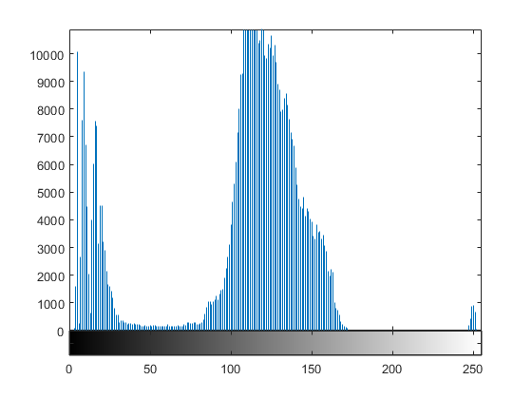

We can observe from the histogram that the threshold region is between (30 and 80) approximately. Anything >80 would be an overestimate and anything <30 . We can confirm that belief by looking at the image above .

(b)

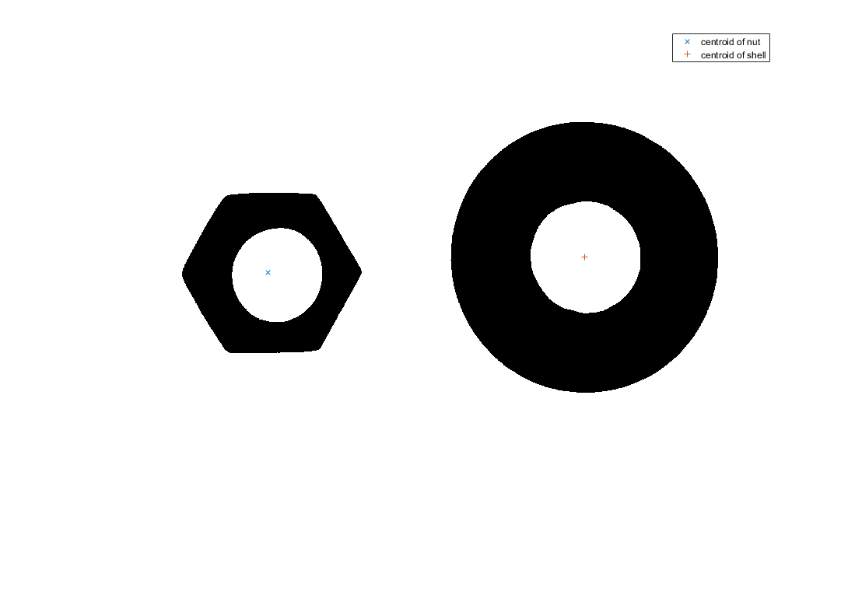

Area of nut = 25159

Area of shell = 78178

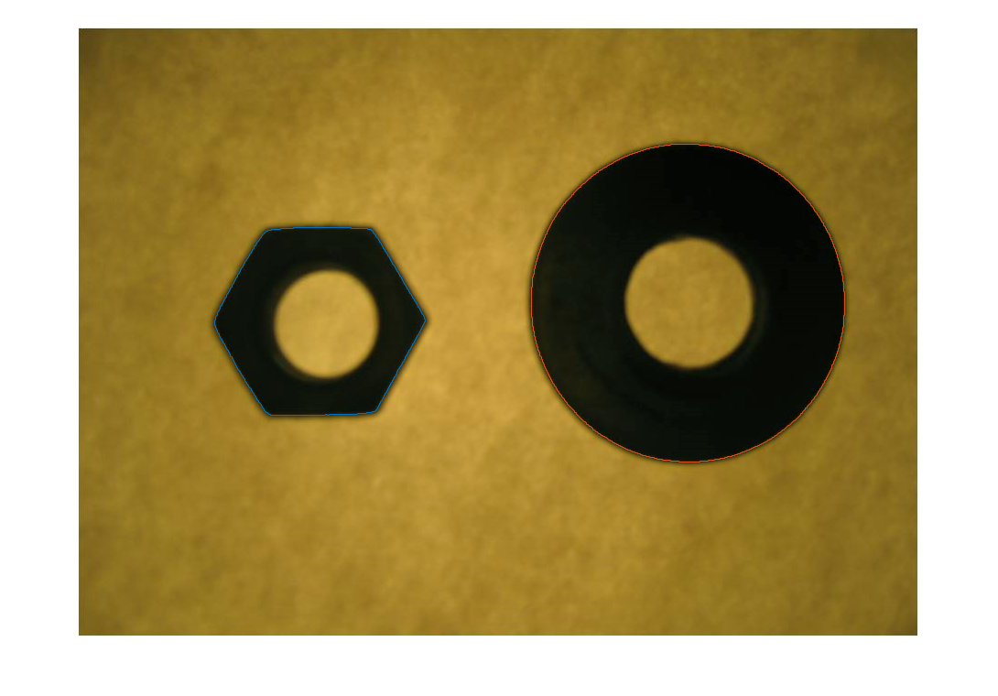4(c)

C(

casc