1a-

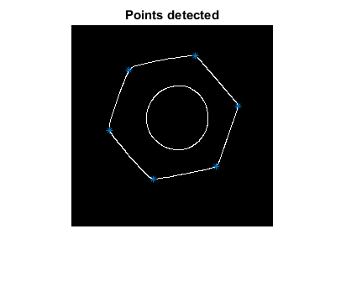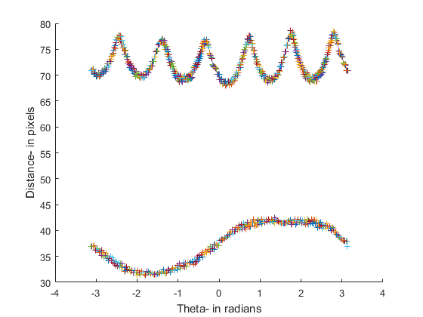

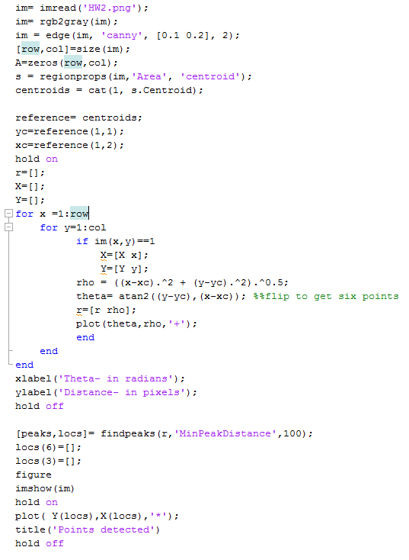

Explanation: The peaks in rho-theta method can be used to identify corners of a hexagon and is pretty accurate.

1b-

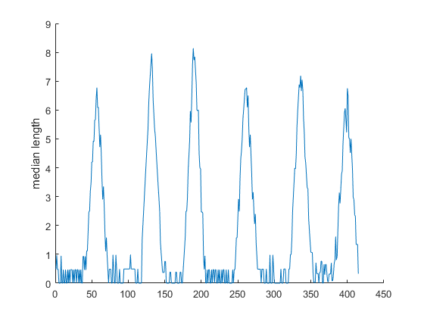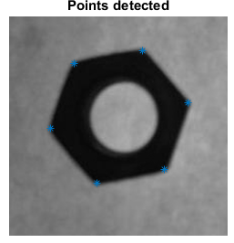

CODE

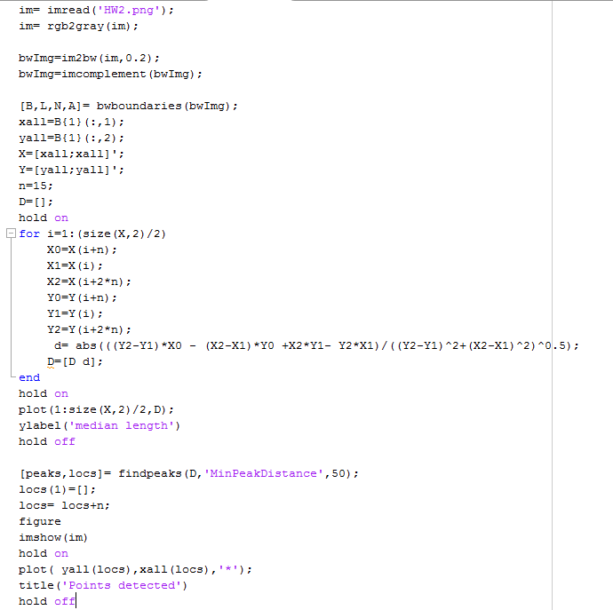

Explanation: The peaks in median length can be used to identify the corners with reasonable accuracy

1c-

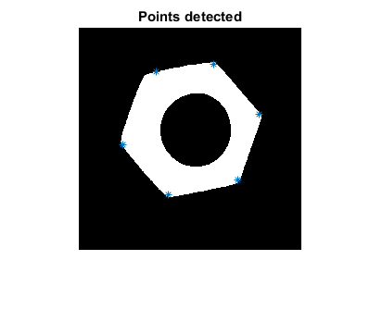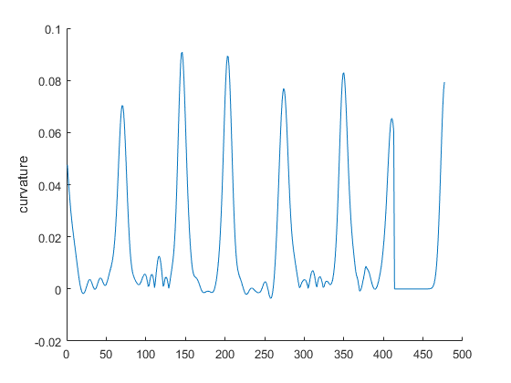

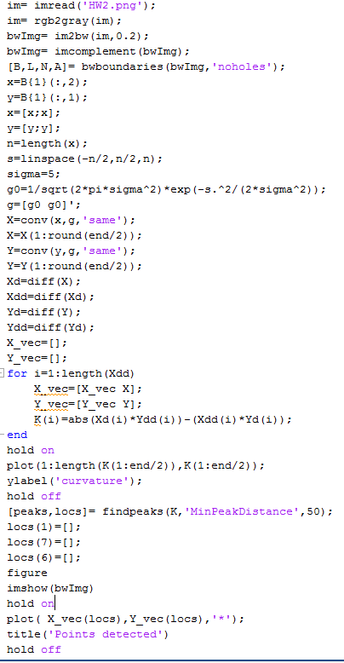

Explanation: The peaks in curvature can be used to identify the corners of a hexagon.

2a-

CODE OUTPUT

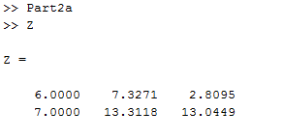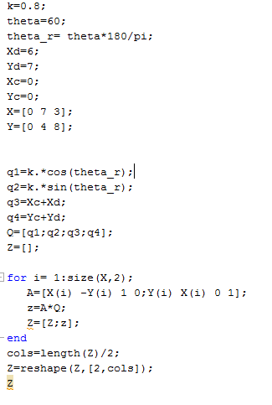

Explanation: The forward transformation is pretty accurate and relies on precision of Matlab.

2b-

CODE OUTPUT

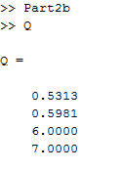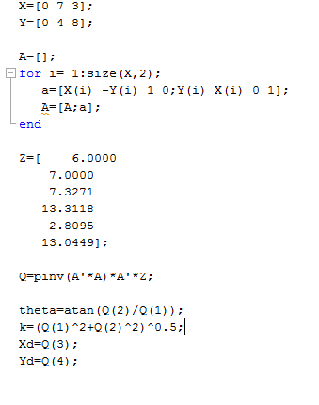

Explanation: Pseudo inverse method is pretty accurate and is able to compute the Q matrix (from part a) pretty accurately.

2c-

CODE OUTPUT

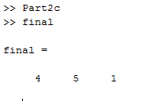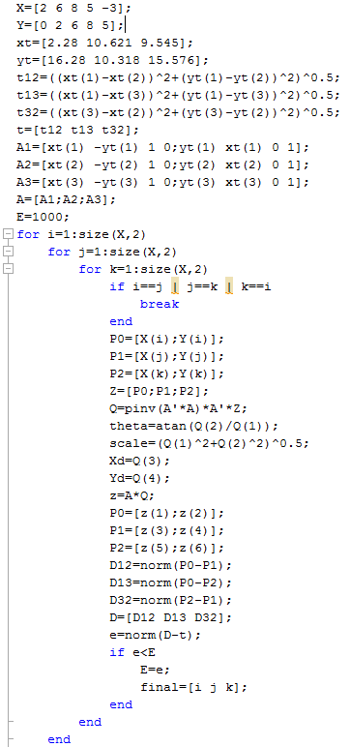

Explanation: The traingle formed by the points [4 ,5 ,1] has the minimum error and is closest to target triangle formed by [a , b, c]

3a-

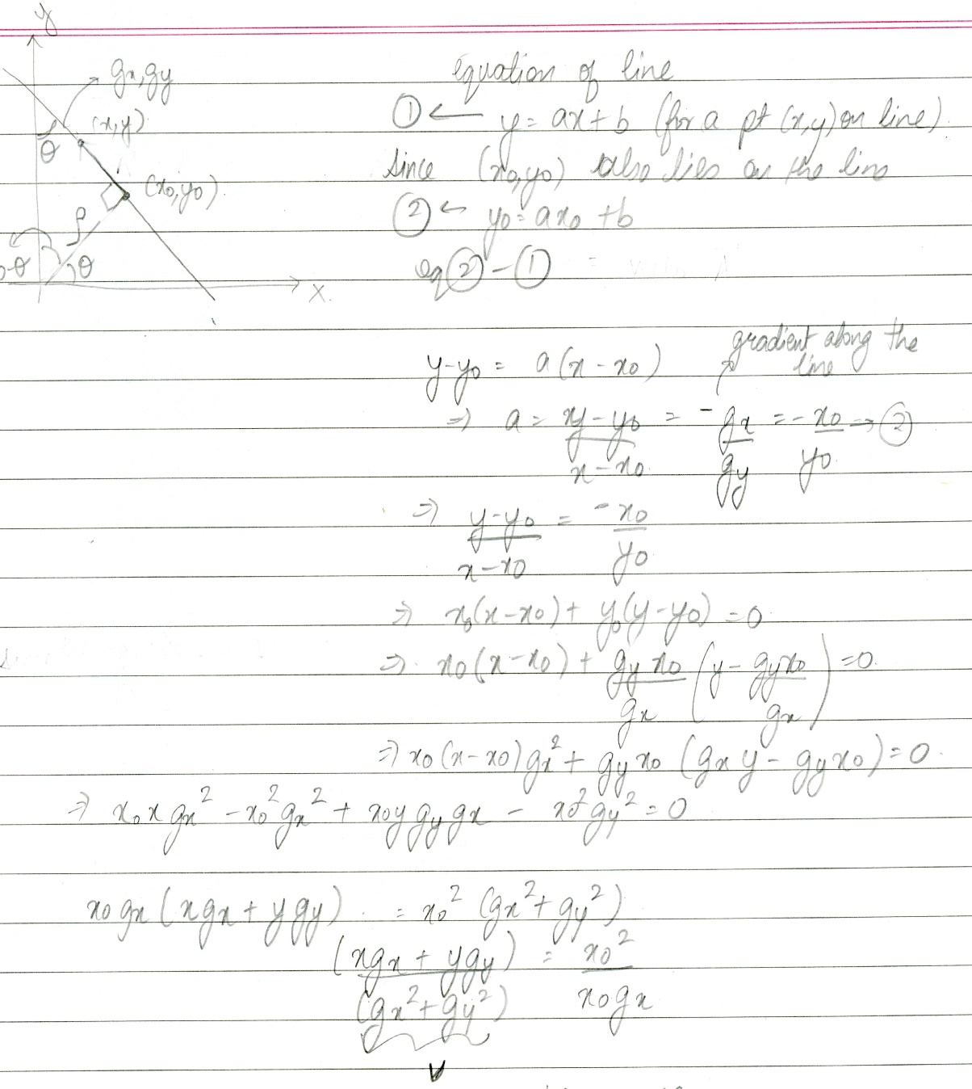

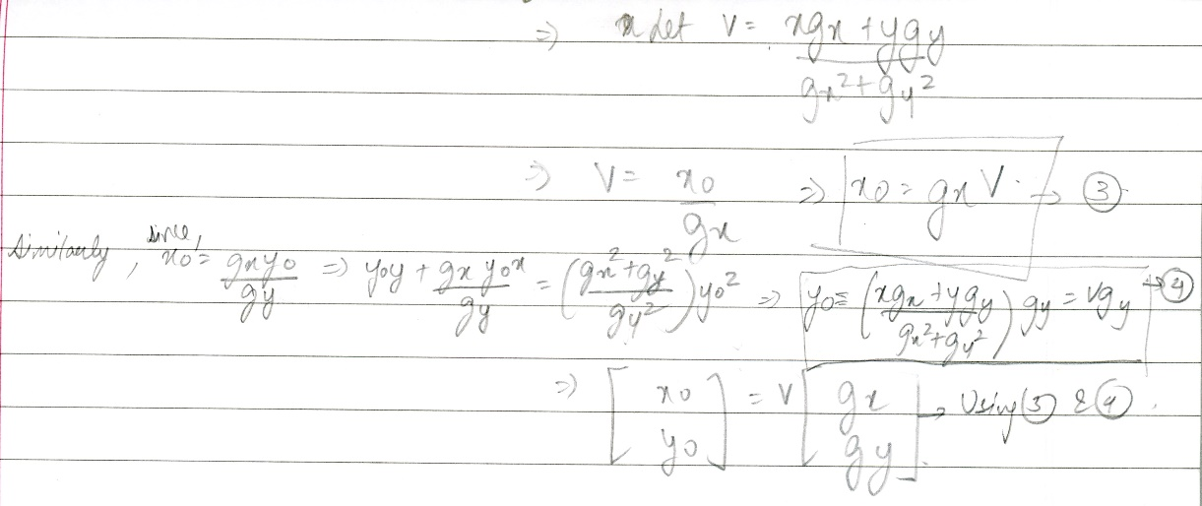

3b-

CODE OUTPUT

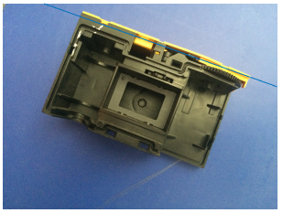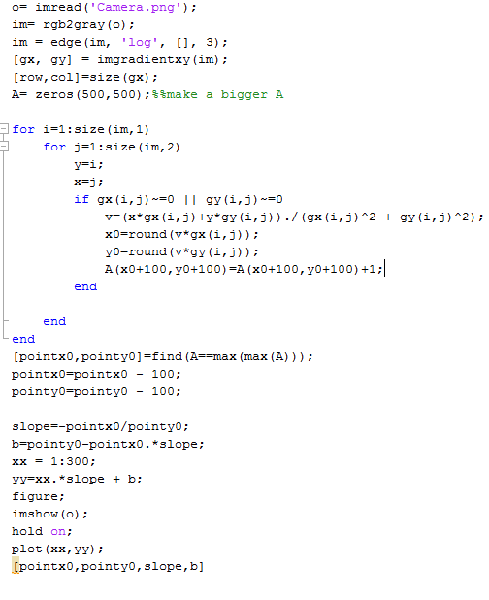

Explanation: The Hough transform is accurate in identifying the yellow line.

3c-

CODE

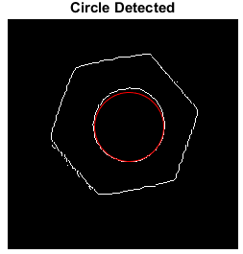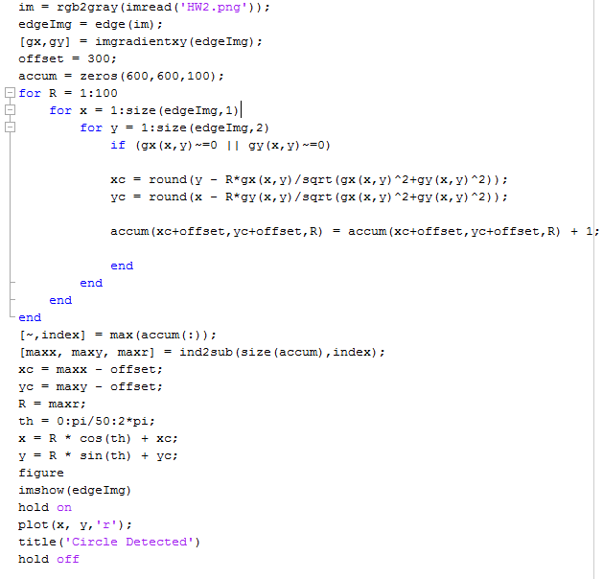

OUTPUT

Explanation: Hough transform is accurately able to identify the circle, although there is a bit of rounding error.