**Task:**

Build a Twitter kind of application by consuming the below API

<https://aravindtwitter.herokuapp.com/twittersearch?key=adobe>

**Design:**

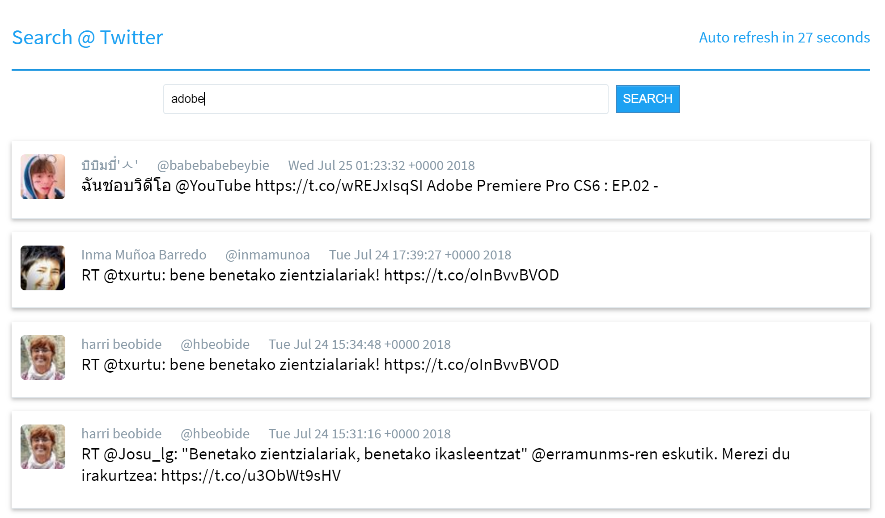

**Assignment breakdown:**

1. Build HTML,CSS (preprocessor like less/sass can be used).Two card layout for tablet.Single card layout for desktop and mobile.
2. Implement search feature by providing different value for 'key' property. Eg : photoshop,xd
3. Implement auto refresh feature (new content after 30 sec)
4. Use templating engine like underscore or handlebar.frameworks/library like angular,React, bootstrap can be used as well.
5. Implement url level search like localhost:3000/key=photoshop should display photoshop related tweets if key value empty show Adobe tweets
6. Implement lazy load feature for cards and animations/loaders where ever required.