KOLKATA PIZZA DELIVERY

## BASED ON PHP AND ANGULAR.JS

**An Online Pizza Delivery Web Application**



**By – Arpit Anand,**

**Registration no – 133000110005**

**Roll no – 300001130005**

At



Ardent , Kolkata

BONAFIDE CERTIFICATE

Certified that this project report on ‘Kolkata Pizza delivery’ – a online pizza delivery Web application is the bona fide work of Arpit anand (Roll No: 30000113005) who carried out the project work under my supervision.

Students’ Name

Signature of Student

Arpit anand,

Signature of H.O.D. Signature of Mentor

___________________ ______________________

Jaydeep Mondal

Ardent Computech Pvt. Ltd.

Salt Lake,kolkata

**ACKNOWLEDGEMENT**

We take this opportunity to express our deep gratitude and most sincere thanks to our project mentor, MR. Jaydeep Mondal of Ardent Tech for giving most valuable suggestion, helpful guidance and encouragement in the execution of this project work.

We would like to thank our HOD and other department faculties for guiding us. Last but not the least we are grateful to all the team members of Ardent.

Yours Faithfully,

Arpit anand

**Contents**

1. Introduction
   1. Relevance
   2. Problem Definition
   3. Objective
2. Basic Concepts & Tools
   1. Html
   2. CSS
   3. JavaScript
   4. Material concept
   5. Materialize css
   6. Angular.js
   7. SQL
   8. PHP
3. System Analysis
   1. Feasibility Study
   2. Existing System
   3. Proposed System
4. Software requirements
5. Hardware requirements
6. Diagram

6.1 Data-flow Diagram

6.2 Use-case Diagram

6.3 Entity-relationship Diagram

6.4 Table Diagram

1. Form Design
2. Testing
   1. Objective
   2. Process Overview
   3. Testing Process
   4. Testing Strategy
   5. Test Cases
3. Results/UI
4. Code
5. Conclusion
6. References
7. Bibliography

**INTRODUCTION**

Relevance:

**KOLKATA PIZZA DELIVERY** is a **WEB** application that is used to provide for online booking of the pizza and to receive it. It is a pizza online booking app that provides functionality like taking order and delivering it at the time. Users don’t have to worry about the going to the shop, just book the good pizza from application and wait for the parcel to receive. It is an ecommerce responsive website that helps to sort the booking of the pizza online and sort the complexity. Since e-commerce web app are being widely used by general population, the **KOLKATA PIZZA DELIEVRY** application can provide on the go support for the users.

Problem Definition:

Since with the beginning of online stores with the rise of wallet stuffs, online booking has increased, so this app helps any one add pizza through admin panel and easily use the CURD stuff.



And user can login, logout so that their sessions can be maintained, they can easily set up pizza update cart and then can, successfully order it.

Admin panel is Basic CURD APPLICATION, LIKE

ADMIN CAN

* CREATE PIZZA DETAILS.
* READ PIZZA DETAILS.
* UPADTE PIZZA DETAILS.
* DELETE PIZZA DETAILS.

So decreasing all type of complexity of modern app.

**Objective:**

Applications has two type of users interacting with it:

1.) Admin : Admin panel has three types of the part -

1. Posting the pizzas has the feature of name, description, price, quantity, Image of the choice.
2. One page to see the, pizzas and delete, update it, so that in case of out of stock they can remove.
3. Third is to see the order list.
4. And Pizza order can also be rejected at some circumstances.

2.) Users.

1. Users has the session, so that successful, login and logout, so that a track can be made.
2. Cart where cart adding removing can be done.
3. And a landing page, so that we can see all the pizzas added by admins.
4. Record can be made and maintained.

**Basic Feature of the application**

Application is based on the Material design and it is same like other ecommerce site of ADD TO CART, using cookies and login track by session and Admin panel which has the Basic CURD features and more and more pizza can be added and deleted. There are forms for all the LOGIN , SIGNUP , USER AND ADMIN BOTH.

BASIC CONCEPT AND TOOLS:

Front-end Development

Markup :

* HTML stands for Hyper Text Mark-up Language
* HTML describes the structure of Web pages using mark-up
* HTML elements are the building blocks of HTML pages
* HTML elements are represented by tags
* HTML tags label pieces of content such as "heading", "paragraph", "table", and so on
* Browsers do not display the HTML tags, but use them to render the content of the page

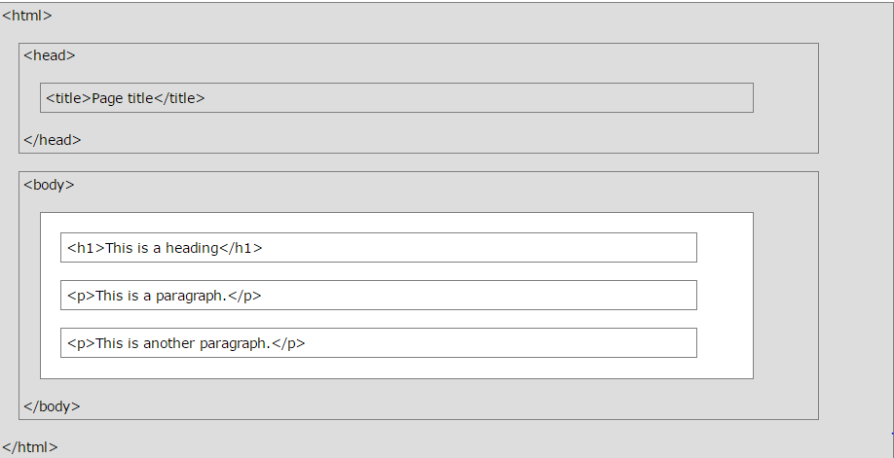

Basic HTML Mark-up design

Cascading Style Sheet CSS:

* **CSS** stands for **C**ascading **S**tyle **S**heets
* CSS describes how HTML elements are to be displayed on screen, paper, or in other media
* CSS saves a lot of work. It can control the layout of multiple web pages all at once
* External stylesheets are stored in CSS files.

Material Design:

Material Design Lite, MDL is a UI component library created with CSS, JavaScript, and HTML. MDL UI components helps in constructing attractive, consistent, and functional web pages and web apps while adhering to modern web design principles like browser portability, device independence, and graceful degradation. It helps in creating faster, beautiful, and responsive websites. It is inspired from Google Material Design.



3-D Style of Material design

MaterializeCss:

Created and designed by Google, Material Design is a design language that combines the classic principles of successful design along with innovation and technology. Google's goal is to develop a system of design that allows for a unified user experience across all their products on any platform.

Some of its salient features are as follows:

* In-built responsive designing.
* Standard CSS with minimal footprint.
* Includes new versions of common user interface controls such as buttons, check boxes, and text fields which are adapted to follow Material Design concepts.
* Includes enhanced and specialized features like cards, tabs, navigation bars, toasts, and so on.
* Requires jQuery javascript library to function properly.
* Cross-browser, and can be used to create reusable web components.
* Free to use

Javascript

JavaScript is a lightweight, interpreted programming language. It is designed for creating network-centric applications. It is complimentary to and integrated with Java. JavaScript is very easy to implement because it is integrated with HTML. It is open and cross-platform.

<html>

<body>

<script language="javascript" type="text/javascript">

<!--

document.write("Hello World!")

//-->

</script>

</body>

</html>

Basic javascript program.

TO MAKE THE FRONT END MORE INTERACTIVE AND SINGLE PAGE WEB APPLICATION: ANGULAR @ 1.6 version is used.

**AngularJS** is a very powerful JavaScript Framework. It is used in Single Page Application (SPA) projects. It extends HTML DOM with additional attributes and makes it more responsive to user actions. AngularJS is open source, completely free, and used by thousands of developers around the world. It is licensed under the Apache license version 2.0.

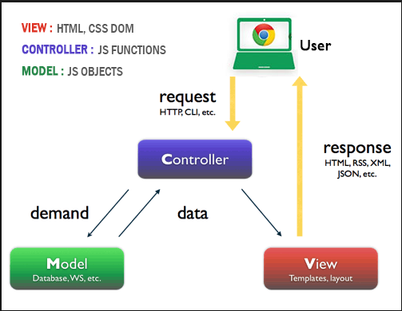

JQuery:

jQuery is a fast, small, and feature-rich JavaScript library. It makes things like HTML document traversal and manipulation, event handling, animation, and Ajax much simpler with an easy-to-use API that works across a multitude of browsers. With a combination of versatility and extensibility, jQuery has changed the way that millions of people write JavaScript.

Server-side programming language:

WAMP server : WampServer is a Windows web development environment. It allows you to create web applications with Apache2, PHP and a MySQL database. Alongside, PhpMyAdmin allows you to manage easily your databases.

* **Using wampserver**
* The “www” directory will be automatically created (usually c:\wamp\www)
* Create a subdirectory in “www” and put your PHP files inside.
* Click on the “localhost” link in the WampSever menu or open your internet browser and go to the URL : <http://localhost>.

**PHP**   
The PHP Hypertext Preprocessor (PHP) is a programming language that allows web developers to create dynamic content that interacts with databases. PHP is basically used for developing web based software applications. This tutorial helps you to build your base with PHP.

* **Web Server** − PHP will work with virtually all Web Server software, including Microsoft's Internet Information Server (IIS) but then most often used is freely available Apache Server. Download Apache for free here − <https://httpd.apache.org/download.cgi>
* **Database** − PHP will work with virtually all database software, including Oracle and Sybase but most commonly used is freely available MySQL database. Download MySQL for free here − <https://www.mysql.com/downloads/>
* **PHP Parser** − In order to process PHP script instructions a parser must be installed to generate HTML output that can be sent to the Web Browser. This tutorial will guide you how to install PHP parser on your computer.

PHPMYADMIN:

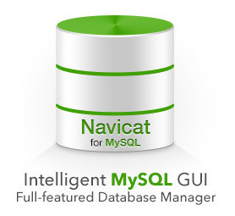

## **Features**

* Intuitive web interface
* Support for most MySQL features:
  + browse and drop databases, tables, views, fields and indexes
  + create, copy, drop, rename and alter databases, tables, fields and indexes
  + maintenance server, databases and tables, with proposals on server configuration
  + execute, edit and bookmark any SQL-statement, even batch-queries
  + manage MySQL user accounts and privileges
  + manage stored procedures and triggers
* Import data from CSV and SQL
* Export data to various formats: CSV, SQL, XML, PDF, ISO/IEC 26300 - OpenDocument Text and Spreadsheet, Word, LATEX and others
* Administering multiple servers
* Creating graphics of your database layout in various formats
* Creating complex queries using Query-by-example (QBE)
* Searching globally in a database or a subset of it
* Transforming stored data into any format using a set of predefined functions, like displaying BLOB-data as image or download-link

**SQL :** SQL tutorial gives unique learning on **Structured Query Language** and it helps to make practice on SQL commands which provides immediate results. SQL is a language of database, it includes database creation, deletion, fetching rows and modifying rows etc.

SQL is an ANSI (American National Standards Institute) standard but there are many different versions of the SQL language.

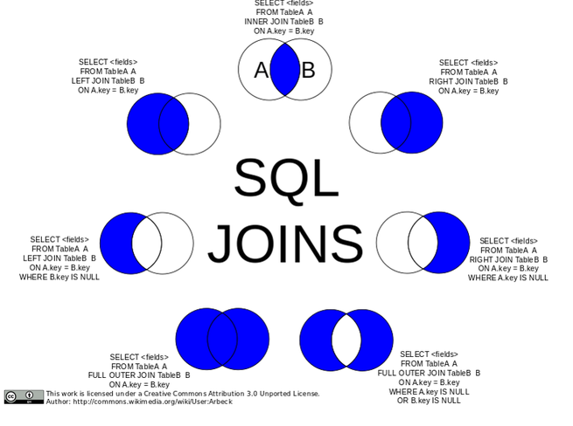

**Feasibility Study**:

The feasibility study is an evaluation and analysis of the potential of a proposed project which is based on extensive investigation and research to support the process of decision making. Depending on the results of the initial investigation the survey is now expanded to a more detailed feasibility study.

|  |  |
| --- | --- |
| **Feasibility Study** | |
| System:Kolkata Pizza Delivery | Date: 27/07/2016 |
| Author: XXX | Page: 1 |
| **Product** | |
| The project is a PIZZA ONLINE DELIVERY. | |
| **Technical Feasibility** | |
| Wamp server , php , angular,js. | |
| **Social Feasibility** | |
| Some training for the users/admin are required but all users are IT literate. | |
| **Market Research** | |
| Market research says that this application would be useful for the users as it could seamlessly help them for their lifestyle. | |
| **Economic Feasibility** | |
| The application can be developed within budget. | |
| **Alternate Solution** | |
| Could be a desktop system but that would not be as portable. | |

**Proposed System:**

The proposed system is an web app will remind their user about the pizza delivery. There will be a UI , where user can come and book a pizza at desired time and asked him for the delivery.

**Table of Comparison :**

Comparison of Existing System & Proposed System

|  |  |  |
| --- | --- | --- |
| Parameters | Existing System | Proposed System |
| Method | Manual | Automatic |
| Time | More time consuming | Less time consuming |
| Database | Required | Not required |
| Reliability | Less | More |

**Software Requirements:**

**Operating System**: Windows , linux.

**Toolkit:** Visual studio code.

**Platform:** Javascript , PHP , SQL , ANGULAR,MATERIAL.

**Database:**  SQL

**Data Flow Diagram:**

A **data flow diagram** (**DFD**) is a graphical representation of the "flow" of data through an information system, modelling its *process* aspects. A DFD is often used as a preliminary step to create an overview of the system. DFDs can also be used for the visualization of data processing.

A DFD shows what kind of information will be input to and output from the system, where the data will come from and go to, and where the data will be stored. It does not show information about the timing of process or information about whether processes will operate in sequence or in parallel.

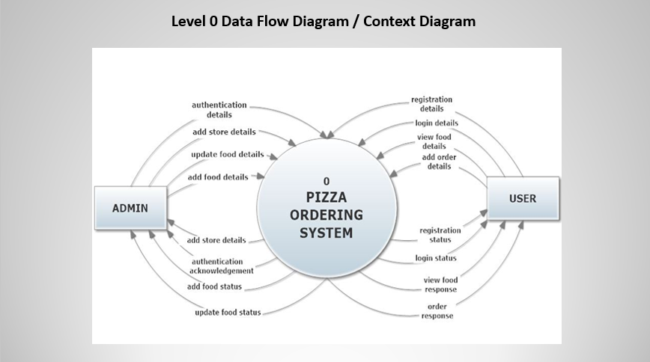

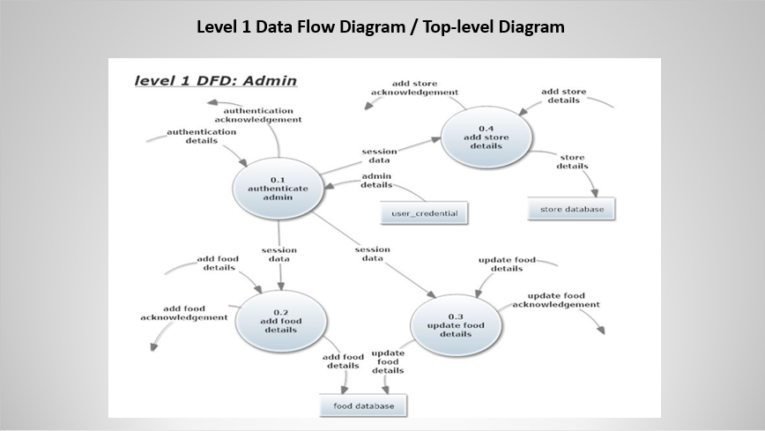

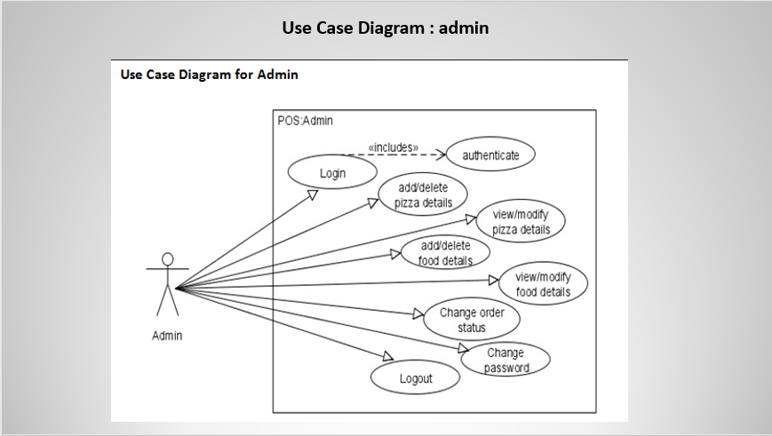

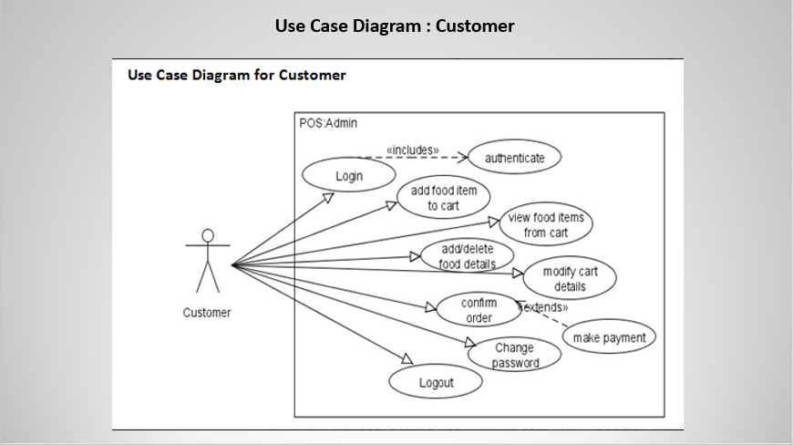

**Testing**

Objective:

The objective our test plan is to find and report as many bugs a possible to improve the integrity of our program. Although exhaustive testing is not possible, we will exercise a broad range of tests to achieve our goal. We will also test the user friendliness of our app . The application will be used as an important tool, but we would like to ensure that it could be run on a variety of platforms with little impact on performance or usability.

**Process Overview :**

The following represents the overall flow of the testing process:

Identify the requirements to be tested. All test cases shall be derived using the current Program

Specification.

Identify which particular test(s) will be used to test each module.

Review the test data and test cases to ensure that the unit has been thoroughly verified and that the test data and test cases are adequate to verify proper operation of the unit.

Identify the expected results for each test.

Document the test case configuration, test data, and expected results.

Perform the test(s).

Document the test data, test cases, and test configuration used during the testing process. This information shall be submitted via the Unit/System Test Report (STR).

Successful unit testing is required before the unit is eligible for component integration/system testing.

Unsuccessful testing requires a Bug Report Form to be generated. This document shall describe the test case, the problem encountered, its possible cause, and the sequence of events that led to the problem. It shall be used as a basis for later technical analysis.

Test documents and reports shall be submitted. Any specifications to be reviewed, revised, or updated shall be handled immediately.

**Testing Process**



Organize



Project



Design



System Test



Design/Build



Organize



Project



Design/Build



Test Proc.



Signoff



The diagram above outlines the Test Process approach that will be followed.

**Organize Project** involves creating a System Test Plan, Schedule & Test Approach, and assigning responsibilities.

**Design/Build System Test** involves identifying

Test Cycles, Test Cases, Entrance & Exit Criteria, Expected Results, etc. In general, test conditions/expected results will be identified by the Test Team in conjunction with the Development Team. The Test Team will then identify Test Cases and the Data required. The Test conditions are derived from the Program Specifications Document.

**Design/Build Test Procedures** includes setting up procedures such as Error Management systems and Status reporting.

**Build Test Environment** includes requesting/building hardware, software and data setups.

**Execute System Tests** identified in the

Design/Build Test Procedures will be executed.

All results will be documented and Bug Report Forms filled out and given to the Development Team as necessary.

**Signoff** happens when all pre-defined exit criteria have been achieved.

**Testing Strategy:**

The following outlines the types of testing that will be done for unit, integration, and system testing. While it includes what will be tested, the specific use cases that determine how the testing is done will be detailed in the Test Design Document. The test cases that will be used for designing use cases is shown below.

UI-design

Front page (Landing page)

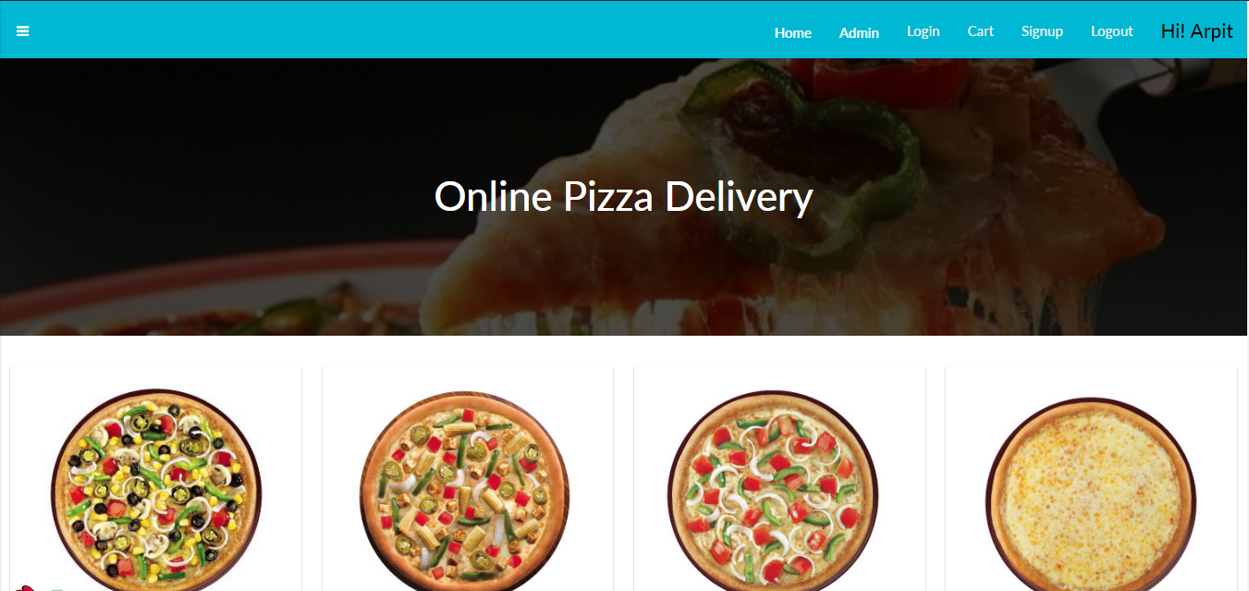

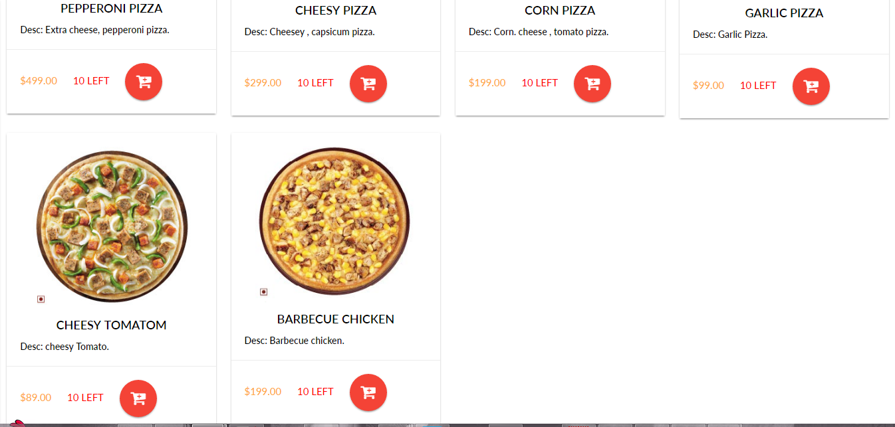

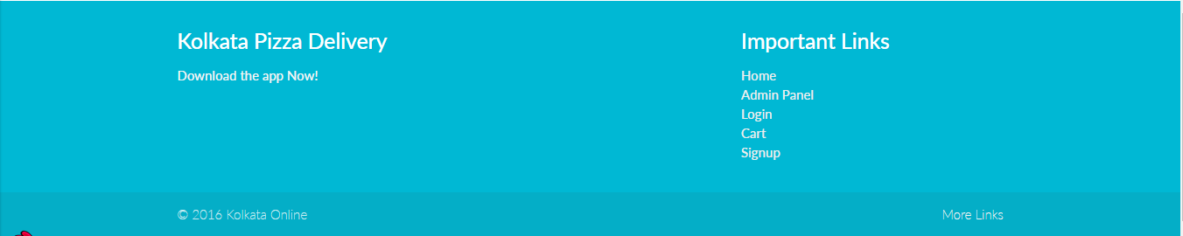

Admin Panel - login

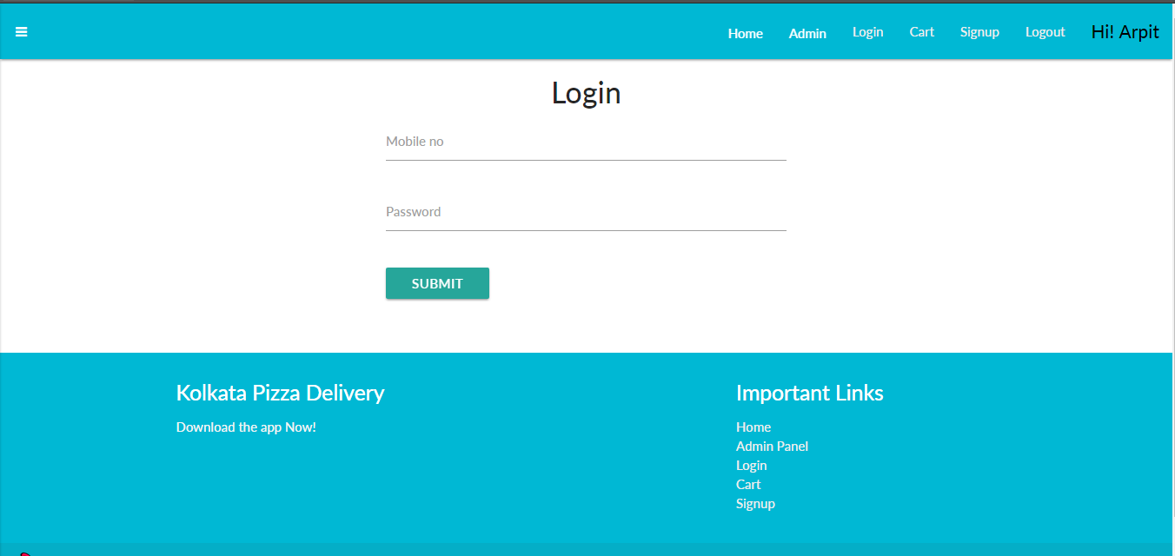

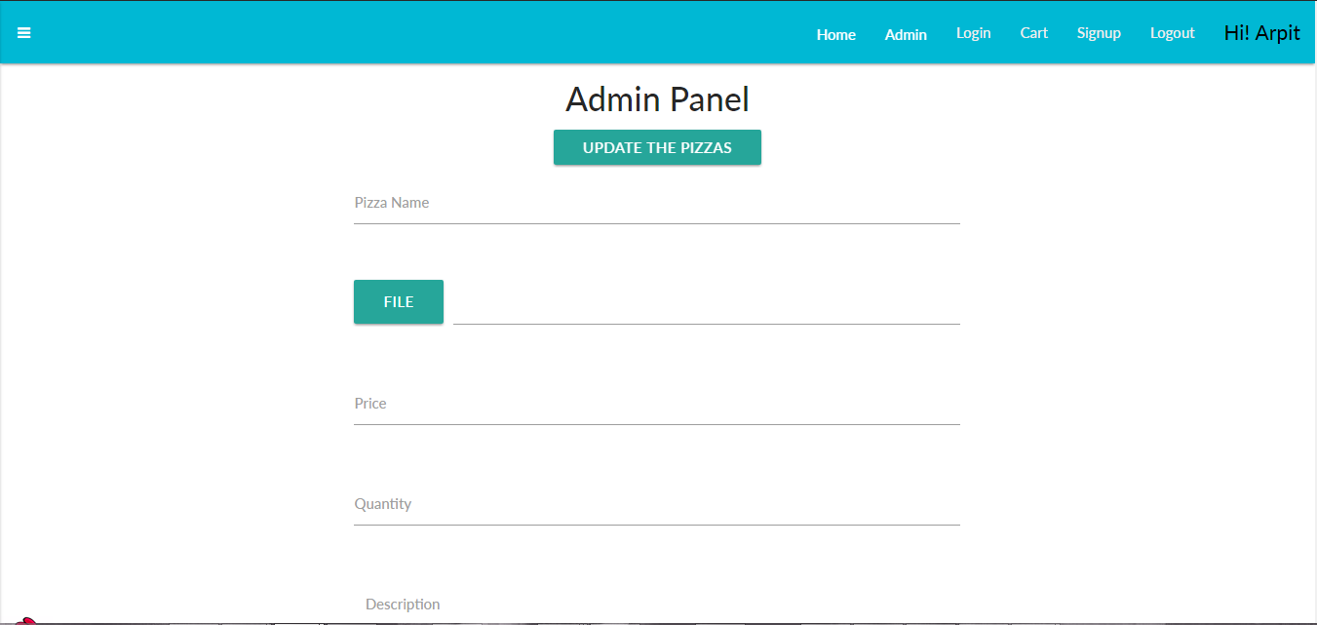

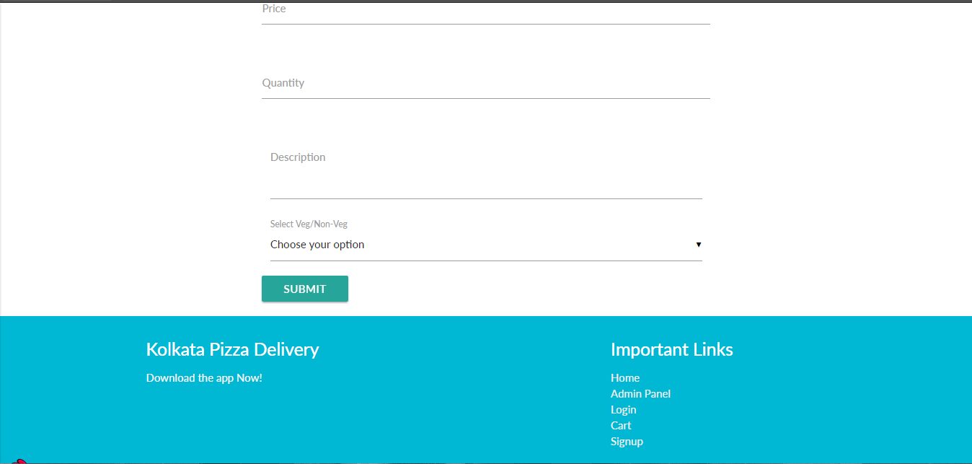

Admin updation page:

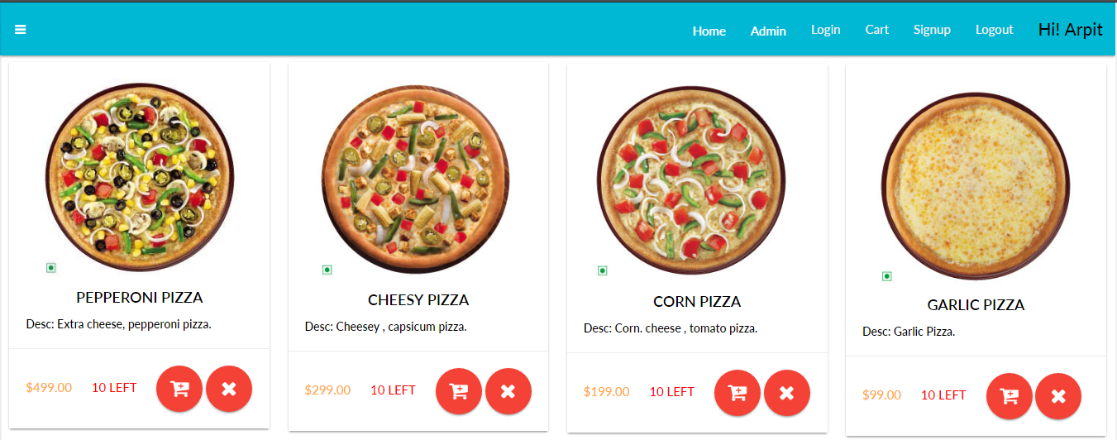

User Sign up:

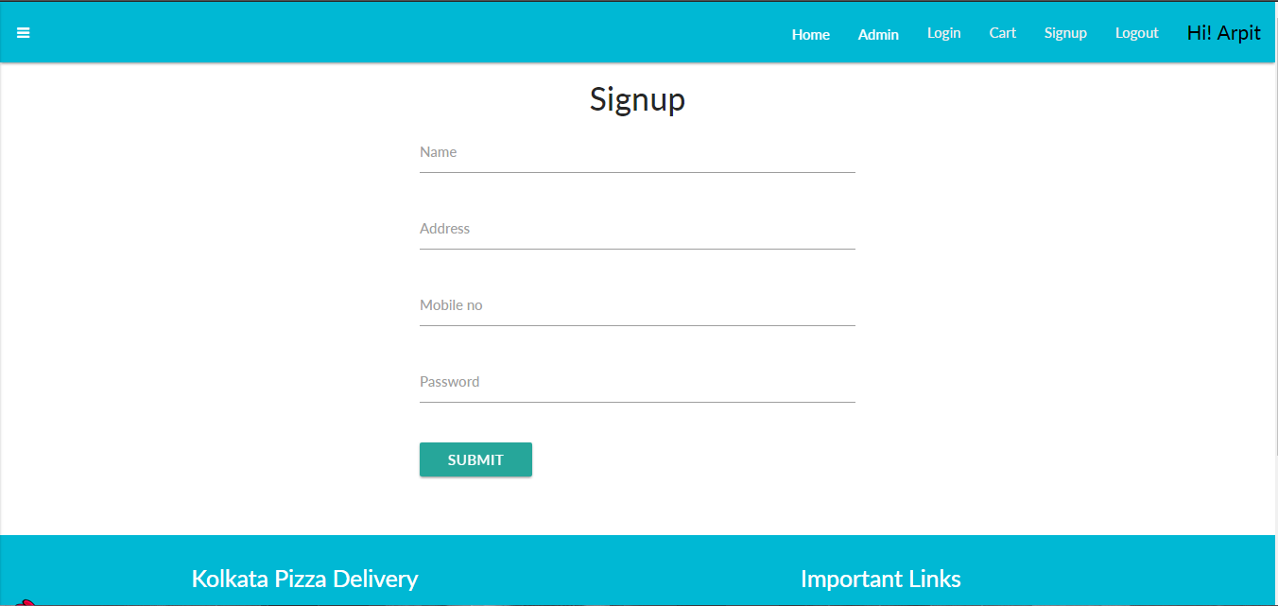

User login :



User Cart :

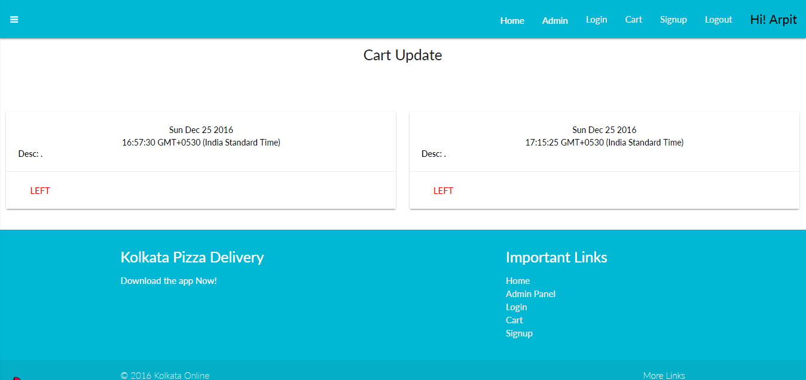



Folder Structure: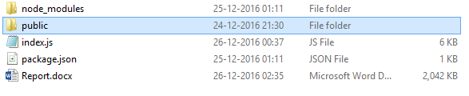

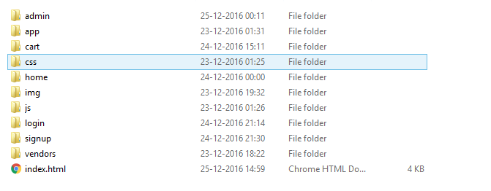

Codes :

* Angular dependency :

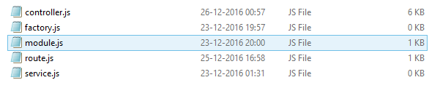

Codes:

Front-end development:

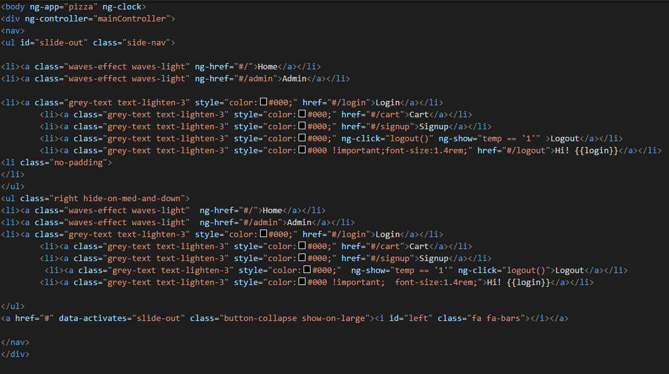

Html markup design

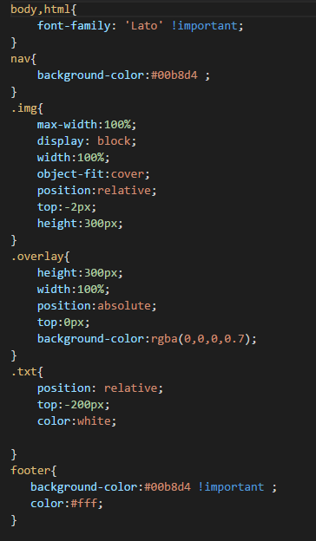

Css Stylesheet

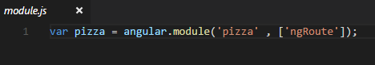

Angular.js to bootstrap the application.

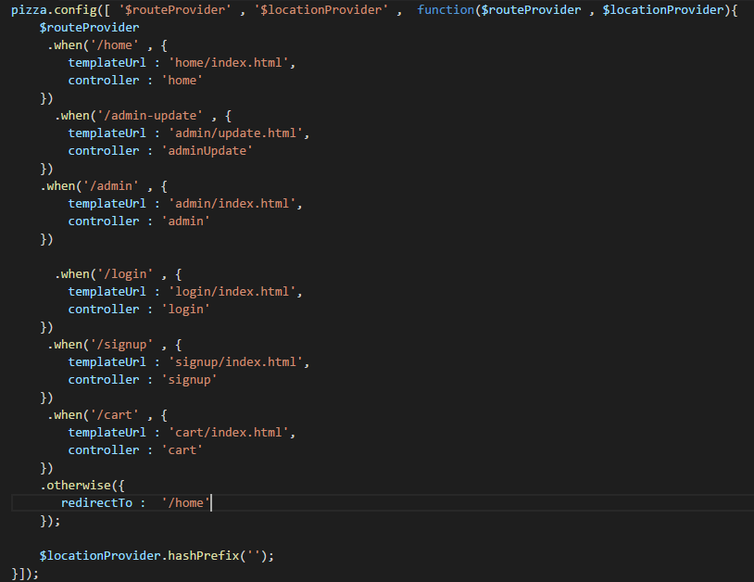

Route Angular to handle the Routes.

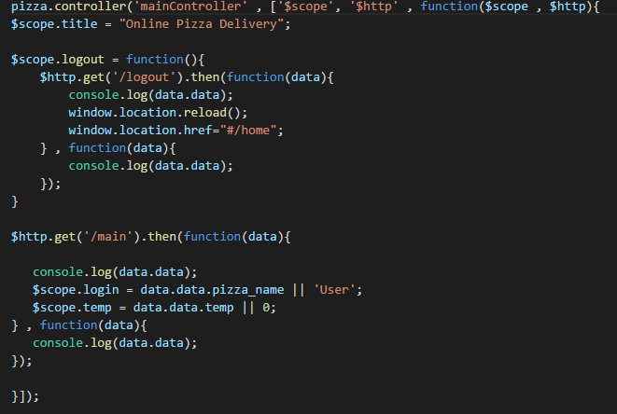

Controller to handle the data to show to the view.

CONCLUSION

This is the basic pizza delivery app, showing the CURD application like CREATE, DELETE , UPDATE , DLETE CALLING VAROUS REST API written in the backend site , calling the api insert , delete update , delete the rows from the MySQL database.

FUTURE SCOPE, I want to enlarge the feature of this app , integrating this with the GEOLATION API an if someone is delivering the pizza we are getting the current location of the guy in the map and getting the street view.

It is a pizza online booking app that provides functionality like taking order and delivering it at the time. Users don’t have to worry about the going to the shop, just book the good pizza from application and wait for the parcel to receive. It is an ecommerce responsive website that helps to sort the booking of the pizza online and sort the complexity. Since e-commerce web app are being widely used by general population, the **KOLKATA PIZZA DELIEVRY** application can provide on the go support for the users.

**References:**

[1] The complete Reference PHP, by Steven Holzner

[2] The complete Reference SQL .

[3] [www.scotch.io/](http://www.scotch.io/) Tutorial on REST API

[4] [www.tutorialspoint.com](http://www.tutorialspoint.com) for angular.js , MVC JavaScript front end framework

[5] [www.w3schools.com](http://www.w3schools.com) for JavaScript basic language

**Bibliography:**

[www.stackoverflow.com](http://www.w3schools.com/)

[www.w3schools.com](http://www.w3schools.com/)

www.wikipedia.org