

Project Proposal

***Yope App***

Version 1.0● October 4, 2013

*Proposal By:*

***TechValensSoftware Systems Pvt. Ltd.***

**“**

*Proposal For:*

***Yope App***

Document History

Paper copies are valid only on the day they are printed. Contact the author if you are in any doubt about the accuracy of this document.

Revision History

|  |  |  |  |
| --- | --- | --- | --- |
| Revision Number | Revision Date | Summary of Changes | Author |
| 1.0 | October3, 2013 | Understanding Document | Ankita Mishra |

Reference Documents

Please see the following documents for more information:

|  |  |  |
| --- | --- | --- |
| Document Name | Version | Author |
|  | 1.0 |  |

Distribution List

This document has been distributed to:

|  |  |  |  |
| --- | --- | --- | --- |
| Name | Position | Company | Action |
|  | - | - | - |

Table of Contents

1 Executive Summary- 5

2 Understanding of Requirements 6

2.1Project Scope: 6

**i)** **Splash Screen** 6

**ii)** **People Screen** 7

**iii)** **Near Screen** 8

**iv)** **Say Screen** 9

**v)** **Talk Screen** 10

**vi)** **Profile Screen** 11

3 Project Management- 15

3.1 CLIENT Effort Required 15

3.2 Project Plan 16

3.3 Project Estimating 17

The Project is being estimated to be delivered in  **working days Yope App** 17

3.4. Assumptions & Queries- 17

3.5 Risks 18

3.6 Issues 19

4 Costs 20

4.1 Fixed Price Model Cost 20

4.2 Technical Support 20

5 Reference Work 21

1. Company Website- 21

2. oDesk Profile 21

3. Freelancer Profile 21

4. Elance Profile 21

5. iPhone Portfolio :- 21

6. Android Portfolio:- 21

7. Web Portfolio- 21

6 Conclusions 22

7 Ownership of Final Product 23

8 General Information 24

8.1 Company Details 24

9 ACCEPTANCE 25

10 Appendix 26

10.1 Glossary of Terms 26

# Executive Summary-

***Yope App***will be developed for iOS. The app will enable user to interact with nearby users .user can share images and chat with other users. No login will required.

**Key Features-**

* The app will enable user to interact with nearby users. User can share images and chat with other users. No login will required.
* On home screen , user can see people in following way:
  + - **Map-** user can view the other app users on map screen. Other app users will be displayed as per the geographical location
    - **Near-** User can view the nearby other app users.
    - **New-** User can view the list of newly joined app users
    - **Yope-** User can view the list of users with whom they interacts most
    - **List-** user can view the other app user in list view.
* User can view the other nearby users.
* Other app users will be shown as per the geographical location on this screen. If someone is located on the left side of user geographically he will be displayed on the left portion of screen. same concept will be of other directions.
* User can tap on particular person and they will be navigated to profile screen of that user
* User can do following with other users:
  + - Talk
    - Add to list
    - Yope
    - Dislike
    - User can send images
* User can share images among other app users
* User and other users can post their comment s on the shared images as shown in above screen
* User can select the other user from different screen and can start chatting with them in a separate screen
* Only images can be shared in chatting screen
* User can create a profile when he start the app for the first time
* In profile following thing will be shown publicly:
  + - Last Login(user can manage last login detail of how much duration will be displayed publically)
    - Location
    - Gender
* User can manager following in profile:
  + - Passcode- in order to allow other user to chat, user can generate a passcode (To be discussed in more detail)
    - Blocked user- user can block any user to restrict them to interact, user can manage block users , they can unblock too
    - My Say appearance(TBD)
    - Message- User can set the parameters that who can message them

# Understanding of Requirements

## 2.1Project Scope:

## **User Verification Process:**

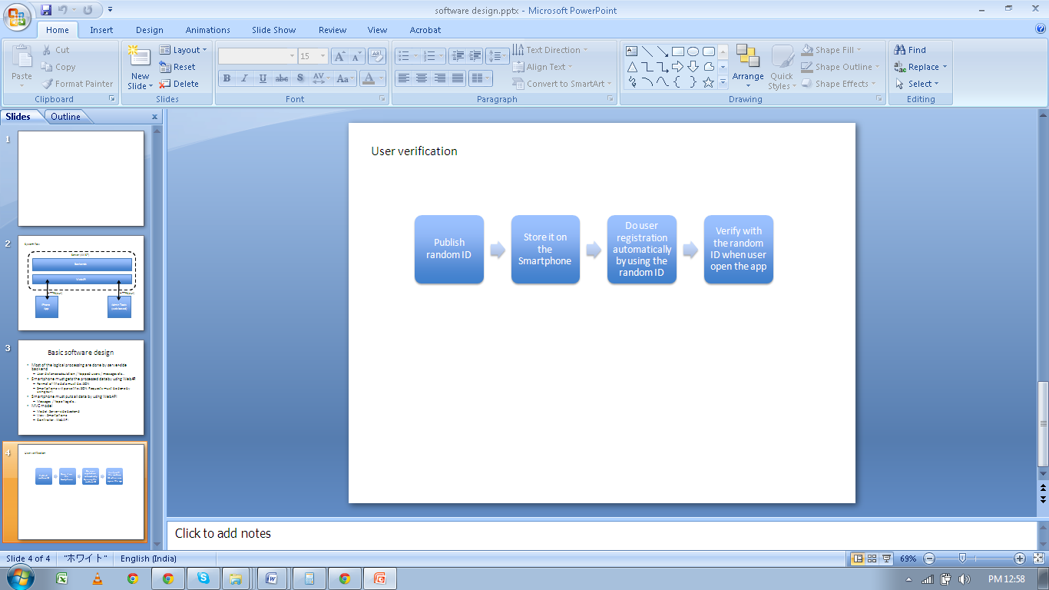

## **Splash Screen**

Client will design. We will send all necessary files

**App Logo**

## **People Screen**

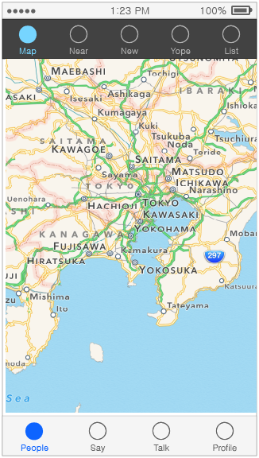

* This screen will be default home screen , user can see people in following way:
  + - **Map**- user can view the other app users on map screen. Other app users will be displayed as per the geographical location
    - **Near**- User can view the nearby other app users.
    - **New**-It will show the most recent posted comments regardless of when the user joined.
    - **Yope**- User can view the list of users with whom they interacts most
      * **Will show other users who you have liked**
      * **If you select a user and go to their profile page then you can “Yope” them. All the users you have yoped will be displayed here, in order of the time you yoped them.**
    - **List**- user can view the other app user in list view.
      * **Only users you have added to list will be displayed here. You can add people to your list on their profile page (page 8)**

## **Near Screen**

## 

In this screen user will have following options:

* User can view the other nearby users.
* Other app users will be shown as per the geographical location on this screen. If someone is located on the left side of user geographically he will be displayed on the left portion of screen. same concept will be of other directions.
* User can tap on particular person and they will be navigated to profile screen of that user
* User can do following with other users:
  + - Talk
    - Add to list
    - Yope
    - Block- If the user selects this they have two options: block the user and report, and block only. We will be able to see a list of reported users on admin site
    - User can send images

## **Say Screen**

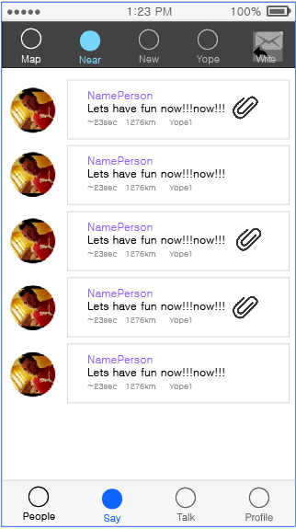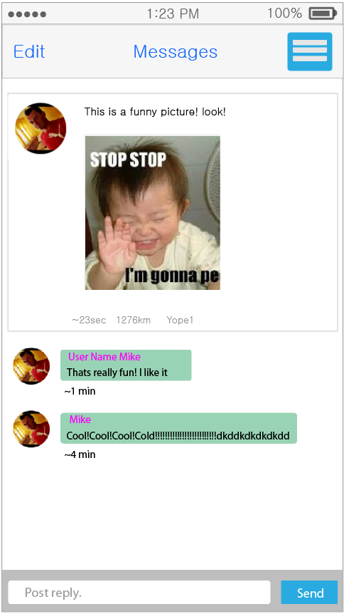

In this screen user will have following options:

* 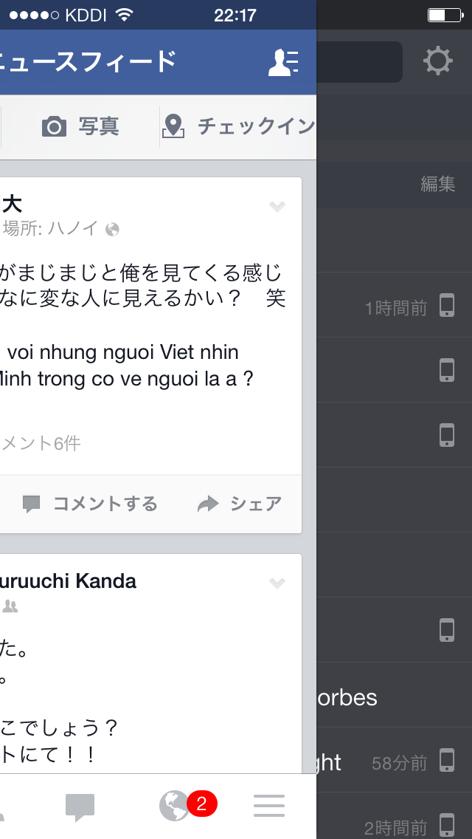User can share images among other app users
* User and other users can post their comment s on the shared images as shown in above screen
* User can swipe down to reveal search box like Apple’s native imessage in ios7

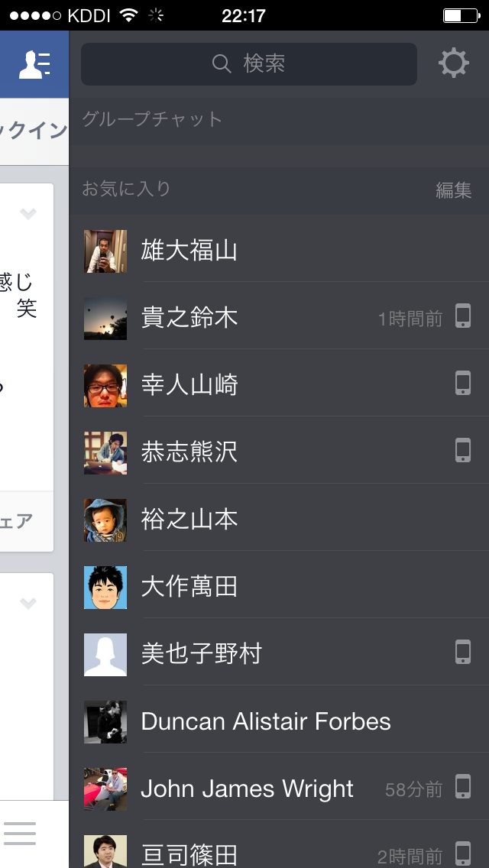

* This will show a list of past posts by the author of the present post
* User can also swipe from the right like facebook screenshot on the left

## **Talk Screen**

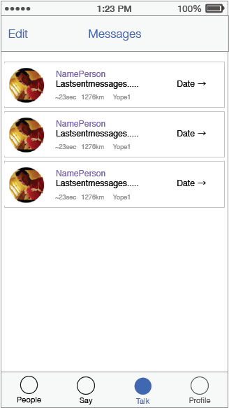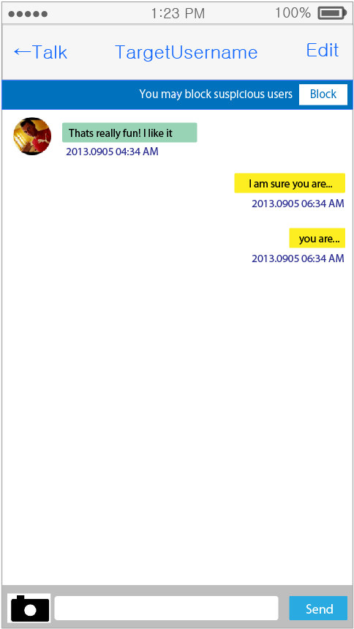

**User can swipe down to reveal search box like Apple’s native imessage in ios7**

* User can select the other user from different screen and can start chatting with them in a separate screen
* Only images can be shared in chatting screen

## **Profile Screen**

* This refers to the number of times the profile has been viewed by other users

## 

In this screen user will have following options:

* User can create a profile when he start the app for the first time. Or at any time after.
* In profile following thing will be shown publicly:
  + - Last Login(user can manage last login detail of how much duration will be displayed publically)
    - Location
    - Gender

Everything entered in the profile will be shown publicly.

* User can manager following in profile:
  + - Blocked user- user can block any user to restrict them to interact, user can manage block users , they can unblock too
    - Message- User can set the parameters that who can message them Options: from everyone, from users you have Yoped, from users in list, from no one

**2.2 Server Implementation**

1. Admin Panel will also be developed using which the admin will enter data for various sections.
2. Web Services will be created in order to track the activity on the server database from the users app

**Application DB Flow**

Users, profiles, chats

will be stored on FTP (physical path) Location

**Cloud Server**

**Mobile App**

**FTP**

**Database**

**Webservices**

Users, profiles, chat

Etc

**Application Compatibility**

https://mail.google.com/mail/u/0/images/cleardot.gif

|  |  |  |
| --- | --- | --- |
| **Platform** | **Screen Resolution** | **Supported Devices** |
| **iPhone(ios 7.0,Xcode 4.5)** | |  |  | | --- | --- | | **3G, 3GS,4,4S** | **5.0** | | 960 x 640**,** | 640 x 1136 | | **iPhone 3G, iPhone**  **3GS, iPhone 4,iPhone 4S, iPhone 5** |

https://mail.google.com/mail/u/0/images/cleardot.gif

**Application Development Methodology**

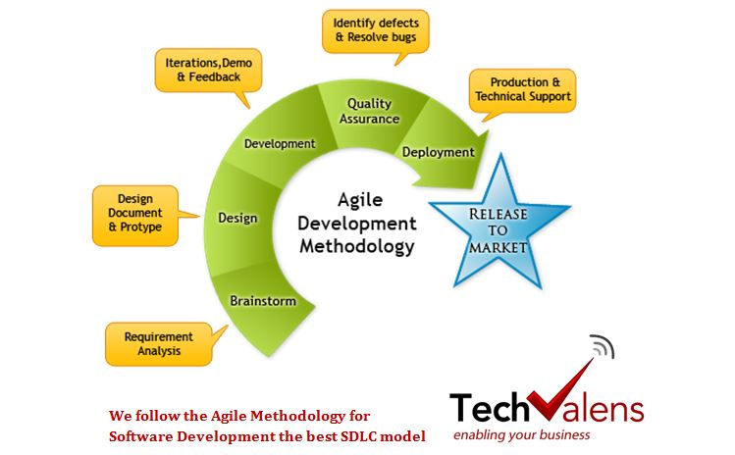

We follow Agile Methodology for ourprojects;TechValensproposes to follow our standard development model for software development.

### **Requirement Analysis:**The TechValensteam, in consultation with the customer, studies the complete system in-depth as given in the contract and the related supporting documents, such that each process linked to the final preparation of the software is clearly understood. The SRS document will be prepared, containing the application overview, scope, objectives, need and purpose, software and hardware interfaces, any issues or concerns, and more.

### **Software Design Phase:** Based on the software requirements and operation concepts documented in the base lined SRS, detailed design solutions are worked out depending upon performance, availability of reusable components, and integration with other applications. TSD and WFD documents are produced and base lined.

### **Development and Integration:** Coding is done based on base lined TSD, WFD, and the SRS. Unit testing is done on completion of development of each unit.

### **Testing:** Product testing will be done at this stage by the QC team in accordance with the test plan and test cases.

### **Releases:** The product will be released to the client after the bug fixing and successful product verification by the QC team.

### **Post Production Support and Maintenance:** Post production and support is provided on the project. In case of maintenance a change request log is maintained in order to keep track of changes and support requests.

# Project Management-

## 3.1 CLIENT Effort Required

|  |  |  |  |
| --- | --- | --- | --- |
| **Task** | **Level of Involvement** | **Days** | **Description** |
| Project Management | Low |  | TechValens shall manage the project |
| Explanatory Meetings | Medium |  | Client may need to involve in requirement explanations. |
| Functional Design | Low |  |  |
| System Usability | Medium |  |  |
| Other |  |  |  |
| Total |  |  |  |

## 

## 3.2 Project Plan

| **Task** | **[Start]** | **[Finish]** | **[Deliverable]** |
| --- | --- | --- | --- |
| **Phase 1** |  |  |  |
|  |  |  |  |
| **Phase 2** |  |  |  |
|  |  |  |  |
| **Phase 3** |  |  |  |
|  |  |  |  |
| **Phase 4** |  |  |  |
|  |  |  |  |
| **Phase 5** |  |  |  |
|  |  |  |  |

## 3.3 Project Estimating

## The Project is being estimated to be delivered in **40 working days for YopeApp**

## 3.4. Assumptions& Queries-

1. The designs for the development would be provided by client.
2. The entire development will be done based on the requirement discussed in these document, any requirement which is not the part of this document may add up the additional cost for the project.
3. After project has been awarded, the project manager would be creating the entire process, functional document layout which will be done as per the regular discussion with client & project manager, on the basis of which the development phase would commence.
4. The project would be developed using Agile Methodology.

## 3.5 Risks

• Known Risks: these are based on assumptions identified during project startup

• Potential Risks: these are known from experience with similar projects

• Unknown Risks: these cannot be confirmed

This table identifies potential risks and suggests appropriate mitigating actions.

| No. | Category | Risk | Detail of Impact | Mitigating Actions |
| --- | --- | --- | --- | --- |
| 1 |  | [L/M/H] |  |  |
| 2 |  | [L/M/H] |  |  |
| 3 |  | [L/M/H] |  |  |
| 4 |  | [L/M/H] |  |  |
| 5 |  | [L/M/H] |  |  |

## 3.6Issues

This table identifies issues that need to be addressed prior to project kick-off.

| No. | Issue | Impact | Owner |
| --- | --- | --- | --- |
| 1 |  |  |  |
| 2 |  |  |  |
| 3 |  |  |  |
| 4 |  |  |  |
| 5 |  |  |  |
| 6 |  |  |  |
| 7 |  |  |  |
| 8 |  |  |  |
| 9 |  |  |  |
| 10 |  |  |  |