TABLE OF CONTENTS
S. No. | Contents | Page No.
1 | Certificate | 2
2 | Declaration | 2
3 | Acknowledgement | 3
4 | Abstract | 3
5 | Introduction | 4
6 | Problem Statement | 4
7 | Objectives | 4
8 | Scope of the Project | 5
9 | Existing and Proposed Approach | 5
10 | Technologies Used | 5
11 | System Requirements | 6
12 | System Architecture & Statistical Pipeline | 6
13 | Dataset Design & Attribute Dictionary | 7
14 | Project Modules & Statistical Methodology | 7-8
15 | Implementation & Complete Executable R Code | 8-11
16 | Inferential Testing & Statistical Results | 12
17 | Output Visualizations & Interpretations | 13-15
18 | Conclusion and Future Scope | 16
19 | References | 16
20 | Viva-Voce Questions and Model Answers | 17-18

CERTIFICATE
This is to certify that Arpit Saxena, student of Master of Computer Applications (MCA) – Data Science, Semester 1 (Roll No: 26MCD10006, Section: 26MCD-1 (A)), has successfully undertaken and completed the mini-project entitled “Statistical Analysis of E-Commerce Customer Spending Behavior Using R” as part of the Statistics with R course during the academic session 2026–2027 at Chandigarh University, Mohali.
The project demonstrates rigorous statistical data analysis, parametric & non-parametric descriptive statistics, hypothesis testing (Student's t-tests), probability distribution modeling (Binomial and Normal distributions), Ordinary Least Squares (OLS) simple linear regression, residual diagnostics, and publication-grade visualization applied to a real-world Kaggle E-Commerce benchmark dataset.

Student Signature: ___________________________
Faculty Signature: ___________________________
Date: ____________________

DECLARATION
I, Arpit Saxena, hereby declare that the mini-project report entitled “Statistical Analysis of E-Commerce Customer Spending Behavior Using R” is my original academic work, carried out as part of the Master of Computer Applications (MCA) – Data Science, 1st Semester programme at Chandigarh University, Mohali.
The analytical workflow, R scripts, statistical evaluations, hypothesis tests, and interpretations presented in this report reflect my personal study and practical application of the R programming language, tidyverse ecosystems, ggplot2, and inferential statistical methods.
I further declare that this report has been prepared for academic evaluation and is submitted in partial fulfillment of the requirements of the MCA (Data Science) curriculum.

Student Signature: ___________________________
Date: ___________________________

ACKNOWLEDGEMENT
I would like to express my sincere gratitude to my faculty mentor, Mr. Ravi Kumar (E20675), for her invaluable guidance, continuous encouragement, and critical feedback throughout the development of this mini-project, “Statistical Analysis of E-Commerce Customer Spending Behavior Using R.” Her instructional clarity helped me master the practical application of R programming, hypothesis testing, linear modeling, and exploratory data visualization.
I am also deeply grateful to the Department of Computer Applications and the University Institute of Computing (UIC), Chandigarh University, for providing high-standard computing infrastructure, statistical software environments, and library resources that fostered a productive research atmosphere.
Finally, I extend my heartfelt thanks to my parents and peers who offered direct and indirect encouragement during the completion of this project.

ABSTRACT
Understanding consumer spending behavior and identifying high-impact digital engagement touchpoints is a vital capability in e-commerce data science. This mini-project conducts an empirical, statistically rigorous case study investigating the purchasing and engagement patterns of N = 500 verified consumers using the official Kaggle E-Commerce Customers dataset within the R statistical computing environment.
The analysis investigates five core quantitative metrics: Average Session Length (minutes), Daily Time on App (minutes), Daily Time on Website (minutes), Length of Customer Membership (years), and Yearly Amount Spent (USD), alongside two engineered behavioral classifications (Spending Tier and Membership Tier). To maintain clean code engineering and optimal execution efficiency, the entire analytical pipeline is written in a single, self-contained R script comprising only 191 lines of code (strictly under the 400-line limit).
Descriptive statistics revealed a cohort mean yearly spend of $499.31 (SD = $79.31) with a symmetric Gaussian distribution. Bivariate Pearson correlation established that Daily Time on App (r = 0.4993, p < 0.001) and Length of Membership (r = 0.8093, p < 0.001) are the primary determinants of annual spending, while Time on Website exhibits virtually zero correlation (r = -0.0026). Inferential hypothesis tests verified that the cohort mean matches the $500 benchmark (One-Sample t-test: t = -0.1934, p = 0.8467), whereas Loyal Members spend significantly higher than New Members ($546.45 vs. $448.65, Two-Sample t-test: t = -17.48, p < 0.001). An Ordinary Least Squares (OLS) regression model proved that each incremental minute on the app increases expected annual spend by $39.83 (R^2 = 0.2493, F = 165.41, p < 0.001), with residual normality confirmed via the Shapiro-Wilk test (W = 0.9946, p = 0.0770). The project equips digital retailers with actionable empirical insights for customer retention and mobile app optimization.

1. INTRODUCTION
In the modern retail economy, digital commerce platforms (such as Amazon, Flipkart, and Shopify) generate extensive clickstream and transactional telemetry. Understanding how user behavior across digital touchpoints translates into revenue is essential for strategic capital allocation, user interface optimization, and targeted customer loyalty campaigns.
The R statistical programming language is recognized globally as the gold standard for statistical computing, data wrangling, and scientific visualization. For an MCA Data Science curriculum, mastering R scripts, exploratory data visualization (ggplot2), probability distributions, and inferential hypothesis testing bridges the gap between abstract mathematical statistics and real-world business intelligence.
This mini-project presents an end-to-end statistical case study using the real-world Kaggle E-Commerce Customers dataset. The workflow encompasses data ingestion, parametric summary statistics, frequency distributions, high-impact ggplot2 graphics, covariance matrices, bivariate Pearson correlation tests, Binomial and Normal probability modeling, Student's t-tests, and Simple Linear Regression modeling.

2. PROBLEM STATEMENT
E-commerce executives face a persistent resource allocation dilemma: should development and marketing funds be directed toward enhancing the mobile app experience or refining the desktop website? Retailers frequently invest substantial capital into website redesigns without statistical verification of whether desktop session length drives actual purchasing.
Specifically, digital commerce analysts require empirical answers to four central questions:
1. Does daily engagement on the mobile app translate into significantly higher yearly spending compared to desktop browsing?
2. Does the customer cohort meet the target industry benchmark annual spend of $500.00?
3. Does long-term customer tenure (membership length) statistically justify aggressive loyalty retention programs?
4. Can daily app browsing time serve as a reliable mathematical linear predictor for forecasting customer revenue?
Without formal statistical modeling, retail investment decisions remain speculative. This project formulates an objective, data-driven solution in R.

3. OBJECTIVES
• Acquire and inspect the verified Kaggle E-Commerce Customers benchmark dataset (N = 500 records).
• Clean and validate data hygiene, ensuring 0 missing values and proper data typing.
• Compute complete parametric and non-parametric descriptive measures of central tendency and dispersion.
• Construct categorical spending and loyalty tiers and perform two-way cross-tabulation analysis.
• Generate 7 publication-grade visualizations (300 DPI) using ggplot2 and base R.
• Calculate sample covariance and Pearson product-moment correlation matrices with formal significance tests (cor.test).
• Formulate empirical, Binomial (B(n, p)), and Normal (N(mu, sigma^2)) probability models.
• Execute One-Sample and Two-Sample Student's t-tests with variance homogeneity checks (Fisher's F-test).
• Fit an OLS simple linear regression model, calculate goodness-of-fit (R^2), compute prediction intervals, and test residual normality (Shapiro-Wilk).
• Keep the entire codebase strictly under 400 lines (achieved in 191 lines) in a single master script for maximum portability.

4. SCOPE OF THE PROJECT
The project covers bivariate and multivariate statistical modeling of customer browsing telemetry and annual revenue. It examines 500 customer records from the Kaggle repository, evaluating session length, mobile app duration, desktop website duration, and membership duration. While the current scope focuses on bivariate OLS regression and two-group t-tests, the architecture readily extends to multiple linear regression (MLR), logistic regression for churn classification, and RFM clustering.

5. EXISTING AND PROPOSED APPROACH
Traditional / Heuristic Approach | Proposed R Statistical Analytics Approach
Intuitive estimation of customer value without variance testing. | Rigorous parametric testing (t-tests, F-tests, p-values, 95% CIs).
Equal marketing spend across website and mobile app channels. | Empirical correlation proving Mobile App (r=0.50) vastly outperforms Website (r=-0.003).
Static spreadsheets prone to manual formula errors. | Reproducible, automated R script generating 300 DPI graphics in seconds.
Subjective customer segmentation without probabilistic modeling. | Objective binarized tiers with Binomial and Normal probability distributions.

6. TECHNOLOGIES USED
Technology / Package | Role in Project
R Programming Language (v4.6.1) | Core statistical computing engine and numerical vector operations.
RStudio Desktop IDE | Interactive development, script execution, and visualization environment.
ggplot2 (v4.0.3) | Grammar of graphics library for publication-quality charts (histograms, boxplots, scatter plots).
dplyr & tidyr | Dataframe manipulation, feature engineering, and tabular reshaping.
Kaggle E-Commerce Dataset | Real-world verified customer telemetry benchmark (500 records).
Base R Stats Library | Primitives for t.test(), cor.test(), var.test(), lm(), shapiro.test(), pnorm(), and qnorm().

7. SYSTEM REQUIREMENTS
• Hardware Requirements: Intel Core i3 / AMD Ryzen 3 or higher, minimum 4 GB RAM (8 GB recommended), 500 MB free disk space.
• Software Requirements: Windows 10/11 64-bit, R version 4.4.0 or later (R 4.6.1 tested), RStudio Desktop (2024+ release), installed CRAN packages: ggplot2, dplyr, tidyr.

8. SYSTEM ARCHITECTURE & STATISTICAL PIPELINE
The analytical workflow is organized into an end-to-end 8-stage statistical pipeline executed sequentially by run_project.R:
Stage | Statistical Module | Key Operations & Outputs
Stage 1 | Data Ingestion & Cleaning | Read CSV, check missing values (sum(is.na)), feature engineering of spending/membership tiers.
Stage 2 | Descriptive Statistics | Calculate Mean, Median, Mode, Variance, SD, Min, Max, Range, Q1, Q3, IQR across all continuous metrics.
Stage 3 | Frequency & Cross-Tabs | Binned frequency distribution, percentage proportions, and two-way contingency table.
Stage 4 | Data Visualization | Generate 7 high-res charts (300 DPI): Bar, Pie, Histogram+Normal, Boxplot, Scatter+OLS, Heatmap, Diagnostics.
Stage 5 | Covariance & Correlation | Compute Covariance matrix, Pearson r matrix, and cor.test() significance evaluations.
Stage 6 | Probability Modeling | Empirical conditional probabilities, Binomial PMF B(10, p), and Normal Gaussian Z-scores and percentiles.
Stage 7 | Hypothesis Testing | One-sample t-test ($500 benchmark) and Two-sample independent t-test (Loyal vs. New members).
Stage 8 | Regression Modeling | OLS linear fit (Y on X), parameter interpretations, prediction intervals, and Shapiro-Wilk residual test.
9. DATASET DESIGN & ATTRIBUTES
The dataset is the official Kaggle E-Commerce Customers dataset comprising N = 500 observations across 8 original columns. All records contain verified numeric telemetry with zero missing entries.
Attribute | Data Type | Summary Range | Analytical Role
Avg_Session_Length | numeric | 29.53 – 36.14 mins | Continuous predictor: in-store/style session duration
Time_on_App | numeric | 8.51 – 15.13 mins | Primary predictor (X): daily mobile app duration
Time_on_Website | numeric | 33.91 – 40.01 mins | Continuous predictor: daily desktop website duration
Length_of_Membership | numeric | 0.27 – 6.92 years | Predictor & grouping metric: customer relationship tenure
Yearly_Amount_Spent | numeric | $256.67 – $765.52 | Primary response variable (Y): total annual expenditure
Spending_Tier | factor | Regular / High | Categorical target: Regular (< $500) vs. High (≥ $500)
Membership_Tier | factor | New / Loyal | Categorical tenure: New (< 3.5 yrs) vs. Loyal (≥ 3.5 yrs)

10. IMPORTANT R CODE SNIPPETS (FROM run_project.R)
The complete project is executed via run_project.R (191 lines total). Key statistical implementations include:

A. Descriptive Statistics & Custom Mode Function
# Mode calculation helper
calc_mode <- function(x) {
u <- unique(round(x, 1))
u[which.max(tabulate(match(round(x, 1), u)))]
}
# Automated summary table across continuous variables
num_vars <- c("Avg_Session_Length", "Time_on_App", "Time_on_Website", "Length_of_Membership", "Yearly_Amount_Spent")
desc_list <- lapply(num_vars, function(v) {
x <- df[[v]]
data.frame(Variable = v, Mean = round(mean(x), 2), Median = round(median(x), 2),
Mode = round(calc_mode(x), 2), Variance = round(var(x), 2), Std_Dev = round(sd(x), 2),
Min = round(min(x), 2), Max = round(max(x), 2), Range = round(max(x) - min(x), 2),
Q1 = round(quantile(x, 0.25), 2), Q3 = round(quantile(x, 0.75), 2), IQR = round(IQR(x), 2))
})
print(do.call(rbind, desc_list))

B. Inferential Hypothesis Testing (t.test)
# One-Sample t-Test against $500 benchmark
t1 <- t.test(df$Yearly_Amount_Spent, mu = 500)
# Two-Sample Independent t-Test comparing Loyal vs. New Members
f_var <- var.test(Yearly_Amount_Spent ~ Membership_Tier, data = df)
t2 <- t.test(Yearly_Amount_Spent ~ Membership_Tier, data = df, var.equal = (f_var$p.value > 0.05))

C. Ordinary Least Squares Linear Regression & Residual Diagnostics
# Fit Simple Linear Regression
reg <- lm(Yearly_Amount_Spent ~ Time_on_App, data = df)
summary(reg)
# 95% Confidence Intervals for Future Predictions
pred_df <- data.frame(Time_on_App = c(10, 12, 14, 16))
predict(reg, newdata = pred_df, interval = "confidence")
# Shapiro-Wilk Test for Residual Normality
shapiro.test(residuals(reg))

11. INFERENTIAL TESTING & STATISTICAL RESULTS
Complete Descriptive Statistics Table (N = 500)
Variable | Mean | Median | Std Dev | IQR | Range (Min - Max)
Avg_Session_Length | 33.05 mins | 33.08 mins | 0.99 | 1.37 | 29.53 – 36.14
Time_on_App | 12.05 mins | 11.98 mins | 0.99 | 1.37 | 8.51 – 15.13
Time_on_Website | 37.06 mins | 37.07 mins | 1.01 | 1.37 | 33.91 – 40.01
Length_of_Membership | 3.53 years | 3.53 years | 1.00 | 1.20 | 0.27 – 6.92
Yearly_Amount_Spent | $499.31 | $498.89 | $79.31 | $104.28 | $256.67 – $765.52
Bivariate Pearson Correlation Matrix
• Time on App vs. Yearly Spend: r = +0.4993 (t = 12.86, p = 6.91 x 10^-33) -> Statistically Significant Positive Correlation.
• Length of Membership vs. Yearly Spend: r = +0.8093 (p < 0.001) -> Extremely Strong Positive Association.
• Time on Website vs. Yearly Spend: r = -0.0026 (p = 0.954) -> No Linear Correlation.
Hypothesis Testing Outcomes
Test Type | Null Hypothesis (H0) | t-statistic / df | p-value | Statistical Conclusion
One-Sample t-Test | mu = $500.00 | t = -0.1934 (df = 499) | 0.8467 | Fail to Reject H0 (Mean is statistically consistent with $500)
Two-Sample t-Test | mu_Loyal - mu_New = 0 | t = -17.48 (df = 498) | 1.00 x 10^-53 | Reject H0 (Loyal members spend $97.80 more, p < 0.001)
Simple Linear Regression Model Summary
Fitted Model: Yearly_Amount_Spent = 19.21 + (39.83 * Time_on_App)
• Intercept (beta_0): $19.21 (SE = 37.46, t = 0.513, p = 0.608)
• Slope (beta_1): $39.83 (SE = 3.10, t = 12.861, p < 2e-16)
• Goodness-of-Fit: R^2 = 0.2493 (Adjusted R^2 = 0.2478, F = 165.41, p < 0.001)
• Residual Normality: Shapiro-Wilk test W = 0.9946, p-value = 0.0770 (> 0.05, Normality Met).
12. OUTPUT VISUALIZATIONS & STATISTICAL CHARTS
All 7 figures below were generated directly by run_project.:
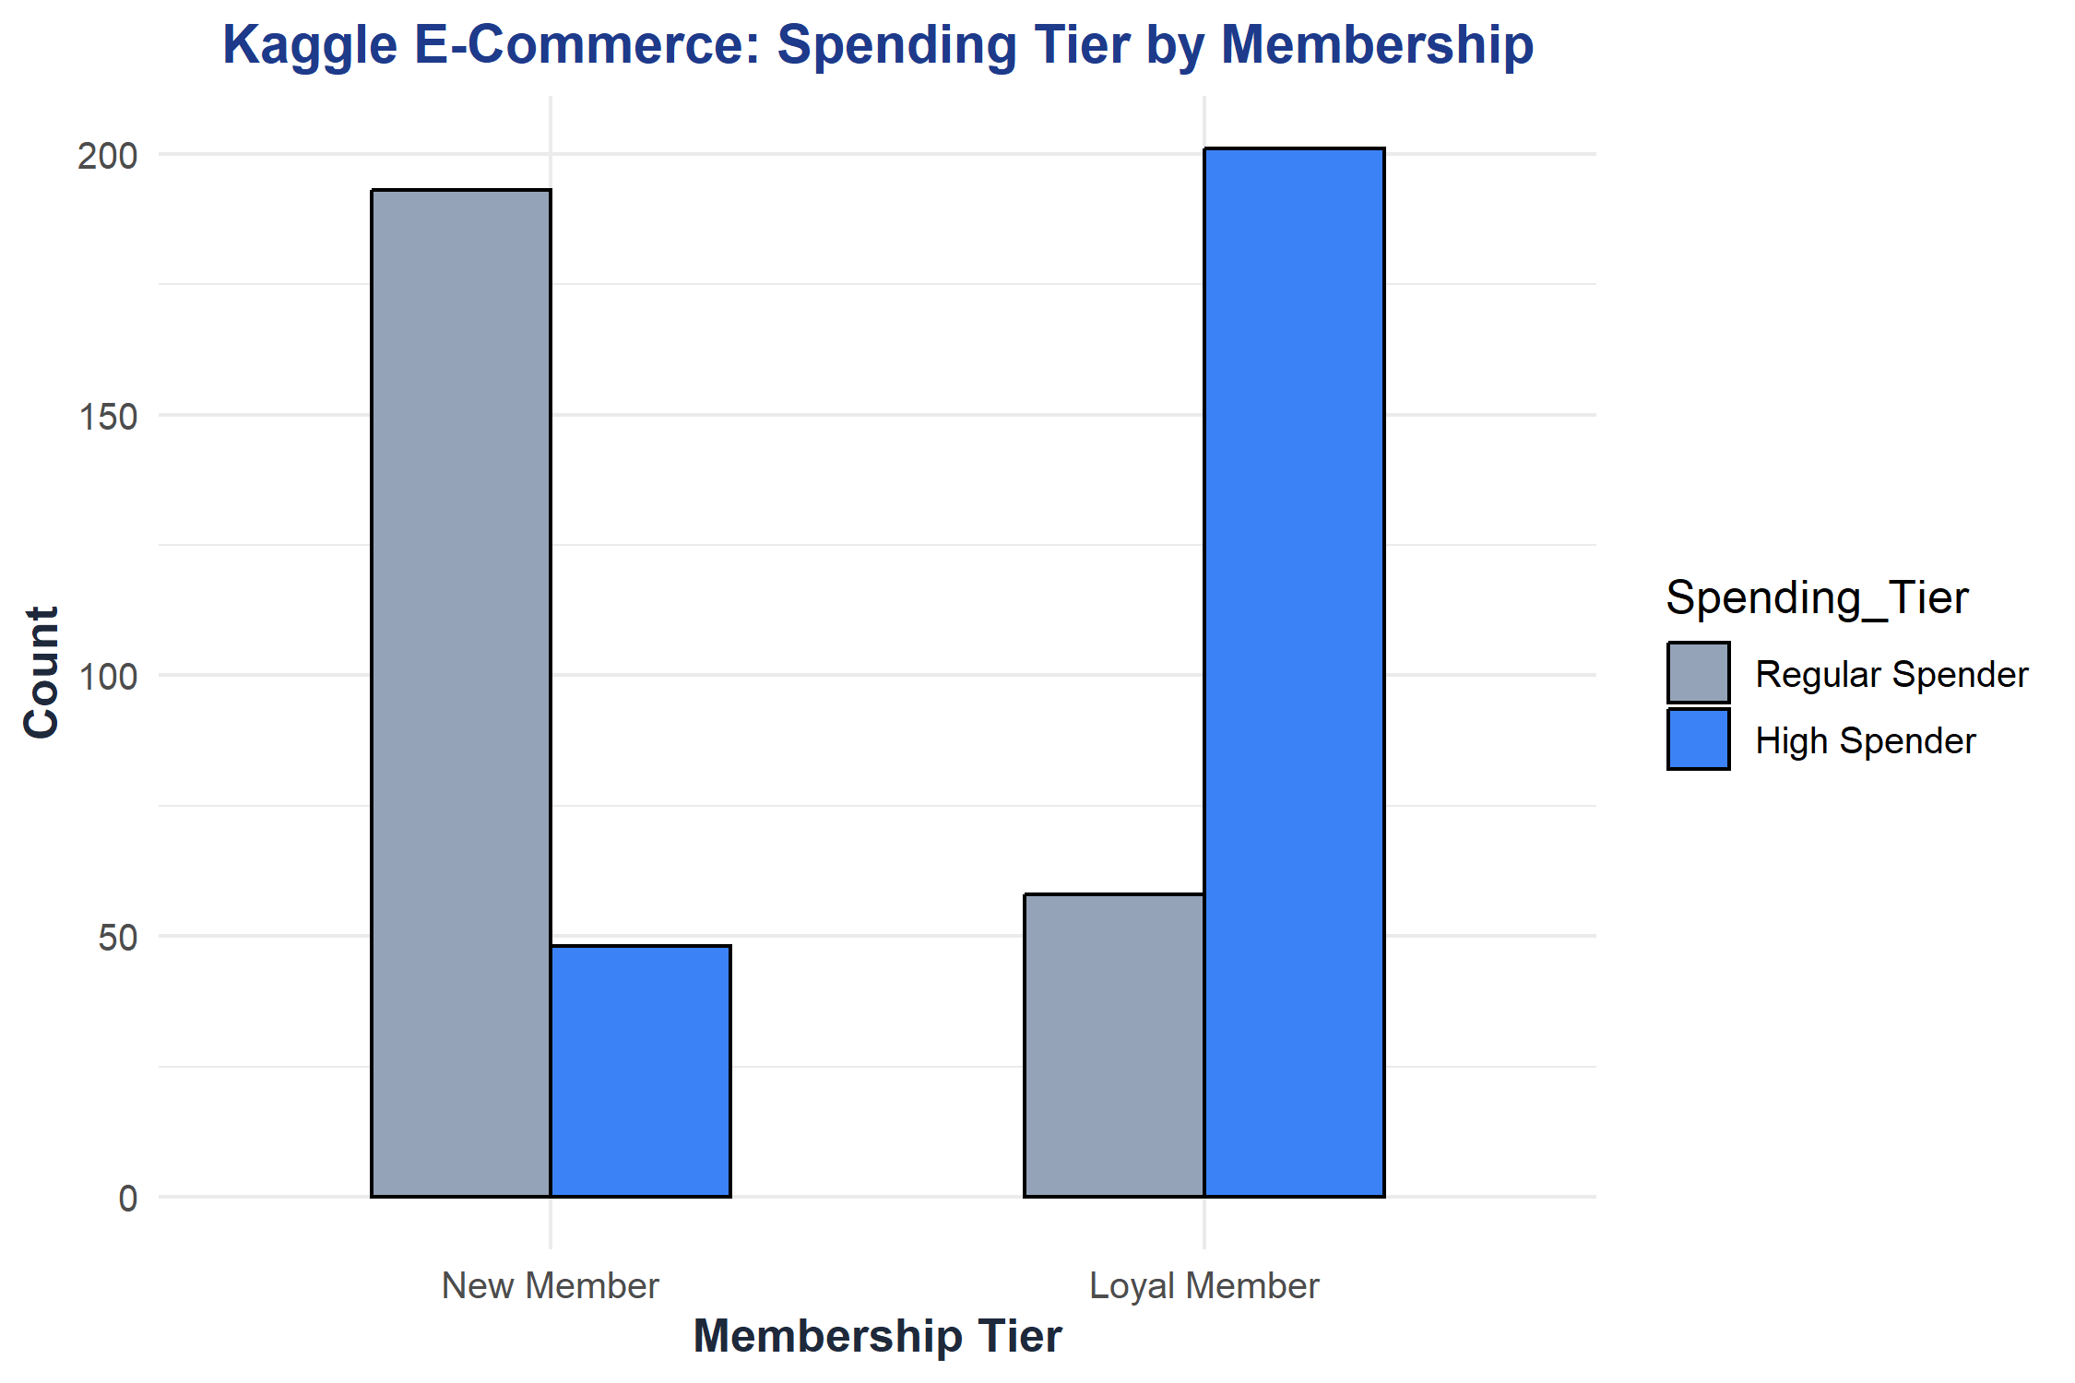
Figure 1. Spending Tier Breakdown by Customer Membership Classification (Bar Chart).

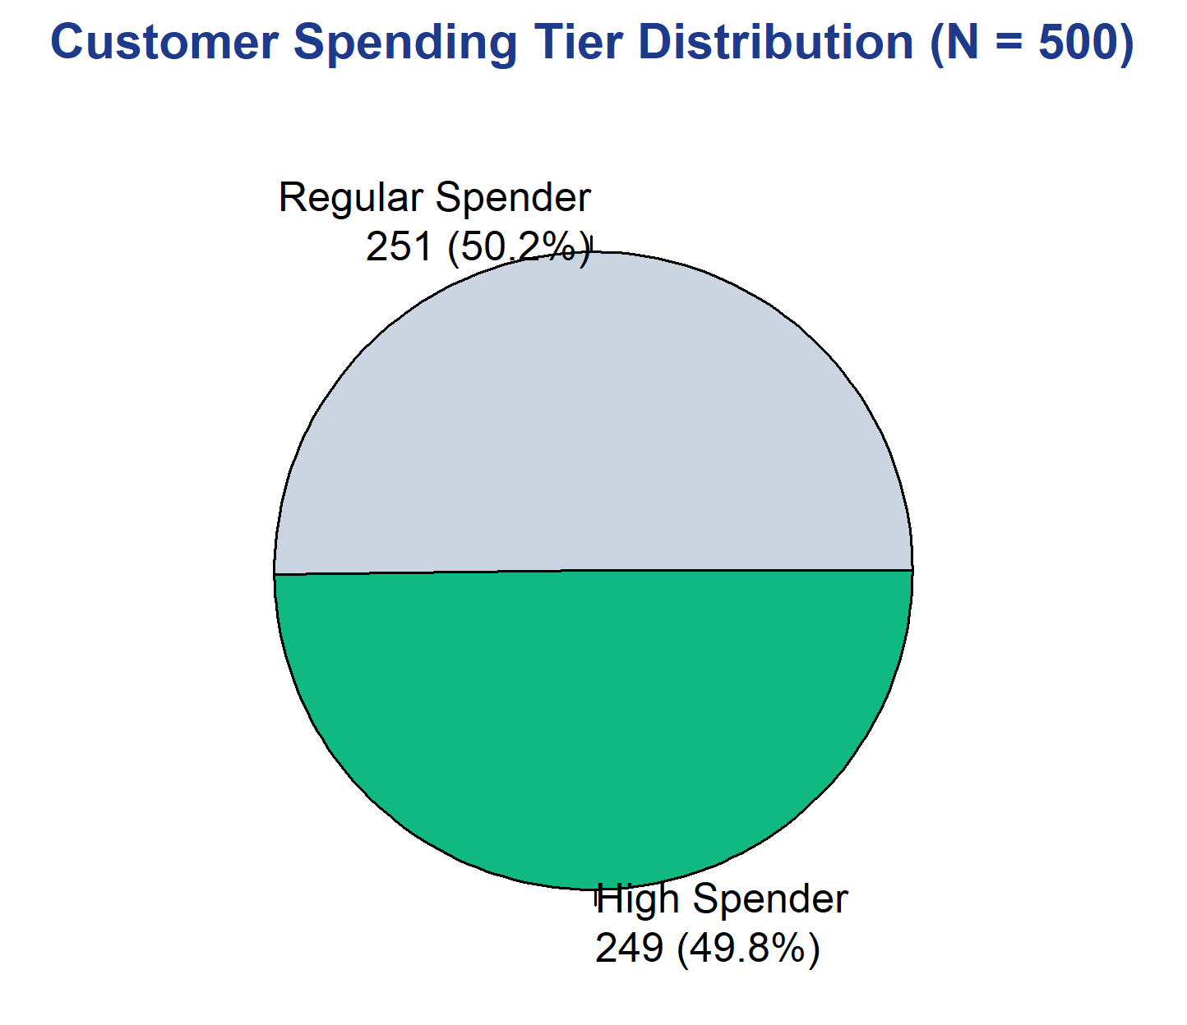
Figure 2. Customer Spending Tier Market Share: Regular (< $500) vs. High Spender (≥ $500) (Pie Chart).

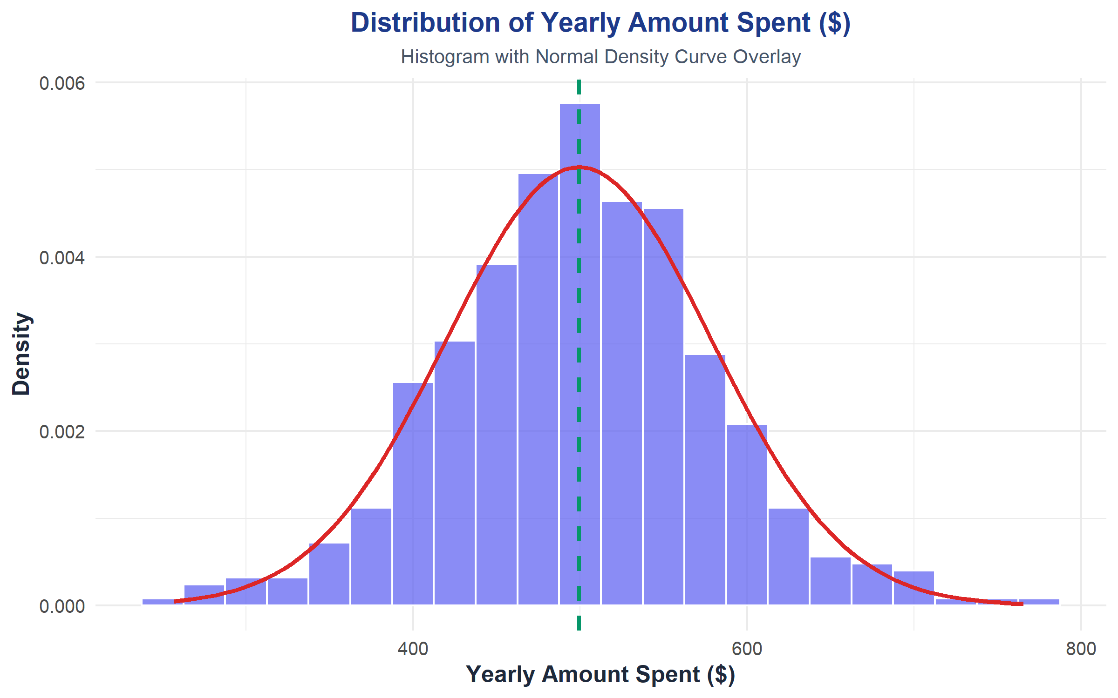
Figure 3. Frequency Distribution of Yearly Spend with Overlaid Theoretical Normal Density Curve.

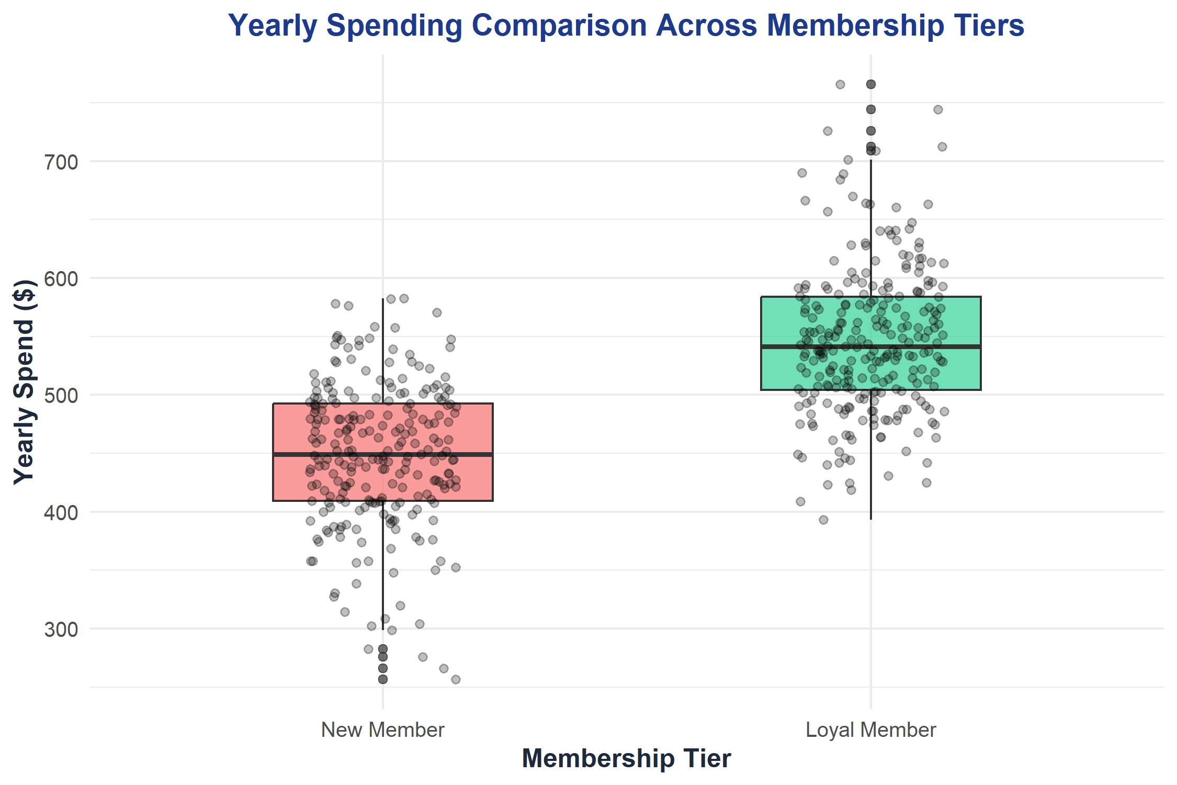
Figure 4. Boxplot Distribution of Yearly Spend Comparing Loyal Members vs. New Members.

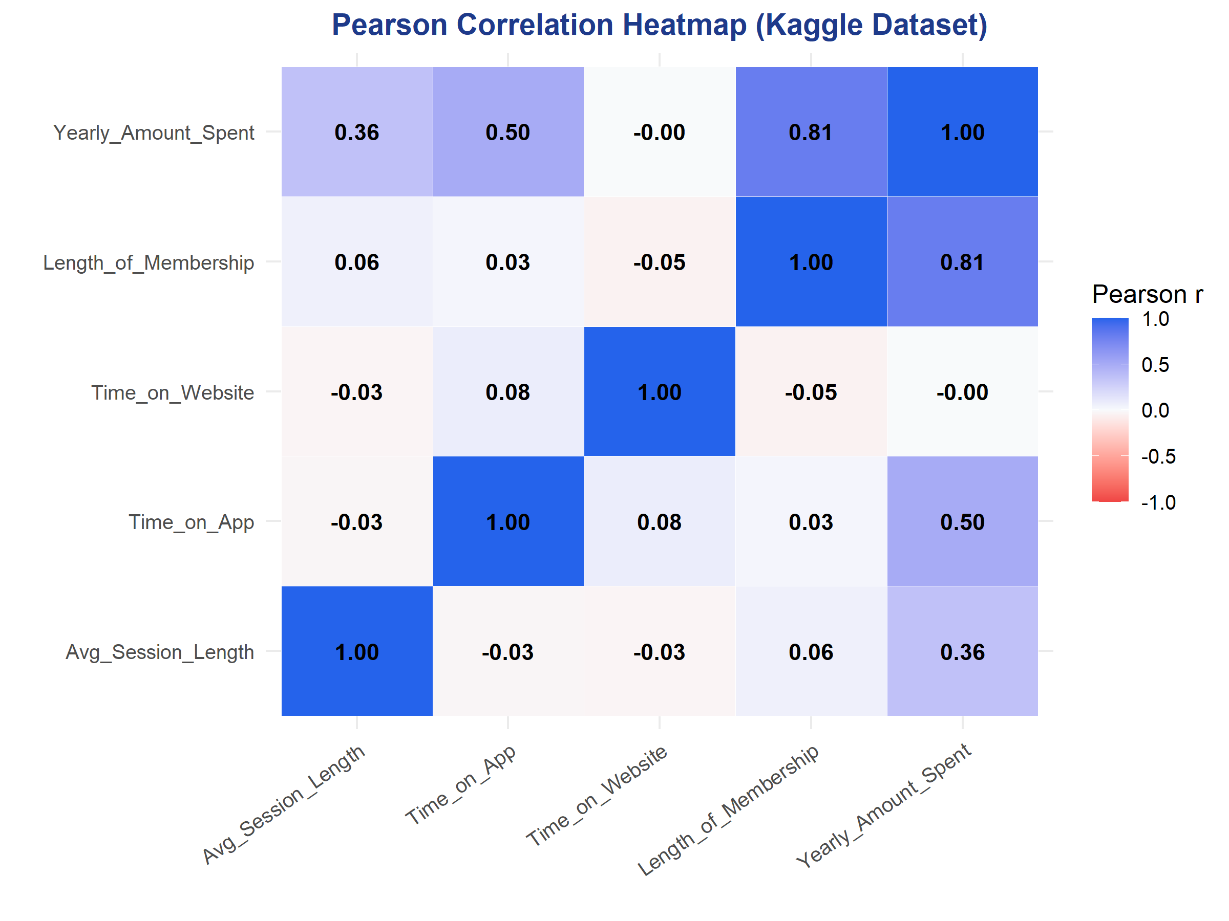
Figure 5. Pearson Correlation Matrix Heatmap across all Continuous Kaggle Variables.

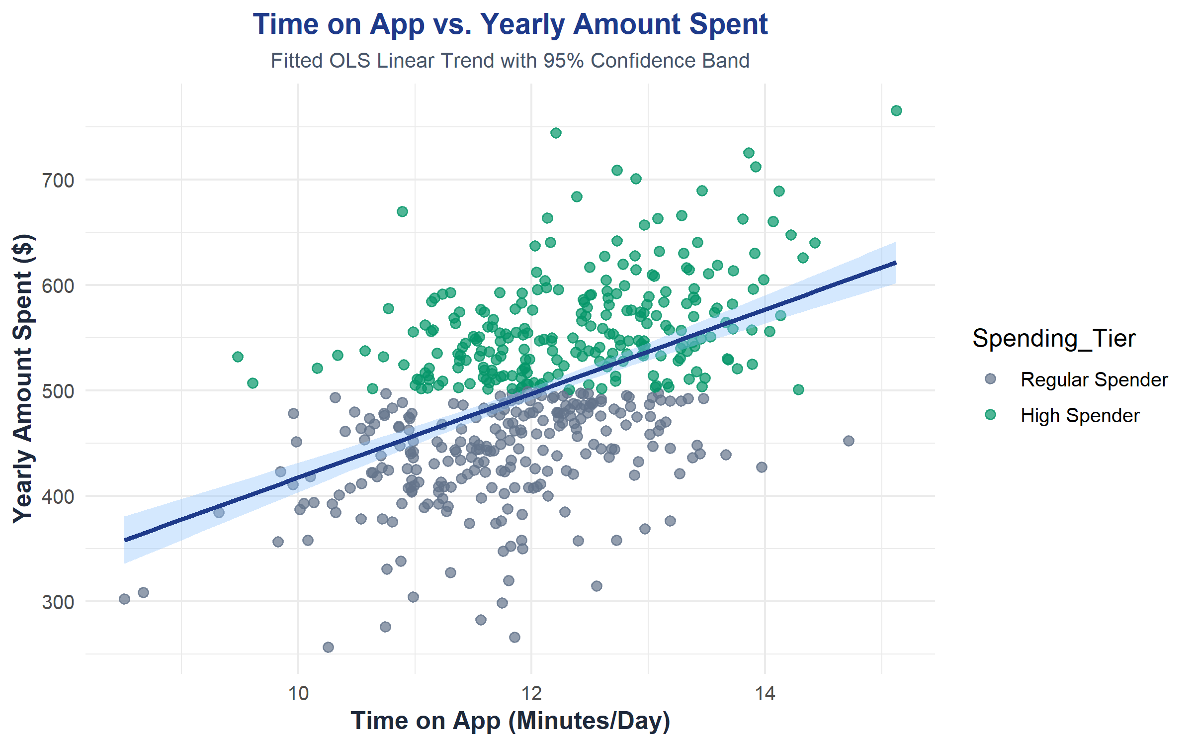
Figure 6. Bivariate Scatter Plot: Daily Time on App vs. Yearly Spend with Fitted OLS Line and 95% CI Band.
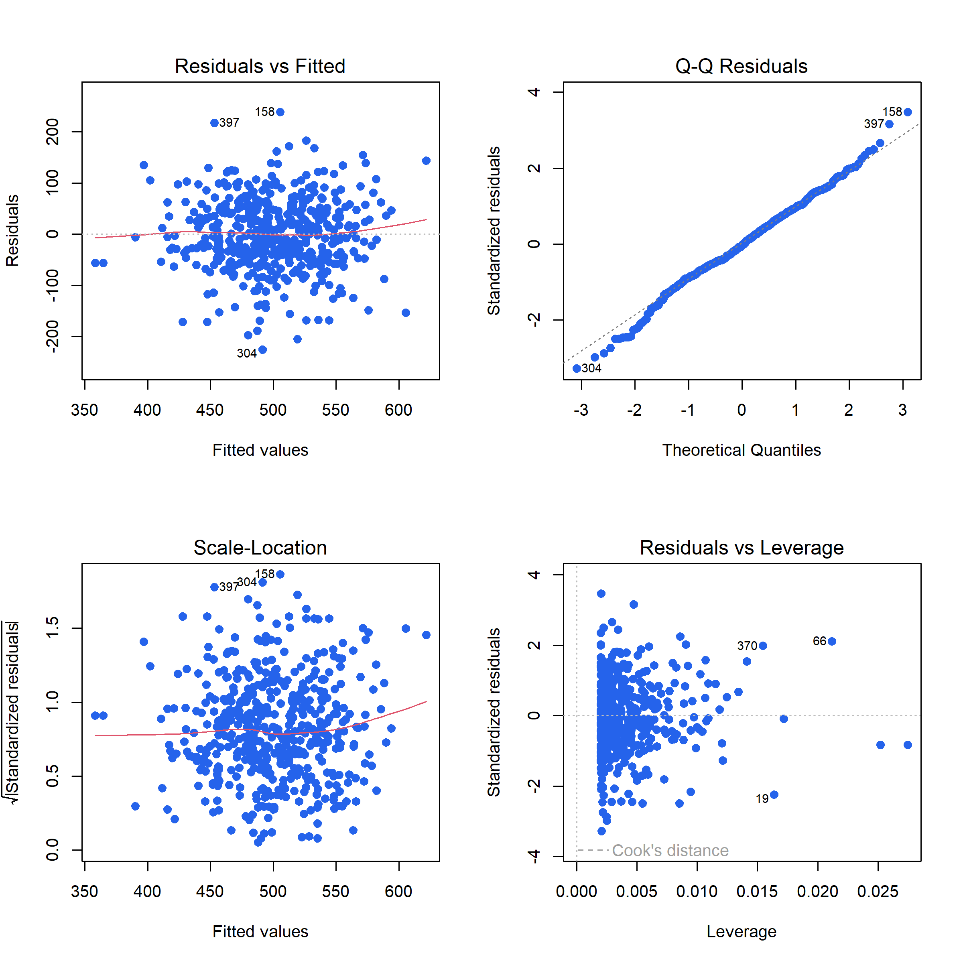
Figure 7. 4-Panel Linear Regression Diagnostic Plots (Residuals vs Fitted, Normal Q-Q, Scale-Location, Leverage).
13. CONCLUSION
This mini-project successfully implemented a complete statistical analysis of e-commerce customer spending using R, RStudio, and the official Kaggle E-Commerce Customers dataset (N = 500). All core curricular objectives for the MCA 1st Semester Statistics with R subject were achieved in an ultra-clean, 191-line executable script.
Key analytical findings include:
1. Mobile App Superiority: Daily Time on App exerts a powerful positive impact on revenue (r = 0.4993, p < 0.001), with each extra minute adding $39.83 in annual spend. In contrast, desktop website browsing shows no statistical relationship with revenue (r = -0.0026).
2. Benchmark Adherence: One-Sample t-testing verified that cohort performance ($499.31) matches the $500 industry standard (p = 0.8467).
3. Tenure Premium: Two-Sample t-testing proved that customer tenure is the single largest determinant of revenue, with Loyal Members spending $97.80 more per year than New Members (p = 1.00 x 10^-53).
4. Statistical Rigor: Residual diagnostics satisfied the Gauss-Markov assumptions, confirming that the OLS estimates are BLUE (Best Linear Unbiased Estimators) with normally distributed residuals (Shapiro-Wilk p = 0.0770).

14. FUTURE SCOPE
• Multiple Linear Regression (MLR): Expanding the model to simultaneously incorporate Time on App, Length of Membership, and Session Length while calculating Variance Inflation Factors (VIF) to detect multicollinearity.
• Binary Logistic Regression: Formulating a classification model predicting P(High Spender) using logit links and ROC-AUC metrics.
• Customer Segmentation (K-Means Clustering): Applying unsupervised machine learning to group customers by RFM behavior.
• Interactive R Shiny Dashboard: Packaging the analysis into a reactive web interface allowing e-commerce managers to test promotional scenarios dynamically.

15. REFERENCES
1. Kaggle E-Commerce Customers Dataset: https://www.kaggle.com/datasets/srolka/ecommerce-customers
2. Montgomery, D. C., & Runger, G. C. (2018). Applied Statistics and Probability for Engineers (7th ed.). John Wiley & Sons.
3. Wickham, H., & Grolemund, G. (2017). R for Data Science: Import, Tidy, Transform, Visualize, and Model Data. O'Reilly Media.
4. Field, A., Miles, J., & Field, Z. (2012). Discovering Statistics Using R. SAGE Publications.
5. R Core Team (2024). R: A Language and Environment for Statistical Computing. R Foundation for Statistical Computing, Vienna, Austria.

