# What is Project Constraints?

Project constraints are the general limitations of a project, including time, costs, and risks. Understanding project constraints is important because they affect project performance. In this piece, we’ll discuss project constraints in detail and explain how to manage them.

During the project life cycle, you’ll encounter various constraints, including time, costs, and risks. Part of your job as an effective project manager is learning how to balance these constraints in order to increase project performance. In this piece, we’ll discuss project constraints in detail and explain how to manage them.

Most project constraints impact one another, which is why constraint management is crucial for project success. If you decide that you must expand the project timeline, then you’ll likely need more money to complete the project as well. Your project scope will also expand when the time and cost of your project expand.

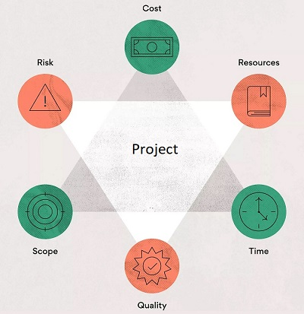

Scope

Project scope refers to a project’s magnitude in terms of quality, detail, and deliverables. Time and money are dependencies of project scope, because as the project scope grows, the project will require more time and money to complete.

You’ll need to be aware of scope creep throughout each project phase and work hard to prevent it. You can prevent scope creep by creating detailed project plans and getting project stakeholders to sign off on everything before production begins.

Cost

Cost constraints include the project budget as a whole and anything of financial value required for your project. Items that may be a cost constraint include:

* Project cost
* Team member salaries
* Cost of equipment
* Cost of facilities
* Repair costs
* Material costs

Include any items in this section that require you to pull from your company’s financial resources.

Time

Time management is essential for project success, and there are various time constraints you’ll face during each phase of your project. When you try to increase your project timeline, there will be consequences like extended deadlines, adjustments to the team calendar, or less time for planning.

Time elements in your project that can lead to constraints may include:

* Overall project timeline
* Hours worked on project
* Internal calendars and goalposts
* Time allotted for planning and strategy
* Number of project phases

Scope, cost, and time are called the iron triangle because these three constraints can be difficult to maneuver around each other while maintaining project quality. For example, if you cut your budget or increase your scope, you’ll likely need to compensate by loosening up on time. You can do this by extending deadlines, adding hours, or adjusting your project schedule.

Risk

Project risks are any unexpected occurrences that can affect your project. While most project risks are negative, some can be positive. For example, a new technology may be released while your project is in progress. This technology may help you finish your project quicker or it may cause more competition in the market and reduce your product value.

You can determine project risks using risk analysis and risk management strategies to keep them at bay. Some risks you may face include:

* Stretched resources
* Operational mishaps
* Low performance
* Lack of clarity
* Scope creep
* High costs
* Time crunch

Resources

Resources tie closely with cost constraints on your project because these project requirements cost money. Without proper resource allocation, can experience lower project quality, an increased budget, and timeline delays.

* Some resources to consider include:
* People
* Equipment or materials
* Facilities
* Software

Use a resource management plan to ensure you have the resources you need for every element of your project so that this constraint doesn’t negatively affect other project areas.

Quality

Project quality is the measure of how well your project deliverables meet initial expectations. Every project constraint affects project quality because project quality is the ultimate result of your project. However, project quality is also its own constraint because there are aspects of the project that can result in poor quality that aren’t necessarily related to cost, time, resources, risk, or scope. These include:

* Lack of communication
* Poor design or development skills
* Too many project changes

You must manage project quality as its own entity while also balancing the other five project constraints if you hope to achieve high project performance. If you fail to manage your constraints, the result can be low project quality and low customer satisfaction.

**Legal/Regulatory:** Compliance requirements, permits, and regulatory standards

**Environmental:** Sustainability requirements, ecological impact, and environmental regulations

**Stakeholder:** Requirements, expectations, and satisfaction levels

Scope

|  |  |
| --- | --- |
| **Project Scope Statement** | |
| **Project Title** | Title of the Project |
| **Project Manager** | Manager of the Project |
| **Project Justification** | A brief statement explaining the need of your project and how the project will help fulfill it. |
| **Project Scope Description** | Within Scope  Describe what falls within the scope of the project. |
| Out of Scope  Describe what is out of scope of the project. |
| **Business Objective** | Outline the targets; your business wants to cover with this project. |
| **Project Deliverables** | Define the deliverables; your team needs to work on producing to meet the set objectives. |
| **Project Exclusions** | Clearly outline what the project doesn’t include or will not produce. |
| **Constraints** | Identify factors that may impose limitations in terms of risks, resources, schedule, method, etc. that could affect the progress of your project. |
| **Assumptions** | What are the certain events that expected to occur during the course of the project? |

Estimated Cost



Actual Cost





Time