**EE 289**

**Project Report**

**Prepared By: Arpit Singh (010810514)**

**Ankita Chandrachud(010804833)**

**Scenario 1:**

**Output of the Parser code**:

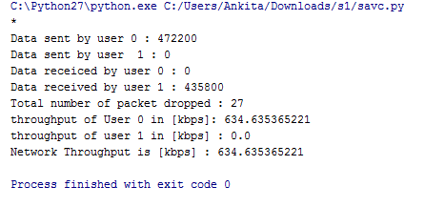

1. Describe how the MAC layer Mac/Simple decides who sends and when?

By the observation of the files mac-simple.cc and mac-simple.h, Following conclusion can be made:

* Its checks whether the channel is idle ie. no transmission is in progress.
* It picks up a back off time if the transmitter is already sending. Since every node uses different antennae for transmission and reception, it can transmit and receive at the same time
* There are the classes like MacSimpleWaitTimer and MacSimpleSendTimer to start the timer for sending and acknowledgement reception. The nodes also look for the event like packet transmitted, packet received or collision.So, the nodes do not see if the line is busy or not. If they have something to send, they start sending, if there are any collision events, the decision is made whether to transmit or choose a back off.

2.

The reason for the dropped packets can be found out by observing the handler function of the cc file

The reasons of the file drop are:

1.If the channel used is not full duplex and the transmission which is taking place is sending and receiving simultaneously then the one of the packet will be dropped.

2.Collision of packet.

3.Packet has errors .(Checksum )

The reason for the dropped file is seen ERR which indicates the packet was dropped either because of checksum or the the received power is less than the threshold

**Scenario 2:**

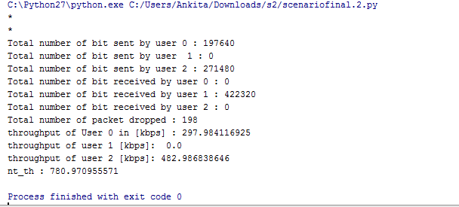

Lines of code that are changed: Added a new user

set val(nn) 3 ;# number of mobilenodes

#added these coordinates

$node_(2) set X_ 200.0

$node_(2) set Y_ 200.0

$node_(2) set Z_ 0.0

# TCP connections between node_(0) and node_(2)

set tcp [new Agent/TCP]

$tcp set class_ 2

$tcp set rate_ 200kb

set sink [new Agent/TCPSink]

$ns_ attach-agent $node_(2) $tcp

$ns_ attach-agent $node_(1) $sink

$ns_ connect $tcp $sink

set ftp [new Application/FTP]

$ftp attach-agent $tcp

$ns_ at 1.5 "$ftp start"

2. Changes in throughput:

Throughput in situation first scenario is: 634.63kbps

Throughput of second scenario is: 780.97 kbps

Hence it can be seen that the throughput of second scenario has increased by 146.34 kbps

**Scenario 3:**

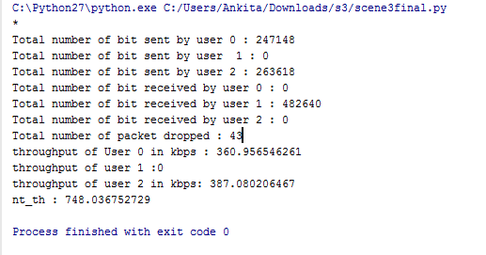

1. Lines of code that are changed:

The changes we have done is to change the MAC to 802.11

set val(mac) Mac/802_11 ;# MAC type

1. Throughput Comparison:

|  |  |  |  |
| --- | --- | --- | --- |
| Sr.No |  | Scenario 2 | Scenario 3 |
| 1 | Transmitter 0 | 297.98 | 360.956546261 |
| 2 | Transmitter 2 | 482.98 | 387.080206 |

* From the above table we can infer that the throughput of the transmitter 0 increased significantly fron 297.98 to 360.95
* Whereas for the second transmitter the throughput reduced from 482.98 to 387.080.

3.Network throughput:

|  |  |  |  |  |
| --- | --- | --- | --- | --- |
| Sr.No |  |  | Scenario 2 | Scenario 3 |
| 1 | Network Throughput | Network Throughput | 780 | 748.03 |

The network throughput of scenario 3 has reduced from scenario 2.

**Scenario 4:**

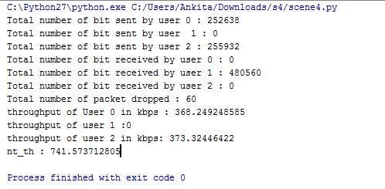

1. Changes made to the code:

* Comented out the folowing lines of code

# Now produce some simple node movements

# Node_(1) starts to move towards node_(0)

#$ns_ at 0.0 "$node_(0) setdest 50.0 50.0 10.0"

#$ns_ at 0.0 "$node_(1) setdest 150.0 150.0 0.0"

#$ns_ at 0.0 "$node_(2) setdest 180.0 180.0 10.0"

# Node_(1)(2) then starts to move away from node_(0)

#$ns_ at 3.0 "$node_(0) setdest 30.0 30.0 30.0"

#$ns_ at 3.0 "$node_(2) setdest 200.0 200.0 30.0"

This is the Propogation type and this sets the transmission range to be 100m

Phy/WirelessPhy set Pt_ 0.1409

#Changed the node locations so that the hidden node problem occurs

node_(0) set X_ 5.0

node_(0) set Y_ 15.0

node_(0) set Z_ 0.0

node_(1) set X_ 95.0

node_(1) set Y_ 15.0

$node_(1) set Z_ 0.0

node_(2) set X_ 180.0

node_(2) set Y_ 15.0

node_(2) set Z_ 0.0

1. Throughput of two scenario:

|  |  |  |  |
| --- | --- | --- | --- |
| Sr.No |  | Scneario 3 | Scenario 4 |
| 1 | Transmitter 0 | 360.956546261 | 368.24 |
| 2 | Transmitter 2 | 387.080206 | 373.32 |

The throughput of transmitter 0 has increased from 360.95 to 368.24

Throughput of transmitter 2 has decreased.

1. Network Throughput:

|  |  |  |
| --- | --- | --- |
|  | Scenario 3 | Scenario 4 |
| Network Throughput | 748.03 | 741.57 |

The throughput of network decreased from scenario 3 .

**Scenario 5:**

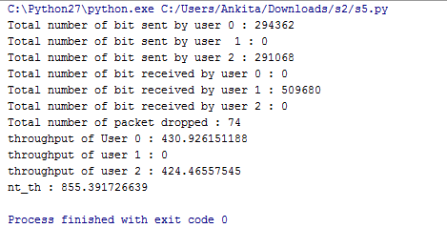

**1.**

**Lines of code changed:**

# changed the threhhold value such that the RTS/CTS will be used, if the packet size is more than 5000kb

Mac/802_11 set RTSThreshold_ 5000

2.Throughput of transmitter:

|  |  |  |  |
| --- | --- | --- | --- |
| Sr.No |  | Scenario 4 | Scneario 5 |
| 1 | Transmitter 0 | 368.24 | 430.92 |
| 2 | Transmitter 2 | 373.32 | 424.46 |

3.Network Throughput:

|  |  |  |
| --- | --- | --- |
|  | Scenario 4 | Scenario 5 |
| Network Throughput | 741.57 | 855.39 |

4.Effect of RTS and CTS on the network.

The number of dropped packet has increased to 74. The number of dropped packet increase is due to the absence of RTS/CTS.The reason for increase in the dropped packet is collision which is in effect of absence of RTS/CTS.

**Scenario 6:**

**Throughput for 2 users:**

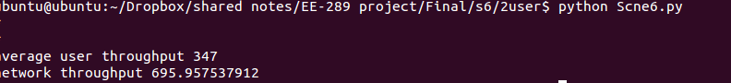

**Throughput for 100 users:**



**Throughput of 10 users:**



Plots:

