DBMS PROJECT REPORT
Police Records & Criminal Management System
A centralized database solution for managing police records, criminal cases, arrests, evidence and court proceedings
Submitted by
Arpit Karna (25BCE2887)
G Nikhil Sreenivas (25BCE0178)
Aryan Menon (25BCE0327)
Thota Manoj Sai Kumar (25BAI0021)

Contents
If the entries below are not shown, right-click this area and choose Update Field (or press F9) to build them from the headings.
Contents
Abstract
Chapter 1: Introduction
Chapter 2: System Design
Chapter 3: Database Design
Chapter 4: Implementation
Chapter 5: User Interface
Chapter 6: Testing
Chapter 7: Results and Future Scope
References

Abstract
Manual, paper-based record keeping in police stations causes duplicated records, slow searching, weak case tracking and time-consuming reporting. The Police Records & Criminal Management System (PCRMS) replaces it with a centralized relational database and a role-based web application. The database is a thirteen-table MySQL 8 schema in third normal form with keys, constraints, three views, three stored procedures and four triggers; the triggers keep case and criminal statuses consistent and log every status change. A Node.js/Express API authenticates users with JWT and enforces three roles, and a React interface provides a dashboard, nine record-management modules, search and reports. The system was verified with 44 automated API and database tests and 24 user-interface tests, all of which passed.

Chapter 1: Introduction

1.1 Background and Problem
Police work produces many related records: stations, officers, complaints, FIRs and cases, criminals, arrests, evidence and court hearings. The project review document identifies four problems with manual record keeping: data duplication, difficult searching, poor case tracking and time-consuming management. A relational DBMS [5] is a natural fit because the records are tightly related and integrity matters.

1.2 Objectives and Scope
- Centralize police records in one secure, normalized database with enforced keys.
- Manage criminals, cases, arrests and evidence digitally, including an evidence chain of custody.
- Track court proceedings and produce reports instantly; support fast search and cross-referencing.
- Automate the case lifecycle inside the database with procedures and triggers.
- Restrict actions by role: viewer (read only), officer (no delete), administrator (full access).

Out of scope: user-registration screens (three demo accounts come from the setup script), photo upload (a photo URL is stored), mobile app, cloud deployment and biometric integration.

Chapter 2: System Design

2.1 Architecture
PCRMS is a three-tier application (Figure 1). The React 18 single-page application [1] talks to a Node.js/Express REST API [2] using JSON and a JWT bearer token. The API runs parameterized SQL against MySQL 8.4 [3]. Rules that must hold for every client (status changes, custody log, audit log) live in the database as procedures and triggers.
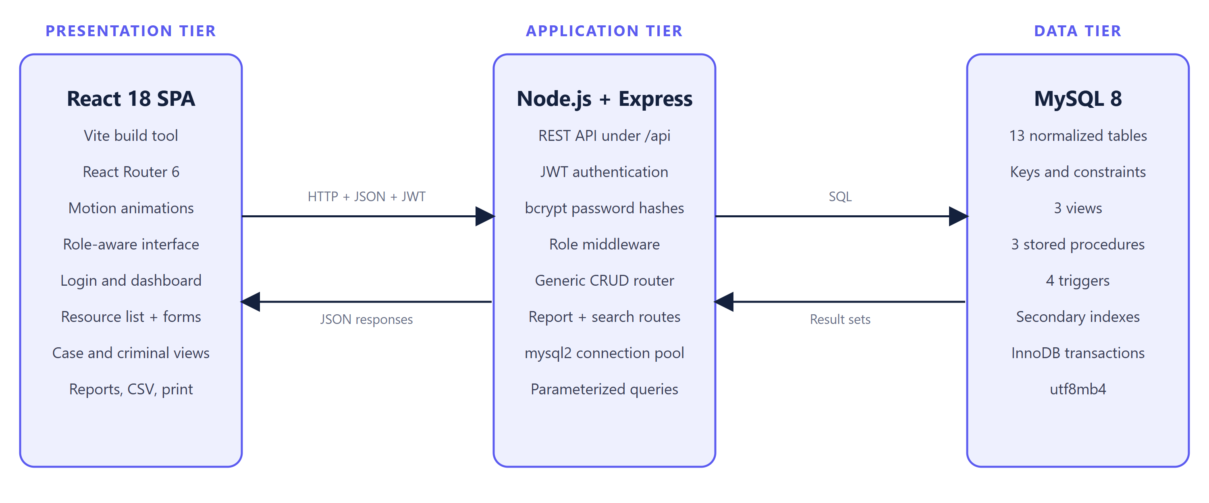
Figure : Three-tier architecture of PCRMS

2.2 Case Lifecycle
Figure 2 shows the main workflow. A complaint becomes an FIR (a case); an arrest marks the criminal as Arrested and the case as Under Investigation; evidence gets a custody log; a hearing moves the case to In Court; closing the case completes the lifecycle.
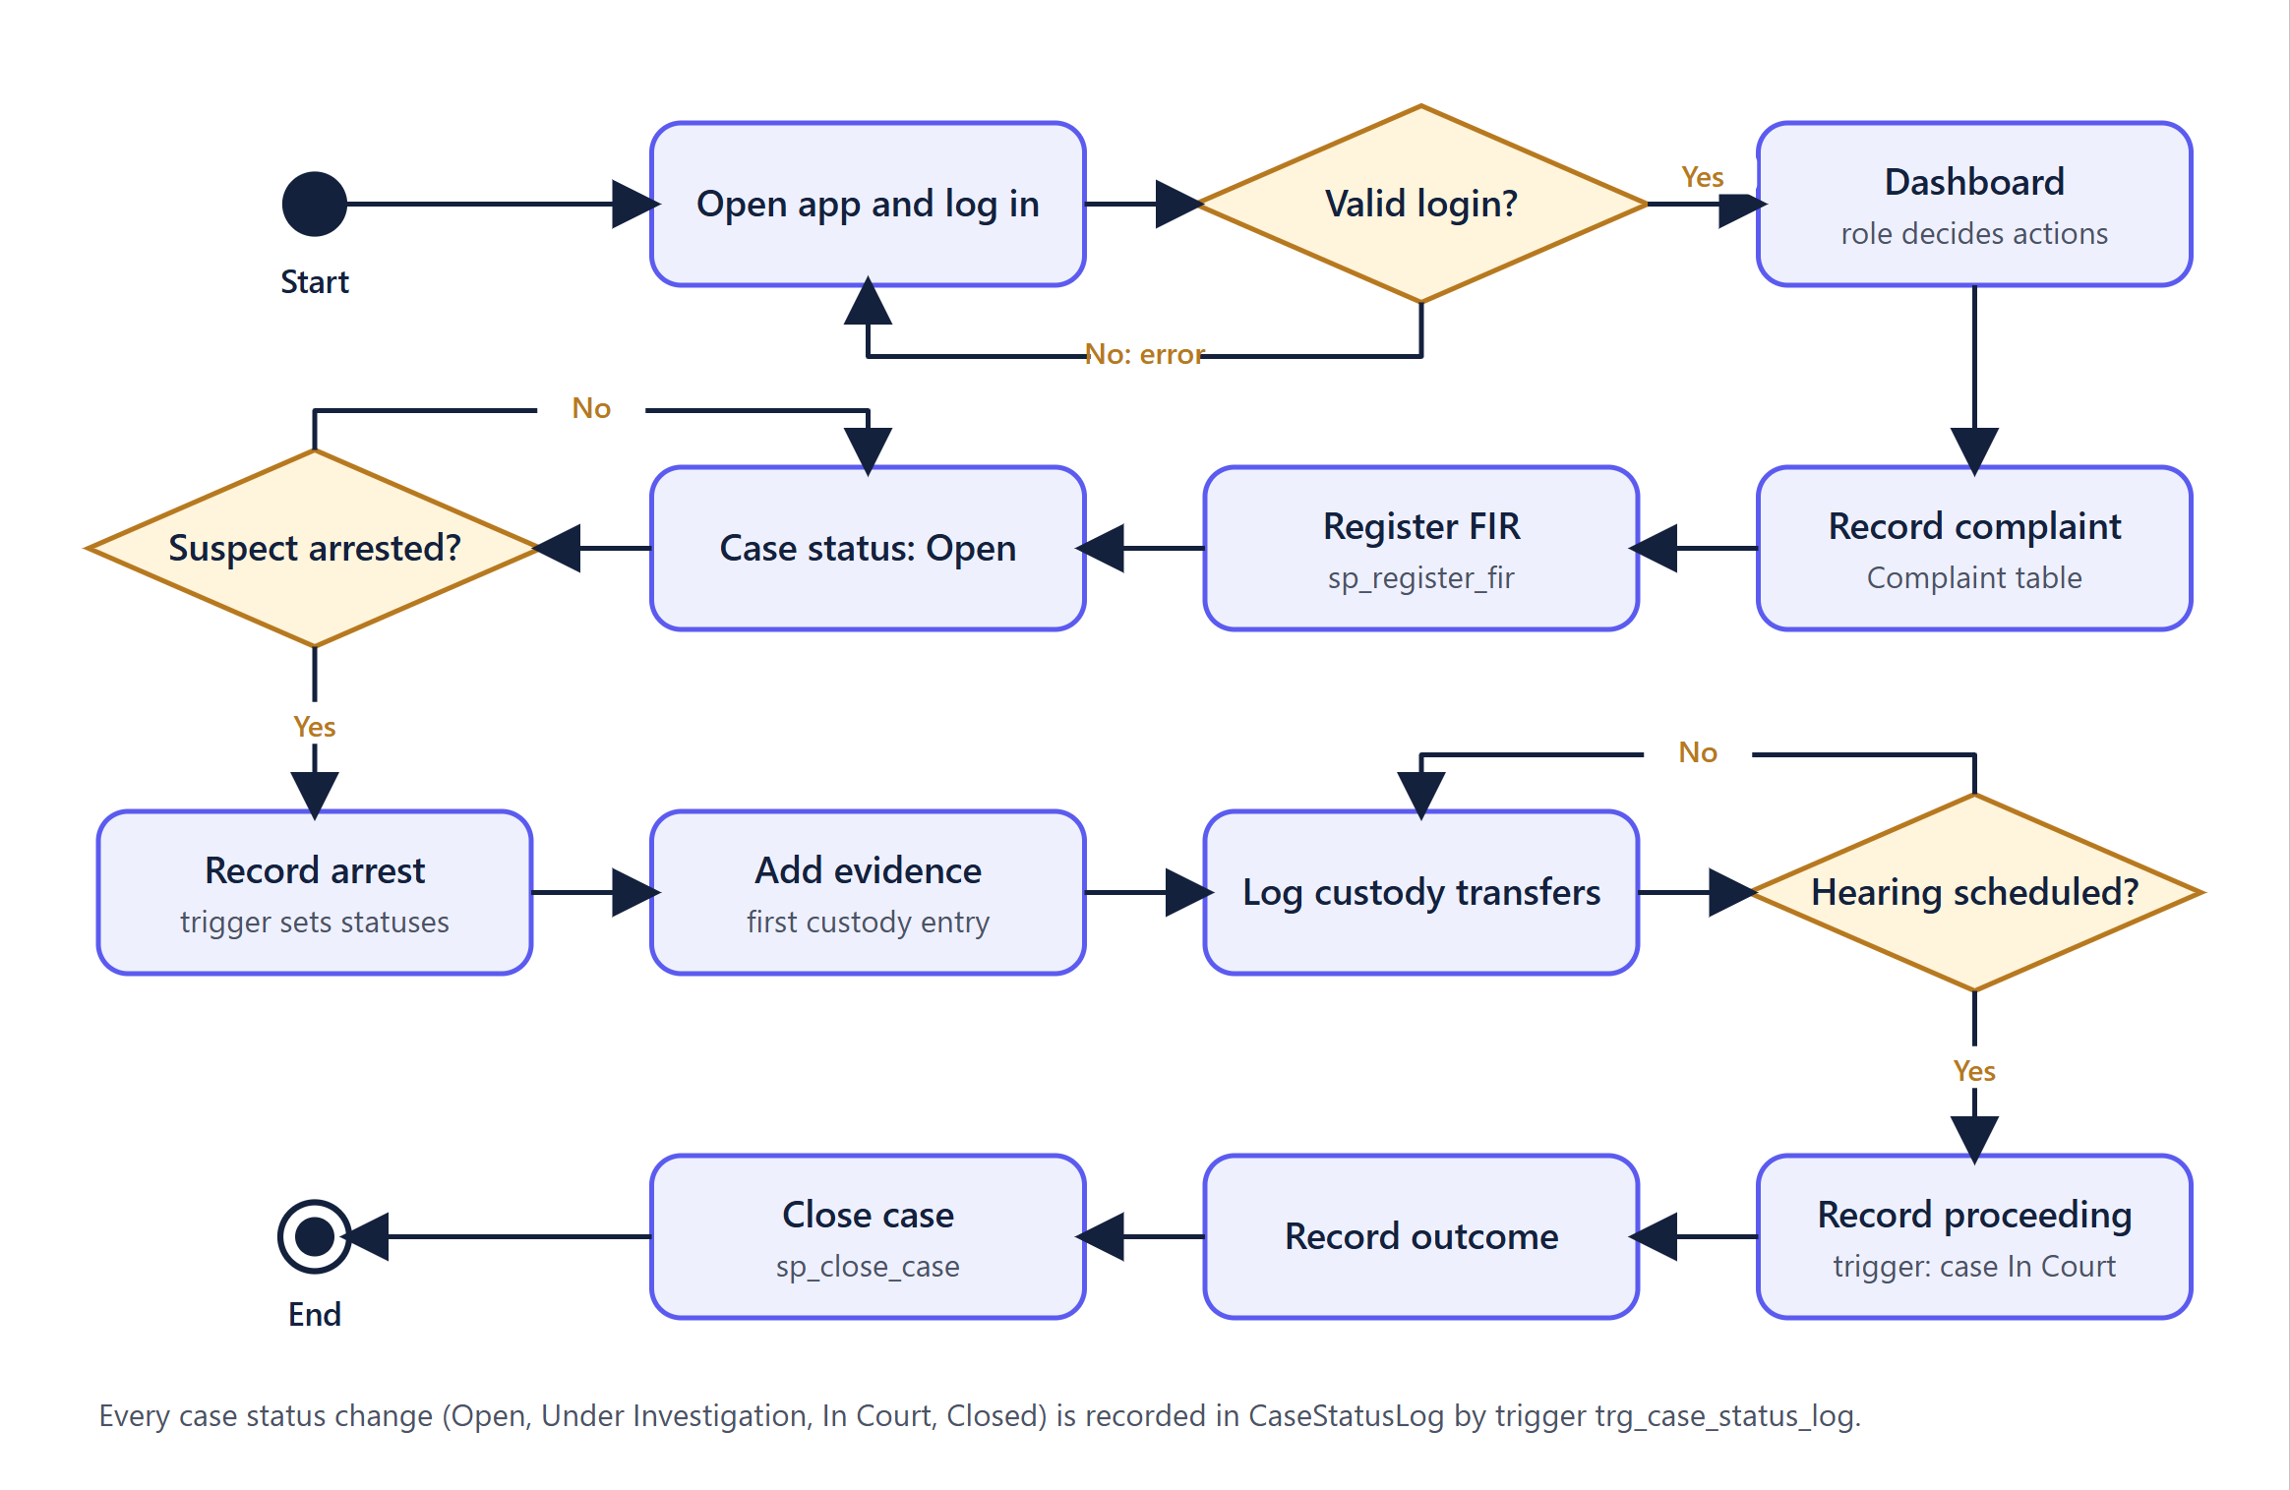
Figure : Case lifecycle workflow

Chapter 3: Database Design

3.1 Entity-Relationship Diagram
Figure 3 is the ER diagram in Chen notation [6]: rectangles are entities, diamonds are relationships, ellipses are attributes (underlined = primary key). Double lines mean total participation and arrows point to the "one" side of many-to-one relationships. Foreign keys appear as relationships. The many-to-many relationship involves is stored as the table CriminalCase, so the 12 entities and this relationship give the 13 tables. The diagram was checked against the live schema.
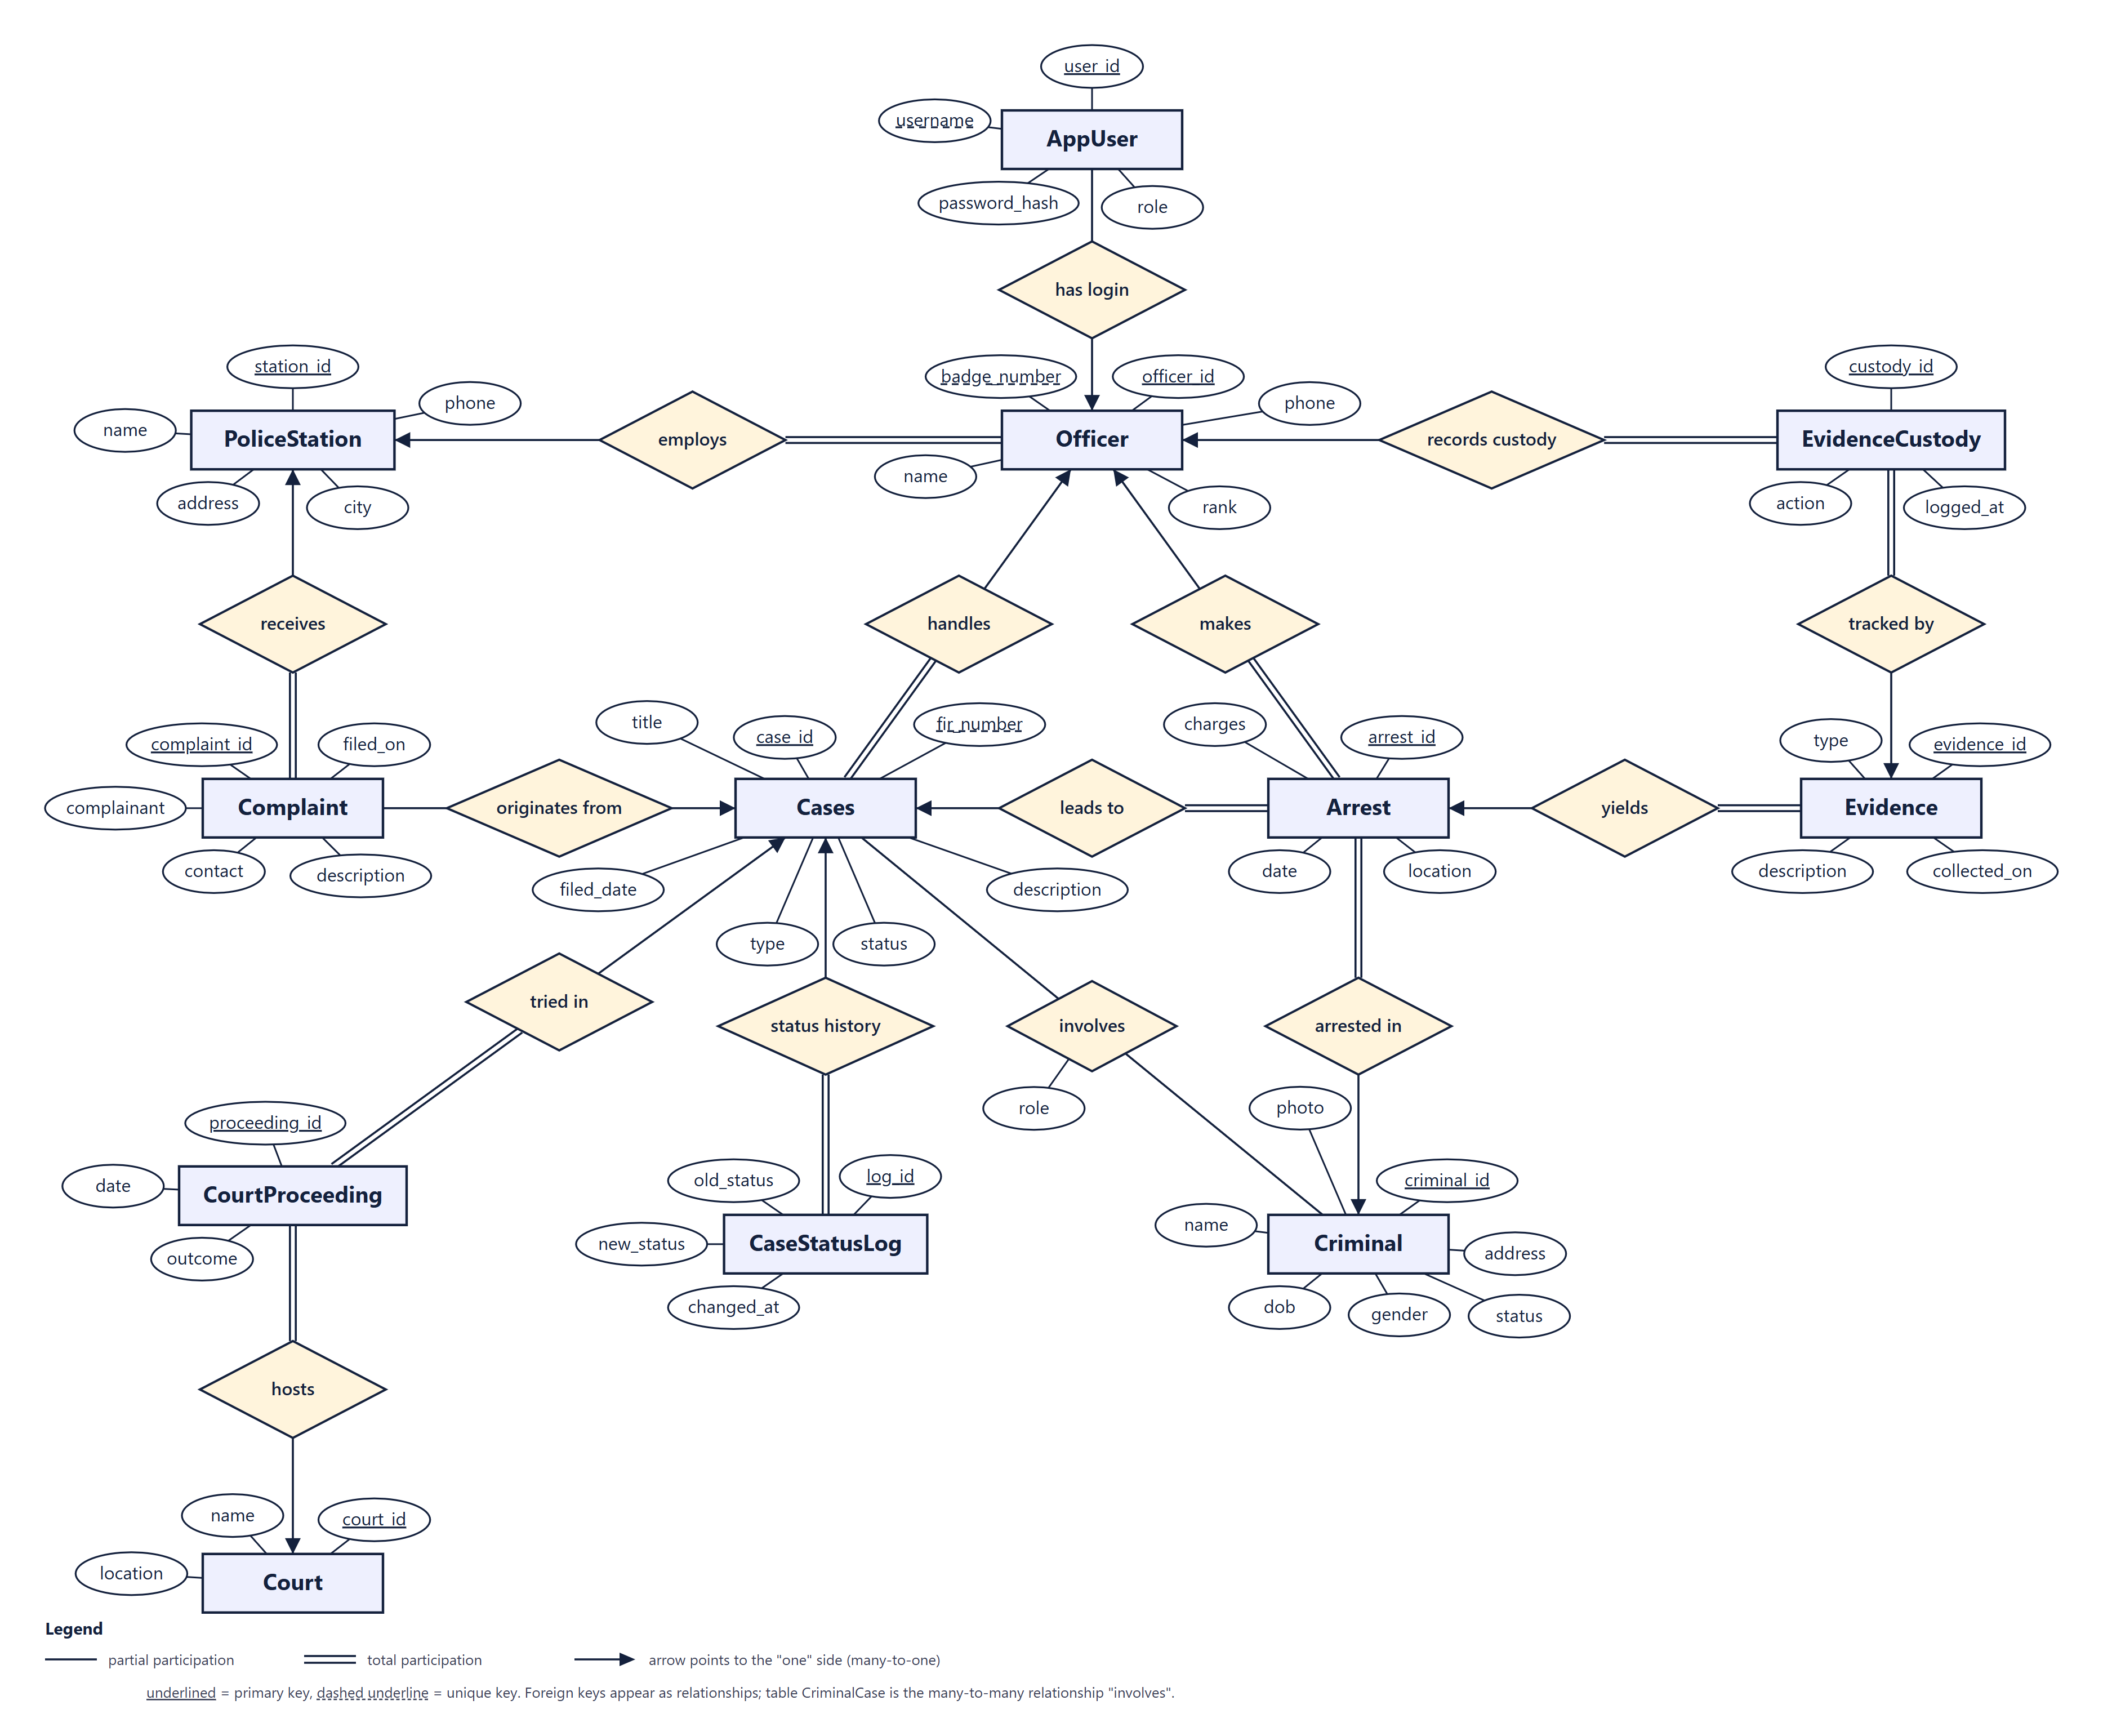
Figure : Entity-relationship diagram of the PCRMS database (Chen notation)

3.2 Tables and Relationships
Table : Tables of the pcrms database
Table | Purpose
PoliceStation | Police stations with address, city and phone. Parent of officers and complaints.
Officer | Police officers with unique badge number, rank and the station they belong to.
Criminal | Persons of interest with personal details, photo link and a status (Wanted, Arrested, Convicted, Released).
Cases | Cases created from an FIR. Holds FIR number, type, status and the officer in charge. Named Cases because CASE is a reserved SQL word.
Complaint | Citizen complaints received at a station; optionally linked to the case they led to.
CriminalCase | Junction table that resolves the many-to-many relationship between criminals and cases; stores the person's role in the case.
Arrest | An arrest of a criminal in connection with a case by an officer, with date, location and charges.
Evidence | Evidence items collected for an arrest.
EvidenceCustody | Chain-of-custody log: each hand-over or action on an evidence item, with the officer and timestamp.
Court | Courts with name and location.
CourtProceeding | Hearings of a case in a court, with date and outcome (NULL until concluded).
AppUser | Application logins with bcrypt password hash and role (admin, officer, viewer); optionally linked to an officer.
CaseStatusLog | Audit rows written by a trigger whenever a case's status changes.

The schema has 16 foreign keys. Main relationships: a station has many officers and complaints; an officer handles cases and makes arrests; a case has many arrests, hearings, status-log rows and optional complaints; an arrest has many evidence items and each item has a custody log; a court hosts many hearings. Criminals and cases form a many-to-many relationship resolved by CriminalCase with composite key (criminal_id, case_id). Deleting a case cascades to its links and status log but only sets Complaint.case_id to NULL, so complaints are never lost.

3.3 Normalization
- 1NF: all columns are atomic; repeating data (criminals per case, evidence per arrest, custody actions) is stored as rows in separate tables.
- 2NF: single-column keys cannot have partial dependencies; in CriminalCase the only non-key attribute (role) depends on the whole key.
- 3NF: no transitive dependencies: station, court and officer details are stored once and referenced by key; counts are computed by views, not stored.

3.4 Views, Procedures and Triggers
Table : Programmability objects
Object | Purpose
v_case_overview, v_wanted_criminals, v_station_stats | Views used by reports and the dashboard.
sp_register_fir | Creates a case and links a complaint in one transaction; rolls back on error.
sp_close_case, sp_criminal_history | Close a case; list a criminal's cases.
trg_arrest_after_insert | Criminal becomes Arrested; Open case becomes Under Investigation; criminal linked to the case.
trg_proceeding_after_insert | Case becomes In Court when a hearing is recorded.
trg_case_status_log | Writes a CaseStatusLog row whenever a case status changes.
trg_evidence_custody_init | Creates the first chain-of-custody entry for new evidence.

Chapter 4: Implementation

4.1 Technology Stack
Table : Technologies and versions used
Layer | Technology
Database | MySQL 8.4.9 (InnoDB, utf8mb4)
Backend | Node.js 22, Express 4.22, mysql2 3.24, jsonwebtoken 9.0, bcryptjs 2.4
Frontend | React 18.3, React Router 6.30, Vite 5.4, Motion for React 14

The application has about 1684 lines of code in three folders: database (schema, procedures and triggers, seed data), server (API) and client (user interface).

4.2 API and Security
The API exposes 57 routes: login, dashboard, reports, FIR registration, case detail and closing, criminal history, custody log, search and generated CRUD routes for nine resources (generated from one configuration file, which also drives one generic list/form page in the interface). Passwords are stored as bcrypt hashes; a successful login returns a JWT [4] valid for eight hours. Every request is checked for a valid token and then for the role, as shown below. All SQL uses parameters and only whitelisted columns are written.
Table : Permissions by role
Role | Read (GET) | Create / update | Delete
viewer | Allowed | Denied (403) | Denied (403)
officer | Allowed | Allowed | Denied (403)
admin | Allowed | Allowed | Allowed

4.3 Error Handling
Database constraint errors are mapped to responses: duplicate keys and foreign-key violations return 409, missing or invalid tokens 401, forbidden roles 403. Other database errors (for example a missing required column) currently return 500 with the database message, which is a known limitation.

Chapter 5: User Interface
The screenshots below were captured from the running application with the seeded sample data. Figure 4 is the entry point; Figure 5 the dashboard; Figure 6 a case detail page that combines data from six tables; Figure 7 a data-entry form whose Criminal, Case and Officer fields are dropdowns filled from the database; and Figure 8 the same Cases page on a phone-sized screen.
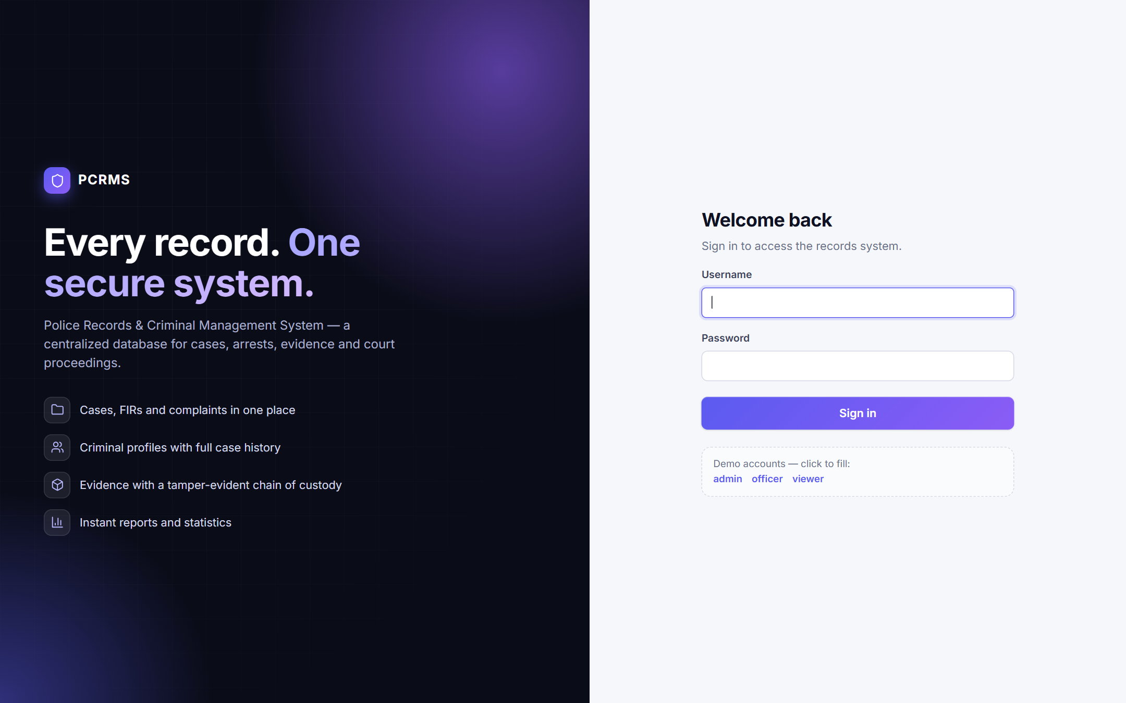
Figure : Login screen
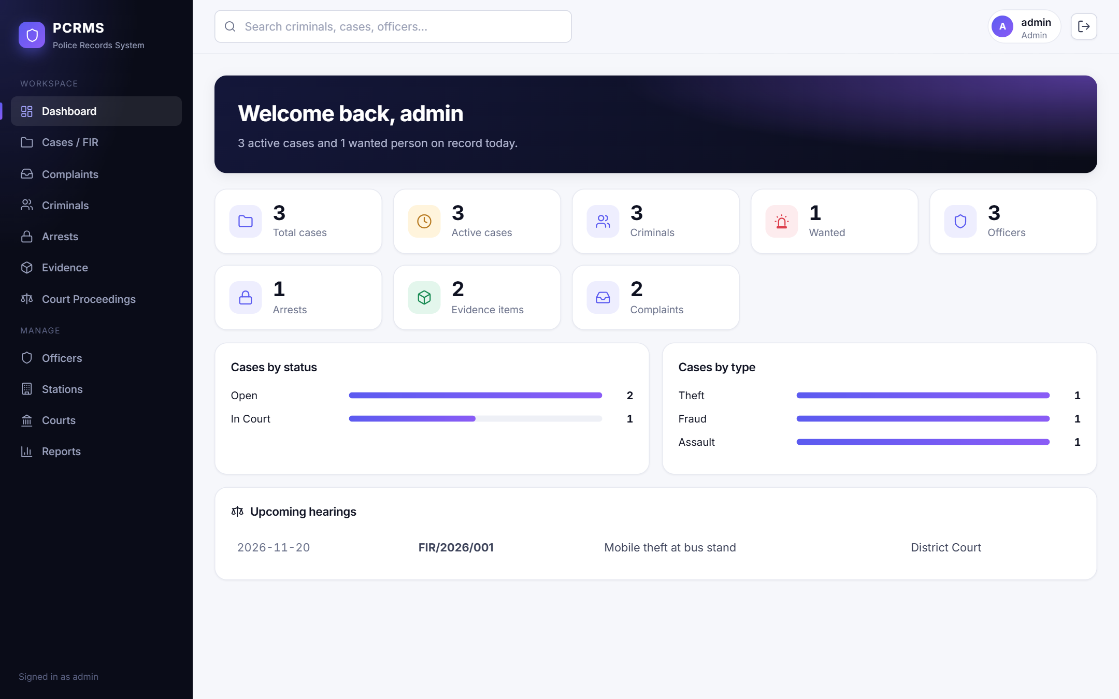
Figure : Dashboard
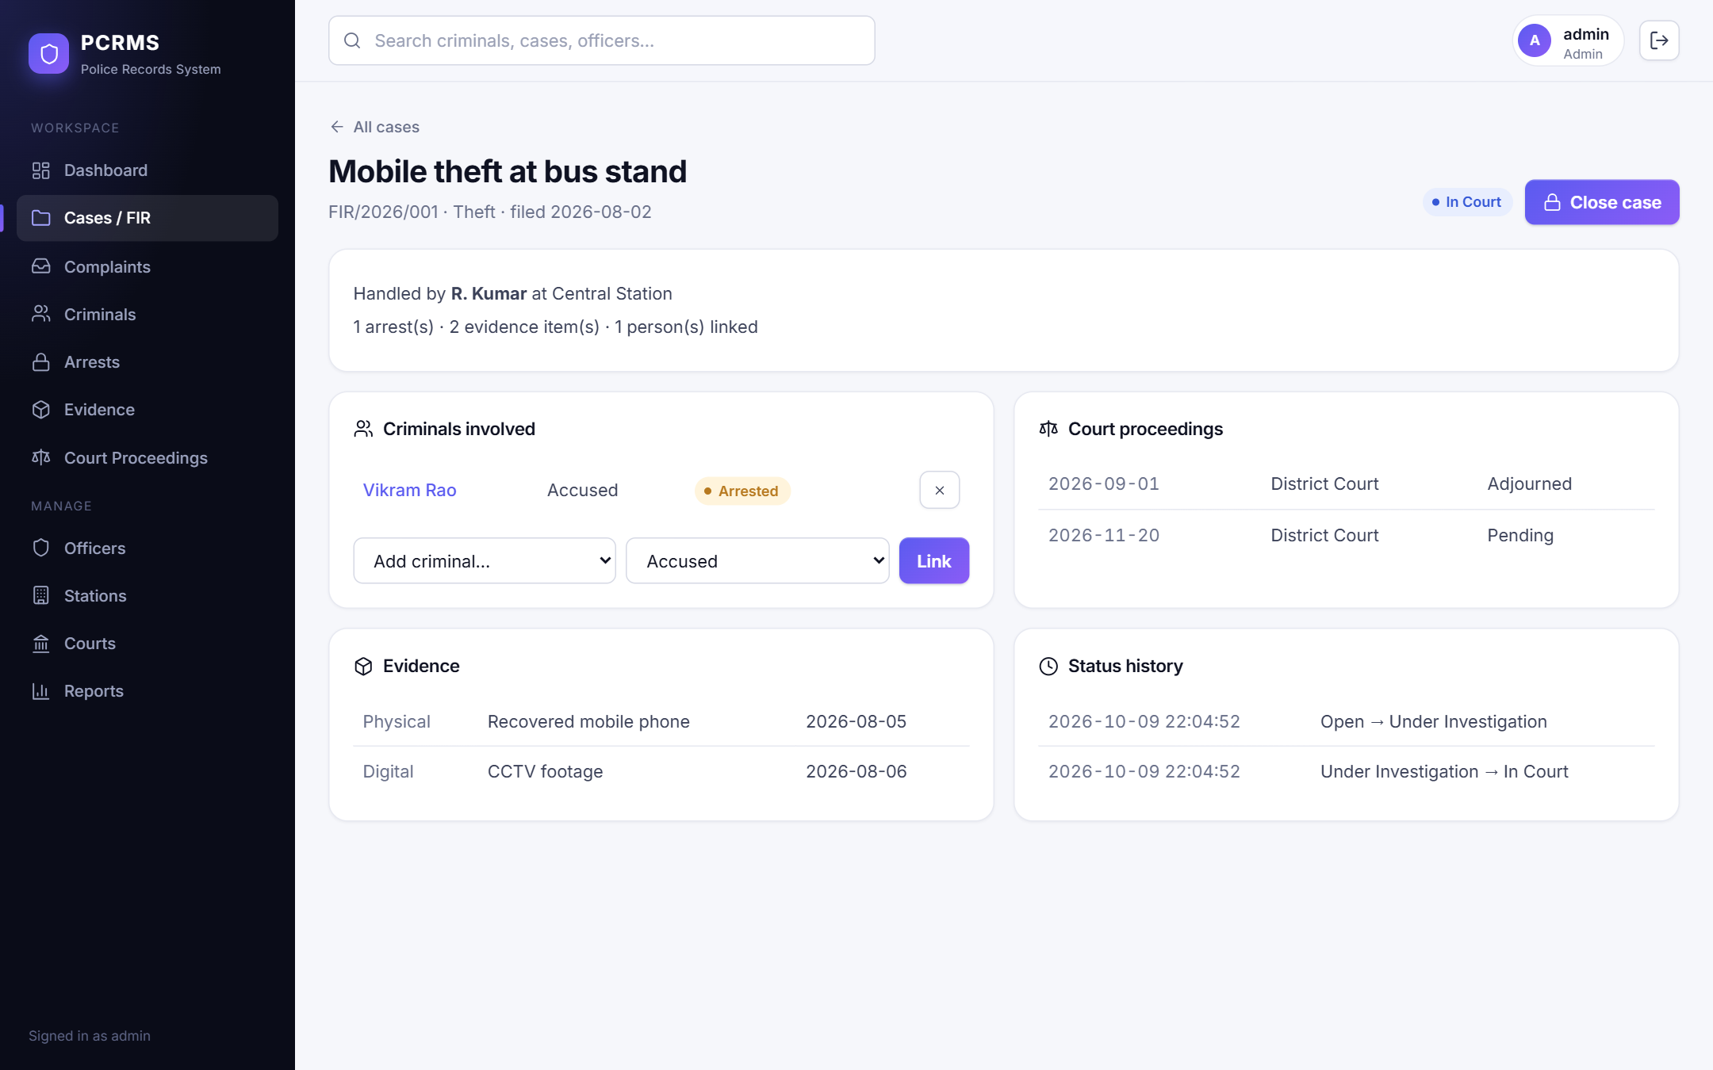
Figure : Case detail page
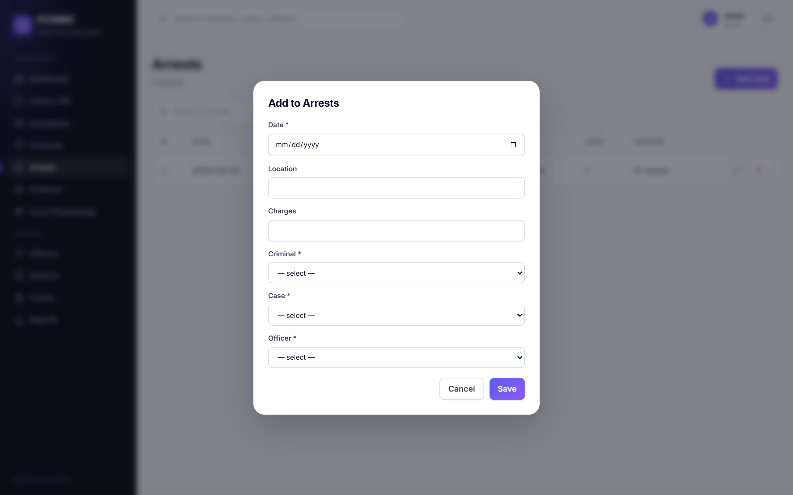
Figure : Add-arrest form with database-backed dropdowns
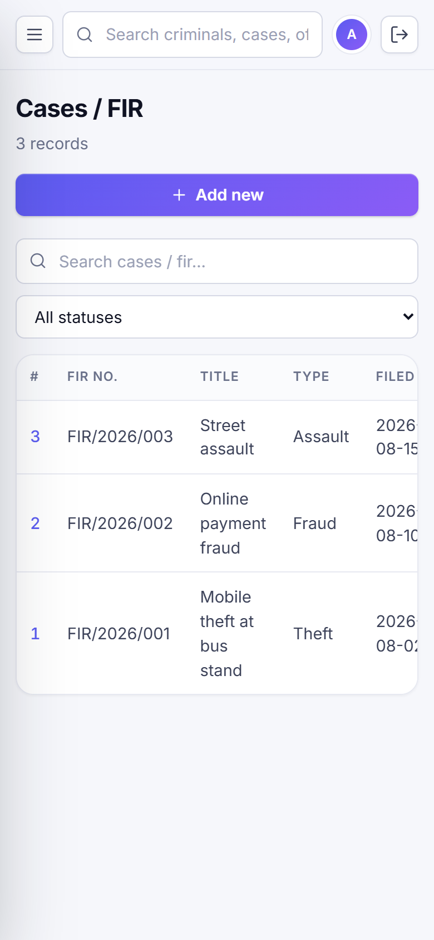
Figure : Cases list on a 390 px wide screen

Chapter 6: Testing
Testing used an automated runner for the API and database (44 cases, server/tests/run-tests.js) and an automated headless-Chrome session for the user interface (24 cases), on Windows 11 with Node.js 22.19 and MySQL 8.4.9. The database was reset to the seed data before the run. All 68 of 68 cases passed.
Table : Summary of executed tests
Group | Cases | Passed | Covers
API and database | 44 | 44 | Authentication, roles, CRUD, validation, procedures, triggers, constraints, reports, search
User interface | 24 | 24 | Login, every page, forms, filter, search, error and empty states, viewer role, mobile layout
Total | 68 | 68

Table : Selected test cases (full list in the detailed report)
ID | Test | Input | Actual result
TC-01 | Valid login | admin / correct password | HTTP 200, token issued, role=admin
TC-08 | Viewer cannot create | POST /api/courts | HTTP 403 "Your role is not allowed"
TC-10 | Officer cannot delete | DELETE /api/courts/:id | HTTP 403, record still present
TC-20 | Duplicate unique FIR number | POST /api/cases with fir_number FIR/2026/001 | HTTP 409 (duplicate entry)
TC-22 | Cannot delete referenced parent row | DELETE /api/officers/1 | HTTP 409, officer still present
TC-25 | sp_register_fir rolls back on error | POST /api/fir with duplicate FIR number | HTTP 409, case count unchanged (4)
TC-26 | Arrest trigger updates criminal and case | POST /api/arrests {criminal 2, case 2} | criminal 2 = Arrested, case 2 = Under Investigation
TC-31 | Court proceeding moves case to In Court | POST /api/proceedings for case 3 | case 3 = In Court
TC-28 | Status change logged | Query CaseStatusLog for case 2 | Log row: Open -> Under Investigation
TC-23 | SQL injection attempt in search | GET /api/search?q=' OR 1=1; DROP TABLE Criminal;-- | HTTP 200, Criminal table intact (3 rows)

Chapter 7: Results and Future Scope
The application meets the objectives: records are centralized with enforced integrity, the case lifecycle is automated and audited, evidence has a custody trail, search and reports are instant, and access is role-based. Known limitations: invalid input returns HTTP 500 instead of 400; there is no user-management or registration screen; the JWT is kept in browser storage; lists are not paginated; and there are no unit, load or cross-browser tests.
Future work (not implemented): field-level validation messages, user administration, pagination, a per-user audit trail, photo upload, per-station data access, a mobile app, a cloud database and real-time notifications.

References
[1] React Team, "React Reference Documentation." [Online]. Available: https://react.dev
[2] OpenJS Foundation, "Express 4.x API Reference." [Online]. Available: https://expressjs.com/en/4x/api.html
[3] Oracle Corporation, "MySQL 8.4 Reference Manual." [Online]. Available: https://dev.mysql.com/doc/refman/8.4/en/
[4] M. Jones, J. Bradley and N. Sakimura, "JSON Web Token (JWT)," RFC 7519, IETF, 2015. [Online]. Available: https://datatracker.ietf.org/doc/html/rfc7519
[5] E. F. Codd, "A relational model of data for large shared data banks," Communications of the ACM, vol. 13, no. 6, pp. 377-387, 1970.
[6] P. P. Chen, "The entity-relationship model: toward a unified view of data," ACM Transactions on Database Systems, vol. 1, no. 1, pp. 9-36, 1976.

