[University Name]
[Department / School Name]
DBMS PROJECT REPORT
Police Records & Criminal Management System
A centralized database solution for managing police records, criminal cases, arrests, evidence and court proceedings
Submitted by
Arpit Karna (25BCE2887)
G Nikhil Sreenivas (25BCE0178)
Aryan Menon (25BCE0327)
Thota Manoj Sai Kumar (25BAI0021)
Under the guidance of
[Guide Name, Designation]
Academic year: [Academic Year]

Certificate
This is to certify that the project report entitled "Police Records & Criminal Management System" is a bonafide record of the work carried out by the following students of the [Department / School Name], [University Name], in partial fulfilment of the requirements of the Database Management Systems course during the academic year [Academic Year]:
- Arpit Karna (25BCE2887)
- G Nikhil Sreenivas (25BCE0178)
- Aryan Menon (25BCE0327)
- Thota Manoj Sai Kumar (25BAI0021)

The work embodied in this report was carried out under the guidance of [Guide Name, Designation] and has not been submitted elsewhere for any other course or degree.
[Guide Name] - Project Guide | [Name] - Head of the Department | [Name] - Examiner

Date: [DD/MM/YYYY] Place: [Place]

Declaration
We hereby declare that the project report entitled "Police Records & Criminal Management System" is our own work, carried out under the guidance of [Guide Name, Designation]. The design, source code, database, tests and screenshots described in this report were produced by the project team. All third-party software, libraries and documentation that we used are acknowledged in the References section, and no part of this report has been copied from another source or submitted for any other course.
- Arpit Karna (25BCE2887)
- G Nikhil Sreenivas (25BCE0178)
- Aryan Menon (25BCE0327)
- Thota Manoj Sai Kumar (25BAI0021)

[Signature] | [Signature] | [Signature] | [Signature]

Date: [DD/MM/YYYY] Place: [Place]

Acknowledgement
We express our sincere gratitude to our project guide, [Guide Name, Designation], for the guidance, encouragement and constructive feedback that shaped this project from the first review to the final report.
We thank the Head of the Department, [HOD Name], and the faculty of the [Department / School Name], [University Name], for providing the knowledge and facilities that made this work possible.
We also thank the maintainers of the open-source tools on which PCRMS is built (MySQL, Node.js, Express, React, Vite and the other libraries listed in the References) and our families and friends for their support.
Project team
- Arpit Karna (25BCE2887)
- G Nikhil Sreenivas (25BCE0178)
- Aryan Menon (25BCE0327)
- Thota Manoj Sai Kumar (25BAI0021)

Abstract
Manual, paper-based record keeping in police stations leads to duplicated records, slow searching, weak case tracking and time-consuming reporting. The Police Records & Criminal Management System (PCRMS) addresses these problems with a centralized relational database and a role-based web application. The database is a thirteen-table MySQL 8 schema in third normal form, with primary, foreign and unique keys, enumerated types and indexes, three views, three stored procedures and four triggers. The triggers and procedures implement the case lifecycle inside the database: recording an arrest marks the criminal as arrested and moves the case to Under Investigation, scheduling a hearing moves it to In Court, evidence receives a chain-of-custody log, and every status change is audited. A Node.js/Express REST API authenticates users with bcrypt and JSON Web Tokens and enforces three roles (viewer, officer, administrator) using parameterized SQL. A responsive React interface provides a dashboard, nine record-management modules, case and criminal detail pages, global search and six exportable reports. The system was verified with 44 automated API and database tests and 24 user-interface tests, all of which passed, and the screenshots in this report were captured from the running application. Known limitations include HTTP 500 responses for invalid input, no user-management screens and no pagination. PCRMS demonstrates how DBMS concepts can be applied to a realistic records-management problem.
Keywords: DBMS, MySQL, normalization, stored procedures, triggers, REST API, React, police records management.

Table of Contents
If the entries below are not shown, right-click this area and choose Update Field (or press F9) to build them from the headings.
Certificate
Declaration
Acknowledgement
Abstract
Table of Contents
List of Figures
List of Tables
List of Abbreviations
Chapter 1: Introduction
1.1 Project Background
1.2 Problem Statement
1.3 Motivation
1.4 Aim and Objectives
1.5 Scope of the Project
1.6 Proposed Solution
1.7 Key Features and Expected Benefits
1.8 Organization of the Report
Chapter 2: Existing System and Proposed System
2.1 Existing Approach and Its Limitations
2.2 Proposed System
2.3 Comparison between Existing and Proposed Systems
2.4 Functional Requirements
2.5 Non-Functional Requirements
2.6 Hardware and Software Requirements
2.7 Assumptions and Constraints
Chapter 3: System Analysis and Design
3.1 Overall System Architecture
3.2 Component and Module Structure
3.3 Data Flow Diagrams
3.4 Use Case Diagram
3.5 Activity Diagram
3.6 Sequence Diagram
3.7 Class Diagram
3.8 Choice of Technologies
Chapter 4: Database Design
4.1 Database Technology and Design Approach
4.2 List of Tables
4.3 Entity-Relationship Diagram
4.4 Relationships and Cardinalities
4.5 Table Schemas
4.5.1 PoliceStation
4.5.2 Officer
4.5.3 Criminal
4.5.4 Cases
4.5.5 Complaint
4.5.6 CriminalCase
4.5.7 Arrest
4.5.8 Evidence
4.5.9 EvidenceCustody
4.5.10 Court
4.5.11 CourtProceeding
4.5.12 AppUser
4.5.13 CaseStatusLog
4.6 Constraints and Indexes
4.7 Normalization Analysis
4.8 Views, Stored Procedures and Triggers
4.9 How Data Is Stored, Retrieved, Updated and Deleted
Chapter 5: System Implementation
5.1 Project Structure
5.2 Frontend Architecture
5.3 Backend Architecture
5.4 API Endpoints
5.5 Database Integration
5.6 Authentication and Authorization
5.7 Input Validation and Error Handling
5.8 Core Business Logic
5.9 Third-Party Libraries and Dependencies
5.10 Integration of Frontend, Backend and Database
5.11 Important Implementation Decisions
Chapter 6: User Interface and Project Screenshots
6.1 Login Screen
6.2 Dashboard
6.3 Lists, Search and Filtering
6.4 Detail Pages
6.5 Forms and Data Entry
6.6 Reports
6.7 Empty and Error States
6.8 Role-Based Interface
6.9 Responsive and Mobile Layout
6.10 Screens That Are Not Available
Chapter 7: Testing and Validation
7.1 Testing Strategy
7.2 Test Environment
7.3 API and Database Test Cases
7.4 User-Interface Test Cases
7.5 Summary of Results
7.6 Observations and Defects
7.7 Tests Not Performed
Chapter 8: Results and Discussion
8.1 Summary of Implemented Features
8.2 Results Observed during Testing
8.3 How the Application Addresses the Original Problem
8.4 Limitations and Unresolved Issues
Chapter 9: Conclusion and Future Scope
9.1 Summary of the Work
9.2 Practical Value
9.3 Limitations
9.4 Future Scope
References
Appendix A: API Endpoint Summary
Appendix B: Database Schema Reference
Appendix C: Additional Screenshots
Appendix D: Source Code and Configuration Notes
Appendix E: Setup and Execution Instructions
Appendix F: Glossary

List of Figures
Right-click and choose Update Field to build the List of Figures.

List of Tables
Right-click and choose Update Field to build the List of Tables.

List of Abbreviations
Abbreviation | Meaning
API | Application Programming Interface
CORS | Cross-Origin Resource Sharing
CRUD | Create, Read, Update, Delete
CSV | Comma-Separated Values
DBMS | Database Management System
DDL | Data Definition Language
DFD | Data Flow Diagram
ER | Entity-Relationship
FIR | First Information Report
FK | Foreign Key
HTTP | Hypertext Transfer Protocol
JSON | JavaScript Object Notation
JWT | JSON Web Token
M:N | Many-to-Many
PK | Primary Key
RBAC | Role-Based Access Control
REST | Representational State Transfer
SPA | Single-Page Application
SQL | Structured Query Language
UI | User Interface
UK | Unique Key
1NF / 2NF / 3NF | First / Second / Third Normal Form

Chapter 1: Introduction

1.1 Project Background
Police departments create and consult a very large amount of structured information: stations and the officers posted to them, citizen complaints, First Information Reports (FIRs), the cases that follow, the people involved, arrests, seized evidence and the court hearings that decide each case. These facts are tightly related. An arrest belongs to a case; evidence belongs to an arrest; a hearing belongs to a case and a court. Keeping them consistent is the kind of problem that relational database management systems (DBMS) were designed to solve [14].
The Police Records & Criminal Management System (PCRMS) is a database-centred web application built as a DBMS course project. It stores this information in a normalized MySQL database and exposes it through a role-based web interface so that authorized users can record, search and cross-reference police data from one place.

1.2 Problem Statement
The team's project review document identifies four problems with traditional, manual and paper-based record keeping in police stations: data duplication (the same person or case recorded separately and inconsistently), difficult searching (no unified way to find a criminal or case file), poor case tracking (no structured status updates, so cases can be delayed or lost) and time-consuming management (manual updates and report generation consume officer time). PCRMS is designed to address exactly these four problems.

1.3 Motivation
A police records system is a good vehicle for applying core DBMS concepts to a realistic scenario: many interrelated entities, a many-to-many relationship (criminals and cases), a strict lifecycle (complaint to FIR to arrest to evidence to hearing to closure), integrity rules that must never be broken, and a need for audit trails. The scenario also requires application-level concerns such as authentication and role-based authorization, which show how a database is used inside a complete system rather than in isolation.

1.4 Aim and Objectives
Aim: to design and implement a centralized, normalized database and a web application that manages police records, criminals, cases, arrests, evidence and court proceedings.
The objectives, as stated in the project review document and refined during implementation, are:
- Centralize police records in one secure relational database with enforced primary and foreign keys.
- Manage criminals, cases, arrests and evidence digitally, including a chain-of-custody log for evidence.
- Track court proceedings and generate reports instantly from live data.
- Provide fast searching and cross-referencing across related entities.
- Automate lifecycle rules inside the database with stored procedures and triggers so that statuses stay consistent.
- Restrict what each user can do through authenticated, role-based access (administrator, officer, viewer).

1.5 Scope of the Project
In scope: nine modules (police stations, officers, criminals, cases/FIR, complaints, arrests, evidence, court proceedings, reports), the thirteen-table database, a REST API, a React single-page application, authentication with three roles, dashboard statistics, six reports with CSV export, global search, and automated API/database and UI tests.
Out of scope (not implemented): user registration and account-management screens (the three demo accounts are created by the setup script), file upload for photographs (a photo URL field is stored), a mobile application, cloud deployment, biometric integration, notifications and analytics beyond the implemented reports. These are discussed as future work in Chapter 9.

1.6 Proposed Solution
PCRMS is a three-tier application (Figure 1). A MySQL 8 database holds the data and enforces integrity; business rules that must hold regardless of the client are implemented inside the database as stored procedures and triggers. A Node.js/Express API authenticates users, checks their role and runs parameterized SQL. A React single-page application provides the user interface. The same schema, API and interface cover the complete case lifecycle shown in Figure 6.

1.7 Key Features and Expected Benefits
- Single source of truth: one database replaces separate paper registers, removing duplicated records.
- Integrity by design: foreign keys, unique keys and enumerated types prevent orphaned or invalid records; the test suite confirms that referenced rows cannot be deleted and duplicate FIR numbers are rejected.
- Automatic status tracking: recording an arrest marks the criminal as Arrested and moves the case to Under Investigation; scheduling a hearing moves it to In Court; every change is logged.
- Evidence accountability: each evidence item has a timestamped chain-of-custody log.
- Fast retrieval: per-module search, a global search, a status filter and criminal and case detail pages with related records.
- Instant reporting: dashboard totals and six reports that can be exported as CSV or printed.
- Role-based access: viewers can only read, officers cannot delete, administrators have full access.

1.8 Organization of the Report
Chapter 2 compares the existing manual approach with the proposed system and lists requirements. Chapter 3 presents the architecture and UML/DFD diagrams. Chapter 4 documents the database design, including the ER diagram, table schemas and normalization. Chapter 5 describes the implementation. Chapter 6 shows the running application. Chapter 7 reports the tests that were executed and their results. Chapter 8 discusses the results and limitations, and Chapter 9 concludes and outlines future work. The appendices contain the API reference, schema reference, additional screenshots, configuration notes, setup instructions and a glossary.

Chapter 2: Existing System and Proposed System

2.1 Existing Approach and Its Limitations
The starting point for this project is manual, paper-based record keeping, as described in the team's project review document. No field study or statistics were collected for this report, so the limitations below are those identified in that document and the logical consequences of keeping related records on separate paper registers or unconnected files:
- Redundant records: the same person or case can be written down in more than one register or station, with no mechanism to keep the copies consistent.
- Slow, error-prone search: finding a criminal or case means looking through registers or files by hand; there is no cross-referencing from a person to their cases, arrests and evidence.
- Weak case tracking: without a structured status field and a history of changes, it is hard to know where a case stands or when its state changed.
- Manual reporting: statistics and reports must be compiled by hand.
- No enforced integrity or access control: nothing prevents an arrest from referring to a case that does not exist, or limits who may change or remove a record.

2.2 Proposed System
PCRMS replaces separate registers with one relational database and an application on top of it. The database stores the entities and relationships of Figure 9; the API enforces authentication and roles; the interface offers lists, forms, detail pages, search, a dashboard and reports. Lifecycle rules (status changes, custody log entries, audit rows) are executed by the database itself, so every client sees the same behaviour.

2.3 Comparison between Existing and Proposed Systems
Table : Comparison of manual record keeping with PCRMS
Aspect | Manual / paper-based approach | PCRMS (as implemented)
Data storage | Separate registers or files | One MySQL database, 13 related tables
Duplicate records | Possible; copies can disagree | Single copy referenced by key; UNIQUE constraints on FIR number, badge number, username
Searching | Manual look-up | Per-module search, global search, status filter, indexes on common search columns
Cross-referencing | Manual | Joins through foreign keys; criminal and case detail pages show related records
Case status tracking | Informal | Status field with fixed values, changed by triggers and procedures, every change logged
Evidence handling | Paper log | EvidenceCustody table with officer and timestamp for each action
Reports | Compiled by hand | Six live reports, dashboard totals, CSV export and print
Integrity | Depends on staff discipline | Primary, foreign, unique and NOT NULL constraints enforced by the DBMS
Access control | Physical access | Login with bcrypt-hashed passwords, JWT, three roles
Availability of information | One physical copy | Any authorized browser session that can reach the server

2.4 Functional Requirements
The functional requirements below were derived from the project review document. The right-hand column states whether each requirement is implemented and where it is verified in Chapter 7.
Table : Functional requirements and their status
ID | Requirement | Status / verification
FR-01 | Users log in with a username and password and receive a session token. | Implemented; TC-01, TC-02, UI-03
FR-02 | Access is restricted by role: viewer (read only), officer (no delete), administrator (all). | Implemented; TC-08, TC-10, TC-11
FR-03 | Create, view, edit and delete police stations, officers and courts. | Implemented; TC-12 to TC-17
FR-04 | Maintain criminal profiles (name, date of birth, gender, address, status, photo link). | Implemented; UI-07
FR-05 | Register an FIR so that a case is created and an optional complaint is linked to it. | Implemented; TC-24
FR-06 | Manage cases, filter them by status and close a case. | Implemented; TC-16, TC-32, UI-18
FR-07 | Link and unlink criminals to a case (many-to-many) with a role. | Implemented; TC-34
FR-08 | Record citizen complaints at a station. | Implemented; UI-06
FR-09 | Record arrests; update criminal and case status automatically. | Implemented; TC-26
FR-10 | Record evidence and keep a chain-of-custody log. | Implemented; TC-29, TC-30
FR-11 | Record court proceedings; moving a case to In Court automatically. | Implemented; TC-31
FR-12 | Keep a history of case status changes. | Implemented; TC-28
FR-13 | Search records per module and across criminals, cases and officers. | Implemented; TC-44, UI-21
FR-14 | Show a dashboard with totals, charts and upcoming hearings. | Implemented; TC-36, UI-04
FR-15 | Provide reports with CSV export and print. | Implemented; TC-37 onwards, UI-20
FR-16 | Show a criminal's case history and arrests. | Implemented; TC-33, UI-15
FR-17 | Usable on desktop and mobile screen sizes. | Implemented; UI-24

2.5 Non-Functional Requirements
Table : Non-functional requirements and how they are addressed
Quality | How it is addressed in the implementation | Evidence
Security | bcrypt password hashes; JWT with 8-hour expiry; role check on every API request; parameterized SQL; only whitelisted columns are written. | TC-06, TC-23
Data integrity | Primary, foreign and unique keys, NOT NULL, ENUM types; transactional FIR registration with rollback. | TC-22, TC-25
Usability | Consistent layout, search on every list, labelled forms, loading, empty and error states, demo-account shortcuts on the login page. | Chapter 6
Maintainability | Nine modules share one generic CRUD router and one generic list/form page, each driven by a small configuration object. | Section 5.3
Portability | Node.js and MySQL run on Windows, Linux and macOS. Only Windows 11 was used for development and testing. | Section 7.2
Responsiveness | Responsive CSS with a slide-in navigation drawer below 900 px. | UI-24
Performance | Connection pool (10), indexes on frequently filtered columns. No load or performance testing was carried out, so no performance figures are claimed. | Section 7.7
Accessibility | Semantic landmarks, labelled controls and keyboard-closable drawer. No formal accessibility audit was performed. | Section 7.7

2.6 Hardware and Software Requirements
Table : Development and test environment (as used)
Item | Specification
Operating system | Windows 11 Home (10.0.26200)
Runtime | Node.js v22.19.0, npm 10.9.3
Database server | MySQL Community Server 8.4.9
Browser used for testing | Google Chrome 154.0.8037.98 (headless, via Puppeteer Core)
Editor / tooling | Visual Studio Code, Git

Table : Software requirements to run PCRMS
Component | Requirement
Server runtime | Node.js 18 or later (tested with 22.19.0)
Database | MySQL 8.x (tested with 8.4.9); InnoDB; utf8mb4
Client browser | A current evergreen browser with JavaScript enabled (tested with Chrome)
Ports | 3306 (MySQL), 4000 (API), 5173 (development UI)

No minimum hardware figures were measured. Any machine able to run Node.js and MySQL 8 and a modern browser is sufficient for the demonstration data set.

2.7 Assumptions and Constraints
- The system runs on a trusted network; HTTPS termination is not configured by the project.
- User accounts are created by the setup script. There is no self-registration, to avoid unauthorized sign-ups to a records system.
- Sample data is fictional and non-sensitive.
- All authenticated users can read all records; there is no per-station data partitioning.
- Photographs are stored as URLs, not uploaded files.
- The system was built within the timeline of a single course project by a four-member team.

Chapter 3: System Analysis and Design

3.1 Overall System Architecture
PCRMS follows a classic three-tier architecture, shown in Figure 1. The presentation tier is a React 18 single-page application built with Vite [1][2]. It communicates with the application tier, a Node.js/Express REST API [6], using JSON over HTTP and a JWT bearer token. The API talks to MySQL 8 [7] through a mysql2 connection pool [8] using parameterized queries. During development the Vite server proxies requests under /api to the API on port 4000, so the browser sees a single origin.
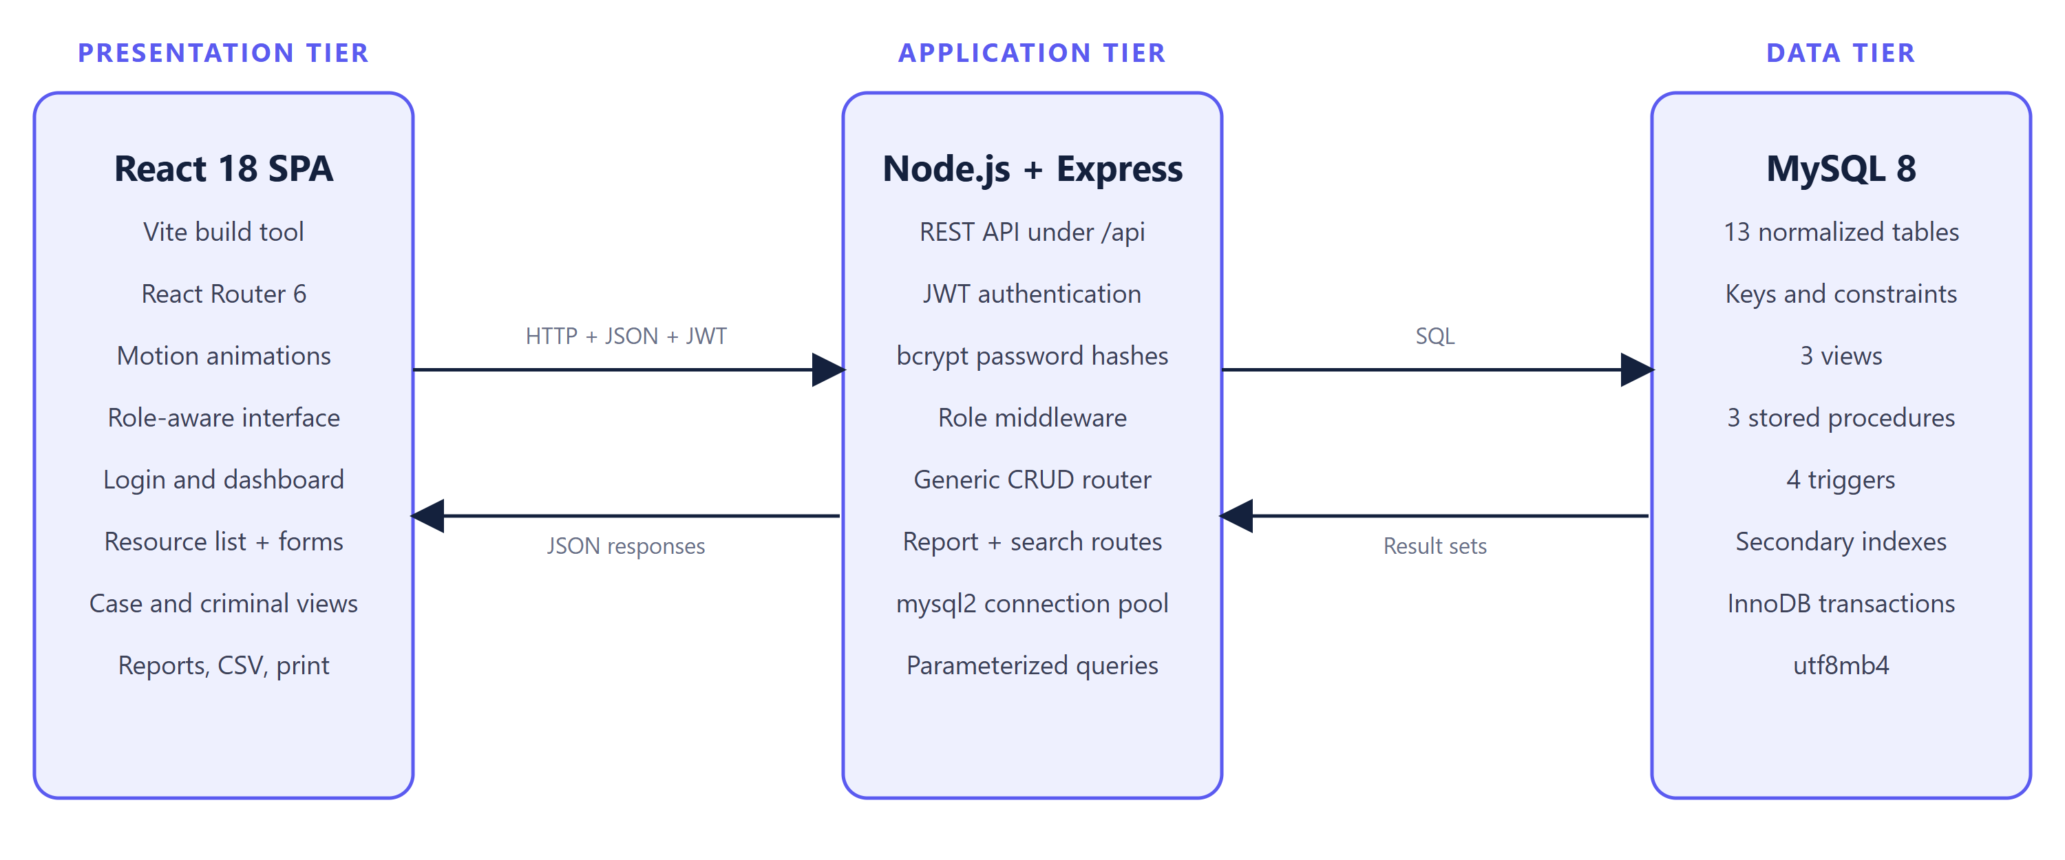
Figure : Three-tier system architecture of PCRMS
The data tier is not a passive store. Views, stored procedures and triggers implement report queries, FIR registration and status automation inside the database, so the rules hold for every client.

3.2 Component and Module Structure
Figure 2 shows how the modules interact. Each page of the frontend calls one family of API endpoints: the generic resource pages use the generic CRUD router, the case and criminal detail pages use the special endpoints, and the dashboard and reports use the report endpoints. All routes pass through the authentication and role middleware before reaching the database.
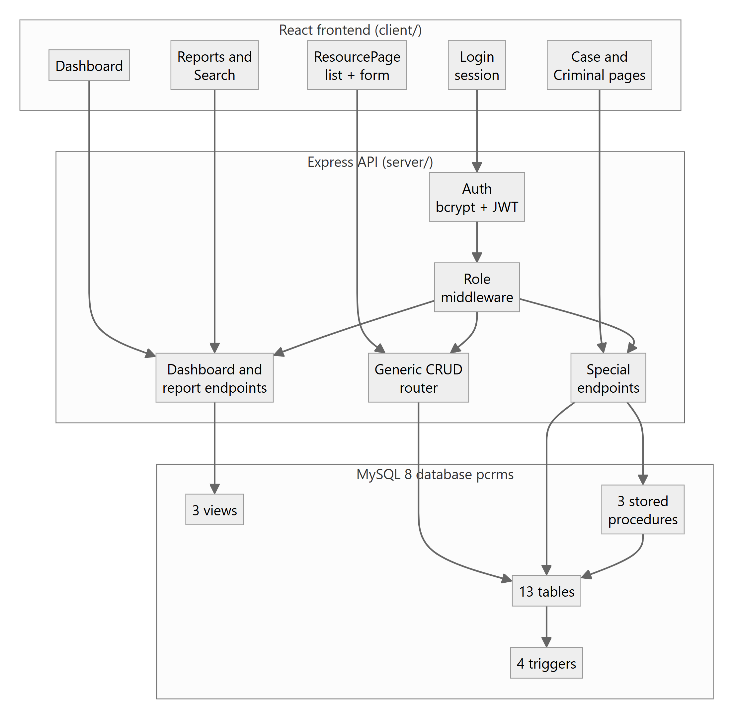
Figure : Component diagram: frontend, API and database modules

3.3 Data Flow Diagrams
Figure 3 is the context-level DFD. PCRMS is a single process exchanging data with three external entities: the administrator (master data and deletions), the police officer (complaints, FIRs, arrests, evidence and hearings) and the viewer (searches and report requests).
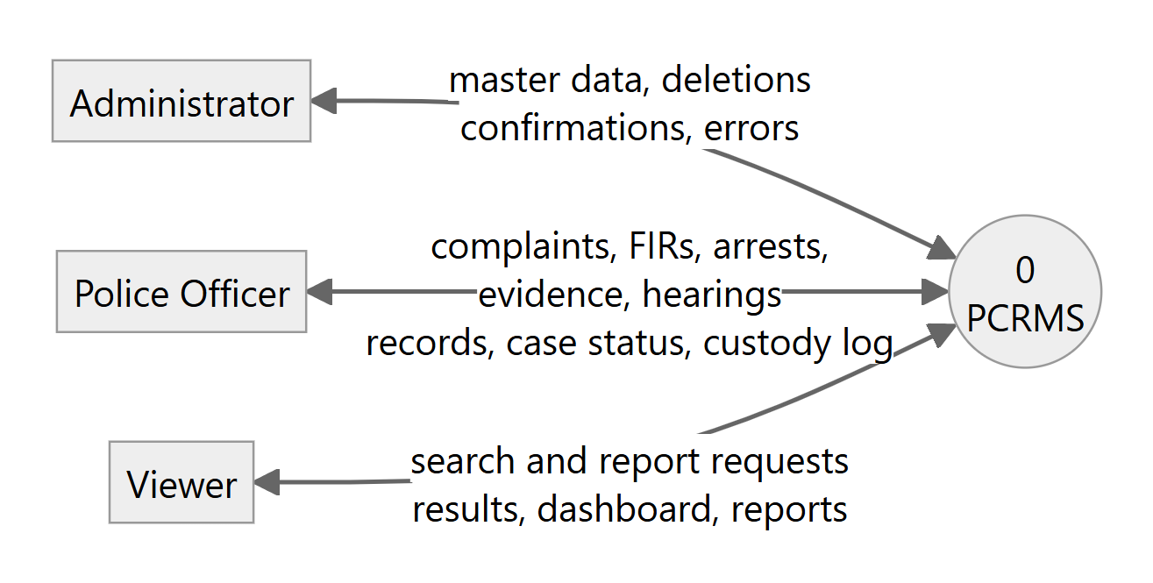
Figure : Level 0 (context) data flow diagram
Figure 4 decomposes the system into six processes: authentication and authorization (1.0), master data (2.0), complaint and FIR registration (3.0), arrest and evidence (4.0), court proceedings (5.0) and search, dashboard and reports (6.0). Data stores D1 to D5 group the thirteen tables by subject. Dotted arrows show database triggers that update case status as a side effect of arrests and hearings. Process 1.0 guards every other process; for readability its authorization flows to the other processes are not drawn individually.
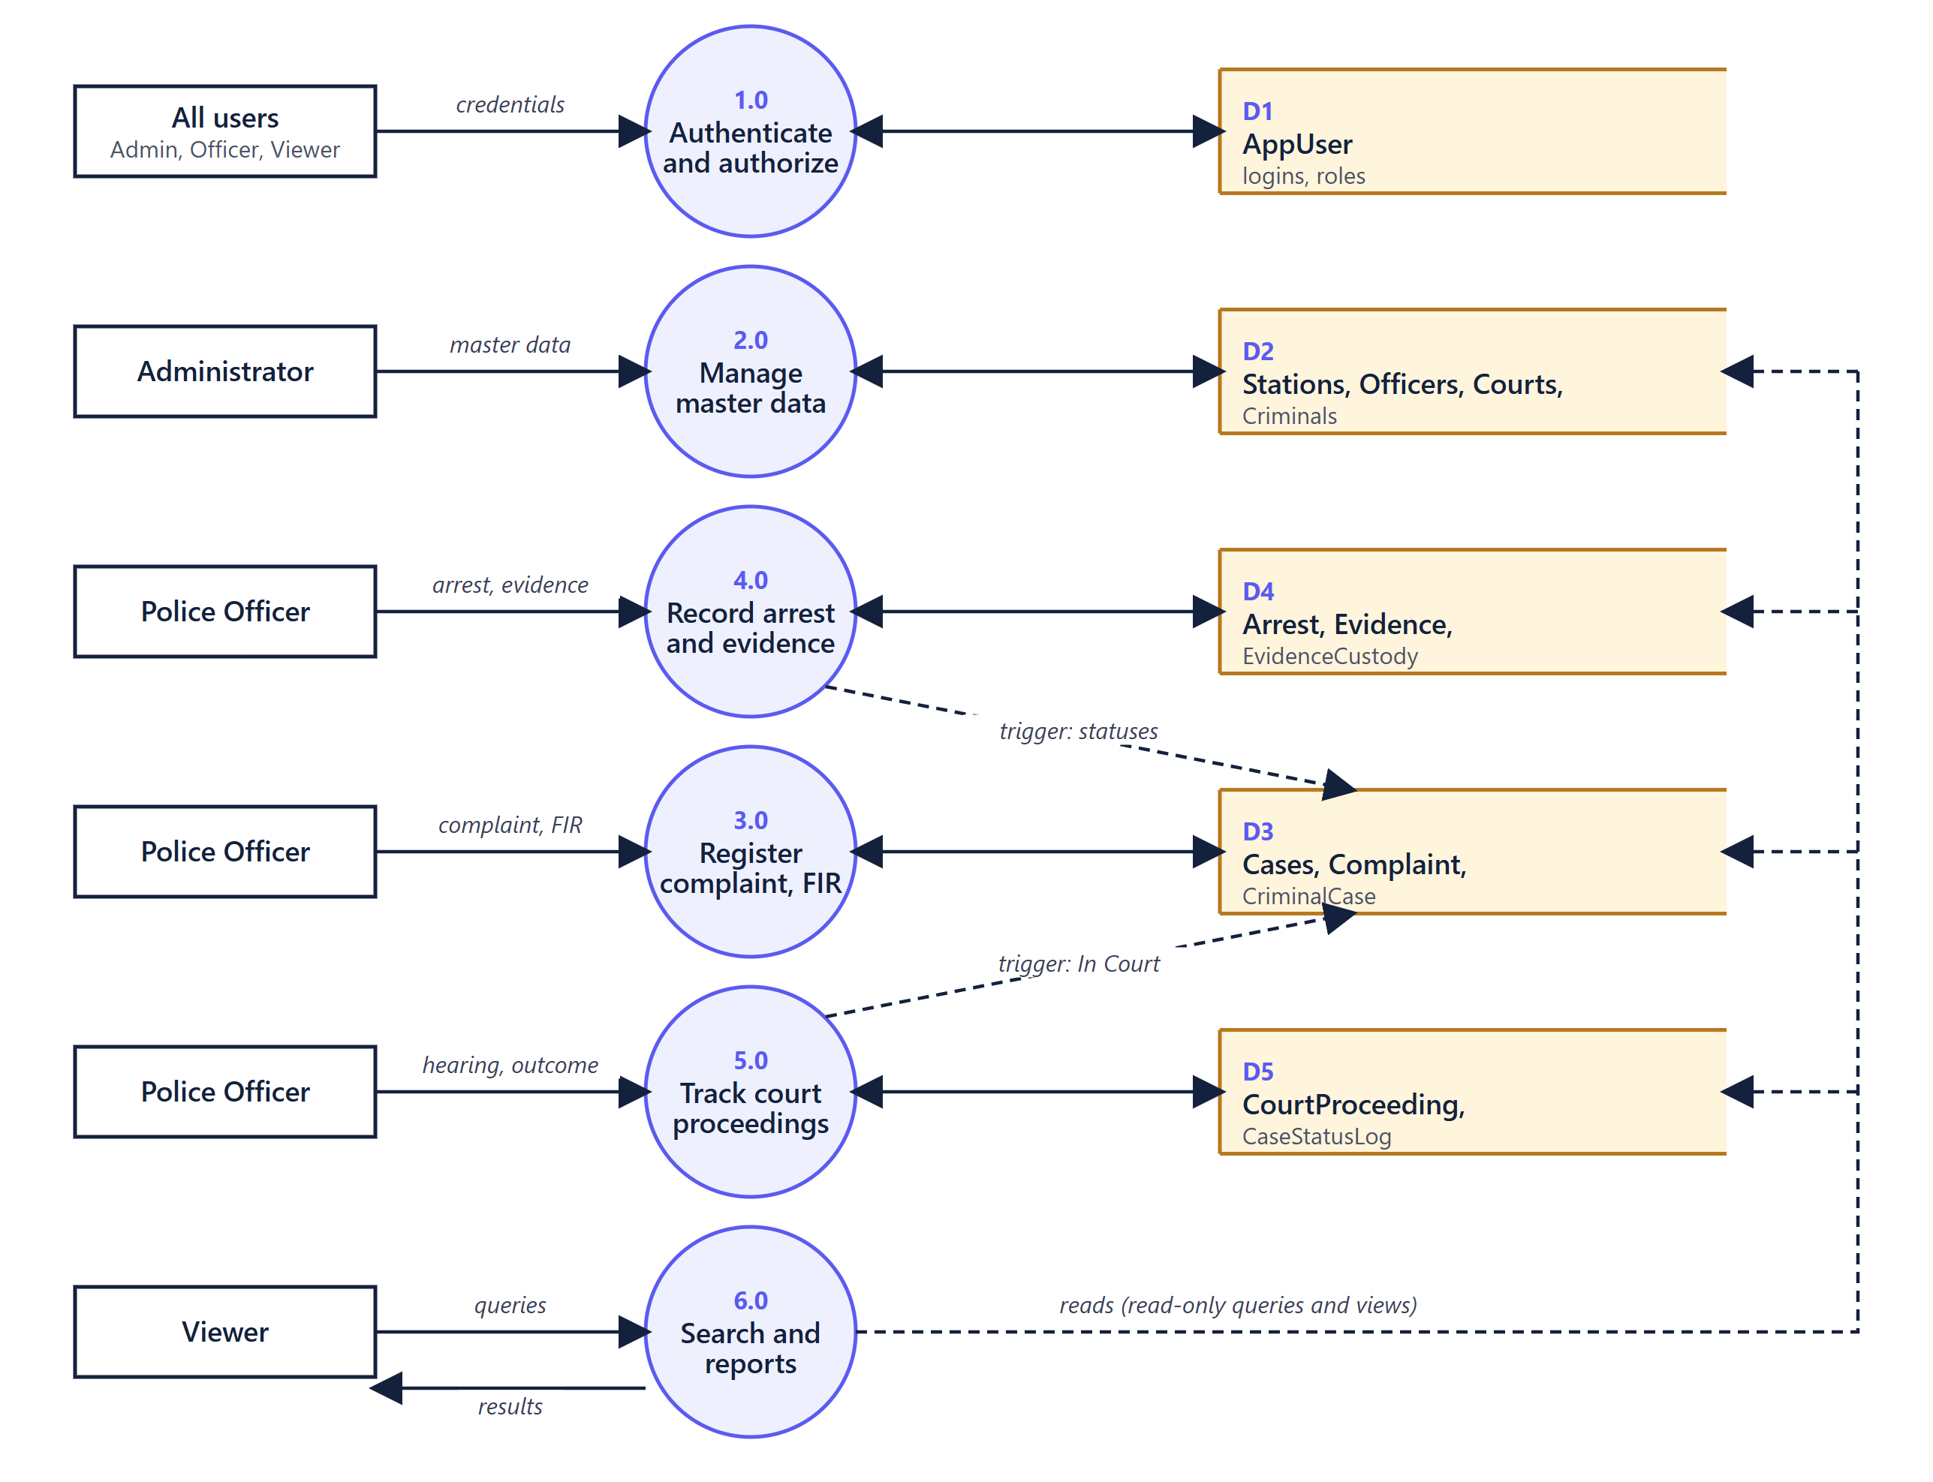
Figure : Level 1 data flow diagram

3.4 Use Case Diagram
Figure 5 shows the actors and use cases. The roles form a hierarchy that mirrors the implemented permissions: the viewer can log in, view the dashboard, search, read reports and view details; the police officer inherits these and can create and edit records (FIRs, complaints, criminals, arrests, evidence, custody, hearings and master data); the administrator inherits everything and can additionally delete records.
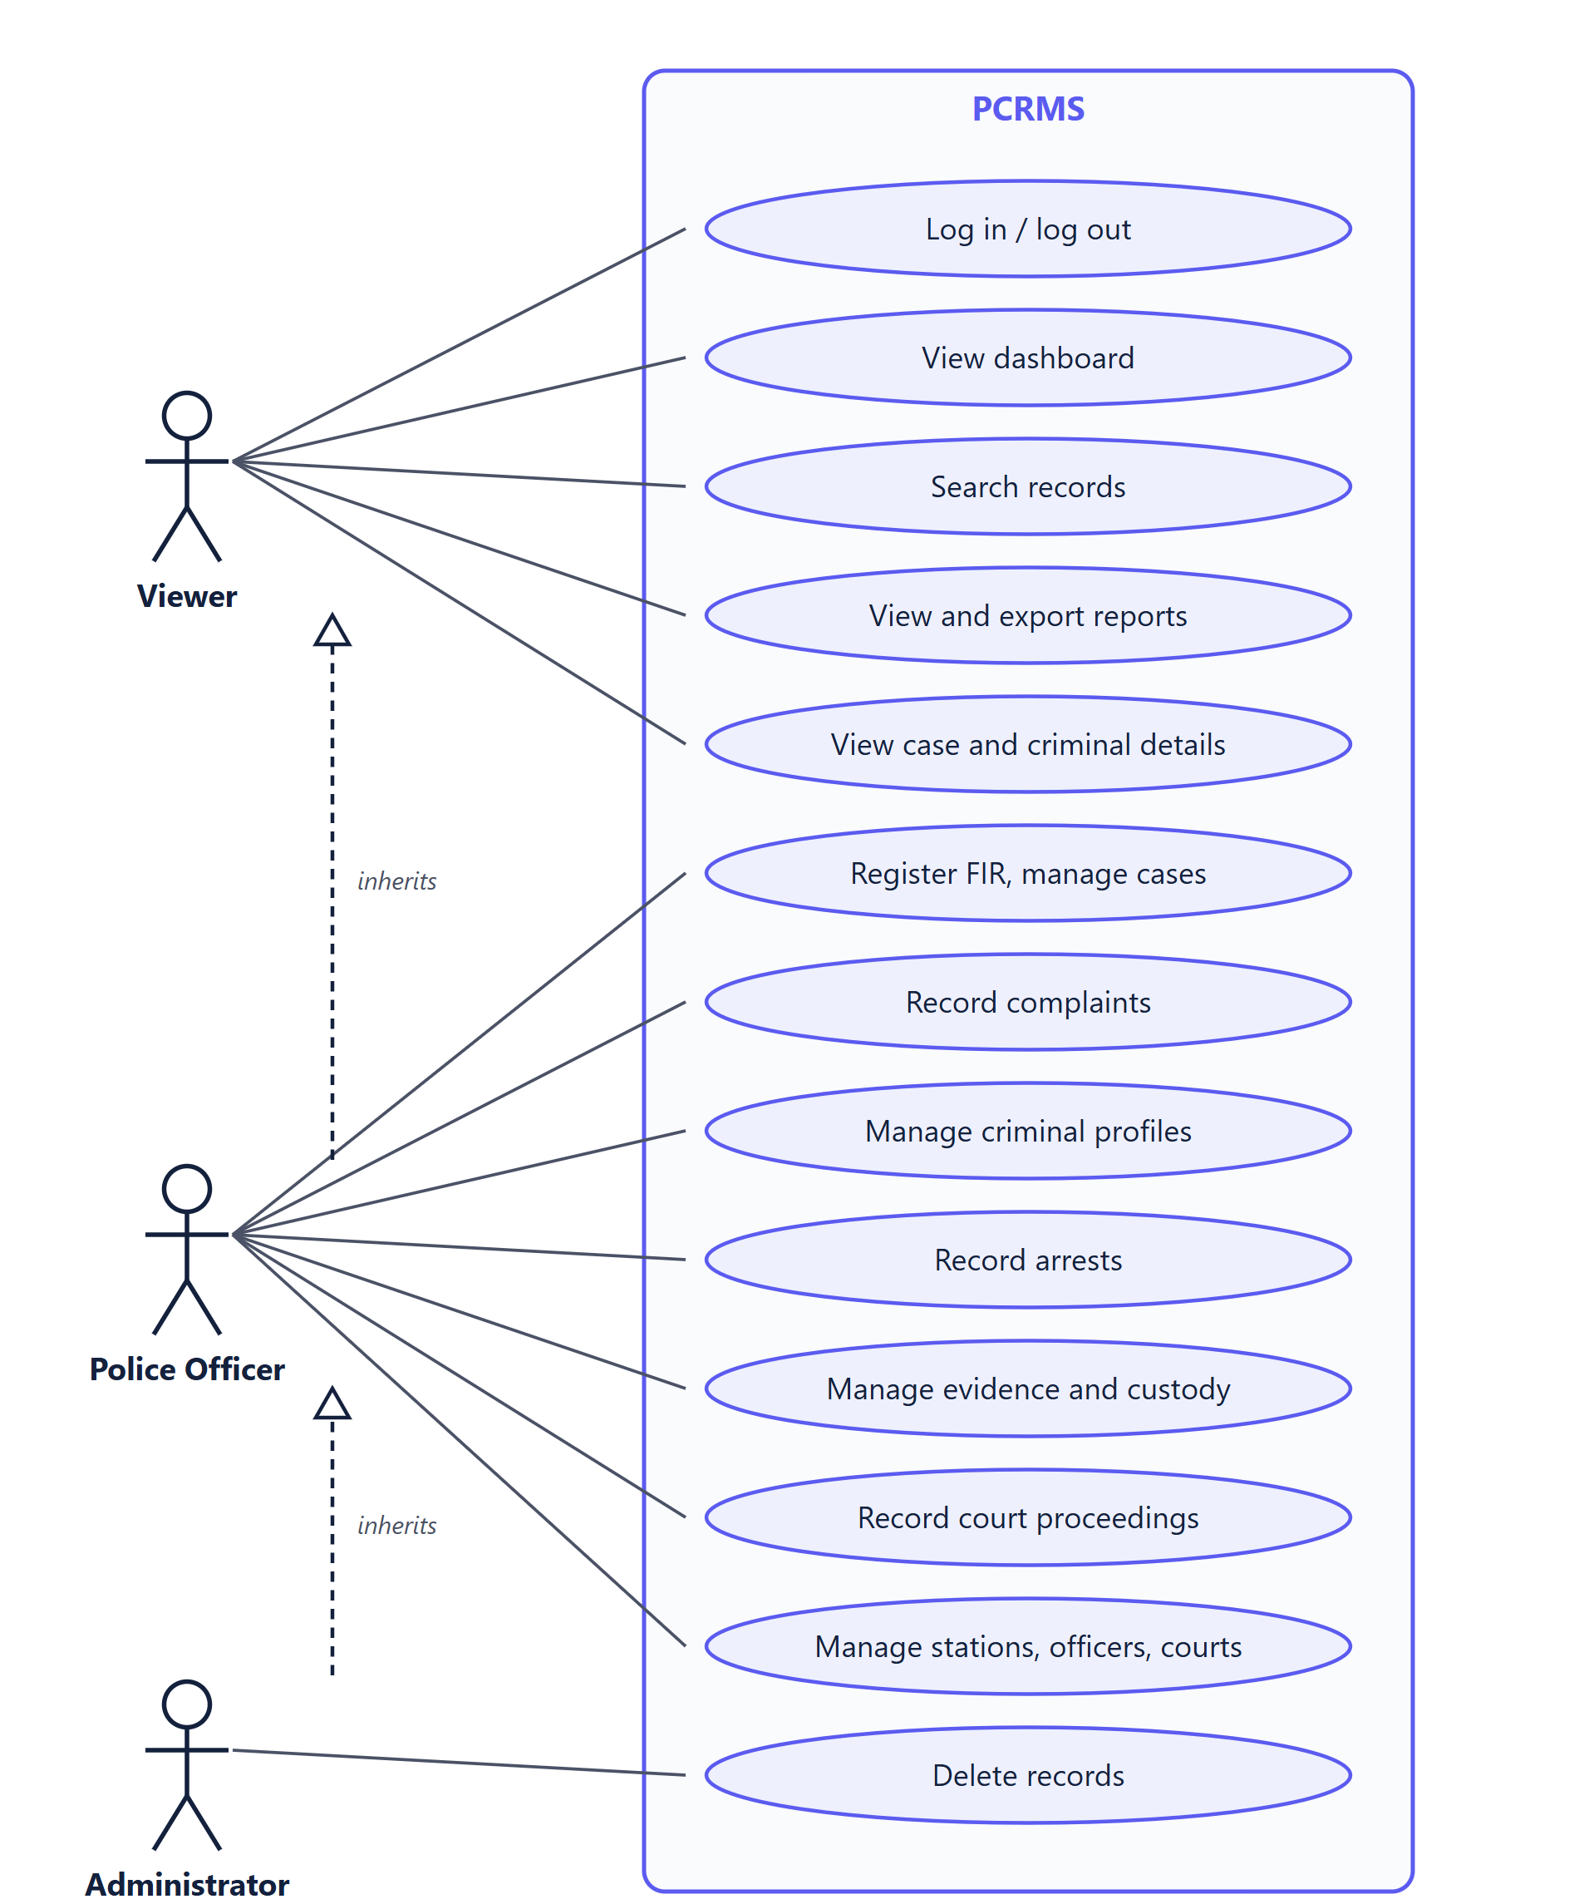
Figure : Use case diagram with actors and role inheritance

3.5 Activity Diagram
Figure 6 follows the main workflow from login to case closure. After a successful login the officer records a complaint and registers an FIR, which creates the case. An arrest triggers automatic status changes; evidence is added with its first custody entry; when a hearing is recorded the case moves to In Court; closing the case completes the lifecycle. The loops show that investigation and custody logging can continue until an arrest or hearing occurs.
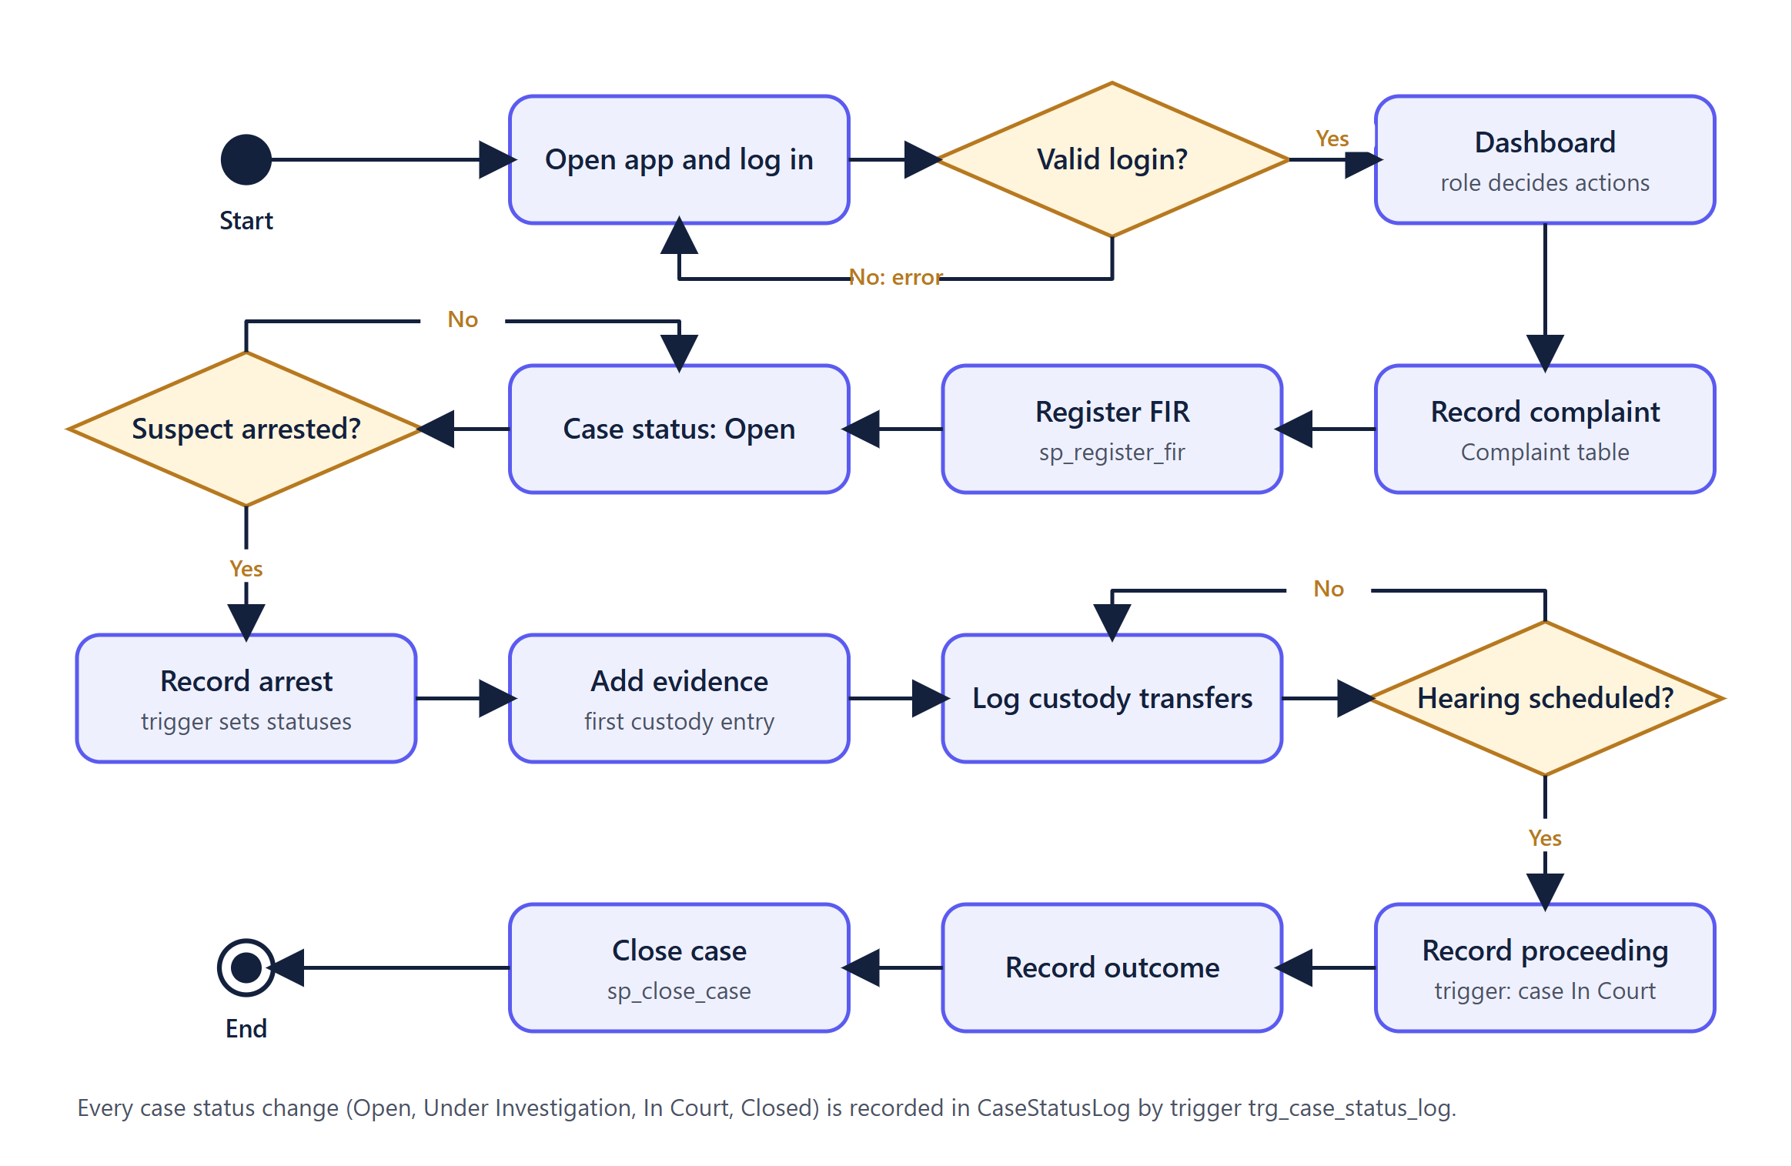
Figure : Activity diagram of the case lifecycle workflow

3.6 Sequence Diagram
Figure 7 shows the end-to-end operation "record an arrest". The request is rejected with 401 if the token is invalid and with 403 if the role is not permitted. Otherwise a parameterized INSERT is executed; the trigger trg_arrest_after_insert runs inside the same statement and updates the criminal and the case, and the trigger on Cases writes a status-log row. The interface then reloads the list.
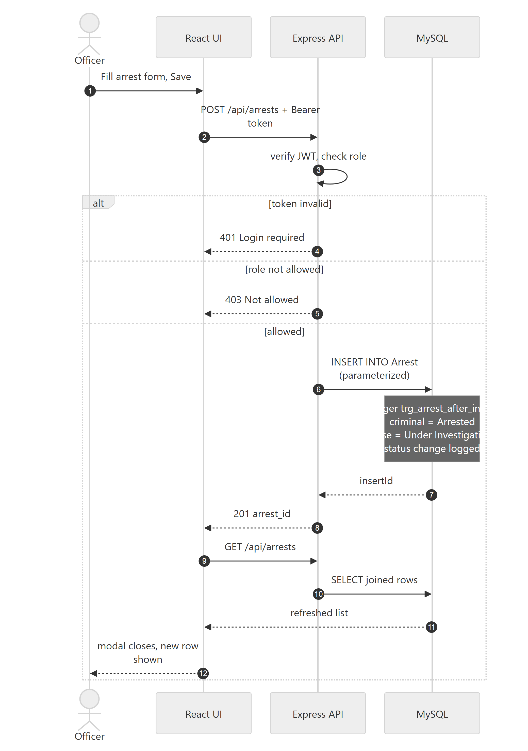
Figure : Sequence diagram: recording an arrest

3.7 Class Diagram
PCRMS is not an object-relational application: its persistent model is the relational schema in Chapter 4, and the API is written in a functional, configuration-driven style. A class diagram of domain objects would therefore duplicate the ER diagram. Figure 8 instead shows the main code-level classes and modules: the React components, the API client, the Express server, the resource configuration and the connection pool, and how they depend on each other.
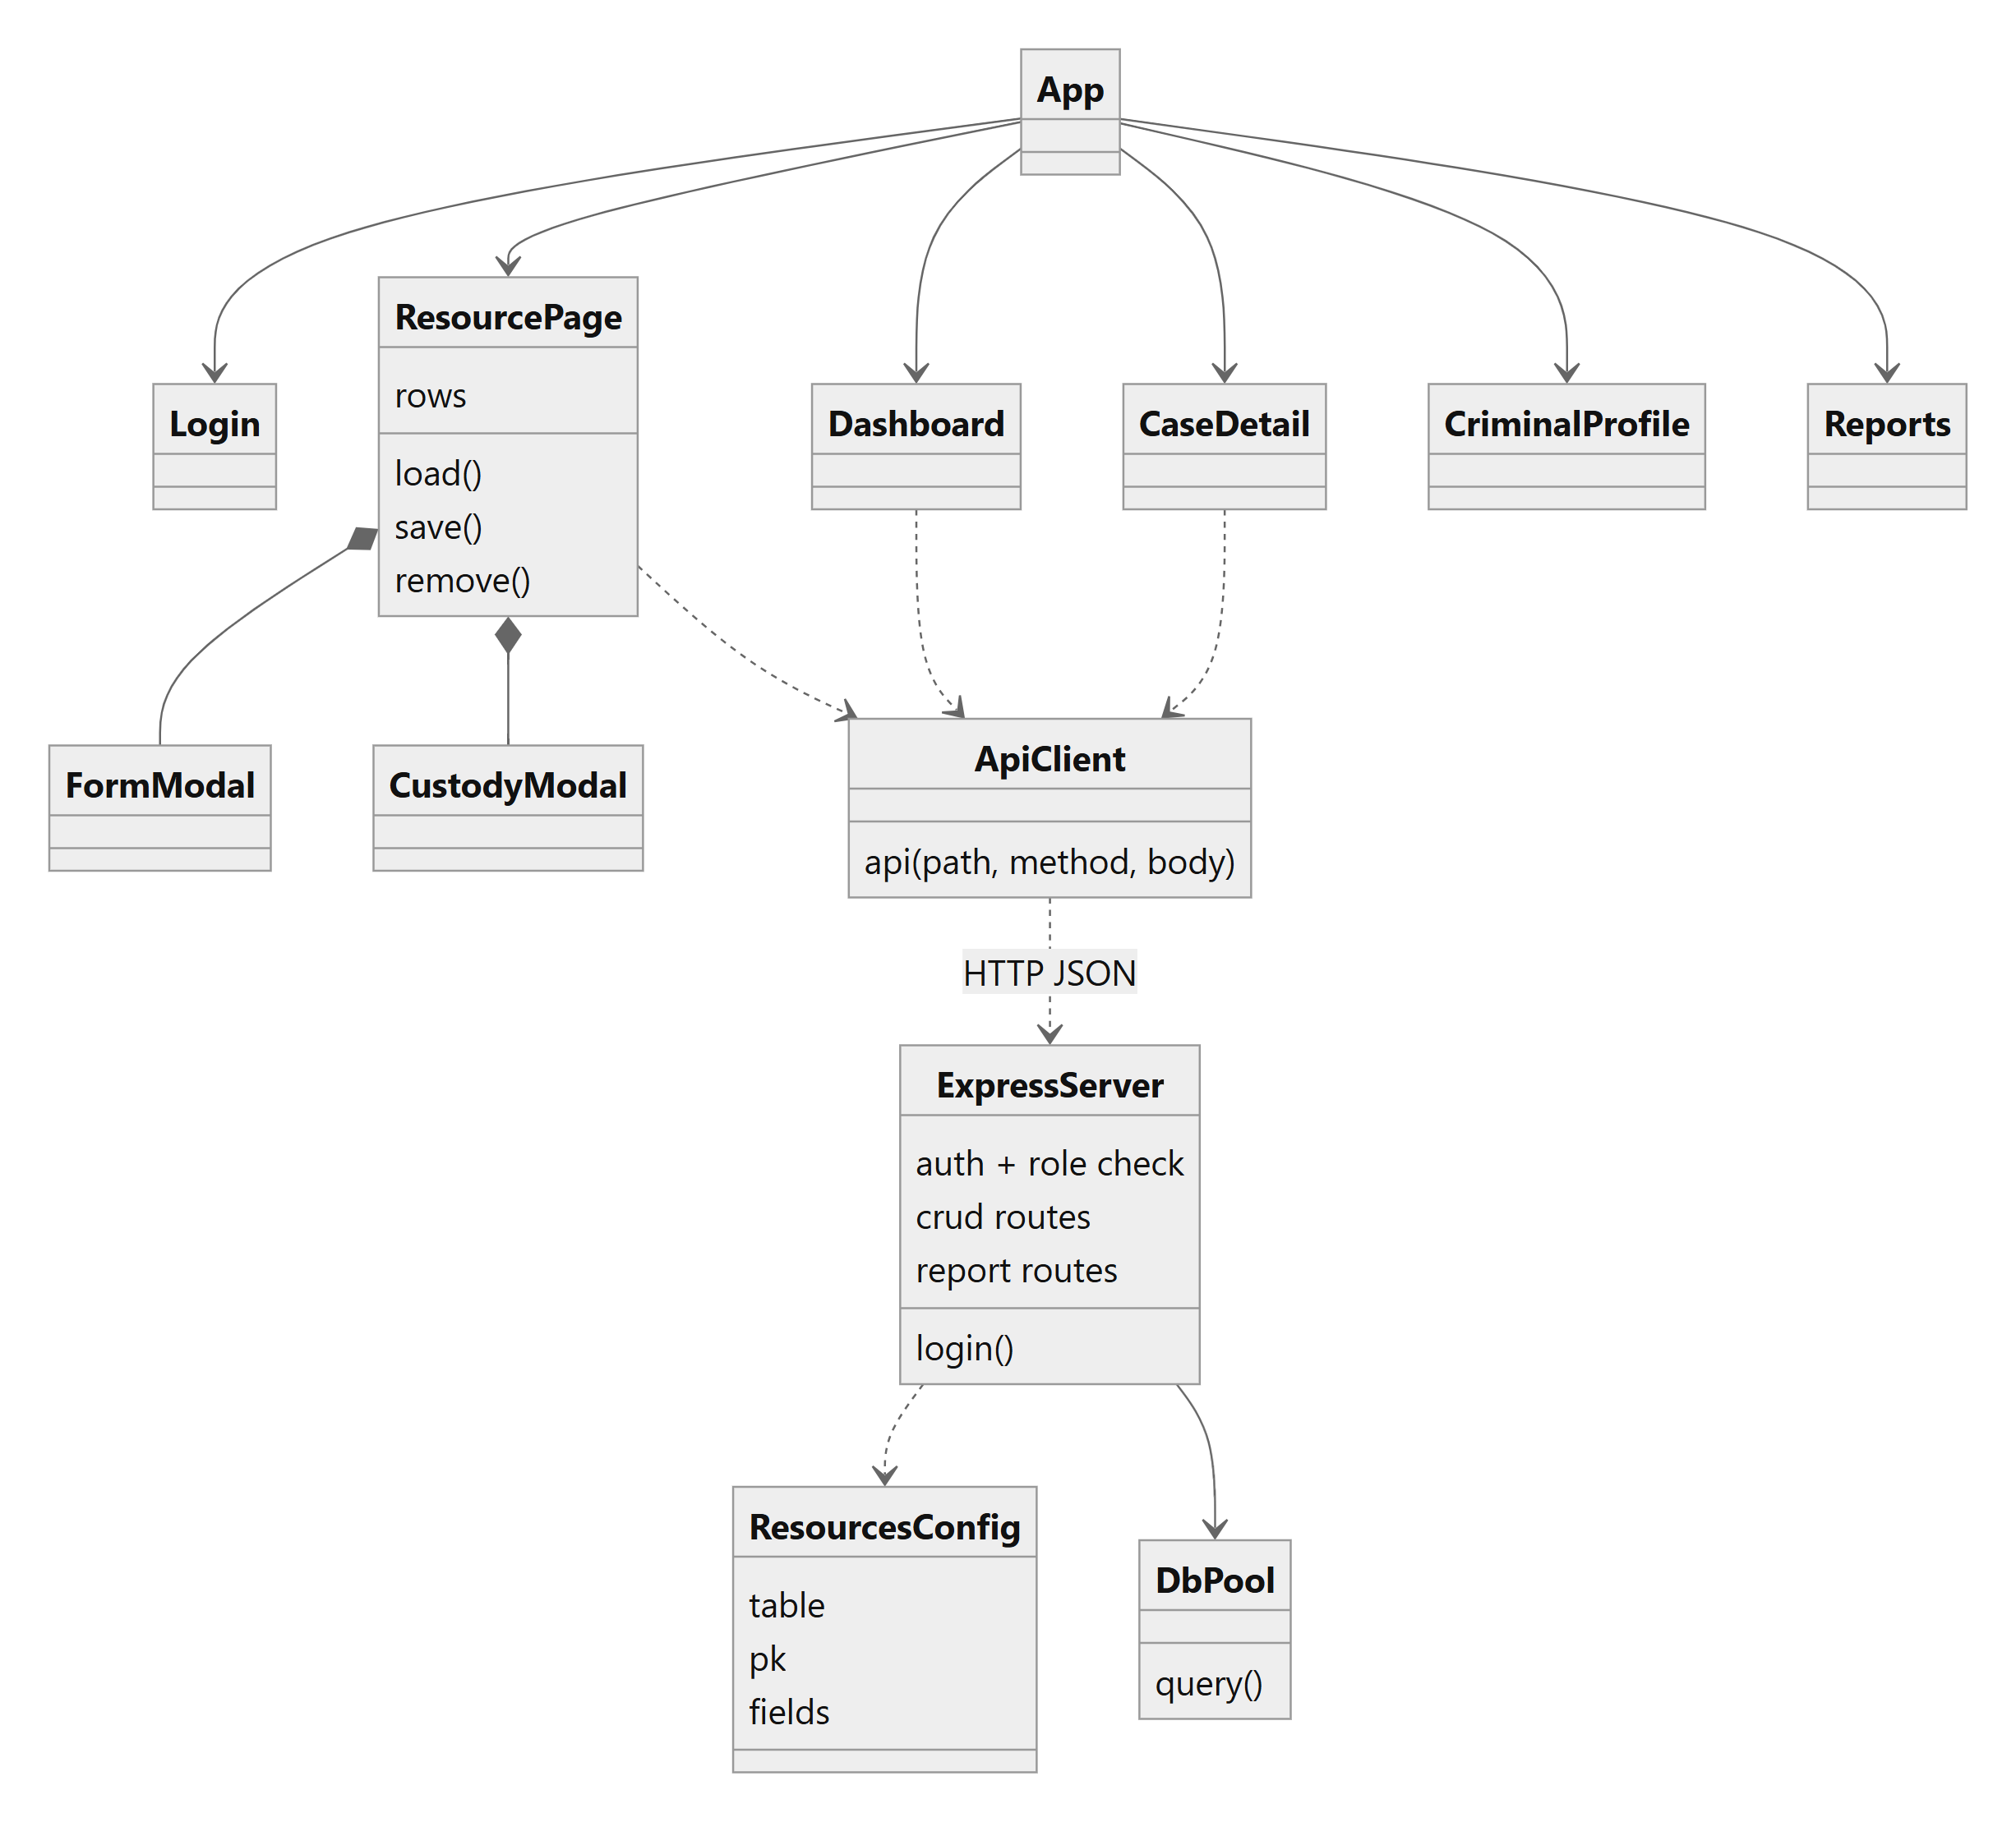
Figure : Class/module diagram of the application code

3.8 Choice of Technologies
Table : Technology choices and rationale
Technology | Role | Reason
MySQL 8.4 | Relational database | Named in the project plan; supports InnoDB transactions, foreign keys, stored procedures, triggers and views.
Node.js + Express 4 | REST API | Same language as the frontend; small, well-documented framework; easy to generate CRUD routes from configuration.
mysql2 | Database driver | Promise API, prepared/parameterized queries, connection pool.
React 18 + Vite | Frontend | Component model suits repeated list/form pages; fast development server and build.
React Router 6 | Client-side routing | Nested routes and navigation without page reloads.
Motion for React | Animations | Page transitions, staggered lists and hover effects using one small library.
JWT + bcryptjs | Authentication | Stateless tokens, adaptive password hashing in pure JavaScript.

Chapter 4: Database Design

4.1 Database Technology and Design Approach
The database is a relational schema named pcrms on MySQL 8.4.9. All thirteen tables use the InnoDB engine and the utf8mb4 character set, which provides transactions and foreign-key enforcement. The design started from the entities named in the project review (police station, officer, criminal, case, arrest, evidence, court, court proceeding) and followed the entity-relationship approach [15]: identify entities and their attributes, identify relationships and their cardinalities, resolve many-to-many relationships with a junction table, and normalize to third normal form [14]. The final schema was then created with the DDL in database/schema.sql and the facts in this chapter were read back from the running database using information_schema, so they describe the implemented schema rather than the plan.
Four tables were added to the nine in the review document, because the modules in the review needed them: Complaint (the Complaints module), EvidenceCustody (the "chain of custody" in the Evidence module), AppUser (role-based login) and CaseStatusLog (status history populated by a trigger). Two foreign keys were also added to make relationships real: Arrest.criminal_id (who was arrested) and CourtProceeding.court_id (where the hearing took place).

4.2 List of Tables
Table : The thirteen tables of the pcrms database
# | Table | Purpose
1 | PoliceStation | Police stations with address, city and phone. Parent of officers and complaints.
2 | Officer | Police officers with unique badge number, rank and the station they belong to.
3 | Criminal | Persons of interest with personal details, photo link and a status (Wanted, Arrested, Convicted, Released).
4 | Cases | Cases created from an FIR. Holds FIR number, type, status and the officer in charge. Named Cases because CASE is a reserved SQL word.
5 | Complaint | Citizen complaints received at a station; optionally linked to the case they led to.
6 | CriminalCase | Junction table that resolves the many-to-many relationship between criminals and cases; stores the person's role in the case.
7 | Arrest | An arrest of a criminal in connection with a case by an officer, with date, location and charges.
8 | Evidence | Evidence items collected for an arrest.
9 | EvidenceCustody | Chain-of-custody log: each hand-over or action on an evidence item, with the officer and timestamp.
10 | Court | Courts with name and location.
11 | CourtProceeding | Hearings of a case in a court, with date and outcome (NULL until concluded).
12 | AppUser | Application logins with bcrypt password hash and role (admin, officer, viewer); optionally linked to an officer.
13 | CaseStatusLog | Audit rows written by a trigger whenever a case's status changes.

In addition to the tables, the database contains 3 views (v_case_overview, v_station_stats, v_wanted_criminals), 3 stored procedures (sp_close_case, sp_criminal_history, sp_register_fir) and 4 triggers (trg_arrest_after_insert, trg_proceeding_after_insert, trg_case_status_log, trg_evidence_custody_init).

4.3 Entity-Relationship Diagram
Figure 9 is the entity-relationship diagram of the implemented database, drawn in Chen notation: rectangles are entities, diamonds are relationships, ellipses are attributes and an underlined attribute is the primary key (a dashed underline marks a unique key). A single line means partial participation and a double line means total participation (every row of that entity must take part, which corresponds to a NOT NULL foreign key). An arrow points to the "one" side of a many-to-one relationship; a relationship drawn without arrows is many-to-many. Foreign-key columns are shown as relationships and not repeated as attributes. The diagram has 12 entities, 15 relationships and every other column as an attribute, and was checked against the live database schema: no column is missing.
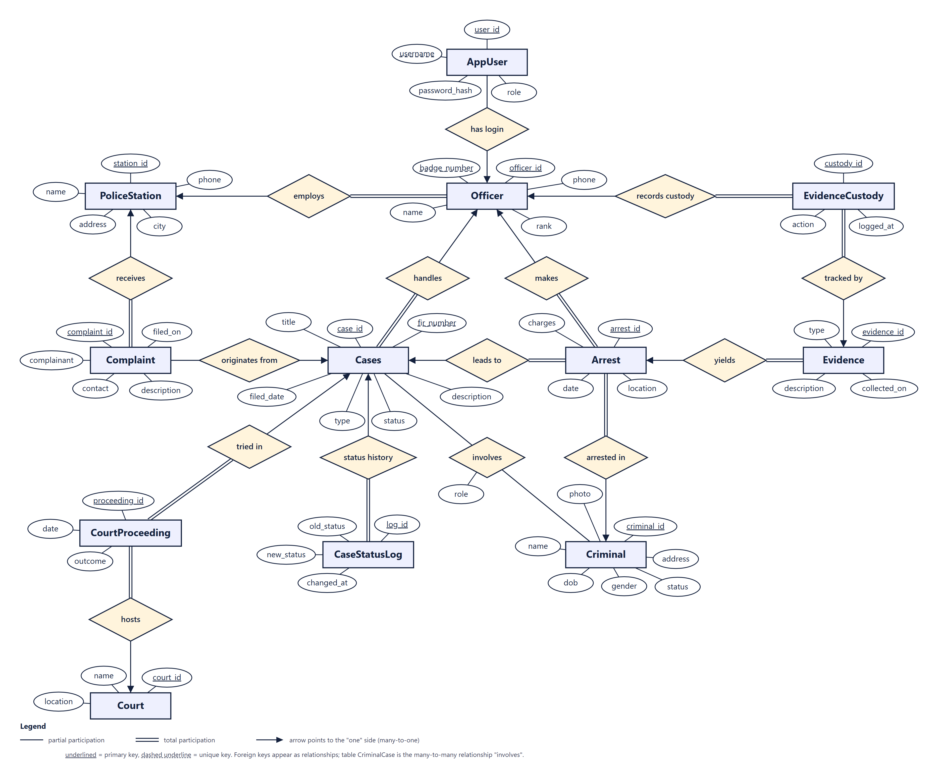
Figure : Entity-relationship diagram of the PCRMS database (Chen notation)
Reading the diagram: a police station employs many officers and receives many complaints; an officer handles cases, makes arrests and records custody actions, and may have login accounts (AppUser); a complaint may originate a case; an arrest leads to a case, arrests a criminal and yields evidence; each evidence item is tracked by custody records; a case is tried in court proceedings, which are hosted by a court, and accumulates status-history rows. The only many-to-many relationship is involves between Criminal and Cases. It is implemented by the junction table CriminalCase (composite primary key criminal_id, case_id), which is why the relational schema has 13 tables while the diagram shows 12 entities: the thirteenth table is the relationship itself, and its descriptive attribute role is attached to the diamond.

4.4 Relationships and Cardinalities
Table : Relationships between entities
Parent (one) | Child (many) | Foreign key | Cardinality | Optional?
PoliceStation | Officer | Officer.station_id | 1 : N | No (NOT NULL)
PoliceStation | Complaint | Complaint.station_id | 1 : N | No
Officer | Cases | Cases.officer_id | 1 : N | No
Officer | Arrest | Arrest.officer_id | 1 : N | No
Officer | EvidenceCustody | EvidenceCustody.officer_id | 1 : N | No
Officer | AppUser | AppUser.officer_id | 0..1 : N | Yes (NULL allowed)
Cases | Complaint | Complaint.case_id | 0..1 : N | Yes (NULL allowed)
Cases | Arrest | Arrest.case_id | 1 : N | No
Cases | CourtProceeding | CourtProceeding.case_id | 1 : N | No
Cases | CaseStatusLog | CaseStatusLog.case_id | 1 : N | No
Criminal | Arrest | Arrest.criminal_id | 1 : N | No
Criminal and Cases | CriminalCase | criminal_id, case_id (composite PK) | M : N | Junction table
Arrest | Evidence | Evidence.arrest_id | 1 : N | No
Evidence | EvidenceCustody | EvidenceCustody.evidence_id | 1 : N | No
Court | CourtProceeding | CourtProceeding.court_id | 1 : N | No

The database declares 16 foreign-key constraints (the 14 one-to-many relationships above plus the two foreign keys of the junction table). Appendix B lists each one with its ON DELETE and ON UPDATE rule.

4.5 Table Schemas
The following tables list every column of every table as read from the database: data type, whether NULL is allowed, default value and constraints. A dash means "none".

4.5.1 PoliceStation
Police stations with address, city and phone. Parent of officers and complaints.
Table : Schema of table PoliceStation
Column | Type | Null | Default | Constraints / notes
station_id | INT | No | - | Primary key; Auto-increment
name | VARCHAR(100) | No | - | -
address | VARCHAR(255) | No | - | -
city | VARCHAR(80) | No | - | -
phone | VARCHAR(20) | Yes | - | -

4.5.2 Officer
Police officers with unique badge number, rank and the station they belong to.
Table : Schema of table Officer
Column | Type | Null | Default | Constraints / notes
officer_id | INT | No | - | Primary key; Auto-increment
badge_number | VARCHAR(20) | No | - | Unique
name | VARCHAR(100) | No | - | -
rank | ENUM('Constable', 'Head Constable', 'Sub-Inspector', 'Inspector', 'DSP', 'SP') | No | - | -
phone | VARCHAR(20) | Yes | - | -
station_id | INT | No | - | FK to PoliceStation.station_id (ON DELETE NO ACTION, ON UPDATE CASCADE)

4.5.3 Criminal
Persons of interest with personal details, photo link and a status (Wanted, Arrested, Convicted, Released).
Table : Schema of table Criminal
Column | Type | Null | Default | Constraints / notes
criminal_id | INT | No | - | Primary key; Auto-increment
name | VARCHAR(100) | No | - | -
dob | DATE | Yes | - | -
gender | ENUM('Male', 'Female', 'Other') | Yes | - | -
address | VARCHAR(255) | Yes | - | -
status | ENUM('Wanted', 'Arrested', 'Convicted', 'Released') | No | Wanted | -
photo | VARCHAR(255) | Yes | - | -

4.5.4 Cases
Cases created from an FIR. Holds FIR number, type, status and the officer in charge. Named Cases because CASE is a reserved SQL word.
Table : Schema of table Cases
Column | Type | Null | Default | Constraints / notes
case_id | INT | No | - | Primary key; Auto-increment
fir_number | VARCHAR(30) | No | - | Unique
title | VARCHAR(150) | No | - | -
type | VARCHAR(60) | No | - | -
description | TEXT | Yes | - | -
filed_date | DATE | No | - | -
status | ENUM('Open', 'Under Investigation', 'In Court', 'Closed') | No | Open | -
officer_id | INT | No | - | FK to Officer.officer_id (ON DELETE NO ACTION, ON UPDATE CASCADE)

4.5.5 Complaint
Citizen complaints received at a station; optionally linked to the case they led to.
Table : Schema of table Complaint
Column | Type | Null | Default | Constraints / notes
complaint_id | INT | No | - | Primary key; Auto-increment
complainant | VARCHAR(100) | No | - | -
contact | VARCHAR(40) | Yes | - | -
description | TEXT | No | - | -
filed_on | DATE | No | - | -
station_id | INT | No | - | FK to PoliceStation.station_id (ON DELETE NO ACTION, ON UPDATE NO ACTION)
case_id | INT | Yes | - | FK to Cases.case_id (ON DELETE SET NULL, ON UPDATE NO ACTION)

4.5.6 CriminalCase
Junction table that resolves the many-to-many relationship between criminals and cases; stores the person's role in the case.
Table : Schema of table CriminalCase
Column | Type | Null | Default | Constraints / notes
criminal_id | INT | No | - | Primary key; FK to Criminal.criminal_id (ON DELETE CASCADE, ON UPDATE NO ACTION)
case_id | INT | No | - | Primary key; FK to Cases.case_id (ON DELETE CASCADE, ON UPDATE NO ACTION)
role | ENUM('Accused', 'Suspect', 'Convict') | No | Accused | -

4.5.7 Arrest
An arrest of a criminal in connection with a case by an officer, with date, location and charges.
Table : Schema of table Arrest
Column | Type | Null | Default | Constraints / notes
arrest_id | INT | No | - | Primary key; Auto-increment
date | DATE | No | - | -
location | VARCHAR(150) | Yes | - | -
charges | VARCHAR(255) | Yes | - | -
case_id | INT | No | - | FK to Cases.case_id (ON DELETE NO ACTION, ON UPDATE NO ACTION)
officer_id | INT | No | - | FK to Officer.officer_id (ON DELETE NO ACTION, ON UPDATE NO ACTION)
criminal_id | INT | No | - | FK to Criminal.criminal_id (ON DELETE NO ACTION, ON UPDATE NO ACTION)

4.5.8 Evidence
Evidence items collected for an arrest.
Table : Schema of table Evidence
Column | Type | Null | Default | Constraints / notes
evidence_id | INT | No | - | Primary key; Auto-increment
type | VARCHAR(60) | No | - | -
description | TEXT | Yes | - | -
collected_on | DATE | No | - | -
arrest_id | INT | No | - | FK to Arrest.arrest_id (ON DELETE CASCADE, ON UPDATE NO ACTION)

4.5.9 EvidenceCustody
Chain-of-custody log: each hand-over or action on an evidence item, with the officer and timestamp.
Table : Schema of table EvidenceCustody
Column | Type | Null | Default | Constraints / notes
custody_id | INT | No | - | Primary key; Auto-increment
evidence_id | INT | No | - | FK to Evidence.evidence_id (ON DELETE CASCADE, ON UPDATE NO ACTION)
officer_id | INT | No | - | FK to Officer.officer_id (ON DELETE NO ACTION, ON UPDATE NO ACTION)
action | VARCHAR(100) | No | - | -
logged_at | DATETIME | No | CURRENT_TIMESTAMP | -

4.5.10 Court
Courts with name and location.
Table : Schema of table Court
Column | Type | Null | Default | Constraints / notes
court_id | INT | No | - | Primary key; Auto-increment
name | VARCHAR(100) | No | - | -
location | VARCHAR(255) | No | - | -

4.5.11 CourtProceeding
Hearings of a case in a court, with date and outcome (NULL until concluded).
Table : Schema of table CourtProceeding
Column | Type | Null | Default | Constraints / notes
proceeding_id | INT | No | - | Primary key; Auto-increment
date | DATE | No | - | -
outcome | VARCHAR(255) | Yes | - | -
case_id | INT | No | - | FK to Cases.case_id (ON DELETE NO ACTION, ON UPDATE NO ACTION)
court_id | INT | No | - | FK to Court.court_id (ON DELETE NO ACTION, ON UPDATE NO ACTION)

4.5.12 AppUser
Application logins with bcrypt password hash and role (admin, officer, viewer); optionally linked to an officer.
Table : Schema of table AppUser
Column | Type | Null | Default | Constraints / notes
user_id | INT | No | - | Primary key; Auto-increment
username | VARCHAR(50) | No | - | Unique
password_hash | VARCHAR(100) | No | - | -
role | ENUM('admin', 'officer', 'viewer') | No | - | -
officer_id | INT | Yes | - | FK to Officer.officer_id (ON DELETE SET NULL, ON UPDATE NO ACTION)

4.5.13 CaseStatusLog
Audit rows written by a trigger whenever a case's status changes.
Table : Schema of table CaseStatusLog
Column | Type | Null | Default | Constraints / notes
log_id | INT | No | - | Primary key; Auto-increment
case_id | INT | No | - | FK to Cases.case_id (ON DELETE CASCADE, ON UPDATE NO ACTION)
old_status | VARCHAR(30) | No | - | -
new_status | VARCHAR(30) | No | - | -
changed_at | DATETIME | No | CURRENT_TIMESTAMP | -

4.6 Constraints and Indexes
Constraints are the first line of defence for data quality. Primary keys identify every row. NOT NULL prevents missing mandatory data. UNIQUE constraints protect natural keys that must not repeat: fir_number, badge_number, username and the pair (station name, city). ENUM types restrict status, rank, gender and role to a fixed vocabulary. Foreign keys prevent orphans and define what happens on deletion (NO ACTION, the MySQL default, behaves like RESTRICT in InnoDB: the delete is refused while child rows exist): for example, deleting a case cascades to its CriminalCase links and status log, but sets Complaint.case_id to NULL so the original citizen complaint is retained.
Table : Indexes in the pcrms database
Table | Index | Unique | Columns
AppUser | officer_id | No | officer_id
AppUser | username | Yes | username
Arrest | case_id | No | case_id
Arrest | idx_arrest_criminal | No | criminal_id
Arrest | officer_id | No | officer_id
Cases | fir_number | Yes | fir_number
Cases | idx_cases_status | No | status
Cases | officer_id | No | officer_id
CaseStatusLog | case_id | No | case_id
Complaint | case_id | No | case_id
Complaint | station_id | No | station_id
CourtProceeding | case_id | No | case_id
CourtProceeding | court_id | No | court_id
Criminal | idx_criminal_name | No | name
CriminalCase | case_id | No | case_id
Evidence | arrest_id | No | arrest_id
EvidenceCustody | evidence_id | No | evidence_id
EvidenceCustody | officer_id | No | officer_id
Officer | badge_number | Yes | badge_number
Officer | idx_officer_station | No | station_id
PoliceStation | name | Yes | name, city

Besides the explicit indexes idx_cases_status, idx_criminal_name, idx_officer_station and idx_arrest_criminal, MySQL creates an index for each unique constraint and for each foreign key column. Free-text search in the application uses LIKE with a leading wildcard, which cannot use an index and therefore scans the table; this is acceptable for the size of the demonstration data but is noted as a limitation in Chapter 8.

4.7 Normalization Analysis
The schema was normalized to third normal form (3NF) [14]. For each table the functional dependencies are those of its primary key; no non-key attribute determines another non-key attribute.
- First normal form (1NF). Every column holds a single atomic value and there are no repeating groups. Multiple criminals per case, multiple evidence items per arrest and multiple custody actions per evidence item are stored as rows in CriminalCase, Evidence and EvidenceCustody, not as lists in a column.
- Second normal form (2NF). Tables with a single-column primary key cannot have a partial dependency. In CriminalCase, whose key is (criminal_id, case_id), the only non-key attribute is role, which describes the pair and depends on the whole key.
- Third normal form (3NF). No transitive dependencies exist. Station details are stored only in PoliceStation and Officer holds only station_id; court details only in Court; a case stores officer_id and not the officer's name or rank; a custody row stores officer_id, not the officer's details. Derived values such as the number of arrests per case are computed by views and queries and never stored.

Deliberate design choices that might look like redundancy: Arrest.case_id and Arrest.criminal_id both exist because an arrest identifies a person and the case it relates to, and CriminalCase additionally records the person's role in the case (the trigger trg_arrest_after_insert ensures the link exists). Cases.status is an explicit attribute rather than a derived value because it represents a workflow state that is changed by procedures and triggers and audited in CaseStatusLog.

4.8 Views, Stored Procedures and Triggers
Table : Programmability objects in the database
Object | Type | Purpose
v_case_overview | View | Each case with officer, station and counts of criminals, arrests and evidence items.
v_wanted_criminals | View | Criminals whose status is Wanted.
v_station_stats | View | Officers and cases handled per station.
sp_register_fir | Procedure | Creates a case inside a transaction and links an optional complaint; rolls back on any error.
sp_close_case | Procedure | Sets a case status to Closed.
sp_criminal_history | Procedure | Returns every case a criminal is linked to with the role and status.
trg_arrest_after_insert | Trigger (AFTER INSERT on Arrest) | Marks the criminal Arrested, moves an Open case to Under Investigation, links the criminal to the case.
trg_proceeding_after_insert | Trigger (AFTER INSERT on CourtProceeding) | Moves an Open or Under Investigation case to In Court.
trg_case_status_log | Trigger (AFTER UPDATE on Cases) | Writes a CaseStatusLog row when the status changes.
trg_evidence_custody_init | Trigger (AFTER INSERT on Evidence) | Creates the first EvidenceCustody row.

Listing 1: Stored procedure sp_register_fir (database/programmability.sql)
CREATE PROCEDURE sp_register_fir(IN p_fir VARCHAR(30), IN p_title VARCHAR(150), IN p_type VARCHAR(60),
IN p_desc TEXT, IN p_officer INT, IN p_complaint INT)
BEGIN
DECLARE new_id INT;
DECLARE EXIT HANDLER FOR SQLEXCEPTION BEGIN ROLLBACK; RESIGNAL; END;
START TRANSACTION;
INSERT INTO Cases(fir_number,title,type,description,filed_date,officer_id)
VALUES (p_fir,p_title,p_type,p_desc,CURDATE(),p_officer);
SET new_id = LAST_INSERT_ID();
IF p_complaint IS NOT NULL THEN
UPDATE Complaint SET case_id=new_id WHERE complaint_id=p_complaint;
END IF;
COMMIT;
SELECT new_id AS case_id;
END

The procedure above wraps the case insertion and complaint linking in one transaction. The exit handler rolls back and re-raises the error, which is why a duplicate FIR number leaves no partial data (verified by TC-25).
Listing 2: Trigger trg_arrest_after_insert (database/programmability.sql)
CREATE TRIGGER trg_arrest_after_insert AFTER INSERT ON Arrest FOR EACH ROW
BEGIN
UPDATE Criminal SET status='Arrested' WHERE criminal_id=NEW.criminal_id;
UPDATE Cases SET status='Under Investigation' WHERE case_id=NEW.case_id AND status='Open';
INSERT IGNORE INTO CriminalCase(criminal_id,case_id) VALUES (NEW.criminal_id,NEW.case_id);
END

This trigger is the core lifecycle rule: one INSERT into Arrest updates three other tables consistently. Because it lives in the database, the rule applies no matter which client performs the insert.

4.9 How Data Is Stored, Retrieved, Updated and Deleted
- Store (INSERT). The API whitelists the columns of the target table, converts empty strings to NULL and runs one parameterized INSERT. Procedures and triggers perform secondary inserts and updates. Auto-increment surrogate keys are returned to the client.
- Retrieve (SELECT). List endpoints select from the table or from a join that adds display names (for example the officer name for a case). Detail pages combine several queries. Reports read from views or aggregate queries (COUNT, SUM, GROUP BY, HAVING). The criminal history page calls sp_criminal_history.
- Update. PUT requests update only the whitelisted columns that were sent. Status changes on Cases are captured by the audit trigger.
- Delete. Deletion is restricted to administrators. Foreign keys decide the outcome: a referenced row cannot be deleted (RESTRICT, reported to the user as a conflict), while child rows with ON DELETE CASCADE are removed with their parent and nullable references are set to NULL.

A representative query, the view that backs the case overview report, is shown below.
Listing 3: View v_case_overview (database/programmability.sql)
CREATE OR REPLACE VIEW v_case_overview AS
SELECT c.case_id, c.fir_number, c.title, c.type, c.status, c.filed_date,
o.name AS officer, ps.name AS station,
(SELECT COUNT(*) FROM CriminalCase cc WHERE cc.case_id=c.case_id) AS criminals,
(SELECT COUNT(*) FROM Arrest a WHERE a.case_id=c.case_id) AS arrests,
(SELECT COUNT(*) FROM Evidence e JOIN Arrest a ON a.arrest_id=e.arrest_id WHERE a.case_id=c.case_id) AS evidence_items
FROM Cases c JOIN Officer o ON o.officer_id=c.officer_id
JOIN PoliceStation ps ON ps.station_id=o.station_id;

Chapter 5: System Implementation

5.1 Project Structure
The repository has three top-level folders: database (SQL), server (API) and client (user interface), plus the report folder. Table 24 lists the source files that make up the application; together they contain about 1684 lines.
Table : Main source files and their sizes
File | Lines | Purpose
client/src/App.jsx | 102 | Application shell: sidebar, top bar, routing, page transitions
client/src/pages/ResourcePage.jsx | 174 | Generic list, search, filter and add/edit/delete page used by nine modules
client/src/config.js | 52 | Field definitions that drive the generic page and navigation
client/src/pages/Dashboard.jsx | 62 | Statistics, charts and upcoming hearings
client/src/pages/CaseDetail.jsx | 76 | Case detail with linked criminals, hearings, evidence, history
client/src/pages/CriminalProfile.jsx | 45 | Criminal profile with case history and arrests
client/src/pages/Reports.jsx | 57 | Report selector, table, CSV export, print
client/src/pages/SearchResults.jsx | 32 | Global search results
client/src/pages/Login.jsx | 72 | Login screen
client/src/ui.jsx | 81 | Icons, page header, loading, empty and error states, badges
client/src/motion.jsx | 34 | Shared animation presets (Motion for React)
client/src/api.js | 14 | Fetch wrapper that attaches the JWT and handles 401
client/src/styles.css | 241 | Design tokens and all styling, responsive rules
server/index.js | 174 | Express app: auth, role middleware, dashboard, reports, special routes, generic CRUD
server/resources.js | 25 | Table configuration that generates the CRUD API
server/db.js | 16 | MySQL connection pool
server/setup.js | 29 | Creates the database, programmability objects, sample data and demo users
server/tests/run-tests.js | 125 | Automated API and database test runner (44 cases)
database/schema.sql | 141 | DDL for 13 tables, indexes and constraints
database/programmability.sql | 76 | Views, stored procedures and triggers
database/seed.sql | 25 | Sample data
database/queries.sql | 31 | Demonstration queries

5.2 Frontend Architecture
The frontend is a React 18 single-page application. main.jsx mounts the App component inside a BrowserRouter. App.jsx renders the shell (sidebar navigation, search box, user chip, logout) and the route table. Routes are generated from the resource configuration, so adding a module requires only a new entry in config.js and server/resources.js. Page transitions use AnimatePresence from Motion for React [4] keyed by the URL path.
The key design decision is the generic ResourcePage. Nine modules (stations, officers, criminals, cases, complaints, arrests, evidence, courts, proceedings) have the same shape: a searchable table plus an add/edit form. Instead of nine hand-written pages, one component reads a configuration object that lists each field, its label, whether it is required, whether it is a dropdown of enumerated values or a foreign key (loaded from the related endpoint) and which joined column to display. An excerpt for the Cases module follows.
Listing 4: Field configuration for the Cases module (client/src/config.js)
cases: { title: 'Cases / FIR', pk: 'case_id', link: (r) => `/cases/${r.case_id}`, statusFilter: ['Open', 'Under Investigation', 'In Court', 'Closed'], fields: [
{ name: 'fir_number', label: 'FIR No.', required: true }, { name: 'title', label: 'Title', required: true },
{ name: 'type', label: 'Type', required: true }, { name: 'filed_date', label: 'Filed On', type: 'date', required: true },
{ name: 'status', label: 'Status', options: ['Open', 'Under Investigation', 'In Court', 'Closed'], required: true },
{ name: 'officer_id', label: 'Officer', ref: ref('officers', 'name'), required: true, show: 'officer' },
{ name: 'description', label: 'Description', type: 'textarea', hideInTable: true }] },

Specialized pages exist where the generic list is not enough: Dashboard (statistics and charts), CaseDetail (linked criminals with add/remove, hearings, evidence, status history, close case), CriminalProfile (case history and arrests), Reports (report selector with CSV export and print) and SearchResults. Shared presentation components (icons, page header, skeleton loader, empty state, error banner, status badge) are in ui.jsx.
Listing 5: API client (client/src/api.js)
export const getUser = () => JSON.parse(localStorage.getItem('user') || 'null');
export const logout = () => { localStorage.removeItem('token'); localStorage.removeItem('user'); };

export async function api(path, method = 'GET', body) {
const res = await fetch('/api' + path, {
method,
headers: { 'Content-Type': 'application/json', Authorization: 'Bearer ' + (localStorage.getItem('token') || '') },
body: body ? JSON.stringify(body) : undefined,
});
const data = await res.json().catch(() => ({}));
if (res.status === 401 && path !== '/login') { logout(); window.location.href = '/login'; }
if (!res.ok) throw new Error(data.error || 'Request failed');
return data;
}

Every request goes through this wrapper, which attaches the JWT from localStorage, parses JSON, logs the user out and redirects to the login page on a 401 response, and turns non-2xx responses into thrown errors whose message is displayed in an error banner.

5.3 Backend Architecture
The backend is a single Express application (server/index.js). Middleware order matters: JSON parsing and CORS first; the public POST /api/login route; then an authentication middleware that verifies the bearer token for every other /api route; then an authorization middleware that checks the role against the HTTP method; and finally the route handlers. Handlers are wrapped so that a rejected promise becomes a JSON error response.
The nine resources share one generic CRUD router. server/resources.js declares, for each resource, the table, the primary key, the writable columns, the searchable columns and an optional joined SELECT. A loop in index.js registers GET (list with search and status filter), GET by id, POST, PUT and DELETE for each resource, which yields 45 routes from a short loop.
Listing 6: Generic CRUD route generation, list and create handlers (server/index.js)
for (const [name, r] of Object.entries(resources)) {
const base = `/api/${name}`;
const pick = (body) => Object.fromEntries(r.fields.filter((f) => f in body).map((f) => [f, body[f] === '' ? null : body[f]]));
const cols = (o) => Object.keys(o).map((k) => `\`${k}\``);

app.get(base, wrap(async (req, res) => {
const from = r.select ? `(${r.select}) t` : `\`${r.table}\` t`;
const params = [];
let where = '';
if (req.query.q) {
where = 'WHERE ' + r.search.map((c) => `t.\`${c}\` LIKE ?`).join(' OR ');
r.search.forEach(() => params.push(`%${req.query.q}%`));
}
if (req.query.status) { where += (where ? ' AND ' : 'WHERE ') + 't.status = ?'; params.push(req.query.status); }
const [rows] = await pool.query(`SELECT t.* FROM ${from} ${where} ORDER BY t.\`${r.pk}\` DESC`, params);
res.json(rows);
}));
app.get(`${base}/:id`, wrap(async (req, res) => {
const [[row]] = await pool.query(`SELECT * FROM \`${r.table}\` WHERE \`${r.pk}\`=?`, [req.params.id]);
row ? res.json(row) : res.status(404).json({ error: 'Not found' });
}));
app.post(base, wrap(async (req, res) => {
const d = pick(req.body);
const [x] = await pool.query(`INSERT INTO \`${r.table}\` (${cols(d).join(',')}) VALUES (${Object.keys(d).map(() => '?').join(',')})`, Object.values(d));
res.status(201).json({ [r.pk]: x.insertId });
}));

Because column names come only from the configuration (never from the request), the generic router is not vulnerable to column-name injection, and request values are always passed as query parameters. The pick() helper ignores any property that is not whitelisted, which protects against mass assignment.

5.4 API Endpoints
PCRMS exposes 57 routes: the public login route, 11 special routes and the 45 generated CRUD routes. The complete reference is in Appendix A. The special routes are summarized in Table 25.
Table : Special (non-CRUD) API routes
Method and path | Purpose
POST /api/login | Verify credentials, return a JWT and the user (public).
GET /api/dashboard | Totals, cases by status and type, next five hearings.
GET /api/reports/:name | One of six reports (case-overview, wanted-criminals, station-stats, officer-workload, repeat-offenders, status-log).
POST /api/fir | Register an FIR by calling sp_register_fir.
POST /api/cases/:id/close | Close a case by calling sp_close_case.
GET /api/cases/:id/detail | Case, linked criminals, hearings, evidence and status history.
POST /api/cases/:id/criminals | Link a criminal to a case with a role.
DELETE /api/cases/:id/criminals/:cid | Remove a link.
GET /api/criminals/:id/history | Criminal profile, cases (sp_criminal_history) and arrests.
GET, POST /api/evidence/:id/custody | Read or append chain-of-custody entries.
GET /api/search?q= | Search criminals, cases and officers.

5.5 Database Integration
server/db.js creates one mysql2 promise pool (10 connections, dateStrings enabled so that DATE columns are returned as plain strings and not shifted by time zones). All SQL uses placeholders. Procedures are called with CALL statements and their result sets are read from the driver's result array. server/setup.js is run once (npm run setup-db): it executes schema.sql, splits programmability.sql on lines containing only $$ (the mysql2 driver does not support the DELIMITER command), loads seed.sql and inserts three demo users with bcrypt-hashed passwords.

5.6 Authentication and Authorization
A user logs in with a username and password. The server looks the user up, compares the password with the stored bcrypt hash and, on success, signs a JSON Web Token [9] containing the user id, username and role, valid for eight hours. The client stores the token in localStorage and sends it as a bearer token.
Listing 7: Login route (server/index.js)
app.post('/api/login', wrap(async (req, res) => {
const { username, password } = req.body;
const [[u]] = await pool.query('SELECT * FROM AppUser WHERE username=?', [username]);
if (!u || !bcrypt.compareSync(password || '', u.password_hash)) return res.status(401).json({ error: 'Invalid credentials' });
const user = { id: u.user_id, username: u.username, role: u.role };
res.json({ token: jwt.sign(user, SECRET, { expiresIn: '8h' }), user });
}));

Listing 8: Role-based authorization middleware (server/index.js)
// viewer: read only; officer: no delete; admin: everything
const can = (role, method) => role === 'admin' || (role === 'officer' && method !== 'DELETE') || method === 'GET';
app.use('/api', (req, res, next) =>
can(req.user.role, req.method) ? next() : res.status(403).json({ error: 'Your role is not allowed to do this' }));

Table : Permissions by role
Role | GET (read) | POST / PUT (create, update) | DELETE
viewer | Allowed | Denied (403) | Denied (403)
officer | Allowed | Allowed | Denied (403)
admin | Allowed | Allowed | Allowed

The user interface mirrors these rules by hiding the Add and Edit buttons from viewers and the Delete button from everyone except administrators. The server-side check is the authoritative one; the hidden buttons are a convenience only.

5.7 Input Validation and Error Handling
Validation happens in layers. In the browser, required fields use the HTML required attribute and enumerated fields are dropdowns. In the API, only whitelisted columns are accepted and empty strings are converted to NULL. In the database, NOT NULL, ENUM, UNIQUE and FOREIGN KEY constraints are the final authority. The wrap() helper turns database errors into JSON responses, and the client shows the message in a red banner.
Listing 9: Error mapping (server/index.js)
const wrap = (fn) => (req, res) => fn(req, res).catch((e) => {
const status = e.code === 'ER_DUP_ENTRY' ? 409 : e.errno === 1451 || e.errno === 1452 ? 409 : 500;
res.status(status).json({ error: e.sqlMessage || e.message });

Table : Mapping of failures to HTTP responses
Situation | HTTP status | Where handled
Missing or invalid token | 401 | Authentication middleware; client redirects to login
Role not allowed | 403 | Authorization middleware
Wrong username or password | 401 | Login route
Duplicate unique value (for example FIR number) | 409 | wrap(): ER_DUP_ENTRY
Foreign key violation (missing parent, or deleting a referenced row) | 409 | wrap(): MySQL errors 1451 and 1452
Unknown report or record | 404 | Report and by-id handlers
Other database errors, including missing required column and invalid ENUM value | 500 | wrap(): fallback. The text of the database error is returned.

The last row is a known weakness found during testing: invalid input is rejected correctly by the database but reported with status 500 rather than 400, and the raw MySQL message is returned. This is listed in Chapter 8 and Chapter 9.

5.8 Core Business Logic
FIR registration. The client posts the FIR to /api/fir, which calls sp_register_fir. The procedure sets the filed date to the current date, inserts the case with status Open (the column default) and updates the complaint's case_id, all in one transaction. The interface therefore hides the status and filed-date fields when adding a new case.
Status automation. Recording an arrest, scheduling a hearing and changing a case's status are handled by the triggers in Section 4.8; the application code does not duplicate these rules.
Listing 10: Audit trigger trg_case_status_log (database/programmability.sql)
CREATE TRIGGER trg_case_status_log AFTER UPDATE ON Cases FOR EACH ROW
BEGIN
IF OLD.status <> NEW.status THEN
INSERT INTO CaseStatusLog(case_id,old_status,new_status) VALUES (NEW.case_id,OLD.status,NEW.status);
END IF;
END

Chain of custody. When evidence is inserted, a trigger writes the first custody row using the officer who made the arrest. Further actions are appended through /api/evidence/:id/custody and are shown in the custody dialog in oldest-first order.
Reporting. The report endpoints are plain SQL: views for the case overview, wanted criminals and station statistics, and aggregate queries for officer workload, repeat offenders (HAVING COUNT > 1) and the status log. The client turns the returned rows into a table and can export them to CSV in the browser.
The save() function of the generic page shows how the interface chooses between update, FIR registration and ordinary insert:
Listing 11: Create/update dispatch in the generic page (client/src/pages/ResourcePage.jsx)
const save = async (form) => {
try {
if (form[cfg.pk]) await api(`/${name}/${form[cfg.pk]}`, 'PUT', form);
else if (name === 'cases') await api('/fir', 'POST', form); // stored procedure sp_register_fir
else await api(`/${name}`, 'POST', form);
setEditing(null); setError(''); load();
} catch (e) { setError(e.message); }
};

5.9 Third-Party Libraries and Dependencies
Table : Runtime and build dependencies (versions from package-lock.json)
Package | Version | Used for
react, react-dom | 18.3.1 | User interface [1]
react-router-dom | 6.30.6 | Client-side routing [3]
motion | 14.0.0 | Animations (imports from motion/react) [4]
vite, @vitejs/plugin-react | 5.4.21, 4.7.0 | Development server, proxy and build [2]
express | 4.22.3 | REST API [6]
mysql2 | 3.24.5 | MySQL driver and pool [8]
jsonwebtoken | 9.0.3 | Signing and verifying JWTs [10]
bcryptjs | 2.4.3 | Password hashing [11]
cors, dotenv | 2.8.6, 16.6.1 | Cross-origin headers; environment configuration

Mermaid [12] and Puppeteer Core [13] were used outside the project to render the diagrams and capture the screenshots of this report; they are not dependencies of the application.

5.10 Integration of Frontend, Backend and Database
In development the browser loads the UI from the Vite server on port 5173. Calls to /api are proxied to Express on port 4000, which uses the pool to reach MySQL on port 3306. A typical interaction, such as opening the Cases page, is: the page mounts, ResourcePage calls api("/cases"), the wrapper adds the bearer token, Express verifies it, checks the role, runs the joined SELECT with the search and status parameters and returns JSON, and React renders the rows. Foreign-key dropdowns issue additional GET requests to the related resources.

5.11 Important Implementation Decisions
Table : Key design decisions and trade-offs
Decision | Benefit | Trade-off
Rules in the database (procedures, triggers) | Consistent behaviour for any client; fewer places to maintain. | Logic is split between SQL and JavaScript; triggers are less visible to application developers.
Generic CRUD router and generic list page | Nine modules from two small configuration files; consistent behaviour. | Special behaviour needs explicit exceptions (for example the FIR route).
Table renamed Cases | Avoids the reserved word CASE. | Name differs from the project review document.
Whitelisted columns and parameterized SQL | Prevents SQL injection and mass assignment. | Every new column must be added to the configuration.
JWT stored in localStorage | Simple stateless client. | Exposed to cross-site scripting if the UI were compromised; httpOnly cookies would be stronger.
No self-registration | Accounts for a police system are issued by administrators. | Account management needs SQL or a script; there is no admin screen.
Database errors passed through as messages | Users see the real reason (for example a foreign key conflict). | Exposes internal table and constraint names; validation errors return 500.

Chapter 6: User Interface and Project Screenshots
All screenshots in this chapter and Appendix C were captured from the running application by an automated browser (headless Chrome 154 via Puppeteer Core, desktop viewport 1440 x 900 at 1.5x scale, mobile viewport 390 x 844 at 2x scale) against the seeded sample database. They show real data, were not edited, and are the same pages that were exercised by the UI tests in Chapter 7. The application has no separate marketing landing page: the login screen is the entry point.

6.1 Login Screen
Figure 10 shows the login page. The left panel introduces the system; the right panel holds the form. The three demo accounts can be filled in with one click, which is useful for demonstration and is stated on screen. The page verifies requirement FR-01.
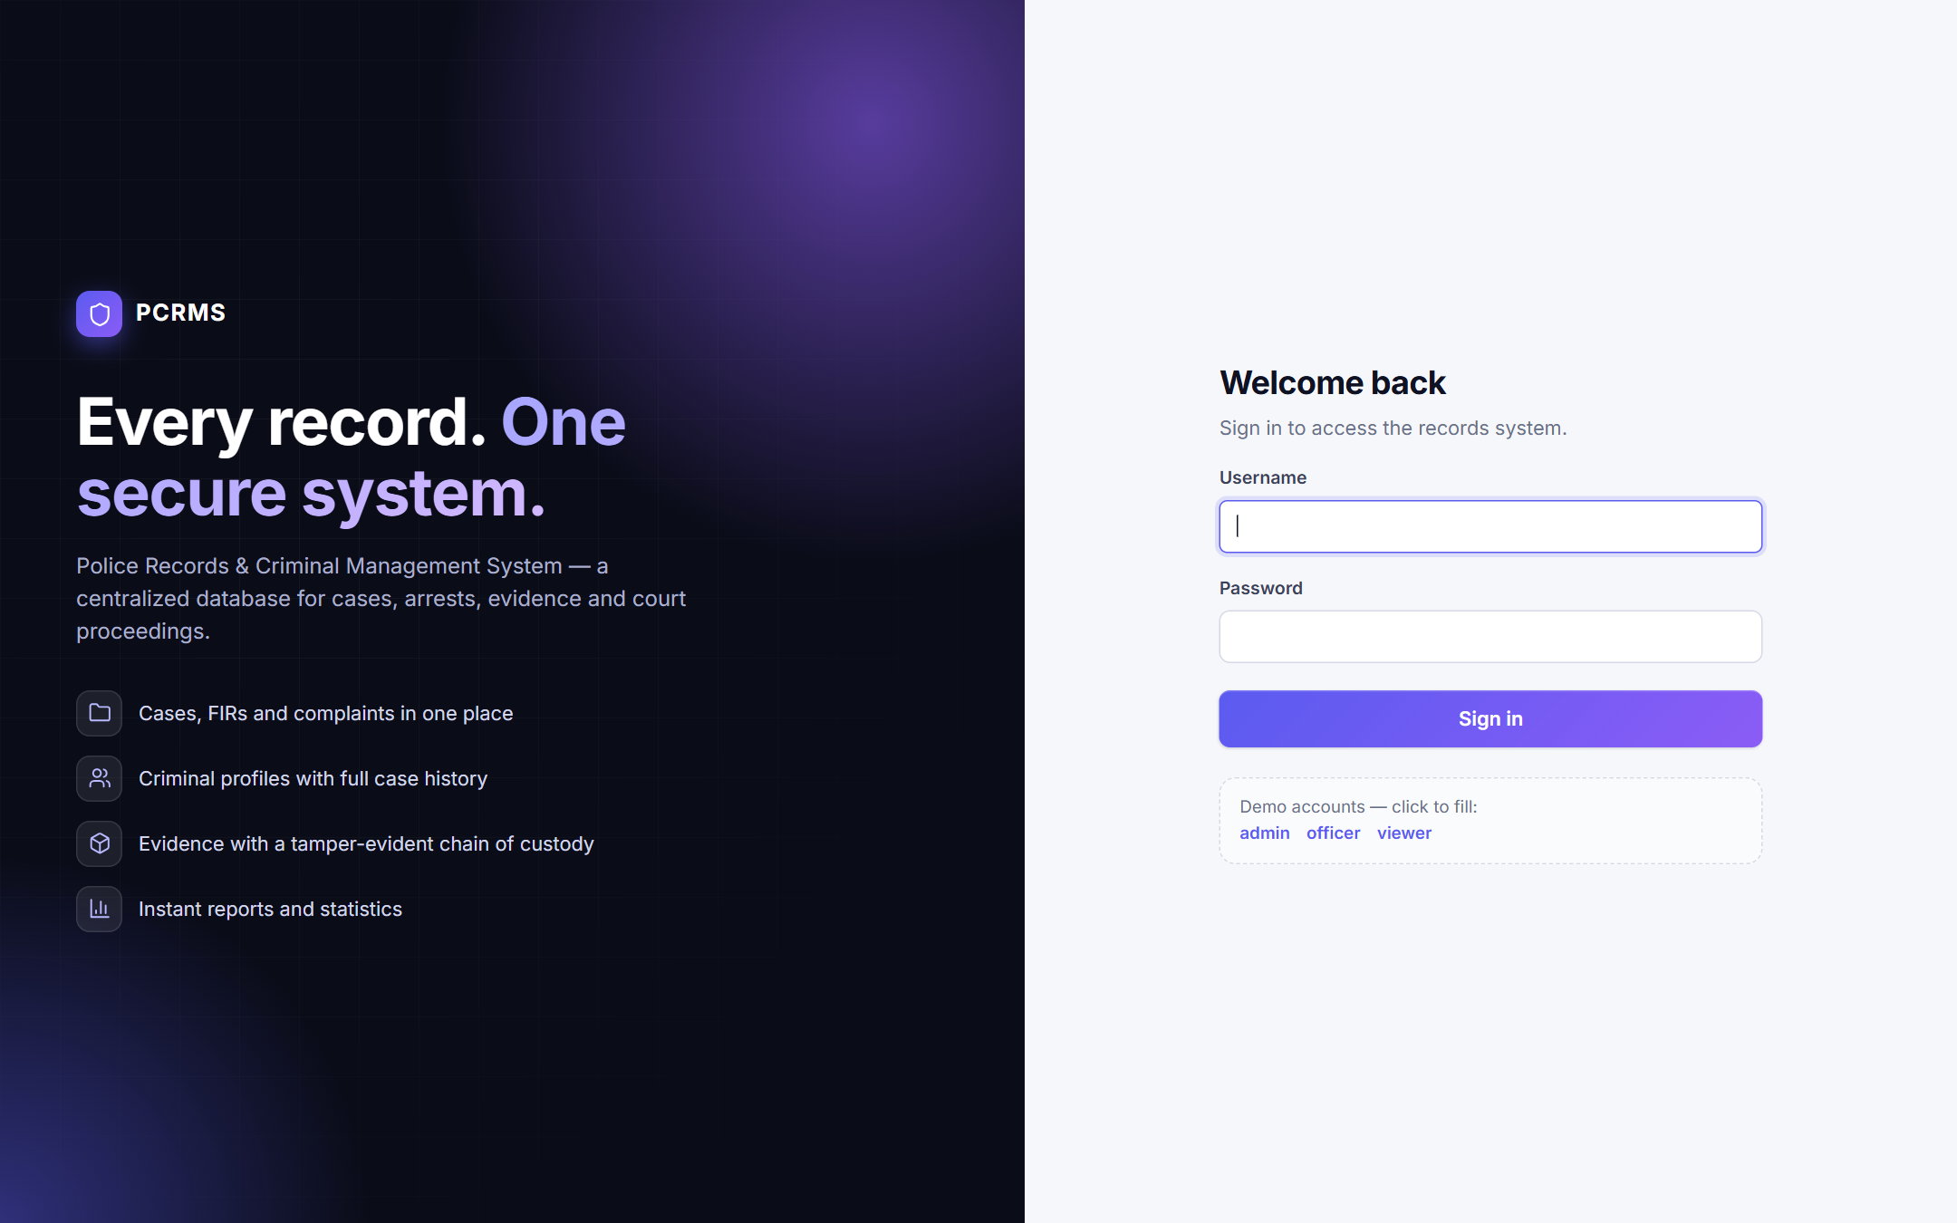
Figure : Login screen
Figure 11 shows the error state after a wrong password: the server answers 401 and the interface displays "Invalid credentials" without leaving the page (UI-02).
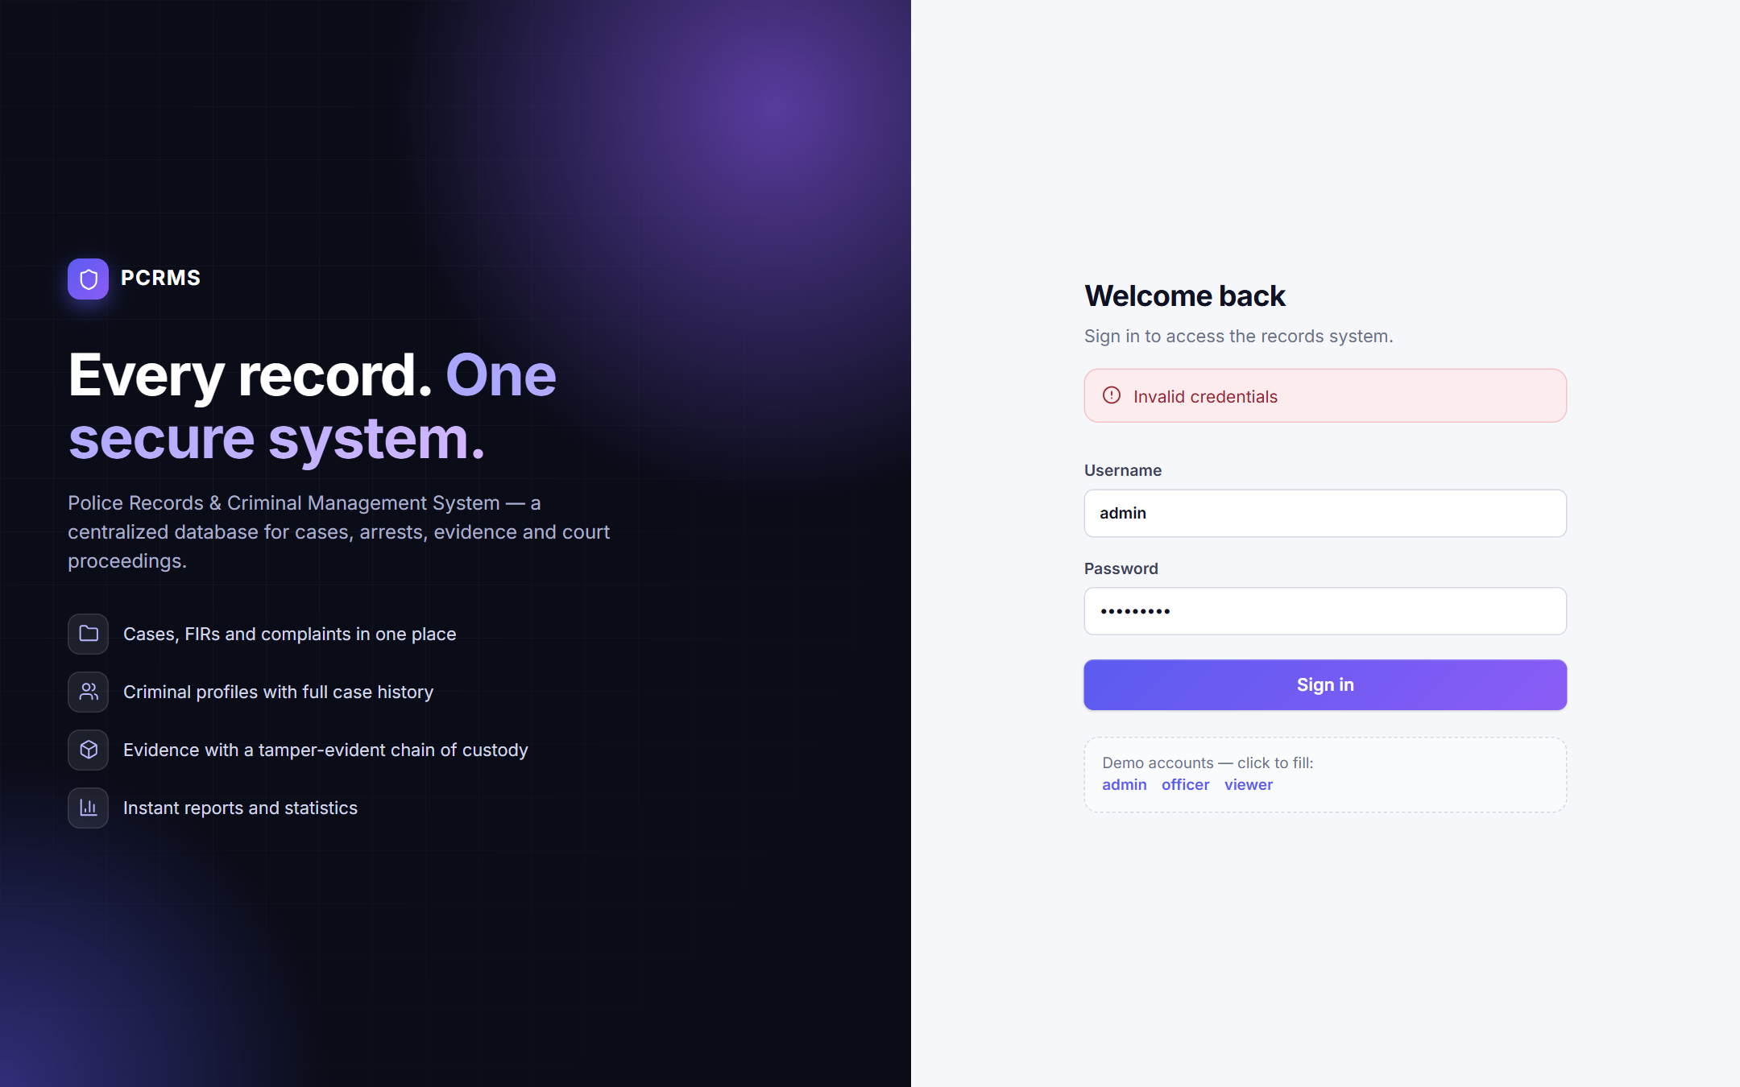
Figure : Login error state after an incorrect password

6.2 Dashboard
Figure 12 is the dashboard shown after login. It displays eight totals, bar charts of cases by status and by type, and the next hearings, all computed live from the database through GET /api/dashboard. It verifies FR-14.
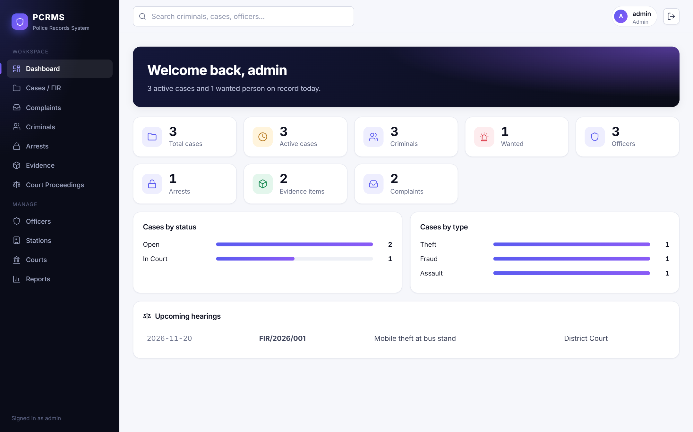
Figure : Dashboard with statistics, charts and upcoming hearings

6.3 Lists, Search and Filtering
Figure 13 shows the Cases module, which is representative of all nine list pages: a header with the record count, a search box, a status filter (for cases), an "Add new" button and a table with colour-coded status badges and edit and delete buttons. Rows come from the joined query that adds the officer name.
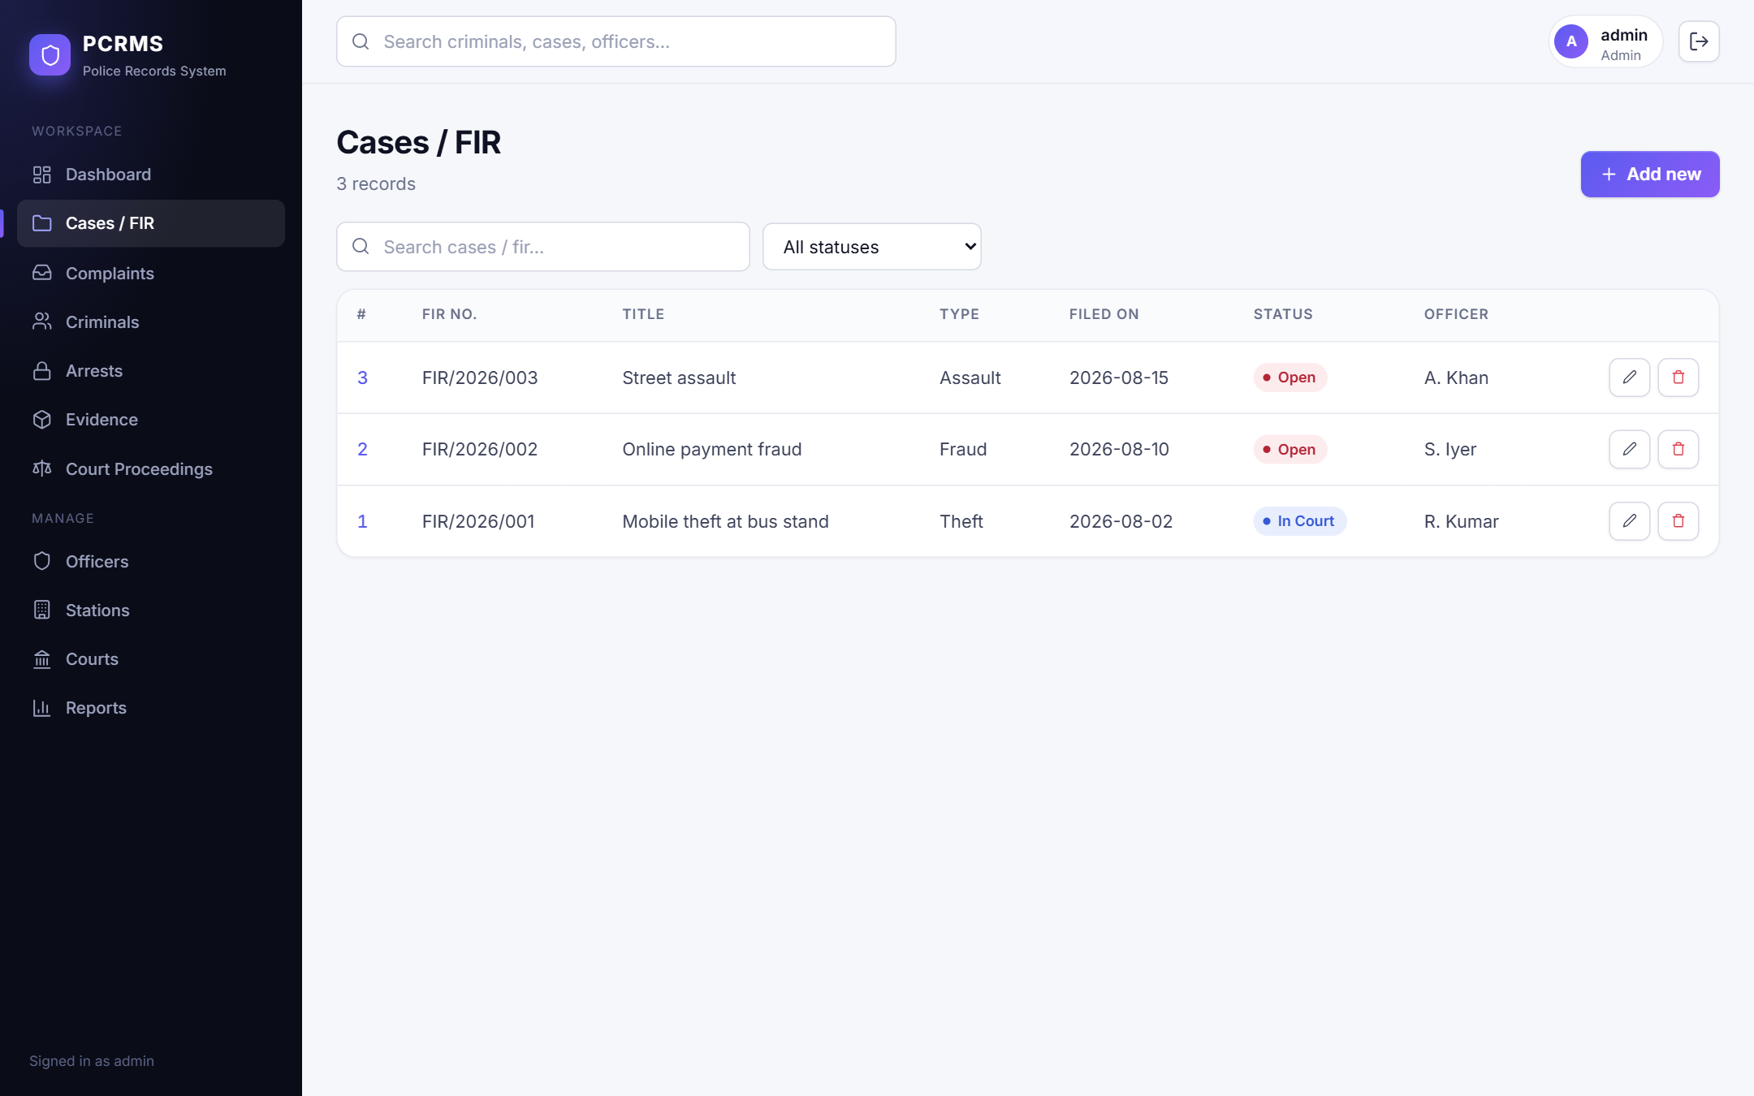
Figure : Cases / FIR list
Figure 14 shows the status filter set to In Court: only the matching case remains (UI-18).
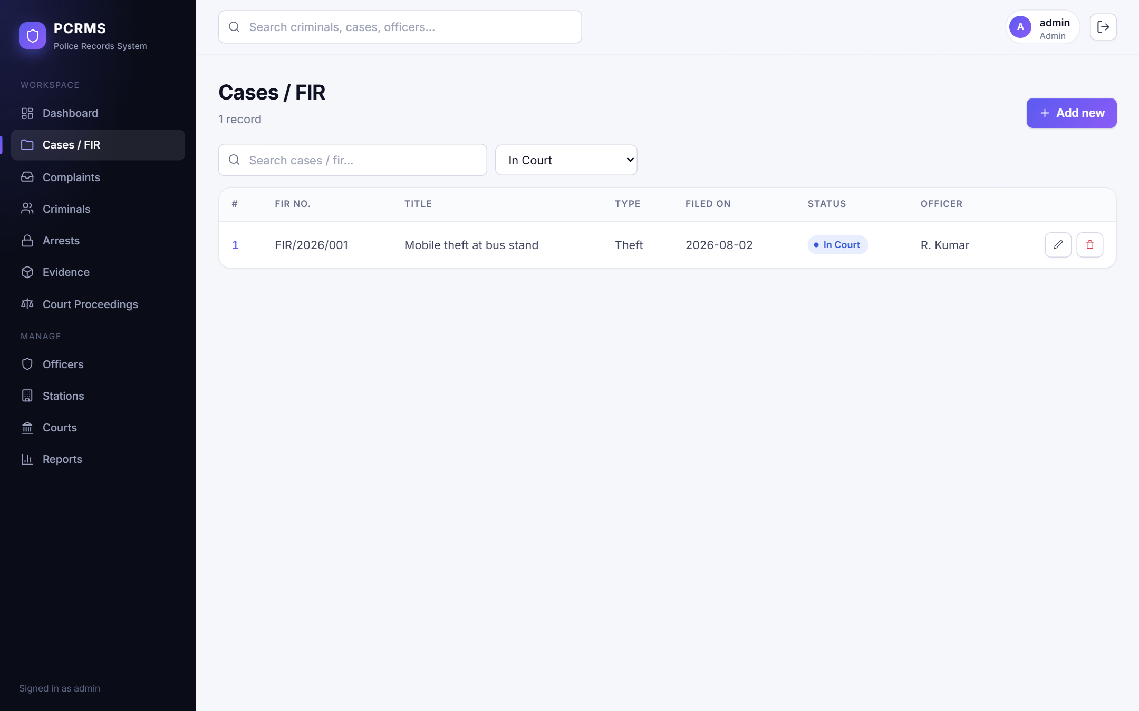
Figure : Cases filtered by status "In Court"
Figure 15 shows the global search. Typing "theft" in the top bar and pressing Enter lists matching criminals, cases and officers with links to the detail pages (UI-21).
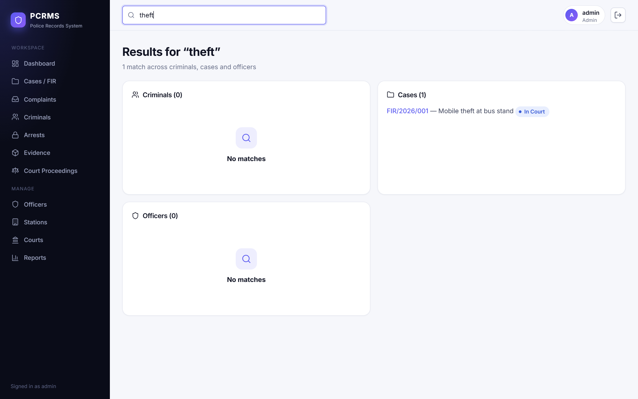
Figure : Global search results

6.4 Detail Pages
Figure 16 shows the case detail page: the case header with status badge, the officer and station, the linked criminals with a form to link another person and a role, the court proceedings, the evidence and the status history written by the trigger. It combines data from six tables.
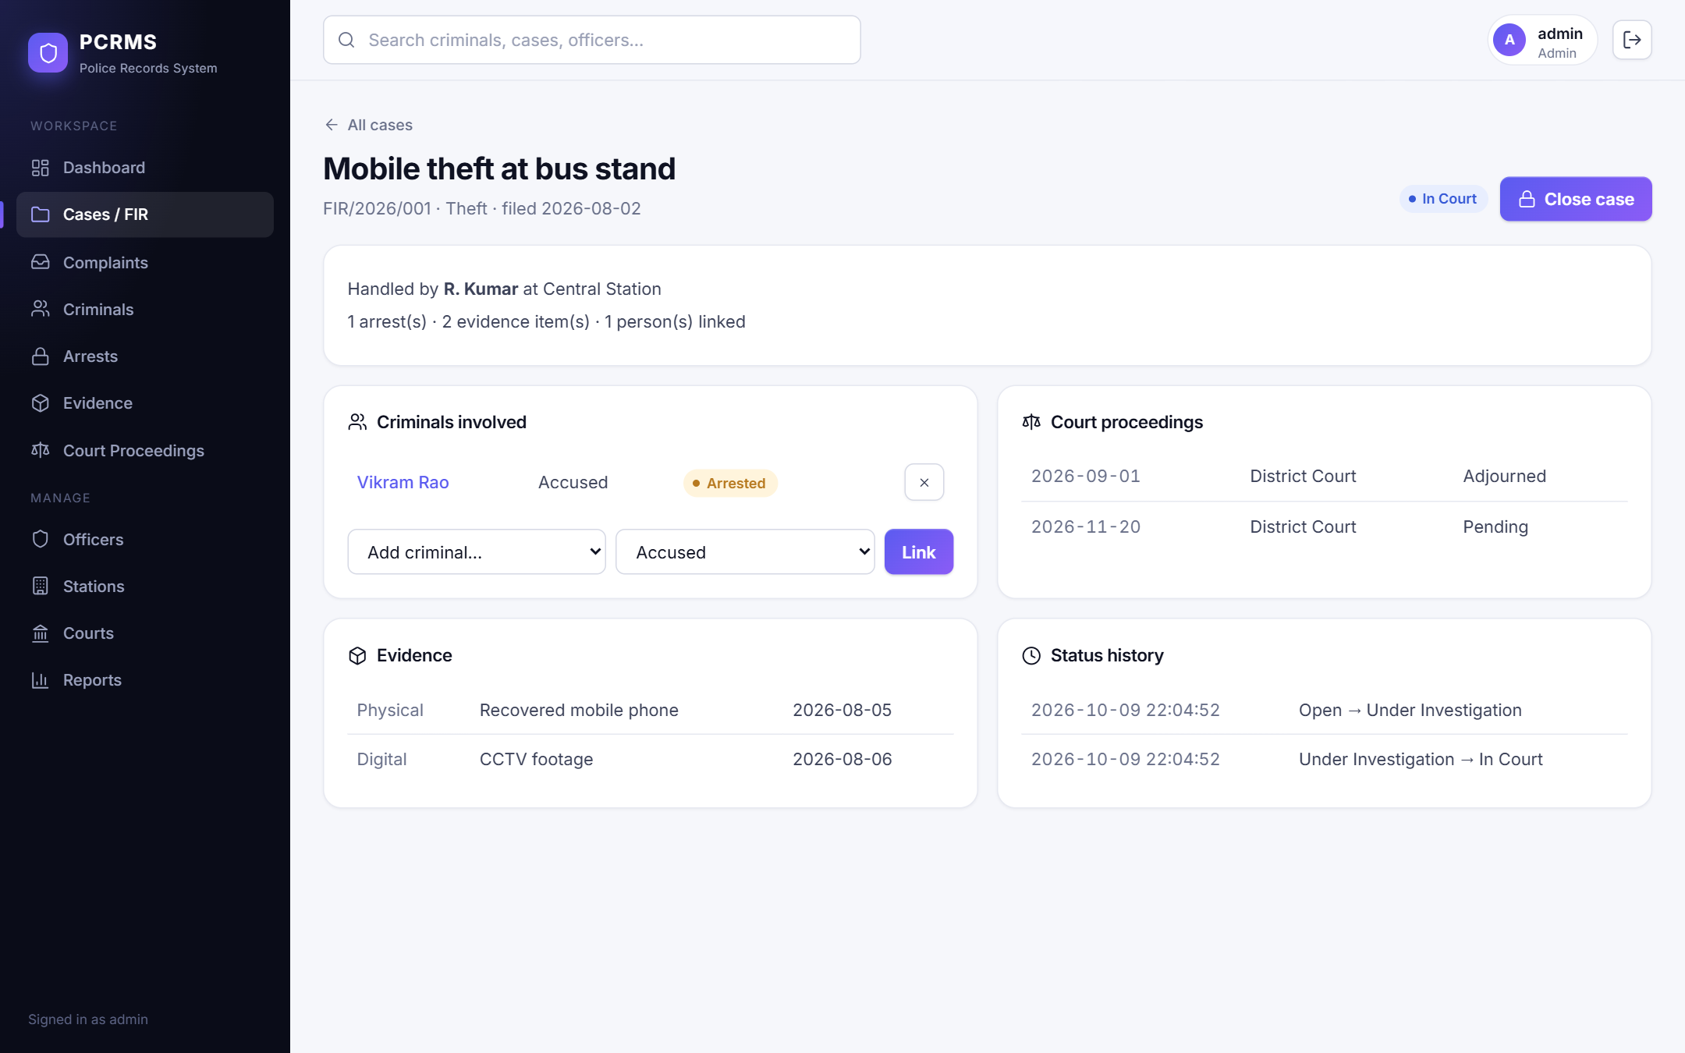
Figure : Case detail page
Figure 17 shows a criminal profile with personal details, case history and arrests (data from sp_criminal_history and the Arrest table).
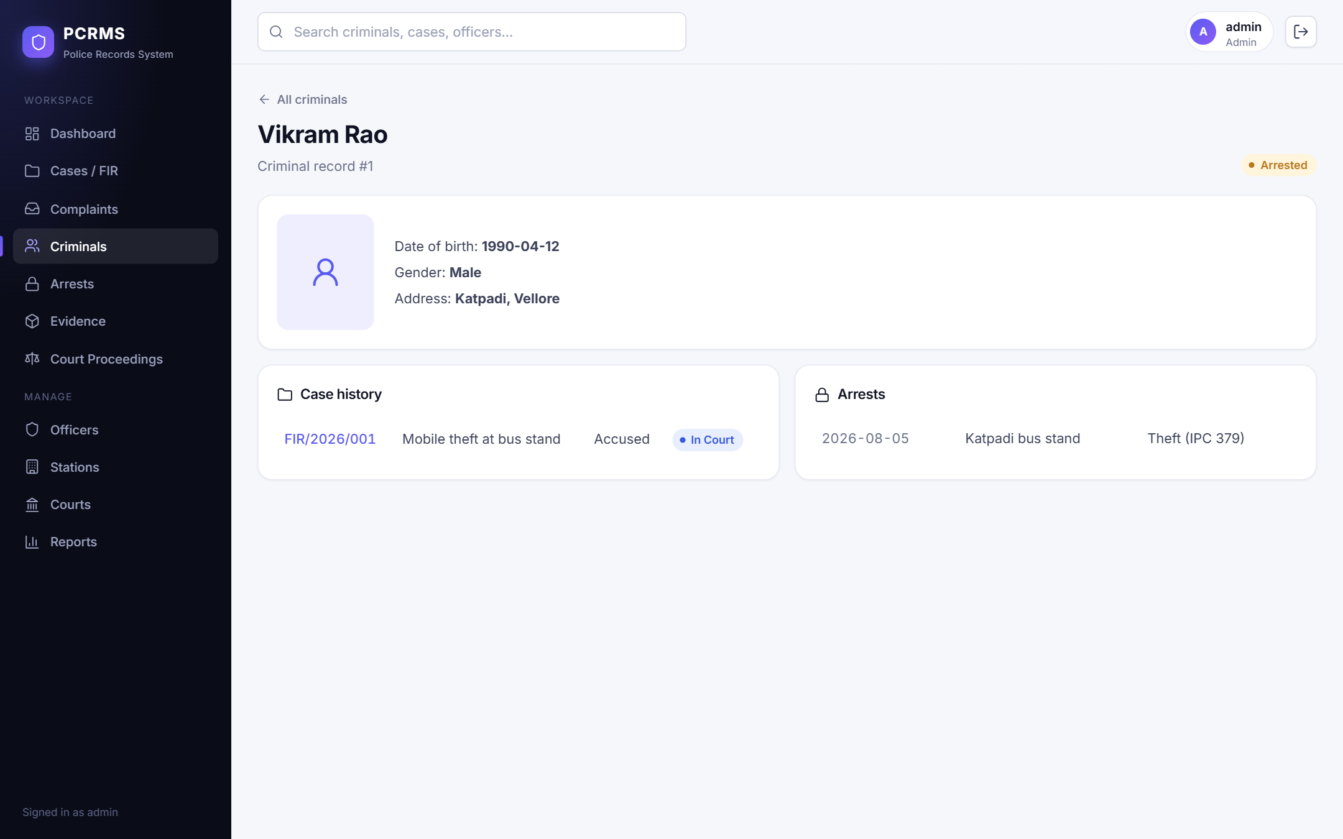
Figure : Criminal profile page
Figure 18 shows the Criminals list, including the status badges (Wanted, Arrested, Convicted).
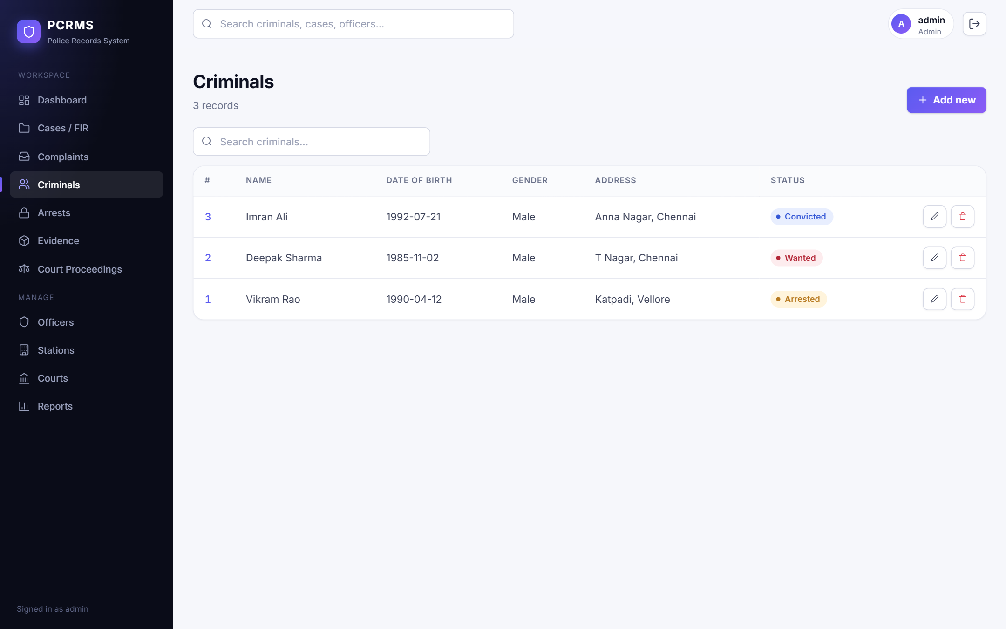
Figure : Criminals list

6.5 Forms and Data Entry
Figure 19 shows the add form for an arrest. The Criminal, Case and Officer fields are dropdowns filled from the database, which enforces valid foreign keys at entry time; required fields are marked with an asterisk. Saving posts to /api/arrests and fires the arrest trigger (UI-16).
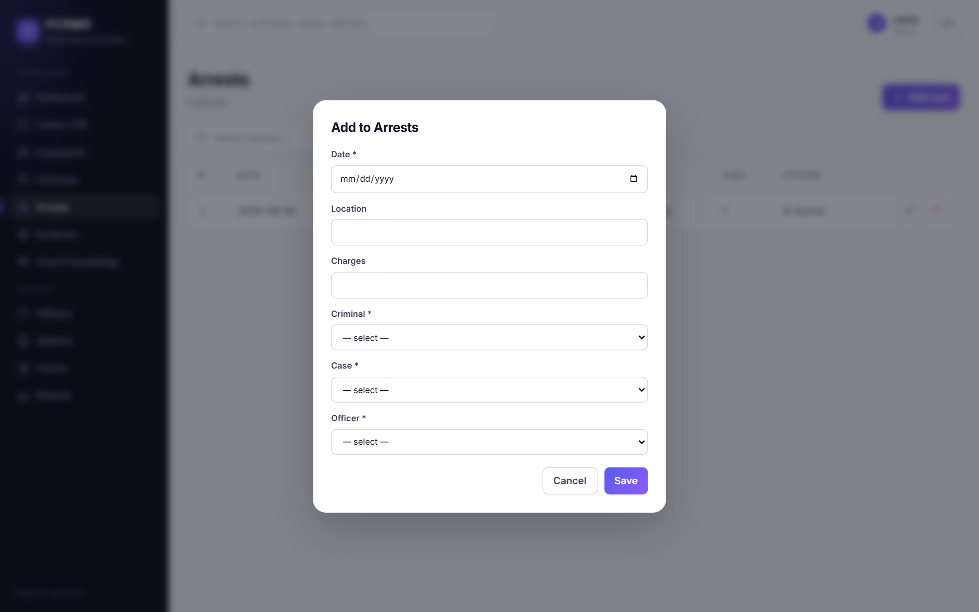
Figure : Add-arrest form with foreign-key dropdowns
Figure 20 shows the chain-of-custody dialog for an evidence item. The first entry was created automatically by the evidence trigger; officers can append further actions.
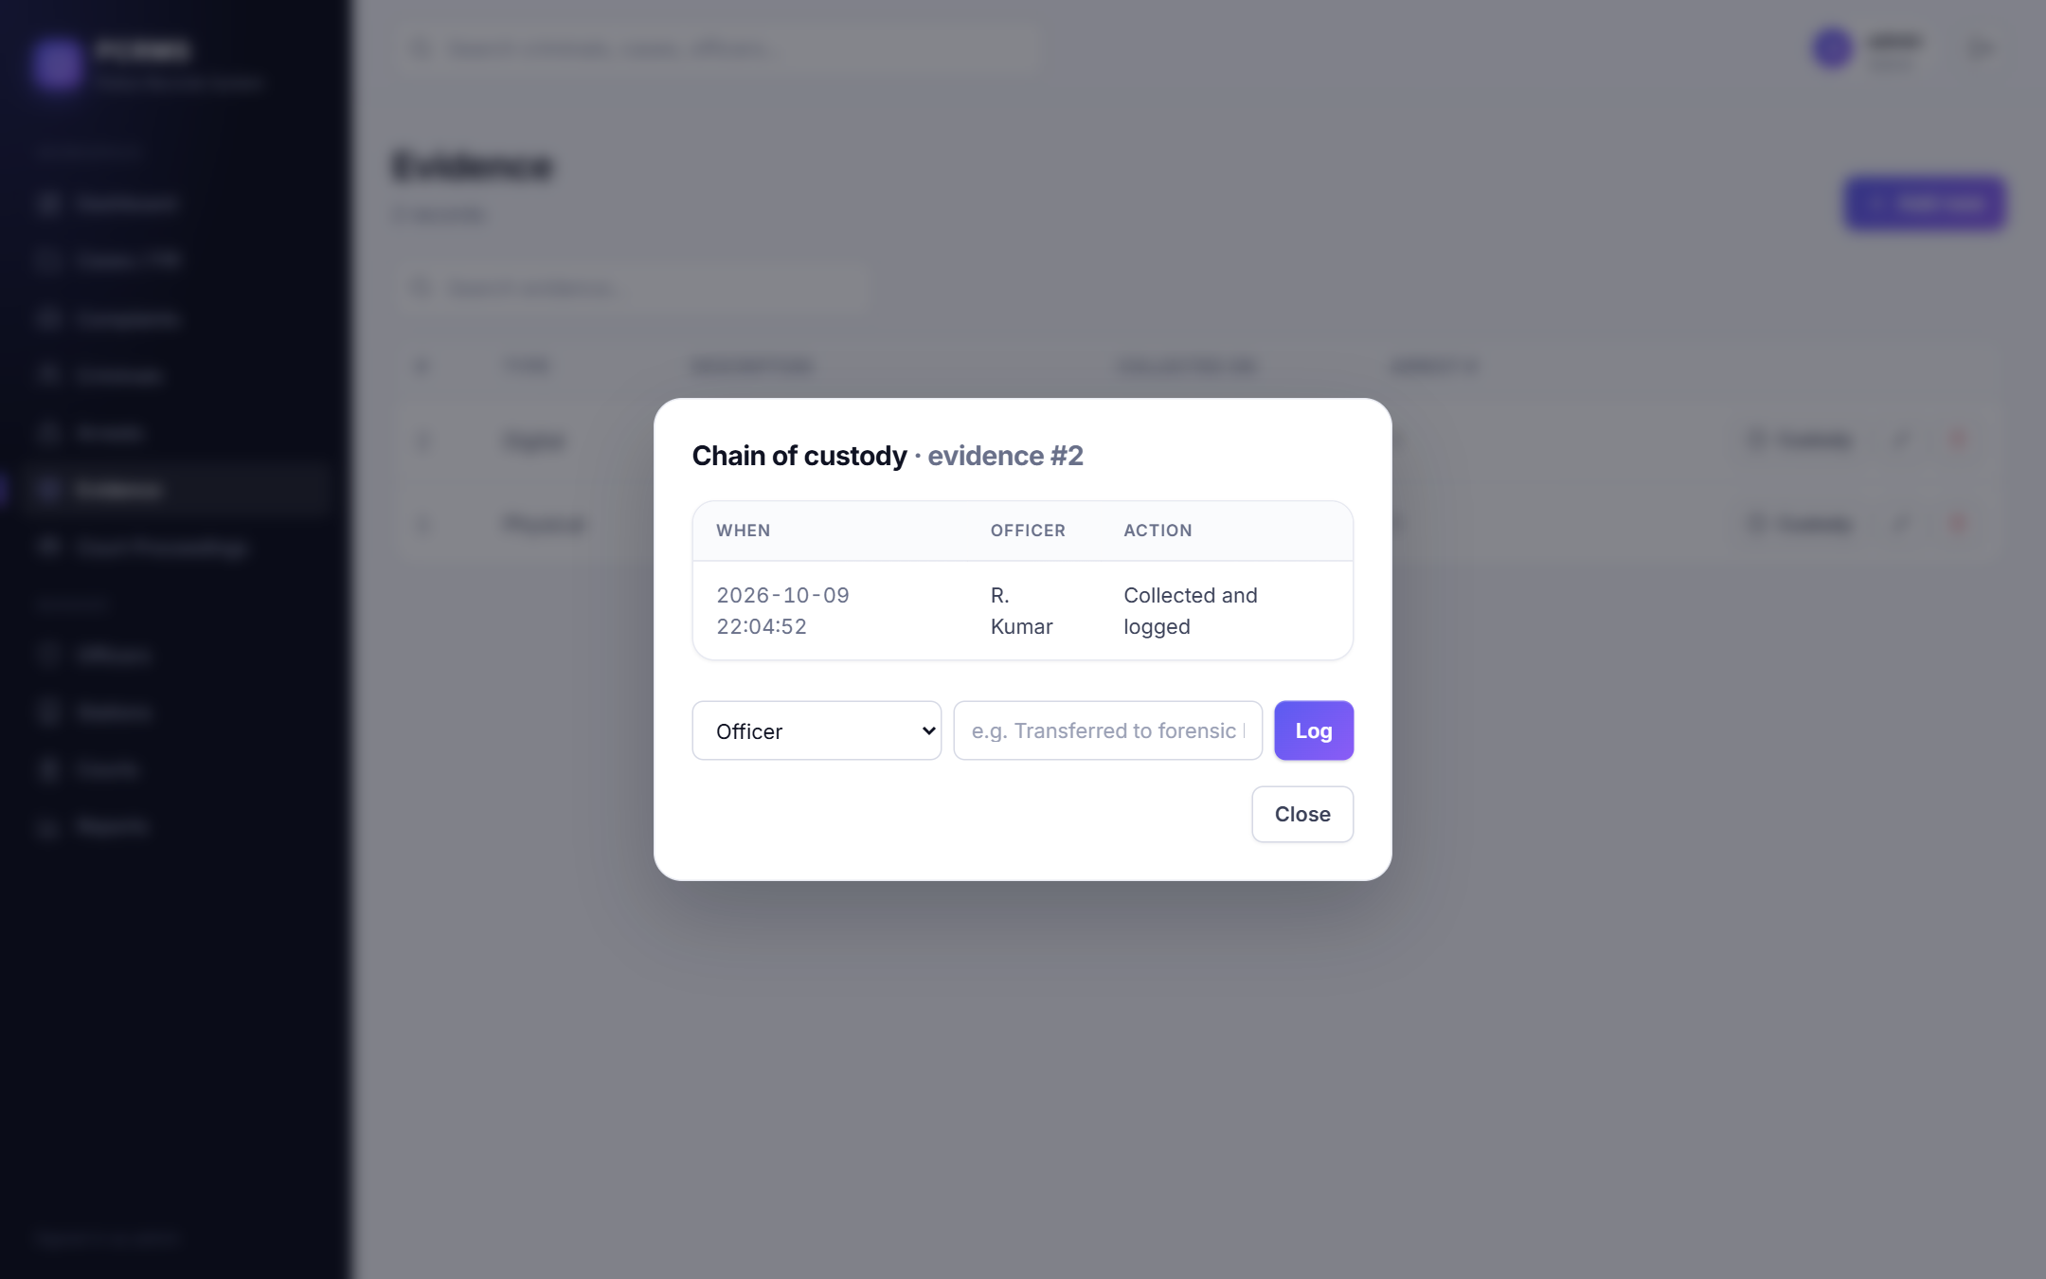
Figure : Chain-of-custody dialog

6.6 Reports
Figure 21 shows the Reports page with the case-overview report (data from the view v_case_overview) and the Export CSV and Print buttons (UI-20). Figure 22 shows another report, officer workload, produced by an aggregate query.
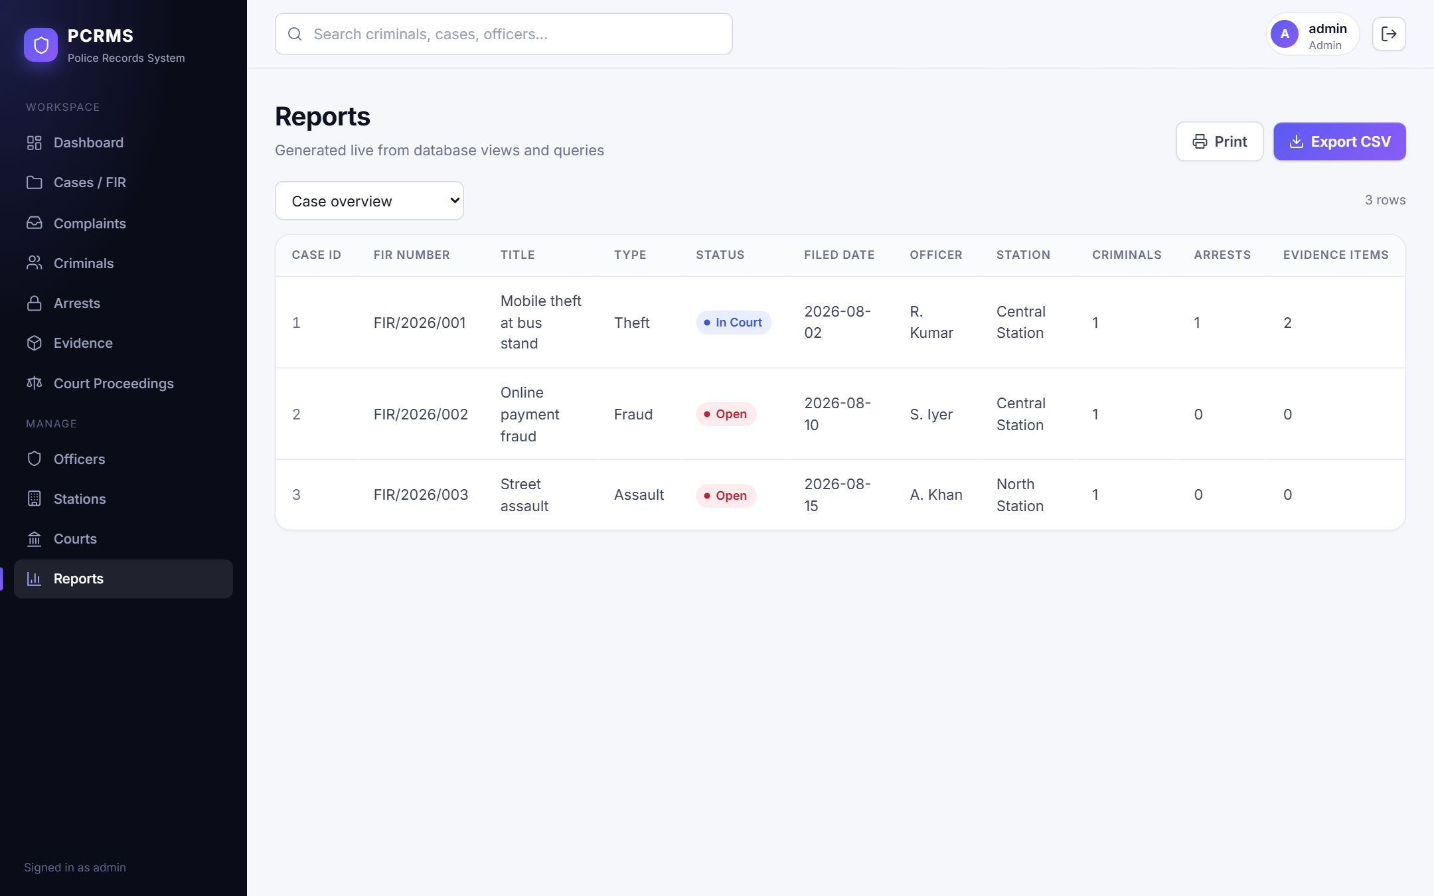
Figure : Reports page: case overview
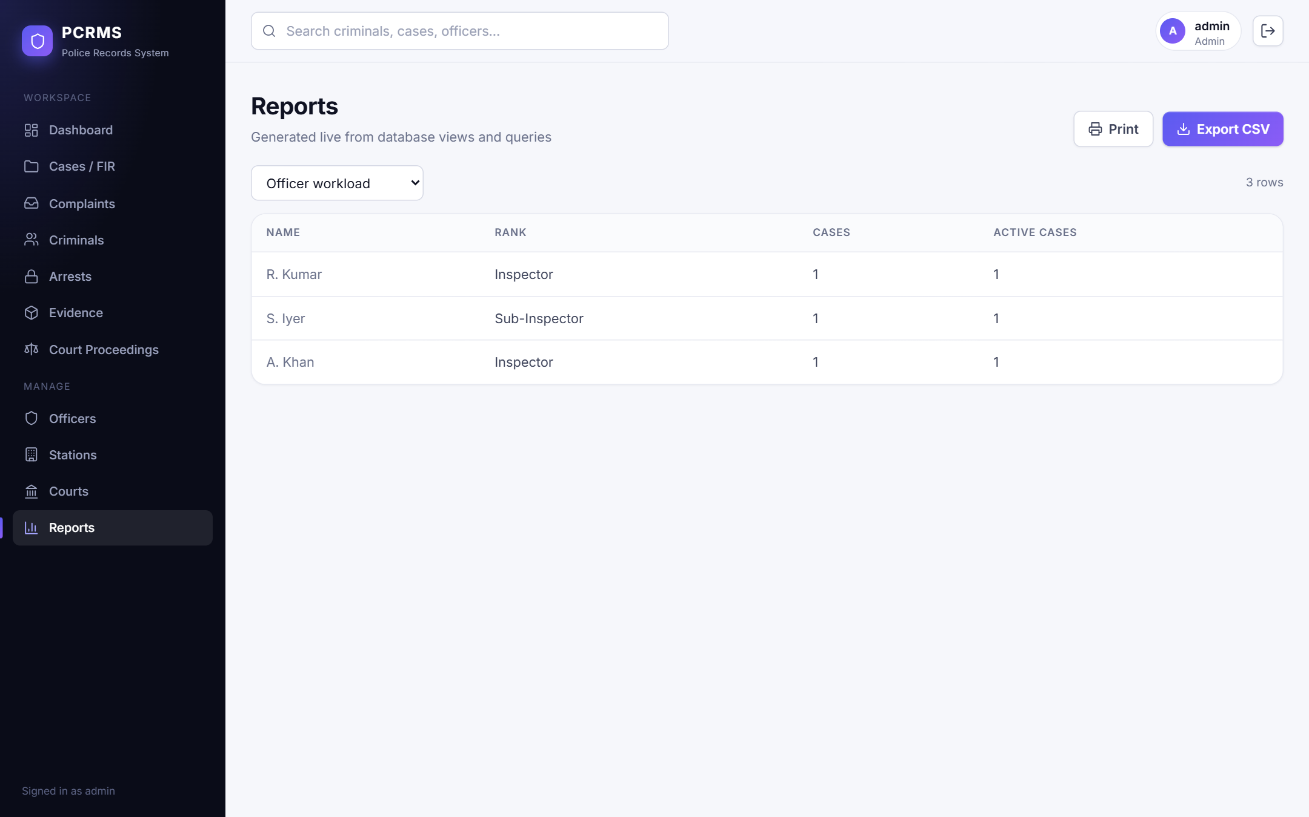
Figure : Reports page: officer workload

6.7 Empty and Error States
Figure 23 shows the empty state for a search with no matches. Figure 24 shows a database error surfaced to the user: an administrator tried to delete an officer who still handles cases, and the foreign-key constraint blocked it (UI-22; API test TC-22). The record remains.
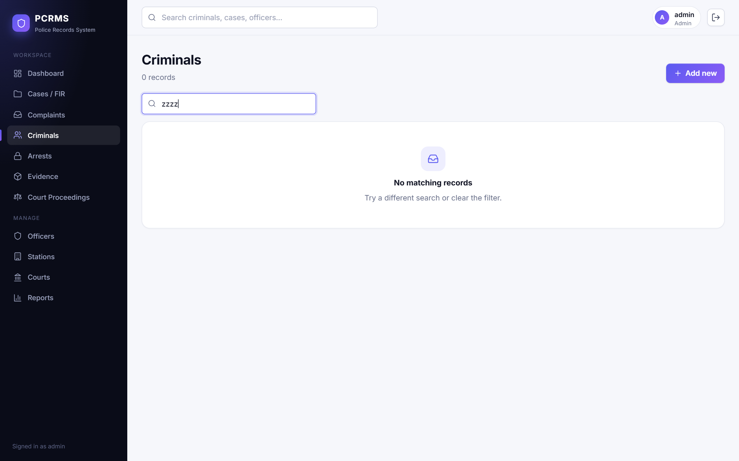
Figure : Empty state when no record matches
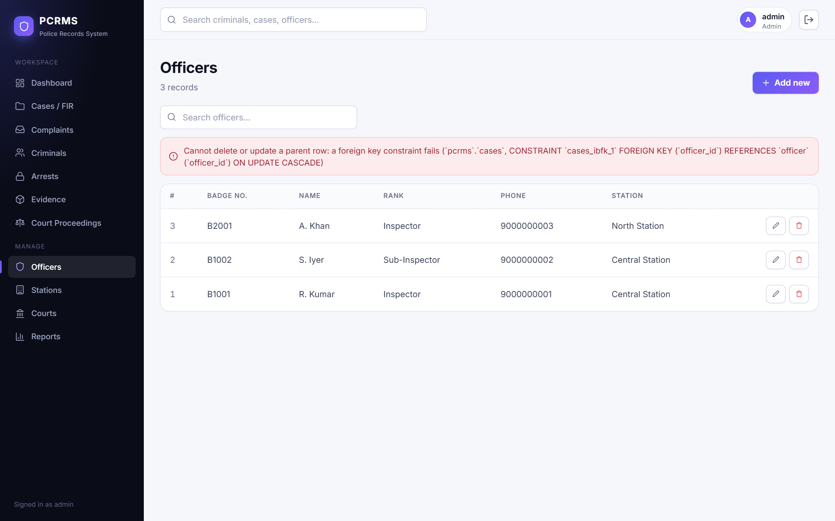
Figure : Database constraint error shown in the interface

6.8 Role-Based Interface
Figure 25 shows the Cases page for the viewer role: the Add button and the Edit and Delete buttons are not rendered (UI-23). The same restrictions are enforced by the API (403).
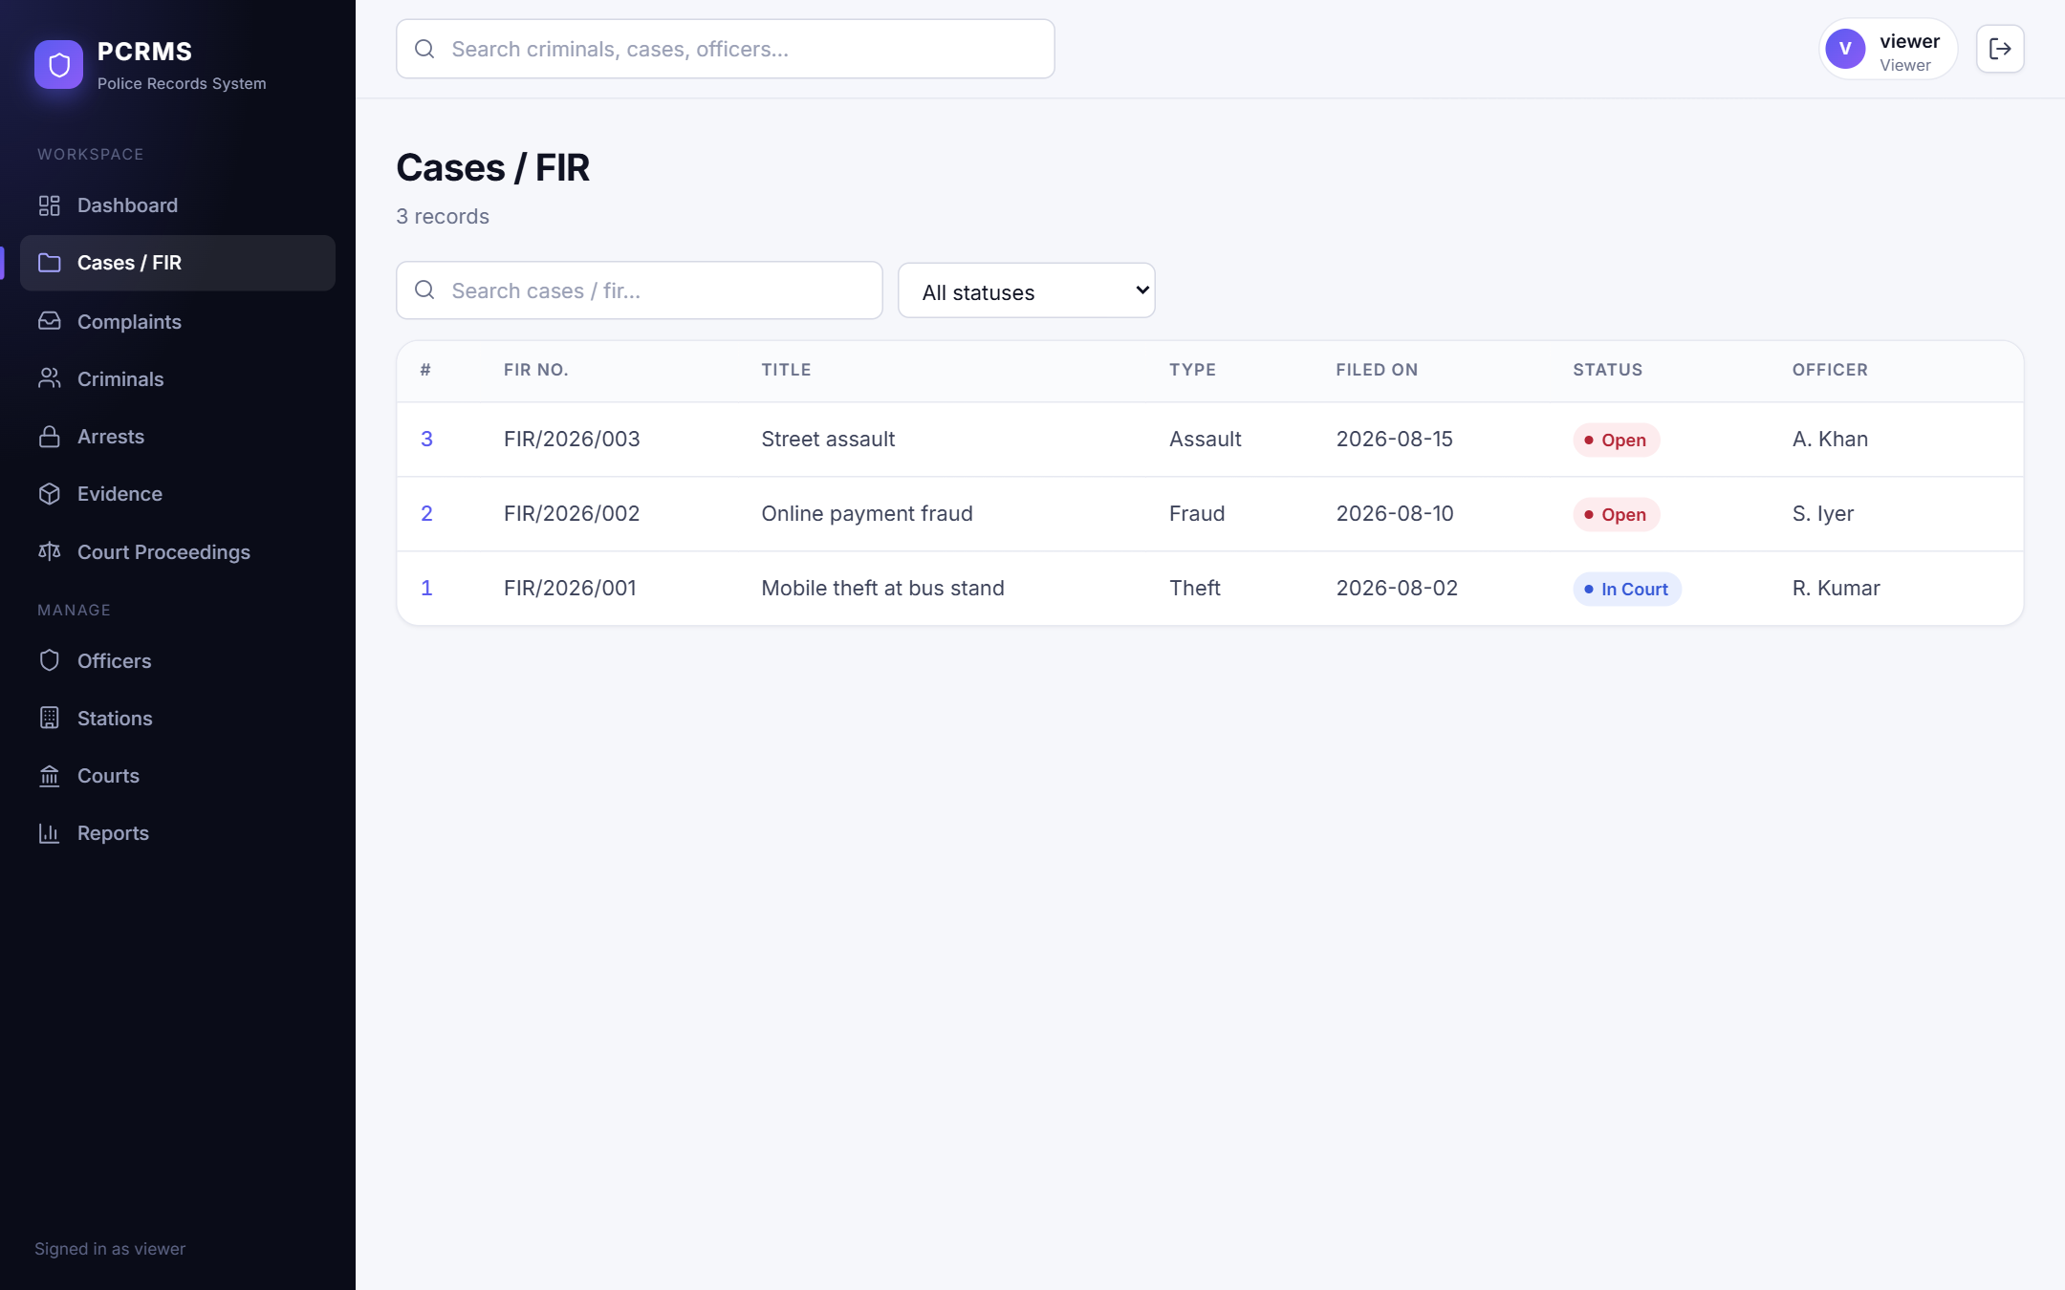
Figure : Cases page as seen by the read-only viewer role

6.9 Responsive and Mobile Layout
Below 900 px the sidebar becomes a slide-in drawer opened with a menu button, tables scroll horizontally inside their card, and controls stack vertically. Figure 26, Figure 27 and Figure 28 were captured at 390 x 844 (UI-24 confirmed that the page has no horizontal overflow and that the drawer opens).
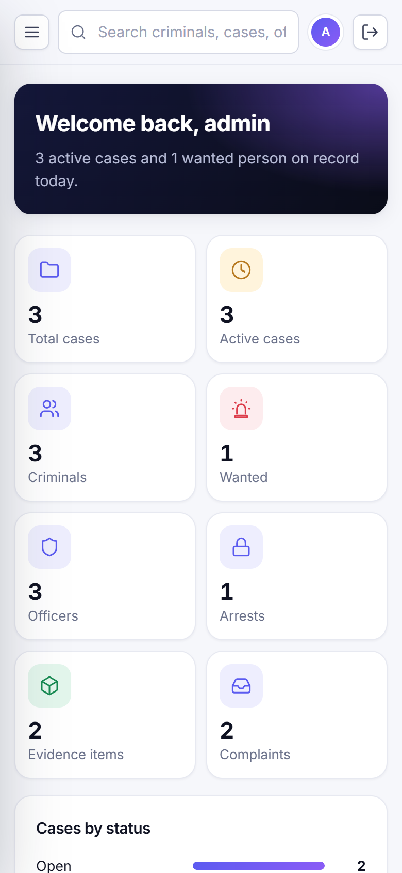
Figure : Dashboard on a 390 px wide screen
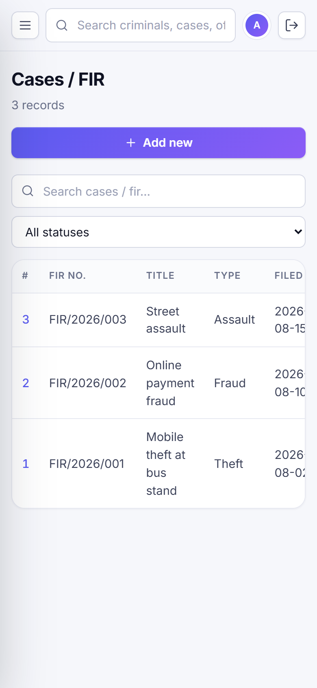
Figure : Cases list on a 390 px wide screen
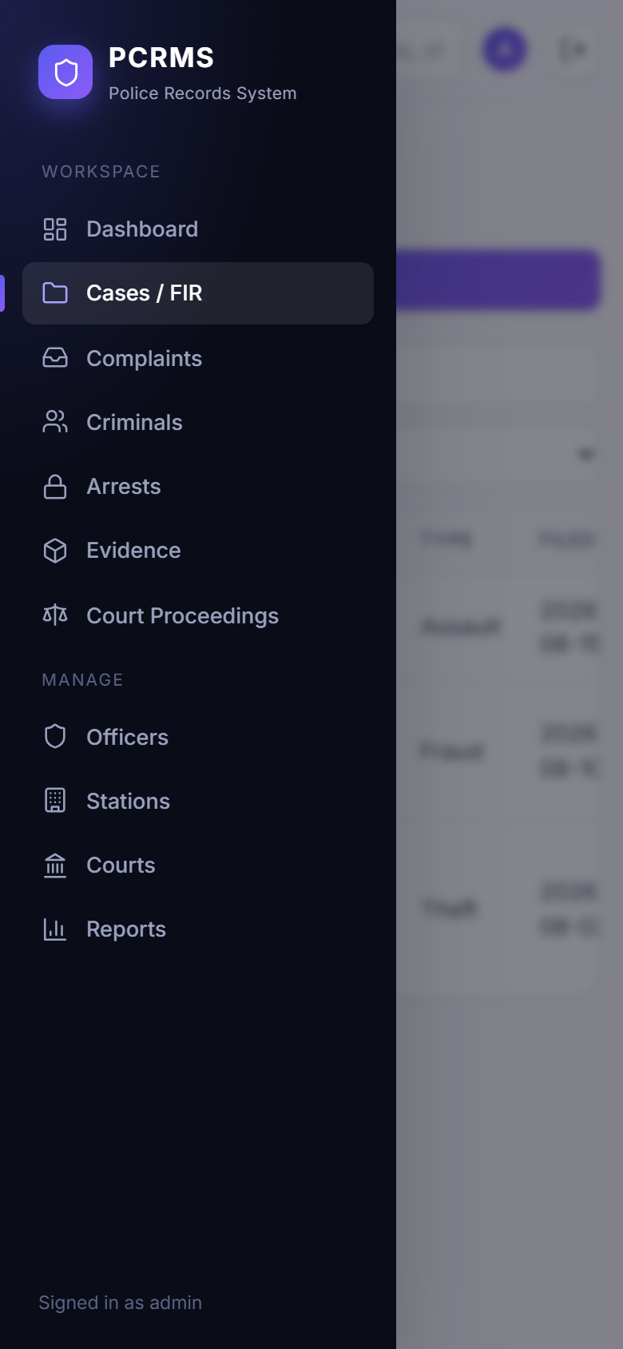
Figure : Navigation drawer on a 390 px wide screen

6.10 Screens That Are Not Available
- Registration screen: not implemented by design (see Section 2.7); there is therefore no screenshot.
- Success messages: the application does not show toast or success banners. After a save the dialog closes and the list refreshes; the new row is the confirmation. No success-message screenshot exists.
- Browser-native validation bubbles (shown when a required field is empty) are drawn by the browser outside the page content and could not be captured by the automated screenshot method.

Chapter 7: Testing and Validation

7.1 Testing Strategy
Testing focused on the layers where defects would be most damaging: the database rules, the API and the user interface. Three kinds of executed test are reported:
- API and database integration tests (44 cases, server/tests/run-tests.js). A Node script logs in as each role and calls the live API, then inspects the database directly with SQL to confirm what was stored. This covers authentication, authorization, CRUD, validation, referential integrity, stored procedures, triggers and reports.
- User-interface (system) tests (24 cases). An automated headless Chrome session drives the real React application against the real API and database: it logs in, navigates every page, opens forms, filters, searches, triggers an error and checks the page content, and resizes to a phone viewport.
- Negative and security tests are included in both sets: wrong credentials, missing and tampered tokens, forbidden roles, invalid enum values, missing required fields, duplicate keys, foreign-key violations and an SQL-injection attempt.

The database was reset to the seed data (npm run setup-db) before each run so that test data was deterministic.

7.2 Test Environment
Windows 11 Home; Node.js v22.19.0; MySQL Community Server 8.4.9 running locally; API on port 4000; Vite development server on port 5173; Google Chrome 154.0.8037.98 driven by Puppeteer Core. Executed on 2026-10-09.

7.3 API and Database Test Cases
Table 30 lists all 44 API and database test cases with the result actually observed. Each row's "Actual result" column is written by the test runner at execution time, not by hand. 44 of 44 passed.
Table : API and database test cases and results (all executed)
ID | Feature: test | Preconditions | Input | Expected result | Actual result | Status
TC-01 | Authentication: Valid login | Seeded user admin exists | admin / correct password | HTTP 200, JWT token and user role returned | HTTP 200, token issued, role=admin | Pass
TC-02 | Authentication: Wrong password rejected | Seeded user admin exists | admin / wrong password | HTTP 401, no token | HTTP 401 "Invalid credentials" | Pass
TC-03 | Authentication: Unknown user rejected | None | unknown user / any password | HTTP 401 | HTTP 401 | Pass
TC-04 | Authentication: Protected route without token | None | GET /api/cases with no Authorization header | HTTP 401 | HTTP 401 "Login required" | Pass
TC-05 | Authentication: Tampered token rejected | None | GET /api/cases with an invalid JWT | HTTP 401 | HTTP 401 | Pass
TC-06 | Authentication: Password hash not stored in plain text | Database seeded | SELECT password_hash FROM AppUser | Values are bcrypt hashes, not the plain passwords | 3 users, all hashes start with $2 (bcrypt) | Pass
TC-07 | Authorization: Viewer can read | Logged in as viewer | GET /api/cases | HTTP 200 with rows | HTTP 200, 3 rows | Pass
TC-08 | Authorization: Viewer cannot create | Logged in as viewer | POST /api/courts | HTTP 403 | HTTP 403 "Your role is not allowed" | Pass
TC-09 | Authorization: Officer can create | Logged in as officer | POST /api/courts {name, location} | HTTP 201 with new id | HTTP 201, court_id=3 | Pass
TC-10 | Authorization: Officer cannot delete | Logged in as officer; court created above | DELETE /api/courts/:id | HTTP 403, record remains | HTTP 403, record still present | Pass
TC-11 | Authorization: Admin can delete | Logged in as admin; court created above | DELETE /api/courts/:id | HTTP 200, record removed | HTTP 200, record removed | Pass
TC-12 | CRUD: Create station | Admin token | POST /api/stations with valid body | HTTP 201, row inserted | HTTP 201, station_id=3 | Pass
TC-13 | CRUD: Read station by id | Station created | GET /api/stations/:id | HTTP 200 with the same values | HTTP 200, city=Testville | Pass
TC-14 | CRUD: Update station | Station created | PUT /api/stations/:id {city: "Newtown"} | HTTP 200, value changed in DB | HTTP 200, DB city=Newtown | Pass
TC-15 | CRUD: Search filter | Seed data | GET /api/criminals?q=Vikram | Only matching rows returned | 1 row: Vikram Rao | Pass
TC-16 | CRUD: Status filter | Seed data | GET /api/cases?status=Closed on seed data | Empty list (no closed cases yet) | HTTP 200, 0 rows | Pass
TC-17 | CRUD: Delete station | Station created | DELETE /api/stations/:id | HTTP 200, row removed | HTTP 200, row removed | Pass
TC-18 | Validation: Missing required column | Admin token | POST /api/stations with only {name} | Rejected with an error, nothing inserted | HTTP 500, row count unchanged (2) | Pass
TC-19 | Validation: Invalid ENUM value | Admin token | PUT /api/criminals/1 {status: "Flying"} | Rejected, status unchanged | HTTP 500, status still Arrested | Pass
TC-20 | Validation: Duplicate unique FIR number | FIR/2026/001 exists | POST /api/cases with fir_number FIR/2026/001 | HTTP 409 duplicate | HTTP 409 (duplicate entry) | Pass
TC-21 | Validation: Foreign key must exist | Admin token | POST /api/officers with station_id 9999 | HTTP 409 FK violation | HTTP 409 (foreign key constraint fails) | Pass
TC-22 | Validation: Cannot delete referenced parent row | Officer 1 handles cases | DELETE /api/officers/1 | HTTP 409, officer remains | HTTP 409, officer still present | Pass
TC-23 | Validation: SQL injection attempt in search | Seed data | GET /api/search?q=' OR 1=1; DROP TABLE Criminal;-- | No error, tables intact (parameterized queries) | HTTP 200, Criminal table intact (3 rows) | Pass
TC-24 | Stored procedure: sp_register_fir with complaint | Seeded complaint 1 exists | POST /api/fir {FIR/2026/090, complaint_id 1} | Case created with status Open and today as filed date; complaint linked to new case | HTTP 201, case_id=5, status=Open, complaint 1 now linked | Pass
TC-25 | Stored procedure: sp_register_fir rolls back on error | FIR/2026/090 exists | POST /api/fir with duplicate FIR number | HTTP 409, no extra case row | HTTP 409, case count unchanged (4) | Pass
TC-26 | Trigger: Arrest trigger updates criminal and case | Criminal 2 Wanted; case 2 Open | POST /api/arrests {criminal 2, case 2} | Criminal status=Arrested, case status=Under Investigation | criminal 2 = Arrested, case 2 = Under Investigation | Pass
TC-27 | Trigger: Arrest trigger links criminal to case | Arrest above created | Query CriminalCase for (2,2) | Row exists (already linked as Suspect) | 1 row, role=Suspect (INSERT IGNORE kept the original) | Pass
TC-28 | Trigger: Status change logged | Case 2 changed status above | Query CaseStatusLog for case 2 | Row Open -> Under Investigation | Log row: Open -> Under Investigation | Pass
TC-29 | Trigger: Evidence creates custody entry | Arrest above created | POST /api/evidence for that arrest | EvidenceCustody row "Collected and logged" created automatically | 1 custody row created by trigger | Pass
TC-30 | API: Add custody event | Evidence created | POST /api/evidence/:id/custody then GET | Two entries in chronological order | HTTP 201, 2 custody entries | Pass
TC-31 | Trigger: Court proceeding moves case to In Court | Case 3 status Open | POST /api/proceedings for case 3 | Case 3 status = In Court | case 3 = In Court | Pass
TC-32 | Stored procedure: sp_close_case | Case 2 exists | POST /api/cases/2/close | Case 2 status = Closed and the change is logged | status=Closed, log row written | Pass
TC-33 | Stored procedure: sp_criminal_history | Criminal 3 linked to case 3 in seed data | GET /api/criminals/3/history | Case list and arrests returned | HTTP 200, 1 case(s) in history | Pass
TC-34 | Constraint: ON DELETE CASCADE on CriminalCase | Case created by the FIR test | Link criminal 3 to new case, delete the case | Junction rows removed automatically | junction rows 1 -> 0 | Pass
TC-35 | Constraint: ON DELETE SET NULL on Complaint.case_id | Complaint 1 was linked to the deleted case | Query Complaint 1 after case deletion | Complaint still exists with case_id NULL | complaint kept, case_id = NULL | Pass
TC-36 | Reports: Dashboard totals | Seed + test data | GET /api/dashboard | Totals and chart data present | HTTP 200, totals.cases=3, upcoming=2 | Pass
TC-37 | Reports: Report: case-overview | Database populated | GET /api/reports/case-overview | HTTP 200 and a JSON array | HTTP 200, 3 row(s) | Pass
TC-38 | Reports: Report: wanted-criminals | Database populated | GET /api/reports/wanted-criminals | HTTP 200 and a JSON array | HTTP 200, 0 row(s) | Pass
TC-39 | Reports: Report: station-stats | Database populated | GET /api/reports/station-stats | HTTP 200 and a JSON array | HTTP 200, 2 row(s) | Pass
TC-40 | Reports: Report: officer-workload | Database populated | GET /api/reports/officer-workload | HTTP 200 and a JSON array | HTTP 200, 3 row(s) | Pass
TC-41 | Reports: Report: repeat-offenders | Database populated | GET /api/reports/repeat-offenders | HTTP 200 and a JSON array | HTTP 200, 0 row(s) | Pass
TC-42 | Reports: Report: status-log | Database populated | GET /api/reports/status-log | HTTP 200 and a JSON array | HTTP 200, 5 row(s) | Pass
TC-43 | Reports: Unknown report | None | GET /api/reports/nope | HTTP 404 | HTTP 404 | Pass
TC-44 | Search: Global search | Seed data | GET /api/search?q=theft | Matching case returned | HTTP 200, 1 case match(es) | Pass

7.4 User-Interface Test Cases
Table 31 lists the 24 UI test cases. 24 of 24 passed. The screenshots in Chapter 6 were captured during this run.
Table : User-interface test cases and results (all executed)
ID | Feature | Preconditions | Input | Expected result | Actual result | Status
UI-01 | Login page | Logged out | Open / | Hero, form and demo-account chips are shown | Form, hero text and demo chips visible | Pass
UI-02 | Login error state | Logged out | admin / wrongpass, Sign in | Error banner "Invalid credentials", user stays on login | Banner "Invalid credentials" shown | Pass
UI-03 | Login success | Seeded admin user | admin / admin123, Sign in | Dashboard with welcome banner is shown | Dashboard shown: "Welcome back, admin" | Pass
UI-04 | Dashboard | Seed data | Open / | Stat cards, charts and upcoming hearings render | All three sections rendered | Pass
UI-05 | Cases / FIR list page | Seed data | Open /cases | Page lists seeded rows (contains "FIR/2026/001") | Rows rendered from the database | Pass
UI-06 | Complaints list page | Seed data | Open /complaints | Page lists seeded rows (contains "M. Patel") | Rows rendered from the database | Pass
UI-07 | Criminals list page | Seed data | Open /criminals | Page lists seeded rows (contains "Vikram Rao") | Rows rendered from the database | Pass
UI-08 | Arrests list page | Seed data | Open /arrests | Page lists seeded rows (contains "Theft (IPC 379)") | Rows rendered from the database | Pass
UI-09 | Evidence list page | Seed data | Open /evidence | Page lists seeded rows (contains "Recovered mobile phone") | Rows rendered from the database | Pass
UI-10 | Court Proceedings list page | Seed data | Open /proceedings | Page lists seeded rows (contains "Adjourned") | Rows rendered from the database | Pass
UI-11 | Officers list page | Seed data | Open /officers | Page lists seeded rows (contains "R. Kumar") | Rows rendered from the database | Pass
UI-12 | Stations list page | Seed data | Open /stations | Page lists seeded rows (contains "Central Station") | Rows rendered from the database | Pass
UI-13 | Courts list page | Seed data | Open /courts | Page lists seeded rows (contains "District Court") | Rows rendered from the database | Pass
UI-14 | Case detail page | Case 1 exists | Open /cases/1 | Title, linked criminals, hearings, evidence and status history shown | All sections present | Pass
UI-15 | Criminal profile page | Criminal 1 exists | Open /criminals/1 | Profile, case history and arrests shown | Profile with both tables | Pass
UI-16 | Add form with FK dropdowns | Admin | Arrests > Add new | Modal with Criminal, Case, Officer dropdowns populated | Modal open, dropdowns populated | Pass
UI-17 | Chain-of-custody dialog | Evidence 2 has a custody row | Evidence > Custody | Dialog shows custody history | Custody history displayed | Pass
UI-18 | Status filter | Case 1 is In Court | Cases > filter "In Court" | Only In Court cases remain | FIR/2026/001 shown, others hidden | Pass
UI-19 | Empty state | None | Criminals > search "zzzz" | Friendly "No matching records" message | Empty state shown | Pass
UI-20 | Reports page | Seed data | Open /reports | Report table plus Export CSV and Print buttons | Table and buttons present | Pass
UI-21 | Global search | Seed data | Type "theft" in top search, Enter | Results page lists the matching case | Results page with FIR/2026/001 | Pass
UI-22 | Database error shown in UI | Officer 3 handles a case | Officers > Delete first officer | Red error banner explains the foreign-key violation; row remains | Banner shows foreign key constraint message | Pass
UI-23 | Viewer role is read-only | Viewer login | Open Cases as viewer | No Add, Edit or Delete controls | No write controls rendered | Pass
UI-24 | Mobile layout and drawer | Viewport 390x844 | Open Cases, tap menu button | Drawer opens; page has no horizontal overflow | Drawer opened, no horizontal overflow | Pass

7.5 Summary of Results
Table : Summary of executed tests
Group | Cases | Passed | Failed
Authentication | 6 | 6 | 0
Authorization | 5 | 5 | 0
CRUD | 6 | 6 | 0
Validation | 6 | 6 | 0
Stored procedure | 4 | 4 | 0
Trigger | 5 | 5 | 0
API | 1 | 1 | 0
Constraint | 2 | 2 | 0
Reports | 8 | 8 | 0
Search | 1 | 1 | 0
User interface (system) | 24 | 24 | 0
Total | 68 | 68 | 0

7.6 Observations and Defects
- During development, several UI pages first failed to compile because of mismatched JSX tags after an edit; these were found by the build and by loading each page, and fixed before the final test run. The final run contains no failing case.
- Behaviour that passed but is not ideal: tests TC-18 and TC-19 pass because the invalid data was rejected and not stored, but the API answered with HTTP 500 instead of a 4xx validation status. This is recorded as a limitation (Section 8.4).
- The first version of the automated login-success UI test failed because the script typed into fields that were already filled; the test was corrected to use a fresh page. This was a test-script issue, not an application defect.

7.7 Tests Not Performed
The following were not executed and no results are claimed for them:
Table : Proposed tests that were not executed
Area | Proposed test | Reason not done
Unit tests | Isolated tests of React components and helper functions with a test framework. | No unit-test framework is configured in the project.
Load / performance | Response times and throughput with many users and large tables. | Out of scope for the demonstration data set; no figures are reported.
Token expiry | Request with an expired JWT (8 hours). | Would need a clock change or a shorter test token.
Cross-browser | Firefox, Safari, Edge. | Only Chrome was used.
Accessibility audit | Screen-reader and contrast audit. | Not performed; only basic labelling was applied.
Security review | Penetration test, rate limiting, XSS review. | Out of scope for the course project.
Backup and restore | Restore the database from a dump. | Not part of the project.

Chapter 8: Results and Discussion

8.1 Summary of Implemented Features
Table : Objectives and the evidence that they were met
Objective (Section 1.4) | Result | Evidence
1. Centralized database with keys | 13 tables, 16 foreign keys, unique and not-null constraints, 3 views. | Chapter 4; TC-21, TC-20
2. Digital management of criminals, cases, arrests, evidence | Full create, read, update and delete for all modules; chain of custody. | Chapter 6; TC-29
3. Court proceedings and instant reports | Hearings per case and court; six reports with CSV and print; dashboard. | TC-37 to TC-43; UI-20
4. Fast searching and cross-referencing | Per-module and global search; criminal and case detail pages. | TC-44, UI-21
5. Automation in the database | 3 stored procedures and 4 triggers keep statuses consistent. | TC-26 to TC-32
6. Role-based access | Three roles enforced by API and reflected in the UI. | TC-08, TC-10, UI-23

8.2 Results Observed during Testing
All 44 API and database test cases and all 24 UI test cases passed in the final run (68 of 68). The most important behaviours confirmed were: the arrest trigger changes the criminal and the case in one statement; every status change is logged; a duplicate FIR number rolls back the whole FIR procedure; referenced parent rows cannot be deleted; cascade and set-null rules behave as designed; role restrictions are enforced by the API and reflected in the UI; and an SQL-injection string in the search box does not damage the database.

8.3 How the Application Addresses the Original Problem
Table : Problems from the project review and the corresponding solution
Problem | How PCRMS addresses it
Data duplication | One normalized database; UNIQUE constraints; related data referenced by key instead of copied.
Difficult searching | Search box on every list, a global search, a status filter and detail pages that gather related records.
Poor case tracking | Status field with fixed values, automatic transitions by triggers, a status-history table shown on the case page.
Time-consuming management | Forms with dropdowns for related records, one-click case closing, six ready-made reports with export.

8.4 Limitations and Unresolved Issues
The following limitations are known and were verified from the code or the tests:
- Validation responses: invalid or incomplete input returns HTTP 500 with the raw database message instead of a 400-level response. There is no server-side validation of formats (for example phone numbers, date ranges) beyond what the database enforces.
- No user management: there is no registration, password change or user administration screen; the three accounts come from the setup script.
- Session storage: the JWT is kept in localStorage and a development fallback secret is used if JWT_SECRET is not set. CORS is open to all origins. These settings are suitable for a demonstration, not for production.
- No pagination: list endpoints return all rows; text search uses LIKE with a leading wildcard, which scans the table. This is adequate for the demonstration data but will not scale to very large tables.
- Audit scope: the status log records what changed and when, but not which user changed it; other tables have no audit trail.
- Photographs: only a URL is stored; there is no upload or storage of image files.
- Access scope: every authenticated user can read every record; there is no per-station restriction.
- Test coverage: there are no unit tests and no load, cross-browser or accessibility tests (Section 7.7).
- Platform coverage: development and testing were done only on Windows 11 with Chrome.

Chapter 9: Conclusion and Future Scope

9.1 Summary of the Work
The team designed a thirteen-table relational schema in third normal form for police records, implemented it in MySQL with constraints, indexes, three views, three stored procedures and four triggers, built a REST API with role-based authentication in Node.js and Express, and built a responsive React interface covering all nine modules of the project plan. The system was exercised with 68 automated test cases, all of which passed, and every page was captured from the running application for this report.

9.2 Practical Value
PCRMS demonstrates how a DBMS can be the core of an application rather than a back-end afterthought. Integrity is enforced by the database; lifecycle rules run in procedures and triggers; the application adds convenience, security and presentation. For a police station the practical gains are a single searchable record of people, cases, arrests, evidence and hearings, an automatic and auditable case status, an accountable evidence trail and instant reports.

9.3 Limitations
The main limitations are listed in Section 8.4: error codes for invalid input, absent user-management screens, demonstration-grade session handling, no pagination and a limited audit trail. None of them affects the correctness of the data model.

9.4 Future Scope
The following are realistic next steps. None of them is implemented in the current version.
- Return 400-level validation errors with field-level messages, and add server-side format validation.
- Add user administration (create users, reset passwords, assign officers) and move the token to an httpOnly cookie; enforce a required JWT secret and restrict CORS.
- Add pagination, server-side sorting and full-text indexes for large data sets.
- Extend the audit trail to record the user for every change and to cover more tables.
- Allow photograph and document upload with secure file storage.
- Restrict data by station or jurisdiction.
- Add automated unit and end-to-end tests to a continuous-integration pipeline.
- Features from the project plan that remain future work: a mobile application, a cloud-hosted database, biometric integration, AI-based crime-pattern analysis and real-time notifications.

References
[1] React Team, "React Reference Documentation," React. [Online]. Available: https://react.dev
[2] Vite Team, "Vite Guide," Vite. [Online]. Available: https://vite.dev/guide/
[3] Remix Software, "React Router Documentation," React Router. [Online]. Available: https://reactrouter.com
[4] Motion, "Motion for React Documentation," Motion. [Online]. Available: https://motion.dev/docs/react
[5] OpenJS Foundation, "Node.js Documentation," Node.js. [Online]. Available: https://nodejs.org/docs/latest/api/
[6] OpenJS Foundation, "Express 4.x API Reference," Express. [Online]. Available: https://expressjs.com/en/4x/api.html
[7] Oracle Corporation, "MySQL 8.4 Reference Manual," MySQL. [Online]. Available: https://dev.mysql.com/doc/refman/8.4/en/
[8] mysql2 contributors, "MySQL2 Documentation," node-mysql2. [Online]. Available: https://sidorares.github.io/node-mysql2/docs
[9] M. Jones, J. Bradley and N. Sakimura, "JSON Web Token (JWT)," RFC 7519, IETF, May 2015. [Online]. Available: https://datatracker.ietf.org/doc/html/rfc7519
[10] Auth0, "jsonwebtoken," GitHub repository. [Online]. Available: https://github.com/auth0/node-jsonwebtoken
[11] D. Wirtz (dcodeIO), "bcrypt.js," GitHub repository. [Online]. Available: https://github.com/dcodeIO/bcrypt.js
[12] Mermaid contributors, "Mermaid Documentation," Mermaid. [Online]. Available: https://mermaid.js.org
[13] Google Chrome team, "Puppeteer Documentation," Puppeteer. [Online]. Available: https://pptr.dev
[14] E. F. Codd, "A relational model of data for large shared data banks," Communications of the ACM, vol. 13, no. 6, pp. 377-387, 1970.
[15] P. P. Chen, "The entity-relationship model: toward a unified view of data," ACM Transactions on Database Systems, vol. 1, no. 1, pp. 9-36, 1976.

Appendix A: API Endpoint Summary
All routes except POST /api/login require an Authorization: Bearer token. Viewers may use GET only; officers may use GET, POST and PUT; administrators may use all methods.
Table : Special API routes
Path | Method | Description
/api/login | POST | Authenticate and return token (public)
/api/dashboard | GET | Totals, cases by status and type, upcoming hearings
/api/reports/:name | GET | case-overview, wanted-criminals, station-stats, officer-workload, repeat-offenders, status-log
/api/fir | POST | Register FIR (sp_register_fir)
/api/cases/:id/close | POST | Close case (sp_close_case)
/api/cases/:id/detail | GET | Case with related records
/api/cases/:id/criminals | POST | Link a criminal to a case
/api/cases/:id/criminals/:cid | DELETE | Unlink a criminal
/api/criminals/:id/history | GET | Profile, case history, arrests
/api/evidence/:id/custody | GET, POST | Chain-of-custody entries
/api/search?q= | GET | Search criminals, cases, officers

Table : Generated CRUD routes (9 resources x 5 routes)
Path | Methods | Description
/api/stations | GET, POST | PoliceStation: list (supports ?q= search) and create
/api/stations/:id | GET, PUT, DELETE | PoliceStation: read one, update, delete (delete: admin only)
/api/officers | GET, POST | Officer: list (supports ?q= search) and create
/api/officers/:id | GET, PUT, DELETE | Officer: read one, update, delete (delete: admin only)
/api/criminals | GET, POST | Criminal: list (supports ?q= search) and create
/api/criminals/:id | GET, PUT, DELETE | Criminal: read one, update, delete (delete: admin only)
/api/cases | GET, POST | Cases: list (supports ?q= search and ?status=) and create
/api/cases/:id | GET, PUT, DELETE | Cases: read one, update, delete (delete: admin only)
/api/complaints | GET, POST | Complaint: list (supports ?q= search) and create
/api/complaints/:id | GET, PUT, DELETE | Complaint: read one, update, delete (delete: admin only)
/api/arrests | GET, POST | Arrest: list (supports ?q= search) and create
/api/arrests/:id | GET, PUT, DELETE | Arrest: read one, update, delete (delete: admin only)
/api/evidence | GET, POST | Evidence: list (supports ?q= search) and create
/api/evidence/:id | GET, PUT, DELETE | Evidence: read one, update, delete (delete: admin only)
/api/courts | GET, POST | Court: list (supports ?q= search) and create
/api/courts/:id | GET, PUT, DELETE | Court: read one, update, delete (delete: admin only)
/api/proceedings | GET, POST | CourtProceeding: list (supports ?q= search) and create
/api/proceedings/:id | GET, PUT, DELETE | CourtProceeding: read one, update, delete (delete: admin only)

Appendix B: Database Schema Reference
Table 38 lists every foreign key with its delete and update rule, as read from information_schema, and Table 39 lists the engine of each table.
Table : Foreign-key constraints
Table | Column | References | ON DELETE | ON UPDATE
AppUser | officer_id | Officer.officer_id | SET NULL | NO ACTION
Arrest | case_id | Cases.case_id | NO ACTION | NO ACTION
Arrest | officer_id | Officer.officer_id | NO ACTION | NO ACTION
Arrest | criminal_id | Criminal.criminal_id | NO ACTION | NO ACTION
Cases | officer_id | Officer.officer_id | NO ACTION | CASCADE
CaseStatusLog | case_id | Cases.case_id | CASCADE | NO ACTION
Complaint | station_id | PoliceStation.station_id | NO ACTION | NO ACTION
Complaint | case_id | Cases.case_id | SET NULL | NO ACTION
CourtProceeding | case_id | Cases.case_id | NO ACTION | NO ACTION
CourtProceeding | court_id | Court.court_id | NO ACTION | NO ACTION
CriminalCase | criminal_id | Criminal.criminal_id | CASCADE | NO ACTION
CriminalCase | case_id | Cases.case_id | CASCADE | NO ACTION
Evidence | arrest_id | Arrest.arrest_id | CASCADE | NO ACTION
EvidenceCustody | evidence_id | Evidence.evidence_id | CASCADE | NO ACTION
EvidenceCustody | officer_id | Officer.officer_id | NO ACTION | NO ACTION
Officer | station_id | PoliceStation.station_id | NO ACTION | CASCADE

Table : Storage engine and collation
Table | Engine | Collation
AppUser | InnoDB | utf8mb4_0900_ai_ci
Arrest | InnoDB | utf8mb4_0900_ai_ci
Cases | InnoDB | utf8mb4_0900_ai_ci
CaseStatusLog | InnoDB | utf8mb4_0900_ai_ci
Complaint | InnoDB | utf8mb4_0900_ai_ci
Court | InnoDB | utf8mb4_0900_ai_ci
CourtProceeding | InnoDB | utf8mb4_0900_ai_ci
Criminal | InnoDB | utf8mb4_0900_ai_ci
CriminalCase | InnoDB | utf8mb4_0900_ai_ci
Evidence | InnoDB | utf8mb4_0900_ai_ci
EvidenceCustody | InnoDB | utf8mb4_0900_ai_ci
Officer | InnoDB | utf8mb4_0900_ai_ci
PoliceStation | InnoDB | utf8mb4_0900_ai_ci

Appendix C: Additional Screenshots
The pages below complete the set of module screens (all captured in the same test run as Chapter 6).
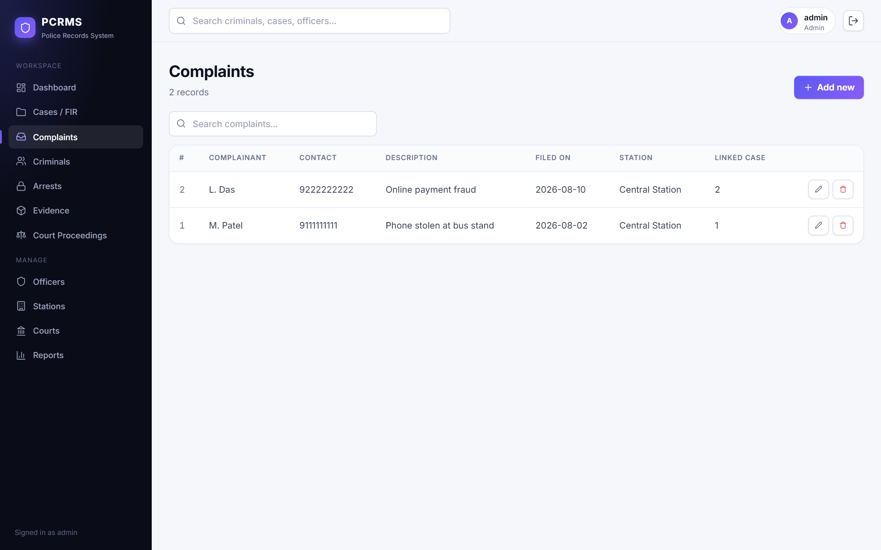
Figure : Complaints list
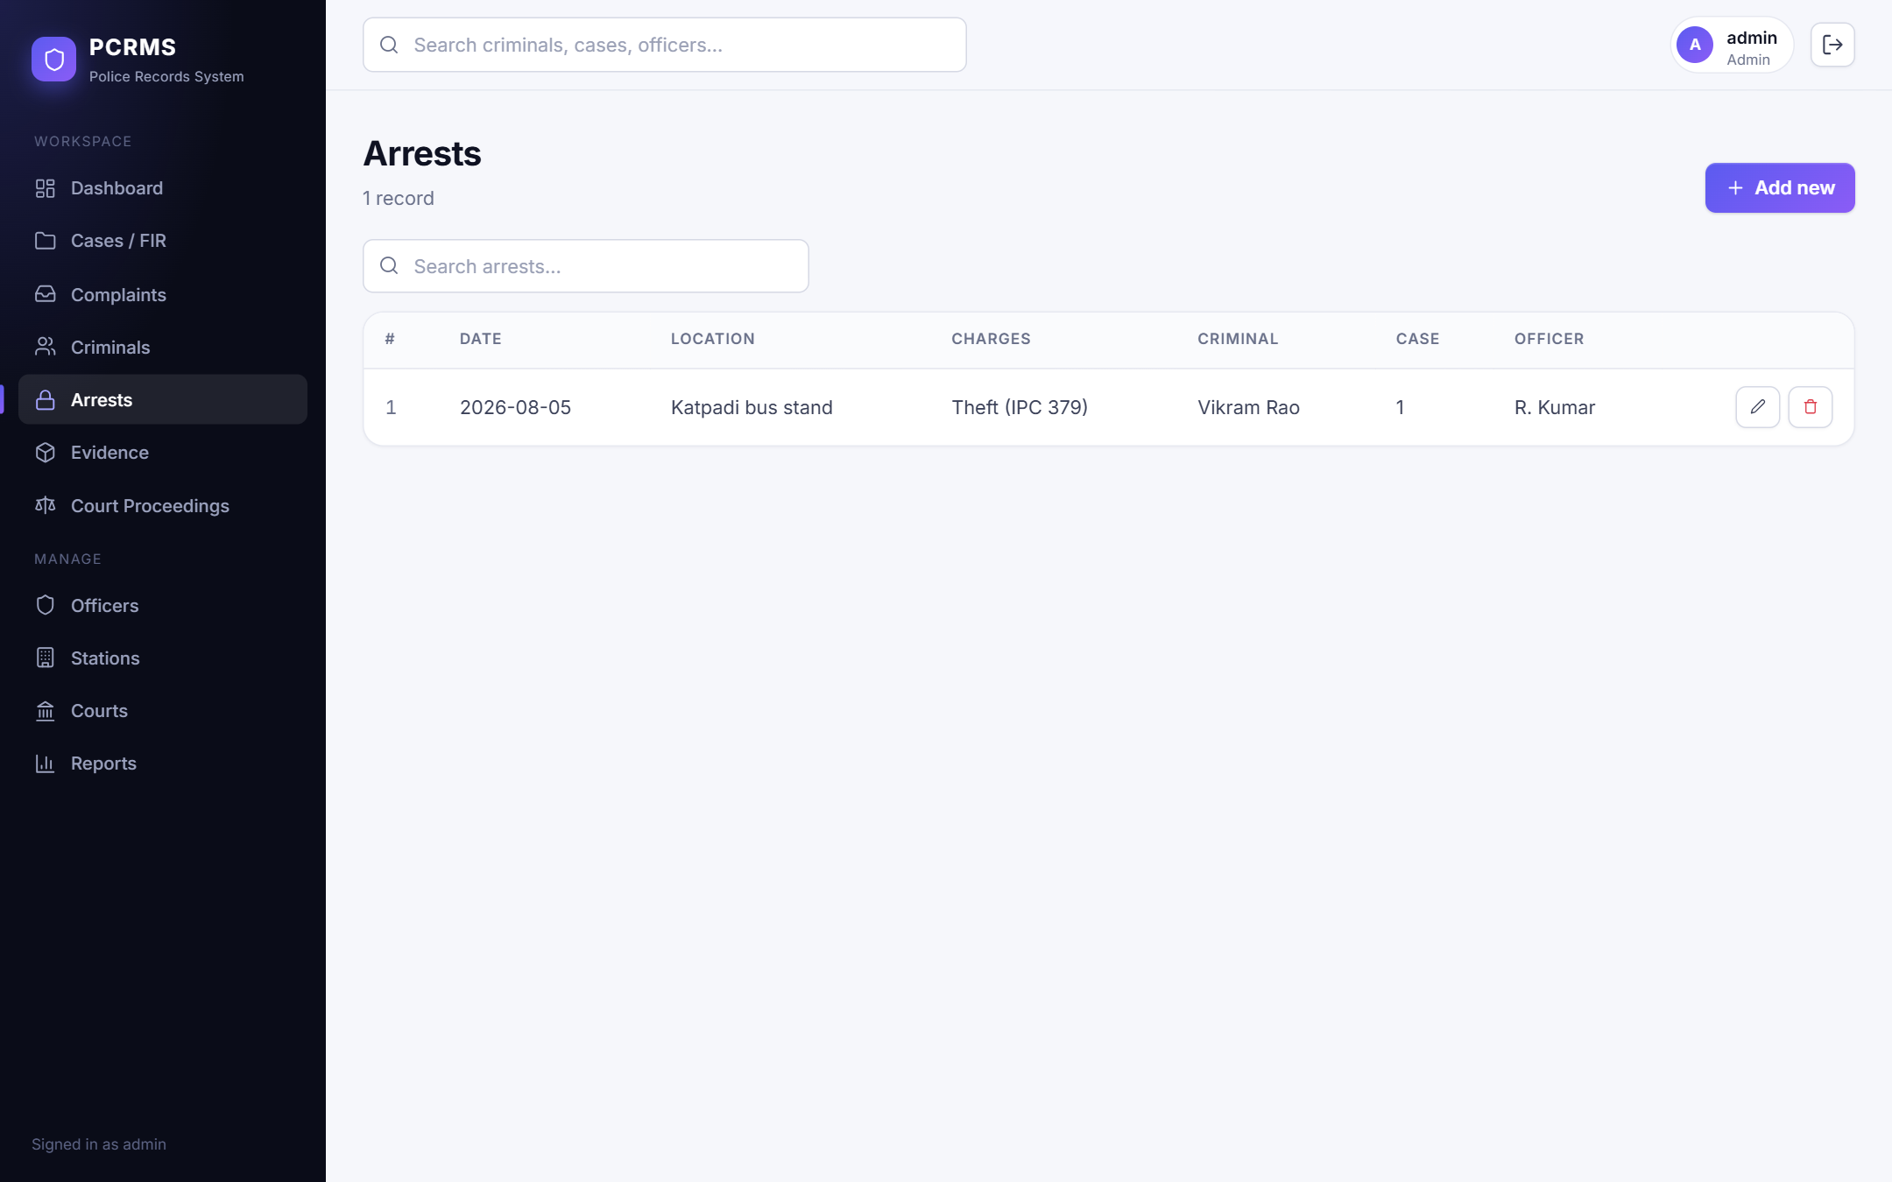
Figure : Arrests list
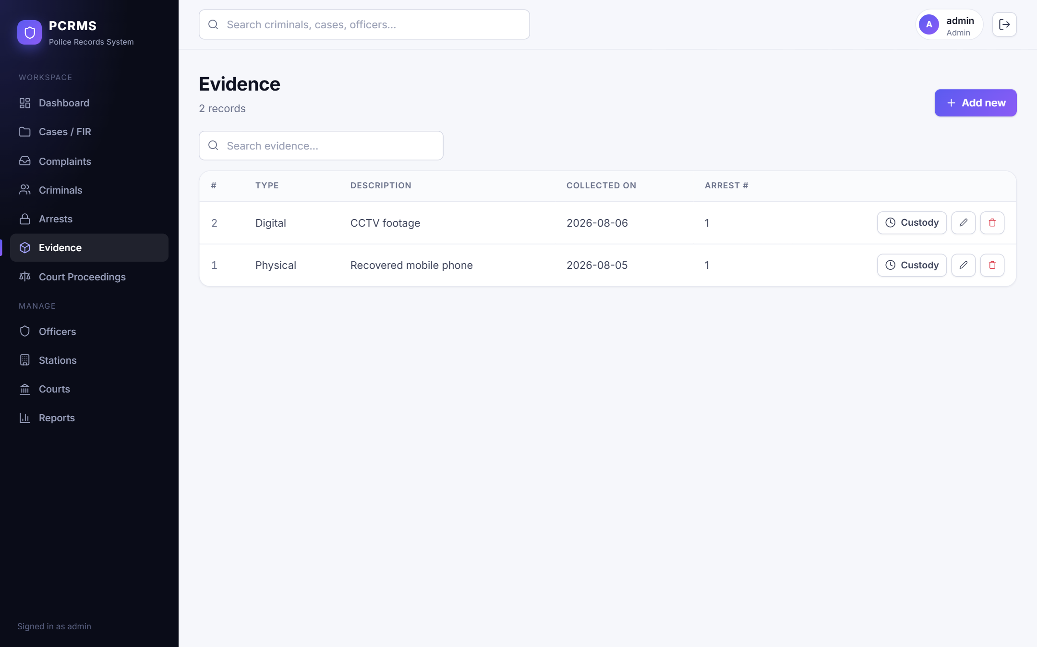
Figure : Evidence list
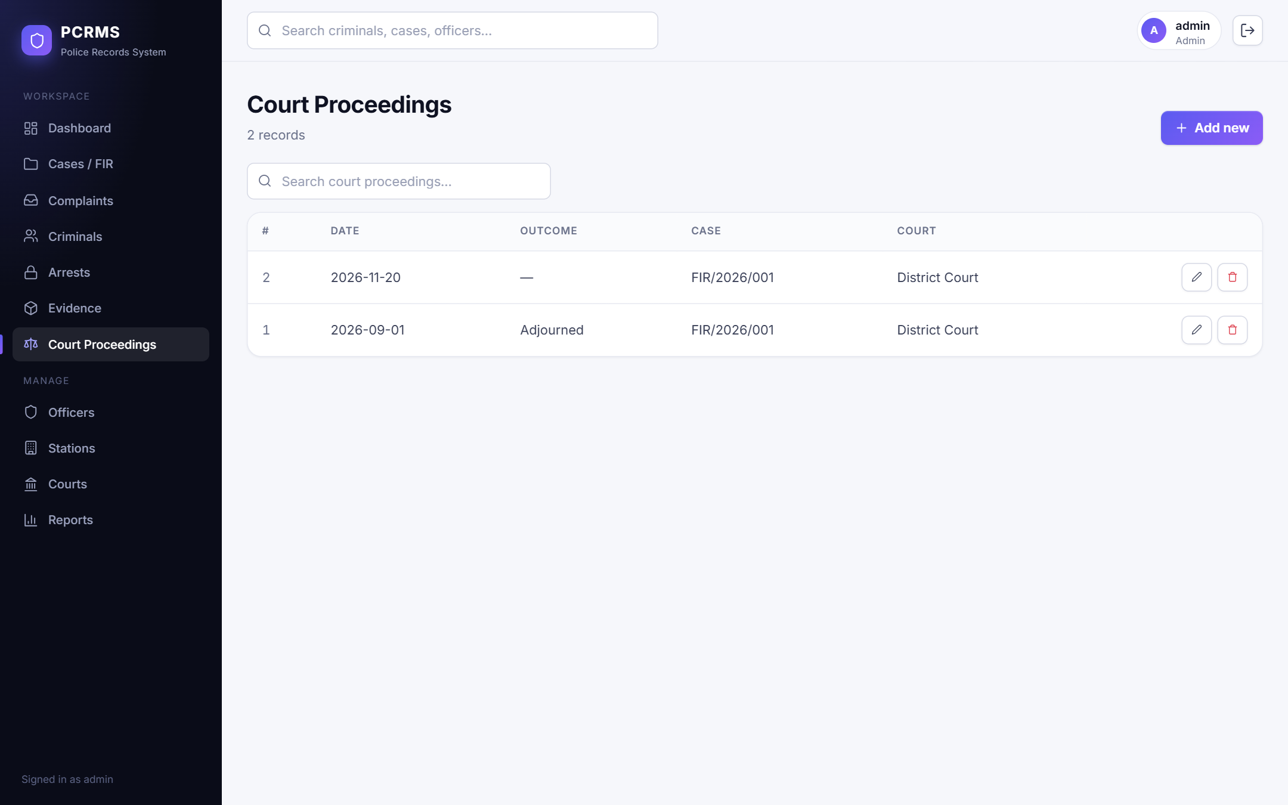
Figure : Court proceedings list
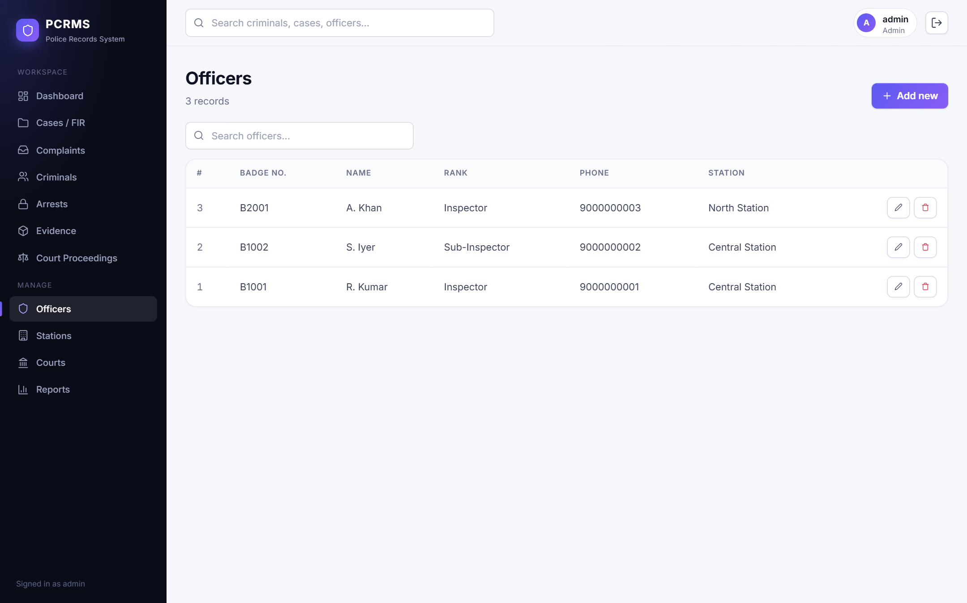
Figure : Officers list
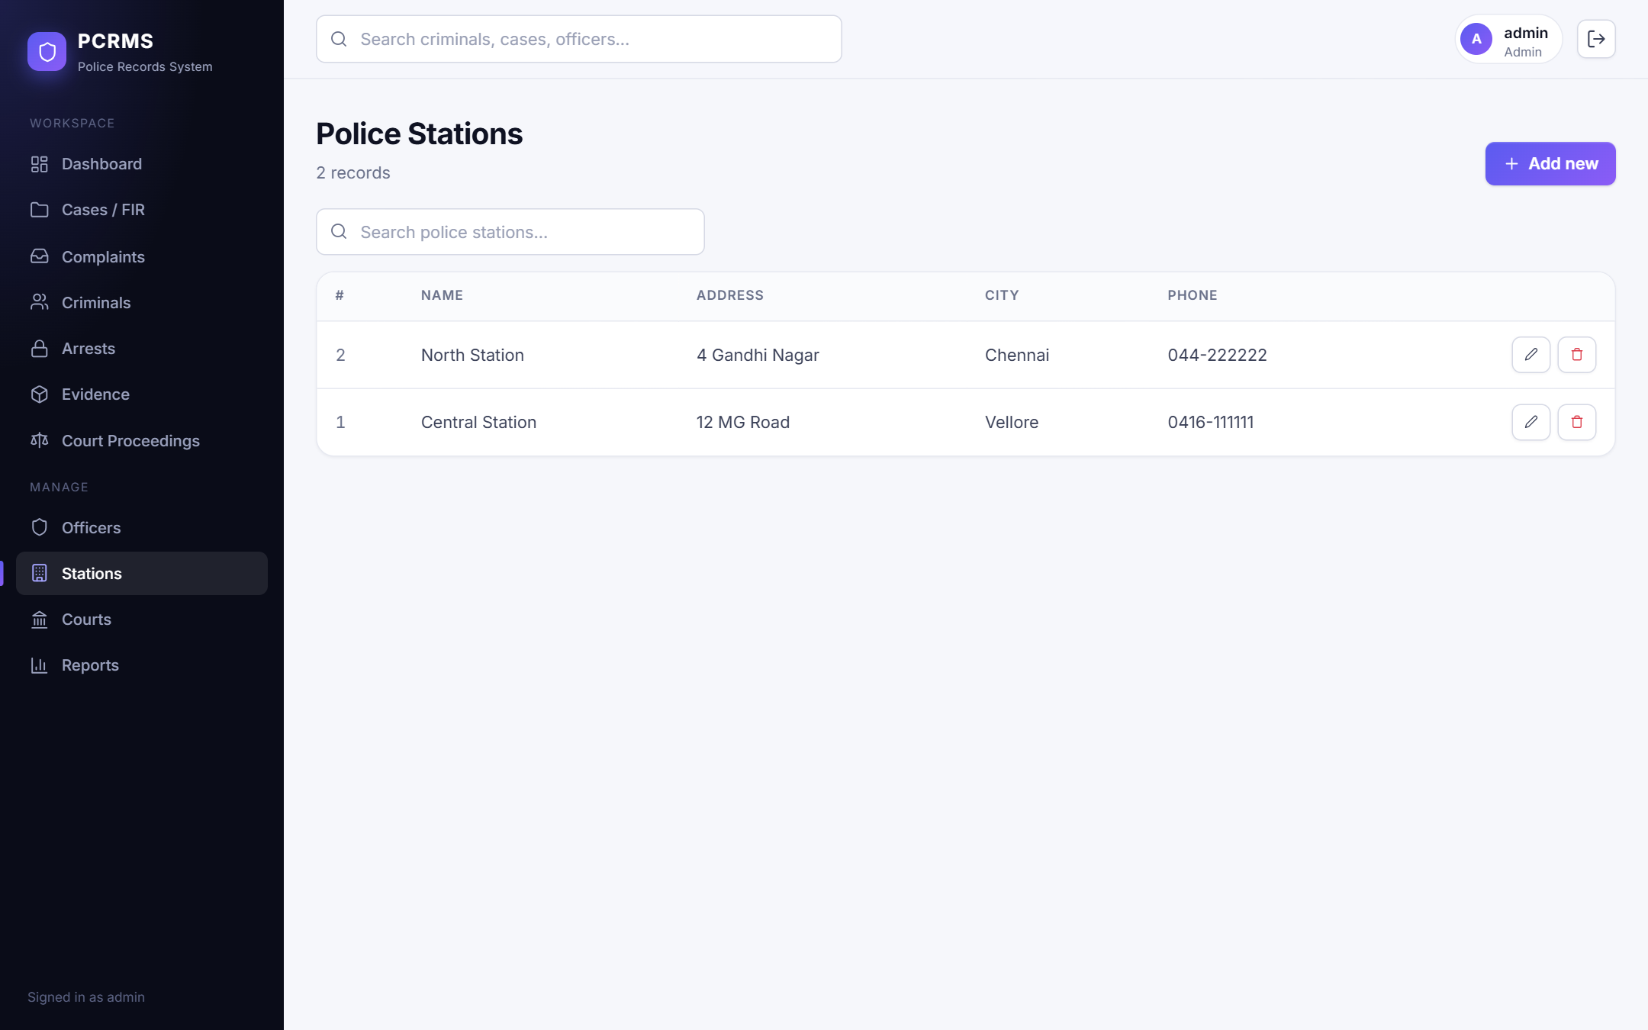
Figure : Police stations list
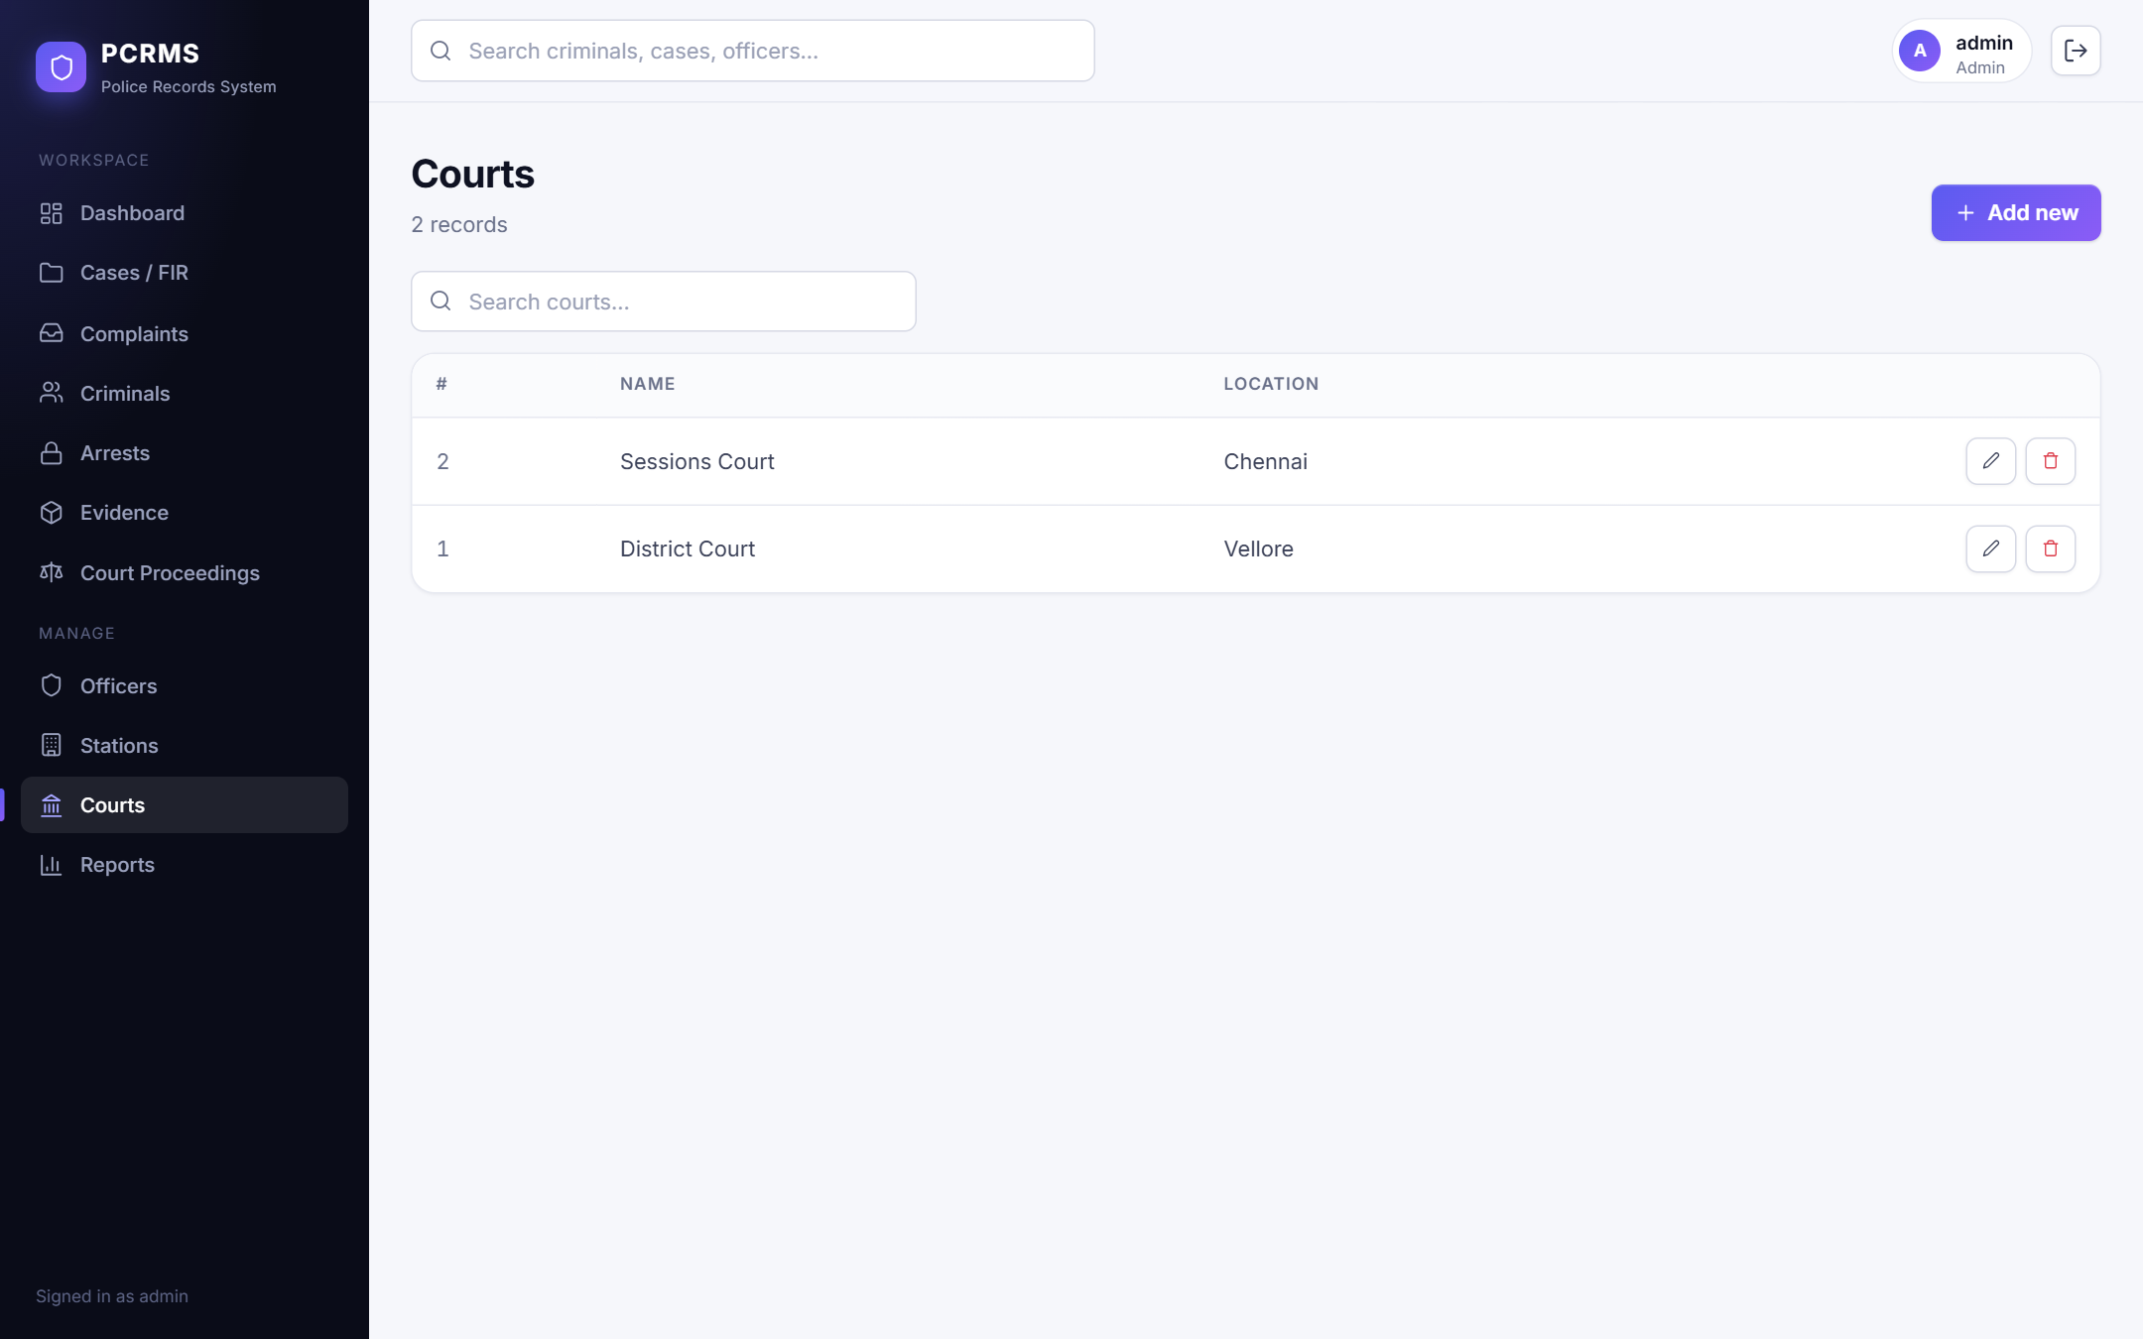
Figure : Courts list

Appendix D: Source Code and Configuration Notes
Selected excerpts are given in Chapters 4 and 5. Configuration notes:
- Database connection (server/.env): DB_HOST, DB_PORT, DB_USER, DB_PASSWORD, DB_NAME, JWT_SECRET and PORT. The file .env.example lists the defaults. JWT_SECRET must be set to a strong value in any real deployment.
- Vite proxy (client/vite.config.js): requests starting with /api are forwarded to http://localhost:4000.
- npm scripts: server: setup-db, start, dev (node --watch); client: dev, build.
- Automated tests: node server/tests/run-tests.js writes its results to a JSON file given as the first argument.

Appendix E: Setup and Execution Instructions
- Install Node.js 18 or later and MySQL 8, and start the MySQL server.
- In the server folder copy .env.example to .env and set DB_PASSWORD (and JWT_SECRET).
- In the server folder run: npm install, then npm run setup-db (creates the database, views, procedures, triggers, sample data and the three demo users), then npm start. The API listens on port 4000.
- In the client folder run: npm install, then npm run dev. Open http://localhost:5173.
- Log in with admin / admin123 (full access), officer / officer123 (no delete) or viewer / viewer123 (read only). These are demonstration credentials.
- To run the automated API tests, run npm run setup-db and then node tests/run-tests.js in the server folder.

Appendix F: Glossary
Table : Glossary
Term | Meaning
FIR | First Information Report: the initial record of a reported offence from which a case is opened.
Chain of custody | Chronological record of who handled an evidence item and what was done.
Junction table | A table that resolves a many-to-many relationship into two one-to-many relationships.
Trigger | Database code that runs automatically after an INSERT, UPDATE or DELETE.
Stored procedure | Named, reusable SQL routine stored in the database.
View | Stored query that behaves like a virtual table.
Normalization | Organizing tables to reduce redundancy and update anomalies.
JWT | JSON Web Token: a signed token that carries identity and role claims.
RBAC | Role-based access control: permissions are assigned to roles, not individuals.
SPA | Single-page application: the browser loads one page and updates it with data from an API.

