Arpan Nagar
180905256 CSE B 35
PP Lab1

Output

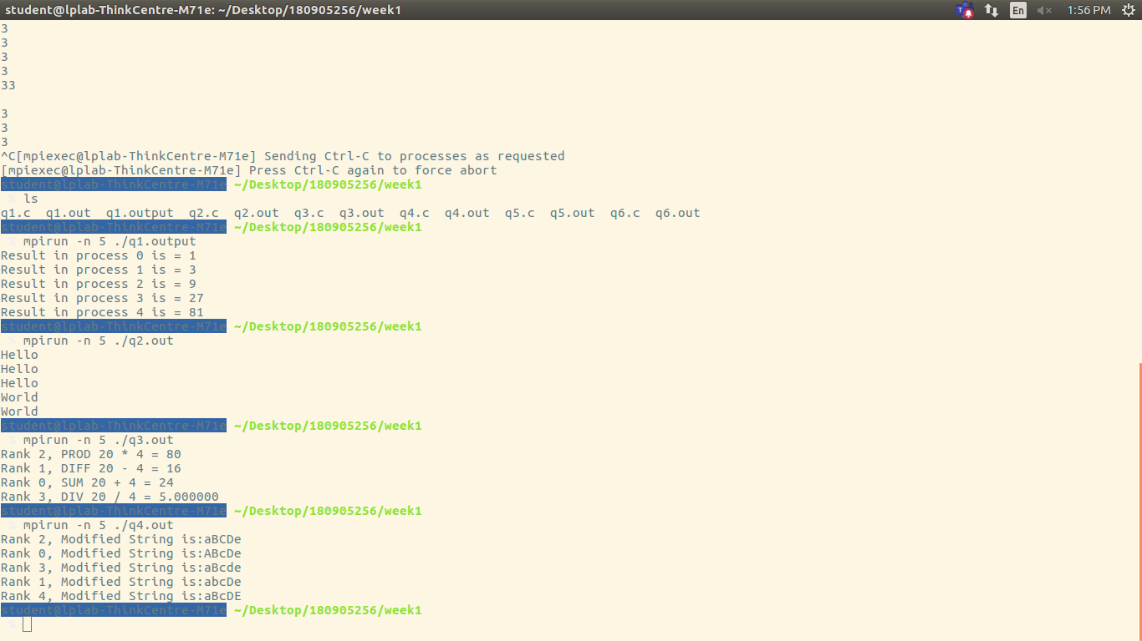
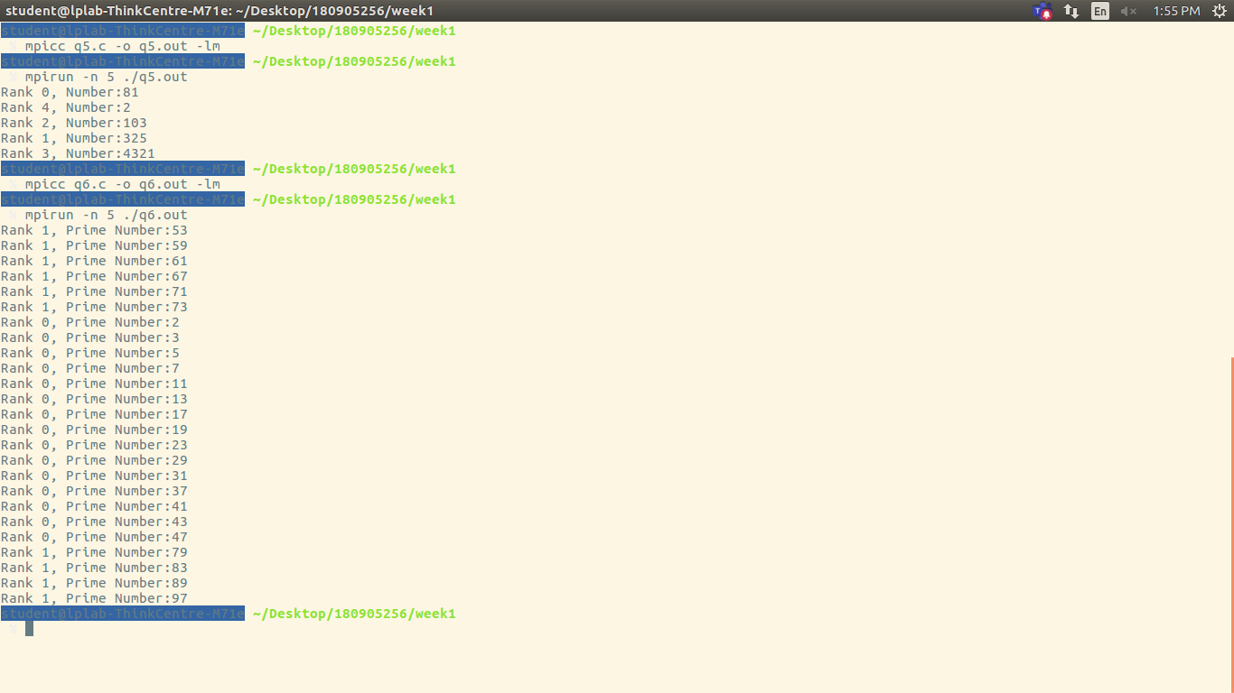

Code

1.
#include <stdio.h>
#include <mpi.h>
#include <math.h>

int main(int argc, char *argv[])
{
int rank,size;
int x=3,result;
MPI_Init(&argc, &argv);
MPI_Comm_rank(MPI_COMM_WORLD, &rank);
MPI_Comm_size(MPI_COMM_WORLD, &size);
result=pow(x,rank);
printf("Result in process %d is = %d\n",rank,result);
MPI_Finalize();
return 0;
}

2.
#include <stdio.h>
#include <mpi.h>
#include <math.h>

int main(int argc, char *argv[])
{
int rank,size;
int x=3,result;
MPI_Init(&argc, &argv);
MPI_Comm_rank(MPI_COMM_WORLD, &rank);
MPI_Comm_size(MPI_COMM_WORLD, &size);
if(rank%2)
printf("World\n");
else
printf("Hello\n");
MPI_Finalize();
return 0;
}

3.
#include <stdio.h>
#include <mpi.h>

int main(int argc, char *argv[])
{
int rank,size;
int x=20,y=4;
MPI_Init(&argc, &argv);
MPI_Comm_rank(MPI_COMM_WORLD, &rank);
MPI_Comm_size(MPI_COMM_WORLD, &size);
if(rank==0)
printf("Rank %d, SUM %d + %d = %d\n",rank,x,y,x+y);
if(rank==1)
printf("Rank %d, DIFF %d - %d = %d\n",rank,x,y,x-y);
if(rank==2)
printf("Rank %d, PROD %d * %d = %d\n",rank,x,y,x*y);
if(rank==3)
printf("Rank %d, DIV %d / %d = %f\n",rank,x,y,(double)(x/y));
MPI_Finalize();
return 0;
}

4.
#include <stdio.h>
#include <string.h>
#include <mpi.h>

int main(int argc, char *argv[])
{
int rank,size;
char str[5]="aBcDe";
MPI_Init(&argc, &argv);
MPI_Comm_rank(MPI_COMM_WORLD, &rank);
MPI_Comm_size(MPI_COMM_WORLD, &size);
if(str[rank]>='a' && str[rank]<='z')
str[rank]=str[rank]-32;
else
str[rank]=str[rank]+32;
printf("Rank %d, Modified String is:%s\n",rank,str);
MPI_Finalize();
return 0;
}

5.
#include <stdio.h>
#include <mpi.h>

int main(int argc, char *argv[])
{
int rank,size;
int rev=0,rem;
MPI_Init(&argc, &argv);
MPI_Comm_rank(MPI_COMM_WORLD, &rank);
MPI_Comm_size(MPI_COMM_WORLD, &size);
int a[9]={18,523,301,1234,2,14,108,150,1928};
int n=a[rank];
while(n!=0){
rem=n%10;
rev=rev*10+rem;
n/=10;
}
printf("Rank %d, Number:%d \n",rank,rev);
MPI_Finalize();
return 0;
}

6.
#include<stdio.h>
#include <mpi.h>

int main(int argc, char *argv[])
{
int rank,size,c1;
MPI_Init(&argc,&argv);
MPI_Comm_rank(MPI_COMM_WORLD,&rank);
MPI_Comm_size(MPI_COMM_WORLD, &size);
if(rank==0)
for(int i=2;i<=50;i++)
{
c1=0;
for(int j=1;j<i;j++)
if(i%j==0)
c1++;
if(c1==1)
printf("Rank %d, Prime Number:%d\n",rank,i);
}
else if(rank==1)
for(int i=51;i<=100;i++)
{
c1=0;
for(int j=1;j<i;j++)
if(i%j==0)
c1++;
if(c1==1)
printf("Rank %d, Prime Number:%d\n",rank,i);
}
MPI_Finalize();
return 0;
}

