

***DEPARTMENT OF COMPUTER SCIENCE ENGINEERING,***

***SCHOOL OF ENGINEERING AND TECHNOLOGY,***

***SHARDA UNIVERSITY, GREATER NOIDA***

**CITIZEN FEEDBACK ON MAINTENANCE**

**OF ROADS (Complaint Box)**

***A project submitted***

***in partial fulfillment of the requirements for the degree of***

***Bachelor of Technology in Computer Science and Engineering***

**by**

**ARQAM JAMAL ANSARI (2018005658)**

**CHIRAG (2018001866)**

**GAURAV GAMBHIR (2018013133)**

**LALIT SHARMA (2018010284)**

**Supervised by:**

**Ms. Jyotsna Seth, Assistant Professor**

**May, 2022**

**CERTIFICATE**

This is to certify that the report entitled entitled **“Citizen Feedback on Maintenance of Roads (Complaint Box)”** submitted by **Arqam Jamal Ansari(2018005658), Chirag(2018001866), Gaurav Gambhir(2018013133), Lalit Sharma(2018010284)** to Sharda University, towards the fulfillment of requirements of the degree of Bachelor of Technology is record of bonafide final year Project work carried out by him/her in the Department of Computer Science and Engineering, School of Engineering and Technology, Sharda University. The results/findings contained in this Project have not been submitted in part or full to any other University/Institute for award of any other Degree/Diploma.

Signature of Supervisor

Name: Ms. Jyotsna Seth

Designation: Assistant Professor

Signature of Head of Department

Name: Prof. (Dr.) Nitin Rakesh

(Office seal)

Place:

Date:

# **Signature of External Examiner**

# **Date:**

**ACKNOWLEDGEMENT**

A major project is a golden opportunity for learning and self-development. We consider our self very lucky and honoured to have so many wonderful people lead us through in completion of this project.

First and foremost, we would like to thank Dr. Nitin Rakesh, HOD, CSE who gave us an opportunity to undertake this project.

My grateful thanks to **Ms. Jyotsna Seth** for his guidance in my project work. **Ms. Jyotsna Seth**, who in spite of being extraordinarily busy with academics, took time out to hear, guide and keep us on the correct path. We do not know where we would have been without his help.

CSE department monitored our progress and arranged all facilities to make life easier. We choose this moment to acknowledge their contribution gratefully.

Name and signature of Students

Arqam Jamal Ansari (2018005658)

Chirag (2018001866)

Gaurav Gambhir (2018013133)

Lalit Sharma (2018010284)

**Declaration**

We hereby declare that the project work entitled **“Citizen Feedback on Maintenance of Roads (Complaint Box)”** submitted to Sharda University, is a record of an authentic and original work completed by us under the guidance of **Ms. Jyotsna Seth, Assistant Professor, School of Engineering and Technology, Sharda University** and this project work is submitted in the partial fulfillment of the requirements for the award of the degree of Bachelor of Degree in Computer Science and Technology. The result presented in this report have not been submitted to any other University or Institution for the award of any degree.

Arqam Jamal Ansari

Chirag

Gaurav Gambhir

Lalit Sharma

**ABSTRACT**

Citizen Feedback application will provide an online way for citizen to give feedback or complaints for the maintenance of roads and other necessities. The Main objective of Citizen Feedback app is to make feedbacks or complaints easier to resolve, monitor and coordinate. This android app will provide a user interface to submit a complaint and follow it. Our App will provide citizens to submit complaints and problem to municipal corporation and let them solve the problem in less time. Citizen feedback will help the system or department to continuously improve their work and do their best for the citizens, an effort to identify the changes that needs to be done. After the complaint has been raised, complaint will be assigned to their respective department. Once the complaint is submitted citizen can check status there of complaint.

Appendix 1

**Contents List**

Title Page…………………………………………………………………………………. i

Certificate…………………………………………………………………………………ii

Acknowledgement………………………………………………………………………. iii

Declaration………………………………………………………………………………. iv

Abstract……………………………………………………………………………...….... v

Chapter-1: Project Introduction

1.1: Problem Definition…………………………………………………………...7

1.2: Project Overview………………………………………………………….….7

1.3: Hardware Requirements……………………………………………………...8

1.4: Software Specifications………………………………………………………8

1.5: Problem of Complaint Management……………………...…...…....………...9

Chapter-2: Literature Survey

2.1: Existing System……………………………………………………………..17

2.2: Proposed System………………...………………………………………….17

2.3: Feasibility Study……………………………………………………………18

Chapter-3: System Analysis and Design

3.1: Data Flow Diagram ………………………………………………………...20

3.2: Pseudo Code………………………………………………………………...21

3.3: Design Criteria ……………………………………………………………..22

3.4: Interface Design………………...…………………………………………..26

Chapter-4: System Testing

4.1: Why Testing is done………………………………………………………..39

4.2: Cause of error……………………………………………............................39

4.3: Testing Principles……………………………..............................................41

4.4: Types of Testing for Mobile Apps………………………………………....43

Chatper-5: Results & Testing…………………………………………………………...45

Chapter-6: Conclusion & Future Improvements………………………………………..49

References

**CHAPTER 1: INTRODUCTION**

* 1. **Problem Definition**

In India It is very difficult to communicate between the citizens of country and the government to solve problems like broken roads, street light bulb fused etc. There is no other way for getting an issue solved as one has to go through a lot of hassle as they need to register their complaint at the respective department office which will be further forwarded to the respective person who can resolve that issue and then the problem may or may not get solved and also takes a lot of time.

* 1. **Project Overview/Specifications**

Citizen Feedback application will provide an online way on working on the issues faced by the citizens of our country by saving time and decreasing the amount of corruption in the department, and the ability of the application for the continuous improvement and to make the process easier to submit a complaint.

**Objective**

1. monitor, coordinate, resolve, and track become easier.

2. To provide organization with an app that can be used to target problem areas, identify and see the complete easily.

3. To do improvements in app.

4. Accurate data retrieval.

5. Flexible application for future and continuous improvements.

6. Reducing the duplicate or same data stored multiple times.

7. Output of the application will be accurate, comprehensive and in timelines.

8. Operability and stability by people of average intelligence.

9. Work or complaint will be resolved on time or within specified time period.

**Value of Complaints**

* **Improve and Evaluate services and programs:** Complaints are used to repair and identify any weaknesses in day-to-day activities like broken roads, transport, procedures etc. Complaints can be used to resolve this issue and improve the services.
* **Giving a perfect solution of complaint:** Citizen should be given a solution of their issue so the problem can be reduced.
  1. **Hardware Requirements**

• Windows 7 and above

• Minimum RAM required 3GB and recommended 8GB

• Minimum space required is 2GB and recommended is 4GB (Android SDK, emulator system image 1.5 GB is required)

**1.4 Software Specification**

**1.4.1 Android Studio**

Android studio is a tool that provide a fast way to build an app for android smartphones. Android Studio is official integrated development environment (IDE) for Android Operating system, Which is built on JetBrains' IntelliJ IDEA software and was specially designed to develop Android Applications

**1.4.2 Firebase**

Firebase Authentication: Firebase security applies Google's internal expertise to easily build app sign-ins. Used to develop sign-up and login platform with firebase authentication.

Firebase Realtime Database: Store and sync data between your users in Realtime with the Firebase Realtime Database. It is used to make your app have strong user-based security and optimize for offline use.

**1.4.3 Java**

Java is the choice of technology that is used to build applications using managed code that can be executed on android phones or device. Using the Java programming language and android SDK we can develop an android application.

**1.4.4 XML**

eXtensible Markup Language, or XML: XML is created as a way to encode data in applications that are based on internet. XML is used in android application to create layout files. Unalike HTML, XML is case-sensitive, in XML each tag needs to be closed and preserve whitespace.

**1.5 Problems of complaint management**

* Details of complaints are insufficient and unclear.
* The redundancy of complaints in the organizations.
* The complaints are not related to responsible department.
* The organizations don’t have channel for asking more information related to complaint and providing feedback.

* 1. **How complaint be raised?**

Citizen will have many options to raise a complaint and if they don’t find the complaints, they can specify in others option. Complaints should be properly viewed and update the status by the admin.

Citizen should be encouraged to raise a complaint if they are face any problem.

**1.7 Who can raise a complaint?**

* Students
* Staff members
* Citizen using the service

**1.8 What complaints can be about?**

* Delay of bus
* Fare Hike
* Heavy Traffic
* No Traffic Signals
* Sidewalks Broken
* Street Lights not working or broken
* Power cut
* Academic Misconduct
* Bribe

**1.9 Types of complaints**

A complaint can be referred as to voicing the dissatisfaction made indirectly or directly, to the respective department.

Complaints are mainly categorized into three categories:

* **Disputes:** Matters that raise problems regarding the administration or management of the department that is not systemic. For example, complaints about exclusions, lack of procedural fairness, about assessment.
* **Misconduct:** Misconduct includes integrity and ethical problems such as biased or unethical work, fraud, conflict of interests, dishonesty, bribery, improper favoritism towards someone, harassment and discrimination.
* **Mismanagement:** Mismanagement includes things such as do not provide the rights to someone, unreasonable decisions, failed to consider the relevant matter, negligence, denied the procedural fairness.

**Advantages**

* Very less time is required to raise a complaint.
* No technical knowledge required to use the app or raise a complaint.
* Easy to maintain the app.
* No cost for citizen to raise a complaint.
* Less time resolve complaints.

**Establishing a complaints centre**

Universities that don't have a centralised complaint handling unit – a complaints centre – should consider establishing one.1 Establishing and right resourcing a complaints centre offers multiplex advantages in guarantying complaints are right, constantly, and professionally dealt with. It also helps to maximise the value of complaints as a operation tool and smooth analysis of complaint records. A complaints centre should have its own point on the university website with a' complaints policy library' indexing links to all programs that relate to complaints and prayers about complaint opinions. The point should also contain a companion to timber and lodging complaints and include template forms to help people lodging the most common types of complaints. Crucial fund and liabilities the proper resourcing of a complaints centre is critical. It requires not only acceptable well-good staff and information technology outfit but also ready access to external investigators, the university solicitor and other professional moxie.

The centre's liabilities should include:

• recording details of all complaints and their determination in the centre's database

• maintaining the complaints database

• registering all staff designated to admit complaints and their position of moxie

• conducting or commissioning applicable training for all staff involved in complaint handling

• maintaining a database of good/ educated investigators

• reviewing and regularly streamlining a detailed primer for complaint instructors

• where referral is needed, relating the most applicable person or agency to which the complaint should be transferred

• advising on all aspects of the complaint process including the conduct of examinations

• drafting, advising on and/ or settling the terms of reference for at least any major examinations

• appointing or advising on the appointment of applicable investigators for major matters

• covering the progress of examinations to insure they're of high quality and there are no detainments

• assessing the conduct of investigators and guaranteeing applicable information is handed to operation

• setting and monitoring complaint data security norms and overseeing the conservation of applicable sequestration conditions

• monitoring complaint trends to identify openings for system enhancement.

**Maintaining a complaint database**

A good complaint recording system can help to identify, assess and manage threats. Precluding and managing threats should be an integral part of a university's operation practices and procedures. Enough detail needs to be captured to allow an applicable position of analysis. This should grease monitoring of performance norms, including timeframes for responses to complaints and the success of different complaint handling styles.

Data should be collected on:

• figures of complaints

• compliance with performance/ punctuality norms

• issues raised in complaints

• trends in complaints over time

• academic or other university units the subject of complaints

• sources of complaints

• styles of handling complaints

• what remedy/ requital was introduced

• recommendations/ strategies to help or limit recurrences

• service advancements initiated due to complaints data.

**Resolving Complaints Informally**

There are many informal ways that can be used to successfully finalise complaint:

* Proving an explanation
* Giving more information
* Suggesting a solution
* Giving an apology
* Expressing understanding and sympathy where there is no solution available.
* Having decision changed or made.

|  |  |  |  |  |  |  |  |  |  |  |  |  |  |  |  |  |  |  |  |  |  |  |  |  |  |  |  |  |  |  |  |  |  |  |  |  |  |  |  |  |  |  |  |  |  |  |  |  |  |  |  |  |  |  |  |
| --- | --- | --- | --- | --- | --- | --- | --- | --- | --- | --- | --- | --- | --- | --- | --- | --- | --- | --- | --- | --- | --- | --- | --- | --- | --- | --- | --- | --- | --- | --- | --- | --- | --- | --- | --- | --- | --- | --- | --- | --- | --- | --- | --- | --- | --- | --- | --- | --- | --- | --- | --- | --- | --- | --- | --- |
| **CHAPTER 2: LITERATURE SURVEY**   |  |  |  |  |  | | --- | --- | --- | --- | --- | | **TITLE** | **AUTHOR** | **OBJECTIVES** | **ALGORITHM / METHODOLOGY / Techniques / Methods** | **RESULT (ACCURACY or ANY OTHER PARAMETER)** | | Citizen Feedback for improving local bodies continuously | Alessandro Minelli, Renato Ruffini (2017) | Feedback of the citizens for the continuous improvement. | Three elements of complaints:  1) Communication  2) Discomfort: It is because of the service failure.  3) Damage | Using three elements i.e., communication, discomfort, damage local bodies can be improved. | | Online Complaint Management System | Sman Nasr, Enayat Alkhider (2015) | complaints can become easy to track, resolve, monitor and coordinate | Provided an online way to solve the problem of citizen. | There Software had optimum utilization of resources, improved productivity and instant access | | Citizen based Complaint system based on mobile devices | Swapnil R.Rajput ,Mohd Sohel Deshmukh (2016) | Track the location of complaint using GPS. | HTML5  Java scripts  C#  AJAX for dynamic content on the map.  SQL Database | They created a platform for communication between the municipal corporation and the citizen. So, it can help the citizens facing problem in urban areas and by tracking them that will result in a clean and peaceful environment | | A mobile city and web reporting maintenance Solution | Jorge Santosa, Fátima Rodriguesb, Lino Oliveira (2013) | System for managing and reporting Non urgent notifications of urban situations and problems of the citizens. | They inherited all the features of representation and manipulation of information on the maps. The entire infrastructure of publishing services KML, WFS and WMS. | Can be integrated in the existing Geographic information system. | | Smart Complaint Management System | Panida Liawsomboon, Narut Phongoen , Pattamaporn Kormpho, Siripen Pongpaichet(2018) | Classifying and forwarding the complaint to the concerned department and checking duplicate complaint submission | Classifying complaint using Artificial Intelligence and machine learning, Data visualization | It was able to provide several channels for filing the complaint, which enables users to send the complaint easier, and also provides the channel for progress tracking by using the mobile application. classifying the complaint and directly sending to the appropriate responsible department, therefore, the system could reduce the cost of hiring the staff and time of the operation. | | Mobile Application interface to register citizen complaint | Shailesh Indradev Gupta, Azaruddin Aianuddin Nayakwadi, Shailesh Indradev Gupta, Asst Prof. Sneha Sankhe | The aim is, to be retired of this excuse of time and physical energy drained with the technologies found to be in and around everyone. | It enables and assists citizen to lodge complaint and follow through complaints using their mobile phone. The main objective of this proposed system is to provide an easy way to lodge complaint related to crime or any other catastrophe without the need of so much time The system proposed by us can be disintegrated into modules, namely client-side module and another is server-side module | It is a system which lets both the police and the common man to eradicate the crime. The system does not reveal the identity of the complainer at the police station. Only the central Office knows the identity of the complainer | | City Complaint Management System | Atit More (2019) | Bridging the gap between government and citizens due to lack of communication by allowing users to register complaint on their own. | There will be two modules one for user and other for admin. Users will register with their details and submit complaint along with the image as a proof. Admins see all grievances with respect to their regions. | It is being developed as a platform independent web application as well as Android Application, so the admin can maintain a proper contact with their users, which may be accessed anywhere. The gap between government body and citizens also reduced. | | Complaint Management System | K.Gowthami, Mrs.Deviselvam,  S.Anjali, M.Dharshna(2017) | The aim is to solve issues that are related to internal system of college and track the complaints that are registered. | Server gets various request form the client and it respond according to the client’s request. | Easy Access as it maintains a proper communication between user and admin. | | Smart Complaint Management System | Arpan Tiwari , Pooja Vijaywargi, Nisarg Gandhewar, Ruchita Narnaware, Prayas Pagade, Devika Radhakrishnan.(2016) | The aim is to make an app that is used to lodge a complaint online in an easy way. | Using the GPS to track the location easily and images is used to properly analyse the issue. | App can be used to raise a complaint by uploading a picture of the issue and providing the location using GPS. | | Mobile Application interface to register citizen complaint | Deep Shah, Prof. Harsh N. Bhor, Dhaval Gherwada, Vipul Shah(2015) | Android app that is cheap, easy and quick to register complaints. | The modules involved in system was communication network, mobile application, camera, server, GPS. | User can raise a complaint regarding the issue they are facing and can attach picture of it, can use GPS for location. |   **2.1 Existing System**  In the existing system the citizen has to go at the respective department to submit the complaint. The citizens have to submit their issues but did not able to get the full details of their complaints and used to take a lot of time. This system was not user friendly and user used to not like much.  **2.2 Proposed System**  Our project main focus is to provide an online way for citizen to give feedback or complaints for the maintenance of roads and other necessities by making an android application using android studio.  It will be having following Departments in which user can raise a complains:   1. Transport Department: In this department user can raise issues regarding the following situations:  * Traffic issues * Bus time schedules * Fare hike  1. Municipal corporation: In this department user can raise issues regarding the following situations:  * Roads * Water * Waste Management  1. Medical care: In this department user can raise issues regarding the following situations:  * Health * Staff * Services  1. Emergency: In this department user can raise issues regarding the following situations:  * Polices * Fire Stations * Safety  1. Electricity: In this department user can raise issues regarding the following situations:  * Power out * Billing * Power theft  1. Education: In this department user can raise issues regarding the following situations:  * Schools * Education’s subsidiary * Others  1. Sharda University: In this department user can raise issues regarding the following situations:  * Accounts * Disputes * Mismanagement * Misconduct   **2.3 Feasibility Study**  Any comprehension of the major specifications for the scheme is necessary for feasibility study.  Feasibility Dimensions for Computers are shown below:   * **Technology**   Is the project technically possible?  Is it a component of the state of the art?  Will failure be limited to the need for an implementation meeting the level?   * **Finance**   Is it financially practicable?  Is it realistic for the software company and its customer or company to achieve production  a reasonable pace?     * **Time**   Can the time for the idea to be sold, beat the competition?   * **Resources**   Will the corporation have the capital necessary for success?  There are two major variables that are used in viability study:   1. Technological Feasibility 2. Cost Feasibility 3. **Technical Feasibility**   The purpose of this analysis is to check the technological viability, that is to say, the system's technical requirements. Any built system does not have a strong need for the technological resources required. This will add to intense strains on the intellectual resources available. It would bring to the customer's already firm hopes. Since this system can only be applied with minor to no modifications, a bare minimum must be met.   1. **Cost Feasibility**   This study evaluates the economic impact of the scheme on the business. It restricts the amount of money that can spend on the research and development of its strategy. It is necessary to justify the expenses. Thus, within the budget, the developed system was also developed and this was done because much of the technology used is readily accessible. It was only appropriate to buy the personalized items. |

**CHAPTER 3: SYSTEM ANALYSIS AND DESIGN**

**3.1 Data Flow Diagram (DFD)**

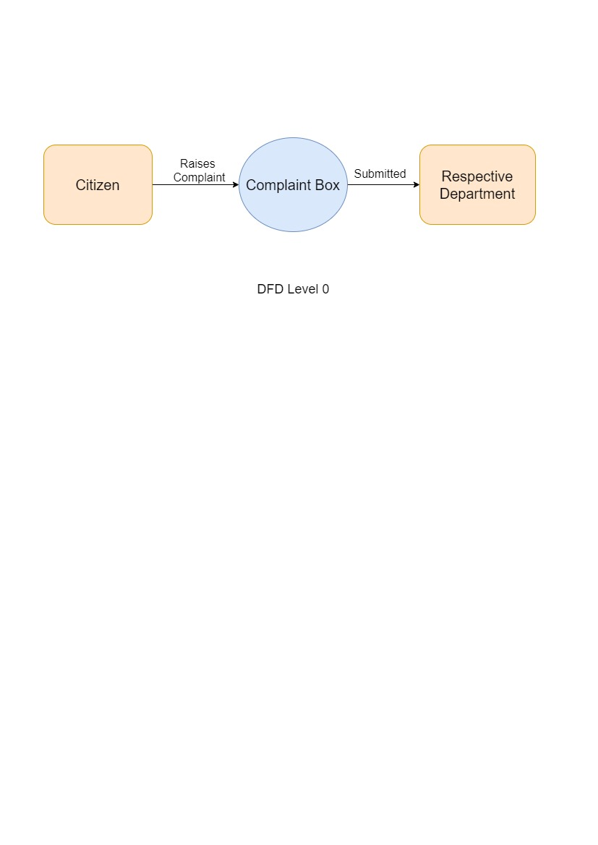

Fig 1: Level 0 Data Flow Diagram

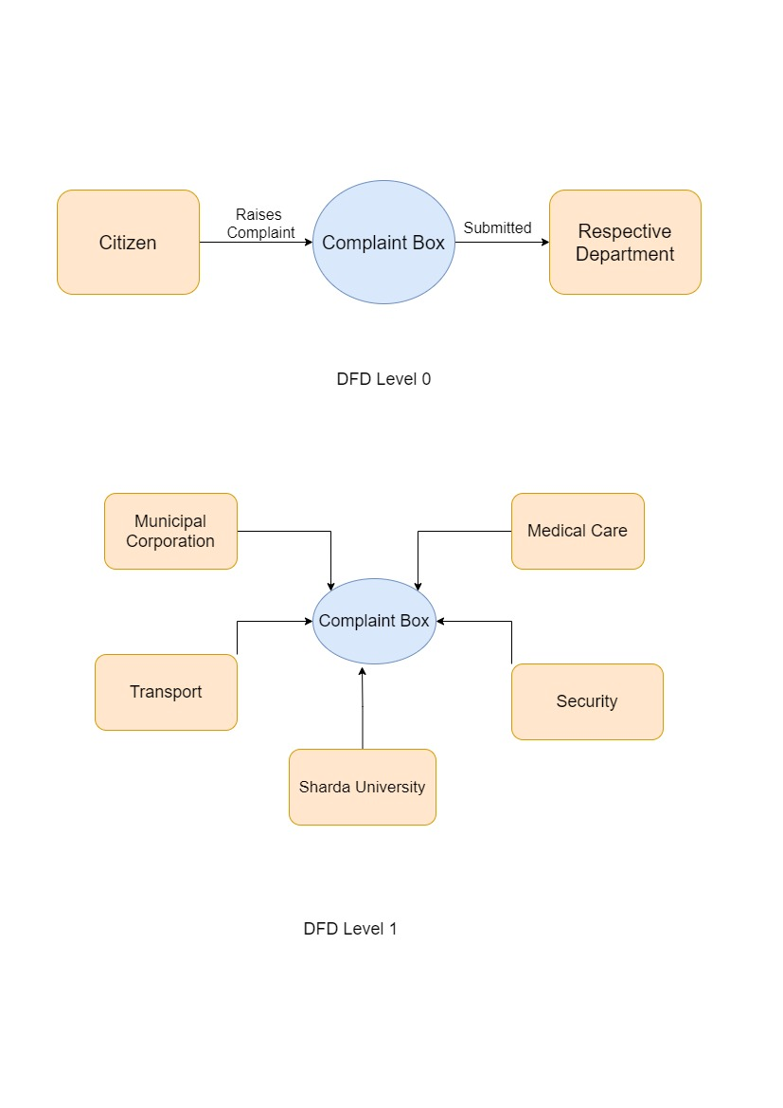

Figure 2: Level 1 Data Flow Diagram

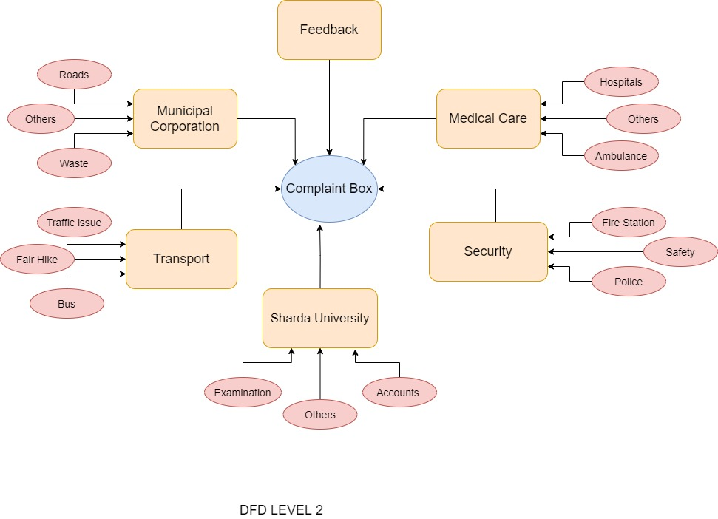

Figure 3: Level 2 Data Flow Diagram

**3.2 Pseudo Code**

1. Citizens have to register himself on application with their Phone/Email.
2. Then citizens can raise complaints or can submit feedbacks.
3. After the complaint has been raised, complaint will be sent to the respective department.
4. After department receive the complain they will monitor the problem and will resolve the problem as soon as possible.
5. Citizens can check Status of their complaints.

**3.3 Design and Test Steps/Criteria**

**3.3.1 Process Model**

In Process Model process is grouped into a model. A model is used to describe a mechanism on the basis of type-level. Even though, paradigm has reached type stage but it is still a process of instantiation. It is the same model used to create many iterations and has various instantiations. System Model is used to describe that how tasks can be carried out concerning the currently taking place.

The objective of process model is:

* **Prescriptive:**
* Define the procedure that is needed including how they are performed.
* Procedures, set laws and pattern of action that can contribute to the required performance of the process. It can be between fluid guidance and strict adherence.
* **Descriptive:**
* Keeping track of the procedure
* Consider an outside expert's perspective who examines how an operations can be done and determines whether changes that are to be made will be reliable and successful or not.
* **Explanatory:**
* Providing details of the methods
* Positions from which can get the tracking data.
* Make a strong connection between both the procedures and the standards which that model would meet.
* Centered on logical reasoning, analyze and compare various potential courses of action.

**3.3.1.1 Agile Model**

Agile Model is a software development approach based on iterative development. In this model task is broken into smaller iterations or it does not directly involve long term planning. In the beginning of development process, we first find out project scope and requirements. Define number of iterations, the scope and duration of each and every iteration in advance.

In Agile process model each iteration is of short time frame, which is mainly of two to five weeks. By making smaller parts of entire project, it reduces the risk and overall time of project delivery. Full team work is required for each iteration to take through a full software development life cycle including planning, requirements, analysis, design, coding, and testing.

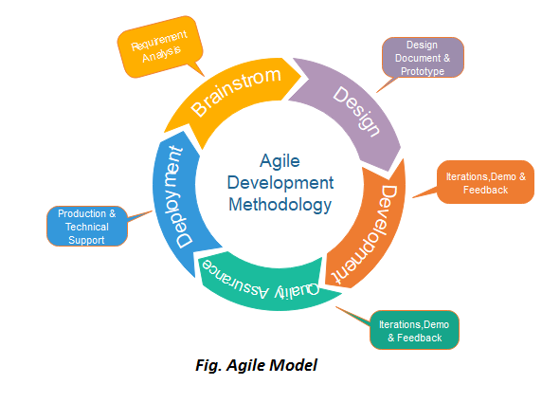

Figure-4: Agile Model

**Phases of Agile Model:**

1. **Requirements Gathering:** In this Phase, requirements is defined. Business opportunities and time management or planning, economic and technical feasibility.
2. **Design the requirements:** Includes four software attributes: Data structure, Software Architecture, representation of the interface & procedural information.
3. **Coding/Iteration**: In this phase, the developers and designers start implementing the project and goes under various stages for improvements.
4. **Testing:** Works with Software logical internals and guarantees that all declarations are right to detect all secret errors.
5. **Deployment:** Product is issued for the users work.
6. **Feedback:** Feedback is the last phase in Agile model in which the team gets feedback about the work and product.

**Advantages of Agile Model:**

1. Regular Delivery
2. Direct Interaction with clients
3. Total development time get reduced
4. Changes can be done easily and at any time.
5. Efficient design
6. Fulfils business requirements
7. Flexible For developers
8. Minimum rules
9. Encourage team work

**Agile Testing methods**

Following are the testing methods for agile model

* Crystal
* Scrum
* Feature Driven Development D(FDD)
* Dynamic Software Development Method (DSDM)
* Lean Software Development
* eXtreme Programming (XP)

**Why is the Agile Model is used?**

* As there are frequent changes in the project.
* The project size is not that big.
* As it is one of the best models for Mobile app development
* To increase the product quality.

**3.4 Interface Design**

1. Figure-5 is showing how our app will look like. Citizen will have to register first on the app with their phone number after that they will receive an OTP (One Time Password) that they need to enter on the app to verify their phone number after verifying the citizen will have to enter details then they can use the app further to register a complaint and will reach on figure-5 where citizen can select the respective department in which they want to raise a complaint in. After that they can raise a complaint in that department after filling the further details that are required to raise a complaint.

Figure-5: Home Page

1. Selected Department page:

In fig6 citizen have selected transport department now they have to select the issue which they are facing.

Fig-6: selected department

1. Complaint details: Now citizen will need to fill required details of the issue such as location sub category of complaint, description of the complaint. After entering all the details that are required citizen have to click on raise a complaint to submit and can see the details and status of complaints in my complaint Section.

Fig-7: filling complaint details

1. My Complaints: In my complaint section citizen can see all the complaints they have submitted and by clicking on the complaint they can view the details of the respective complaint like status of the complaint, complaint id etc.

Fig-8: My complaints

**3.4 MODULE OF PROJECT**

The significance can be summed up in a single word: quality. In software development, design is an area where quality is advanced. Design allows us to define software that can be evaluated for quality. The only way we can accurately translate a customer's vision into a final software product or system is through design. All of the software engineering steps that follow start with software design. Without a strong design, we risk creating an insecure system that will be difficult to test and whose quality will not be assessed until the very end.

During the design phase, the data structure, software structure, and procedural points are gradually strained, examined, and documented. From a technical or project management standpoint, the design can be viewed. Architectural design is one of four activities that make up design from a technical standpoint.

a. the creation of a data structure.

b. user interface design

c. design that is procedural.

**Module I: New User**

A new user must first register before logging in for the first time. The Complaint service, which is used to raise complaint in the respective department.

**Module II: Existing User**

Users can only login to the page in this part, after which they will be able to raise a complaint see the complaints that they have already registered.

**Module III: Admin**

Database management and user support are two of the most important responsibilities of administrators. Admin will update the status of the complaints which users can see in the my complaint section and admin will send the complaints to respective department.

**3.5 Departments**

**3.5.1 Transport Department**

Transport Department have complaints related to the transport which is as follows:

1. Bus Time: Citizen can complaint if the
   * + - bus is delayed,
       - have less frequency
       - any other issue they are facing.
2. Fare Hike: Can Complaint about if
   * + - * fare hike,
         * scams
         * any transport is taking additional charges.
3. Traffic Issues: Can Complaint about if

* there is a traffic jam,
* traffic signal is not working,
* any accidents on the roads.

**3.5.2 Education Department**

Education Department have complaints related to the schools, colleges which is as follows:

1. Schools: Citizen can complaint if the

* schools are not giving any practical knowledge,
* poor infrastructure of school,
* teacher don’t have good knowledge of their subject.

1. Subsidiary: Can Complaint about if

* Transport service problem
* Lodging issue
* Medical and health service problem
* Bad food services

1. Scholarship: Can Complaint about if

* Less awareness
* Knowledge gap
* Dynamic Competition
* Others

**3.5.3 Municipal Corporation**

Municipal Corporation have complaints related to the roads, waste, Street which is as follows:

1. Roads: Citizen can complaint to this department if
   * + - Roads are not well maintained
       - Sidewalk is broken or not maintained
       - Uncovered pit-holes.
2. Waste: Can Complaint about if
   * + - * Garbage is not being picked up.
         * Soil contamination.
         * Plastic Waste.
         * Impacting the health
3. Street: Can Complaint about if

* Street light is not working or broken.
* Street surveillance.
* Drains are open.

**3.5.4 Electricity Department**

Electricity Department have complaints related to the Power supply which is as follows:

1. Billing: Citizen can complaint if the
   * + - Bill is incorrect.
       - Bill has any additional charges.
       - any other issue they are facing.
2. Power Outage: Can Complaint about if
   * + - * There are any unscheduled cuts.
         * Short circuit.
         * Failure of any equipment.
3. Theft/Unauthorized use of Power: Can Complaint about if

* Someone is bypassing the energy meter.
* Directly hooking from the line.
* Any foreign element in energy meter.
* Any other issue.

**3.5.5 Medical Care Department**

Medical Care Department have complaints related to the health issues which is as follows:

1. Health: Citizen can complaint about
   * + - There is any issue with the Doctor.
       - Wrong or any issue the health records.
       - Time spent with the Doctor.
2. Staff of Hospital: Can Complaint about if
   * + - * Having any issue with the staff members.
         * Someone is misbehaving or have wrong attitude.
         * Lack of communication and dismissiveness with staff.
3. Services: Can Complaint about if

* Equipment is not available in hospital.
* Any billing discrepancies.
* Rooms are unhygienic and not well maintained.
* Any other issue.

**3.5.6 Security Department**

Security Department have complaints related to the safety which is as follows:

1. Police: Citizen can complaint if the
   * + - Investigation of crime is not proper.
       - Police inspector is taking bribe
       - Use of violence to handle the situation.
2. Safety: Can Complaint about if
   * + - * No proper security for women.
         * Someone is doing child trafficking.
         * Illegal insurance agency .
3. Fire Station: Can Complaint about if

* Taken very long time to arrive.
* Risk of heavy fire.
* No firefighting facilities.
* Any other issue.

**3.5.7 Sharda University**

Sharda University can have any complaint that is regarding the Sharda University which is as follows:

1. Accounts: Students can raise a complaint if having issue related to
   * + - Tuition fee.
       - Hostel fee.
       - Registration Fee.
       - Examination Fee.
       - Late Fee.
       - FI/FR Fee.
       - Wrong compilation of ledger.
2. Disputes: Students can raise a complaint if having issue related to
   * + - * Assessments.
         * Exclusions.
         * Discontinuation of courses.
         * Lack of procedural fairness.
         * Bulling
3. Mismanagement: Students can raise a complaint if having issue related to

* Failure to provide rights.
* Negligence.
* Failing to consider relevant matters.
* Unreasonable decisions.
* Denial of Procedural Fairness

1. Misconduct: Students can raise a complaint if having issue related to

* Ethical and integrity issue.
* Unethical or biased marking.
* Conflicts of interests.
* Fraud.
* Bribery.
* Improper favoritism towards any student.
* Caste and any other discrimination.
* Sexual and other harassment.
* Any other issue

**3.5 NORMALIZATION**

It is the transformation of a relationship into a standard format. The technique is used to address issues that may exist as a consequence of data redundancy, such as database data repetition, as well as issues that may come as a result of insertion, updating, and deletion anomalies. Decomposing relationships into separate relations to eliminate anomalies and ensure data integrity is referred to as decomposing. We employ standard forms or standards for relation structuring to do this.

Insertion anomaly:

Due to a lack of other data, it is unable to contribute to the database.

**Deletion anomaly**:

Unintentional data loss as a result of the deletion of other data.

**Update anomaly**:

Data inconsistency exists as a result of data redundancy and partial updates.

**Normal Forms**:

These are the rules for arranging relationships in a way that prevents anomalies.

**FIRST NORMAL FORM**:

The values of a relation are said to be in first normal form if they are atomic for each attribute in the relation. This simply indicates that no attribute value can be a collection of values, sometimes known as a repeating group.

**SECOND NORMAL FORM**:

A relationship is said to be in second place when it is in second position. It is in first normal form, and in order to be termed normal, it must meet one of the following criteria:

1) A primary key is not a composite primary key.

2) There are no attributes that aren't essential.

3) Each non-key property is completely reliant on the entire set of main keys in order to function.

**THIRD NORMAL FORM:**

A relationship is considered to be in third normal form if it has no transitive dependencies.

Transitive Dependency: If two non-key attributes are reliant on each other as well as the main key, they are said to be transitively dependent. Using the aforesaid normalisation procedures, the data was split into several tables, allowing the data to be retained in a consistent state.

**3.6 Database**

**3.6.1 Main Database tree:** It have all the details of users, complaints, Sharda University.

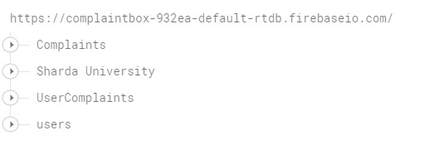

**3.6.2 Users Tree:** In users tree we store the users information like phone number, email ID, First name and Last name.

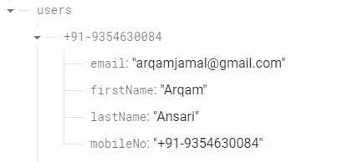

**3.6.3 Complaint Tree:** In Complaint tree we have stored information of complaints according to the department and their sub categories of complaints such as Complaint No. 04172022160359 is raised in Theft or unauthorized use of electricity in electricity department.

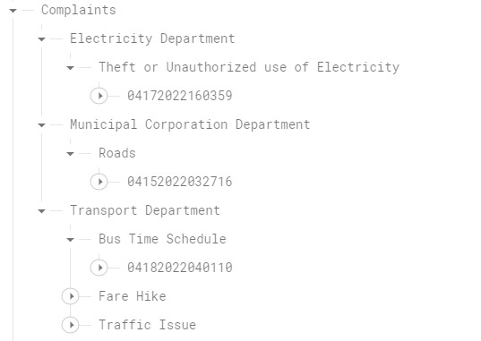

**3.6.4 Sharda University Tree:** In Sharda University tree we have stored information of complaints raised in the sharda university after which it is categorized in to complaints such as Complaint No. 04132022021851 is raised in accounts.

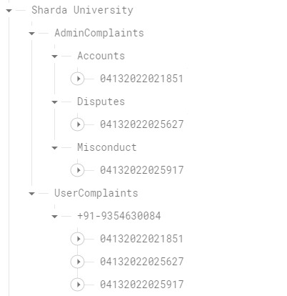

**3.6.5 User Complaints Tree:** In User complaints tree we have stored information of complaints raised by a particular user under their phone. This tree is mainly used for my complaint section where user can see all the complaints. such as Complaint No. 04152022032716 is raised by the user with phone number 9354630084

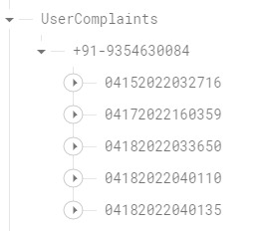

**CHAPTER 4: SYSTEM TESTING**

The process of executing software to see if it contains any faults is known as testing. It's the final stage of the verification and validation procedure. We endeavoured to check the product's quality during the testing phase. We've also sought to correct mistakes from previous phases.

**4.1 Why is testing done?**

* Testing is the process of putting a system through its paces in order to find flaws.
* Testing increases a system's reliability by detecting design problems.
* The purpose of testing is to identify areas that are prone to mistakes. This helps to keep system faults at bay.
* Testing adds value to a product by ensuring that it fits the needs of the user.

**4.2 Cause of error?**

The most common causes of software system faults are as follows:

* **Communication gap between the developer and the business decision maker:** Small personality differences are the most prevalent source of a communication gap between the developer and the business decision maker. Variations can be observed in five areas: thought process, history and experience, interest, priorities, and language.
* **The amount of time given to a developer to complete the project:** Time constraints in product delivery are a major source of project issues. To keep to the schedule, some features may be eliminated. To preserve the features, the schedule could be shifted. Failure to adjust the feature list or timetable when problems are discovered might result in hasty development and flawed systems.
* **The developer's over-commitment:** A developer's high level of passion can lead to an over-commitment. Developers are generally unable to fulfil deadlines or maintain quality in these situations due to a lack of resources or key skills on the team.
* **Inadequate testing and quality control:** Testing is essential at all phases of development, therefore inadequate testing is a major cause of e-commerce system failures.
* **Inadequate requirements gathering: Due** to the short time to market, developers start building Web sites before fully understanding the business and technological needs.
* Developers may also build client-side scripts in a language that isn't supported by all browsers.
* **Keeping up with rapidly changing technology:** New technologies are always being released. There's a chance that there won't be enough time to learn about new technology. This is a problem for two reasons. First, the technology might not be used correctly. Second, the technology may not be suitable for the current situation.

**4.3 Testing Principles:**

* To discover errors that have gone unnoticed.
* All testing should be able to be tied back to the customer's requirements.
* Tests should be scheduled well in advance of when they are to be conducted.
* Testing should start small and work its way up to "testing in the big."
* Testing should begin modest and progress to "large testing."
* To be most effective, training should be conducted by an independent third party.

**Testing Objective**

* Testing is the process of running a software to see if it contains any errors.
* A good test case is one that has a high likelihood of revealing a previously undetected fault.
* A successful test is one that reveals a previously undetected flaw.

**Appium**

Appium is main used to do automated app testing on different types platform like iOS, Windows and Android. It is an open-Source framework.

It automates the testing for the following:

* **Native Mobile Applications:** Apps that are written in windows, Android or iOS SDKs
* **Hybrid Mobile Applications:** Web view that have native Wrapper around them.
* **Mobile Web Applications:** Application that can be used from the browser of the mobile such as Chrome, Safari or android devices which have in-built native browser.

Appium is a cross-platform testing framework that enables testers to write testing scripts Opposed to many platforms and is flexible such as Windows, iOS and Android with the help of same API which means that QAs can be used for Android as for iOS with same code and less effort and time.

**Architecture of the Appium Framework**

Appium is a HTTP server that has been written in the Node.js programming language whose setup is being comprises a REST API and implemented selenium Web divers. It mainly works on a Server or client architecture. Appium also allows us to use the available web driver clients to fire the tests.

The Rest API can be used to perform actions as mentioned below.

* It listens the commands.
* Is used to execute the command on android device
* Receives the Connection from the Client-side
* Returns the command status which is executed as an HTTP response to the client.

**4.4 Types of Testing for Mobile Apps**

1. **Functional Testing:**

Testing is mainly achieved when test flows is initiated by user interface. Its not only the flow of use case is being tested but also the various rules of business are also been tested. Testing is mainly done so that we can certify the requirements is fulfilled or not and whether the app is working according to the requirements or not.

1. **Android UI Testing:**

This is mainly user point of view testing of the app. In this phase of the testing, items such as interactive messages, visibility of text on the different screens of the application, the data is aligned or not, How the look and feel of the app is for the different size of screen and fields etc., are tested under this phase of testing.

1. **Compatibility Testing:**

In this phase, testing is mainly done in two different forms i.e., Device Model vs app and OS vs app. Normally it gives the list of all the supported OS and sometimes of the device which is provided by the customer or product owner.

1. **Interface Testing:**

In this phase, testing is only when the developer has completely developed all the modules of the project and all the bugs have been fixed and verified. This phase of testing includes the tests such as interaction with the other apps like using of microphone to enter text in the app, end to end testing of the app.

1. **Network Testing:**

* This is an in-house testing.
* The app should can connect to the internet service to carry out the process of the app.
* This test is mainly done to verify that how much time the app is taking to respond the activity the app is performing.
* This test is done for both mobile data network connection and Wi-Fi connection.
* In this testing the response and request is tested in various condition.

1. **Performance Testing:**

In the phase of testing, we test the performance of the app in the worst conditions.

Condition of the test are as follows.

* Very less memory in the mobile device
* Very bad or low reception of network on mobile device.
* The battery on mobile device is very low.

**CHAPTER 5: RESULT**

* **Admin**

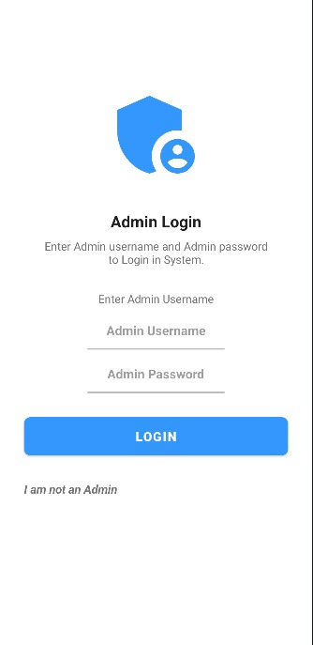

* **Sharda University**

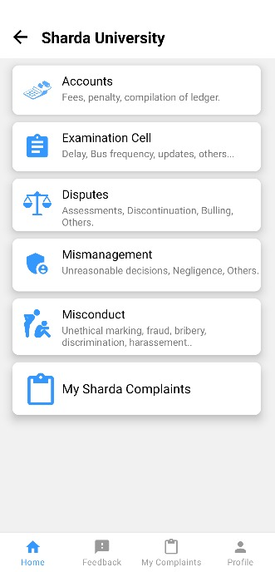

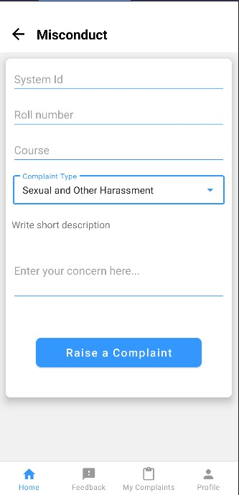

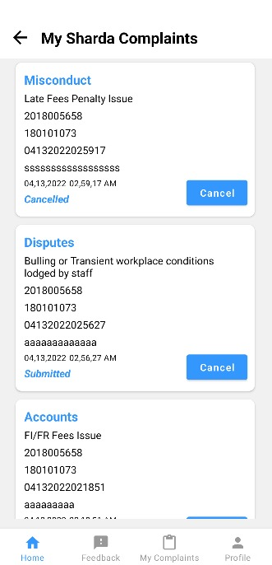

* **Municipal Corporation**

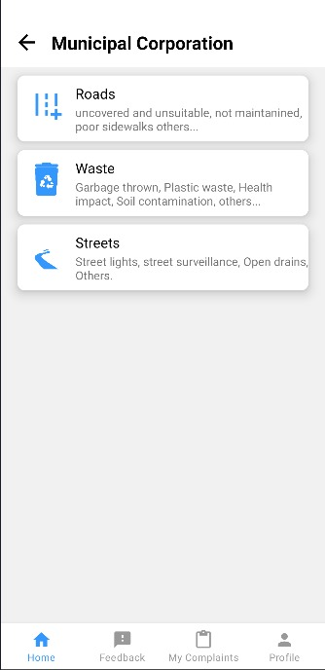

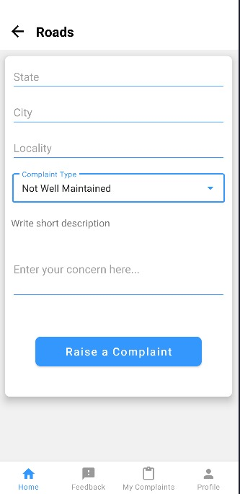

* **My Complaints**

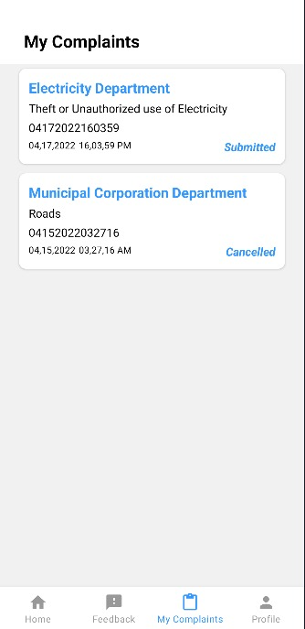

**CHAPTER 6: CONCLUSION**

Citizen feedback android app has been completed and we were able to test the application using different test cases like registering as different user and submitting complaints from their id’s. We have made the application user friendly so it will be very easy for citizens to raise a complaint and our app have all the options which can be used to raise a complaint for the respective department like medical and transport. We have designed our application in keeping in mind the future and present requirement of the industry. This app has potential to make countries operations more effective and responsive. Our app can also help citizens of country to increase their belief in government and have more faith that elected members and officers will take good decision for the citizen and city. We were able achieve by our app is user friendly UI, instant access, flexible for future improvements, Fast actions on complaints etc. Our application can play a vital role in communication between the municipal corporation and people of our country to help the citizen to resolve their issues fast and in an efficient way.

**REFERENCES**

1. Alessandro Minelli, Renato Ruffini, “Citizen Feedback as a Tool for Continuous Improvement in Local Bodies” (2017).
2. Sman Nasr, Enayat Alkhider, “Online Complaint Management System” (2015).
3. Mohd Sohel Deshmukh, Swapnil R.Rajput, “Smartphone Based Citizen Complaint System for Urban Maintenance Using GIS” (2016).
4. Jorge Santosa, Fátima Rodriguesb, Lino Oliveira, “A Web & Mobile City Maintenance Reporting Solution” (2013).
5. Panida Liawsomboon, Narut Phongoen , Pattamaporn Kormpho, Siripen Pongpaichet,” Smart Complaint Management System”(2018)
6. Shailesh Indradev Gupta, Azaruddin Aianuddin Nayakwadi, Shailesh Indradev Gupta, Asst Prof. Sneha Sankhe, “Mobile Application interface to register citizen complaint”(2017).
7. Atit More ,” City Complaint Management System”(2019).
8. K.Gowthami, Mrs.Deviselvam, S.Anjali, M.Dharshna,” Complaint Management System”(2017).
9. Arpan Tiwari , Pooja Vijaywargi, Nisarg Gandhewar, Ruchita Narnaware, Prayas Pagade, Devika Radhakrishnan,” Smart Complaint Management System”(2016)
10. Deep Shah, Prof. Harsh N. Bhor, Dhaval Gherwada, Vipul Shah,” Mobile Application interface to register citizen complaint”(2015).
11. R. Johnston, "Linking complaint management to profit," International Journal of Service Industry Management, vol. 12, pp. 60-69,2001.
12. V. Bosch and F. Enriquez, "TQM and QFD: exploiting a customer complaint management system," International Journal of Quality and Reliability Management, vol. 22, pp. 30-37,2005.
13. Patrícia Abreu, Sérgio Sousa, Member, IAENG, and Isabel Lopes, “Using Six Sigma to Improve Complaints Handling”, Proceedings of the World Congress on Engineering 2012 Vol IIIWCE 2012, July 4 - 6, 2012, London,
14. Complaint”, International Journal for Research in Engineering Application & Management (IJREAM), Vol-01, Issue 03, June 2015
15. Android Studio: <https://developer.android.com/studio>
16. Java :<https://www.javatpoint.com/java-tutorial>
17. XML: <https://www.w3schools.com/xml/xml_whatis.asp>
18. Google: <https://www.google.co.in/>
19. Web Application for Complaint Tracking and Resolving pp:1397-1398 - Ms. Sneha Alve 1, Ms. Vishakha Babardesai 2, Ms. Sneha Bhosale 3, Ms. Siddhi Kapadi 4, Prof. Atul. B. Yadav
20. C. Chiao-Chen and C. Yang-Chieh, "Comparing consumer complaint responses to online and offline environment," Internet Research, vol. 21
21. Julia Meik, Markus Blut and Christian Brock, “Complaining Customers as Innovation Contributors”, SRII Global Conference
22. Trupti Bomble, Ritika Raut, Ruchi Kanekar, Prof.Shekh, AhmadHusen - Android Based Complaint Management System For Municipal Corporation, vol. 5, Issue 4, ( Part - 3).
23. Daniel tumminelli o’brien ,”Citizen Connect :A smartphone Application that reduces “Broken windows””[2013].
24. Aaditeshwar Seth, Abhishek Katyal, Rohit Bhatia, Dinesh Kapoor, Balachandran C, Vidya Venkat, Aparna Moitra, Sayonee Chatterjee, Mayank Shivam, Z. Koradia, Praveen Naidu, “Application of Mobile Phones and Social Media to Improve Grievance Redressal in Public Services”, m4dposition.