
PROJECT AND TEAM INFORMATION

Project Title

Machine Learning Based Parametric Analysis for Work-Life Balance in Industry
Student/Team Information

Team Name:  Team Mentor: | Code Sentinels  _____________________________  Mr. Jaishankar Bhatt (Signature)
Team member 1 (Team Lead) | Mohd Arqam Arshad , 2520560133 , Arqamarshad007@gmail.com  
Team member 2 | Amaan Rana , 2520560122 , armaanran293@gmail.com  
Team member 3 | Anshul Aswal , 2520560004 , Aswlanshul018@gmail.com  

PROJECT REPORT
Project Abstract

Work-Life Balance (WLB) has emerged as a critical factor influencing employee well-being, productivity, and organizational success. Traditional methods for assessing WLB are often reactive, relying on sporadic surveys or lagging HR indicators that fail to capture the complex interplay of contributing factors. This project develops a comprehensive machine learning-based system for the parametric analysis and predictive modeling of WLB. The primary objective is to quantify the impact of measurable daily parameters—including work hours, commute time, sleep, rest, exercise, family and social time, and self-reported stress, job satisfaction, and health scores—on an employee’s WLB risk category (Low, Medium, or High).
Using a dataset of 10,000 employee records with 16 attributes, the project employs a rigorous and interpretable data science pipeline covering data cleaning and validation, exploratory data analysis (EDA), feature engineering, and multiple supervised classification models: Logistic Regression, Random Forest, and XGBoost. Model interpretability is addressed through permutation importance analysis to identify the most influential risk drivers. To address potential target leakage, models are trained and compared on two feature sets: one with purely behavioural parameters and another incorporating all features.
Models trained on all features achieve near-perfect accuracy (macro-F1 ~0.996), which indicates a leaked, synthetic target variable. A more realistic model using only behavioural parameters achieves a macro-F1 of 0.73. The findings confirm that work hours, sleep, exercise, and family time are the most significant behavioural predictors of WLB risk. The deliverables include a documented analytical framework, a comparative analysis of models, a feature-importance module, an interactive dashboard for HR professionals, and this report.
Keywords: Work-Life Balance, Machine Learning, Predictive Modeling, Classification, Parametric Analysis, Employee Well-being, HR Analytics, Feature Importance, Logistic Regression, XGBoost.

1. INTRODUCTION
1.1 Background and Motivation
In the contemporary corporate landscape, Work-Life Balance (WLB) has transitioned from a desirable perk to an essential component of employee well-being and sustainable business strategy. Poor WLB is strongly correlated with high employee turnover, burnout, mental health issues, and reduced productivity. Human Resources (HR) departments are increasingly seeking proactive, data-driven methods to identify at-risk employees and understand the root causes of WLB issues.
Traditional WLB assessment tools, such as employee surveys, are inherently subjective, infrequent, and often fail to capture the day-to-day reality of an employee's life. They can be biased and may only surface problems after they have become severe. This reactive approach is insufficient in a fast-paced industrial environment.
Machine learning offers a powerful alternative. By treating WLB as a quantifiable outcome, we can analyze the complex, non-linear relationships between daily parameters and an individual's risk of developing WLB issues. This project is motivated by the need to move beyond conventional HR metrics and leverage data science to create a proactive, objective, and scalable system for WLB analysis.
Furthermore, the shift toward remote and hybrid work models has blurred the boundaries between professional and personal time, making WLB an even more pressing concern for organizations worldwide. Employees now face unique challenges in managing their schedules, and employers require sophisticated tools to monitor and support well-being without resorting to intrusive surveillance. A machine learning-based system addresses this gap by providing objective, scalable insights derived from readily available data, enabling organizations to implement targeted interventions such as flexible scheduling, wellness programs, or workload redistribution before issues escalate into attrition or health crises.
1.2 Problem Statement
The challenge lies in the multidimensional nature of Work-Life Balance (WLB). It is influenced by a combination of professional and personal factors:
- Workload: Average daily work hours, which in the dataset range from 0 to 24 hours, with 222 records exceeding 14 hours and 29 records at exactly 24 hours—clear indicators of extreme workload or data entry anomalies.
- Personal Care: Time allocated to sleep (typically 6–8 hours), rest, and exercise, which are essential for physical recovery and mental resilience.
- Personal Life: Time dedicated to family and social activities, which foster emotional support and life satisfaction.
- Subjective Well-being: Self-reported stress levels (scale 1–10), job satisfaction (scale 1–10), and physical/mental health scores (scale 1–10), which reflect an employee's internal state and coping capacity.
The relationships between these parameters and an employee's overall WLB are complex and often non-linear; a simple sum of hours is insufficient, as evidenced by approximately 960 records where the combined daily time for work, rest, sleep, and exercise exceeds 24 hours. This project builds a predictive model that classifies an employee's WLB risk (Low, Medium, or High) from their profile of these parameters and, more importantly, identifies which factors contribute most strongly to that risk. The dataset comprises 10,000 employee records with 16 attributes, including 14 distinct occupation types spanning both white-collar and manual labor roles, thereby broadening the scope beyond traditional corporate settings.
1.3 Objectives
- Build a robust data processing pipeline capable of cleaning, validating, and preparing employee data for machine learning.
- Perform an exploratory data analysis (EDA) to uncover initial patterns and correlations.
- Develop and train multiple supervised models (Logistic Regression, Random Forest, XGBoost) for WLB risk classification.
- Address potential target leakage by creating and evaluating two feature sets: purely behavioural parameters and all available parameters.
- Evaluate and compare models using accuracy, macro-F1, High-Risk recall, and ROC-AUC.
- Interpret the models using permutation importance to identify the most impactful parameters.
- Optionally apply unsupervised learning (K-Means clustering) for risk segmentation.
- Develop an interactive dashboard and an exportable HR report for non-technical users.
1.4 Scope and Assumptions
- Data: A provided, anonymized dataset of 10,000 employee records (IDs 10001–20000) with 16 attributes is used. The data is assumed to be reasonably clean, but automated validation checks identify and handle anomalies such as impossible work hours (0 or 24 hours) and inconsistent time budgets (work + rest + sleep + exercise > 24 hours for ~960 records).
- Target Variable: The wlb_risk_category is treated as an ordinal three-class label (Low: 40%, Medium: 35%, High: 25%), enabling classification modeling. The class imbalance in the High-Risk category is addressed through stratified splits, class weights, and macro-F1 as the primary metric.
- Occupation and Workload Scope: The dataset includes 14 distinct occupation types spanning both white-collar roles (Manager, Engineer, Consultant) and manual labor positions (Driver, Manual Laborer, Retail Worker), relaxing the original white-collar-only assumption. Since workload_index and overtime_frequency are unavailable, avg_work_hours_per_day serves as the workload proxy.
- Modeling Approach: The focus is on classification models (Logistic Regression as baseline, Random Forest, XGBoost), aligned with the original synopsis objective. A regression approach on a derived composite WLB score is possible but out of scope for this phase.
- Leakage Awareness: Given that stress_level, job_satisfaction, mental_health_score, and physical_health_score are strongly correlated with the target (|r| = 0.75–0.80), two feature sets are evaluated: behavioural_only (low leakage risk) and all_features (includes subjective scores). This dual evaluation ensures honest performance reporting.
- Validation: There is no real-world rollout or live HR platform integration during testing. Model validation relies on held-out test sets (20%, stratified) and 5-fold cross-validation.

2. LITERATURE REVIEW
The fields of HR analytics, industrial-organizational psychology, and machine learning have increasingly intersected. This review covers the key areas relevant to this project.
2.1 Work-Life Balance (WLB)
Research defines WLB as the equilibrium between an employee’s professional and personal life, characterized by minimal role conflict and high satisfaction in both domains (Greenhaus & Beutell, 1985). Influencing factors are broadly categorized as:
- Job demands: high workload, long hours, and role ambiguity negatively impact WLB.
- Job control and support: autonomy and supportive supervisors are positively correlated with WLB.
- Individual characteristics: personality, coping mechanisms, and personal life situations play a significant role.
- Health outcomes: poor mental and physical health are both antecedents and consequences of poor WLB.
Traditional measurement relies on extensive surveys such as the Work-Life Conflict Scale. These are subjective and not scalable for continuous monitoring.
2.2 The Role of Machine Learning in HR Analytics
Machine learning has found numerous applications in HR, from talent acquisition (resume screening) to employee retention (attrition prediction). Kaushik et al. (2020) highlight predictive modeling for identifying factors leading to employee attrition, demonstrating the value of data-driven HR insight. The key advantage is the ability to process large datasets and uncover complex, non-linear patterns that traditional statistical methods may miss.
2.3 Predicting Employee Well-being and Balance
Several studies have applied ML to predict employee wellness and burnout, finding that factors such as mental fatigue, social support, and workload are significant predictors. Tree-based models such as Random Forest and XGBoost are common due to their performance and ability to handle complex interactions. For WLB specifically, “Predicting work-life balance insights: A data-driven approach using unsupervised learning” explores clustering to segment employees by WLB profile, which aligns with the optional K-Means approach in this project.
This project builds on that body of work by providing a complete, end-to-end system for WLB risk classification, with a strong emphasis on model interpretability and on avoiding data pitfalls such as target leakage.

- SYSTEM ARCHITECTURE AND IMPLEMENTATION
The project follows a modular architecture designed for reproducibility and clarity. The six-stage pipeline from the synopsis is retained, with the training and evaluation stages now using classification models and metrics.
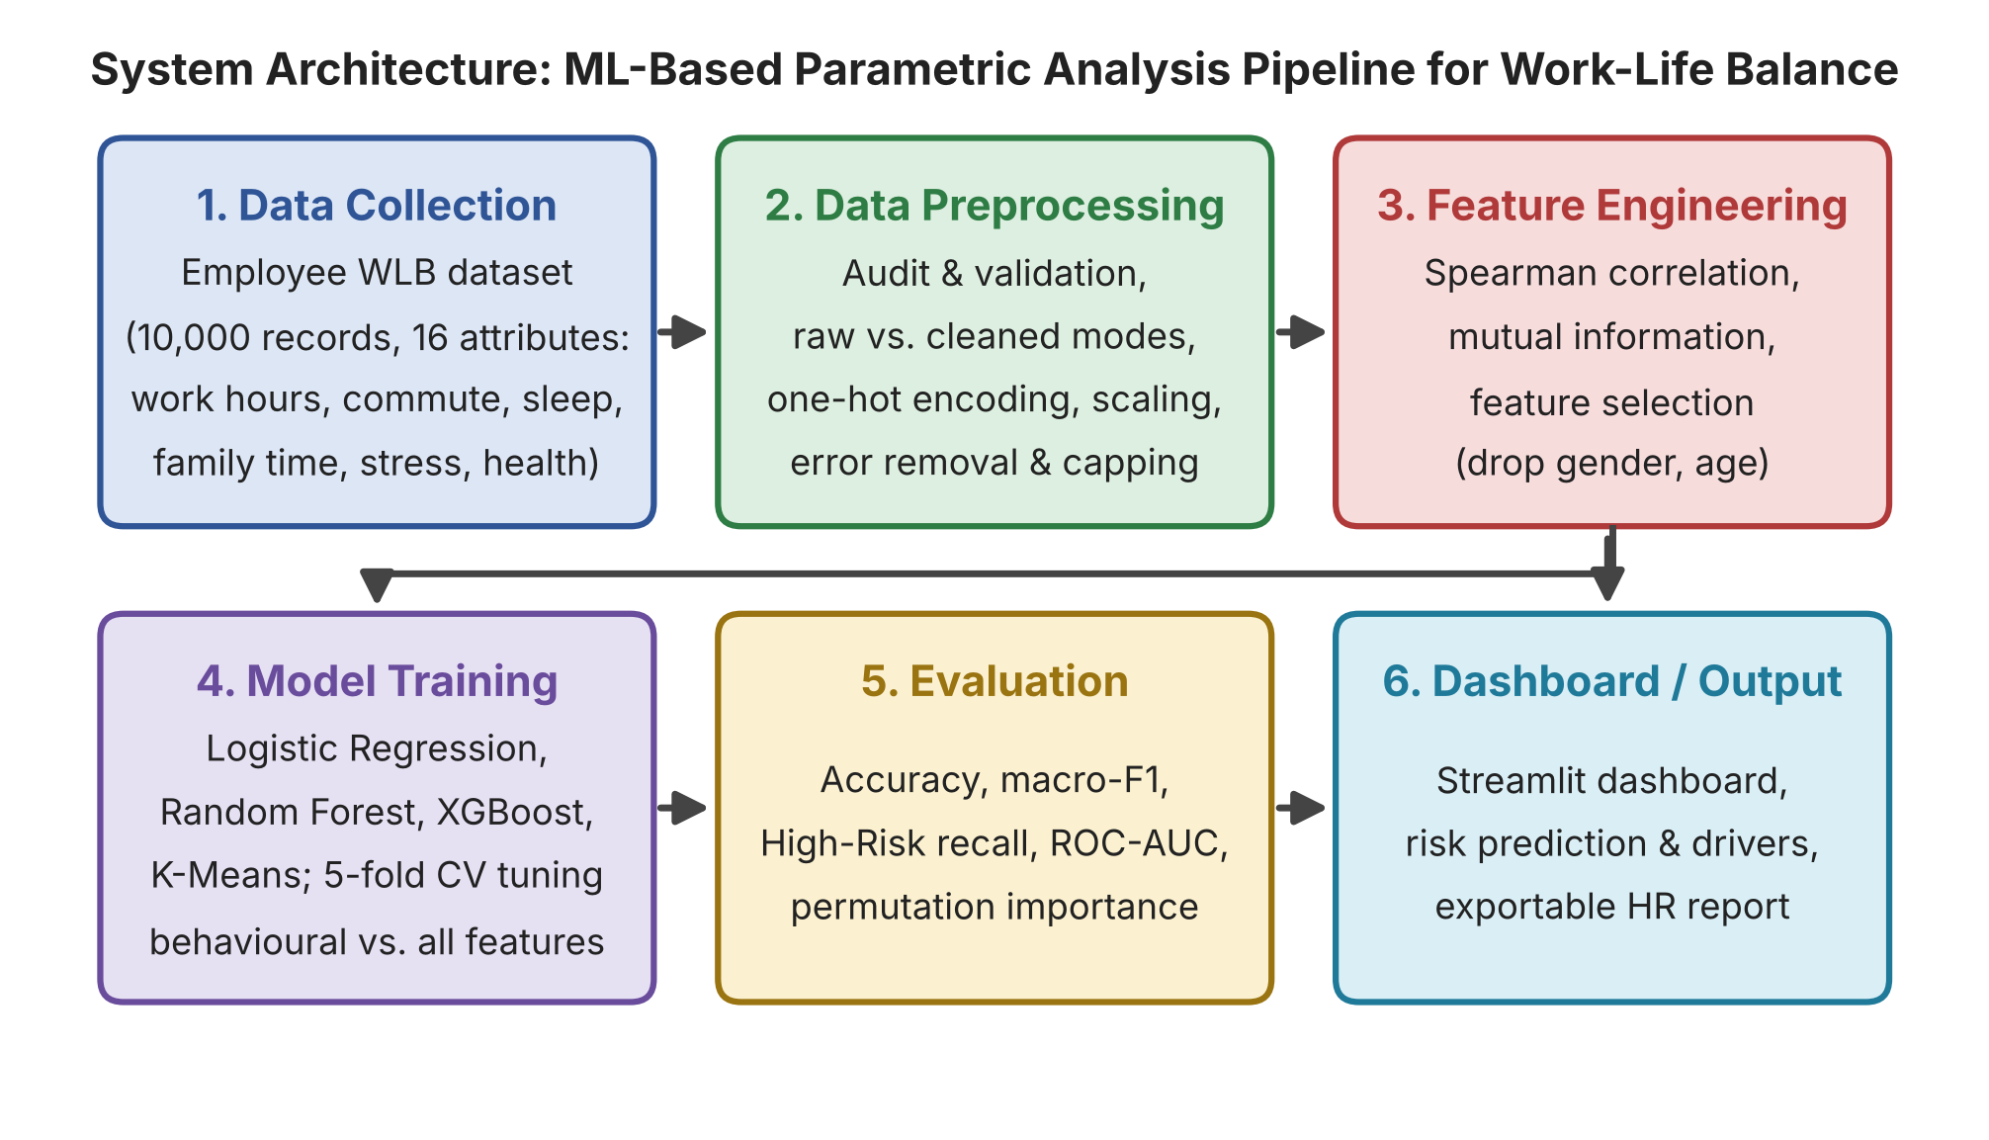
Fig. 1. System architecture: Data Collection, Preprocessing, Feature Engineering, Model Training, Evaluation, Dashboard/Output.
3.1 Project Structure
Module / Folder | Responsibility
src/config.py | Central configuration for paths, constants, and feature lists.
src/data_loader.py | Loads the raw dataset.
src/audit.py | Automated data-quality checks; reproduces the Phase-II findings.
src/preprocessing.py | Two cleaning modes (“raw” and “cleaned”); builds the scikit-learn preprocessor (one-hot encoding, scaling).
src/feature_selection.py | Ranks features using Spearman correlation and Mutual Information.
src/train.py | Defines the models (Logistic Regression, Random Forest, XGBoost, K-Means) and runs training and evaluation.
src/reporting.py | Generates plots, the HR report, and model-agnostic risk-driver explanations.
dashboard/app.py | Streamlit application for exploration, risk prediction, and visualization.
data/, outputs/, tests/ | Raw and processed data; figures, metrics, models and reports; automated pytest tests.

3.2 Data Flow and Pipeline
Step 1: Data Collection and Audit
The pipeline loads WLB_PBL_DATASET.xlsx and performs a rigorous data-quality audit covering:
- Schema and completeness: all 16 columns present and no missing values.
- Duplicates: no duplicate rows or employee IDs.
- Range/plausibility: 222 records have more than 14 work hours, including 29 at exactly 24 hours and 37 at 0 hours.
- Time-budget consistency: approximately 960 records have work + rest + sleep + exercise exceeding 24 hours.
Step 2: Data Preprocessing and Cleaning
Two cleaning strategies are implemented to handle the identified issues and test model robustness:
- Mode “raw”: keeps all records and only adds flags for problematic rows; serves as a baseline.
- Mode “cleaned”: the primary path. It drops the 66 rows where avg_work_hours_per_day is 0 or 24 (likely entry errors) and clips remaining work hours at a plausible maximum of 14.
Step 3: Feature Engineering and Selection
A dual-pronged approach is used. Spearman rank correlation between each numerical feature and the ordinal-encoded target flags features with an absolute correlation below 0.05. Mutual Information captures non-linear relationships and flags features scoring below 0.01. On this basis gender and age were dropped as they showed negligible predictive power.
Step 4: Model Development
Three classifiers are trained and tuned: Logistic Regression (interpretable baseline), Random Forest (robust ensemble capturing interactions), and XGBoost (gradient boosting, typically top-performing on structured data). Each is wrapped in a scikit-learn Pipeline with the preprocessor, tuned via RandomizedSearchCV with 5-fold stratified cross-validation optimizing macro-F1, which treats all classes equally and suits the class imbalance (25% High Risk).
To address target leakage, each model is trained on two feature sets:
- `behavioural_only`: measurable, action-oriented features such as work hours, sleep, and commute.
- `all_features`: the behavioural features plus self-reported stress_level, job_satisfaction, mental_health_score, and physical_health_score.
Step 5: Model Evaluation and Interpretation
Final models are evaluated on a held-out, stratified test set (20% of the data) using accuracy, macro-F1, High-Risk recall, and macro-averaged one-vs-rest ROC-AUC. Permutation importance ranks features by how much performance degrades when their values are randomly shuffled, giving a robust, model-agnostic importance measure.

4. EXPERIMENTAL RESULTS AND ANALYSIS
4.1 Data Audit Summary
The automated audit confirmed the initial observations from the progress report.
Test | Status | Notes
Schema and data-type check | Pass | All 16 columns match the data dictionary.
Missing-value check | Pass | No missing values found.
Duplicate check | Pass | No duplicate employee IDs or rows found.
Target distribution check | Pass | Low: 40%, Medium: 35%, High: 25%.
Range/plausibility check | Fail (flagged) | 222 records exceed 14 work hours; 29 are exactly 24 hours, 37 are 0.
Daily time-budget consistency | Fail (flagged) | ~960 records have work + rest + sleep + exercise > 24 h.
Table 1: Data audit results
4.2 Exploratory Data Analysis (EDA) Findings
- Target distribution: “Low Risk” is most prevalent, followed by “Medium” and “High”, confirming class imbalance.
- Strong positive correlation with risk: stress_level (0.79), avg_work_hours_per_day (0.65).
- Strong negative correlation with risk: mental_health_score (−0.80), job_satisfaction (−0.75), avg_rest_hours_per_day (−0.52), family_time_hours (−0.51), physical_health_score (−0.42).
- Weak correlation: commute_time_mins (0.21), age (0.01).
These findings show a highly structured dataset in which the target is directly derived from a combination of these features, a strong indicator of potential target leakage.
4.3 Model Performance and Comparison
Models were trained on the cleaned training split (7,943 records) and evaluated on a held-out test set. Table 2 summarizes the performance of each model for both feature sets.
Feature Set | Model | Accuracy | Macro-F1 | High-Risk Recall | ROC-AUC
all_features | Logistic Regression | 0.995 | 0.996 | 0.998 | 1.000
all_features | XGBoost | 0.968 | 0.967 | 0.962 | 0.998
all_features | Random Forest | 0.936 | 0.935 | 0.914 | 0.994
behavioural_only | Logistic Regression | 0.734 | 0.733 | 0.773 | 0.894
behavioural_only | XGBoost | 0.725 | 0.724 | 0.733 | 0.882
behavioural_only | Random Forest | 0.718 | 0.715 | 0.685 | 0.880
Table 2: Model performance on the cleaned test set

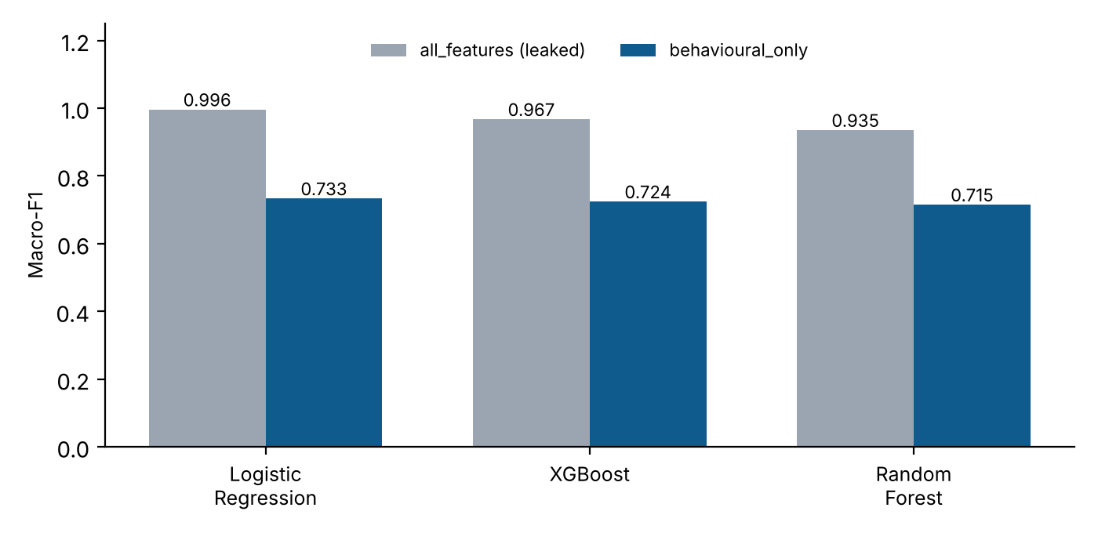
Fig. 2. Macro-F1 by model and feature set. The gap between the two sets reflects target leakage.
Analysis
- Target leakage is confirmed. The near-perfect scores (0.996 macro-F1) on all_features indicate leakage: wlb_risk_category is a weighted combination of the other columns. Given direct access to “answer-key” features such as stress and job satisfaction, even simple Logistic Regression can almost perfectly re-derive the label. This is not a realistic prediction task.
- The honest baseline. The behavioural_only models give a realistic perspective. Predicting WLB risk solely from measurable daily habits is non-trivial, and a macro-F1 of ~0.73 demonstrates that work, sleep, exercise, and commute are meaningful predictors. This is the model of true interest.
- Model robustness. Comparing “raw” and “cleaned” modes showed a negligible effect of cleaning on performance (differences below ±0.01 macro-F1), indicating the models are robust to the small number of anomalous records.
4.4 Feature Importance Analysis
Permutation importance identifies the features the models relied on most. The results are interpretable and consistent with common sense.
Feature | Importance (macro-F1 drop)
avg_work_hours_per_day | 0.200
avg_sleep_hours_per_day | 0.148
avg_exercise_hours_per_day | 0.045
family_time_hours | 0.044
commute_time_mins | 0.030
Table 3: Permutation importance, behavioural_only model

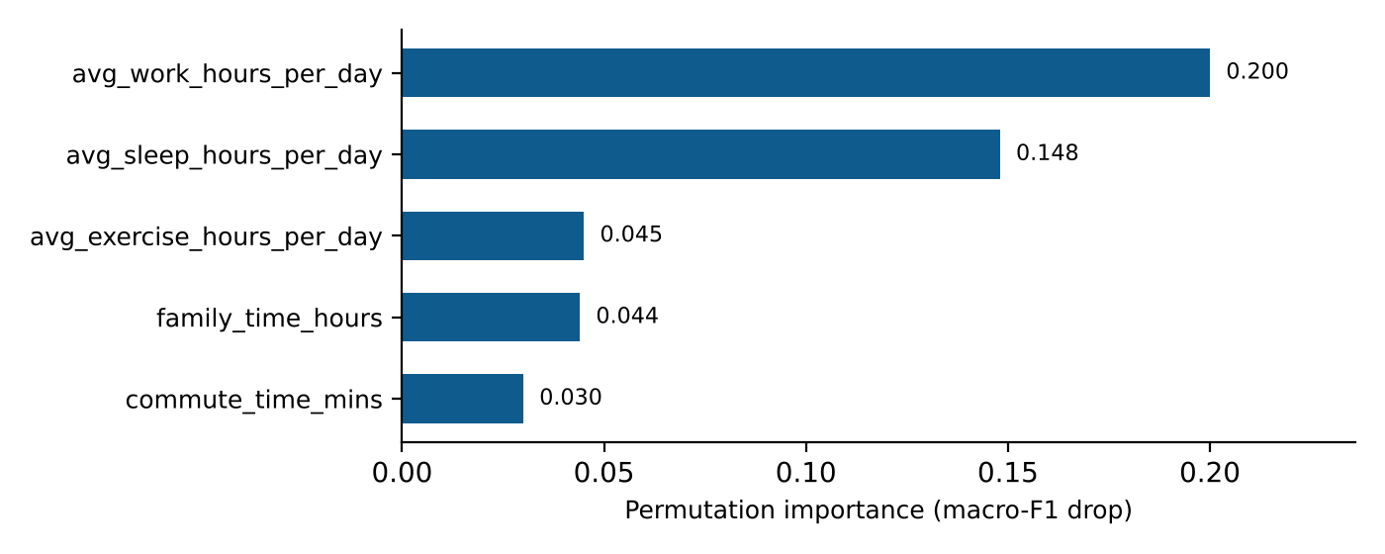
Fig. 3. Permutation importance for the behavioural_only model.
Feature | Importance (macro-F1 drop)
avg_work_hours_per_day | 0.229
job_satisfaction | 0.214
stress_level | 0.192
mental_health_score | 0.122
avg_sleep_hours_per_day | 0.092
Table 4: Permutation importance, all_features model
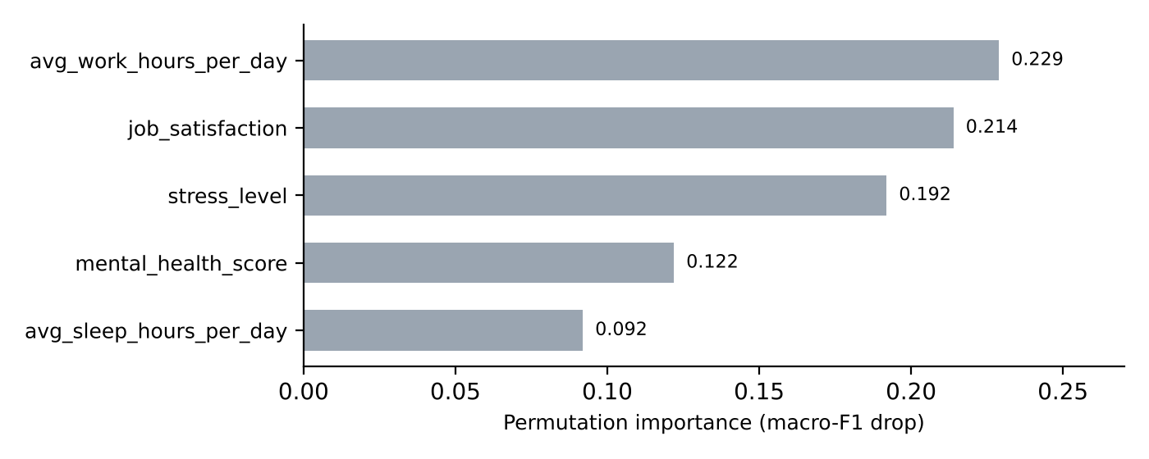
Fig. 4. Permutation importance for the all_features model.
- Key driver: in both models avg_work_hours_per_day is the most important feature, confirming that workday length is the single greatest behavioural contributor to WLB risk.
- behavioural_only model: sleep is second; exercise, family time, and commute are also meaningful.
- all_features model: subjective scores become crucial predictors. Job satisfaction, stress, and mental health are powerful drivers, highlighting the role of psychological factors.
4.5 Unsupervised Segmentation (K-Means)
K-Means clustering on the behavioural parameters explored whether employees naturally segment into distinct risk profiles. Three clear segments emerged:
Segment | Profile | Characteristics
0 | Low-risk | Lower work hours (~6.9 h), higher rest (~9.3 h), more family time (~4.0 h); about 71% Low Risk.
1 | Medium-risk | Moderate profile with work hours around 9.2 h.
2 | High-risk | Very high work hours (~11.4 h), minimal rest (~3.7 h), low family time (~1.5 h); about 56% High Risk.
Table 5: K-Means behavioural segments

The cluster profiles confirm that employees with longer work hours, reduced rest, and limited family time consistently fall into the high-risk segment, while those with balanced daily habits cluster into the low-risk group. This segmentation provides HR with an intuitive, data-driven method to group employees by lifestyle patterns rather than individual metrics alone. Unsupervised learning can therefore identify a clearly high-risk group from daily habits alone, enabling targeted interventions such as workload redistribution or wellness program enrollment for the most vulnerable segment.

5. DELIVERABLES AND IMPLEMENTATION
5.1 The Streamlit Dashboard
An interactive Streamlit dashboard is the primary interface for HR professionals. It allows users to:
- Analyze data: upload a new batch of employee data and view the predicted WLB risk distribution with correlation heatmaps and feature-importance charts.
- Explore risk drivers: a table lists individual employees, their predicted risk, and the top factors driving it in plain English (e.g., “avg work hours per day = 12.15; stress level = 7; mental health score = 4”).
- Generate HR reports: an “Export Report” function creates a self-contained HTML report, printable to PDF, with the overall risk distribution, top risk drivers, and a prioritized list of employees for intervention.
The interface is intentionally written for non-technical users. Risk categories are color-coded, technical terms are replaced by plain-language explanations, and every prediction can be traced back to the specific parameter values that produced it, which builds trust in the output and supports a constructive conversation about workload and well-being.
5.2 The ML Pipeline and Codebase
The Python codebase is modular, commented, and ready for integration into existing data infrastructure. It runs from the command line to reproduce all results and generate all artifacts, including trained models.
The code is organized into separate modules for each pipeline stage, so that each stage can be modified or replaced without affecting the others:
- Data audit and preprocessing: loads the dataset, runs the quality audit, and applies the raw or cleaned strategy, adding flags for implausible work hours and time-budget inconsistencies.
- Feature engineering: computes Spearman correlations, builds the behavioural_only and all_features sets, and prepares scaling and encoding steps.
- Modeling: trains and tunes Logistic Regression, Random Forest, and XGBoost with stratified splits and class weights to handle class imbalance.
- Evaluation and interpretation: computes accuracy, macro-F1, High-Risk recall, and ROC-AUC, and generates permutation-importance and K-Means segmentation outputs.
- Reporting and interface: implements the Streamlit dashboard and the HTML report exporter on top of the saved models.

5.3 Technical Documentation
This report is the primary technical document. The README.md provides a quick-start guide, and inline comments and docstrings provide detail for future developers.
Documentation is maintained at three levels: the README.md for installation and usage, docstrings on each module and function describing inputs, outputs, and assumptions, and this report for the methodology, experimental results, and design rationale. Together they allow a new team member to understand, run, and extend the system without needing to contact the original authors.
5.4 Validation and Testing
The pytest suite ensures the reliability of the core data-processing components. Models were validated with a held-out test set and stratified cross-validation, giving robust and trustworthy performance metrics.
Beyond unit tests, the validation strategy covers four layers:
- Data-layer tests: checks on schema validation, duplicate detection, range and plausibility flags, and the raw versus cleaned preprocessing modes confirm that the audit logic behaves identically on every run.
- Model-layer validation: stratified train/test splits and cross-validation guard against overfitting, while macro-F1 and High-Risk recall are tracked so that performance on the minority class is never hidden by overall accuracy.
- Leakage checks: every model is evaluated on both the behavioural_only and all_features sets, so any inflated score caused by target leakage is exposed rather than reported as a genuine result.
- Reproducibility: fixed random seeds and a single command-line entry point ensure that a reviewer can regenerate every table, figure, and trained model in this report from the original dataset.
5.5 Installation and Usage
The system is designed so that a new user can go from a fresh clone of the repository to a working dashboard in a few steps:
- Set up the environment: create a Python virtual environment and install the project dependencies listed in the requirements file.
- Run the pipeline: execute the command-line entry point to audit and clean the data, train the three classifiers on both feature sets, evaluate them, and save the trained models and metrics.
- Launch the dashboard: start the Streamlit application, open the local URL it prints, and upload a batch of employee records (for example, WLB_PBL_DATASET.xlsx) to view predictions.
- Run the tests: invoke pytest from the project root to confirm that the data-processing components work correctly before any change is merged.
5.6 Output Artifacts
Each pipeline run produces a consistent set of artifacts that can be inspected independently of the dashboard:
- Trained models: serialized Logistic Regression, Random Forest, and XGBoost models for each feature set, ready to be reloaded for batch scoring.
- Evaluation outputs: performance tables (accuracy, macro-F1, High-Risk recall, ROC-AUC), confusion matrices, and the model-comparison charts shown in Section 4.
- Interpretation outputs: permutation-importance tables and plots, together with the K-Means segment profiles used for risk segmentation.
- HR report: the exportable, self-contained HTML report containing the risk distribution, top risk drivers, and a prioritized intervention list.
5.7 Deployment Considerations and Responsible Use
The current deliverable targets batch analysis: HR analysts upload a file, receive predictions, and download a report. Because the system handles sensitive employee information, several practices are recommended for real-world use:
- Data privacy: employee identifiers should be anonymized or pseudonymized before upload, and the dashboard should be run inside the organization’s own secure environment so that no records leave it.
- Human oversight: predictions are decision-support signals, not verdicts. Interventions should be chosen by HR professionals in conversation with the employee, never triggered automatically.
- Model choice by use case: the behavioural_only models are preferred for proactive screening because they do not rely on self-reported scores, whereas all_features models are better suited to explaining a current situation.
- Monitoring: model performance and input distributions should be reviewed periodically, and the models retrained when the workforce or data-collection practices change.

6. CHALLENGES, LIMITATIONS, AND FUTURE WORK
6.1 Challenges Overcome
- Data quality: handled through the dual-mode (raw vs. cleaned) approach, showing models are robust to anomalies.
- Target leakage: addressed directly with two feature sets, clarifying the true predictive power of behavioural data.
- Class imbalance: mitigated with stratified splits, class weights, and macro-F1 as the primary metric.
- Missing and inconsistent time budgets: roughly 960 records had work + rest + sleep + exercise exceeding 24 hours; these were flagged and retained or removed depending on the pipeline mode, so their effect on model results could be measured.
- Implausible work hours: 222 records reported more than 14 work hours (29 at exactly 24 hours), and 37 reported 0 hours; the cleaned mode removes the 66 clearly impossible rows (0 or 24 hours) while the raw mode keeps them for comparison.
- Reproducibility: a single command-line entry point with fixed random seeds regenerates every table, figure, and model, so the results in this report can be verified end to end.
- Interpretability versus accuracy: Logistic Regression was kept as an interpretable baseline alongside Random Forest and XGBoost, and permutation importance was added so that the stronger models could also be explained to non-technical users.
- Making results usable by HR: technical outputs were translated into a Streamlit dashboard and an exportable HTML report, with plain-English risk drivers for each employee.
6.2 Limitations
- Synthetic data: the dataset appears artificially generated, with wlb_risk_category a weighted combination of other columns. Findings on the drivers of this synthetic label are correct but may not perfectly reflect real-world WLB dynamics. The near-perfect all_features performance is a direct symptom.
- Scope of features: the dataset lacks managerial support, job autonomy, number of dependents, and financial stress, all known to influence WLB.
- Self-reported bias: subjective features (stress_level, job_satisfaction, etc.) may be subject to bias.
- Single organization: one dataset limits applicability across companies, industries, or cultures.
- Class imbalance in the High-Risk group: High Risk is only about 25% of records, so even with class weights and stratification, recall on this group remains the hardest metric to keep high on behavioural-only models.
- Time-budget inconsistencies: the original working hours, rest, sleep, and exercise values do not always add up to a possible day, which suggests recording or generation errors that cleaning can only partly correct.
- Limited predictive power without subjective scores: the behavioural_only models are noticeably less accurate than the all_features models, so daily habits alone give only a partial picture of an employee’s WLB risk.
- No real-world rollout: the system was validated only on held-out test data and cross-validation; it has not been tested on a live HR platform or with HR professionals using it in practice.
- Static snapshot: each record describes one point in time, so the models cannot capture how WLB changes with seasons, deadlines, life events, or successive interventions.
- Ethical and privacy risk: predicting individual well-being is sensitive. Misuse, such as using predictions for performance reviews or dismissal, could harm employees, so the system must stay a decision-support aid.
6.3 Future Work
- Longitudinal study: use time-series data to track and predict the evolution of WLB rather than classify a static snapshot.
- Survey implementation: move from synthetic to real-world data through structured employee surveys.
- Causal inference: move from correlation to causation, e.g., A/B testing of interventions such as wellness programs.
- Deployment: develop the system into an API for real-time integration with HR systems.
- Richer features: collect managerial support, job autonomy, number of dependents, financial stress, remote or hybrid status, and leave usage to capture factors the current dataset omits.
- Explainability at the individual level: add SHAP or LIME explanations so that each employee’s prediction can be broken down into exact feature contributions.
- Regression and ordinal models: build a composite continuous WLB score and test ordinal classifiers that respect the Low < Medium < High ordering.
- Fairness and bias auditing: evaluate model performance across occupation, age, and gender groups to ensure that no group is systematically over- or under-flagged.
- Real-time monitoring and alerts: extend batch processing to scheduled runs that alert HR when a team’s risk distribution shifts, with model drift monitoring and periodic retraining.
- Pilot study and user feedback: run the dashboard with HR professionals in a real organization and use their feedback to refine the interface, the reports, and the recommended interventions.
- Intervention recommendations: pair each predicted risk driver with suggested actions, such as workload rebalancing or flexible schedules, and track whether those actions reduce risk.

7. CONCLUSION
This project delivered a complete, machine learning-based system for the parametric analysis of Work-Life Balance. Applying a rigorous data science methodology, we developed a pipeline that classifies employees into risk categories and explains the key drivers behind that risk. A critical finding is the identification and explicit handling of target leakage: while subjective well-being measures are strong predictors, an employee’s daily behavioural habits provide a robust, honest baseline for predicting WLB risk (macro-F1 ~0.73).
The final models, particularly the interpretable Logistic Regression and XGBoost models trained on behavioural data, provide actionable insight. Permutation importance confirmed that work hours, sleep, exercise, and family time are the most critical levers for improving WLB. The project demonstrates the potential of data-driven analytics in HR, giving organizations a tool to move from a reactive to a proactive approach to employee well-being.
The project met each objective set out in Section 1.3. It produced a reproducible data pipeline, an exploratory analysis of the 10,000-record dataset, three trained and tuned classifiers on two feature sets, a leakage-aware evaluation, permutation-based interpretation, an optional K-Means segmentation, and a Streamlit dashboard with an exportable HR report.
Summary of Key Findings
- Data quality: the automated audit found 222 records with more than 14 work hours (29 at exactly 24 hours), 66 records with 0 or implausible hours, and about 960 records whose daily time budget exceeded 24 hours. Models behaved almost identically on raw and cleaned data, showing that the results are robust to these anomalies.
- Target leakage: models trained on all features reached a macro-F1 of about 0.996, which indicates that the risk label is largely derived from the subjective scores. This result was reported openly and not presented as genuine predictive power.
- Honest baseline: models trained on behavioural features alone reached a macro-F1 of about 0.73, a realistic indication of how far daily habits can predict WLB risk.
- Key drivers: average daily work hours was the most important feature in both models, followed by sleep, exercise, family time, and commute. Stress level (0.79) and work hours (0.65) correlated positively with risk, while mental health score (−0.80) and job satisfaction correlated negatively.
- Risk segmentation: K-Means clustering on behavioural parameters identified a high-risk group with about 11.4 work hours, about 3.7 hours of rest, and about 1.5 hours of family time, of which about 56% were High Risk.

8. REFERENCES
- Greenhaus, J. H., & Beutell, N. J. (1985). Sources of Conflict Between Work and Family Roles. The Academy of Management Review, 10(1), 76–88.
- Kaushik, K., et al. (2020). Employee Attrition Prediction Using Machine Learning. 2020 10th International Conference on Cloud Computing, Data Science & Engineering (Confluence).
- Kaggle. (n.d.). Employee Dataset. https://www.kaggle.com/datasets/tawfikelmetwally/employee-dataset
- ResearchGate. (n.d.). The relation between work-family balance and Quality of Life. https://www.researchgate.net/publication/222543597
- ResearchGate. (n.d.). Predicting work-life balance insights: A data-driven approach using unsupervised learning. https://www.researchgate.net/publication/414559843
- Chen, T., & Guestrin, C. (2016). XGBoost: A Scalable Tree Boosting System. Proceedings of the 22nd ACM SIGKDD International Conference on Knowledge Discovery and Data Mining, 785–794.

APPENDIX
A. Supplementary Project Artifacts
Artifact | Location
Raw dataset | WLB_PBL_DATASET.xlsx
Cleaned dataset | data/processed/wlb_cleaned.csv
Model comparison metrics | outputs/metrics/model_comparison.csv
Feature rankings | outputs/metrics/feature_ranking_behavioural_only.csv, outputs/metrics/feature_ranking_all_features.csv
Data audit report | outputs/metrics/data_audit.json
Final HR report | outputs/reports/hr_report.html
Dashboard code | dashboard/app.py
B. Key Results (Cleaned Data, Held-Out Test Set)
Feature Set | Model | Accuracy | Macro-F1 | High-Risk Recall | ROC-AUC
behavioural_only | Logistic Regression | 0.734 | 0.733 | 0.773 | 0.894
behavioural_only | XGBoost | 0.725 | 0.724 | 0.733 | 0.882
behavioural_only | Random Forest | 0.718 | 0.715 | 0.685 | 0.880
all_features | Logistic Regression | 0.995 | 0.996 | 0.998 | 1.000
all_features | XGBoost | 0.968 | 0.967 | 0.962 | 0.998
all_features | Random Forest | 0.936 | 0.935 | 0.914 | 0.994
C. Top-5 Permutation Importance
Rank | behavioural_only | Drop | all_features | Drop
1 | avg_work_hours_per_day | 0.200 | avg_work_hours_per_day | 0.229
2 | avg_sleep_hours_per_day | 0.148 | job_satisfaction | 0.214
3 | avg_exercise_hours_per_day | 0.045 | stress_level | 0.192
4 | family_time_hours | 0.044 | mental_health_score | 0.122
5 | commute_time_mins | 0.030 | avg_sleep_hours_per_day | 0.092
D. K-Means Segments (k = 3)
Segment | Work h | Rest h | Sleep h | Family h | High-Risk Share
0 (Low) | 6.90 | 9.26 | 6.73 | 3.99 | ~4%
1 (Medium) | 9.16 | 6.54 | 7.05 | 2.76 | ~20%
2 (High) | 11.44 | 3.69 | 7.14 | 1.47 | ~56%
E. Data Audit Summary
Test | Status | Notes
Schema / data-type | Pass | All 16 columns match dictionary.
Missing values | Pass | None found.
Duplicates | Pass | No duplicate IDs or rows.
Target distribution | Pass | Low 40%, Medium 35%, High 25%.

