Answers to questions in

Lab 1: Filtering operations

Name: Arturs Kurzemnieks Program: Computer Science

**Instructions**: Complete the lab according to the instructions in the notes and respond to the questions stated below. Keep the answers short and focus on what is essential. Illustrate with figures only when explicitly requested.

Good luck!

___________________________________________________________________________

**Question 1**: Repeat this exercise with the coordinates p and q set to (5, 9), (9, 5), (17, 9),

(17, 121), (5, 1) and (125, 1) respectively. What do you observe?

Answers:

We enable specific frequencies corresponding to frequency *p*-1 in y direction and frequency *q­*-1in x direction (due to Matlab coordinates starting with 1 instead of 0). Therefore when setting (p,q) to, e.g. (5,9), we can see 5 peaks in y direction (4 full periods) and 9 peaks in x direction (8 periods), similarly for (9,5). These yield (*uc*,*vc*) values of (4,8) and (8,4), so they can be viewed as two rotations of the same vector. Since rotation in one domain becomes a rotation in the other domain, the corresponding image we get in the spatial domain is the same, just rotated as well.

Since we only set one point in the frequency spectrum, we get one frequency in each dimension.

As we have a resolution of 128x128, the maximum frequency we can represent is 64 (which gives 1 pixel stripes / period of 2 pixels), so everything above that we can only sample as some lower frequency. So for (17,121), when centering, we get the same the same frequencies with the same wavelengths as for (17,9), only symmetrical over y axis. Respectively, the (*uc*,*uv*) pairs we get are (16,8) and (16,-8), again a rotation resulting in two differently rotated images of essentially the same waveform.

Similar case for (5, 1) and (125, 1), which gives (*uc*,*vc*) pairs of (4,0) and (-4,0). Since we only have non-zero frequency in the vertical direction, we get horizontal bars. The negative frequency results in a shifted phase for the imaginary (sine) part.

___________________________________________________________________________

**Question 2**: Explain how a position (p, q) in the Fourier domain will be projected as a sine wave in the spatial domain. Illustrate with a Matlab figure.

Answers:

If we expand the inverse discrete Fourier transform based on Euler’s formula, we get

The position values *p* and *q* correspond to the vector *u* in the equation, so for every spatial position *x* we get some sum (divided by factor N) of real cos and imaginary sin values multiplied by the Fourier coefficient, which affects the amplitude and phase of the wave. Since we only enable one frequency pair (coefficient is non-zero only for the specific *p* and *q*), the sum yields one two-argument cosine in the real part and one two-argument sine in the imaginary part.

So from the value pair (*p*,*q*) we can get both frequency and direction. The waveform will have a frequency of *p*-1 periods in y direction and *q*-1 periods in x direction, with the orientation facing coordinates (*p*,*q*) as the two-argument functions change uniformly in that direction.

It is worth noting that the *p* and *q* values we provide are in Matlab coordinate system that starts with 1 and are mapped to frequencies *p-*1 and *q*-1 respectively.

*p=*1 and *q*=1 gives (0,0), i.e. 0 frequency so the cosine and sine are obviously constant, which we can see in the following example:

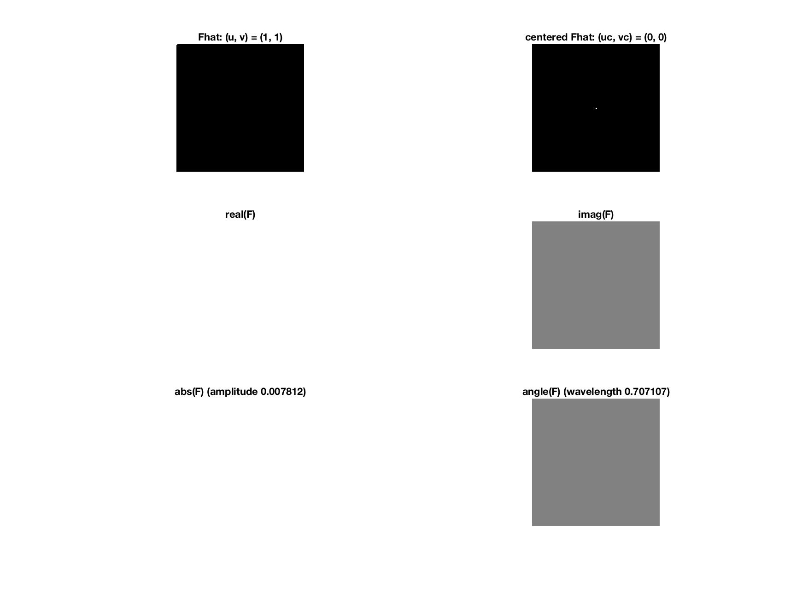

Similarly, for *p*=1 and *q*=3, it gives (0,2), so we have a non-zero frequency only in the x direction in which it completes 2 periods.

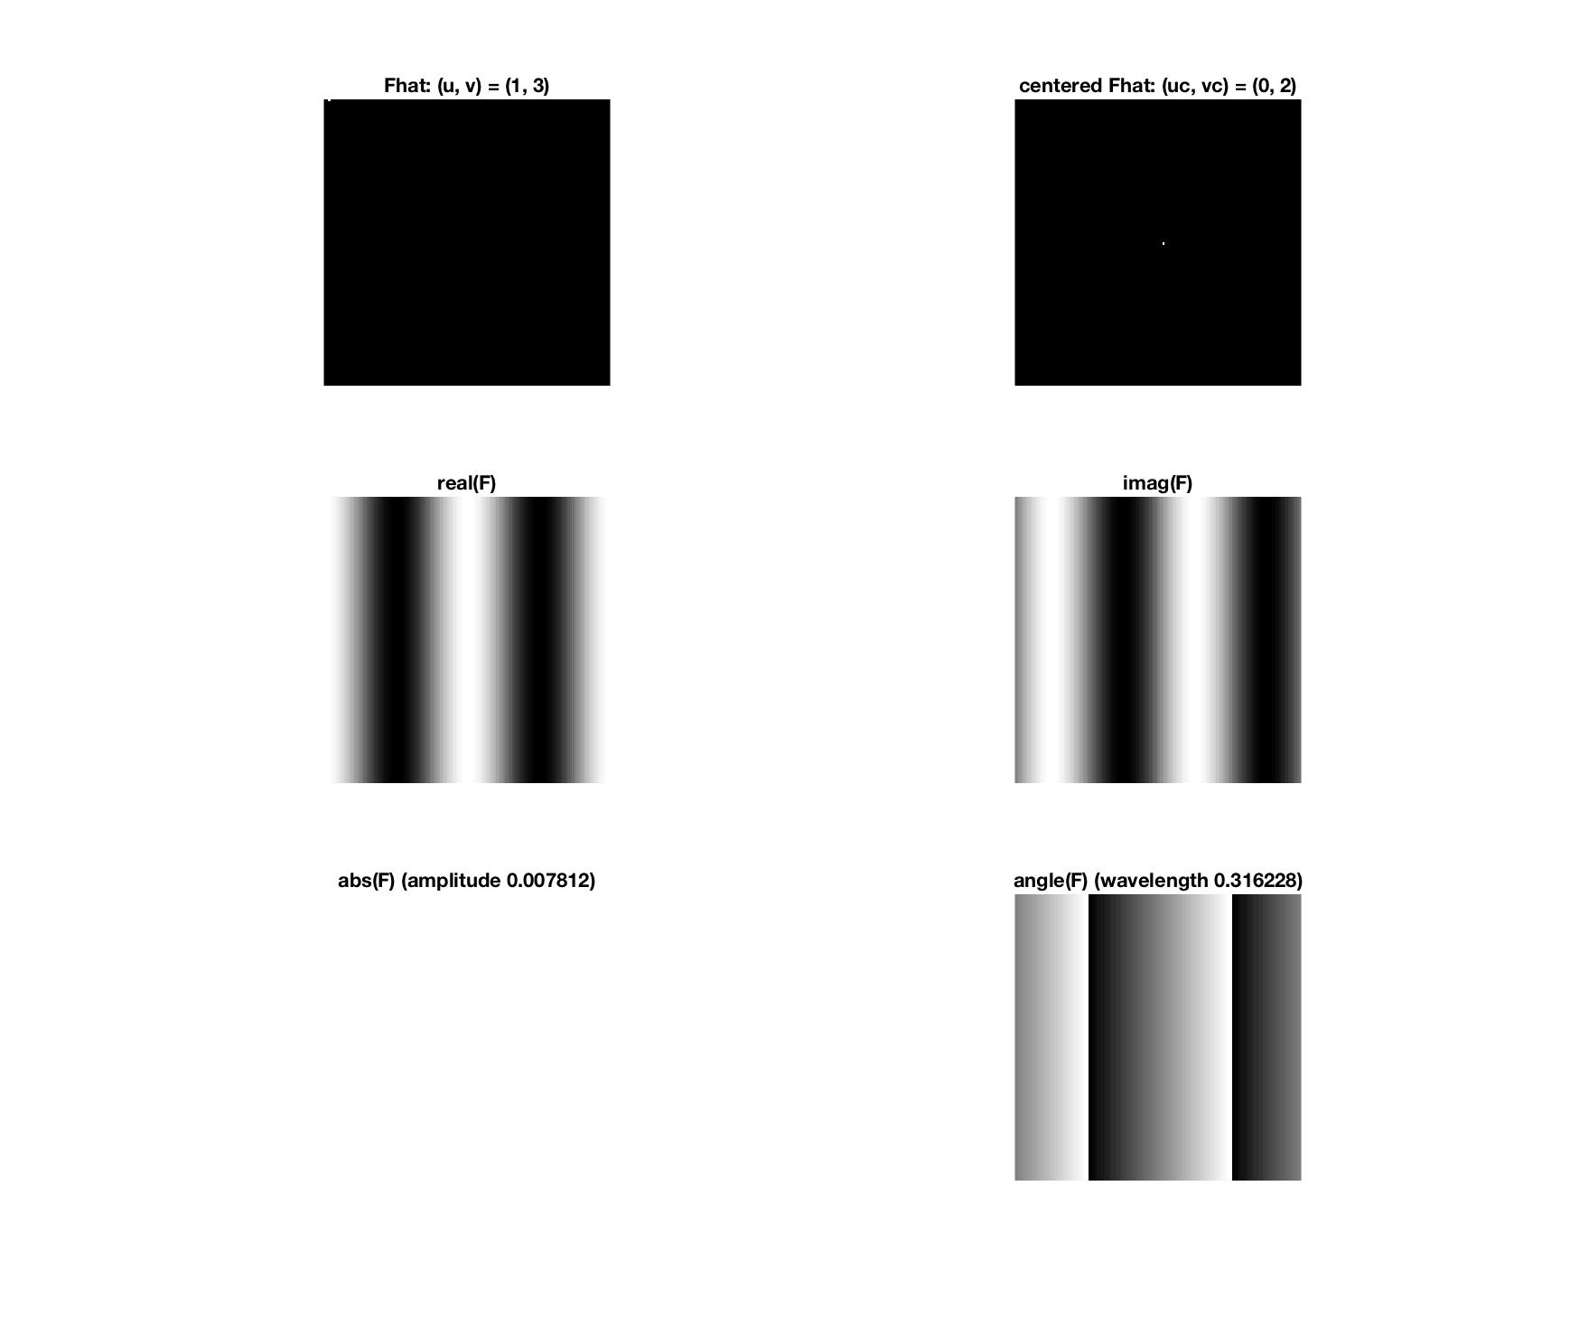  
___________________________________________________________________________

**Question 3**: How large is the amplitude? Write down the expression derived from Equation (4) in the notes. Complement the code (variable amplitude) accordingly.

Answers:

We can get the amplitude from that we set ourselves to one, so = 1 as well. As the equation states, it is normalized by factor of , which results in amplitude being

If we have:

we get the amplitude A as

where *Re(u*) = 1 and *Im(u)* = 0 are the real and imaginary parts of , i.e. we only have the real part by which we multiply all the cosines and sines. As we’re summing over N points, we also normalize over N, giving the final amplitude of for these examples.

__________________________________________________________________

**Question 4**: How does the direction and length of the sine wave depend on p and q? Write down the explicit expression that can be found in the lecture notes. Complement the code (variable wavelength) accordingly.

Answers:

The larger *p* and *q* values we have, the larger frequency waveforms we have. The larger the frequency is, the shorter the length of the wave. Since we have a two-argument sine function, the *p* and *q* values act as coordinates, showing the direction vector the wave is pointed to.

As for the wavelength, we have

The frequencies corresponding to *p* and *q* are *uc* and *vc*, from those we calculate the corresponding angular frequencies and the wavelength, i.e.

___________________________________________________________________________

**Question 5**: What happens when we pass the point in the center and either p or q exceeds half the image size? Explain and illustrate graphically with Matlab!

Answers:

We exceed the maximum frequency that can be represented in the spatial domain. Maximum frequency we can display is 2 pixels per period (1 pixel stripes), any frequencies higher than that we can’t sample with the resolution, aliasing starts to occur and we happen to see some other lower frequency in the image, possibly with a phase shift.

An example can be seen with *p,q* pairs (5,1) and (125,1), which when converting to actual frequencies and zero-centering map to (4,0) and (-4,0) respectively, resulting in the same image for the real part and a phase shifted one for the imaginary part.

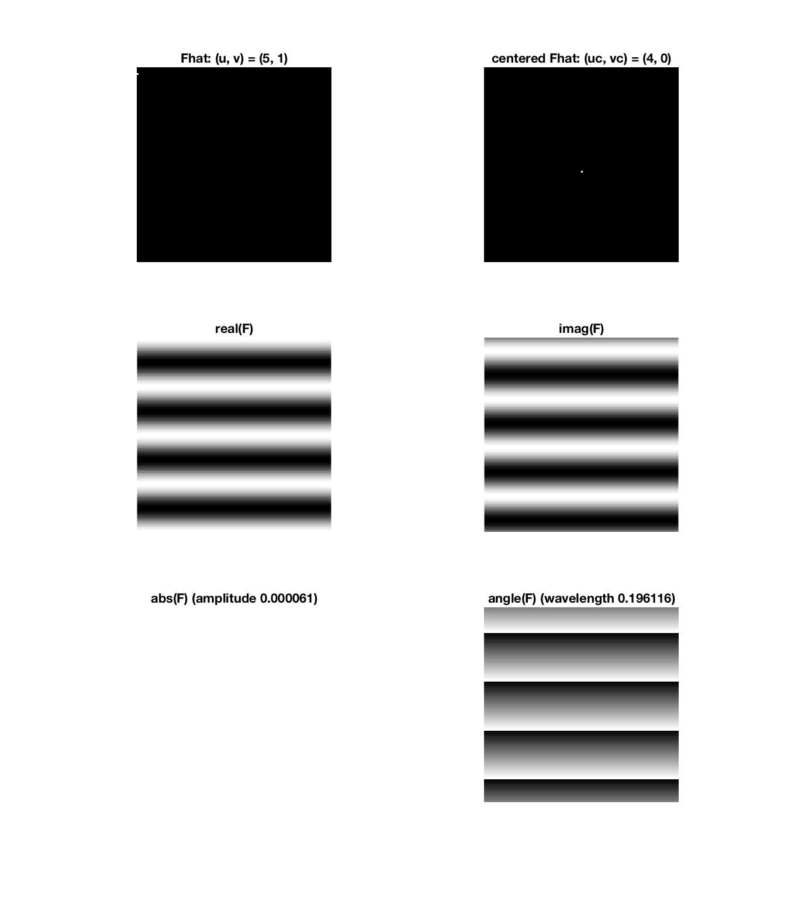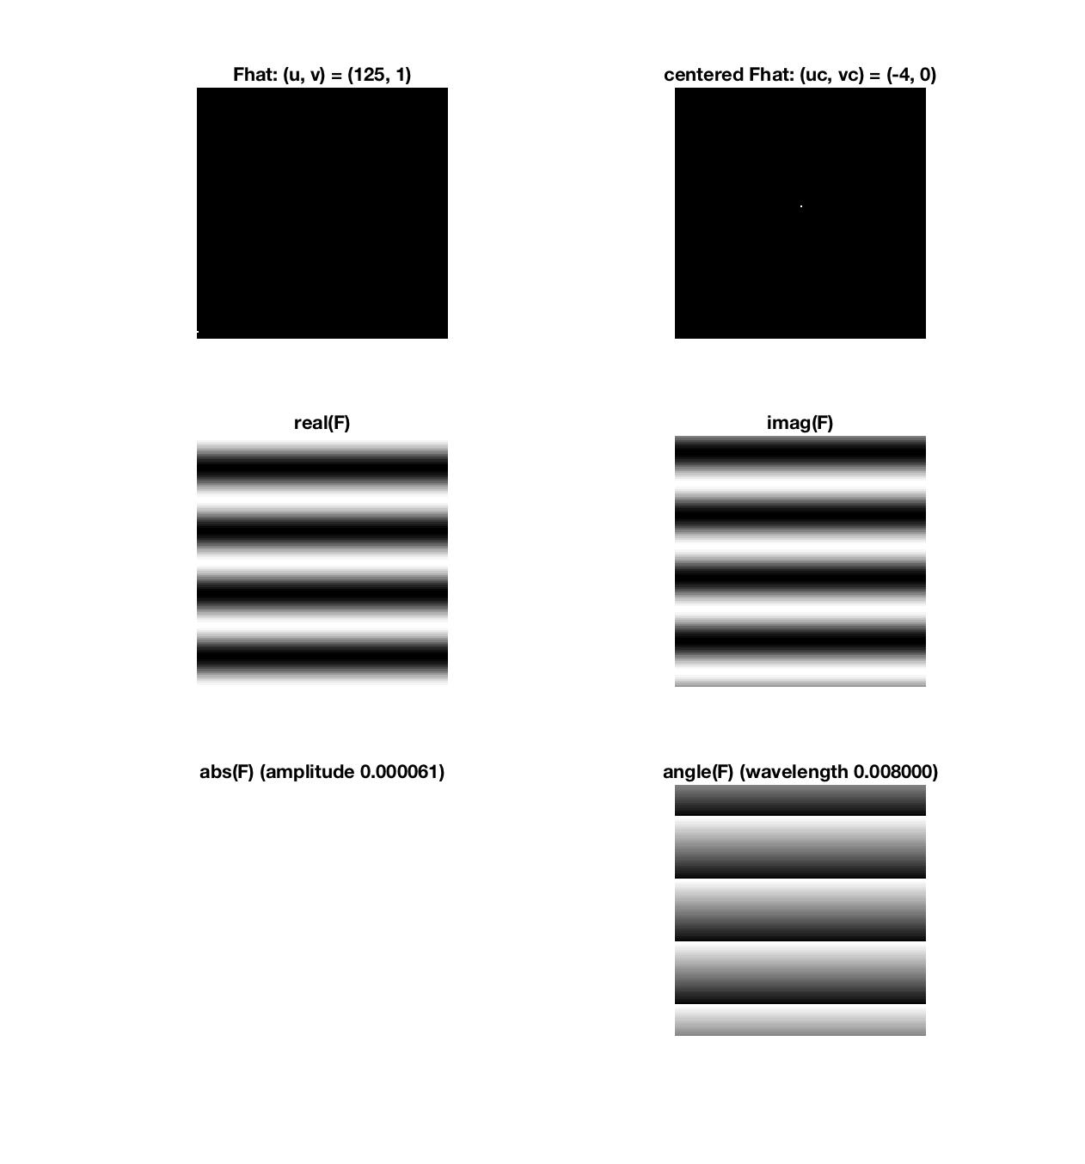

___________________________________________________________________________

**Question 6**: What is the purpose of the instructions following the question *What is done by these instructions?* in the code?

Answers:

Zero centering. Originally, when we set , we have the lowest frequencies in the upper-left corner (0,0), with values going 0..N-1 on both axes. By zero centering we shift the range from [0,N-1] to [-]

These instructions correspond to what fftshift does, swapping first and third quadrants, and second and fourth quadrants.

Even for *u* and *v* less than half image size we set *uc* = *u* – 1 and *vc* = *v* – 1 respectively as Matlab uses coordinate system that starts at 1, so we just do a mapping to the real frequencies.

___________________________________________________________________________

**Question 7**: Why are these Fourier spectra concentrated to the borders of the images? Can you give a mathematical interpretation? Hint: think of the frequencies in the source image and consider the resulting image as a Fourier transform applied to a 2D function. It might be easier to analyze each dimension separately!

Answers:

In the case of **F** we have a horizontal bar, so if we look at it as a 2D function, it has no changes moving in the x direction, it only changes in the y direction in which it can be viewed as a step function. Therefore in the Fourier domain we end up with a lot of different frequencies in the y direction that make up this step function, while in the x direction it is constant so we only have the zero frequency. Since for the uncentered version the origin (0,0) is at the upper-left corner (0 to 2π), we get all the values over the left border of the spectrum, where *v* = 0.

It’s a similar case with **G**, where we only get change moving in the x direction and the y direction is constant, so we have all the values in the Fourier domain over the top border, where *u* = 0.

For **H** we have the bars from **F** and **G** combined (with **G** having higher amplitude), so the resulting Fourier transform is constructed the same way, as it is a linear transform, i.e. if we sum the two images and then transform, the result is the same as if we transform each one separately and then sum.

Finally for the shifted version the bars in the Fourier domain just move to the middle of the image as the 0 valued axis are now both centered there (origin in the center instead of upper-left corner).

___________________________________________________________________________

**Question 8**: Why is the logarithm function applied?

Answers:

It is applied for value compression to improve visual readability when observing the magnitudes, bringing the lowest and highest values tighter together.

If we look at the graph of ***log(1 + x)***

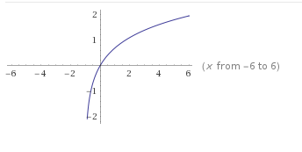

we can see that the lowest value range is accented and thus can be more clearly distinguished, while the higher values flatten out more. Adding 1 to the term, i.e. doing ***log(1 + x)*** instead of ***log(x***), ensures that 0 values still get mapped to 0.

___________________________________________________________________________

**Question 9**: What conclusions can be drawn regarding linearity? From your observations can you derive a mathematical expression in the general case?

Answers:

As mentioned already in Question 7, the Fourier transform is linear, which we can clearly observe in the case of **H = F + G**. As the resulting transform is made up of the individual transforms of **F** and **G**, we can say that for any *f, g* the Fourier transform **F**(*f + g*) = **F**(*f*) + **F**(*g*)

___________________________________________________________________________

**Question 10**: Are there any other ways to compute the last image? Remember what multiplication in Fourier domain equals to in the spatial domain! Perform these alternative computations in practice.

Answers:

___________________________________________________________________________

**Question 11**: What conclusions can be drawn from comparing the results with those in the previous exercise? See how the source images have changed and analyze the effects of scaling.

Answers:

___________________________________________________________________________

**Question 12**: What can be said about possible similarities and differences? Hint: think of the frequencies and how they are affected by the rotation.

Answers:

___________________________________________________________________________

**Question 13**: What information is contained in the phase and in the magnitude of the Fourier transform?

Answers:

___________________________________________________________________________

**Question 14**: Show the impulse response and variance for the above-mentioned t-values. What are the variances of your discretized Gaussian kernel for t = 0.1, 0.3, 1.0, 10.0 and

100.0?

Answers:

___________________________________________________________________________

**Question 15**: Are the results different from or similar to the estimated variance? How does the result correspond to the ideal continuous case? Lead: think of the relation between spatial and Fourier domains for different values of t.

Answers:

___________________________________________________________________________

**Question 16**: Convolve a couple of images with Gaussian functions of different variances (like t = 1.0, 4.0, 16.0, 64.0 and 256.0) and present your results. What effects can you observe?

Answers:

___________________________________________________________________________

**Question 17**: What are the positive and negative effects for each type of filter? Describe what you observe and name the effects that you recognize. How do the results depend on the filter parameters? Illustrate with Matlab figure(s).

Answers:

___________________________________________________________________________

**Question 18**: What conclusions can you draw from comparing the results of the respective methods?

Answers:

___________________________________________________________________________

**Question 19**: What effects do you observe when subsampling the original image and the smoothed variants? Illustrate both filters with the best results found for iteration i = 4.

Answers:

___________________________________________________________________________

**Question 20**: What conclusions can you draw regarding the effects of smoothing when combined with subsampling? Hint: think in terms of frequencies and side effects.

Answers:

___________________________________________________________________________