Sofia University
Department of Mathematics and Informatics
Course : OO Programming with C#.NET
Student Name:
Lab No. 2a

Submit the all C# .NET files developed to solve the problems listed below. Use comments and Modified-Hungarian notation.

Problem No. 1
Use VS Visual designer to produce the following classes

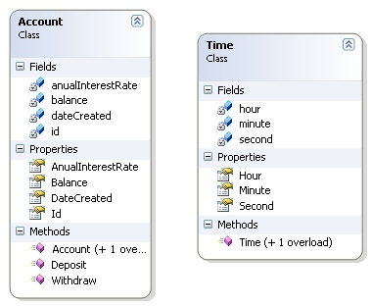

Problem No. 2
Modify class GradeBook from Fig. 4.12 as follows:
- Include a second string instance variable that represents the name of the course's instructor.
- Provide a property with accessors to change the instructor's name and to retrieve it employing an auto-implemented property.
- Modify the constructor to specify two parameters one for the course name and one for the instructor's name.
- Modify method DisplayMessage such that it first outputs the welcome message and course name, then outputs "This course is presented by: ", followed by the instructor's name.
Use your modified class in a test application that demonstrates the class's new capabilities.
Problem No. 3
Employing the Visual Designer develop a model for a class called Invoice that a hardware store might use to represent an invoice for an item sold at the store. An Invoice should include four pieces of information as instance variables - a part number (type string), a part description (type string), a quantity of the item being purchased (type int) and a price per item (decimal). Your class should have a constructor that initializes the four instance variables. Provide a property with a get and set accessor for each instance variable.
Generate the necessary C# code and in addition provide a method named GetInvoiceAmount that calculates the invoice amount (i.e., multiplies the quantity by the price per item), then returns the amount as a decimal value. If the quantity is negative, it should be left unchanged. Similarly, if the price per item is negative, it should be left unchanged.
Write a test application named InvoiceTest that demonstrates class Invoice's capabilities.

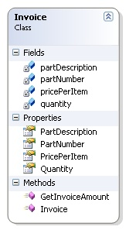
Problem No. 4
What does the following application print?
1 // Ex. 5.25: Mystery2.cs
2 using System;
3
4 public class Mystery2
5 {
6 public static void Main( string[] args )
7 {
8 int count = 1;
9
10 while ( count <= 10 )
11 {
12 Console.WriteLine( count % 2 == 1 ? "****" : "++++++++" );
13 count++;
14 } // end while
15 } // end Main
16 } // end class Mystery2

****
++++++++
****
++++++++
****
++++++++
****
++++++++
****
++++++++

Problem No. 5

Identify and correct the errors in each of the following pieces of code. [Note: There may be more than one error in each piece of code.]

if ( age >= 65 )
Console.WriteLine( "Age greater than or equal to 65" );
else
Console.WriteLine( "Age is less than 65 ”);

int x = 1;
int total = 0;
while ( x <= 10 )
{
total += x;
++x;
}

while ( x <= 100 )
{
total += x;
++x;
}

while ( y > 0 )
{
Console.WriteLine( y );
++y;
}

