Coding Practice Week 7

Aaryan Agarwal Fall 2023

Part 1

Q2

Q3

{

'birth year': 1980

}

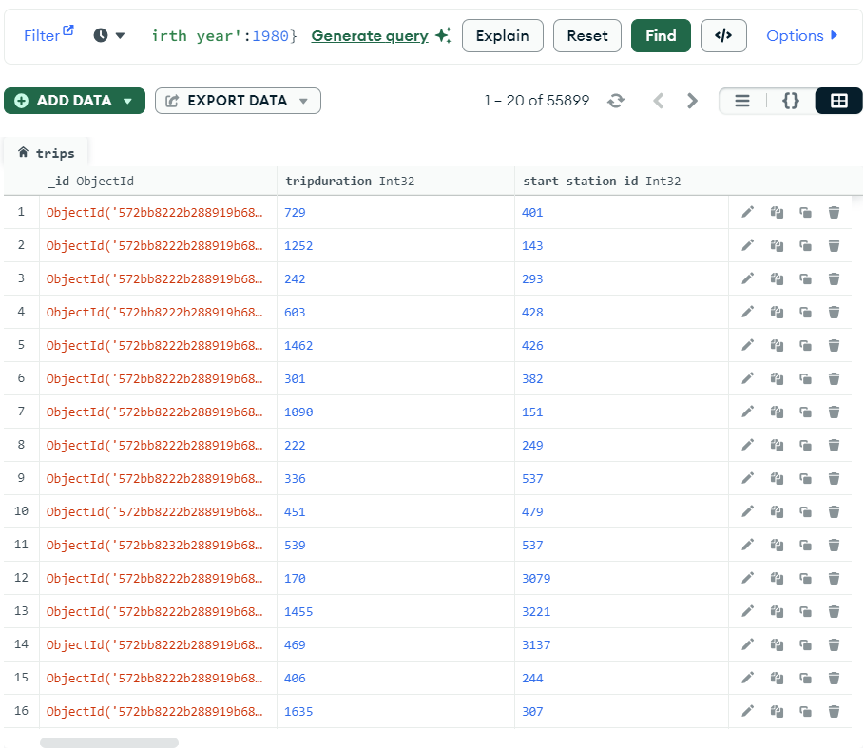

Q4

{

'birth year': {

$gt: 1999

}

}

Q5

{

'birth year': {

$gt: 1999

}

}

Q6

{

'birth year': {

$gt: 1999,

$lt: 2001

}

}

Q7

{

'birth year': {

$gte: 1999

}

}

Q8

{"wind.type": "C"}

Q9

{

'wind.direction.quality': '1'

}

Q10

{

"runtime": {

$gt: 90

},

"viewerRating": {

$gt: 7

}

}

Q11

{

"genre": {

$ne: ""

}

}

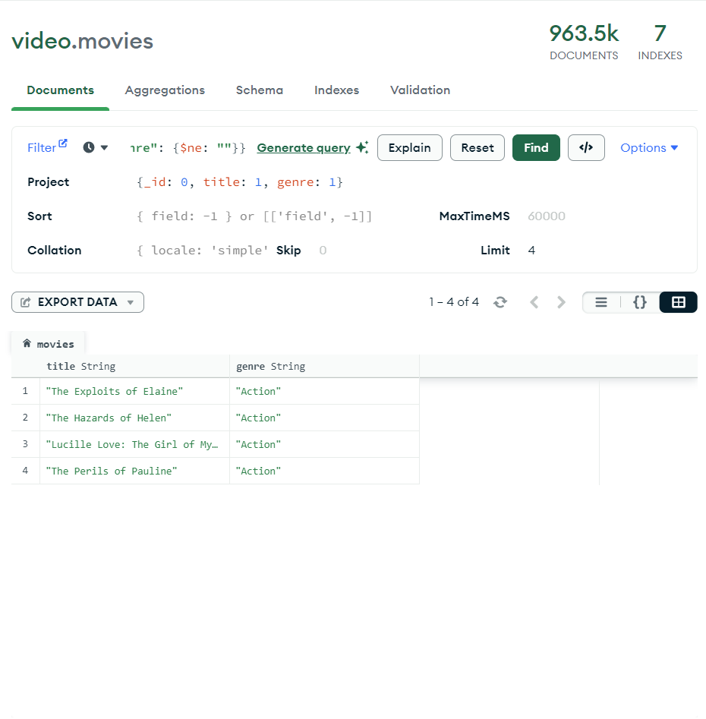

Q12

{genre: {$in: ['Short','Drama']}}

Q13

{

language: {

$exists: true

}

}

# Part 2

