1. Import `beer-sample` bucket

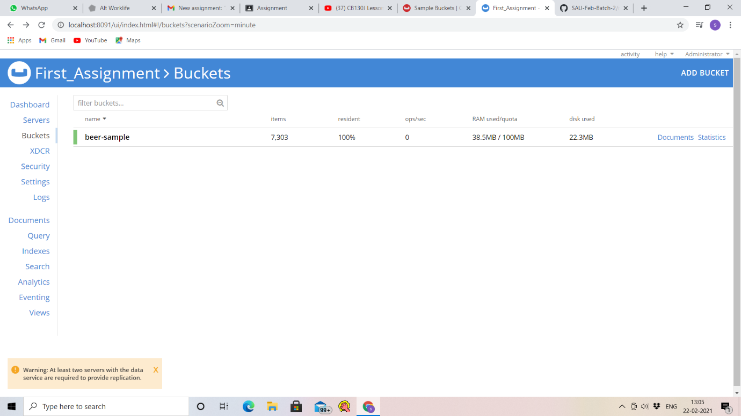

1. Write a join query to fetch the Top 10 brewery(type=”beer”) and their country(type=”brewery”) which produces more varieties of beers.

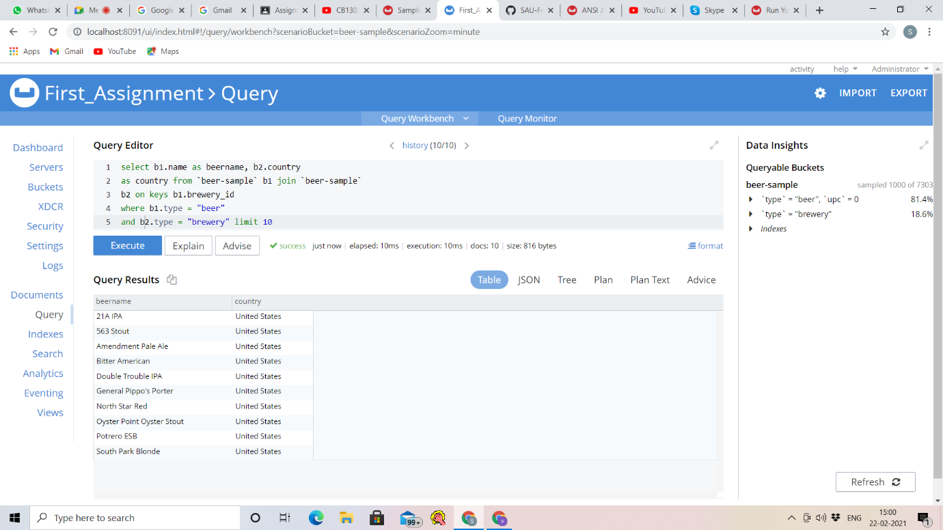

3.Write a mapreduce to get the number of breweries based on country. Please attach the mapreduce code and json output screenshot.

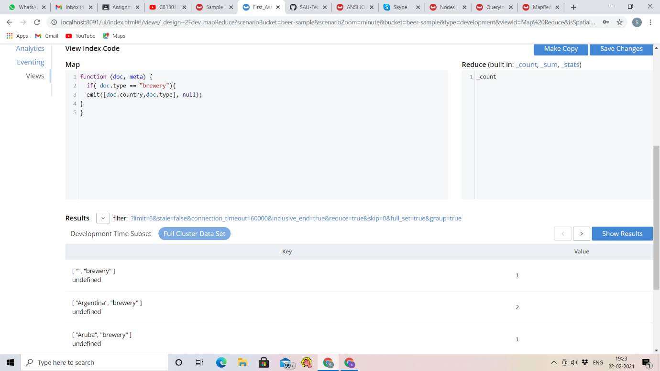

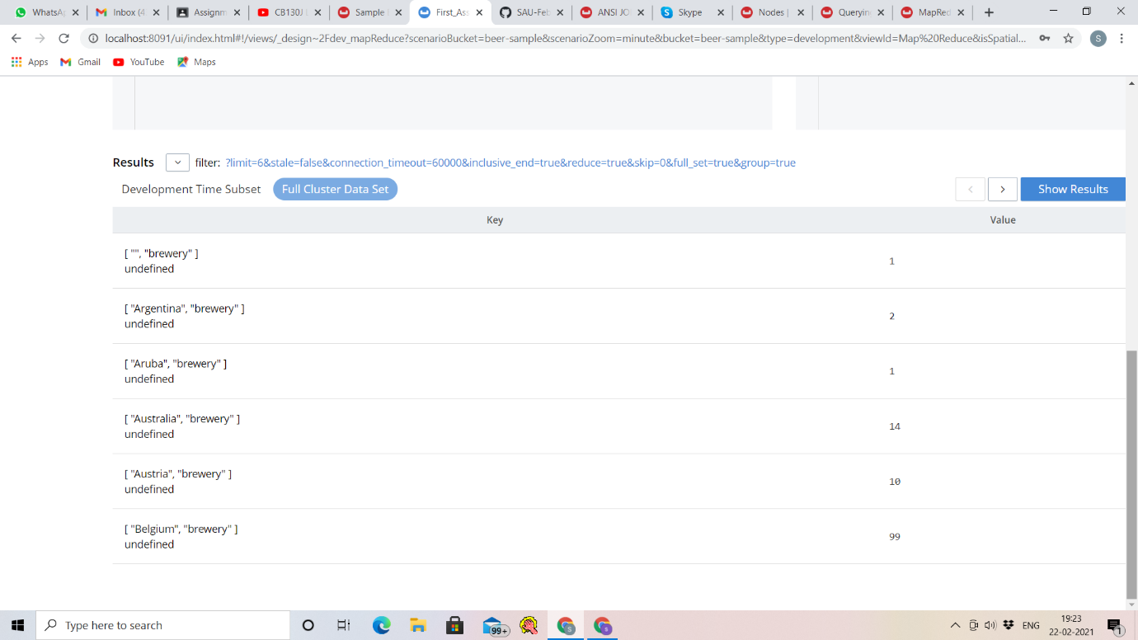

4.

1. XDCR:
   1. Add a new bucket “Brewery”.
   2. Create a XDCR with a filter(type=’brewery’) to replicate only the brewery entity from `beer-sample` bucket.

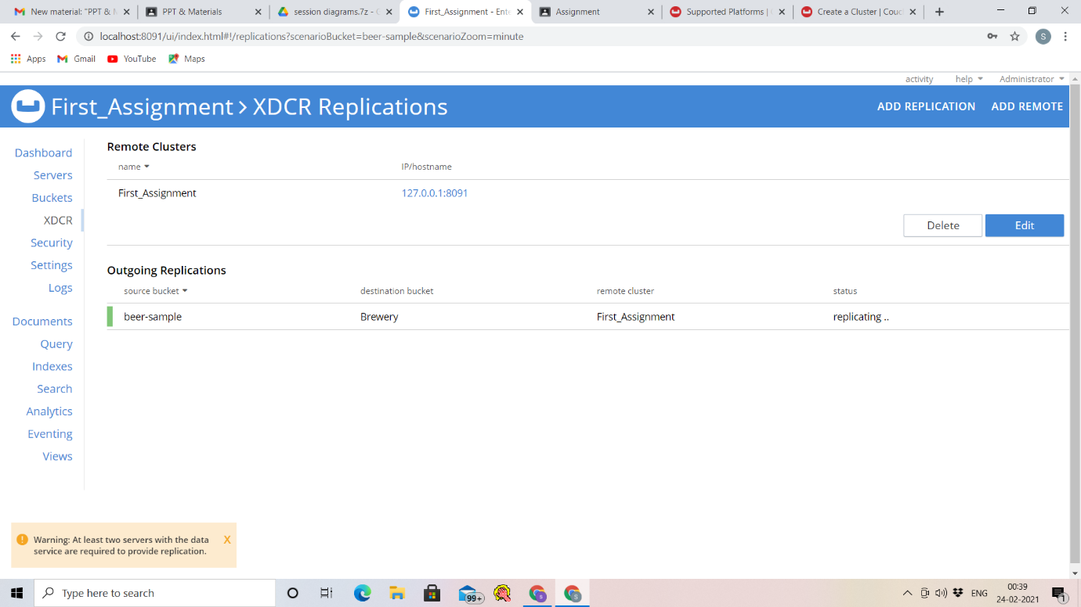

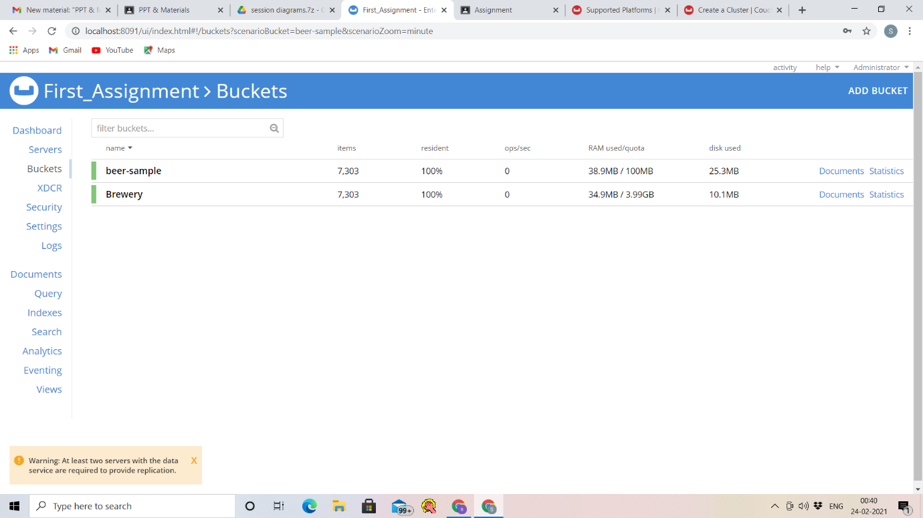

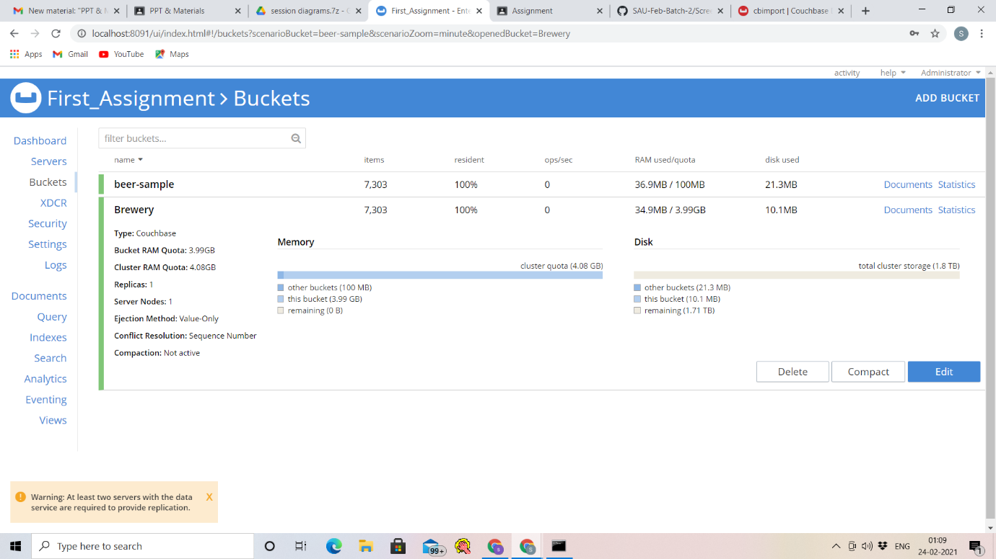

5. CLI:

* 1. Add a new bucket “Beer”.
  2. Using CLI - do a cbexport of the entire `beer-sample`
  3. And do a cbimport with “brewery_id” as primary key. As a result, in the new bucket - only “beer” documents will be imported with their respective brewery name as meta().id
  4. Share your observation on counts with screenshot.

