**Introductory Section:**

**Preliminary analysis:-**

**ANALYSIS OF AIRLINES CUSTOMER’S ITERATION**: -

Customers satisfaction plays a key role in any firm. If customers are satisfied with all facilities, then we would definitely be on profit scale. Existing customers are very much necessary for our further development.

Let’s look at the scenario’s which needed to be addressed:

Major out breaking reasons for customer’s iteration can be divided into 4 categories:

CATEGORY 1) PRICING

The techniques and strategies so fast in recent times that pricing of the ticket depends on many factors and its price keep changing.

* EXPENSIVE TICKETS:

Tickets can be expensive due to many reasons (High fuel rate, fastest etc.) but as everyone can’t afford it, they drop off. For eg-some airlines provides free food for small routes also which makes their tickets costly and generally travellers do not care much about food all they need is cheap flights.

* AVAILABILITY OF DISCOUNTS:

Customers mostly look after the discounts, by the services that airlines can provide.

Aspects for price changing could be:

* SEASONAL:

Some days which mark the auspiciousness and are said to be pure, generally we have bonds like marriage, business deals …etc. During all those aspects travelling is must for every person. Deals provided by different airlines are being chosen by customer.

* VACATION:

Vacation time is next major important time where we have large set of customers coming during that time. We need to make sure our pricing during that time.

* URGENCY:

Based on the surfing towards a place deals needed to be provided to the customer when in urgency.

Primary target is gaining customers and for that, its general tendency of people to choose the lower price during all the times. If we make sure of a flight under major people cost of living it would definitely mark a step of having customers.

CATEGORY 2) COMPETITION

We are living in a competitive world and hence, it is our responsibility to make sure we are a step ahead of our competitors. Aspects that make competition or competitors better:

* FREQUENCY:

Metropolitan cities like Delhi, Hyderabad have flights with more frequencies. If in case the customer misses a flight he need to have immediate flight after that in a less time. Therefore, they prefer airline with more frequency of flights.

* CONNECTIVITY:

Customers choose airline having many places connected. This means you need to have all the nearby towns connected with you to have better customers.

* SERVICES (GROUND AND INTERNAL):

This is one of the major out breaking reason for people leaving a particular Airlines. Services here mean any kind of flights and internal services offered, seating comfort, cleanliness, Ground services like smooth take-off and landing and so on.

* AMBIENCE:

Ambience is given the next priority after the flight these days. Even in the case of choosing a restaurant people first choose ambience and then go with their choice of food. So, ambience even marks its own place.

* ATTRACTIVE FEATURES:

More attractive features (fare, facilities) in other airlines when compared with each other, as the customer mostly crosschecks more airlines in order to book for the best one with maximum benefits.

* MARKETING:

Not very well practise of marketing. It is like not promoting their airlines up to the point that includes not having any clear insights why customer should choose their company, not increase in existing customer base, monitoring results by previous ones.

* BUSINESS STRATEGY:

Most of top management are still following the old way of administration while things have changed a lot in recent years which are unacceptable and unimaginable. They should try in different perspective in order to gain customer attention.

CATEGORY 3) NEGATIVITY

People hate negativity and negative vibes always. Hence we need to make sure our company is completely out of negativity. It is often said negativity is spread faster than positivity. Hence we need to avoid negativity. Aspects that may cause negativity:

* REVIEW OF PAST CUSTOMER:

4 out of 5 people go with the rating and review of the previous customer before doing anything. Therefore, it is really important to maintain healthy relation and make the customer feel satisfied as much as possible.

* PLANE CRASHES /ACCIDENTS:

Safety and security always place a major in travelling from place to place, customers mostly check for secured airlines by considering the previous major past incidents in order to avoid all the disturbances. If an airline has repetitive no of plane crashes and accidents customers generally step back. We need make sure we don’t have such crashes too often and have a staff which is well qualified.

* DELAYED OR LOST BAGGAGE:

Lost baggage is regarded by many customers as a violation of their personal property, and causes major upset to many. The inconvenience of lost or misplaced luggage has to be experienced for other customers to fully understand.

* EXTERNAL EVENTS:

Airline industry is particularly vulnerable to external events such as terrorism, political instabilities and natural disaster, which can drastically affect their operations and passenger demand.

CATEGORY 4) OTHER FACTORS:

* BAGGAGE CAPACITY:

Maximum of the people who are settlers in the destination have so much luggage to carry and if the baggage capacity is less, there is a chance of customer’s iteration

* CABIN CLEANLINESS:

Today’s airline customers seem to be much more aware about cleanliness and hygiene. With increased aircraft utilisation an important factor for airlines, shorter turnaround times often don’t allow sufficient time for thorough cleaning. But there are large complaints about poor cabin condition, dirty aircraft and cleanliness of cabin washrooms being a prime source of angst.

* UNCOMFORTABLE SEATS:

A common cause for complaint, almost evenly distributed between long haul and short haul airline seats. Whilst many airlines have introduced new slim line seats that use a smaller seat pitch and are supposed to offer equal or better “personal living space” for customers

* AIRLINE MEALS:

Most customer complaints about airline meals refers to special order meals. eg. vegetarian, gluten free, Halal, child meals etc. Prime discontent is when pre-ordered meals have not been loaded onto the flight, or they have been served to the wrong customer. Some customers choose those services which offer quality food in addition to varieties.

* UNAVAILABILITY OF SEATS:

If it is a mismatch in demand and availability of the airlines. For instance, there was over provisioning of wide body aircraft where as it didn’t have required number of customers and vice versa.

* DELAYED FLIGHTS:

Time is more valuable than anything in the world. Many people choose airway for the time constraint. If we have delayed flights very common, then definitely it makes the no.1 reason for standing out of customers

Based on the exposure to these all factors, we have created dummy dataset to have a clear view on which algorithm and what factors need to be taken into conscience are being analysed

The dummy data we have taken has exactly equal churn and non-churn rate i.e 50-50.

The results of churn and non churn are: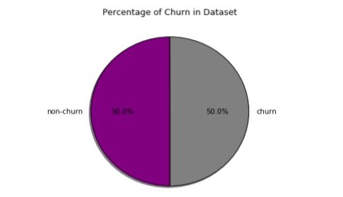

When we used logistic regression:

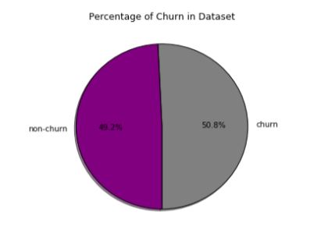

When used random forest algorithm:

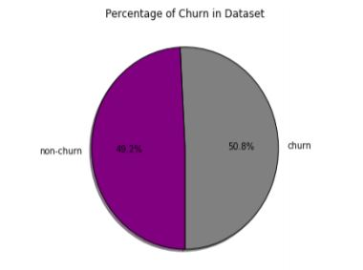

Finally, after having Employed Random forest mechanism, the results were as follows:

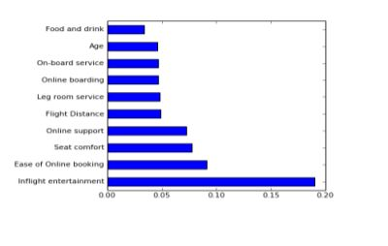

After working on a dummy dataset, we have come to know the pre requisite for the problem analysis i.e:

Out of all the factors, loyalty plays a major role. For an analysis to have correct result we need customers who are loyal and therefore, we have taken the primary target to achieve this solution as “ACTIVE /INACTIVE”

DATA:

Given Data has 8 independent variables and 1 dependent variable

INDEPENDENT VARIABLES ARE:

1)"Unnamed:0 "is the name of the customers but represented in numerical and does not have effect on output variable.

2) "AGE" represents age of the customer (It is continuous data)

3) "GENDER" describes the gender of the customer (It is categorical - male, female)

4) IS_COBRAND describes whether customer have subscription in other airlines. (Categorical -0(no),1(yes)

5) "TIER" describes the type of subscription they have (Categorical - base, gold, platinum and silver)

6) "YEARS_IN_PROGRAM" describes no.of years customers are using the airlines company.(It is continuous )

7) " IS_AIRACCruAL " describes whether the airlines ticket prices or expenses increased (Categorical -0(no),1(yes)

8) "IS_HOTEL REDEMPTION" describes whether they have used privilege points at hotels (Categorical -0(no),1(yes)

DEPENDENT VARIABLE: "IS_INACTIVE" describes whether he is actively using the airlines or not (Categorical -0(no),1(yes)

We have taken a data whose

EXPLORATORY DATA ANALYSIS:

1. *1st BUSINESS MOMENT DECISION(CENTRAL TENDENCIES):*

Mean age group of people who are traveling more is 42-43 and

On an average people were active since 6 years. In other factors there is 50-50 probability.

Mode of the given data is

Age: 23

Gender: Male

Is_cobrand: N0

Tier: Gold

Years_in_program: 6

Is_airaccrual: No

Is_hotelredemption : yes

Is_inactive: yes

1. Variances ,standard deviation and range:

Age: 62

Years_IN_Program: 10

1. Skewness

FOR AGE, IS_COBRAND,YEARS AND AIR ACCURAL SKEWNESS IS +VE .. IT STATES MEAN>MEDIAN DATA OF THAT FEATURES ARE RIGHT SKEWED.

FOR HOTEL REDEMPTION SKEWNESS IS -VE IT STATES MEAN<MEDIAN

1. Kurtiosis

KURTOSIS IS <3 FOR ALL FEATURES IT MEANS LESS OUTLIERS ,LESS STANDARD DEVIATIONS.. OUR DATA SET GOOD. BUT WE STILL TREAT OR DO ACTION ON OUTLIERS FOR BETTER ACCURACY.

1. Correlation:

There is much stronger and higher correlation only among Is_Inactive and Is_hotelredemption.

REGRESSION MODELLING:

1)Logistic Regression:

2)Ridge and lasso

3)Elasto net

4)Random Forest

1. LOGISTIC REGRESSION:

After PCA:

2.RIDGE REGRESSION:

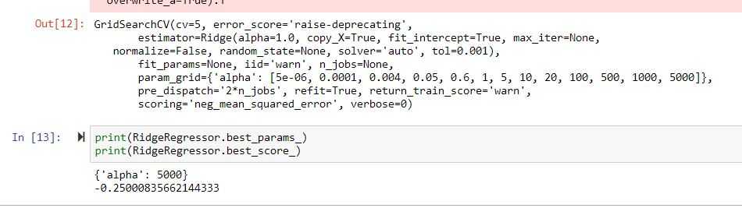

The larger is the alpha, the higher is the smoothness constraint. The smaller the value of alpha, the higher would be the magnitude of the coefficients. Therefore, Smoothness constraint is higher in the given dataset since the alpha value is tending to infinite.

3.LASSO REGRESSION:

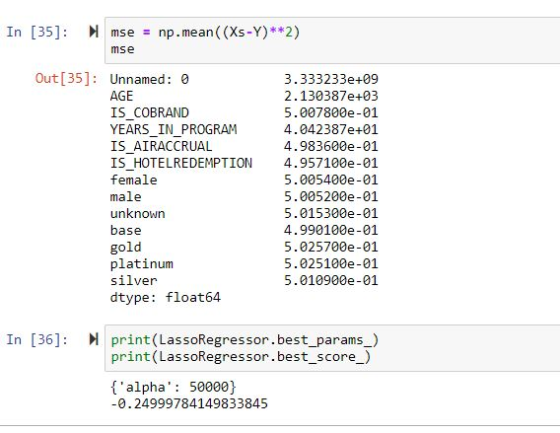

alpha is very large; all coefficients are zero. That is not all factors are being correlated.

4, ELASTO NET:

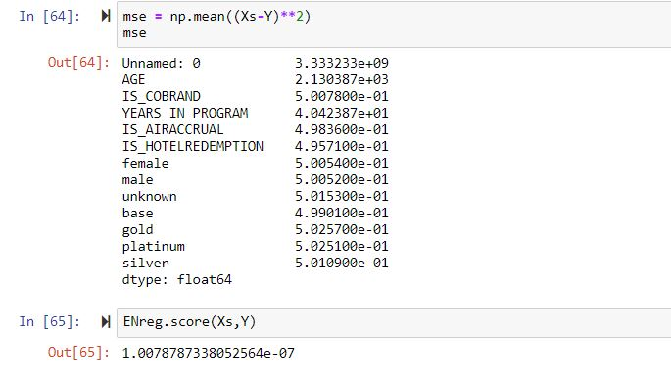

The best possible score for an elastic net is 1 and it is obtained for alpha=28.Any alpha above 28 it is returning 0 any alpha below 28 the score is increasing as you go down.

FINAL CONCLUSION:

The factor “IS_HOTELREDEMPTION” plays a hyper role in effecting the target “IS_INACTIVE”

Therefore, customers are looking for hotel redemption facility more and have given much higher priority than all other ones.