Installation Guide for Aggregate Profiler 6.0.3

OSDQ – Open Source Data Quality Project
http://sourceforge.net/projects/dataquality/

1.) Pre Requisite Setup

a.)Hardware Requirement:
Windows, Solaris, Linux (HP and AIX not tested but it should work fine as Java is portable across platforms). Any platform that supports JDK/JRE 1.7 or higher should work fine.

For UNIX machines “telnet” session to server will not work. CDE (common desktop environment), XManager (eXeed, hummingbirds etc) or any Desktop based login to server (Xterm) is needed to start the graphics.

Freely available XManager software is available for UNIX. You can download one if still you have not any XManager. Most of companies have XManager bought or downloaded to connect to UNIX servers from window desktops.
Typing following on command line for UNIX
>> xterm
should launch Xwindow on unix.

b.)Software requirement:
JDK / JRE 1.7.0_07 or above.

Type “java –version” on command line to see what java you have?

>>java –version
java version "1.7.0_07"
Java(TM) SE Runtime Environment (build 1.7.0_07-b11)
Java HotSpot(TM) Client VM (build 23.3-b10, mixed mode, sharing)

c.)Database Certified:
MS Access, SQL Server, MySQL, Oracle, Db2, Postgres, HIVE Thrift , Informix, Splice DB

d.)Database Prerequisite:

Window User should know how to create DSN or Use existing DSN for MS Access, SQL Server, MySQL, and Oracle on Windows. ODBC driver for MySQL can be downloaded from http://www.mysql.com (if you do not have ODBC driver for MySQL on Windows) MySQL ODBC driver does not come by default with Windows.

Oracle User should add the service name in tnsnames.ora file.

On windows DSN can be created
Start → Control Panel → Administrative Tools → Data Sources → System DSN

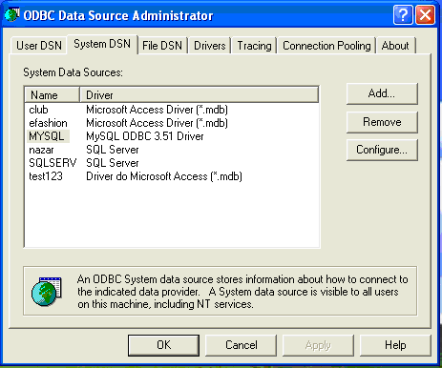
Fig 1

MySQL, MS Access and SQL Server and Oracle is supported via JDBC:ODBC bridge.

MySQL, MS Access and SQL Server user can do “Test connection” from ODBC Data Source Administrator Panel. Oracle user can do following on command line
>> tnsping <SERVICE_NAME>
to check the connection.

Oracle, MySql, Postgres, DB2 and Hive are also supported via JDBC on both UNIX and Windows.

<ORACLE_HOME>/lib should be in LIBPATH (for AIX), LD_LIBRARY_PATH (for Solaris) or SHLIBPATH (for HP) for UNIX user. For Windows user it will be in PATH by default if Oracle is installed.

Technically speaking any data source that supports JDBC can use this profiler.

Preferable one should use JDBC driver wherever possible.

2. Product Installation:

- Create a folder or Directory
- unzip or “jar –xvf ProfilerV6.0.3.zip” in the folder you want to install.

WINDOWS
- runprofiler.bat or
- runprofiler.bat “configFile.txt” ( if Database parameters are set in configFile.txt)

UNIX
- runprofiler.sh or
- runprofiler.sh “configFile.txt” ” ( if Database parameters are set in configFile.txt)

UnInstall :

- Remove the folder.

Enjoy!!

