Data Structures and Algorithms  
Week 1 problem sheet

## A. Algorithms and Data Structures

1. In your own words, complete the following sentences.
   1. “An algorithm is … .”
   2. “A data structure is …. .”

## B. Java basics

1. Consider the following Java code:

* class Person {  
   private String name;  
   private int age;  
   Person bestFriend;  
    
   public Person(String name, int age, Person bestFriend) {  
   this.name = name;  
   this.age = age;  
   this.bestFriend = bestFriend;  
   }  
    
   public int getAge() {  
   return age;  
   }  
    
   public void setAge(int age) {  
   this.age = age;  
   }  
    
  }
* Answer the following questions about the code.
  1. What is the name of the class being defined here?
  2. Where is the constructor for the class? What does it do?
  3. What are the *instance variables* of the class?
  4. What are the *methods* of the class?
  5. What are the *parameters* of the setAge method? What are their *types*?
  6. What is the type of the bestFriend instance variable? In what ways is it different from the age instance variable?

1. What kind of “thing” is each part of the following Java statement? How does it work?

* System.out.println(myObject);

1. What is meant by each part of the following Java code fragment:

* public static void main(String[] args)

1. What is meant by each part of the Java statement:

* import java.util.ArrayList;
* How does it differ from the following?
* import java.util.*;

1. Suppose we execute the following two Java statements:

* int a = 32;  
   int b = 32;
* What would then be the value of the expression “a == b”?

1. Suppose we execute the following two Java statements:

* java.awt.Color red = new java.awt.Color(255,0,0);  
   java.awt.Color xxx = new java.awt.Color(255,0,0);
* What would then be the value of the expression “red == xxx”, and why?

1. We have two monkeys, A and B, and the boolean variables aSmile and bSmile indicate if each is smiling. We are in trouble if they are both smiling or if neither of them is smiling. Which of the following expressions evaluates to true if and only if we are in trouble?
   1. aSmile || bSmile
   2. aSmile && bSmile
   3. aSmile == bSmile

For more Java revision questions, see

[**http://teaching.csse.uwa.edu.au/units/CITS2200/Tutorials/tutorial02.html**](http://teaching.csse.uwa.edu.au/units/CITS2200/Tutorials/tutorial02.html)

## C. Linked Lists

1. Let Link be an object with two member variables:

* public class Link {  
   char item;  
   Link next;  
   }
* Assume that the variable first is a reference to a Link object containing 'a', whose next is a link object containing 'b', whose next is null.
* 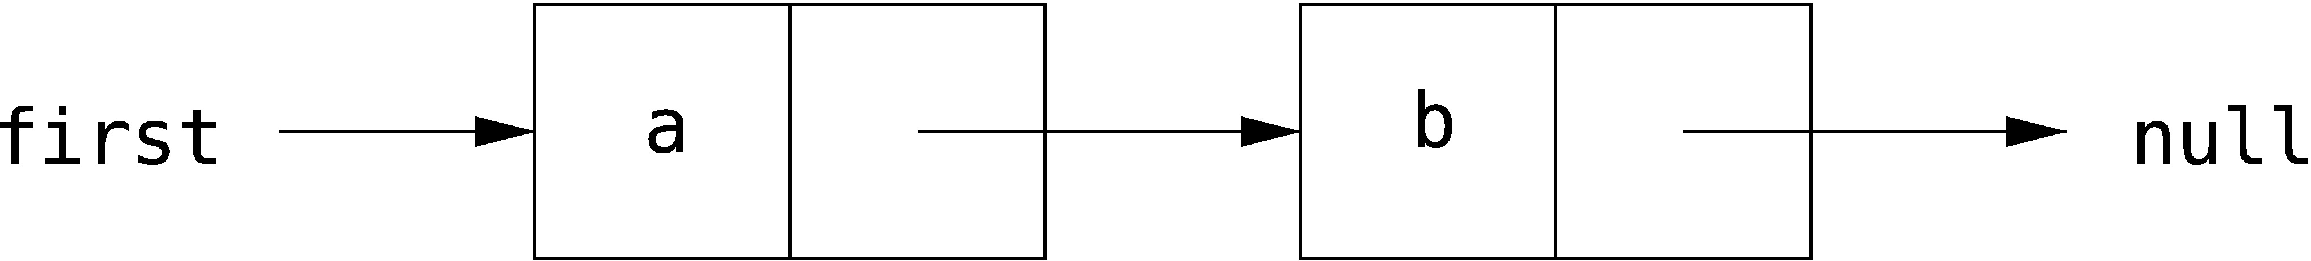
* Which of the following code snippets successfully reverses this structure, so as to give the following list?
* 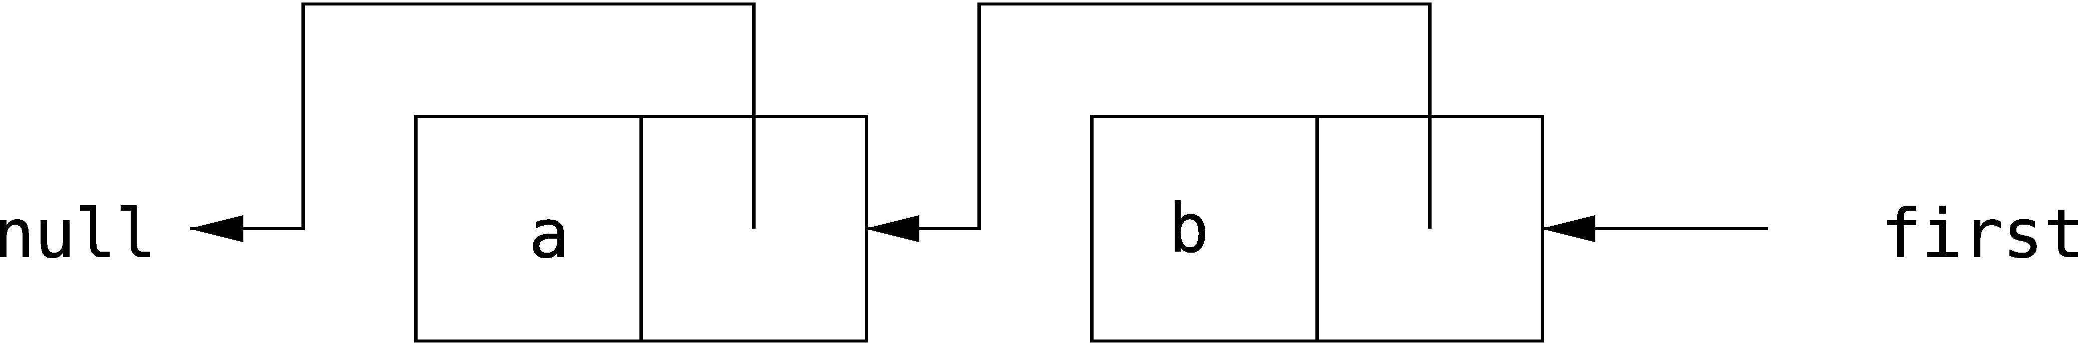
* Draw a picture of the result of each code snippet to explain your answer.
  1. first.next = null;  
     first.next.next = first;  
     first = first.next;
  2. first.next.next = first;  
     first = first.next;  
     first.next.next = null;
  3. Link temp = first;  
     first = temp.next;  
     first.next = temp;  
     temp = null;
  4. Link temp = first.next;  
     temp.next = first;  
     first.next = null;