**ArraysAtOne Capstone Database**

**SENSORS**

This table is used as an index of all the sensors in the system. It will also be used to keep track of the temperature threshold and the last time an email was sent about a particular sensor.

Structure:

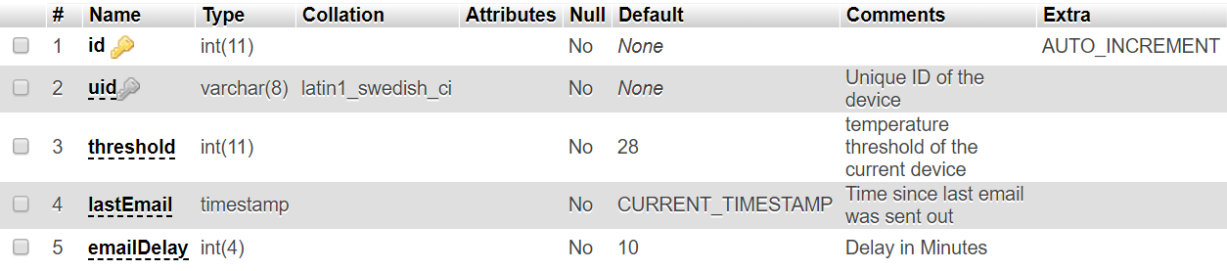

Example Row:



Example Queries:

Insert:

INSERT INTO `SENSORS`(`uid`, `threshold`, `lastEmail`, `emailDelay`) VALUES ([value-1],[value-2],[value-3],[value-4])

The threshold, lastEmail and emailDelay values can be omitted in an insert as they do have default values. ID column will autoincrement and should never be inserted into.

Update:

UPDATE `SENSORS` SET `uid`=[value-1],`threshold`=[value-2],`lastEmail`=[value-3],`emailDelay`=[value-4] WHERE 1

Obviously the ID value should never be changed as this is the primary key and it will throw an error.

**SENSOR_\***

These tables will be for storing the temperature and movement values of each sensor. The current table is SENSOR_0001203B. This naming format will allow for easy use of wildcards to make the modularity of the site go more smoothly.

Structure:

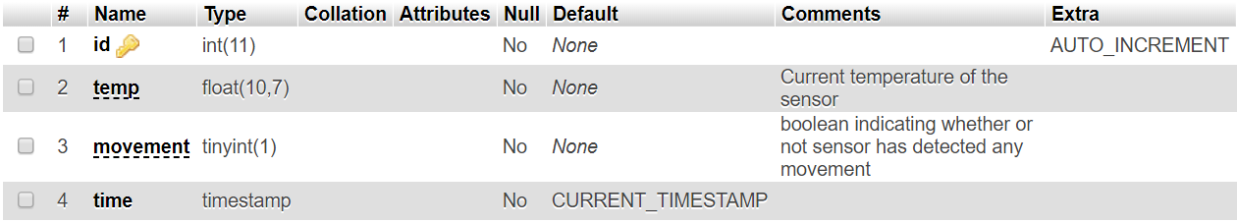

Example Rows:

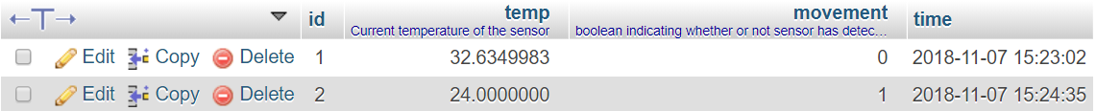

Example Queries:

Insert:

INSERT INTO `SENSOR_0001203B`( `temp`, `movement`) VALUES ([value-2],[value-3])

Do not insert into the ID and Time rows as they will be handled by default.

Update:

**These tables should never be updated as the data needs to be preserved as is for historical record.**

**EMAIL_LIST**

This table will keep track of the email addresses that will have emails sent to them when a sensor event occurs.

Structure:

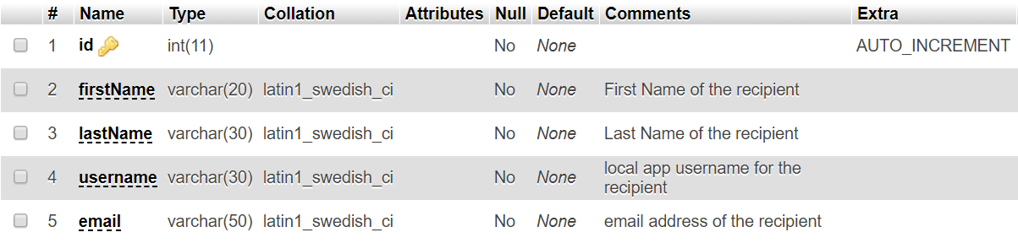

Example Rows:



Example Queries:

Insert:

INSERT INTO `EMAIL_LIST`( `firstName`, `lastName`, `username`, `email`) VALUES ([value-1],[value-2],[value-3],[value-4])

Do not insert into the ID row as it will be incremented by default.

Update:

UPDATE `EMAIL_LIST` SET `firstName`=[value-1],`lastName`=[value-2],`username`=[value-3],`email`=[value-4] WHERE 1

Obviously do not update the ID row as it is a unique, auto-incrementing primary key