Datos-madera-fdac.R

Usuario

2024-09-10

# Importar datos de GitHub  
  
url <- "https://raw.githubusercontent.com/mgtagle/Met_Est_2024/main/Datos_Madera_MET.csv"  
  
madera <- read.csv(url, header = T)  
  
boxplot(madera$Peso_g ~ madera$Especie)

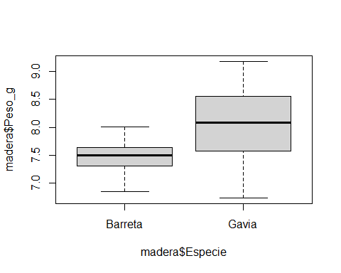

shapiro.test(madera$Peso_g)

##   
## Shapiro-Wilk normality test  
##   
## data: madera$Peso_g  
## W = 0.959, p-value = 0.1548

bartlett.test(madera$Peso_g ~ madera$Especie)

##   
## Bartlett test of homogeneity of variances  
##   
## data: madera$Peso_g by madera$Especie  
## Bartlett's K-squared = 11.867, df = 1, p-value = 0.0005715

madera$peso_t <- sqrt(madera$Peso_g)  
  
boxplot(madera$peso_t ~ madera$Especie)

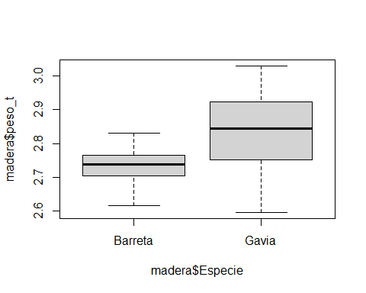

t.test(madera$Peso_g ~ madera$Especie, var.equal = T)

##   
## Two Sample t-test  
##   
## data: madera$Peso_g by madera$Especie  
## t = -3.4297, df = 38, p-value = 0.001469  
## alternative hypothesis: true difference in means between group Barreta and group Gavia is not equal to 0  
## 95 percent confidence interval:  
## -0.8690778 -0.2239222  
## sample estimates:  
## mean in group Barreta mean in group Gavia   
## 7.4825 8.0290

boxplot(madera$Lado_C ~ madera$Especie)

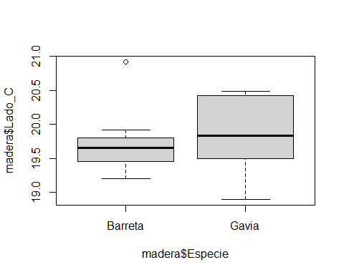

shapiro.test(madera$Lado_C)

##   
## Shapiro-Wilk normality test  
##   
## data: madera$Lado_C  
## W = 0.92731, p-value = 0.01318

bartlett.test(madera$Lado_C ~ madera$Especie)

##   
## Bartlett test of homogeneity of variances  
##   
## data: madera$Lado_C by madera$Especie  
## Bartlett's K-squared = 0.45707, df = 1, p-value = 0.499

which(madera$Lado_C > 20.5)

## [1] 23 30