EjercicioArañas.R

Usuario

2024-10-07

# Fatima Daniela Arriaga de la Cerda  
# 2070816  
#07/10/2024  
  
grupo <- gl(2, 12, labels = c("Foto", "Araña"))  
Niv_ans <- c(30, 35, 45, 40, 50, 35, 55, 25, 30, 45, 40, 50, 40, 35, 50,  
 55, 65, 55, 50, 35, 30, 50, 60, 39 )  
datos <- data.frame(grupo, Niv_ans)  
  
head(datos)

## grupo Niv_ans  
## 1 Foto 30  
## 2 Foto 35  
## 3 Foto 45  
## 4 Foto 40  
## 5 Foto 50  
## 6 Foto 35

tapply(datos$Niv_ans, datos$grupo, mean)

## Foto Araña   
## 40 47

boxplot(datos$Niv_ans ~ datos$grupo)

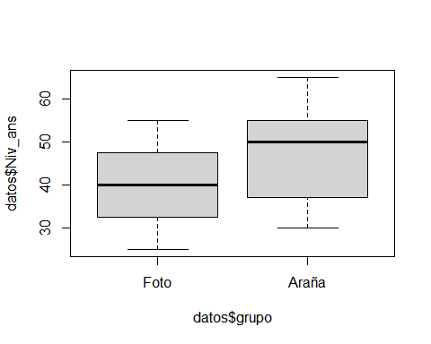

t.test(datos$Niv_ans ~ datos$grupo, var.equal = T)

##   
## Two Sample t-test  
##   
## data: datos$Niv_ans by datos$grupo  
## t = -1.6813, df = 22, p-value = 0.1068  
## alternative hypothesis: true difference in means between group Foto and group Araña is not equal to 0  
## 95 percent confidence interval:  
## -15.634222 1.634222  
## sample estimates:  
## mean in group Foto mean in group Araña   
## 40 47

t.test(datos$Niv_ans ~ datos$grupo, var.equal = T,  
 alternative = "greater")

##   
## Two Sample t-test  
##   
## data: datos$Niv_ans by datos$grupo  
## t = -1.6813, df = 22, p-value = 0.9466  
## alternative hypothesis: true difference in means between group Foto and group Araña is greater than 0  
## 95 percent confidence interval:  
## -14.14904 Inf  
## sample estimates:  
## mean in group Foto mean in group Araña   
## 40 47

t.test(datos$Niv_ans ~ datos$grupo, var.equal = T,  
 alternative = "less")

##   
## Two Sample t-test  
##   
## data: datos$Niv_ans by datos$grupo  
## t = -1.6813, df = 22, p-value = 0.05342  
## alternative hypothesis: true difference in means between group Foto and group Araña is less than 0  
## 95 percent confidence interval:  
## -Inf 0.1490421  
## sample estimates:  
## mean in group Foto mean in group Araña   
## 40 47

costal <- c(87.7, 80.01, 77.28, 78.76, 81.52, 74.2, 80.71, 79.5, 77.87, 81.94,   
 80.7, 82.32, 75.78, 80.19, 83.91, 79.4, 77.52, 77.62, 81.4, 74.89,  
 82.95, 73.59, 77.92, 77.18, 79.83, 81.23, 79.28, 78.44, 79.01, 80.47,   
 76.23, 78.89, 77.14, 69.94, 78.54, 79.7, 82.45, 77.29, 75.52, 77.21,   
 75.99, 81.94, 80.41, 77.7)  
  
mean(costal)

## [1] 78.91068

plot(density(costal),  
 main = "Densidad producto costal",   
 xlab = "Peso (kg) costales",  
 ylab = "Densidad",  
 col = "green",  
 lwd = 4)  
abline(v=mean(costal), col = "red", lwd = 4, lty = 4)  
abline(v = 80, col = "blue", lwd = 4, lty = 4)

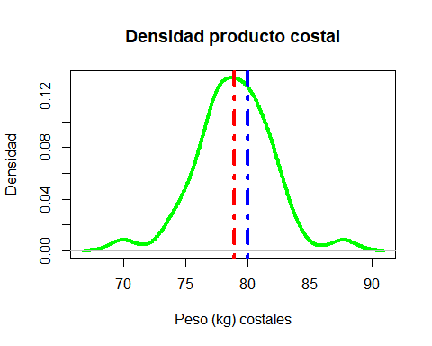

t.test(costal, mu = 80, alternative = "less")

##   
## One Sample t-test  
##   
## data: costal  
## t = -2.3644, df = 43, p-value = 0.01132  
## alternative hypothesis: true mean is less than 80  
## 95 percent confidence interval:  
## -Inf 79.68517  
## sample estimates:  
## mean of x   
## 78.91068