REPORT

Team name: 8Q1S  
Bakaev Eldos 210103094, Assan Nurislam 210103229, Aitkazin Anuar 210103136, Bolatbek Sagynysh 210107092, Mukangali Zhanibek 210103153

**TOPICS:**

* About
* ERD
* Procedures
* Functions
* Exceptions
* Triggers
* Conclusion

**ABOUT:**

A database for a clothing shop would store information about the items, customers, and orders. The database would typically have several tables, each with its own set of fields.

The items table would contain details about the clothing items available for sale, such as their types, size, and price. Each item would be assigned a unique identifier or PK.

The customers table would contain information about the shop's clients, including their name, contact information, and bank account. The bank account is connected with cards table, which table contains all info about cards, and also has address attribute. This table would contain and store all common info about customer with pk c_id

And Customer chooses clothes and add them into table basket where would be shown to amount of money to pay within an attribute called “Sum” and after transaction ended all info from basket goes to “Orders” table, which is table about all orders that customers have made and there is an attribute called “shipping_id” which connects this table with “Shipping” table

Shipping table would contain all orders that have to be delivered to customers with attribute like ‘address_id’ which is connected with customers table, so with that we know where the order should go

But besides in our database system we have a review or a rating system for items or clothes, with that all customers can write a review for a every item or simply give a rating

In conclusion we believe that our system provides helpful functions for a every service to satisfy all clients wants

**ERD:**

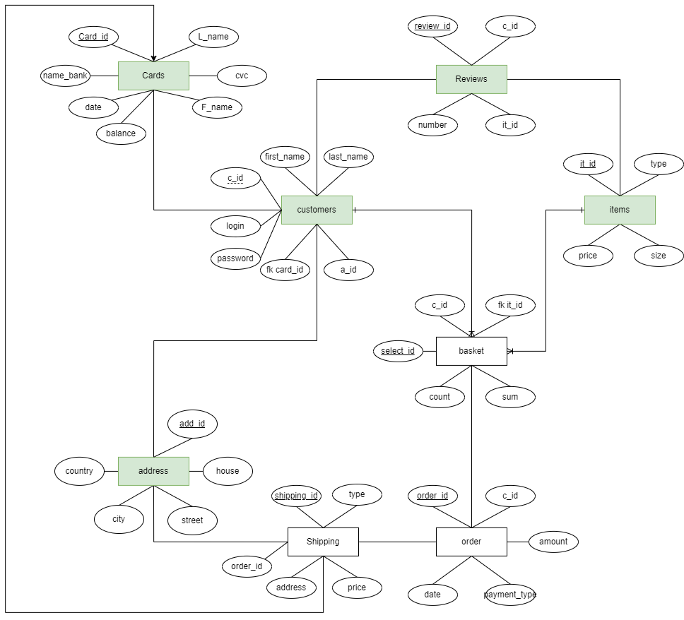

**PROCUDERS:**

Our database has various procedures like “add_address”, “add_bascket”, “add_item”, “balance_up”, “ordering”, “reg”, “sale”

Procedure “add_basket” is used to add items(clothes) to client’s basket

Procedure “add_address” is used to add various addresses of clients

Procedure “add_item” is for workers and is used to add new items to catalog

Procedure “balance_up ” is used to update client’s balance info

Procedure “ordering” is to confirm all items in basket to be an order

Procedure “reg” is for register new client’s profile in the site

Procedure “sale” is to make a sale or a discount to an item and is used mostly by workers

**FUNCTIONS**:

In our database we have a 3 functions like:

Function “Counter” returns a sum of all items in table “Basket”

Function “get_card_sum” returns

Function “basket_count” returns count of rows in table “basket”

**EXCEPTIONS:**

All exceptions are in procedures like length exceptions which used to prevent naming something least than 5 characters, and like “not_enough_money” exception which returns error if clients does not have enough money in card

**TRIGGERS:**

Trigger “ADDRESSES_row_count” returns count of rows as s stringline from table “Address” (before delete or insert or update on table addresses)

Triggers “add_ship” is for adding info from orders(if there is a shipping) to a table “Shipping” (after insert on table order)

Triggers “BASKET_row_count”, “CARDS_row_count”, “CUSTOMER_row_count”, “ITEM_row_count”, “ORDER_row_count”, “REVIEWS_rwo_count” are same with same function like trigger “ADDRESSES_row_count”

**FINAL:**

We hope that our work really solves a problem and would be helpful in real case scenarios

We created and made this to test our skills and improve it.

In conclusion we hope you enjoyed and find a new things

“8Q1S” team