Tabel Instrument

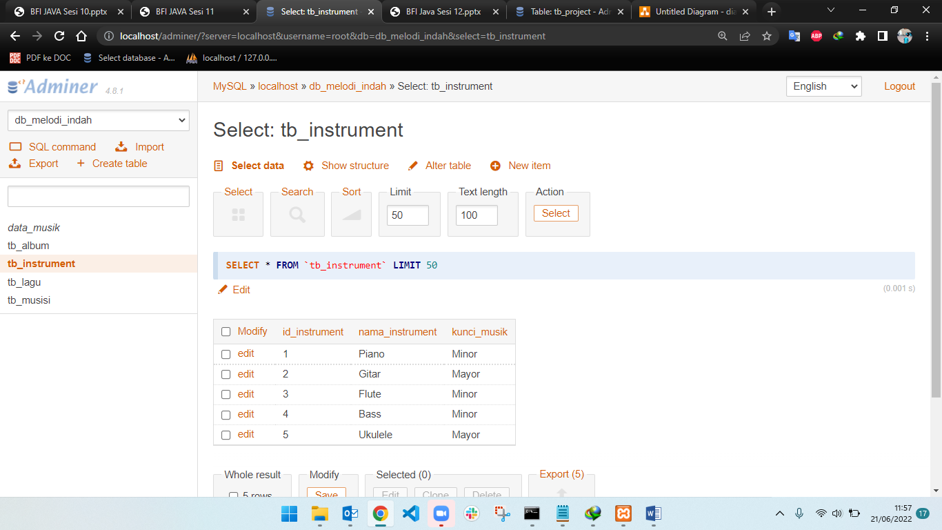

Tabel Musisi

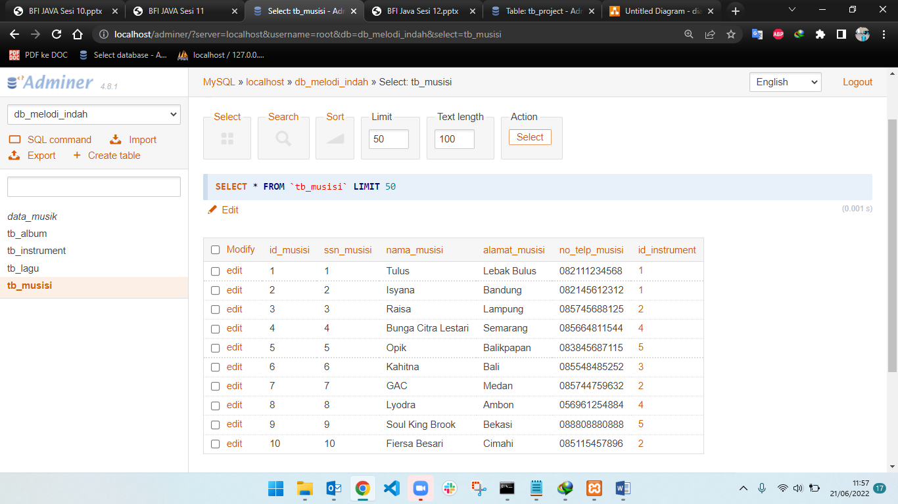

Tabel Album

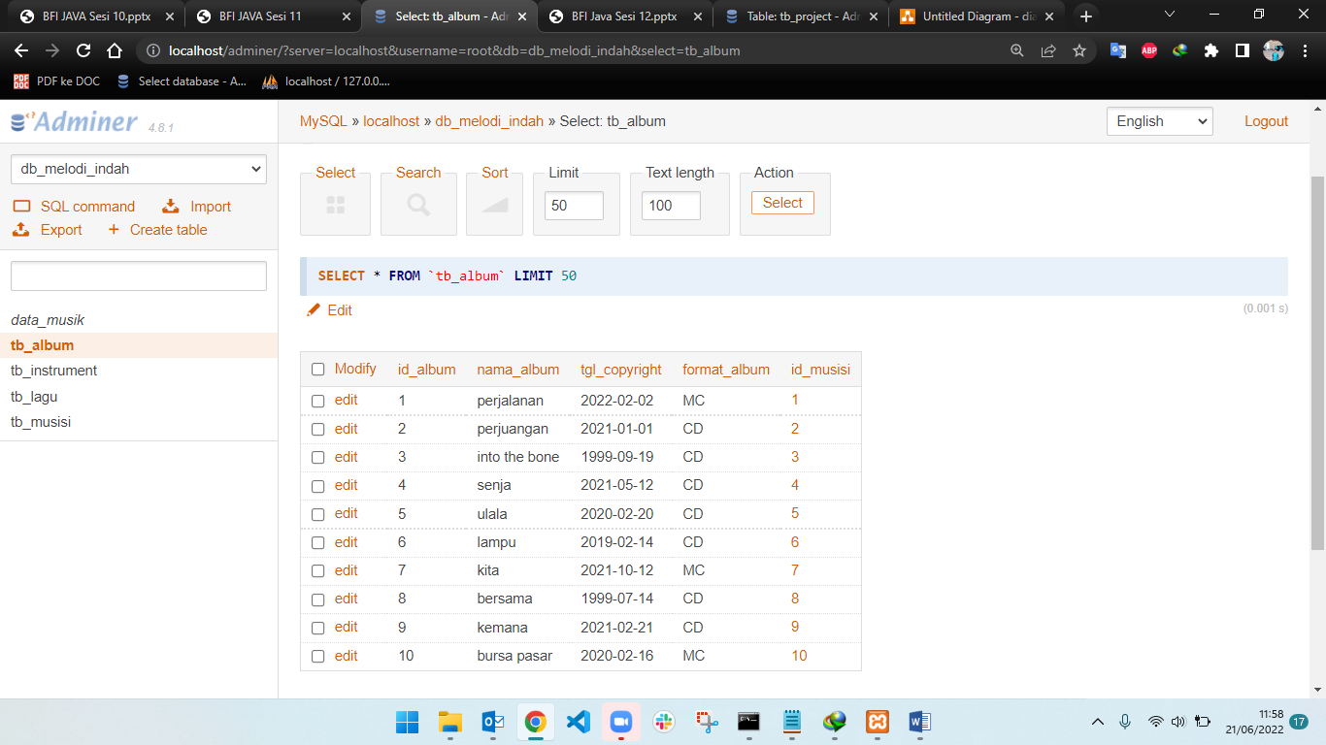

Tabel Lagu

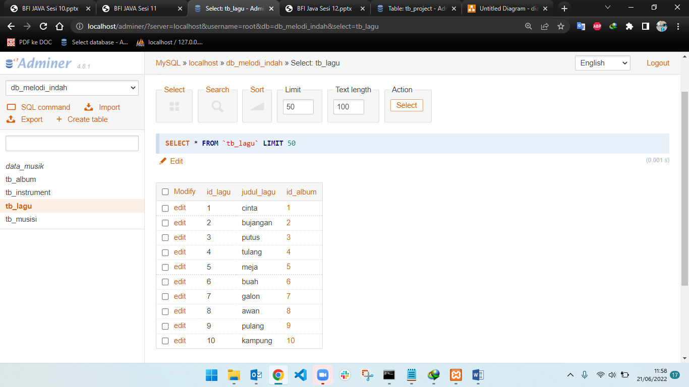

Create view data music

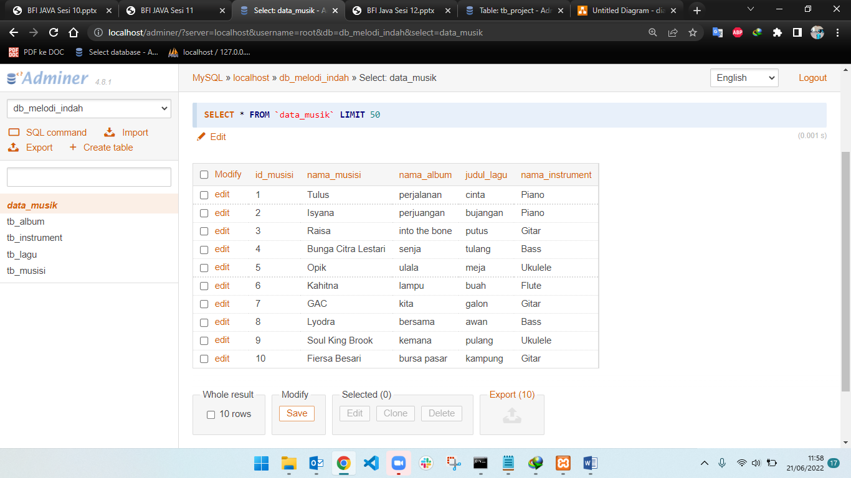

Query

-- Adminer 4.8.1 MySQL 5.5.5-10.4.24-MariaDB dump

SET NAMES utf8;

SET time_zone = '+00:00';

SET foreign_key_checks = 0;

SET sql_mode = 'NO_AUTO_VALUE_ON_ZERO';

DROP VIEW IF EXISTS `data_musik`;

CREATE TABLE `data_musik` (`id_musisi` int(11), `nama_musisi` varchar(50), `nama_album` varchar(50), `judul_lagu` varchar(50), `nama_instrument` varchar(50));

SET NAMES utf8mb4;

DROP TABLE IF EXISTS `tb_album`;

CREATE TABLE `tb_album` (

`id_album` int(11) NOT NULL AUTO_INCREMENT,

`nama_album` varchar(50) NOT NULL,

`tgl_copyright` date NOT NULL,

`format_album` enum('CD','MC') NOT NULL,

`id_musisi` int(11) NOT NULL,

PRIMARY KEY (`id_album`),

KEY `id_musisi` (`id_musisi`),

CONSTRAINT `tb_album_ibfk_1` FOREIGN KEY (`id_musisi`) REFERENCES `tb_musisi` (`id_musisi`)

) ENGINE=InnoDB DEFAULT CHARSET=utf8mb4;

TRUNCATE `tb_album`;

INSERT INTO `tb_album` (`id_album`, `nama_album`, `tgl_copyright`, `format_album`, `id_musisi`) VALUES

(1, 'perjalanan', '2022-02-02', 'MC', 1),

(2, 'perjuangan', '2021-01-01', 'CD', 2),

(3, 'into the bone', '1999-09-19', 'CD', 3),

(4, 'senja', '2021-05-12', 'CD', 4),

(5, 'ulala', '2020-02-20', 'CD', 5),

(6, 'lampu', '2019-02-14', 'CD', 6),

(7, 'kita', '2021-10-12', 'MC', 7),

(8, 'bersama', '1999-07-14', 'CD', 8),

(9, 'kemana', '2021-02-21', 'CD', 9),

(10, 'bursa pasar', '2020-02-16', 'MC', 10);

DROP TABLE IF EXISTS `tb_instrument`;

CREATE TABLE `tb_instrument` (

`id_instrument` int(11) NOT NULL AUTO_INCREMENT,

`nama_instrument` varchar(50) NOT NULL,

`kunci_musik` enum('Minor','Mayor') NOT NULL,

PRIMARY KEY (`id_instrument`)

) ENGINE=InnoDB DEFAULT CHARSET=utf8mb4;

TRUNCATE `tb_instrument`;

INSERT INTO `tb_instrument` (`id_instrument`, `nama_instrument`, `kunci_musik`) VALUES

(1, 'Piano', 'Minor'),

(2, 'Gitar', 'Mayor'),

(3, 'Flute', 'Minor'),

(4, 'Bass', 'Minor'),

(5, 'Ukulele', 'Mayor');

DROP TABLE IF EXISTS `tb_lagu`;

CREATE TABLE `tb_lagu` (

`id_lagu` int(11) NOT NULL AUTO_INCREMENT,

`judul_lagu` varchar(50) NOT NULL,

`id_album` int(11) NOT NULL,

PRIMARY KEY (`id_lagu`),

KEY `id_album` (`id_album`),

CONSTRAINT `tb_lagu_ibfk_2` FOREIGN KEY (`id_album`) REFERENCES `tb_album` (`id_album`)

) ENGINE=InnoDB DEFAULT CHARSET=utf8mb4;

TRUNCATE `tb_lagu`;

INSERT INTO `tb_lagu` (`id_lagu`, `judul_lagu`, `id_album`) VALUES

(1, 'cinta', 1),

(2, 'bujangan', 2),

(3, 'putus', 3),

(4, 'tulang', 4),

(5, 'meja', 5),

(6, 'buah', 6),

(7, 'galon', 7),

(8, 'awan', 8),

(9, 'pulang', 9),

(10, 'kampung', 10);

DROP TABLE IF EXISTS `tb_musisi`;

CREATE TABLE `tb_musisi` (

`id_musisi` int(11) NOT NULL AUTO_INCREMENT,

`ssn_musisi` int(11) NOT NULL,

`nama_musisi` varchar(50) NOT NULL,

`alamat_musisi` text NOT NULL,

`no_telp_musisi` varchar(13) NOT NULL,

`id_instrument` int(11) NOT NULL,

PRIMARY KEY (`id_musisi`),

UNIQUE KEY `ssn_musisi` (`ssn_musisi`),

KEY `id_instrument` (`id_instrument`),

CONSTRAINT `tb_musisi_ibfk_1` FOREIGN KEY (`id_instrument`) REFERENCES `tb_instrument` (`id_instrument`),

CONSTRAINT `tb_musisi_ibfk_2` FOREIGN KEY (`id_instrument`) REFERENCES `tb_instrument` (`id_instrument`)

) ENGINE=InnoDB DEFAULT CHARSET=utf8mb4;

TRUNCATE `tb_musisi`;

INSERT INTO `tb_musisi` (`id_musisi`, `ssn_musisi`, `nama_musisi`, `alamat_musisi`, `no_telp_musisi`, `id_instrument`) VALUES

(1, 1, 'Tulus', 'Lebak Bulus', '082111234568', 1),

(2, 2, 'Isyana', 'Bandung', '082145612312', 1),

(3, 3, 'Raisa', 'Lampung', '085745688125', 2),

(4, 4, 'Bunga Citra Lestari', 'Semarang', '085664811544', 4),

(5, 5, 'Opik', 'Balikpapan', '083845687115', 5),

(6, 6, 'Kahitna', 'Bali', '085548485252', 3),

(7, 7, 'GAC', 'Medan', '085744759632', 2),

(8, 8, 'Lyodra', 'Ambon', '056961254884', 4),

(9, 9, 'Soul King Brook', 'Bekasi', '088808880888', 5),

(10, 10, 'Fiersa Besari', 'Cimahi', '085115457896', 2);

DROP TABLE IF EXISTS `data_musik`;

CREATE ALGORITHM=UNDEFINED SQL SECURITY DEFINER VIEW `data_musik` AS select `tm`.`id_musisi` AS `id_musisi`,`tm`.`nama_musisi` AS `nama_musisi`,`ta`.`nama_album` AS `nama_album`,`tl`.`judul_lagu` AS `judul_lagu`,`ti`.`nama_instrument` AS `nama_instrument` from (((`tb_musisi` `tm` join `tb_album` `ta` on(`tm`.`id_musisi` = `ta`.`id_musisi`)) join `tb_lagu` `tl` on(`ta`.`id_album` = `tl`.`id_album`)) join `tb_instrument` `ti` on(`ti`.`id_instrument` = `tm`.`id_instrument`)) order by `tm`.`id_musisi`;

-- 2022-06-21 04:59:36