My first Markdown demo: European stock Indices between 1991-1998

Kathy Arriola

3/11/2020

This is my first Markdown document.

library(datasets)  
data(EuStockMarkets)  
summary(EuStockMarkets)

## DAX SMI CAC FTSE   
## Min. :1402 Min. :1587 Min. :1611 Min. :2281   
## 1st Qu.:1744 1st Qu.:2166 1st Qu.:1875 1st Qu.:2843   
## Median :2141 Median :2796 Median :1992 Median :3247   
## Mean :2531 Mean :3376 Mean :2228 Mean :3566   
## 3rd Qu.:2722 3rd Qu.:3812 3rd Qu.:2274 3rd Qu.:3994   
## Max. :6186 Max. :8412 Max. :4388 Max. :6179

First step is to download the data. The data I will be using the data set already available in RStudio.The data is the daily closing prices of major European stock Indices between 1991-1998. The main objective of this Markdown demo is to use this as a self-taught demonstration. I will also use this data further explore the trends of the stock market throughout history.

plot(EuStockMarkets,main="European Stock Market from 1991-1999")

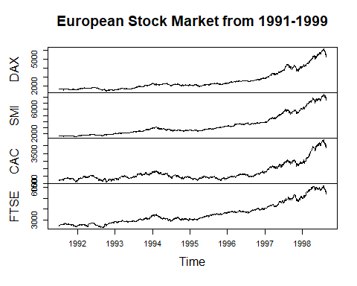

Here is some general exploritory analysis. I started with plot of the data and showing the trends between the stock market. Ther breakdown is based on the daily closing prices. These data points excluded except for weekends and holiday. The four European stock exchanges: the DAX (Germany), the SMI (Switzerland), the CAC (France), and the FTSE (UK).

ts.plot(EuStockMarkets, col = 1:4, xlab = "Year", ylab = "Prices in Euro", main = "European Stock Indices")  
legend("topleft", colnames(EuStockMarkets), lty = 1, col = 1:4, bty = "n")

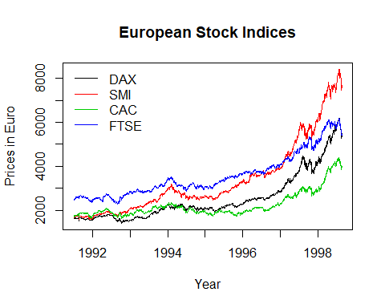

The chart above highlights the prices of each European stock market. The color Germany is represented in black, Switzerland in red, France in green and UK in blue. There is clear an exponential growth from 1991. It appears Switzerland had the most growth within that recorded period of time.