Questions

Visualization Design Principles
- What are Gestalt Principles of Visual Perception?
They are a set of psychological rules that describe how humans naturally organize and interpret visual information. According to Gestalt theory, the human brain automatically groups visual elements based on certain characteristics such as similarity, and continuity. These principles explain how viewers interpret shapes, patterns, and relationships in visual environments, allowing them to quickly understand complex visual information.
- Why are Gestalt principles important in visualization design?
Because it helps the audience to have a better and easier perception of the data. It guides the data arrangement somehow that the patterns get more recognized.
- What are the main Gestalt principles?
Proximity: Objects that are close to each other are perceived as related or belonging to the same group.
Similarity: Elements similar in matter of color, shape, or size, are perceived as part of the same group.
Continuity: The human eye tends to follow continuous lines or patterns rather than sudden changes.
Common Fate: Elements moving in the same direction are perceived as related or grouped together.

Dashboards and Storytelling
- What is a dashboard?
a dashboard is a group of sheets and is used widely as part of storytelling. It contains charts, KPI’s and important information. Dashboards allow the users to have a quick monitoring of the data.
- What is the purpose of a dashboard?
The main purpose of a dashboard is to provide a clear and quick overview of important information so that users can monitor performance. Dashboards help users track key metrics, trends or problems, and evaluate progress toward goals. By presenting data visually, dashboards reduce the time needed to analyze large amounts of data and allow users to focus on the most important aspects of the information.
- What makes a good dashboard?
A good dashboard presents information clearly, accurately, and efficiently. It should focus on the most important metrics and avoid unnecessary or distracting elements. Effective dashboards are easy to read, visually organized, and designed so that users can quickly understand the information being presented.

Score Function and Sampling Bias in Langevin Dynamics
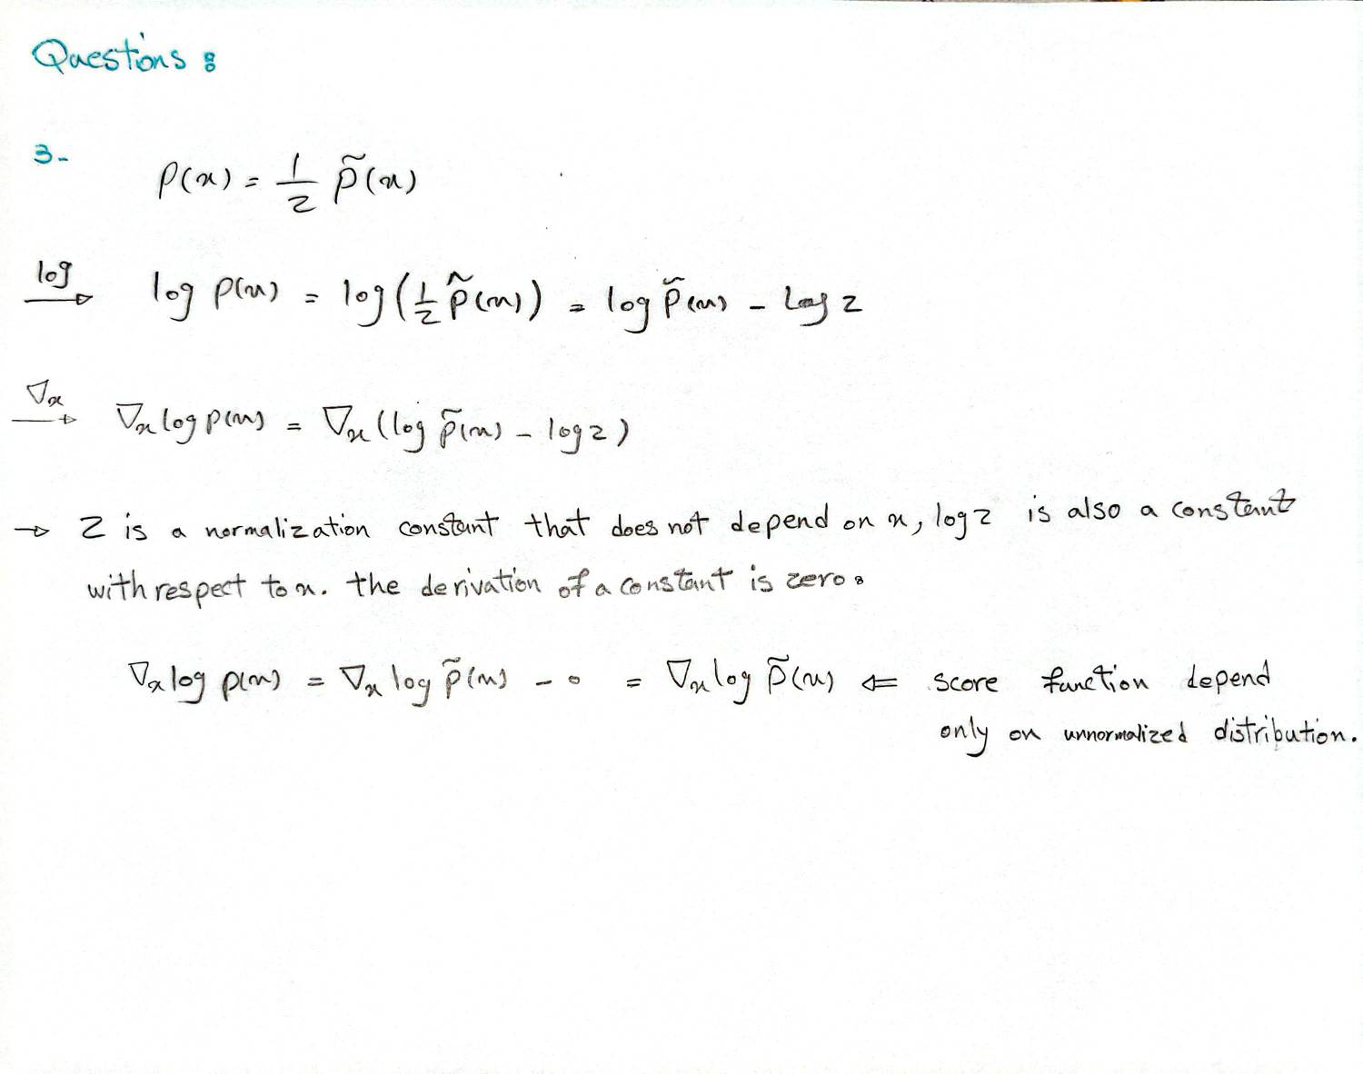
Explain why this property is important for Langevin Dynamics:
In many practical machine learning and Bayesian inference problems, the normalization constant Z=∫p~(x) dx is computationally intractable to evaluate, especially in high-dimensional spaces. Because the score function cancels out Z, Langevin Dynamics can simulate samples from the target distribution p(x) using only the easily computable unnormalized density p~(x) and its gradient.
Explain at least three reasons why this bias may occur (Relating to the experiment):
Even with the correct target distribution, Langevin samples can yield biased estimates due to:
- Discretization Error (Step Size ϵ): Standard Langevin Dynamics uses continuous time, but in computational implementations, we approximate it using discrete steps of size ϵ (Euler-Maruyama method). This Unadjusted Langevin Algorithm (ULA) causes the Markov chain to converge to an approximate distribution q(x) rather than the exact target p(x).
- Insufficient Burn-in (Finite T): The Markov chain needs time to “forget” its starting position and reach its stationary distribution. In your experiment, particles started from a Uniform distribution. If the total number of iterations T is too small, the final samples will still be heavily influenced by this initial Uniform distribution, leading to biased estimates.
- Sample Autocorrelation: The standard estimators for variance assume independent and identically distributed (i.i.d.) samples. Because Langevin Dynamics generates a Markov chain, sequential samples are highly correlated. If you compute statistics using sequential samples without “thinning” (skipping steps between collected samples), your variance estimates will be biased.

Markov Dependence in Langevin Sampling
Explain why Langevin samples are generally dependent:
Langevin samples are generated using the update rule:
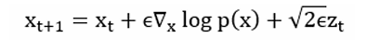​
By definition, the position of the sample at time step t+1 is explicitly calculated using the position at the immediate prior time step t. This creates a Markov chain where each sample is directly correlated to the previous one, breaking the independence assumption found in direct sampling methods like NumPy’s multivariate normal generator.
How does this dependence affect: variance estimation, standard error, and confidence intervals?
Because the samples are positively correlated (they cluster near each other across sequential steps):
- Variance Estimation: Standard variance formulas assume i.i.d. samples. Using them on autocorrelated Markov chain samples typically results in an underestimation of the true variance.
- Standard Error: The standard error of the mean calculation (σ/$\sqrt{N})$assumes N independent observations. Because of dependence, the “effective sample size” (Neff) is much smaller than the actual number of steps N. Therefore, standard formulas will severely underestimate the true standard error.
- Confidence Intervals: Because the standard error and variance are underestimated, the calculated confidence intervals will be too narrow. This gives a false sense of precision, and the true population parameter will fall outside the confidence interval more often than the stated confidence level implies.

The Role of Data Labels
data visualization serves as the critical rule for understanding the data’s pattern. When we want to make a chart and try to tell a story with data. One of the biggest choices we have to make is whether to write the labels on the chart, or leave them off.

When should omit data labels.
we should leave labels off when we want people to focus on the overall trend or pattern. If we have a lot of data points, putting a number on every single one will make our chart look like a mess. When we leave the labels off, viewers can just look at the shape of the data and use the tab on beside to get a general idea of the numbers.

When to Keep Labels ON
we should use labels when exact precision matters. Sometimes, the general shape of the data isn’t enough. If the audience needs to know exact figures to make a decision, we should put the labels right on the data points. This saves them from having to guess the value by drawing an imaginary line over to the side axis.

Where to Draw the Line: Clutter vs. Clarity
It becomes Clutter when: The labels overlap, hide the actual chart, or don’t really add anything new. If the exact number doesn’t change the story, adding the label just makes the chart ugly and hard to read. It becomes Clarity when: The specific number is the story. If someone cannot easily guess the number by looking at the side axis, and that number is super important, the label creates clarity.
Example (No label)
In a scatter plot graph showing the size and price of 10,000 different houses, the goal is just to show that bigger houses generally cost more money. If we try to put a price tag label on all 10,000 points, the chart would be completely unreadable.
Example (labeled)
in a pie chart about show the share of different groups of people’s share in taxing, the label is crucial. Because we can not have a good judgment on the angles and the audience may have a wrong interpretation of the numbers.

Cognitive Load and Visual Simplicity

In the context of data visualization, the single most effective step for reducing cognitive load is often the elimination of structural visual clutter—specifically, removing heavy chart borders and background gridlines. This step directly applies concept of the Data-Ink Ratio, which argues that every drop of ink on a graphic should represent actual data. Gridlines, axis lines, and bounding boxes are “non-data ink.” By stripping them away (or making them very faint), you maximize the proportion of ink used for the data itself.
The Impact of Removing Structural Visual Clutter
Every visual element placed on a dashboard or chart demands a fraction of the viewer’s working memory to process. When designers include heavy bounding boxes (chart borders) and prominent background gridlines, they inadvertently create visual competition. The viewer’s brain must actively work to parse which lines represent actual, meaningful data and which are merely the structural scaffolding of the graph.
- Chart Borders: Bounding boxes enclose data artificially. The human eye is naturally drawn to high-contrast lines and sharp corners. When a chart is framed by a dark, solid border, that border draws attention away from the data points within it. Removing the border allows the white space to naturally frame the visualization, creating a cleaner, more modern aesthetic that breathes and guides the eye directly to the data.
- Background Gridlines: Thick or dark gridlines are particularly detrimental because they physically intersect with the data—cutting across line charts or slicing through bar graphs. This intersection creates visual interference and can even cause optical illusions that make the data harder to read.
By removing these elements entirely—or, when necessary for precision, mutating gridlines to a very faint, light gray—designers dramatically lower the “noise-to-signal” ratio. This decluttering process ensures that the viewer’s cognitive resources are spent solely on interpreting the trends, patterns, and insights the data reveals, rather than untangling the data from its container.

