Postman

Get Join

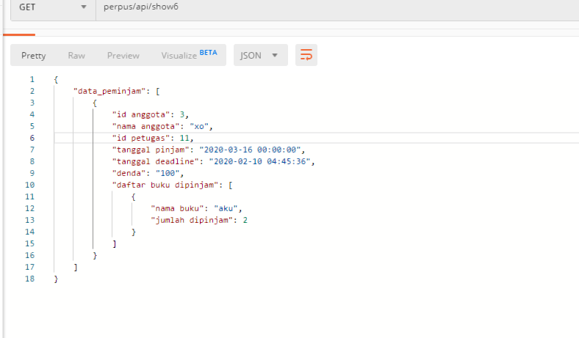

Insert peminjaman

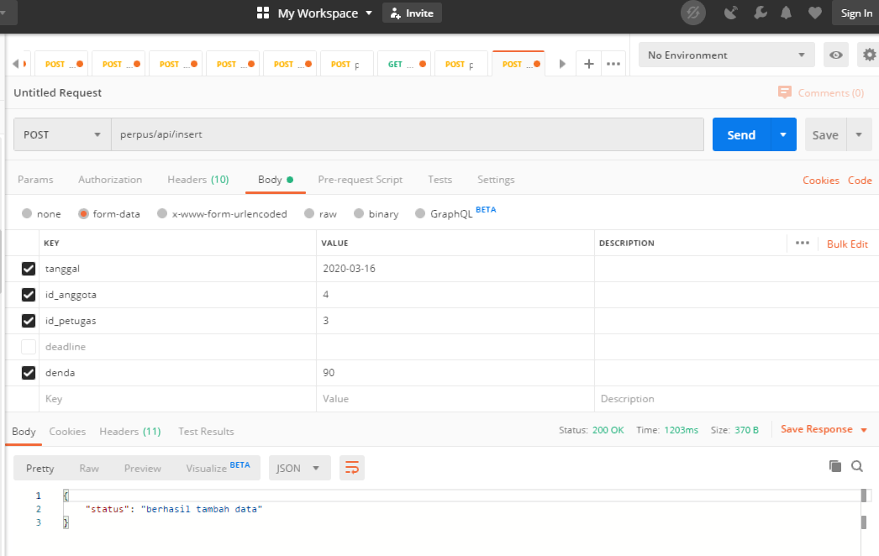

Insert detail peminjaman

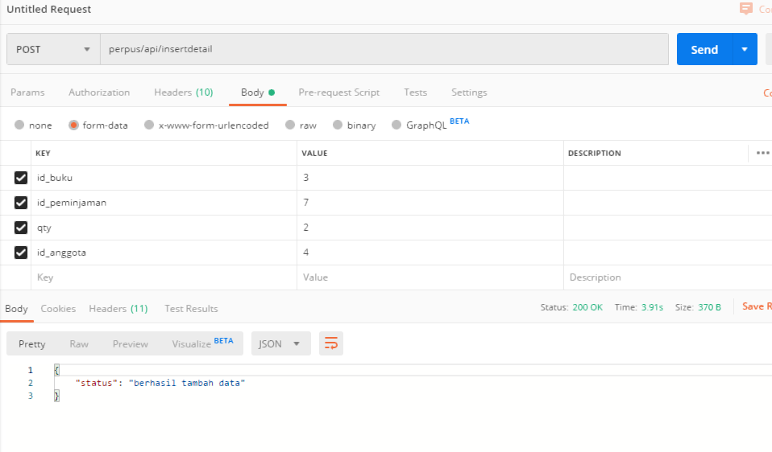

Script

Controller

Detailcontroller

<?php

namespace App\Http\Controllers;

use Illuminate\Http\Request;

use Auth;

use DB;

use Session;

use App\peminjaman;

use App\detail;

use Validator;

class detailcontrolle extends Controller

{

public function detail(Request $req){

    $Validator=Validator::make($req->all(),

    [

    'id_peminjaman'=>'required',

    'id_anggota'=>'required',

    'qty'=>'required',

    ]);

    if($Validator->fails()){

        response()->json('invalid input') ;

    }

    if(Auth::user()->levels=="admin" ){

        $simpan=detail::create([

            'id_buku'=>$req->id_buku,

            'qty'=>$req->qty,

            'id_peminjaman'=>$req->id_peminjaman,

            'id_anggota'=>$req->id_anggota

        ]);

        if($simpan){

            return response ()->json(['status'=>'berhasil tambah data']);

        }

        else{

            return response ()->json(['status'=>'gagal']);

        }

            }

            else{

                return response()->json(['status'=>'gagal :(']);

            }

        }

}

Peminjaman controller

<?php

namespace App\Http\Controllers;

use Illuminate\Http\Request;

use Auth;

use DB;

use Session;

use App\peminjaman;

use App\detail;

use App\anggota;

use Validator;

class peminjamancontroller extends Controller

{

public function peminjaman(Request $req){

    $Validator=Validator::make($req->all(),

    [

    'tanggal'=>'required',

    'id_anggota'=>'required',

    'id_petugas'=>'required',

    'deadline'=>'required',

    'denda'=>'required'

    ]);

    if($Validator->fails()){

        response()->json('invalid input') ;

    }

    if(Auth::user()->levels=="admin" ){

        $date=date("y-m-d H:i:s");

        $deadline=date("y-m-d H:i:s",strtotime('+7 days',strtotime($date)));

        $simpan=peminjaman::create([

            'tanggal'=>$req->tanggal,

            'id_anggota'=>$req->id_anggota,

            'id_petugas'=>Auth::user()->id,

            'deadline'=>$deadline,

            'denda'=>$req->denda

        ]);

        if($simpan){

            return response ()->json(['status'=>'berhasil tambah data']);

        }

        else{

            return response ()->json(['status'=>'gagal']);

        }

            }

            else{

                return response()->json(['status'=>'gagal :(']);

            }

        }

        public function show($id){

            $datapinjam = DB::table('table_peminjaman')->join('table_anggota','table_peminjaman.id_anggota','=','table_anggota.id')

                          ->where('table_peminjaman.id','=',$id)

                          ->select('table_peminjaman.*','table_anggota.*')->first();

            $data_peminjam = array();

                $buku = DB::table('table_detail_peminjaman')->join('table_buku','table_detail_peminjaman.id_buku','=','table_buku.id')

                        ->where('table_detail_peminjaman.id_peminjaman','=',$id)

                        ->select('table_detail_peminjaman.*','table_buku.*')->get();

                $arr_buku = array();

                foreach($buku as $b){

                    $arr_buku[] = array(

                        'nama buku' => $b->judul,

                        'jumlah dipinjam' => $b->qty

                    );

                }

                $data_peminjam[] = array(

                    'id anggota' => $datapinjam->id_anggota,

                    'nama anggota' => $datapinjam->nama_anggota,

                    'id petugas' => $datapinjam->id_petugas,

                    'tanggal pinjam' => $datapinjam->tanggal,

                    'tanggal deadline' => $datapinjam->deadline,

                    'denda' => $datapinjam->denda,

                    'daftar buku dipinjam' => $arr_buku

                );

            return response()->json(compact('data_peminjam'));

        }

}

Model

Peminjaman

<?php

namespace App;

use Illuminate\Database\Eloquent\Model;

class peminjaman extends Model

{

    protected $table="table_peminjaman";

    protected $primaryKey="id";

    protected $fillable=['tanggal','id_anggota','id_petugas','deadline','denda'];

}

Detail

<?php

namespace App;

use Illuminate\Database\Eloquent\Model;

class detail extends Model

{

    protected $table="table_detail_peminjaman";

    protected $primaryKey="id";

    protected $fillable=['id_peminjaman','id_buku','qty','id_anggota'];

}