CS4121 Assignment 8 Due: 11/07/17

- (20 points) Suppose a TCP segment of size 3000 bytes (including data plus application overhead plus TCP headers) is passed to IP for delivery across three networks of the Internet (i.e. from the source host to a router say R1 to another router say R2 to the destination host).

The first network has an MTU of 1260 bytes; the second network has an MTU of 880 bytes; and the third network has an MTU of 1100 bytes. Each network’s MTU gives the size of the largest IP datagram that can be carried in a data-link layer frame. Assume all IP headers are 20 bytes. Give value of the flag, the length (header + data) and offset fields of the sequence of fragments delivered to the network layer at R1, R2, and the destination host. It is important to be reminded that segment reassembly is only done at the final destination host.
You must justify your answers. No justification=0 point.
MTU=1260 bytes

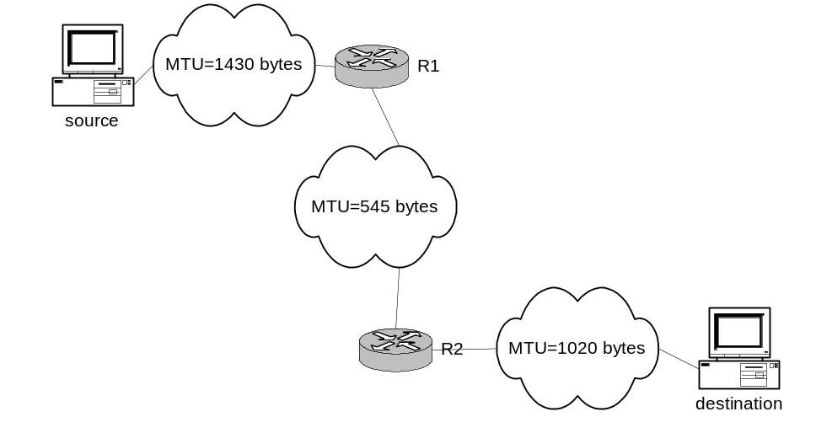
MTU=880 bytes
MTU=1100 bytes

For each of R1, R2, and the destination host, I am expecting a table like following.
Flag | Offset | Length
? | ? | ?
… | … | …

R1 (MTU = 1260 b)
Flag Offset Length
1 0 1260
1 155 1260
0 310 540

Justification:
- 1260 – 20 header bytes = 1240 bytes, which is divisible by 8
- Length = message bytes + 20 TCP header bytes; 1240 becomes 1260 and 520 becomes 540
- Offset is 0 to start, and then the total amount sent divided by 8 afterwards

R2 (MTU = 880 b)
Flag Offset Length
1 0 876
1 107 404
1 155 876
1 262 404
1 310 540

Justification:
- 880 – 20 header bytes = 860 bytes, which is not divisible by 8, so we go to the next closest, which is 856 bytes
- Length = message bytes + 20 TCP header bytes; 856 becomes 876 and 384 becomes 404
- Finally, the third fragment is 540, which is less than 1100 so it goes through without problem (560 with header bytes)

Destination (MTU = 1100 b)
Flag Offset Length
1 0 876
1 107 404
1 262 876
1 497 404
1 780 560

Justification:
- 1100 – 20 header bytes = 1080 bytes, which is divisible by 8
- Length = message bytes + 20 TCP header bytes; 856 becomes 876 and 384 becomes 404
- Finally, the last fragment is 540, which is less than 1100 so it goes through without problem (560 with header bytes)
- Offset is 0 to start, and then the total amount sent divided by 8 afterwards

- (8 points) Path MTU is the smallest MTU of any link on the current path (route) between two hosts. Assume we could discover the path MTU of the path used in the previous question, and that we use this value as the MTU for all the path fragments. Redo the previous question.
You must justify your answers. No justification=0 point.

R1 (MTU = 880 b)
Flag Offset Length
1 0 876
1 107 404
1 155 876
1 262 404
0 310 540

R2 (MTU = 880 b)
Flag Offset Length
1 0 876
1 107 404
1 155 876
1 262 404
0 310 540

Destination (MTU = 880 b)
Flag Offset Length
1 0 876
1 107 404
1 155 876
1 262 404
0 310 540

Justification:
- 880 – 20 header bytes = 860 bytes, which is not divisible by 8, so we go to the next closest, which is 856 bytes
- Length = message bytes + 20 TCP header bytes; 856 becomes 876 and 384 becomes 404
- Finally, the third fragment is 540, which is less than 880 so it goes through without problem (560 with header bytes)

