CS4121 Assignment 7 Due: 10/27/17
- (15 points) Assuming TCP Reno is the protocol experiencing the behavior described below.

- Initial Threshold = 36 segments
- At the transmission round that the 40th segment is sent, segment loss is detected by a timeout.
Note: pay attention here since it is not necessarily at the 40th transmission round when timeout occurs. You need to figure out the transmission round like what we did in class.
- At the 23rd transmission round, segment loss is detected by triple duplicate ACKs.
Plot the evolution of the TCP’s congestion window from the 1st through the 30th transmission round.

On the curve, mark clearly the transmission round and the congestion window size at the 1st point, the last point, and all the turning points. E.g. at the 1st point, you should mark (1,1).

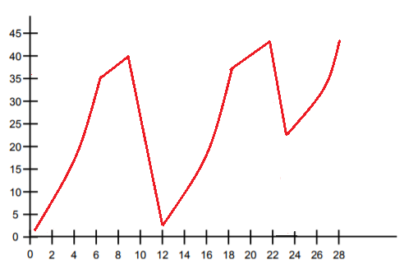

- (10 points) Let’s examine TCP Reno from a closer perspective again.
Suppose sender is in its slow start phase. Assume MSS = 2000bytes, CongWin = 4000bytes, LastByteACKed = 3000, LastByteSent = 7000. Assume each of the ACKs acknowledges exactly 1 MSS, or 2000 bytes. Sender always sends the largest allowed number of bytes and each packet the sender sends is exactly of size 1 MSS. Fill up the following chart to show the values of MSS, CongWin, LastByteACKed(LBA), LastByteSent(LBS), and RightWallofCongestionWindow(RightWall) after each of the next 6 ACKs received and new segments sent.

Hint: Among the 6 ACKS received, 2 ACKs were received in one RTT and 4 ACKS were received in the next RTT.

After ACK | MSS | CongWin | LBA | LBS | RightWall
1st | 2000 | 4000 | 3000 | 7000 | 7000
2nd | 4000 | 6000 | 5000 | 11000 | 11000
3rd | 6000 | 8000 | 7000 | 15000 | 13000
4th | 8000 | 10000 | 9000 | 19000 | 19000
5th | 10000 | 12000 | 11000 | 23000 | 23000
6th | 12000 | 14000 | 13000 | 27000 | 27000

Use diagrams similar to what I drew on the board in class to justify your answers above … Remember, no justification = 0 point.

1 | 2 | 3 | 4
3 | 4 | 5 | 6 | 7 | 8
5 | 6 | 7 | 8 | 9 | 10| 11
7 | 8 | 9 | 10| 11| 12| 13| 14| 15
9 | 10| 11| 12| 13| 14| 15| 16| 17| 18 | 19
11| 12| 13| 14| 15| 16| 17| 18| 19| 20 | 21| 22| 23|

