Mobile App Development

With

Ionic and AngularJS

(Single codebase for Multiple Platform)

L.Aswin

B.Sc., Computer Science
Madura College

Madurai, India
arronissac@gmail.com

www.aswin.esy.es

Abstract—

Ionic is an HTML5 mobile app development framework targeted at building hybrid mobile apps. Hybrid apps have many benefits over pure native apps, specifically in terms of platform support, speed of development, and access to 3rd party code.

- INTRODUCTION

Android, IOS and Windows Phone are some of the most popular Mobile Operating Systems nowadays. There are so many devices use these OS, even the devices from small phone manufacturers use android OS. Of course, there is no need to talk too much about the popularity of these three OS, everyone is already know right? Let’s talk about the main topic of this book, creating a mobile app. In this , i don’t want to talk about java nor Objective-C, which is the language used to develop android and IOS native application. Instead we’ll talk about Developing Hybrid Application using the power of Javascript (especially AngularJS) and a promising brand new

framework called Ionic.

  - WHY WE NEED A MOBILE APP?

- Customer Engagement and Loyalty

It is the best way to engage your customers while they are IN your business or store, or while they are away from it. With easy sharing capabilities, you could easily engage users that are not even on your app, through your loyal customers..

B. Overcome Competition

In order to stay on top of the competition, you must have a mobile application. A mobile-friendly website may not cut it.

Measures proportionately more than are customary. This measurement and others are deliberate, using specifications

C. Promotion

Mobile coupons and location-based push notifications will let your customers know when there is a great promotion going on, and it will likely bring more customers in.

- WHAT IS IONIC?

Ionic is open source framework used for developing mobile applications. It provides tools and services for building mobile UI with native look and feel. Ionic framework needs native wrapper to be able to run on mobile devices.

Ionic Framework is an Advanced Mobile App Framework which utilizes AngularJS for the application to be fully functional. It comes with command line utility to start a project and build the code into installable native app. When you a standard native Framework for packaging web app into installable native app. There is another project called phonegap which is based on cordova. Both phonegap and cordova have almost the same functionality, which is why some people assume that cordova = phonegap. Ionic comes with a lot of components that can be used to create nice looking UI, including CSS and Javascript Component. You can read more about the components by visiting its Documentation. We will also talk about several components in this book and learn about how the components work.install Ionic, you will also install cordova. Apache Cordova is

A. Hybrid vs Native Application

We will use AngularJS and Ionic to Develop mobile App. It’s mean, the app that we created is a hybrid app. So, what is hybrid app? and What is the different between hybrid and native apps? And why should we choose hybrid over native app? We will talk about it soon.

The old debate about which best between Hybrid and Native Application is already been around for years. In case you don’t know yet, here are the differences between the two:

  - Native app refers to app built for specific operating system and can be accessed only from dedicated app store

  - Hybrid app on the other hand, refers to app built for several operating systems and distributed across multiple app store.

  - If you want to develop native apps for several operating systems, you need to develop for each OS one by one.

  - On the other hand, if you want to develop hybrid apps for several OS, you only need to develop once.

  - Native apps are coded in the native language of the device (e.g. Java For Android and Objective-C for IOS).

  - Hybrid apps are coded with HTML, CSS and JavaScript.

  - Native apps run directly on the device.

  - Hybrid apps run through an invisible browser that is packaged into a native application.

- Install Ionic

Ionic comes with a convenient command line utility to start, build, and package Ionic apps. To install it, simply run:

$ sudo npm install -g ionic

C. Create the project

Now, we need to create a new Cordova project somewhere on the computer for the code for our app:

$ ionic start todo blank

That will create a folder called todo in the directory the command was run. Next, we will go into that directory and list the contents. Here is what the outer structure of your Ionic project will look like:
$ cd todo && ls
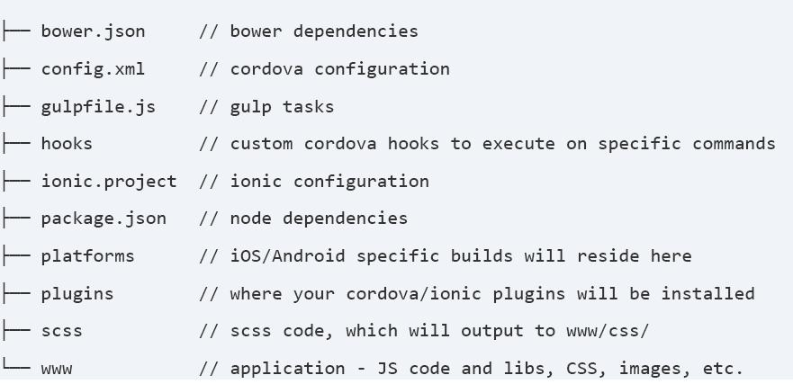

D. Configure Platforms

Now, we need to tell ionic that we want to enable the iOS and Android platforms. Note: unless you are on MacOS, leave out the iOS platform:

$ ionic platform add ios

For Android,

$ ionic platform add android

E. Test it out

Just to make sure the default project worked, try building and running the project (substitute ios for android to build for Android instead):

$ ionic build ios

$ ionic emulate ios

For Android,

$ ionic build android

$ ionic emulate android

IV. INTRODUCTION TO ANGULARJS

AngularJS is a javascript framework originaly for creating single page web application. Single page mean when you click a link within the application, the browser won’t reload. It’s also meaning the browser only access one HTML files to run entire application. However, from the user’s point of view, the page still looks like have multiple pages, with no browser reload when transitioning between pages.

When talk about AngularJS, some people may assume that AngularJS is a JQuery plugin or has dependency with JQuery, but actually it’s not. You don’t need JQuery to play with AngularJS, just AngularJS itself. All you need to do is download the the assets (angular.js file), then refer it from your HTML file and you’re ready to go.

A. Why AngularJS needed?

There are several feature that make AngularJS a very awesome frameworks, Here are some of them:

- Two Way Data Binding :

This is a really awesome feature of AngularJS. With this feature, you don’t have to put data into the view manually. Everytime a data changed inside a controller, it will also change in the view which uses the controller and vice versa. When you use Two Way Data Binding, You’ll feel like you have created ajax functionality with a really easy way.

2) The Directive:

Directive is an HTML extension that allows us to create new behaviours. The very basic directive we know is called ngModel. It allows us to display a variable value directly to the screen as well as set the variable value via input text.

3) Services:

Services are javascript functions which responsible to do a spesific tasks. Services are created to do a specific task only, which make them maintainable and testable as an individual Entity.

4) Dependency Injection:

5) Dependency Injection:

The whole angularJS apps is linked together with Dependency Injection. And when testing apps with unit test, we usually mock some data into a function. Here is Dependency Injection can help to make things easier.

B. MVC concept

MVC is nothing but a Model View Controller.

- Layers

    - View: visual appearance (declarative language)

    - Model: Data model of the app (javascript objects)

    - Controller: Add behavior (impressive language)
- Workflow

  - User interacts with the view changes the model calls controller(data binding)

  - Controller manipulates model, interacts with server

  - Angularjs detects model changes and updates the view (two way data binding)
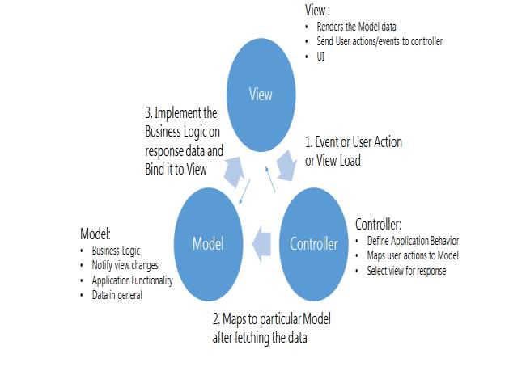

- CONCLUSION

Within Controllers and Filters we can call services using dependency injection. Simply type the name of the service as function parameter and you’re ready to use the services inside the function

Ionic is open source framework used for developing mobile applications. It provides tools and services for building mobile UI with native look and feel. Ionic framework needs native wrapper to be able to run on mobile devices

REFERANCE

- Ionic, April 2015. (available: http://ionicframework.com/ )

- LigerMobile, . (available: http://reachlocal.github.io/liger/ )

- Why Ionic. (available: http://coenraets.org/blog/2014/06/qcon-new-york-slides-creating-native-like-mobile-apps-with-cordova-angularjs-andionic/ )

- Angular js MVC, AngularJS with TypeScript and Windows Azure Mobile Services

- Cihad Horuzoðlu, “(available: http://cihadhoruzoglu.com )

- "How 2015 Went for Ionic". The Official Ionic Blog. January 5, 2016.

- Asep Edi Kurniawan. (2015-05-18). Leanpub book. (2nd ed.) [Online]. Available: http://leanpub.com/angularjs-ionic

- Sergey N. Bolshchikov. New ProImage, 2012. (2nd ed.) [Online]. Available:http://bolshchikov.net, sergey.bolshchikov@newproimage.com

- Sarah Perez (10 March 2014). "Drifty, Makers Of The Ionic Mobile Framework, Raise $1 Million".

- "Top JavaScript Frameworks for Enterprise Mobility", Allan bolliger

