STAT 414 - Class Project

Part 3

Kyle Nessen, Justin Mai, Aiden Kelly, Arneh Begi

2024-11-18

## Introduction

Our project focuses on the habitat characteristics of overwintering monarch butterflies. Specifically, we are investigating whether there are distinct patterns within a grove related to temperature, humidity, and light that monarch butterflies are selecting. Due to the structure of our data, we cannot directly predict monarch presence based on these climatic conditions. Instead, we are reversing the question and asking if monarch presence is a significant predictor of the following measures:

* Average temperature (C)
* Minimum temperature (C)
* Maximum temperature (C)
* Average humidity (%)
* Average light (lux)
* Standard Deviation of light (lux)

We are analyzing daily summaries from weather stations positioned within eight monarch groves. Each grove is geographically distinct from each other, and within each grove are five weather stations, or “arrays.” One array is placed at the location of overwintering butterflies (“Cluster”) and four other arrays are positioned both within the grove (SW, NE) and outside the canopy (SE, NW). We created a new variable, butterfly_present, where Cluster arrays = 1, and all others = 0, which we use to assess if monarchs help predict climatic variables. We also account for time (seasonDay) by counting days since the beginning of the monitoring period (December 1st, 2018). We include seasonDay as both a fixed and random effect to account for both the overall seasonal temperature pattern and allow each grove to have its own unique seasonal trajectory, since groves may warm or cool at different rates due to their distinct physical characteristics (e.g., elevation, canopy cover, proximity to coast). Finally, we treat groves as random effects, as they are a sample from a larger pool of other potential groves that monarchs can overwinter at.

### Data

df <- read_csv('allgr_array_KianaRawdat.csv')  
df <- df |>   
 mutate(  
 # Parse the month and day components  
 month = as.integer(substr(month.day, 1, 2)),  
 day = as.integer(substr(month.day, 4, 5)),  
   
 # Assign year based on month  
 year = ifelse(month >= 10, 2022, 2023),  
   
 # Create a Date column  
 Date = as.Date(paste(year, month, day, sep = "-"), format = "%Y-%m-%d"),  
   
 # Calculate seasonDay and seasonWeight  
 seasonDay = as.numeric(difftime(Date, as.Date("2022-12-01"), units = "days"))  
 )  
  
colSums(is.na(df)) # lots of cols with missing vals so log like wont worksince lmer will drop nas

...1 array month.day temp.avg hum.avg dew.pt.avg light.avg   
 0 0 0 31 618 618 109   
 light.min light.max temp.min temp.max temp.std light.std dew.pt.std   
 109 109 31 31 31 109 618   
 hum.std hum.max hum.min dp.max dp.min daynum grove   
 618 618 618 662 662 0 0   
 month day year Date seasonDay   
 0 0 0 0 0

df$array <- as.factor(df$array)  
df$array <- relevel(df$array, ref = "NE")  
df$butterfly_present <- ifelse(df$array == "Cluster", 1, 0)  
  
# Center variables  
df$temp.avg_centered <- df$temp.avg - mean(df$temp.avg, na.rm = TRUE)  
df$temp.min_centered <- df$temp.min - mean(df$temp.min, na.rm = TRUE)  
df$temp.max_centered <- df$temp.max - mean(df$temp.max, na.rm = TRUE)  
df$hum.avg_centered <- df$hum.avg - mean(df$hum.avg, na.rm = TRUE)  
df$light.avg_centered <- df$light.avg - mean(df$light.avg, na.rm = TRUE)  
df$light.std_centered <- df$light.std - mean(df$light.std, na.rm = TRUE)

## Temperature

### Average Temperature

temp.avg.model1 <- lmer(temp.avg_centered ~ seasonDay + (1 + seasonDay | grove), data=df)  
temp.avg.model2 <- lmer(temp.avg_centered ~ seasonDay + butterfly_present + (1 + seasonDay | grove), data=df)  
anova(temp.avg.model1, temp.avg.model2)

Data: df  
Models:  
temp.avg.model1: temp.avg_centered ~ seasonDay + (1 + seasonDay | grove)  
temp.avg.model2: temp.avg_centered ~ seasonDay + butterfly_present + (1 + seasonDay | grove)  
 npar AIC BIC logLik deviance Chisq Df Pr(>Chisq)  
temp.avg.model1 6 10332 10366 -5159.9 10320   
temp.avg.model2 7 10333 10373 -5159.3 10319 1.2872 1 0.2566

performance::icc(temp.avg.model2)

# Intraclass Correlation Coefficient  
  
 Adjusted ICC: 0.248  
 Unadjusted ICC: 0.237

ggplot(df, aes(x=factor(butterfly_present), y=temp.avg)) +  
 geom_boxplot(fill=c("#66c2a5", "#fc8d62")) +  
 labs(x="Butterfly Present", y="Average Temperature (°C)",   
 title="Average Temperature by Butterfly Presence") +  
 scale_x_discrete(labels=c("No", "Yes")) +  
 theme_minimal()

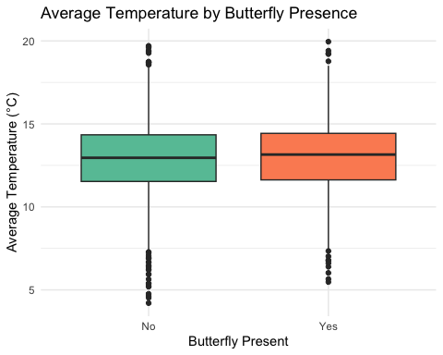

The intraclass correlation coefficient (ICC) of 0.248 indicates that about 25% of the variation in average temperature (after accounting for seasonal effects) can be attributed to differences between groves. When we added butterfly presence to the model, a likelihood ratio test showed no significant improvement in model fit (p = 0.2566), suggesting that locations selected by monarchs do not differ significantly in average temperature from other monitored locations within the groves.

### Maximum Temperature

temp.max.model1 <- lmer(temp.max_centered ~ seasonDay + (1 + seasonDay | grove), data=df)  
temp.max.model2 <- lmer(temp.max_centered ~ seasonDay + butterfly_present + (1 + seasonDay | grove), data=df)  
anova(temp.max.model1, temp.max.model2)

Data: df  
Models:  
temp.max.model1: temp.max_centered ~ seasonDay + (1 + seasonDay | grove)  
temp.max.model2: temp.max_centered ~ seasonDay + butterfly_present + (1 + seasonDay | grove)  
 npar AIC BIC logLik deviance Chisq Df Pr(>Chisq)  
temp.max.model1 6 15126 15161 -7557.2 15114   
temp.max.model2 7 15127 15167 -7556.3 15113 1.8249 1 0.1767

performance::icc(temp.max.model2)

# Intraclass Correlation Coefficient  
  
 Adjusted ICC: 0.507  
 Unadjusted ICC: 0.500

ggplot(df, aes(x=factor(butterfly_present), y=temp.max)) +  
 geom_boxplot(fill=c("#66c2a5", "#fc8d62")) +  
 labs(x="Butterfly Present", y="Maximum Temperature (°C)",   
 title="Maximum Temperature by Butterfly Presence") +  
 scale_x_discrete(labels=c("No", "Yes")) +  
 theme_minimal()

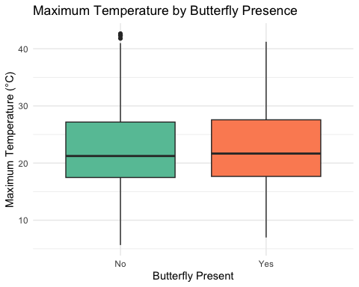

The ICC of 0.507 indicates that about 51% of the variation in maximum temperature (after accounting for seasonal effects) can be attributed to differences between groves. When we added butterfly presence to the model, a likelihood ratio test showed no significant improvement in model fit (p = 0.1767), suggesting that locations selected by monarchs do not differ significantly in maximum temperature from other monitored locations within the groves.

### Minimum Temperature

temp.min.model1 <- lmer(temp.min_centered ~ seasonDay + (1 + seasonDay | grove), data=df)  
temp.min.model2 <- lmer(temp.min_centered ~ seasonDay + butterfly_present + (1 + seasonDay | grove), data=df)  
anova(temp.min.model1, temp.min.model2)

Data: df  
Models:  
temp.min.model1: temp.min_centered ~ seasonDay + (1 + seasonDay | grove)  
temp.min.model2: temp.min_centered ~ seasonDay + butterfly_present + (1 + seasonDay | grove)  
 npar AIC BIC logLik deviance Chisq Df Pr(>Chisq)  
temp.min.model1 6 11416 11450 -5701.8 11404   
temp.min.model2 7 11417 11457 -5701.5 11403 0.566 1 0.4518

performance::icc(temp.min.model2)

# Intraclass Correlation Coefficient  
  
 Adjusted ICC: 0.473  
 Unadjusted ICC: 0.468

ggplot(df, aes(x=factor(butterfly_present), y=temp.min)) +  
 geom_boxplot(fill=c("#66c2a5", "#fc8d62")) +  
 labs(x="Butterfly Present", y="Minimum Temperature (°C)",   
 title="Minimum Temperature by Butterfly Presence") +  
 scale_x_discrete(labels=c("No", "Yes")) +  
 theme_minimal()

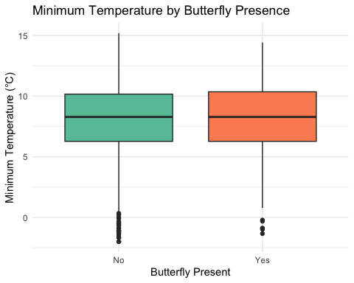

The ICC of 0.452 indicates that about 45% of the variation in minimum temperature (after accounting for seasonal effects) can be attributed to differences between groves. When we added butterfly presence to the model, a likelihood ratio test showed no significant improvement in model fit (p = 0.4518), suggesting that locations selected by monarchs do not differ significantly in minimum temperature from other monitored locations within the groves.

## Humidity

hum.avg.model1 <- lmer(hum.avg_centered ~ seasonDay + (1 + seasonDay | grove), data=df)  
hum.avg.model2 <- lmer(hum.avg_centered ~ seasonDay + butterfly_present + (1 + seasonDay | grove), data=df)  
anova(hum.avg.model1, hum.avg.model2)

Data: df  
Models:  
hum.avg.model1: hum.avg_centered ~ seasonDay + (1 + seasonDay | grove)  
hum.avg.model2: hum.avg_centered ~ seasonDay + butterfly_present + (1 + seasonDay | grove)  
 npar AIC BIC logLik deviance Chisq Df Pr(>Chisq)  
hum.avg.model1 6 15261 15294 -7624.6 15249   
hum.avg.model2 7 15262 15301 -7624.2 15248 0.744 1 0.3884

performance::icc(hum.avg.model2)

# Intraclass Correlation Coefficient  
  
 Adjusted ICC: 0.110  
 Unadjusted ICC: 0.105

ggplot(df, aes(x=factor(butterfly_present), y=hum.avg)) +  
 geom_boxplot(fill=c("#66c2a5", "#fc8d62")) +  
 labs(x="Butterfly Present", y="Average Humidity (%)",   
 title="Average Humidity by Butterfly Presence") +  
 scale_x_discrete(labels=c("No", "Yes")) +  
 theme_minimal()

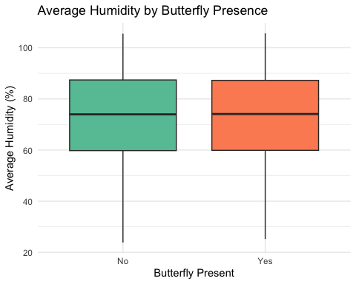

The ICC of 0.110 indicates that about 11% of the variation in average humidity (after accounting for seasonal effects) can be attributed to differences between groves. When we added butterfly presence to the model, a likelihood ratio test showed no significant improvement in model fit (p = 0.3884), suggesting that locations selected by monarchs do not differ significantly in average temperature from other monitored locations within the groves.

## Light

### Average light

# Just random intercepts, no random slopes  
light.avg.model1 <- lmer(light.avg_centered ~ seasonDay + (1 | grove), data=df)  
light.avg.model2 <- lmer(light.avg_centered ~ seasonDay + butterfly_present + (1 | grove), data=df)  
anova(light.avg.model1, light.avg.model2)

Data: df  
Models:  
light.avg.model1: light.avg_centered ~ seasonDay + (1 | grove)  
light.avg.model2: light.avg_centered ~ seasonDay + butterfly_present + (1 | grove)  
 npar AIC BIC logLik deviance Chisq Df Pr(>Chisq)   
light.avg.model1 4 47454 47477 -23723 47446   
light.avg.model2 5 47449 47478 -23720 47439 6.8248 1 0.00899 **  
---  
Signif. codes: 0 '***' 0.001 '**' 0.01 '*' 0.05 '.' 0.1 ' ' 1

performance::icc(light.avg.model2)

# Intraclass Correlation Coefficient  
  
 Adjusted ICC: 0.135  
 Unadjusted ICC: 0.134

ggplot(df, aes(x=factor(butterfly_present), y=light.avg)) +  
 geom_boxplot(fill=c("#66c2a5", "#fc8d62")) +  
 labs(x="Butterfly Present", y="Average Light (lux)",   
 title="Average Light by Butterfly Presence") +  
 scale_x_discrete(labels=c("No", "Yes")) +  
 theme_minimal()

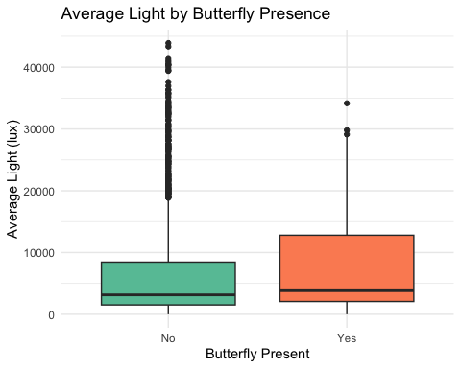

The ICC of 0.135 indicates that about 13.5% of the variation in average light can be attributed to differences between groves. When we added butterfly presence to the model, a likelihood ratio test showed a significant improvement in model fit (p = 0.00899), suggesting that locations selected by monarchs differ significantly in average light levels from other monitored locations within the groves. Note that due to model convergence issues, we had to simplify the random effects structure to only include random intercepts for groves.

### Standard deviation of light

light.std.model1 <- lmer(light.std_centered ~ seasonDay + (1 | grove), data=df)  
light.std.model2 <- lmer(light.std_centered ~ seasonDay + butterfly_present + (1 | grove), data=df)  
anova(light.std.model1, light.std.model2)

Data: df  
Models:  
light.std.model1: light.std_centered ~ seasonDay + (1 | grove)  
light.std.model2: light.std_centered ~ seasonDay + butterfly_present + (1 | grove)  
 npar AIC BIC logLik deviance Chisq Df Pr(>Chisq)   
light.std.model1 4 50856 50879 -25424 50848   
light.std.model2 5 50843 50872 -25417 50833 14.589 1 0.0001337 ***  
---  
Signif. codes: 0 '***' 0.001 '**' 0.01 '*' 0.05 '.' 0.1 ' ' 1

performance::icc(light.std.model2)

# Intraclass Correlation Coefficient  
  
 Adjusted ICC: 0.135  
 Unadjusted ICC: 0.134

ggplot(df, aes(x=factor(butterfly_present), y=light.std)) +  
 geom_boxplot(fill=c("#66c2a5", "#fc8d62")) +  
 labs(x="Butterfly Present", y="Light Standard Deviation (lux)",   
 title="Light Variability by Butterfly Presence") +  
 scale_x_discrete(labels=c("No", "Yes")) +  
 theme_minimal()

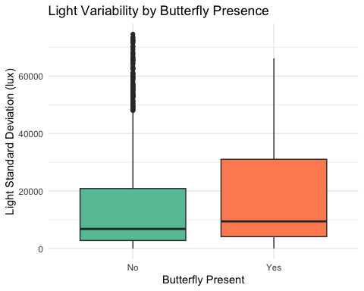

The ICC of 0.135 indicates that about 13.5% of the variation in light variability can be attributed to differences between groves. When we added butterfly presence to the model, a likelihood ratio test showed a highly significant improvement in model fit (p = 0.0001337), suggesting that locations selected by monarchs differ significantly in light variability from other monitored locations within the groves. The boxplots indicate that butterfly-present locations have higher light variability compared to other monitored locations.

# Cross-level interaction model  
cross_level_model <- lmer(light.avg_centered ~ seasonDay * butterfly_present + (1 | grove), data = df)  
  
# Summary of the model  
summary(cross_level_model)

Linear mixed model fit by REML ['lmerMod']  
Formula: light.avg_centered ~ seasonDay * butterfly_present + (1 | grove)  
 Data: df  
  
REML criterion at convergence: 47385.9  
  
Scaled residuals:   
 Min 1Q Median 3Q Max   
-1.5470 -0.6194 -0.2599 0.2045 4.7908   
  
Random effects:  
 Groups Name Variance Std.Dev.  
 grove (Intercept) 8407508 2900   
 Residual 54623148 7391   
Number of obs: 2295, groups: grove, 9  
  
Fixed effects:  
 Estimate Std. Error t value  
(Intercept) 54.815 1042.840 0.053  
seasonDay -10.066 9.916 -1.015  
butterfly_present -1290.628 832.242 -1.551  
seasonDay:butterfly_present 66.180 21.217 3.119  
  
Correlation of Fixed Effects:  
 (Intr) sesnDy bttrf_  
seasonDay -0.334   
bttrfly_prs -0.172 0.402   
ssnDy:bttr_ 0.149 -0.435 -0.886

To further investigate the relationship between butterfly presence and light conditions over time, we fit a model including an interaction between seasonDay and butterfly presence. The model revealed a significant interaction between seasonDay and butterfly presence (Est. = 66.180, t = 3.119). This suggests that not only do monarchs select locations with different light conditions, but this relationship changes throughout the overwintering season. Note that this model also used the simplified random effects structure with only random intercepts for groves due to convergence issues with the more complex random effects structure.