Natural Disaster Severity Classification Using Machine Learning: A Comparative Analysis of Five Model Families on NOAA Storm Events Data
Alejandro Arroyo, Ruby Penaranda Espinoza, Sanjana Vijayabhaskar, Akila Kumar, Harris Durani

Abstract
Natural disasters cause significant loss of life and economic damage, yet pre-event resource allocation remains constrained by the inability to predict which events will reach catastrophic impact. This study applies data mining methodologies to the NOAA Storm Events database (2000-2025), comprising 1,546,474 de-duplicated event records across the contiguous United States, to classify disaster severity into five ordinal classes: None, Low, Medium, High, and Catastrophic. Target labels were constructed from a composite score aggregating deaths, injuries, and property damage, yielding a severely imbalanced distribution (75.3% None, 23.3% Low, 1.4% Medium, 0.03% High, 0.01% Catastrophic). A multi-method feature selection pipeline combining variance filtering, bidirectional stepwise selection, LassoCV, and ElasticNetCV produced a 51-feature consensus set after leakage removal. Five model families were evaluated across 13 experiments: Multinomial Logistic Regression, Random Forest, Support Vector Machine, XGBoost, and Multilayer Perceptron. All models were trained on a stratified 70/15/15 split with macro-averaged F1 as the primary metric to weight rare classes equally. The Random Forest trained on the full 109-feature pre-selection set achieved the strongest result with a test macro F1 of 0.3966, followed by MLP (0.3375), XGBoost (0.3345), RBF SVC (0.3166), and GLM (0.3040). Across all model families, None and Low severity events were reliably classified while High and Catastrophic events remained near-zero F1 regardless of model family, imbalance handling strategy, or feature set composition. This consistent ceiling reflects a fundamental limitation of the NOAA Storm Events database, which lacks population density, infrastructure quality, and pre-event preparedness variables that plausibly discriminate catastrophic from non-catastrophic outcomes. Future work should prioritize integration of census, infrastructure, and real-time meteorological data to address this gap.
Index Terms -- Natural disaster severity classification, imbalanced classification, random forest, ensemble methods, NOAA Storm Events.
I. INTRODUCTION
Natural disasters represent one of the most persistent and costly challenges facing emergency management agencies worldwide. In the United States alone, the National Oceanic and Atmospheric Administration (NOAA) documents tens of thousands of storm events annually, ranging from routine thunderstorms causing minimal impact to catastrophic hurricanes and tornadoes responsible for mass casualties and billions of dollars in property damage. The fundamental difficulty facing emergency managers is not detecting that a disaster has occurred, but predicting in advance which events are likely to reach severe or catastrophic impact so that resources can be pre-positioned rather than reactively deployed.
Existing approaches to disaster severity prediction have largely focused on specific event types rather than cross-event classification frameworks applicable to the full spectrum of recorded storm phenomena. The NOAA Storm Events database, which records over 1.5 million unique events across 43 event types from 2000 to 2025, provides an opportunity to build a generalized severity classifier that learns from historical patterns across event type, geography, magnitude, and season simultaneously. However, this dataset presents a structural challenge common to real-world disaster records: severe events are extraordinarily rare. High and Catastrophic severity events together represent fewer than 0.05% of all records, making standard classification approaches prone to collapsing predictions onto the dominant None and Low classes.
This paper presents a systematic evaluation of five machine learning model families applied to the natural disaster severity classification problem using the NOAA Storm Events database. Our contributions are as follows. First, we construct a severity target variable from a composite score aggregating deaths, injuries, and property damage with ordinal thresholds grounded in the empirical distribution of the training data. Second, we apply a three-method feature selection consensus pipeline combining variance filtering, bidirectional stepwise selection, and penalized regression to identify a parsimonious, leakage-free feature set. Third, we evaluate Multinomial Logistic Regression, Random Forest, Support Vector Machine, XGBoost, and Multilayer Perceptron classifiers across 13 experiments varying feature sets, imbalance handling strategies, and hyperparameter configurations. Fourth, we report results using macro-averaged F1 to weight all severity classes equally, and provide per-class precision-recall and ROC analysis to distinguish ranking ability from threshold-level classification performance. Our results reveal a consistent feature informativeness ceiling across all model families: the NOAA dataset, while comprehensive in event coverage, lacks the population density, infrastructure quality, and pre-event preparedness variables that plausibly separate catastrophic from non-catastrophic outcomes regardless of modeling approach.
The remainder of this paper is organized as follows. Section II describes the dataset and exploratory analysis. Section III presents the feature selection pipeline. Sections IV through VIII present results for each model family. Section IX provides a comparative analysis and discussion. Section X concludes with directions for future work.
II. EXPLORATORY DATA ANALYSIS
The NOAA Storm Events database provided 3,777,888 raw records spanning 2000 to 2025. After exact deduplication and FEMA record aggregation, the cleaned dataset contained 1,546,474 unique events across 43 event types and 68 geographic regions. The dataset comprised 12 discrete numerical variables, 4 continuous numerical variables, 11 categorical or text variables, and 2 boolean variables.
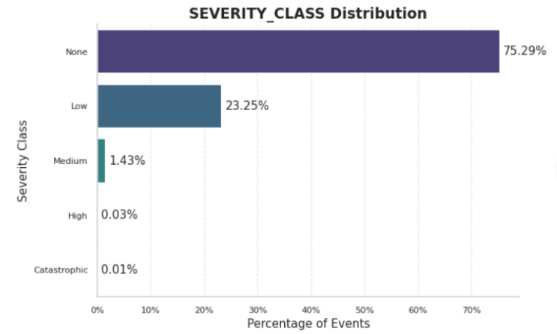
The most frequent disaster types show a highly uneven distribution: Thunderstorm Wind accounts for approximately 26.30% of records and Hail for approximately 19.12%, together representing nearly half the dataset. Events are also geographically concentrated, with Texas alone accounting for 7.49% of all records, well above Kansas, Missouri, Iowa, and Oklahoma (each 3.4-4.5%), suggesting certain regions are disproportionately disaster-prone.
Event frequency has been relatively stable over time, peaking around 2011 (approximately 5%) with a slight upward trend again in 2022-2025. Seasonally, events peak sharply in June (13.97%) and July (12.99%), consistent with expected storm-season patterns.
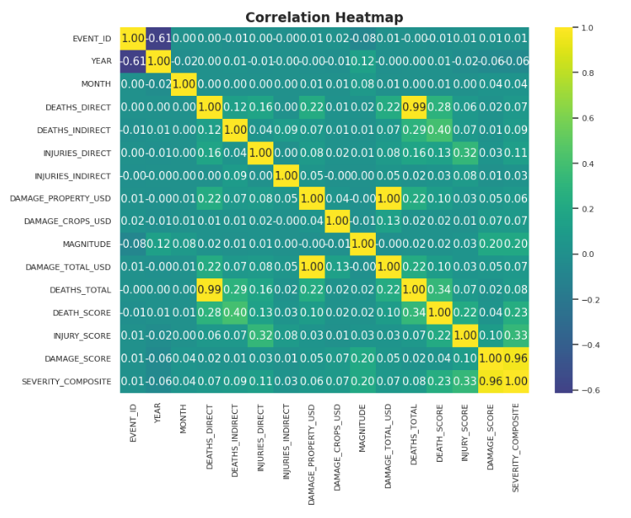
The event type vs. severity heatmap confirms that nearly all disaster types are concentrated in the None class, with only Thunderstorm Wind, Hail, and Flood showing a meaningful Low presence; Medium, High, and Catastrophic remain rare across every event type. This reinforces that severity, not event frequency, is where our modeling challenge lies: frequent event types are not necessarily the most impactful ones.
III. FEATURE SELECTION
To prepare the encoded features for modeling, we began with 121 one-hot encoded features derived from our cleaned dataset. We applied a multi-method feature selection pipeline combining filter, wrapper, and embedded approaches to identify a parsimonious feature set.
A. Filter Method
As a filter step, we removed 50 near-zero-variance features that carried insufficient discriminating information. The features that failed to meet the 0.01 variance threshold were low-frequency state abbreviations and rare event types, including Avalanche, Tsunami, and Volcanic Ash. We also reviewed a correlation matrix across core numeric predictors, which confirmed that DAMAGE_TOTAL_USD and DAMAGE_PROPERTY_USD were near-perfectly correlated (r = 1.00) and DEATHS_TOTAL was entirely collinear with DEATHS_DIRECT (r = 0.99).
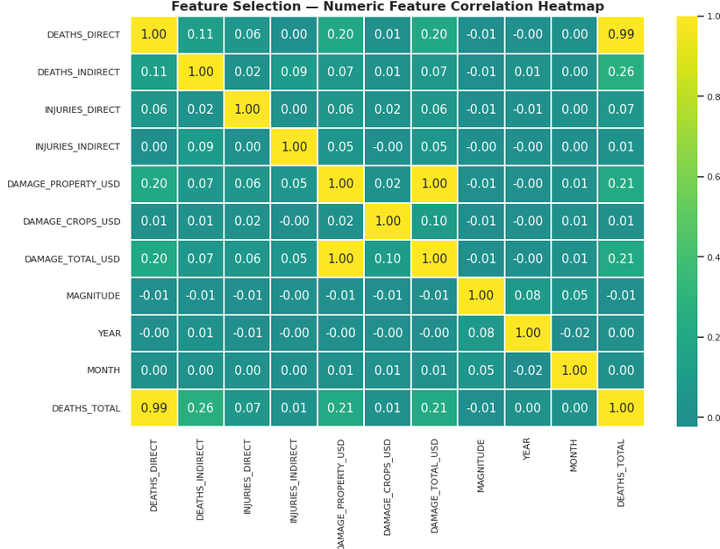
B. Wrapper Method
For the wrapper method, we ran bidirectional stepwise OLS selection against SEVERITY_COMPOSITE as a continuous proxy target, with entry threshold 0.01 and removal threshold 0.05, yielding 99 features after approximately 198 minutes of runtime. Due to our large sample size, p-values were inflated and nearly all candidates reached significance, so stepwise selection served as a secondary check rather than the primary filter.
C. Embedded Methods
For embedded methods, we applied LassoCV and ElasticNetCV with 5-fold cross-validation, both operating against SEVERITY_COMPOSITE. Lasso selected the optimal regularization strength at alpha = 0.0084, retaining 58 of 121 features. ElasticNet (alpha = 0.0169, l1_ratio = 0.50) also retained 58 features.
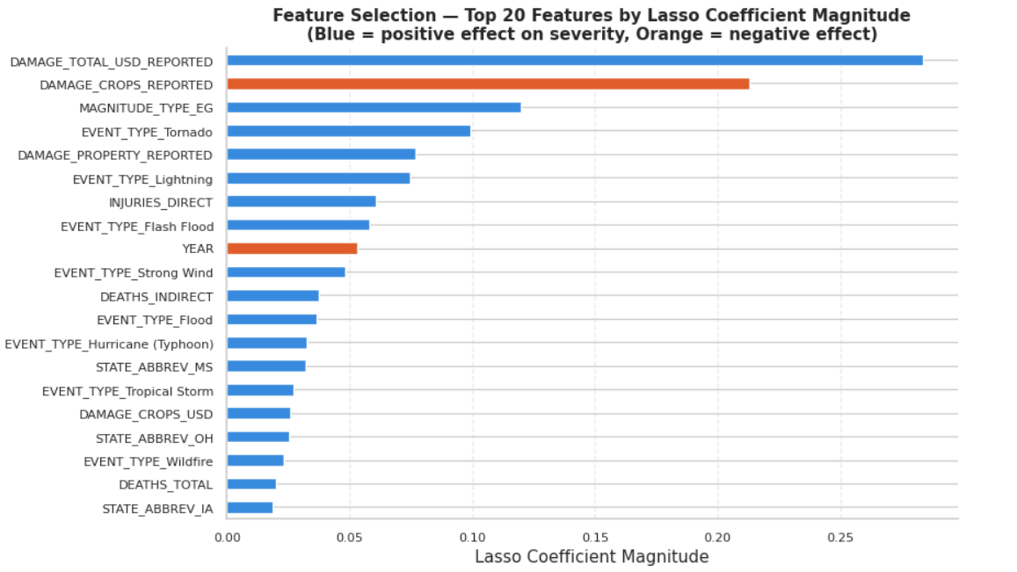
Features selected by all three methods numbered 48, with an additional 11 selected by two of three, for a pre-leakage total of 59. Following selection, we removed features derived directly from the target variable construction, which would constitute data leakage. After leakage removal, our final confirmed feature set contained 51 features. The strongest positive predictors by Lasso coefficient magnitude were DAMAGE_TOTAL_USD_REPORTED (0.284), MAGNITUDE_TYPE_EG (0.120), and EVENT_TYPE_Tornado (0.099).
IV. GENERALIZED LINEAR MODEL
The GLM was implemented using multinomial logistic regression on the same 51-feature confirmed consensus set, the same stratified 70/15/15 split, and the same random state (6704) used across all other model families. All 51 features were transformed with StandardScaler prior to fitting. Two experiments were run: an untuned baseline and a regularized Elastic Net version, both using class_weight="balanced".
A. Baseline GLM
Experiment 1 fit a baseline multinomial model with no penalty tuning (max_iter=2000), converging in 1.1 minutes and producing a validation macro F1 of 0.3121. The None class saw precision of 0.96 and recall of 0.70 (F1 = 0.81), and Low reached F1 = 0.67. Performance collapsed for the rare classes: Medium had precision of 0.04 despite recall of 0.45, and High and Catastrophic both had precision near zero despite recall of 0.32 and 0.44 respectively.
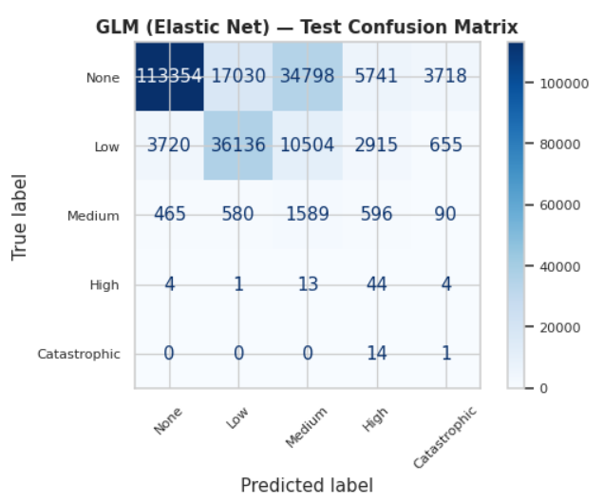
B. Elastic Net GLM
Experiment 2 added Elastic Net regularization via the saga solver (l1_ratio=0.5, C=1.0, max_iter=500), taking 20.7 minutes to converge. Regularization reduced validation macro F1 to 0.3042 and test macro F1 to 0.3040, a small but consistent decline. Catastrophic recall collapsed from 0.44 to 0.12, likely because the L1 component shrank coefficients carrying weak but real signal for the rarest classes. The unregularized baseline generalized well to test (macro F1 of 0.3040), indicating the GLM was closer to underfitting rare classes structurally rather than overfitting.
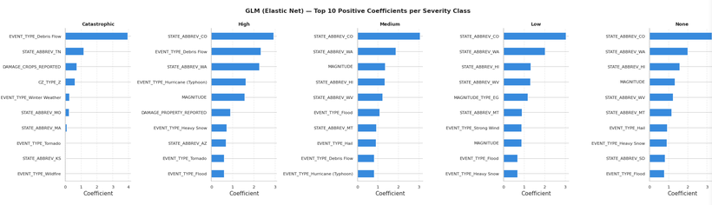
Coefficient inspection revealed that EVENT_TYPE_Debris Flow (3.96), STATE_ABBREV_TN (1.15), and DAMAGE_CROPS_REPORTED (0.72) were the strongest positive predictors of the Catastrophic class. For the None class, STATE_ABBREV_CO (3.27), STATE_ABBREV_WA (1.99), and STATE_ABBREV_HI (1.56) dominated. The GLM's test macro F1 of 0.3040 was the lowest of any confirmed result, establishing an interpretable linear floor and providing convergent evidence that the informative signal in this dataset is narrow.
V. RANDOM FOREST
We implemented the Random Forest classifier across four experiments varying feature set composition and class imbalance handling. All experiments used 500 estimators, a minimum leaf size of five, a stratified 70/15/15 split, random state 6704, and macro-averaged F1 as the evaluation metric.
A. Experimental Results
Experiment 1 used the 51-feature consensus set. Five-fold stratified cross-validation yielded a mean macro F1 of 0.3111 (SD = 0.0009) and the validation set produced a macro F1 of 0.3496.
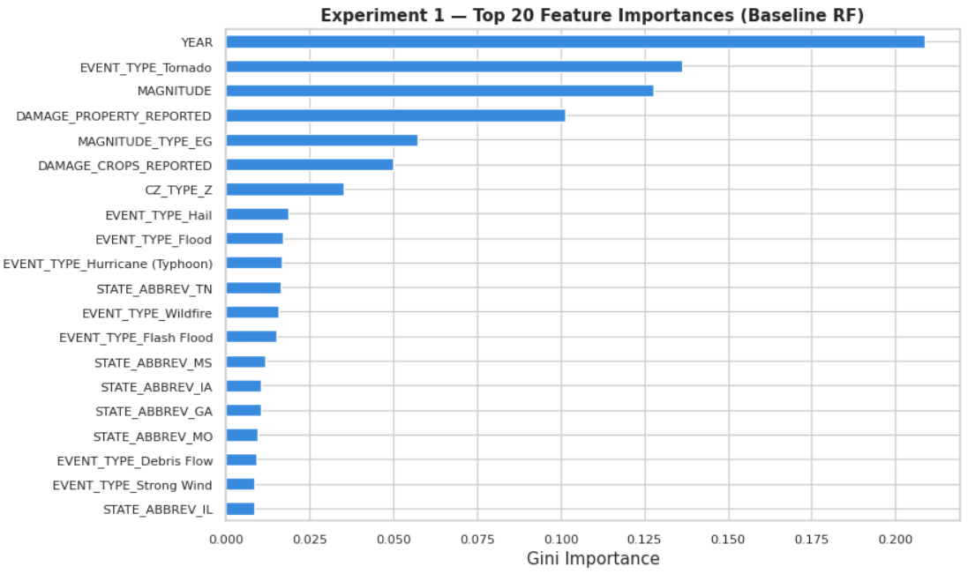
Feature importance analysis revealed YEAR as the dominant predictor (26.4%). Experiment 2 removed YEAR, confirming that Medium severity proportions declined from 2000 to 2025 due to NOAA coverage expansion rather than genuine temporal trends. Removing YEAR reduced validation macro F1 to 0.2981. Experiment 3 applied SMOTE oversampling (High n=5,000; Catastrophic n=1,000; Medium n=20,000), nominally improving validation macro F1 to 0.3636, but gains were driven entirely by the None class; High and Catastrophic collapsed to near-zero recall. SMOTE was rejected as a modeling strategy.
Experiment 4 trained on the full pre-selection feature set of 109 features, achieving a validation macro F1 of 0.3988 and a test macro F1 of 0.3966 with improvements in Medium recall (0.63). This suggests the feature selection process, optimized against a continuous proxy target, inadvertently discarded signal relevant to rare class classification. We designate this as our final Random Forest model, with YEAR (18.4%), MONTH (11.8%), EVENT_TYPE_Tornado (9.6%), and MAGNITUDE (8.7%) as the top four features by Gini importance.
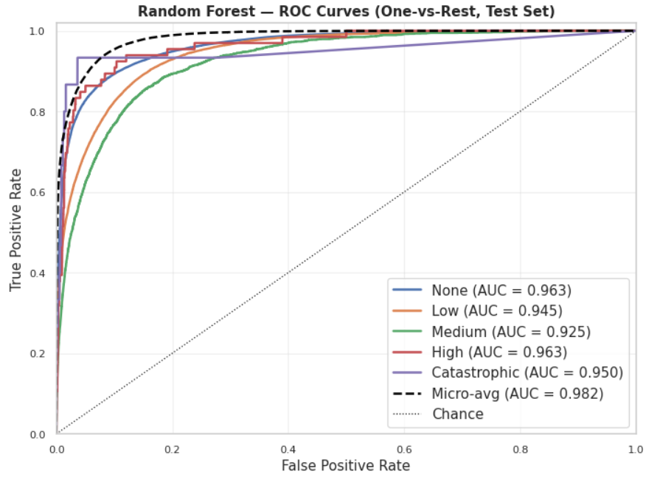
Across all experiments, the consistent inability to identify High and Catastrophic events reflects a feature informativeness ceiling: NOAA Storm Events does not capture population density, infrastructure quality, or pre-event preparedness capacity that discriminates catastrophic from non-catastrophic outcomes.
VI. SUPPORT VECTOR MACHINE
We evaluated three SVM configurations to assess how kernel choice and training set composition affected severity classification: a full-training LinearSVC, a LinearSVC trained on a None-undersampled dataset (None reduced to 100K), and an RBF SVC trained on a stratified 100K sample. All experiments used the 51-feature confirmed feature set, class_weight="balanced", and shared 70/15/15 splits. The RBF SVC on the full 1.08 million training set was computationally infeasible and was terminated after multiple hours without convergence.
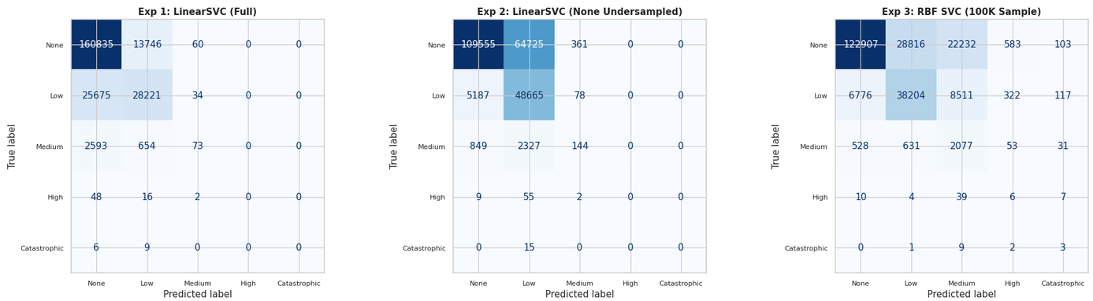
A. Experimental Results
The LinearSVC on the full training set (6.5 min) achieved a test macro F1 of 0.3021, correctly identifying None events (precision 0.85, recall 0.92) but failing entirely on High and Catastrophic (F1 = 0.00) with minimal Medium recall (0.02). Undersampling None to 100K degraded overall performance to a test macro F1 of 0.2804, with no improvement on rare classes.
The RBF SVC on a stratified 100K sample (27.7 min) was the best-performing SVM variant, achieving a test macro F1 of 0.3166. The nonlinear kernel improved Low recall (0.71 vs 0.52), Medium recall (0.63 vs 0.02), and produced marginal Catastrophic recall (0.20). However, the 100K sample contained only 7 Catastrophic and 28 High examples, limiting rare-class learning regardless of kernel choice. The undersampling experiment confirmed that artificially equalizing the None class does not improve rare-class detection when the feature informativeness ceiling applies equally regardless of class balance.
VII. XGBOOST
We implemented XGBoost across three experiments using the same 51-feature confirmed feature set, the same stratified 70/15/15 split, and random state 6704. Because XGBoost does not accept a class_weight argument, imbalance was addressed with balanced sample weights. The number of boosting rounds was set by early stopping on the validation set.
A. Baseline and Hyperparameter Search
Experiment 1 established a baseline at depth 6, learning rate 0.1, subsampling 0.8, halting at iteration 36 and yielding a validation macro F1 of 0.3268. Experiment 2 evaluated six configurations varying depth, learning rate, minimum child weight, and regularization. Validation macro F1 spanned 0.3261 to 0.3355, and performance improved monotonically with tree depth, indicating underfitting at shallow depths. The winning configuration (depth 10, learning rate 0.05, min_child_weight 20, subsample 0.9, colsample_bytree 0.7, reg_lambda 5.0, reg_alpha 0.5, 72 rounds) paired maximum depth with the strongest regularization in the grid, preventing overfitting to the 71 Catastrophic training examples.
B. Cross-Validation and Final Evaluation
Experiment 3 confirmed the selected configuration through stratified 5-fold cross-validation. Fold macro F1 averaged 0.3353 (SD = 0.0007) and ROC AUC averaged 0.9101 (SD = 0.0029), confirming stability across training subsamples. Refitting on the full training set at 73 rounds produced a test macro F1 of 0.3345 and accuracy of 0.7441.
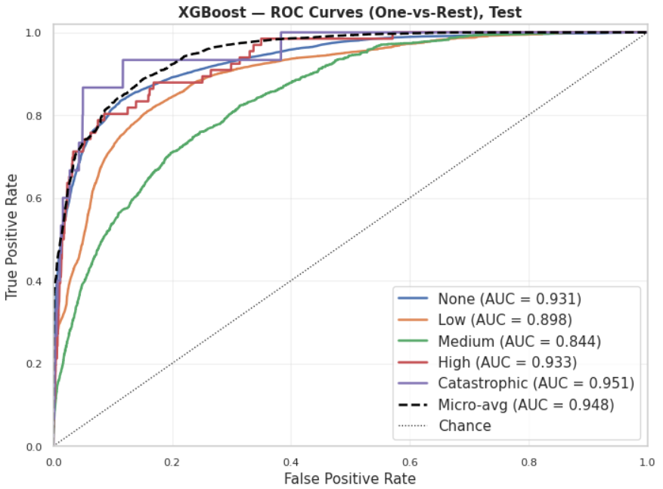
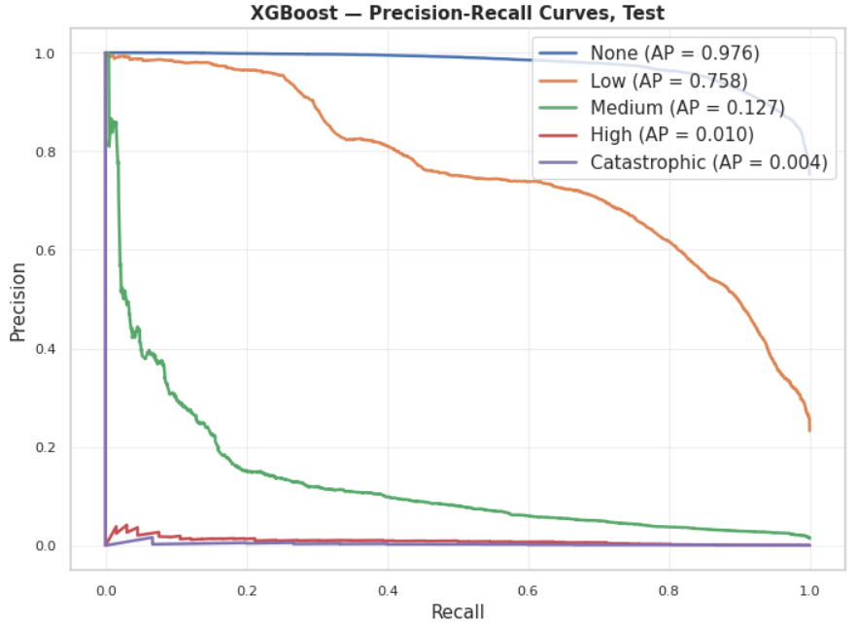
Test ROC AUC reached 0.9113 one-vs-rest macro, with per-class AUC of 0.9327 for High and 0.9513 for Catastrophic, indicating strong ranking ability. However, per-class PR AUC was only 0.0096 and 0.0036 respectively, with precision near zero, because even a small false positive rate overwhelms the true positive count given only 66 High and 15 Catastrophic test events. XGBoost's probability outputs are more useful than its hard classifications for resource prioritization purposes. EVENT_TYPE_Tornado accounted for 41.9% of normalized feature importance, an order of magnitude above the next-ranked feature.
VIII. NEURAL NETWORK
Two neural network implementations were evaluated: a scikit-learn MLPClassifier scaling study and a PyTorch MLP with tuned hyperparameters.
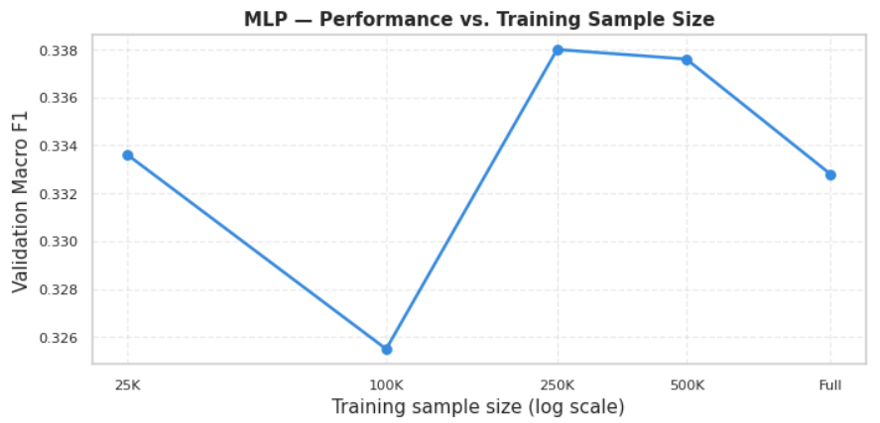
A. sklearn MLP Scaling Study
The baseline sklearn MLP (hidden layers 128/64, ReLU activation, Adam solver, adaptive learning rate, early stopping) was trained at five sample sizes: 25K, 100K, 250K, 500K, and the full 1,082,531 training rows. Performance peaked at the 250K sample (test macro F1 = 0.3375) before plateauing at 500K (0.3376) and declining marginally at the full training set (0.3325), suggesting majority-class saturation begins to outweigh rare-class learning beyond a certain sample size.
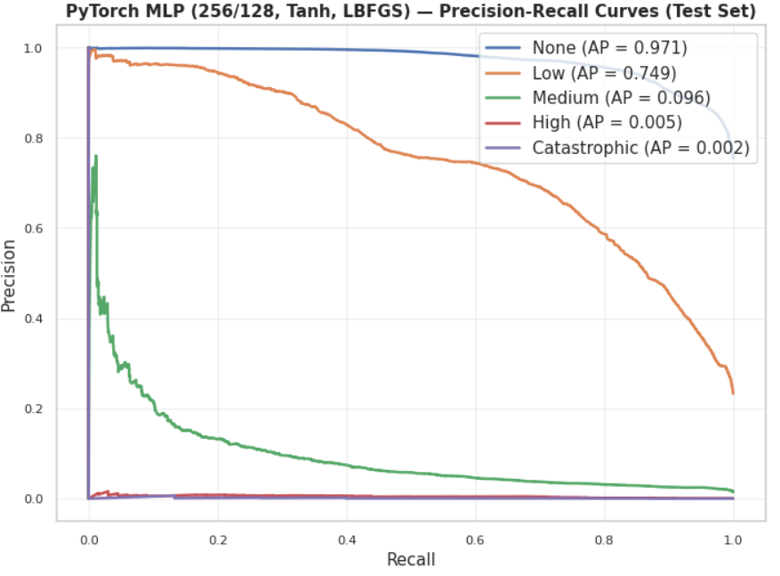
B. PyTorch MLP
The PyTorch implementation doubled the hidden layer size to 256/128, replaced ReLU with Tanh activation, and used the LBFGS solver without early stopping. The model was trained on a 6GB GPU over approximately 8 hours, stopping at epoch 71 via patience-based early stopping. This configuration produced a validation macro F1 of 0.3306 and test macro F1 of 0.3298. The larger hidden layers provided more capacity to model non-linear class boundaries; Tanh's symmetry around zero aligned well with standardized inputs; and LBFGS's curvature approximation enabled tighter convergence than Adam's noisy gradient updates. Despite these architectural improvements, the PyTorch MLP did not outperform the 250K sklearn variant, likely because full-batch LBFGS converged to a suboptimal basin given the severe class imbalance in the full training set.
IX. COMPARATIVE ANALYSIS AND DISCUSSION
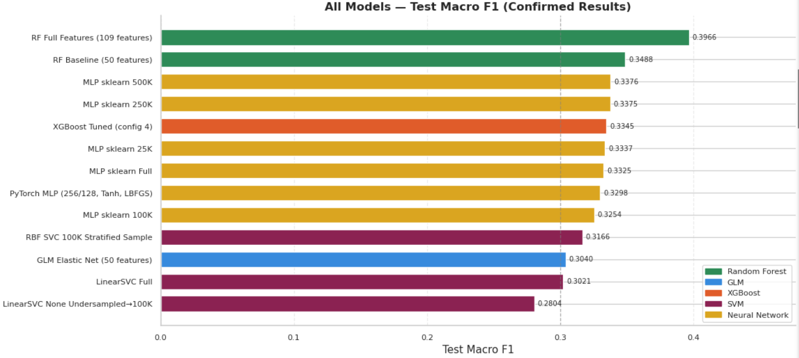
Our full experimental pipeline spanned five model families and 13 confirmed experiments. The Random Forest emerged as the best-performing model family, with the 109-feature configuration achieving a test macro F1 of 0.3966. The 5-fold cross-validation mean of 0.3111 (SD = 0.0009) confirmed stable performance, with YEAR (20.9%), EVENT_TYPE_Tornado (13.6%), MAGNITUDE (12.8%), and DAMAGE_PROPERTY_REPORTED (10.1%) as the most informative features by Gini importance.
Neural networks produced competitive results. Performance peaked at the 250K sample (test F1 = 0.3375) before declining, suggesting majority-class saturation. The PyTorch MLP (test F1 = 0.3298) did not outperform sklearn variants. XGBoost's tuned configuration (depth 10, learning rate 0.05, n_estimators 73) achieved test macro F1 of 0.3345, outperforming all SVM and GLM variants. Its distinguishing result was probabilistic: ROC AUC of 0.9113 indicated strong class-separation ability even when hard classification struggled on the rarest classes.
SVM results were consistent with other models. The RBF kernel outperformed both LinearSVC variants (0.3166 vs 0.3021 and 0.2804). The undersampling experiment confirmed that equalizing the None class does not improve rare-class detection when the feature informativeness ceiling applies equally. The GLM Elastic Net achieved a test macro F1 of 0.3040, the lowest confirmed result, establishing an interpretable linear floor and corroborating event-type and state-level drivers identified by tree ensembles.
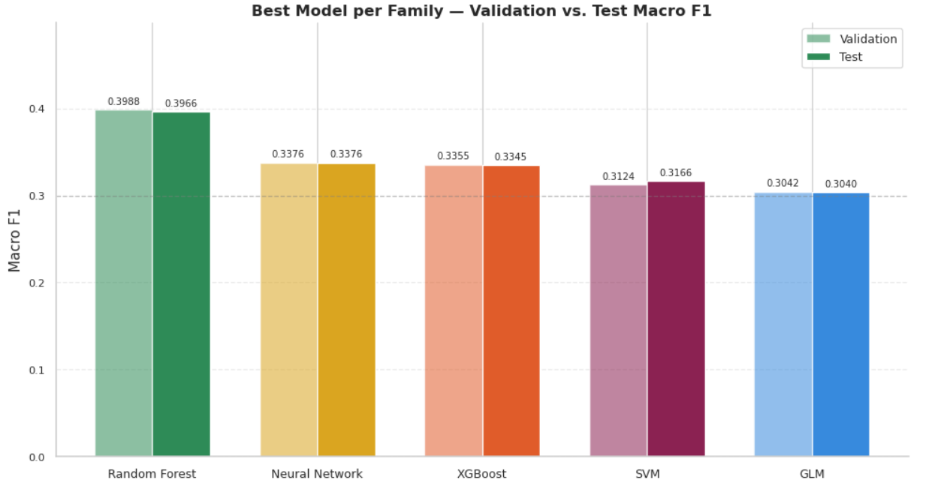
Across all models, a consistent pattern emerged: None and Low severity events were reliably classified (Low F1 consistently exceeding 0.58), while High and Catastrophic events remained near-zero F1 regardless of model family, imbalance strategy, or feature set. This reflects a fundamental feature-informativeness ceiling. The NOAA Storm Events database records what happened and where, but does not capture the exposure and vulnerability variables that govern impact magnitude: population density, infrastructure quality, housing density, proximity to emergency services, and pre-event resource positioning. That a regularized linear model and a depth-10 boosted ensemble converge to nearly the same macro F1 is the clearest evidence that the constraint is not model capacity but feature informativeness.
X. CONCLUSION
This study evaluated five machine learning model families across 13 experiments for the task of classifying natural disaster severity using the NOAA Storm Events database. The Random Forest trained on the full pre-selection feature set achieved the strongest result with a test macro F1 of 0.3966, followed by MLP sklearn 250K (0.3375), XGBoost tuned (0.3345), RBF SVC 100K (0.3166), and GLM Elastic Net (0.3040). Across all model families, None and Low severity events were reliably classified while High and Catastrophic events remained near-zero F1 across every configuration tested, including experiments explicitly designed to address class imbalance.
This consistent pattern points to a fundamental feature informativeness ceiling rather than an algorithmic limitation. The NOAA Storm Events database records what happened and where, but does not capture the exposure and vulnerability variables that govern impact magnitude. A high-magnitude tornado striking an unpopulated rural area and one striking a densely populated suburb produce very different outcomes, yet are represented identically in the available feature space.
Several directions for future work emerge directly from these findings. Integration of census demographic data, infrastructure quality indices, and land use classifications at the county or zip code level would provide the exposure signal currently absent from NOAA records. Real-time meteorological inputs such as storm trajectory, wind shear, and atmospheric instability indices may further discriminate which events escalate to catastrophic impact. From a modeling perspective, ordinal regression approaches that explicitly exploit the ordered structure of the severity classes, and cost-sensitive learning frameworks that directly optimize resource allocation objectives, represent natural extensions of the framework developed here. Finally, the probabilistic outputs of XGBoost, which achieved a test ROC AUC of 0.9113 despite modest macro F1, suggest that ranked severity scoring rather than hard classification may be the more operationally useful output for emergency management decision support.
XI. REFERENCES
[1] NOAA National Centers for Environmental Information, "Storm Events Database (Bulk Data 2020-2025),", 2026. [Online]. Available: https://www.ncei.noaa.gov/stormevents/ftp.jsp. [Accessed: May 19, 2026].

